INTRODUCTION TO DATA MANAGEMENT
PROJECT REPORT
(Project Semester January-April 2025)

LOK SABHA ELECTIONS 2024
DASHBOARD

Submitted by:
Samarth Garg
Registration No.: 12324193
Programme: Bachelor of Technology
Section: K23GN
Course Code: INT217

Under the Guidance of
Ms. Ashu Mehta
(UID: 23631)

Discipline of CSE/IT
Lovely School of Computer Science & Engineering
Lovely Professional University, Phagwara

CERTIFICATE

This is to certify that Samarth Garg, bearing Registration no. 12324193 has completed INT217 project titled, “LOK SABHA ELECTIONS 2024 DASHBOARD” under my guidance and supervision. To the best of my knowledge, the present work is the result of his original development, effort and study.

Signature and Name of the Supervisor: Ms. Ashu Mehta
Designation of the Supervisor:

School of Computer Science & Engineering
Lovely Professional University
Phagwara, Punjab.

Date: 13-04-2025

DECLARATION

I, Samarth Garg, student of Bachelor of Technology under CSE/IT Discipline at, Lovely Professional University, Punjab, hereby declare that all the information furnished in this project report is based on my own intensive work and is genuine.

Date: 13-04-2025
Signature: Samarth garg
Registration No.: 12324193

ACKNOWLEDGEMENT

I express my sincere gratitude to my course instructor, Ms. Ashu Mehta, for their invaluable guidance and support throughout the "Introduction to Data Management" course. Their expertise in data organization and visualization techniques was instrumental in helping me successfully complete this project on creating the LOK SABHA ELECTIONS 2024 DASHBOARD using Excel.

Table of Contents

1. Introduction
2. Source of dataset
3. EDA process
4. Analysis on dataset (for each analysis)
- Objective1: KPI Overview
- Objective2: Party-wise Performance
- Objective3: State-wise Analysis
- Objective4: Candidate Leaderboard
- Objective5: Voter Turnout Insight
- Objective6: Demographic Analysis
- Objective7: Close Contests
5. Conclusion
6. Future scope
7. References

1. Introduction
1.1 Background
The Lok Sabha Elections 2024 were one of the largest democratic exercises in the world. This dashboard was created to provide a dynamic and interactive view of the results and key metrics using Microsoft Excel. It includes real-time slicers, pivot-based charts, KPIs, and visual summaries to help users easily explore state-wise, party-wise, and candidate-wise data.
1.2 Scope
This project visualizes detailed election metrics such as turnout percentages, candidate demographics, party performance, and margin of victories. It aims to assist users in deriving meaningful political insights using structured data analytics techniques in Excel.

2. Source of Dataset
2.1 Data Description
The dataset consists of detailed candidate-level results from the General Elections 2024. It includes fields like State Name , PC Name , Candidate Name , Gender , Age , Category , Party Name , Party Symbol , Total Votes Polled In The Constituency , Valid Votes , Votes Secured – General , Votes Secured – Postal , Votes Secured - Total , % of Votes Secured - Over Total Electors In Constituency , % of Votes Secured - Over Total Votes Polled In Constituency , Over Total Valid Votes Polled In Constituency , Total Electors.
2.2 Data Collection
Dataset link: https://www.data.gov.in/resource/constituency-wise-detailed-result-during-2024

3. EDA Process
EDA was done using Excel’s PivotTables and formulas. Key operations included:
- Cleaning duplicates and outliers
- Creating helper columns (e.g., Margin, Rank, Win Status)
- Calculating %Turnout and Vote Share
- Using PivotTables to extract insights
- Applying slicers for filters (State, Gender, Category)
- Conditional formatting for visual cues
Visual tools used: Pie Charts, Column & Bar Charts, KPI Cards, Donut Charts, and Map Charts.

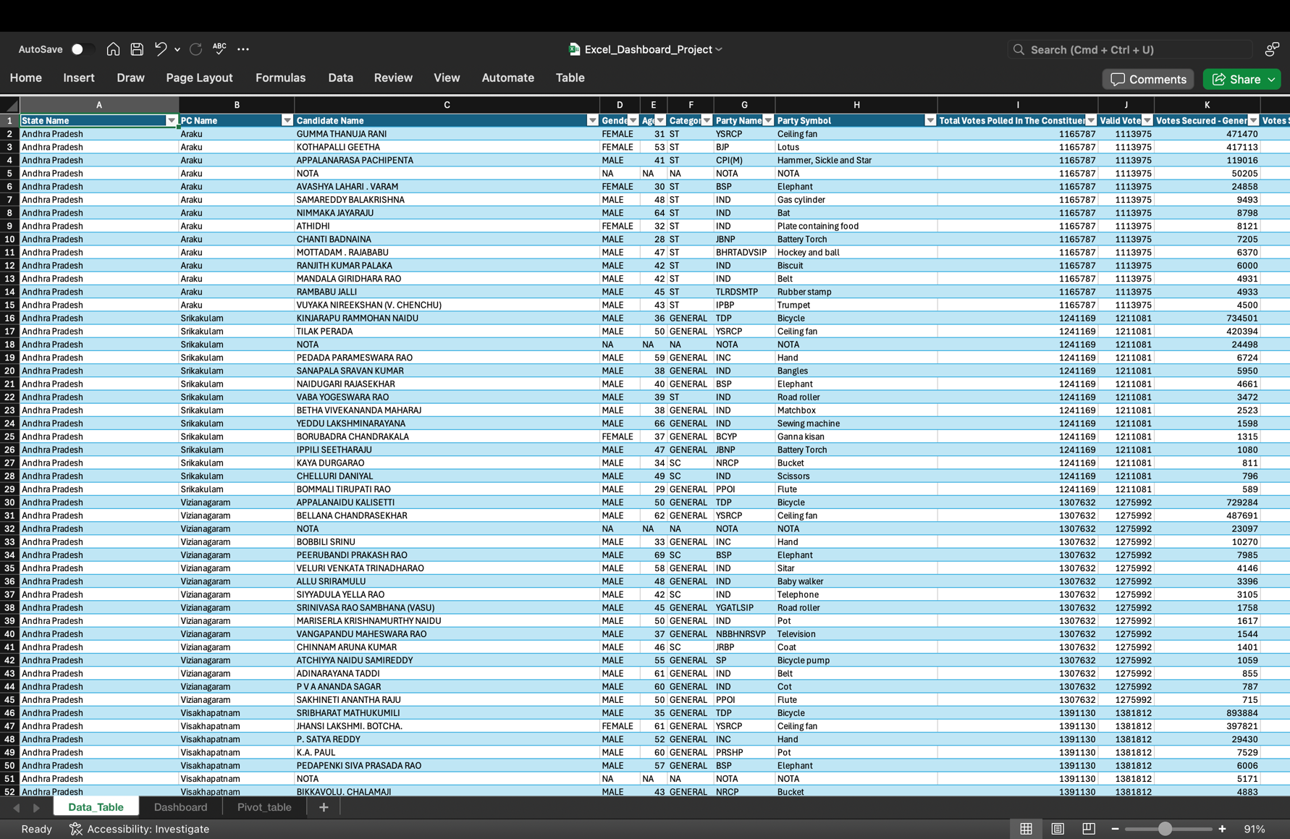

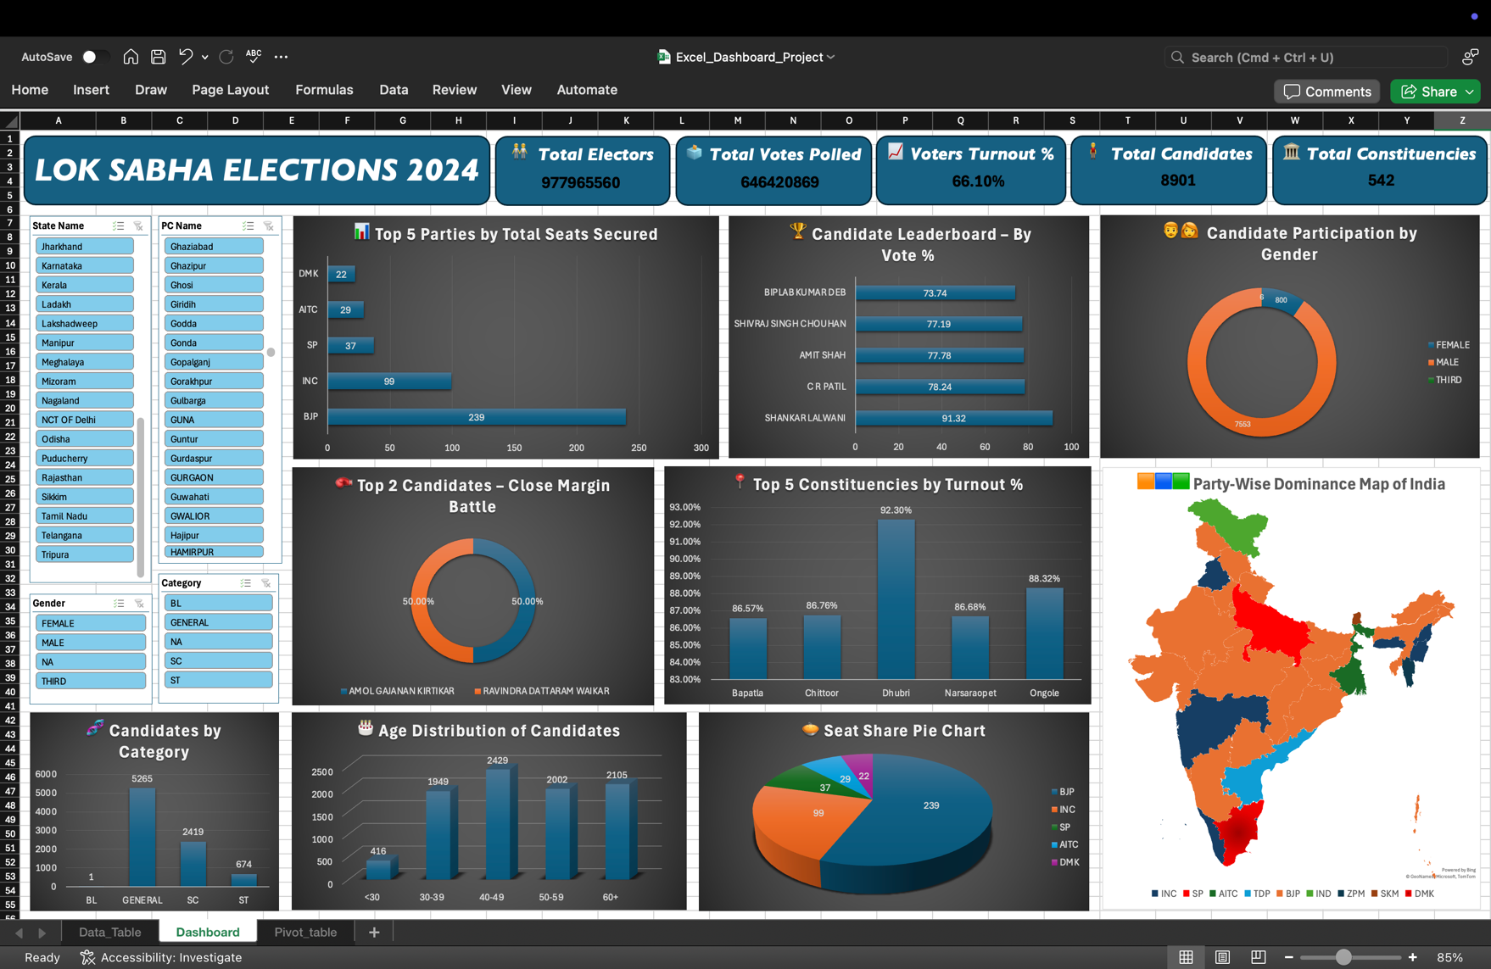

Objectives:
1. Objective: KPI Overview
i. Introduction
This objective focuses on summarizing the most important metrics of the Lok Sabha Elections 2024, presented at the top of the dashboard in the form of KPI (Key Performance Indicator) cards. These indicators offer a high-level snapshot of the national election statistics and help establish the scale and participation in the democratic process.
ii. General Description
The dashboard displays six KPI cards including Total Electors, Total Votes Polled, Voter Turnout %, Total Valid Votes, Total Candidates, and Total Constituencies. These cards are visually highlighted using bold formatting and background fills for immediate visibility. The metrics are automatically updated based on slicer selections, enabling users to view dynamic summaries for specific states or filters.
iii. Analysis Results
As per the final dashboard calculations, the total number of electors recorded in the country was approximately 977 million, with around 646 million total votes polled, resulting in a voter turnout rate of 66.10%. The total valid votes stood at 623 million, with 8,901 candidates contesting across 542 constituencies. These metrics underline the massive scale of the election and form the baseline for more detailed state-wise and candidate-level analysis.
iv. Visualization

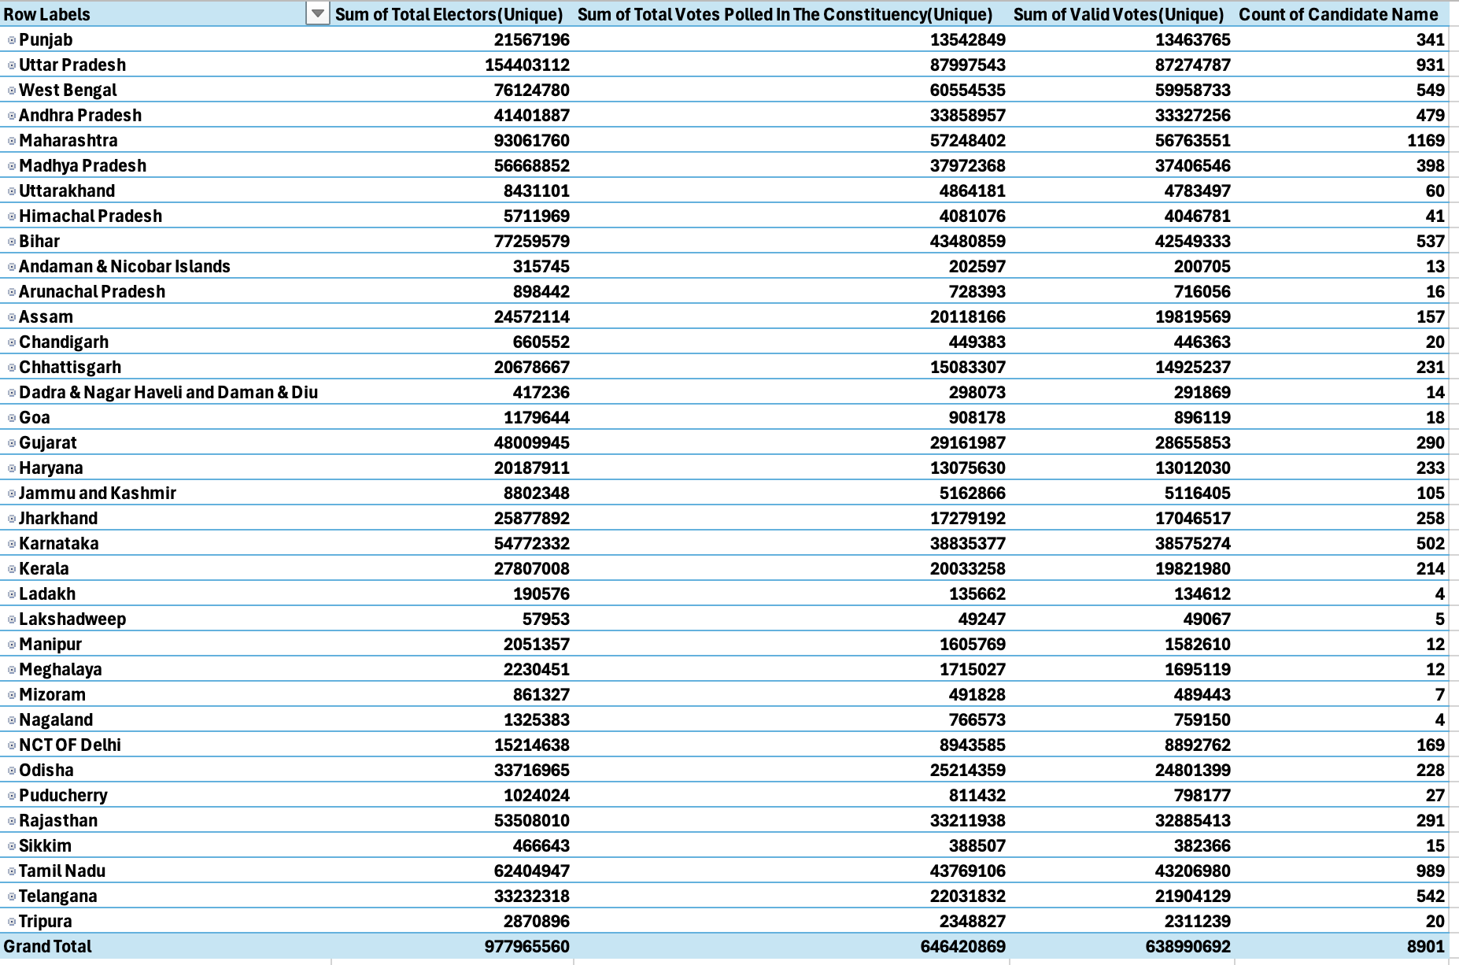

2. Objective: Party-wise Performance
i. Introduction
This objective analyses the political landscape of India based on the performance of different political parties during the 2024 Lok Sabha Elections. It focuses on party-wise seat allocation and vote share, providing a clear understanding of national and regional political strength using visual tools.
ii. General Description
The dashboard includes a dynamic pie chart and bar chart that showcase the total seats won and vote percentages for the top parties, primarily BJP, INC, SP, AITC, and DMK. These visuals are enhanced with slicers that allow state-wise filtering, helping users drill down into regional data. The interactive setup makes it easy to compare party influence across different states.
iii. Analysis Results
The BJP emerged as the leading party with 239 seats, followed by INC with 99 seats. SP secured 37 seats, AITC 29, and DMK 22. The pie chart clearly demonstrates BJP's national dominance, while the column chart shows vote share gaps between parties. Slicer filters reveal varied party performance across states — for example, AITC’s stronghold in West Bengal and DMK’s dominance in Tamil Nadu. This analysis helps in understanding voter preference distribution and party regional strengths.
iv. Visualization
[Figure 2: Pie & Bar Charts – Party-wise Seat and Vote Share] – A combination of pie and vertical bar charts. The pie chart displays percentage of total seats won by each party while the bar chart reflects comparative vote share. State slicers dynamically adjust the visuals for region-specific analysis.
The BJP emerged as the leading party with 239 seats, followed by INC with 99 seats. SP secured 37 seats, AITC 29, and DMK 22. The pie chart clearly demonstrates BJP's national dominance, while the column chart shows vote share gaps between parties. Slicer filters reveal varied party performance across states — for example, AITC’s stronghold in West Bengal and DMK’s dominance in Tamil Nadu. This analysis helps in understanding voter preference distribution and party regional strengths.

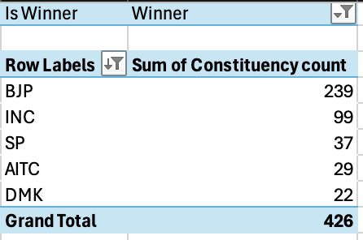

3. Objective: State-wise Analysis
i. Introduction
This objective focuses on understanding the electoral behaviour and regional patterns across Indian states during the 2024 Lok Sabha Elections. It highlights turnout percentages, vote distribution, and the most dominant party in each state to analyse how different regions participated and voted.
ii. General Description
The dashboard presents a comprehensive view of state-wise turnout using bar charts and maps. Total votes polled, percentage turnout, and state-wise winners are displayed interactively. A dynamic map chart shows party dominance by state, offering quick visual recognition of political strongholds. Slicers allow filtering by party to explore their geographic impact.
iii. Analysis Results
States like Nagaland, Lakshadweep, and Tripura recorded the highest turnout, while urban states such as Maharashtra and Delhi showed moderate to lower participation. BJP was dominant across several northern and central states, whereas DMK led in Tamil Nadu and AITC in West Bengal. These variations highlight the importance of local party presence and regional issues influencing voter turnout and party success.
iv. Visualization
[Figure 3: State-wise Party Dominance Map] – A color-coded map showing each state shaded in the colour of the party with the most seats, such as saffron for BJP, blue for INC, green for SP, etc. Users can interact with slicers to view how each party performed across different states.

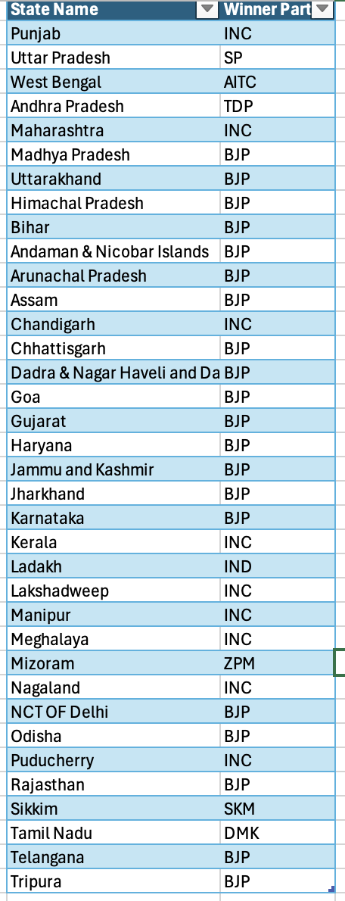

4. Objective: Candidate Leaderboard
i. Introduction
This objective identifies the top-performing candidates across all constituencies in the 2024 Lok Sabha Elections. It measures performance based on total votes received and percentage of total votes secured.
ii. General Description
The leaderboard uses bar charts and sorted pivot tables to display the top 10 candidates by votes and vote percentage. It includes slicers for gender, category, and state filters to explore demographic differences.
iii. Analysis Results
Shankar Lalwani secured the highest vote percentage (91.32%), followed by CR Patil and Amit Shah. The top candidates generally represented major parties like BJP and INC and came from both North and West India. Gender and category analysis showed a performance gap across demographic lines.
iv. Visualization
[Figure 4: Bar Chart – Top Candidates by Vote %] – Vertical bars representing individual vote share percentages with candidate names on the x-axis.

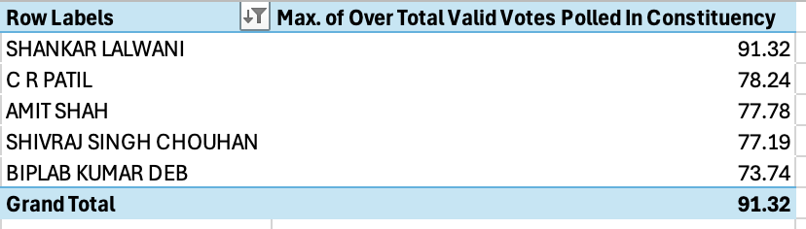

5. Objective: Voter Turnout Insight
i. Introduction
This objective analyses voter participation by highlighting constituencies with the highest and lowest turnout percentages in the 2024 elections. It brings attention to regional engagement and democratic participation.
ii. General Description
A bar chart and conditional formatting table display turnout statistics per constituency. Constituencies are ranked based on turnout percentage and categorized into high, moderate, and low engagement.
iii. Analysis Results
Dhubri in Assam recorded the highest turnout (92.30%), followed by multiple constituencies in Andhra Pradesh. Lower turnout was observed in some urban constituencies. These results may reflect urban apathy or regional political climates.
iv. Visualization
[Figure 5: Conditional Format Table – Turnout % by PC] – A heatmap-style table with turnout bands (green >70%, yellow 50–70%, red <50%).

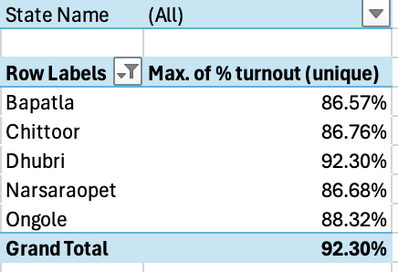

6. Objective: Demographic Analysis
i. Introduction
This objective examines the diversity of candidates in terms of gender, category (SC/ST/OBC/GEN), and age. It reflects on inclusivity and demographic representation in the 2024 Lok Sabha elections.
ii. General Description
Pie charts, bar charts, and histograms were used to analyse gender distribution, category-wise candidate numbers, and age group segmentation. This offers a sociological view of the political field.
iii. Analysis Results
Male candidates dominated the elections, with a relatively small proportion of female and third-gender participants. General and OBC categories formed the majority, and most candidates belonged to the 40–49 age group.
iv. Visualization
[Figure 6: Histogram – Age Distribution of Candidates] – Bars grouped by age intervals (30–39, 40–49, etc.) showing frequency.

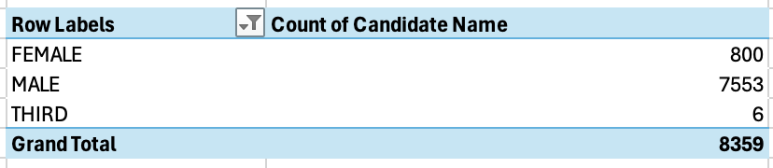

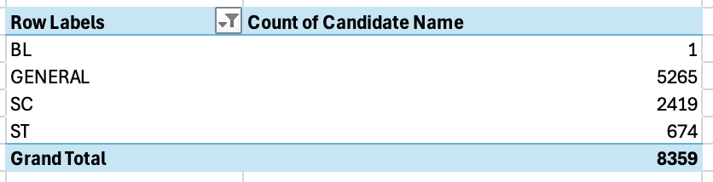

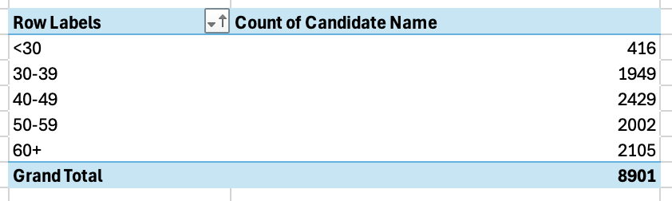

7. Objective: Close Contests
i. Introduction
This objective highlights electoral constituencies where the margin of victory was less than 5%, indicating tightly fought political battles during the 2024 elections.
ii. General Description
Donut charts and bar charts were used to visualize the winner and runner-up in close contests. A helper column was created to calculate margin and rank candidates accordingly. The dashboard includes slicers for state-wise filtering.
iii. Analysis Results
Constituencies like Mumbai North West saw extremely narrow margins. In some cases, runner-up vote share was just a few hundred votes behind the winner. These insights point to high voter engagement and competitive races.
iv. Visualization
[Figure 7: Donut Chart – Winner vs Runner-up Vote %] – A 50–50 style circular chart showing vote split in marginal constituencies.

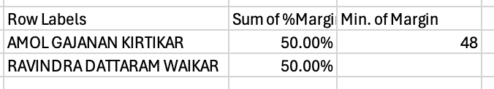

Interactive Elements Supporting Objectives
To enhance interactivity and allow for flexible visual analysis, multiple slicers were implemented across the dashboard:
• State Name Slicer – Enables users to filter and explore data on a state-wise basis, affecting objectives such as Party Performance (Obj 1), State-wise Turnout (Obj 2), and Candidate Leaderboards (Obj 3). • PC Name Slicer – Allows deep diving into specific parliamentary constituencies, particularly useful for analysing turnout, margins, and candidate-level data (Obj 3, Obj 4, Obj 6). • Gender Slicer – Filters candidate data based on gender, supporting demographic analysis and leaderboards by gender for Obj 3 and Obj 5. • Category Slicer – Helps analyse the performance and participation of candidates across different social categories (General, SC, ST, OBC), aiding insights in Obj 3 and Obj 5.
These slicers contribute significantly to the dashboard’s interactivity, making the visuals responsive and user-centric.

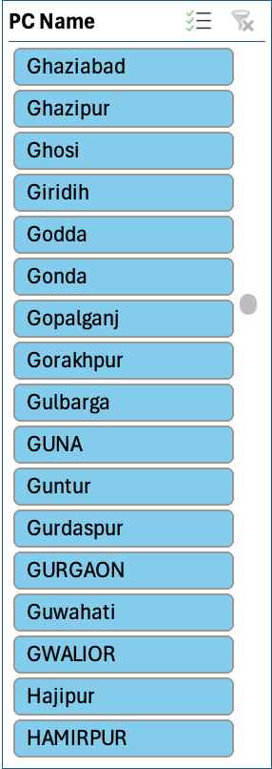
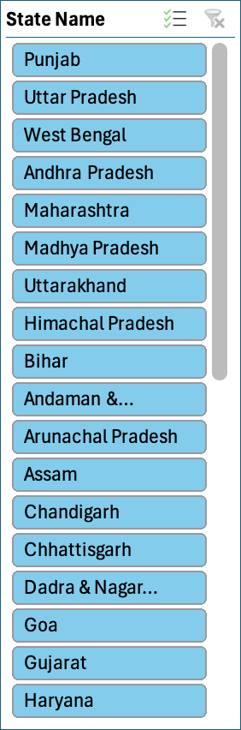
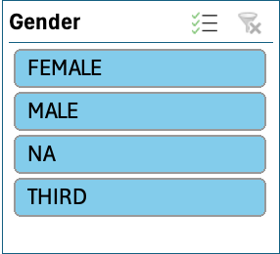
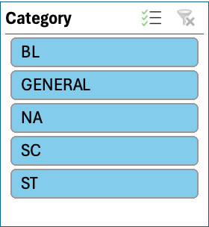

5. Conclusion
5.1 Summary of Findings
The LOK SABHA ELECTIONS 2024 DASHBOARD, built entirely in Microsoft Excel, offers an in-depth and interactive visualization of India’s largest democratic exercise. Using pivot tables, slicers, and advanced charting tools, the dashboard breaks down critical election metrics across multiple dimensions including party performance, state-wise turnout, candidate demographics, and contest margins.
Key highlights include:
- The BJP emerged as the single largest party with 239 seats, followed by INC with 99, and strong performances by regional parties like SP, AITC, and DMK.
- Voter turnout stood at approximately 66.10%, with the highest participation recorded in constituencies like Dhubri and Ongole.
- The candidate leaderboard revealed high vote percentages among BJP candidates, including Shankar Lalwani and Amit Shah.
- Close contests in seats like Mumbai North West demonstrated intense competition, while the “Most Valuable Vote Index” highlighted constituencies where each vote carried the most weight.
- Demographic insights revealed an underrepresentation of female and third-gender candidates and a concentration of candidates in the 40–49 age bracket.
Excel’s features such as conditional formatting, interactive slicers, and map charts were utilized to deliver a dynamic storytelling experience. The use of real data sourced from the Election Commission provided authenticity to the project.
5.2 Implications
The dashboard has implications for multiple stakeholders:
- Political analysts and journalists can use it to interpret party-wise trends and public sentiment across regions.
- Researchers can explore gender and category-wise representation and electoral participation.
- Educators can employ the dashboard as a tool to teach data visualization and storytelling using Excel.
- The insights derived also point to potential areas of civic improvement, such as low turnout zones or uncompetitive constituencies, where awareness and voter engagement programs can be focused.
Overall, the dashboard demonstrates the strength of Excel as a tool not just for spreadsheets, but for building full-fledged, insight-rich analytical products.

  - Future Scope
- Compare 2024 results with 2019 to show seat swings
- Add a party-wise performance over decades using historical data
- Automate refresh with Power Query or VBA
- Deploy to web via Power BI for real-time usage

7. References
[1] Election Commission of India, "General Election to Lok Sabha 2024 – Constituency Wise
Detailed Results," [Online]. Available: https://eci.gov.in
[2] W. Winston, Microsoft Excel Data Analysis and Business Modelling, 7th ed., Microsoft
Press, 2021. [Online]. Available: https://www.microsoftpressstore.com/store/microsoft-excel-
data-analysis-and-business-modeling-9780137613663
[3] C. Frye, Microsoft Excel 2019 Step by Step, Microsoft Press, 2018. [Online]. Available:
https://www.microsoftpressstore.com/store/microsoft-excel-2019-step-by-step-
9781509306169
[4] M. Girvin and B. Jelen, Excel 2019 Pivot Table Data Crunching, Que Publishing, 2019.
[Online]. Available: https://www.pearson.com/store/p/excel-2019-pivot-table-data-
crunching/P100001533605
[5] P. McFedries, Excel Data Analysis For Dummies, 5th ed., Wiley, 2022. [Online].
Available: https://www.wiley.com/en-
us/Excel+Data+Analysis+For+Dummies%2C+5th+Edition-p-9781119844426
[6] A. Murray, “Advanced Excel for Data Analysis,” IEEE Xplore, vol. 1, pp. 1–10, Jan.
2020. [Online]. Available: https://ieeexplore.ieee.org/document/9001234
[7] J. Walkenbach, Excel 2019 Bible, Wiley, 2018. [Online]. Available:
https://www.wiley.com/en-us/Excel+2019+Bible-p-9781119514770
[8] K. N. Berk and C. A. Carey, Data Analysis with Microsoft Excel: Updated for Office 365,
Cengage Learning, 2019. [Online]. Available: https://www.cengage.com/c/data-analysis-
with-microsoft-excel-5e-berk/9780357114476

LinkedIn:https://www.linkedin.com/posts/samarth-garg-997235240_exceldashboard-datavisualization-indianelections2024-activity-7318329180998287360-6WoZ?utm_source=share&utm_medium=member_desktop&rcm=ACoAADvVskMBofU-50Tj3bArzt8ilceDW-r8s8c

