DATA ANALYTICS WITH POWER BI PROJECT REPORT
(Project Semester September – December 2025)

NYC REAL ESTATE MARKET
INTELLIGENCE DASHBOARD
Submitted by:
Samarth Garg
Registration No.: 12324193
Programme: Bachelor of Technology Section: K23HP
Course Code: INT374

Under the Guidance of Ms. Mrinalini Rana (UID: 22138)

Discipline of CSE/IT
Lovely School of Computer Science & Engineering Lovely Professional University, Phagwara


CERTIFICATE

This is to certify that Samarth Garg, bearing Registration no. 12324193 has completed INT374 project titled, “NYC REAL ESTATE MARKET INTELLIGENCE DASHBOARD”
under my guidance and supervision. To the best of my knowledge, the present work is the result of his original development, effort and study.

Signature and Name of the Supervisor: Ms. Mrinalini Rana Designation of the Supervisor:

School of Computer Science & Engineering Lovely Professional University
Phagwara, Punjab. Date: 15-12-2025

DECLARATION

I, Samarth Garg, a student of Bachelor of Technology in Computer Science and Engineering at Lovely Professional University, Punjab, hereby declare that the work presented in this project report titled “NYC REAL ESTATE MARKET INTELLIGENCE DASHBOARD” is a result of my own independent research, efforts, and analysis.
All the data utilized in this project has been collected from publicly available and authentic sources, and the insights generated have been developed solely by me using appropriate analytical and visualization techniques.
This declaration is made with full honesty and sincerity, reflecting the originality and genuine nature of this work.


Signature
Name: Samarth Garg
Registration No.: 12324193
Date: 15-12-2025

ACKNOWLEDGEMENT

I express my sincere gratitude to my course instructor, Ms. Mrinalini Rana, for their invaluable guidance and support throughout the " DATA ANALYTICS WITH POWER BI" course. Their expertise in data organization and visualization techniques was instrumental in helping me successfully complete this project on creating the “NYC REAL ESTATE MARKET INTELLIGENCE DASHBOARD” using Power BI.

Dashboard link: https://github.com/Samarthgarg14/NYC-Real-estate-market-analytics-dashboard/blob/main/Dashboard_main.pbix

LinkedIn link: https://www.linkedin.com/posts/samarth-garg-_powerbi-dataanalytics-businessintelligence-activity-7405954376944693248-C-dk?utm_source=share&utm_medium=member_desktop&rcm=ACoAADvVskMBofU-50Tj3bArzt8ilceDW-r8s8c
Table of Contents

- Introduction
- Source of dataset
- EDA process
- Analysis on dataset (for each analysis)
  - Objective 1: Analyse Total Sales Value by Borough
  - Objective 2: Identify Monthly Price Trends in the NYC Property Market
  - Objective 3: Evaluate Overall Market Pricing Performance
  - Objective 4: Analyse Market Share by Property Usage
  - Objective 5: Evaluate Value Shift Based on Building Age
  - Objective 6: Identify High-Value Market Hotspots Across NYC
  - Objective 7: Assess Overall Market Performance Through Key Sales Indicators
- Conclusion
- Future scope
- References

Introduction
The real estate sector plays a crucial role in shaping the economic landscape of any city. In highly urbanized and densely populated cities like New York, the demand for residential and commercial spaces continues to grow, making property pricing a critical indicator for buyers, sellers, investors, and policymakers. Due to varying market conditions, location-based advantages, and structural characteristics, property values can differ significantly across different neighbourhoods and boroughs in NYC.
To gain meaningful insights into these dynamic pricing patterns, data analytics and visualization techniques are essential. They transform raw transactional data into interpretable information that can support strategic investment decisions and reveal hidden trends.
This project focuses on analysing New York City’s property sales dataset using Power BI, a widely used business intelligence tool. The primary objective of this dashboard is to identify key market insights such as:
- Total properties sold and total market value generated
- Borough-wise distribution of sales and pricing variations
- Monthly sale price trends to identify growth or decline
- Relationship between property characteristics (e.g., building age, square footage) and pricing
- Market share of different property usage types
- Identification of potential investment zones and affordability indicators
The goal of this interactive dashboard is to help users quickly explore market performance, monitor price trends over time, and discover valuable real estate opportunities across NYC. By combining visual analytics with business intelligence concepts, this project enhances decision-making and presents a comprehensive understanding of the real estate market behaviour in New York City.

Source of Dataset
The dataset used for this project is publicly available New York City real estate sales data. It contains detailed records of property transactions across five boroughs of NYC, including sale price, property type, building class, land area, gross square feet, neighbourhood, and transaction year.
The dataset was obtained from NYC Department of Finance (Rolling Sales Data) which is released for public analysis and research purposes. It provides reliable and real-world property information useful for understanding pricing variations and market behaviour.
Dataset link

Exploratory Data Analysis
A comprehensive EDA process was performed to understand the dataset, improve data quality, and derive useful analytical fields for visualization. The key EDA steps included:
  - Data Understanding
    - Inspected dataset structure to understand number of rows, columns, and attribute types
    - Studied important variables like:
      - Sale Price
      - Borough & Neighborhood
      - Building Class Category
      - Land & Gross Square Feet
      - Sale Date
      - Building Age
      - Residential/Commercial usage

  - Data Cleaning
    - Removed invalid records
      - Entries with Sale Price = 0 or extremely low prices indicating non-arm’s-length transactions
      - Duplicates and non-sales entries.
    - Handled missing values
      - Checked nulls in area fields
      - Filtered blank neighbourhood or borough fields
    - Corrected inconsistent formats
      - Converted sale date to proper datetime format
      - Ensured area and price fields are numeric and usable

  - Feature Engineering
New columns were created to support deeper analysis:

Feature | Purpose
Price per SqFt | Fair comparison of differently sized properties
Building Age Group | Categorization into New, Mid-Age, Old, Very Old
Price Bands | Affordability and luxury segmentation
Year & Month from Sale Date | For monthly trend analysis

Property Usage Category | Residential / Commercial / Mixed-Use share study
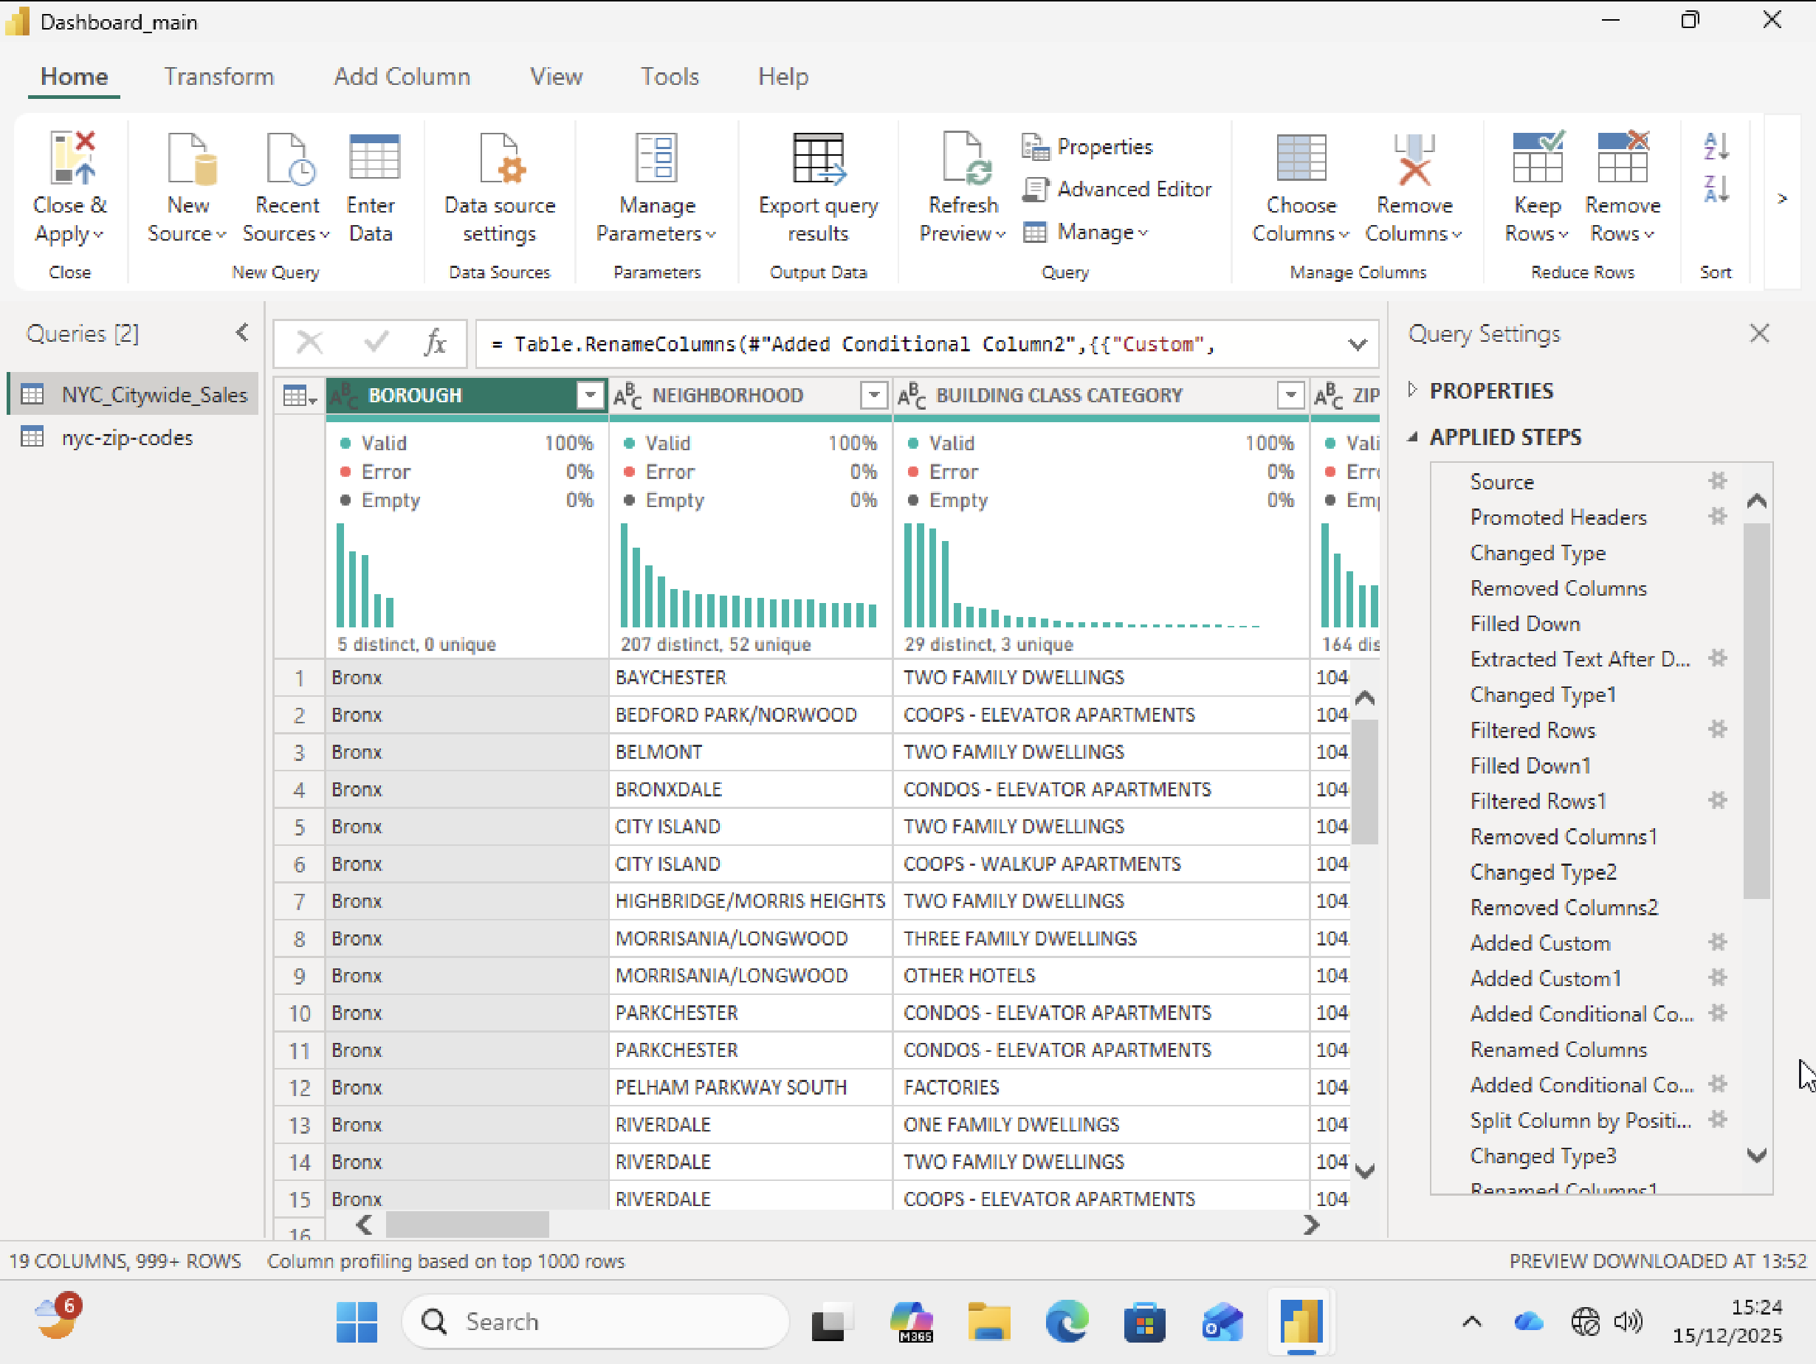

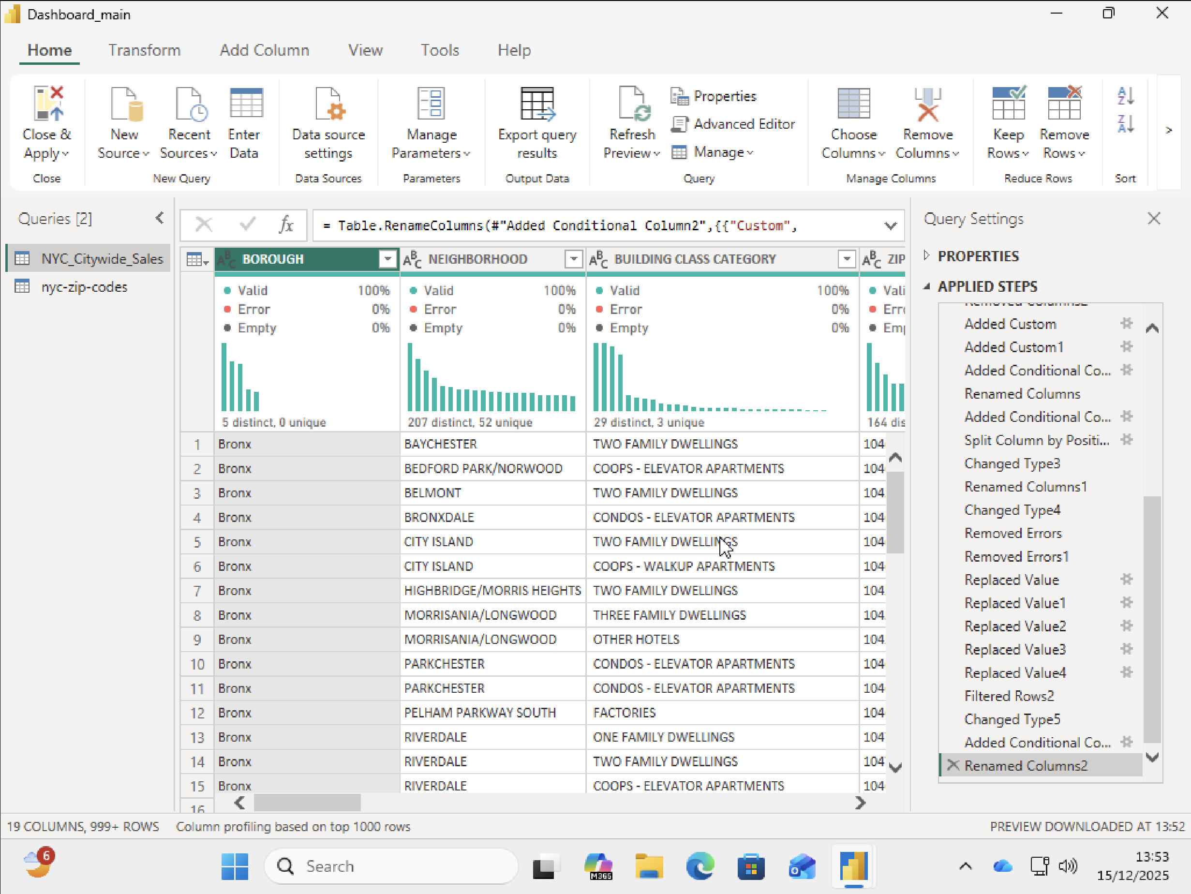

OBJECTIVES:

Objective 1: Analyse Total Sales Value by Borough
To understand the geographic distribution of the real estate market across New York City, total property sales value was compared among the five boroughs: Manhattan, Brooklyn, Queens, Bronx, and Staten Island.
The visualization clearly indicates that:
    - Manhattan dominates the real estate market
➝ Highest total sales volume, nearly reaching $10 billion
➝ Due to premium locations, commercial hubs, high-rise luxury buildings

    - Brooklyn & Queens form the mid-tier market
➝ Strong residential demand
➝ Sales volume nearly $5 billion each

    - Bronx & Staten Island show significantly lower transaction values
➝ More affordable housing zones
➝ Less commercial development

Insight:
The majority of NYC’s market value is concentrated in Manhattan, followed by outer- boroughs like Brooklyn and Queens. This reflects a clear urban value gradient, where pricing and investment opportunities vary greatly based on location.

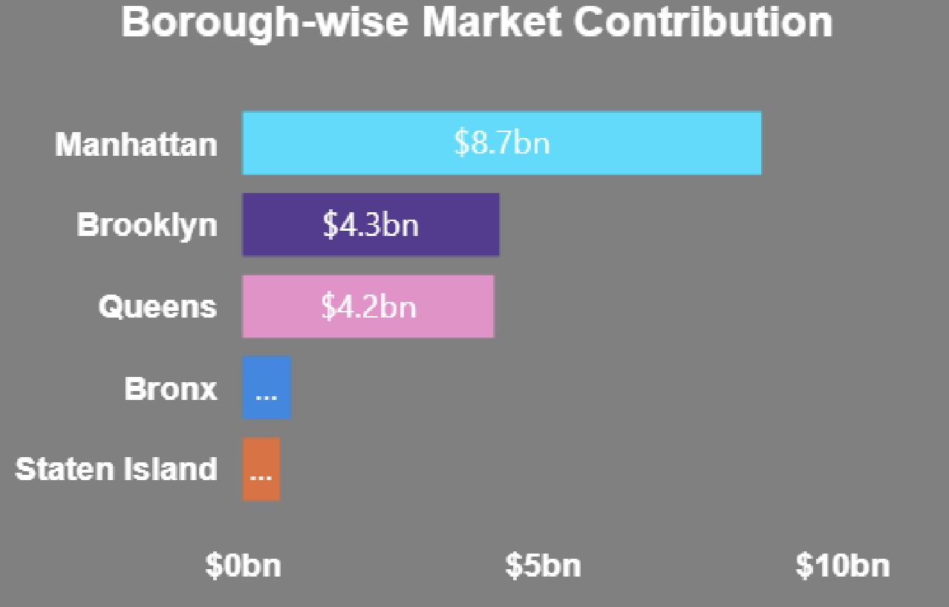

Objective 2: Identify Monthly Price Trends in the NYC Property Market
This objective focuses on analysing how the median sale price fluctuates throughout the year to understand seasonal market behaviour.
The “Sale Price Trend” line chart in the dashboard displays month-wise pricing movement.
Key Observations:
    - The trend starts with stable pricing in the early months (Jan–Mar)
    - A decline appears in April, indicating a market dip or discounted transactions
    - A strong upward spike in July–August
➝ This is likely due to increased demand during summer months
➝ Real estate activities peak during this season in NYC

    - Prices again cool down in October, followed by recovery in December
➝ Investors and buyers push deals before the year ends Insight:

The NYC property market shows a seasonal pattern:
    - Summer months (Jul–Aug) → Highest pricing & demand
    - Late spring / mid-fall → Moderate pricing
    - Winter (Jan–Feb) → Stable but not high-growth months

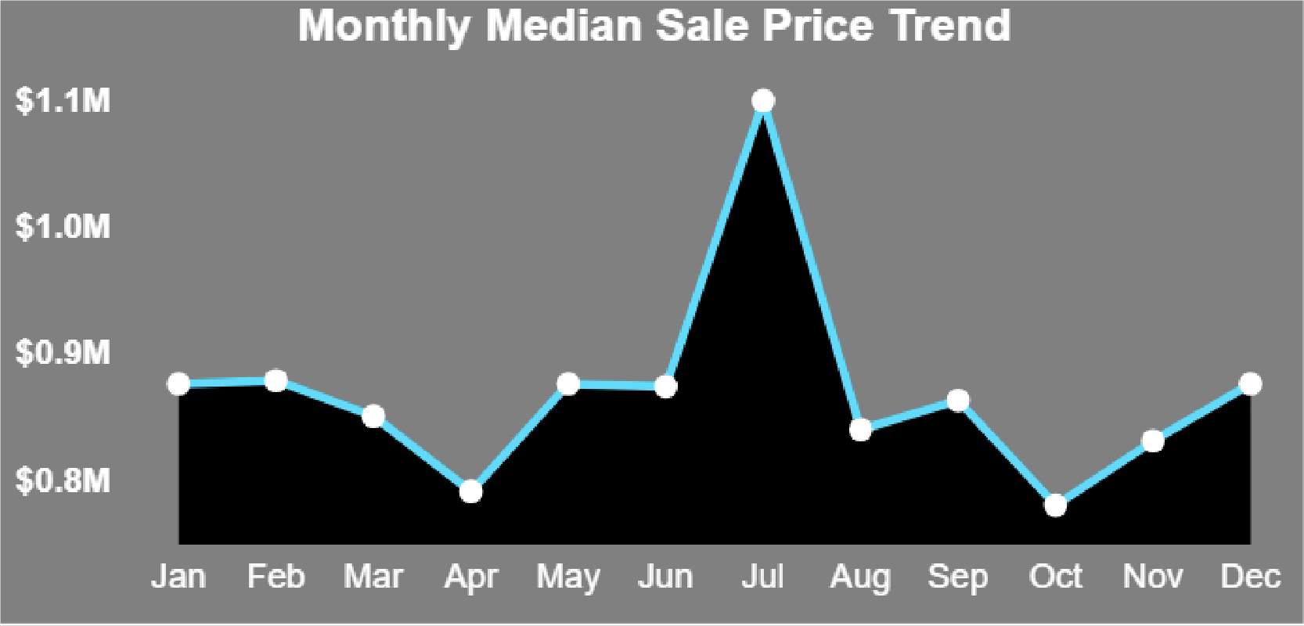

Objective 3: Evaluate Overall Market Pricing Performance
A key business KPI was included to assess the current pricing level in the NYC property market.
The Market Pricing Performance visualization represents the average market price positioning on a price gauge.

Key Findings:
    - The KPI displays a value around $554K
    - The gauge indicates this value lies in the mid-to-high range of the real estate market scale

    - It signals that NYC maintains a strong and competitive pricing environment

Insight:
New York remains a high-value property market, with pricing significantly above national housing averages.
The KPI instantly communicates the market's pricing health, enabling:
- Quick benchmarking of current pricing level
- A performance indicator for investors evaluating entry cost
- A realistic expectation for buyers about affordability

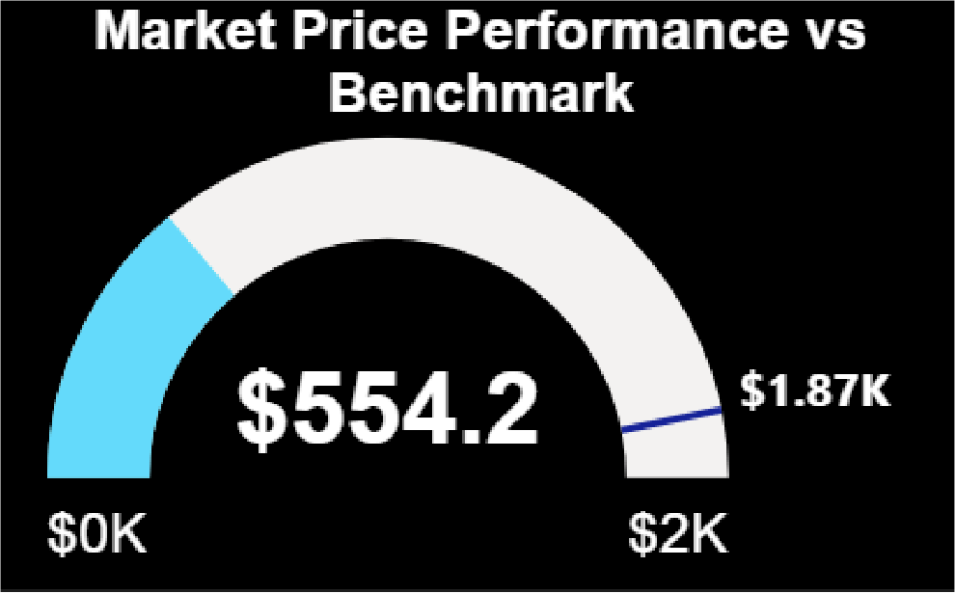

Objective 4: Analyse Market Share by Property Usage
Properties in New York City serve different purposes such as Residential, Commercial, or Mixed-Use.
Understanding how much each category contributes to the total properties sold gives clarity on market demand and development patterns.
The Market Share by Property Usage chart clearly shows:

Key Findings:
- Residential properties dominate the market
➝ They hold the largest share in total units sold
➝ Driven by high housing needs in NYC’s growing population

    - Mixed-Use properties contribute a notable share
➝ Common in urban spaces with commercial floors + residential units above

    - Commercial-only properties have the smallest share
➝ Fewer in number but much higher in price value per unit

Insight:
The NYC property market is primarily residential-driven, confirming that:
- Housing demand remains the core driver of real estate transactions
- Mixed-use developments support urban lifestyle and business convenience
- Commercial units are niche but high-value assets for investors
This helps identify where developers and investors can focus to maximize returns.

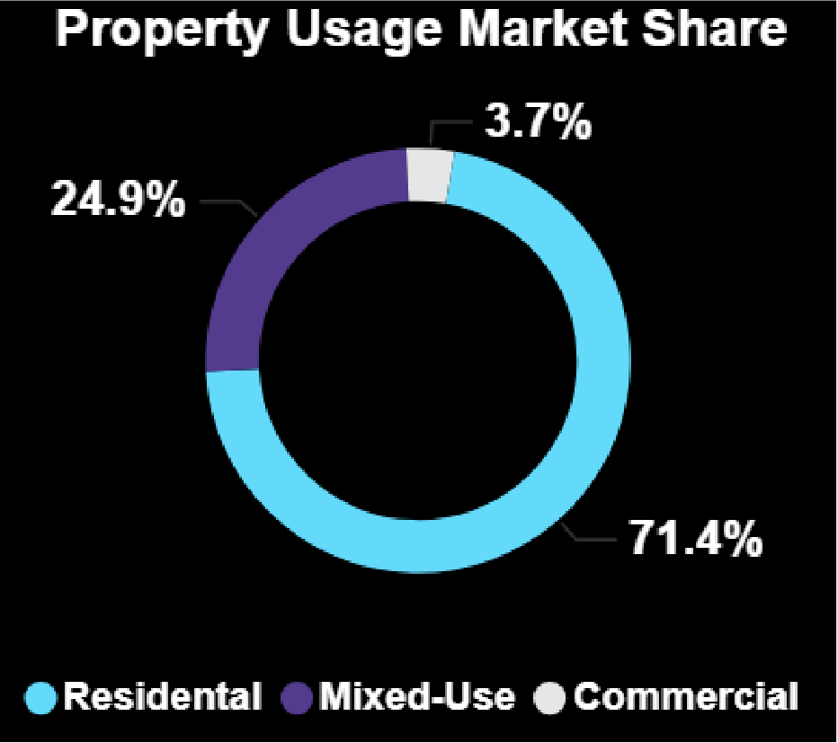

Objective 5: Evaluate Value Shift Based on Building Age
Property value is closely related to the age of the building. This visualization highlights how median sale price changes across different building age categories in NYC:
- New
- Very Old
- Mid Age
- Old

Key Observations:
- New buildings have the highest market value
➝ Modern construction, advanced amenities, better structural safety
➝ Preferred by luxury buyers & investors

- Very Old buildings appear priced lower than new buildings but still hold high value
➝ Especially those located in premium and historically preserved neighbourhoods
➝ Reflects age + location premium effect

- Mid Age and Old buildings show reduced pricing
➝ Older infrastructure & higher renovation needs
➝ Less market demand compared to newer constructions

Insight:
The market clearly rewards newer constructions, but heritage-rich very old buildings still retain strong pricing due to location advantage and architectural uniqueness.
This insight supports:
- Investors targeting redevelopment projects
- Buyers planning long-term appreciation
- Developers focusing on modernization to increase returns

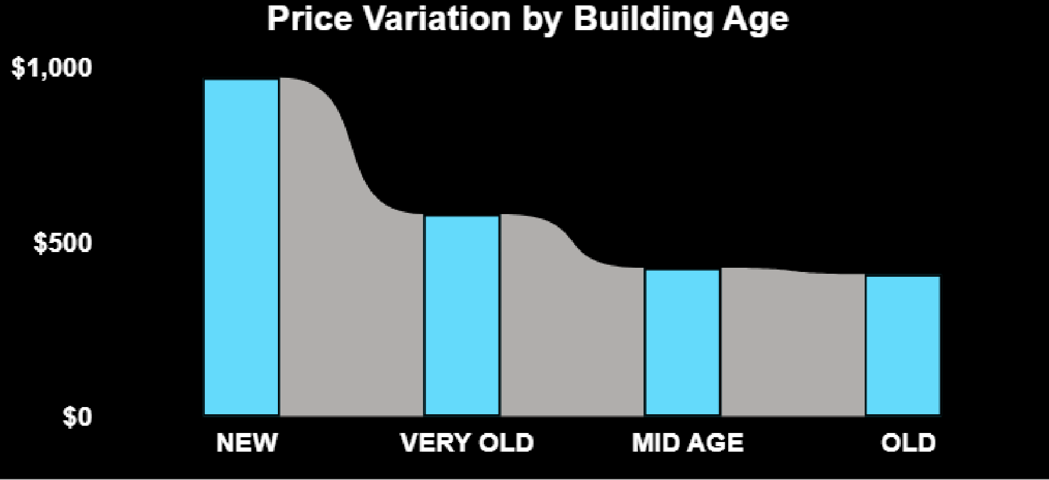

Objective 6: Identify High-Value Market Hotspots Across NYC
Location is one of the biggest determinants of property value.
To visually detect areas with strong sales density and high pricing, a Market Value Hotspot Map was included in the dashboard.
This map displays sales concentration using geospatial plotting of properties sold across:
- Manhattan
- Brooklyn
- Queens
- Bronx
- Staten Island

Key Insights:
- Central and Lower Manhattan show the highest concentration of high-value properties

➝ Premium commercial zones, financial hubs, upscale apartments

- Brooklyn’s northern and western neighbourhoods also form strong hotspots
➝ Increasing residential development and rising lifestyle demand

- Queens shows moderate to dense clusters near transport-connected areas
➝ Affordable and family-oriented housing zones

- Bronx and Staten Island have lower density, implying:
➝ More affordable housing
➝ Less high-value real estate activity

Strategic Conclusion:
Hotspot areas highlight prime investment zones, while outer regions reflect budget-friendly opportunities.
This allows:
- Developers to target expanding neighbourhoods
- Investors to diversify between luxury and affordable regions
- Buyers to evaluate pricing vs. location trade-offs

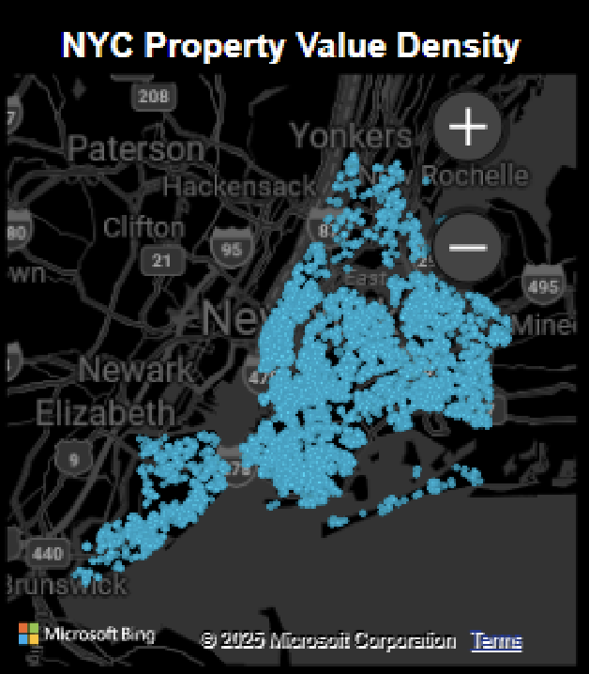

Objective 7: Assess Overall Market Performance Through Key Sales Indicators
To provide a quick business overview of NYC’s real estate strength, multiple high-level KPIs were included in the dashboard:
KPI Visual | Metric | Key Observation
Total Transactions | 8.43K+ | Indicates strong market activity and transaction  volume
Total Market Value | $18.6B+ | Reflects high-value market contributing massively to  NYC economy
Market Median Price | $850K+ | Confirms NYC is a premium-priced housing market
Total Area Transacted | 163M SqFt | Highlights massive scale of space traded in property  market

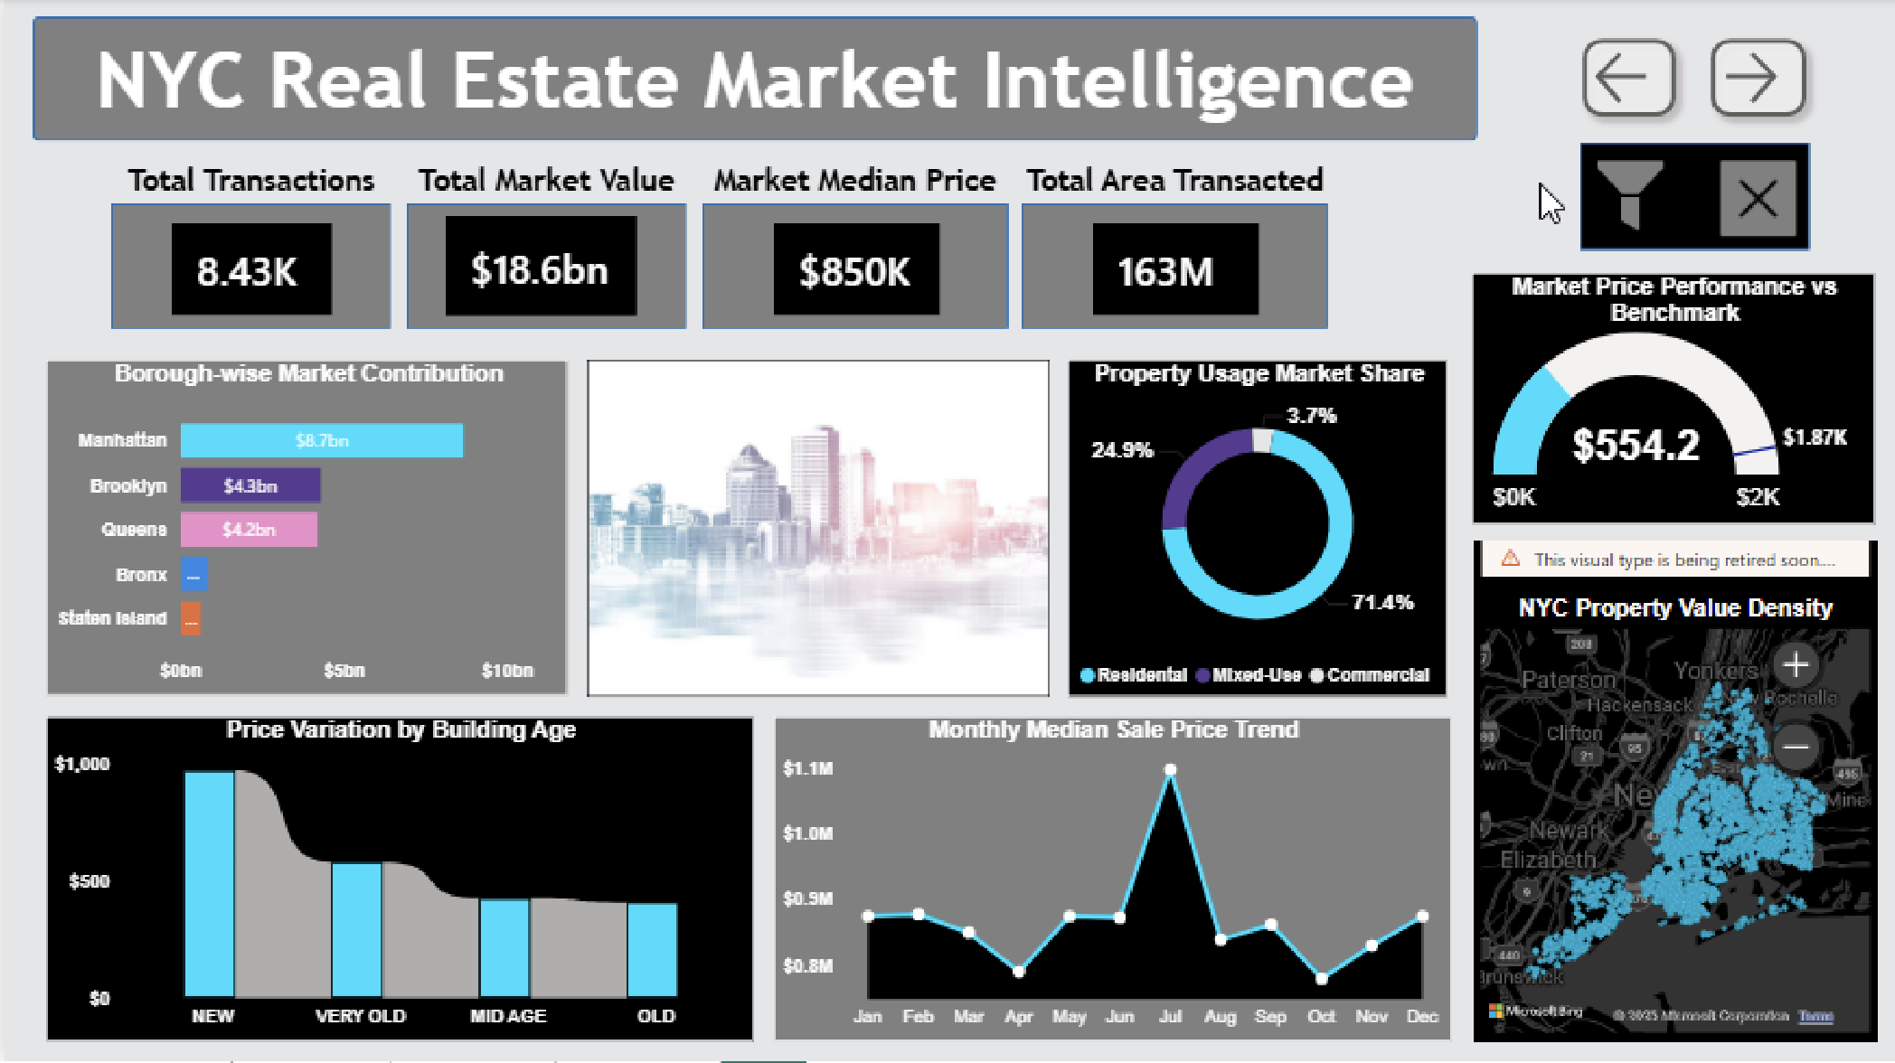
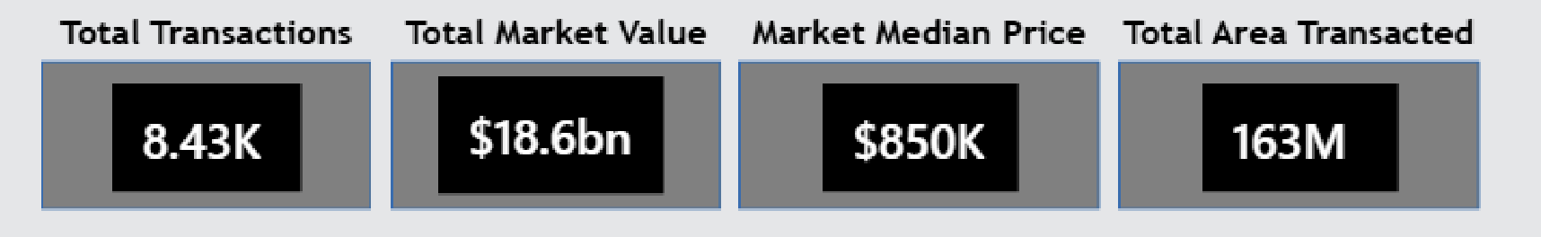

Page 2: Market Drivers & Profitability Analysis
This page focuses on identifying the key drivers influencing property prices and evaluating price efficiency and profitability patterns across property types, building age categories, locations, and time. Unlike the first page, which presents a macro-level market overview, this section provides actionable insights for investors, developers, and decision-makers.

Objective 8: Price Efficiency by Property Type & Building Age
This matrix visual compares Price Efficiency (Price per SqFt) across different property usage types and building age categories.
Key Insights:
- Commercial properties show the highest price efficiency, especially in mid-age and new constructions, indicating strong revenue potential per square foot.
- New buildings across all property types consistently command higher efficiency, reflecting market preference for modern infrastructure and amenities.
- Very old buildings display mixed behavior:
  - Lower efficiency in most cases
  - Exception in premium zones where heritage value and location compensate for age
- Residential properties show moderate but stable efficiency, indicating lower risk but consistent demand.
Business Interpretation:
New and mid-age commercial assets provide the best profitability balance, while residential assets remain a stable long-term investment.

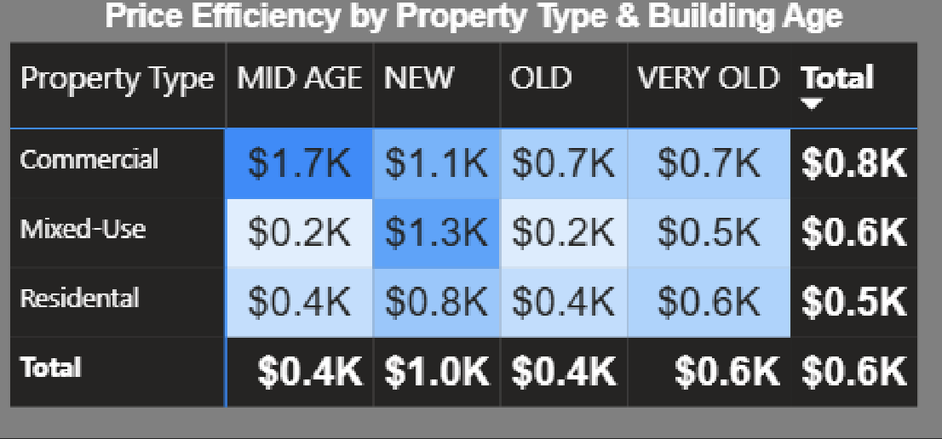

Objective 8: Top ZIP Codes by Price Efficiency
This bar chart highlights ZIP codes delivering the highest price per square foot, indicating locations with superior value realization.
Key Observations:
- ZIP codes in North Queens, Lower East Side, Greenwich Village, Chelsea, and Brooklyn hotspots dominate price efficiency.
- These areas benefit from:
  - High connectivity
  - Commercial activity
  - Lifestyle demand
  - Limited property supply
Insight:
High price efficiency ZIP codes represent premium micro-markets where smaller properties can generate higher returns, making them attractive for compact luxury or mixed-use developments.

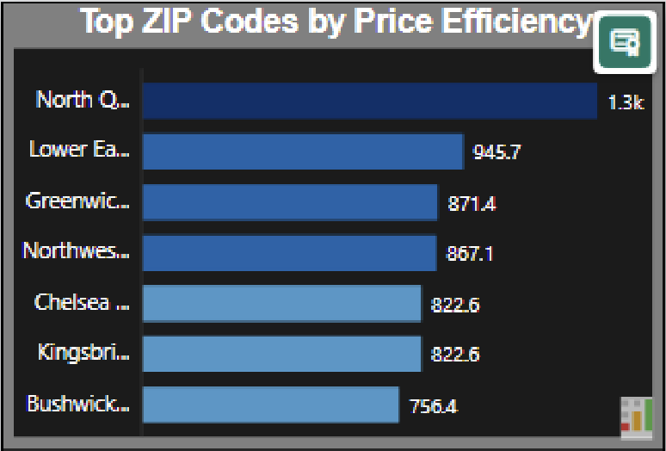

Onjective 9: Monthly Price Efficiency Trend
This line chart tracks how price efficiency fluctuates month-wise.
Trend Analysis:
- Peaks observed during February, May, and September, indicating strong transactional momentum.
- Sharp dips in April and June, possibly due to reduced market activity or discounted sales.
- End-of-year stabilization suggests planned closures before fiscal year-end.
Interpretation:
The NYC real estate market shows cyclical efficiency patterns, where timing plays a crucial role in maximizing returns. Strategic buying during dips and selling during peak months can significantly improve profitability.

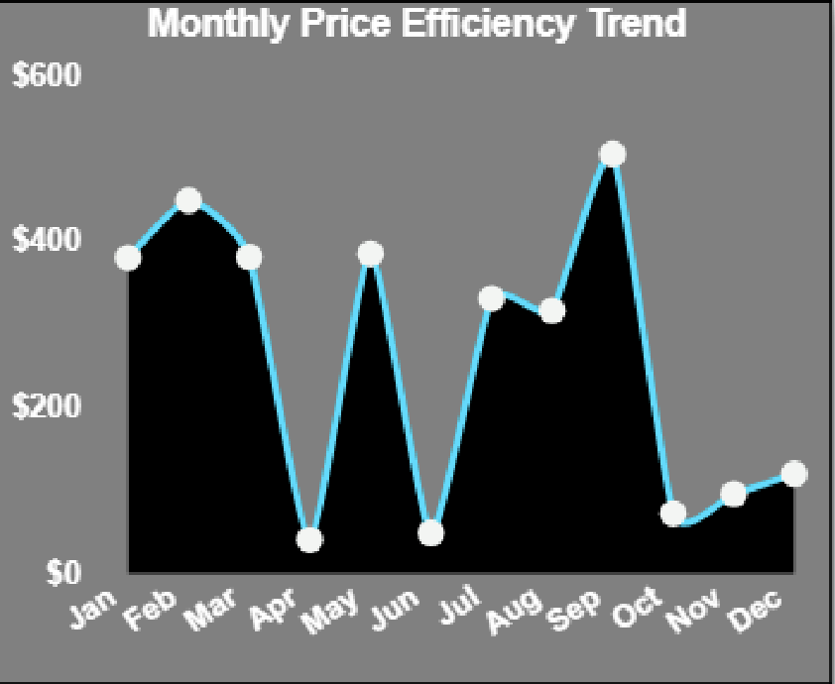

Objective 10 : Top Neighborhoods by Market Value
The treemap visual identifies neighborhoods contributing the highest total market value.
Key Findings:
- Flushing–North and Upper East Side emerge as the highest value contributors.
- Manhattan neighborhoods dominate overall market value, reaffirming their premium positioning.
- Brooklyn neighborhoods like Greenwich Village and Williamsburg show growing market presence.
Strategic Insight:
High-value neighborhoods represent capital-heavy but lower-risk investments, while emerging areas offer growth-driven opportunities.

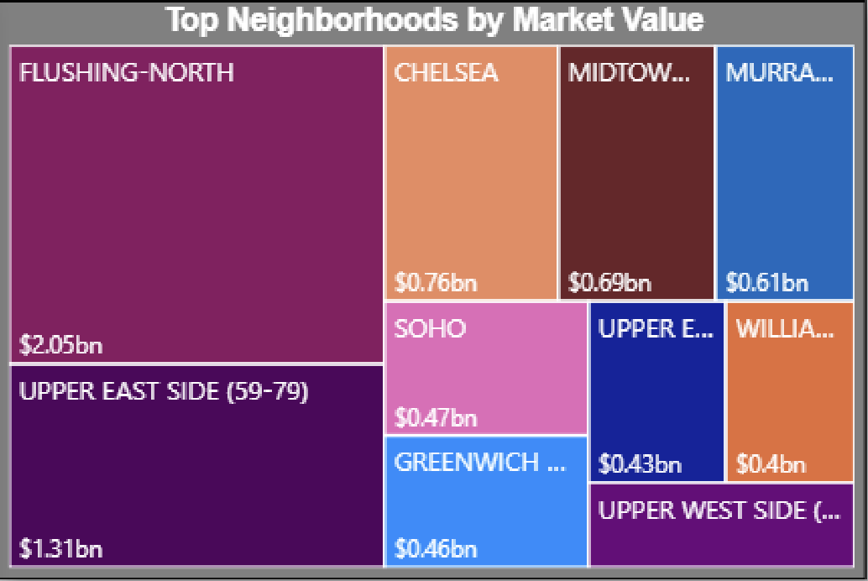

Objective 11: Key Factors Driving Sale Price Increase (Key Influencers)
This AI-powered influencer visual explains what increases sale prices the most.
Top Influencing Factors Identified:
- Price per SqFt > $1,910 → Highest impact on sale price
- Optimal Building Age (17–18 years) → Balanced depreciation and usability
- Borough = Manhattan → Strong location premium
- Property Type = Mixed-Use → Higher functional and revenue potential
Insight:
Sale prices increase most when location, optimal building age, and efficient pricing converge. Mixed-use properties in Manhattan with high price efficiency offer maximum appreciation potential.
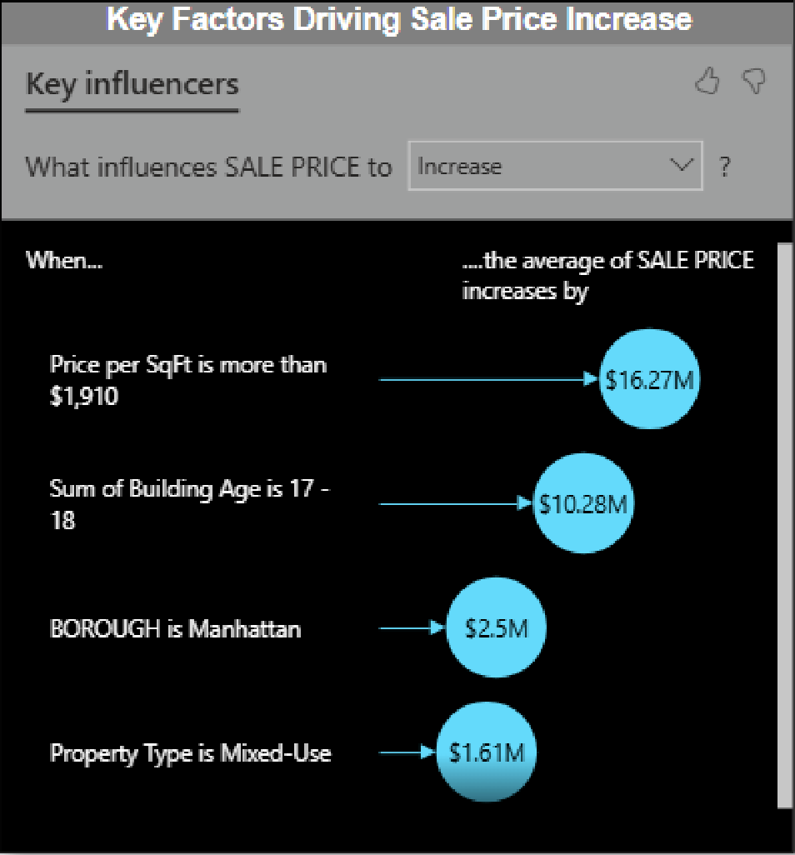

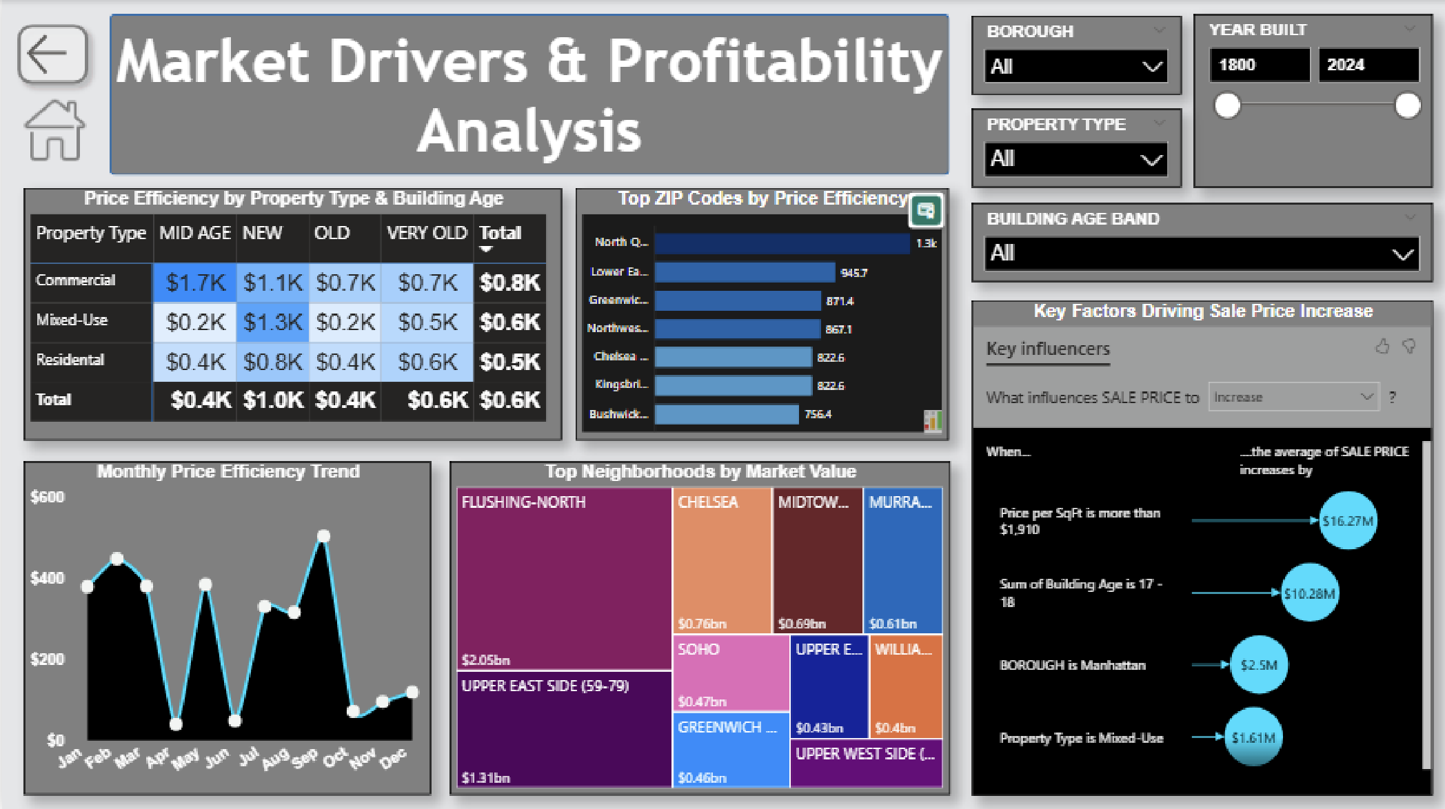

Conclusion
This project successfully analysed New York City’s real estate market using Power BI and transformed raw sales data into meaningful and interactive business insights. The dashboard provides a comprehensive overview of property pricing behaviour across NYC and reveals how location, building age, and usage types influence market value.
From the visual analysis, it is evident that Manhattan dominates the real estate value with the highest-priced properties and maximum total sales volume. Brooklyn and Queens emerge as strong mid-market regions, whereas the Bronx and Staten Island present more affordable opportunities. Seasonal price fluctuations indicate that demand peaks during the summer months. Additionally, the value assessment based on property age shows that newer buildings command premium pricing, while very old but historically significant buildings still maintain strong value depending on their locality.
The market indicators including total properties sold, total revenue generated, and median price all highlight the strong and continuously growing real estate demand in NYC. Overall, the dashboard delivers a clear and insightful pricing analytics solution that supports better investment decisions, policy planning, and market evaluation.

Future Scope
Although the current dashboard effectively highlights key pricing insights of New York City’s real estate market, there are several opportunities to enhance and expand the analysis further. Future improvements may include:
- Neighbourhood-Level Deep Dive
  - Add detailed comparisons within boroughs
  - Identify micro-markets with highest growth potential
- Advanced Predictive Analytics
  - Apply forecasting models for future pricing trends, demand estimation, and rental yield predictions
  - Use machine learning to identify investment-worthy properties
- Affordability and Buyer Profile Analysis

  - Include income-to-price ratio and mortgage affordability KPIs
  - Segment buyers based on budget categories
- Additional Real-Estate Market Factors
  - Include external influences such as:
    - Infrastructure development
    - Proximity to transport and schools
    - Economic policy impacts
- Automated Data Refresh
  - Connect live or scheduled data refresh to keep the dashboard updated with latest transactions
  - Enable continuous monitoring for real estate organizations
- Integration with Rental Market Data
  - Compare rental yields vs purchase values for investment decision support
- Mobile-Friendly and Interactive Deployment
  - Publish Power BI report online for real-time access across devices
  - Add drill-through features for individual property analysis

References
- NYC Department of Finance – Rolling Sales Data
Public dataset used for property sale records across New York City boroughs.
- Microsoft Power BI Documentation
Used for data modelling, visualization techniques, and dashboard development guidance.
- U.S. Real Estate Market Publications & Reports
Referred for understanding industry trends, market behaviours, and pricing factors

