**Social Networking Webapp**

##### A PROJECT REPORT

###### **Submitted by**

**SAMARTH SHRIVASTAVA – 161B193**

**RISHI PRAJAPATI – 161B177**

**GARVIT SINGH – 161B079**

**Under the guidance of: Mr. Navaljeet Singh**



***Submitted in partial fulfillment for the award of the degree***

***Of***

***BACHELOR OF TECHNOLOGY***

***IN***

***COMPUTER SCIENCE AND ENGINEERING***

***DEPARTMENT OF COMPUTER SCIENCE & ENGINEERING***

***JAYPEE UNIVERSITY OF ENGINEERING & TECHNOLOGY,***

***A-B ROAD, RAGHOGARH, DT.GUNA-473226, MP, INDIA***

Title page

Declaration by the Student

Certificate from the Supervisor

Acknowledgement

Summary (Not more than 250 words)

List of Figures

List of Tables

List of Symbols and acronyms

Table of Contents

Chapter-1 Introduction

Chapter-2 Review / Background Material

Chapter-3 or more Contributional work

Description and Results

-

-

-

-

Chapter 6 or more Conclusion

Appendices

A

B

C

**Declaration by the Student**

I hereby declare that the work reported in the B. Tech. project entitled as “**Social Networking Webapp**”, in partial fulfillment for the award of degree of B. Tech submitted at Jaypee University of Engineering and Technology, Guna, as per best of my knowledge and belief there is no infringement of intellectual property right and copyright. In case of any violation I will solely be responsible.

**SAMARTH SHRIVASTAVA – 161B193**

**RISHI PRAJAPATI – 161B177**

**GARVIT SINGH – 161B079**

                                                                 Department of Computer Science & Engineering

                                                           Jaypee University of Engineering and Technology

                                                                       Guna, M.P., India

Date:

**CERIFICATE**

This is to certify that the work titled “**Social Networking Webapp**” submitted by “**SAMARTH SHRIVASTAVA,RISHI PRAJAPATI,GARVIT SINGH**” in partial fulfillment for the award of degree of B . TECH of Jaypee University of Engineering & Technology, Guna has been carried out under my supervision. As per best of my knowledge and belief there is no infringement of intellectual property right and copyright. Also, this work has not been submitted partially or wholly to any other University or Institute for the award of this or any other degree or diploma. In case of any violation concern student will solely be responsible.

Signature of Supervisor

MR. NAVALJEET SINGH

Designation

Date

**ACKNOWLEDGEMENT**

It is great pleasure for me to undertake this project I feel highly doing the project entitled “**SOCIAL NETWORKING WEBAPP**”.

I am grateful to my project guide “Mr. Navaljeet Singh”

This Project would not have completed without their enormous help and worthy experience. Whenever I was in need, they were there behind me.

Although, this report has been prepared with utmost care and deep routed interest. Even then I accept respondent and imperfection.

Signature of Student

SAMARTH SHRIVASTAVA

Signature of Student

RISHI PRAJAPATI

Signature of Student

GARVIT SINGH

Date

**EXECUTIVE SUMMARY**

**SUMMARY:**

**Project background:**

The project objective is to make a website for the college students. This project is an attempt to provide a discussing problem online with them, booking an appointment online by using a website. Thus, the user can use it to solve their problems in various emergency hours.

**Project task:**

Project task summarize as follows:

* Gathering requirements.
* Knowing languages in making website.
* Designing the website looks and connectivity.
* Developing frontend part.
* Developing backend part.
* Connecting front and backend.
* Testing
* Deployment.

**Project progress:**

To date, the modules have been built and tested as planned which has been included in this project report. We had completed all tasks despite of difficulties.

**TABLE OF CONTENT**

**TITLE**___________________________________________________________________ 1

**DECLARATION _____________________________________________________________2**

**CERTIFICATE** ______________________________________________________________ 3

**ACKNOWLEDGEMENT** _____________________________________________________ 4

**ABSTRACT**____________________________________________________________ 5

**LIST OF FIGURES**___________________________________________________________ 6

**CHAPTER 1. INTRODUCTION** _______________________________________9

1.1. Objective...................................................................................................................... 9

1.2. History........................................................................................................................ 10

1.3. Brief............................................................................................................................11

1.4. Advantage of RES...................................................................................................... 12

1.5. Proposed System........................................................................................................ 12

**CHAPTER 2. PROJECT PLANNING__________________________________________ 13**

2.1. Identification of Need.................................................................................................13

2.2. UI Design....................................................................................................................13

2.3. Reports of Railway Enquiry System………………………………………………...14

2.4. System design of RES................................................................................................ 15

2.5. Feasibility Study.........................................................................................................16

2.6. Project Planning..........................................................................................................17

**CHAPTER 3.TECHNOLOGY AND TOOLS_____________________________________19**

**CHAPTER 4. SOFTWARE REQUIREMENT SPECIFICATION___________________ 20**

4.1. Introduction…............................................................................................................. 20

4.1.1. Purpose........................................................................................................ 21

4.1.2. Scope ………………….............................................................................. 22

4.1.3. Reference ....................................................................................................22

4.1.4. Definition Acronyms and Abbreviation....................................................... 22

4.1.5. Overview..................................................................................................... 22

4.2. The Overall Description............................................................................................. 23

4.2.1 Product Perspective…...................................................................................23

4.2.1.1 System Interface….........................................................................24

4.2.1.2 Hardware Interface.........................................................................25

4.2.1.3 Software Interface..........................................................................25

4.2.1.4 Communication Interface...............................................................25

4.2.2.User Characteristic….....................................................................................25

4.2.3. Constraints ................................................................................................. 25

4.3. Specific Requirements…………………...………………………………………….26

4.3.1. External Interface………........................................................................... 26

4.3.2 Performance Requirements…..................................................................... 26

4.3.3. Software System Attributes........................................................................ 27

4.3.4. Functional Requirements.............................................................................27

4.3.5. Non- Functional Requirements……........................................................... 28

**CHAPTER 5. DIAGRAMS____________________________________________________ 29**

5.1. Use Case......................................................................................................................29

5.2.DFD……………....................................................................................................30

5.2.1 DFD Level 0 ……........................................................................................30

5.2.2. DFD Level 1 .............................................................................................. 31

5.3. ER Diagram................................................................................................................32

5.4. Sequence Diagram……..............................................................................................33

5.5. Activity Diagram……................................................................................................34

5.6. PERT Chart............................................................................................................... 35

5.7. Gantt Chart................................................................................................................ 36

**CHAPTER 6. PROJECT FUNCTIONS_________________________________________ 37**

6.1. General overview of application…….........................................................................37

**CHAPTER 7. CONCLUSION** _________________________________________________ 45

**CHAPTER 8. LIMITATION**__________________________________________________ 46

**CHAPTER 9. FUTURE SCOPE**_______________________________________________ 47

**CHAPTER 10. BIBLIOGRAPHY** _____________________________________________ 48

**Chapter 1. Introduction**

* 1. **Introduction**

The project includes the registration of the user and then let them acquire the role of employer as well as employee. SOCIAL NETWORKING WEBAPP is concerned with initiating trade between the user and their fellow peers. The project also keeps the information of the employers, employees as well as information. It keeps track of information that have been bought and sold by a particular user. The SOCIAL NETWORKING WEBAPP treats both employees and employers. It has to maintain in full information of the employee and employer for the purpose of historical use. The software has the facility to give a unique id to every employee in the system. User can be entered using the user name and the password. It is only accessible by administrators. Only they can add the data with the database. The data can be retrieved easily. The interface is user friendly.

* 1. **Problem Definitions**

Lack of immediate information storage: - The information generated by various transactions takes time and efforts to be stored at right place.

* Lack of verification of user’s authenticity: - It’s not possible to verify if the details submitted by the user matches with that in real life.
* Lack of verification of information description: - It’s not possible to verify if the details submitted by the employer of the product matches with that in real life.
  1. **Project Overview/Specifications*:-**

1 The site will open with a front page with two option -log in and sign up at top upper corner of webpage

1. User have to sign up for taking advantages of our website.
2. After making the account user can access the website by simply logging into it any time.
3. The employer will send admin the information to be updated.
4. After logging, home page will appear where user will get different information which is relevant to them.
5. Then employee will be provided with id and employers contact info as well.
6. Then the employee can continue searching information about as well.
7. All services are available for 24x7 hours.
8. To computerize all details regarding the product.
   1. **Hardware Specification**

Processor: Pentium IV AND motherboard

RAM: 512MB or above Hard

Input Devices: Keyboard, Mouse

Output Devices: Monitor; -14” VGA

* 1. **Software Specification**

OPERATING SYSTEM: Windows XP,10, Linux (any possible distro)

FRONT END: HTML, CSS, JAVASCRIPT

BACK END: DJANGO

* 1. **Idea/Goals**

By analysis of our surrounding, we came to know that most of the possessions of fellow students were going unused after surveying we concluded that there was no alternate way for students to get rid of those belongings so as a result, we came up with the concept of SOCIAL NETWORKING WEBAPP that allow students to initiate trade between their fellow peers. As a result, consumer/fellow students can get the information in a cheaper & more affordable way.

. Our goals are as follows

* Simple for user to use.
* User can simply signup to website can get easy access to it.
* Very useful for employees and employers in this case fellow students.
* User can get quick access to no of available information, also will provide them all the details require to complete the transaction.
* Scheduling the task in proper systematic way as a result the trade can be fully utilized in effective and efficient manner by the students.
* The specific target for the system will be colleges, schools or any other particular organization.

**PROPOSED SYSTEM**

Today one cannot afford to rely on the fallible human beings of be really wants to stand against today's merciless competition where not to wise saying "to err is human" no longer valid, it's outdated to rationalize your mistake. So, to keep pace with time, to bring about the best result without malfunctioning and greater efficiency so to replace the unending heaps of flies with a much sophisticated hard disk of the computer. One has to use the data management software. Software has been an ascent in atomization various organizations. Many software information working are now in markets, which have helped in making the organizations work easier and efficiently. Data management initially had to maintain a lot of ledgers and a lot of paper work has to be done but now software product on this organization has made their work faster and easier. Now only this software has to be loaded on the computer and work can be done.

This prevents a lot of time and money. The Work becomes fully automated and any information regarding the organization can be obtained by clicking the button.

Moreover, now it's an age of computers of and automating such an organization gives the better look.

**Project Planning**

**Followings points should be well considered:**

* Documents and reports that must be rovided by the new system; there can also be few reports ,which can help management in decision-making and cost controliong,but since these reports do not get required attention,such kind of reports and information were also identified and given required attention.
* With the implementation of computerized system, the task of keeping records in an organized manner will be solved. The greatest of all is the retrival of information,which will at the click of the mouse.so the proposed system helps in saving the time in different operations and making information flow easy giving valuable reports.

**User Interface Design:**

User Interface Design is concerned with the dialogue between a user and the computer .It is concerned with everything from starting the system on web browser to the presentation of desired inputs and outputs.The overall flow of screens and messages is called a dialogue.

**The followings steps are various guidelines for user interface design:**

* The system user should always be aware of what to do next.
* The screen should be formatted so that various types of information,instructions and messages always appear in the same general display area.
* Message ,instruction or information should be displayed long enough to allow the system user to read them.
* Use display attributes sparingly.
* Default values for fields and answers to be entered by the user should be specified.
* A user should not be allowed to proceed without correcting an error.

**The Software Quality Plan:**

* In the first step ,we will select the test factors and rank them. The Selected test factors such as reliability ,maintainability,portability or etc.
* The second step is for identifying the phases of the development process.
* The third step is that identifying the bussiness risks of the software deliverables.The risks will be ranked into three ranks such as high ,medium and low.

**System Design**

In this phase, a logical system is built which fulfills the given requirements. Design phase of software development deals with transforming the client’s requirements into a logically working system. Normally, design is performed in following two steps:

**1: Primary Design phase:** In this phase, the system is designed at block level. The blocks are created on the basis of analysis done in problem identification phase. Different blocks are created for different functions emphasis is put on minimizing the information flow between blocks. Thus, all activities which require more interaction are kept in one block.

**2: Secondary Design phase:**

In secondary phase the detailed design of every block is performed.

**The general tasks involved in the design process are the following:**

1. Design various blocks for overall system process.
2. Design smaller, compact and workable modules in each block.
3. Specify details of programs to achieve desired functionality.
4. Design the form of inputs, and outputs of the system.
5. Perform documentation of the design.
6. System reviews.

**Feasibility Study**

After doing the project, study and analyze all the existing or required functionalities of the system, the next task is to do the feasibility study for the project. All projects are feasible- given unlimited resource and infinite time.

Feasibility study includes consideration of all the possible ways to provide a solution to the given problem. The Proposed solution should satisfy all the user requirements and should be flexible enough so that future changes can be easily done based on the future upcoming requirements.

1. **ECONOMICAL FEASIBILITY**

This is a very important aspect to be considered while developing a project .We decided the technology based on minimum possible cost factor.

* All hardware and software aspect to be considered while developing a project. We decided the technology based on minimum possible cost factor.

B. **Technical Feasibility**

This includes the study of function, performance and constraints that may affect the ability to achieve an acceptable system. For this feasibility study, we studied complete functionality to be provided in the system, as described in the system Requirement Specification, and checked if everything was possible using different type of frontend and backend platform.

C**. OPERATIONAL FEASIBILITY**

No doubt the proposed system us fully web based system as well as mobile based too and user friendly and al inputs to be taken all self-explanatory even to a layman. Beside, a proper training has been conducted to let know the essence of the system to the users so they feel comfortable with new system.

**Project planning:**

Software project plan can be viewed as following:

1. **Within the Group:** Who the project is to be implemented? What are various constraints (time, cost and staff)? What is market strategy?
2. With respect to the customer: we have to look in as customers and try to improve services as they demand and try to solve the problem as they give feedback and then give it to them.

**For a successful software project, the following steps can be followed:**

* **Select a project**
* Identifying Project's aims and objectives
* Understanding requirements and specification
* Methods of analysis , design and implementation
* Testing Techniques
* Documentation
* **Project milestones and deliverables**
* **Budget allocation**
* Exceeding limits within control
* **Project Estimates**
* Cost
* Time
* Size of code
* Duration
* **Resource Allocation**
* Hardware
* Software
* Previous relevant project information
* Digital Library
* **Risk Management**
* Risk avoidance
* Risk detection

***CHAPTER-2.SRS***

1. **Introduction**

* Purpose
* The Software is for the initiating information between fellow peers.
* It maintains levels of users.

(1) Administrator Level

(2) Employee Level

(3) Employer Level.

* The Software includes maintaining necessary details.
* Employee id generation.
* Search for information.
* Find information near your college.
* Online interaction between employee and employer.
* Scope
* To cover the client problem.
* Provide solution to problem of client.
* Interaction of employee and employer.
* Provide information nearby so, one can learn about them.
* Overview
* Problem of client like finding information nearby general information about employers can be solved by using this website.
* Goal is to provides solution to problem in short period of time.
* Success of project is when it comes through all solution to user problem.
* The user must be familiar to use of websites is a risk factor.

1. **General Description**

* Product Perspective

This SOCIAL NETWORKING WEBAPP is a self-contained website that manages activities such as initiating trade on consumer-to-consumer level through the website.

* Product features

The system functions can be described as follows:

**#** User have to sign up for taking advantages of our website.

**#** After making the account can any time access the website by simply logging into it.

**#** The employer will send admin the information to be updated.

#After logging, home page will appear where user will get different blocks.

#The employee can select the from any of the given blocks.

#Then he will be provided with a id and employers contact info as well.

#Then the employee can continue searching information about other sources as well.

#All services are available for 24x7 hours.

#The inventory should be updated automatically whenever a transaction is made.

* Design and Implementation Constraints
* **Database:**

The system is using the SQLITE3 Database, which is open source and free.

* **Operating System**

The Development environment shall be Windows XP,7,10, Linux, Unix., Etc.

* **Web-Based**

The system shall be a Web-based application.

* Assumption and dependencies

It is assumed that the server hosting the website will work 24/7 without any inconvenience.

It is assumed that the consumers signing in are real person with a real product.

1. **Function Requirement**

* Description
* User have to sign up for taking advantages in our website.
* After making the account user can access the website by simply logging into it any time.
* Then there opens home page, where user will get different product types to sell and buy, contact us and about.
* In services section there is finding information (by categories), and availability status.
* In subsection to finding a particular source of information, checking its condition and after checking-out the employee will be provided with the product id and employers details.
* In information section user can read details about different information.
* In details section user can read about related information, and find related information from the categories.
* And in contact section there are further contact details and in about information about website.
* The project functionality consists of providing the location of nearby available information.
* Provides the employer details, employee can consult with employer regarding the anything which concerns them.
* Can search for further information about product and employer or employee.
* All services are available for 24x7 hours.
* To computerize all details regarding employee & employer details.
* Technical issues

**Database:-**The system shall use the SQLITE3 Database, which is open source and free.

**Operating System:-**The Development environment shall be Windows XP,7,10, Linux, Unix., Etc.

**Web-Based:-**The system shall be a Web-based application.

1. **Interface Requirements**

* User Interface

The software provides good graphical interface for the user any administrator can operate on the system, performing the required task such as create, update, viewing the details of the employees and employer and the user interface screen shall report within a 5 sec.

**Hardware interface**

Processor: Pentium IV AND motherboard

RAM: 512MB or above Hard

Input Devices: Keyboard, Mouse

Output Devices: Monitor; -14” VGA

**Software interface**

OPERATING SYSTEM: Windows XP,10, Linux (any possible distro)

FRONT END: HTML, CSS, JAVASCRIPT

BACK END: HTML

Communication Interface

**#** Window

1. **Software requirement Analysis**

* Define Problem:-

Lack of immediate information storage: - The information generated by various transactions takes time and efforts to be stored at right place.

Lack of prompt updating: - Various changes to information like product details or availability details of consumer are difficult to make as paper work is involved.

Preparation of accurate and prompt reports: - This becomes a difficult task as information is difficult to collect from various registers

* Define module & Functionality
* Login/signup- employer or employee both have to first log-in sign-up to interact with.
* Information-details of information alphabetically.
* Consumer can find about his or her product by going through the categories.
* Services-provide services like booking product, consult employee, quality check etc.

1. **Non function Requirement**

* Performance

**Response Time:-**

The system shall give responses in 1 second after checking the information.

**Capacity:-**

The System must support 1000 people at a time.

**User-interface:-**

The user-interface screen shall respond within 5 seconds.

**Conformity:-**

The systems must conform to the Microsoft Accessibility

* Security

**Product Identification:-**

The system allows consumer to identify information using product id.

**Login ID: -**

Any user who uses the system shall have a Login ID and Password.

**Modification**

Any modification (inert, delete, update) for the Database shall be synchronized only by the administrator.

**Consumer Rights: -**

Employee shall be able to view all product related information on site, employers will be able to add new information to system with permission from administrator but the consumer shall not be able to modify any information in database.

**Administrators**' **Rights: -**

Administrators shall be able to view and modify all information in system.

* Reliability

How general the form generation language is Simplicity vs. functionality of the form language= Speeds up form development but does not limit functional.

* Availability

The system shall be available all the time.

* Safety

Humans are error-prone, but the negative effects of common errors should be limited.

E.g., users should realize that a given command will delete data, and be asked to confirm their intent or have the option to undo.

* Software Quality

Good quality of the framework= produces robust, bug free software which contains all necessary requirements Customer satisfaction.

* Reusability

Is part of the code going to be used elsewhere= produces simple and independent code modules that can be reused

* Maintainability

**Back Up**

The system shall provide the capability to back-up the Data.

**Errors**

The system shall keep a log of all the errors.

**Diagrams**

There has been continous effort to develop tools,which can ease the process of software development.But with the evolving trend of diffrent programing paradigms today's software developers are really challenged to deal with the changing technology.This project makes a novel attempt to address the issued of program analysis and generation of diagrams,which can be depictthe structure of a program in a better way. Today UML is being considered as an industrial standard for software engineering design process. It essential provides several diagramming tools that can express diffrent aspects of programs such as

**Use Case**

Elicit requirement from users in meaningful chunks ,construction planning is built arround delievring some use cases in each interaction basis for system testing.

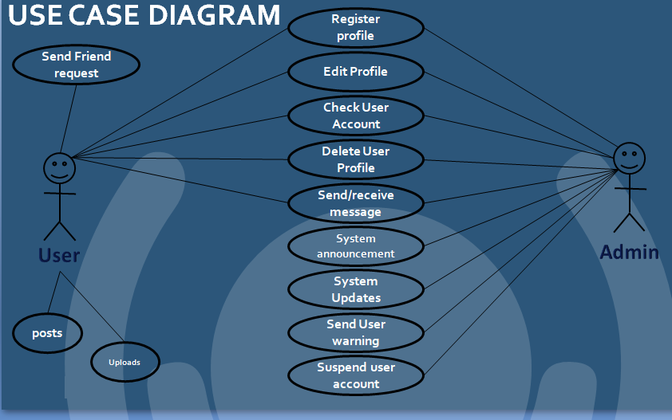

**FLOWCHART**

**A flowchart is a type of diagram that represents an algorithm, workflow or process. The flowchart shows the steps as boxes of various kinds, and their order by connecting the boxes with arrows. This diagrammatic representation illustrates a solution model to a given problem. Flowcharts are used in analyzing, designing, documenting or managing a process or program in various fields.**

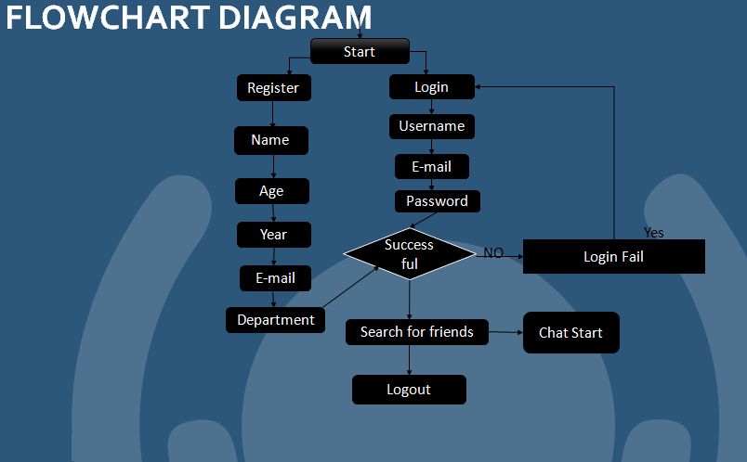 **WEBSITE ARCHITECTURE**

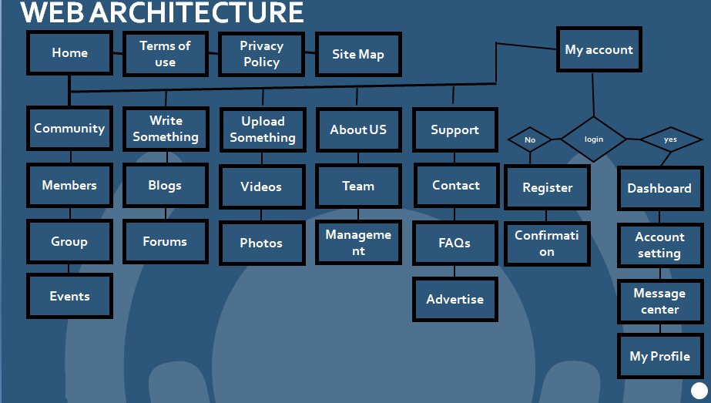**Website architecture is an approach to the design and planning of websites that involves technical, aesthetic and functional criteria. As in traditional architecture, the focus is on the user and on user requirements. This requires particular attention to web content, the business plan, usability, interaction design, and information architecture and web design. It also include deciding technology stack, sitemap and navigation system of website**

**TESTING**

8.1 WHAT IS TESTING?

Testing is the process of demonstrating that errors are not present.

The purpose of testing is to show that a program performs its intended functions

correctly.

Testing is the process of establishing confidence that a program does what it is

Supposed to do.

Software testing is a specialized discipline in the process of software development.

Levels of Testing

We perform integration testing using bottom up integration and we get positive

Results in test.

Integration Testing

There are three levels of testing:

Unit Testing

Unit testing is the process of taking a module and running it in isolation from the rest

of the software product by using prepared test cases and comparing actual results with

The results predicted by the specifications and design of the Module. As we use

waterfall model for designing our software thus we perform unit testing side by side

after coding every individual module.

Acceptance Testing

This type of testing covers all the test cases applied by the customer and comprises of

two main parts

1. Alpha Testing

2. Beta Testing

**Screenshots**

**A screenshot is a digital image of what should be visible on a monitor, television, or other visual output device. A common screenshot is created by the operating system or software running on the device. A screenshot or screen capture may also be created by taking a photo of the screen.**

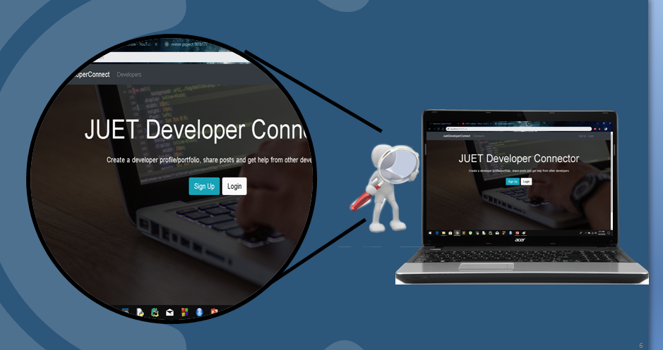

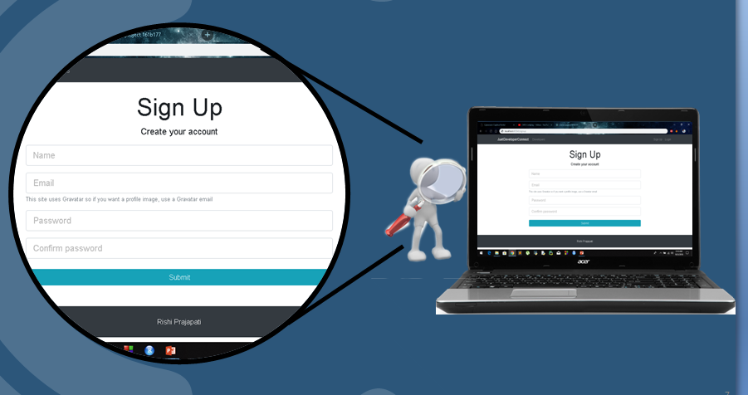

**Conclusion**

Our Project in only humble venture to satisfy the needs to manage their project work. Several user friendly coding have also adopted. This package shall prove to be a powerful package in satisfying basic requirements. The objective of software planning is to provide a framework that enables the employees and the employers to make reasonable estimates made within a limited time frame at the beginning of the software project.

At the end it is concluded that we have made effort on following points…

* A description of the background and context of the project and its relation to work already done in the area.
* Made statement of the aims and objectives of the project.
* The description of Purpose, Scope, and applicability.
* We define the problem on which we are working in project.
* We describe the requirement Specification of the system and the actions that can be done on these things.
* We understand the problem domain and produce a model of the system, which describes operations that can be performed on the system.
* We include features and operations, including screen layouts.
* We designed user interface and security issues related to system.
* Finally the system is implemented and tested according to test cases.

**Limitations**

Although we have put our best efforts to make the software flexible, easy to operate but limitations cannot be ruled out. Though the software presents a broad range of options to its users some intricate options could not be covered into it, partly because of logistic and lack of sophistication. Paucity of time was also major constraint, thus it was not possible to make the software foolproof and dynamic. Lack of time also compelled us to ignore some part such as booking tickets etc.

Considerable efforts have made the software easy to operate even for the people not related to the field of computers but it is acknowledged that users may find it a bit problematic at the first instance. The user is provided help at each step for his convenience in working with software.

**Future Scope of the project:**

In a nutshell, it can be summarized that the future scope of the project circles around maintaining information regarding:

* We can add login credentials for others as well.
* We can add printer in future.
* We can give more advance software for our project including more facilities.
* Integrate multiple load balancers to distribute the loads of the system.

The above mentioned points are enhancements that can be done to increase the applicability and usage of this project.

We have all the options open so that if there is any other future requirement in the system by the user for the enhancement of the system then it is possible to implement them. In the last we would like to thank all the persons involved in the development of the system directly or indirectly. We hope that the project will serve its purpose for which it is developed there by underlining success of process.

**References and bibliography:**

* [www.google.com](http://www.google.com)/ for problem solving.
* [www.tutorialspoint.com](http://www.tutorialspoint.com)/ for front end part help.
* [www.stackoverflow.com](http://www.stackoverflow.com)/ for more references.
* <https://github.com/> for hosting the project online.
* [www.w3school.com](http://www.w3school.com)/ for coding part help.

********