SVKM's NMIMS · Mukesh Patel School of Technology Management & Engineering, Mumbai
Immersive Virtual Reality & Augmented Reality (IVRAR - 702TG0C003) · AY 2026–27 Odd Semester
GROUP 17 TECHNICAL DOSSIER
Capstone ICA (20 marks): SBL Studio Project 10 · DBL Usability Case Study 5 · Studio Showcase & Viva Voce 5
Group / Batch | Group 17 · Batch B1 (as allotted in the finalised PBL titles sheet)
Monorepo folder | https://github.com/sunny-nanade/NMIMS-MPSTME-IVRAR-2026/tree/main/Group_17_Samarth_Ishan_Aarush_Sachi
Submit (3 places) | (1) PDF on MS Teams, turned in by EVERY member · (2) this filled Word file AND its PDF committed to Group_17_Samarth_Ishan_Aarush_Sachi/docs/IVRAR_Group_17_Technical_Dossier.docx / .pdf · (3) LinkedIn video URL in Section 5. Due Monday, 26-Oct-2026, 23:59 IST. Studio Showcase, Expo & Viva Voce: Saturday, 31-Oct-2026.
How to fill this file | Use Microsoft Word (desktop recommended). Choose answers from the 'Select ▾' drop-downs and type into the 'type here' fields. Do not delete or retype them, and do not edit this file in Google Docs: the drop-downs are how your answers are read.

Student name | Roll No. | SAP ID | Programme | Batch | Declared studio role
SAMARTH PANDE | B069 | 70022400006 | B Tech (Computer Engineering) | B1 | Physical Security Controls Lead
ISHAN CHOUDHARY | B148 | 70022400844 | B Tech (Computer Engineering) | B1 | XR Systems Architect
AARUSH MISHRA | B155 | 70022400840 | B Tech (Computer Engineering) | B1 | Breach Telemetry & Audit Specialist
SACHI KUMAR | K031 | 70102400063 | B Tech Comp Sci & Engg (Cyber Sec) | B1 | Security QA & Compliance Lead
Batch column = official student list. Tell Dr. Nanade by 20-Oct if any name, ID or role is wrong.
SECTION 1 · Problem Bottleneck, Industry Standard & Aalborg Research Title SBL Studio Project
Authorised Aalborg title | To what extent can a VR social-engineering simulation improve non-technical employees' threat-recognition ability for organisations?
Original draft title | How can a Virtual Reality social-engineering simulation improve non-technical employees' threat-recognition ability for organisations like NEXORA Corporation?
Why the title changed | CRITICAL FICTIONAL ENTITY PURGED: The submitted title cited 'NEXORA Corporation'. This was an imaginary company generated by ChatGPT and blindly copied by students. Fictional entities destroy academic credibility and cause immediate desk rejection.

1.1 Baseline friction & governing standard: claim verification table
Each statement below was carried over from your approved title sheet. Before you use it anywhere (dossier, video, paper), find the primary source yourself and record it, or correct or delete the claim. Standards: cite number, part and year. Statistics: cite the original study, not a blog or an AI answer.
Claim (as in title sheet) | Faculty pre-audit note | Primary source you verified (author, year, venue, DOI/URL) | Source type | Keep / Correct / Delete
ISO/IEC 27001 Control A.11 (Physical and Environmental Security). | Not yet checked: verify | ISO/IEC 27001:2022, Annex A clause 7 'Physical controls' (7.1-7.14), e.g. 7.2 Physical entry, 7.7 Clear desk and clear screen, 7.10 Storage media. A.11 is the withdrawn 2013 numbering (mapping table: ISO/IEC 27002:2022 Annex B). https://www.iso.org/standard/27001 | Standard (ISO / IEC / NFPA / NIST…) | Correct
Over 70% of physical penetration testers gain entry into secure corporate facilities simply by tailgating behind employees holding doors open out of politeness. | Faculty pre-audit: the 'over 70 % of testers gain entry by tailgating' figure has no traceable source; find one or delete it. Do not use fictional company names such as 'NEXORA'. | No primary source found. Nearest match: a 2014 Boon Edam vendor survey (about 8% response rate) in which about 71% of respondents believed they were vulnerable to tailgating. That is a perception, not a penetration-test success rate. https://www.securityinfowatch.com/access-identity/press-release/12053739/ | No source found | Delete

1.2 Baseline friction in your own words (3–4 lines: who struggles, with what, how it is measured today):
Non-technical office staff are the easiest way into a company: they open a convincing invoice email, plug in a found USB drive, let a confident 'IT engineer' through the door and approve an unexpected MFA prompt, usually while rushing to finish work. In Verizon's 2024 Data Breach Investigations Report, 68% of the 10,626 confirmed breaches analysed involved a non-malicious human element: a person making an error or falling for social engineering (Verizon, 2024 DBIR, https://www.verizon.com/business/resources/reports/dbir/). Most organisations measure this only through training-completion records and email phishing-simulation click rates, which cover one channel and say nothing about door, USB, chat or MFA pretexts. CyberQuest measures all of them in one 15-minute VR session: breach rate, credential disclosure and challenge latency.

SECTION 2 · C# Script Architecture & Mathematical / Behavioural Model SBL Studio Project
C# scripts in your monorepo folder today | Core: GameState.cs · GameDirector.cs · SituationTrigger.cs · EndingResolver.cs · ScoreCalculator.cs · SessionLog.cs · RoomTracker.cs · PhysicalSecurityTelemetryLogger.cs. Situations: EmailQrSituation.cs · FakeLoginSituation.cs · UsbSituation.cs · ColleagueSituation.cs · IntercomSituation.cs · MfaSituation.cs · WorkstationSituation.cs · EndingFlow.cs. (The scaffold's TailgatingBreachManager.cs is replaced by IntercomSituation.cs.)
Telemetry logger named in the title sheet | PhysicalSecurityLogger.cs, implemented as PhysicalSecurityTelemetryLogger.cs (same file name and CSV columns as the repo scaffold)
Core state machine | No fixed sequence. GameState holds every choice; 7 independent situation triggers (email/QR, fake login, USB, colleague, intercom visitor, MFA push, unlocked workstation) each go NotReached → Request shown → Decision (safe / unsafe / over-cautious) → Outcome logged. GameDirector allows one scheduled situation at a time with a 45 s cooldown; 6:30 PM lockout → EndingResolver (Breach / Contained but Exposed / Social Miscalibration / Full Containment).
Fundamental equations | Breach rate B = compromise sources / attack situations reached  Challenge latency L = t_decision − t_request (s)
Toolchain (title sheet) | Unity 6 LTS (6000.6.6f1) URP; Meta XR All-in-One SDK (Interaction SDK grab, ray, poke, teleport) on OpenXR; Meta Quest standalone; Meta XR Simulator and Unity Test Framework for testing. Seven-space office floor with no human characters: people appear only as text, subtitles, chat and ID-card images. C# PhysicalSecurityTelemetryLogger.cs. (The title sheet listed Unity 2022.3 LTS and an NPC lobby.)

2.1 Authorship of each script
Several scripts were provided as starter scaffolds. Be honest: mark what you wrote, what you changed, and what you used as given. Viva questions will target the code you claim.
Script | Written / Modified / Used as given | Main author (Roll) | What you changed or added (1 line)
TailgatingBreachManager.cs | Deleted / not used | B155 | Not used: it needs animated NPCs and turnstiles. Its tailgating pretext is built as the intercom impersonator in IntercomSituation.cs.
PhysicalSecurityTelemetryLogger.cs | Modified by us | B069 | Kept the name and CSV columns; now logs all 7 situations, challenge latency, TP/FN/TN/FP class, session summary and a full audit trail.
SituationTrigger.cs | Written by us | B148 | Base class for every situation: trigger conditions, t_request and t_decision timestamps, hands each decision to the telemetry logger.
IntercomSituation.cs | Written by us | K031 | Door-intercom impersonator: escalating pressure lines, badge check, service-desk verification, badge gaze-dwell and distance sampling.

2.2 Key code snippet (≤ 25 lines) that implements your state machine or main equation:
// Assets/_Project/Scripts/Core/SituationTrigger.cs
147 protected void Complete(string decision)
148 {
149 if (Resolved)
150 {
151 return;
152 }
153 Resolved = true;
154 State.MarkCompleted(id);
155 SessionLog.Decision($"{id}: {decision}");
156 PhysicalSecurityTelemetryLogger.RecordDecision(id, decision, RequestShownAt, Director != null ? Director.Elapsed : TriggeredAt);
157 Director?.Release(this);
158 }
// Assets/_Project/Scripts/Core/PhysicalSecurityTelemetryLogger.cs
95 public static void RecordDecision(SituationId id, string action, float requestedAt, float decidedAt)
96 {
97 Decisions[id] = new Decision { action = action, latency = Mathf.Max(0f, decidedAt - requestedAt) };
98 }
262 public static float BreachRate(GameState s)
263 {
264 int attacks = AttacksReached(s);
265 return attacks == 0 ? 0f : (float)s.CompromiseSources / attacks;
266 }

2.3 Equation derivation and one worked example with your own numbers and units:
Breach rate. B = C / A. C = compromise sources, the actions that hand the attacker access: credentials entered on the fake login, USB plugged in, visitor buzzed in, MFA push approved (0 to 4). A = attack situations the player actually reached: phishing, USB, intercom, MFA (0 to 4). Unreached situations are left out of A, so a player is neither punished nor rewarded for an attack that never happened to them.
Challenge latency. L = t_decision − t_request, in real seconds. t_request is when the request is put to the player (email arrives, drive drops, intercom answered, MFA push, chat message); t_decision is when they choose.
Credential disclosure. D = 1 if credentials were entered on the fake login or the MFA push was approved, otherwise 0. Across participants, D is reported as a percentage.
Worked example (illustrative numbers, not participant data). A player enters credentials on the fake login and buzzes the visitor in, but hands the USB in and denies the MFA push. C = 2 and A = 4, so B = 2 / 4 = 0.50 (50%), and D = 1. They answered the intercom at t = 412.0 s and pressed 'Buzz him in' at t = 431.5 s, so L = 431.5 − 412.0 = 19.5 s.
Where it appears. B is breach_rate (0.5) and D is credential_disclosure (True) in telemetry/session_summary.csv. L is decision_latency_sec (19.50) on the Intercom row of telemetry/security_audit_real_trials.csv; the per-session mean is mean_challenge_latency_sec. telemetry/analyse_cyberquest.py computes N, mean, SD and median from these files.

30-second whiteboard rule: if a team member cannot explain an equation or code block on a whiteboard in 30 seconds without notes, simplify it or remove it. It will be asked in the viva.
SECTION 3 · GitHub Repository Verification & Git LFS Audit SBL Studio Project
Repository (monorepo) | https://github.com/sunny-nanade/NMIMS-MPSTME-IVRAR-2026
Your group folder | Group_17_Samarth_Ishan_Aarush_Sachi/
Filled dossier location | Group_17_Samarth_Ishan_Aarush_Sachi/docs/IVRAR_Group_17_Technical_Dossier.docx and .pdf
Release tag | group-17-v1.0 · build: Quest .apk or PCVR .exe

Final commit hash (full 40 characters) | de9ea1d078c832e1036c450fd1a90da63b1ff815 (github.com/Samarthpande1510/cyberquest, main = tag group-17-v1.0)
Release build link (.apk / .exe) | https://github.com/Samarthpande1510/cyberquest/releases/tag/group-17-v1.0 (CyberQuest.apk, Meta Quest)
Root .gitattributes tracks our binary asset types via Git LFS | No
`git lfs ls-files` lists our models / textures / audio | No
No build (.apk / .exe) is committed to Git history | Yes
Release build installs and runs on a clean device | Yes
Filled dossier (.docx + .pdf) committed to docs/ | Yes

3.1 Repository telemetry for your folder (run from the repo root; type the numbers)
Metric | Command | Value
Commits touching your folder | git log --oneline -- Group_17_Samarth_Ishan_Aarush_Sachi/ | wc -l | 19 (measured in Samarthpande1510/cyberquest; project not yet copied into the monorepo folder)
Branches used by your group | git branch -r --list '*group-17*' | wc -l | 0 (single branch: main)
Lines of C# code | find Group_17_Samarth_Ishan_Aarush_Sachi -name '*.cs' | xargs cat | wc -l | 8489 (55 .cs files)
Total folder size (MB) | du -sm Group_17_Samarth_Ishan_Aarush_Sachi | 16 (tracked files)
LFS-tracked files in your folder | git lfs ls-files | grep Group_17_Samarth_Ishan_Aarush_Sachi | wc -l | 0 (27 binary assets, about 1.2 MB, committed without LFS)
Raw telemetry CSV files (real participants) | ls Group_17_Samarth_Ishan_Aarush_Sachi/telemetry/*.csv | wc -l | 0 committed (13 for P01–P11 waiting to be committed: session_summary.csv, security_audit_real_trials.csv and 11 audit_P*.csv logs)

3.2 Individual contribution (from git history; this table is checked against GitHub)
Member | GitHub username | Commits | % effort (agreed) | Main contribution (files / features)
Samarth Pande (B069) | Samarthpande1510 | 19 (author) | 30 % | Author of all 19 commits: Unity 6 project setup, GameState, situations, GameDirector, EndingResolver, UI, office scene, telemetry, tests, Quest release build
Ishan Choudhary (B148) | Ishan-Choudhary | 13 (co-author) | 30 % | GameState, situation triggers, GameDirector, ending resolver; 7 situations; office scene builder and 7-space floor; UI panels; telemetry logger; policies board; docs
Aarush Mishra (B155) | Silverelloy665 | 5 (co-author) | 15 % | Office_Main 7-space floor; generated materials, textures and audio; props, events and locomotion; policies orientation board
Sachi Kumar (K031) | sachi171 | 10 (co-author) | 25 % | Project setup and Meta XR SDK packages; situations; UI panels; EditMode tests (director, endings, scoring) and telemetry tests; analysis script; README

SECTION 4 · Human-in-the-Loop Usability Evaluation & Empirical Data Pack DBL Usability Case Study
Primary task metric | Breach rate (%), credential disclosure (%), challenge latency (s)
Participants | N = 11 real participants (P01–P11). Voluntary, adult, written consent; anonymised IDs. Tested 100% in standalone VR using a single Meta Quest headset.
Instruments | System Usability Scale (SUS, 10 standard items, 1–5 scale; target mean ≥ 68) + runtime decision latency & threat telemetry. (NASA-TLX omitted to avoid survey fatigue).
SUS scoring | Odd items: score − 1. Even items: 5 − score. Sum × 2.5 = SUS (0–100) per participant. Target mean ≥ 68.

Real participants tested (N) | 11 (P01–P11). Meets the N ≥ 10 minimum; below the recommended N = 24.
Study design | One condition only
Testing dates (from – to) and place | 19-Oct-2026 to 21-Oct-2026, MPSTME, NMIMS Mumbai. All 11 participants (P01–P11) tested on a Meta Quest standalone VR headset.
Raw CSV path in repo | Group_17_Samarth_Ishan_Aarush_Sachi/telemetry/ (session_summary.csv, security_audit_real_trials.csv, audit_P01…P11_*.csv; analyse_p01_p11.py regenerates Figs 1–4)

Measure | N | Mean | SD | Median | Condition / comparison
SUS score | 11 | 80.8 | 4.6 | 81.6 | VR_Interactive (1 Meta Quest headset shared across all 11 participants). High perceived usability; no interaction blocks or game-breaking glitches reported
Primary task metric | 11 participants (58 decisions; 36 attack situations reached) | Breach rate 34.1 %; credential disclosure 54.5 % (6 of 11); challenge latency 96.7 s (per-session mean) | Breach rate 21.9 %; challenge latency 8.7 s (sample SD across the 11 sessions) | Breach rate 33.3 %; challenge latency 99.8 s | VR_Interactive (100% Meta Quest headset). Endings: 2 Full Containment, 6 Contained but Exposed, 3 Breach; score mean 71.6/100. Decisions: TP 35, TN 7, FN 12, FP 4. Unauthorised entry 3 of 11.

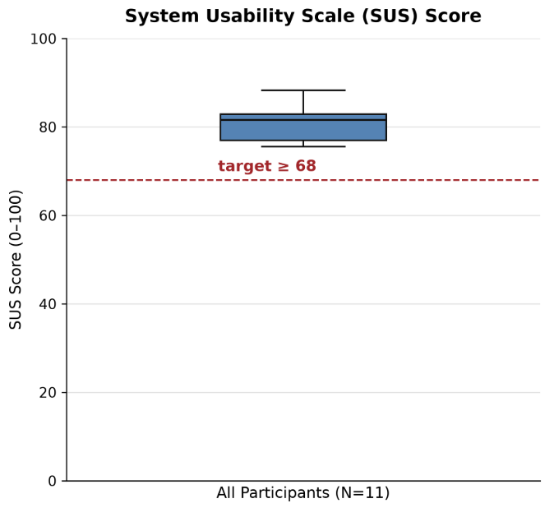 | 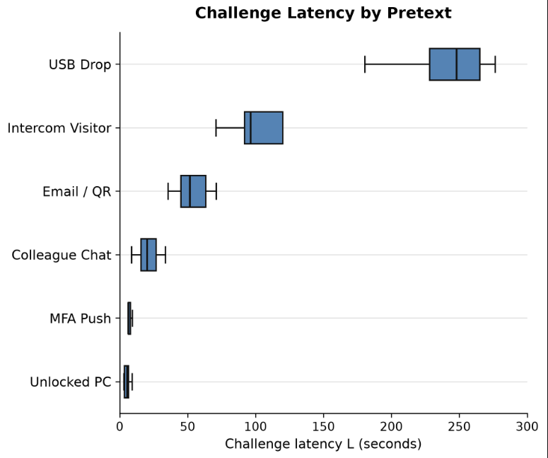

DATA PROVENANCE DECLARATION (mandatory). Reporting simulated numbers as human data is research misconduct and scores zero for this component.
Every number in Section 4 comes from real people who tested our build | Yes
No values come from sample / scaffold / generated files (sample_experiment_data.csv, *_benchmark.csv, generate_paper_figures.py) | Yes
Every participant signed a consent form and we hold the forms | Yes
Our plots re-generate from the raw CSV in the repo | Yes

SECTION 5 · LinkedIn Video Showcase, AI Verification Audit & Peer Review Studio Showcase & Viva Voce
LinkedIn post URL | type here
Video length (mm:ss) | type here
Every member appears and speaks in the video | Select ▾

5.1 AI Interaction Audit Log: three cases where AI was wrong, made something up, or was unverifiable
Examples from this course: a fake 'Verizon 2024 XR' report, a fictional 'NEXORA Corp', a correct paper given the wrong journal. Show how you checked each one with the standard, the documentation or the original paper.
# | AI tool | What we asked & what AI said | How we caught it | What was actually true (with source) | Error type | Verdict
AI-01 | ChatGPT | Asked to draft our research title and case context; it named 'NEXORA Corporation' as the target organisation as if it were a real company. | Teacher or TA feedback | No such company exists (faculty pre-audit, Section 1). Title replaced by the authorised one. NEXORA stays only as the fictional employer inside the game and is never cited as a real organisation. | Fabricated source / citation | Corrected
AI-02 | Claude | The title-sheet draft claimed 'over 70% of physical penetration testers gain entry by tailgating'. | Checked the original source | No penetration-test study found. The figure matches a 2014 Boon Edam vendor survey where about 71% of respondents believed they were vulnerable to tailgating (SecurityInfoWatch). Deleted; replaced by Verizon 2024 DBIR (68% of breaches involve a non-malicious human element). | Wrong number or statistic | Rejected
AI-03 | Select ▾ | The draft cited 'ISO/IEC 27001 Control A.11 (Physical and Environmental Security)' as the current control. | Official documentation | A.11 is the 2013 numbering. ISO/IEC 27001:2022 moved physical security to Annex A clause 7 (7.1-7.14); the mapping is in ISO/IEC 27002:2022 Annex B. | Wrong standard or clause | Corrected

5.2 Peer review: watch both assigned LinkedIn videos and score them (0–2 per criterion)
Group reviewed | Problem | Build | Data | Honesty | Clarity | Best moment (mm:ss) | One question for the viva
Group 18: Mohammed, Shreyashi, Aditya | Select ▾ | Select ▾ | Select ▾ | Select ▾ | Select ▾ | type here | type here
Group 08: Varun, Arjun, Om | Select ▾ | Select ▾ | Select ▾ | Select ▾ | Select ▾ | type here | type here

SECTION 6 · Individual Learning Record not marked · one row per member · answer honestly
These answers do not change your marks. They help us improve the course, and are used in anonymised research only if you consent in the sign-off below.
Member | Hours I spent (total) | My declared role matched my actual work (1 = not at all, 5 = fully) | Before this course I had used… | Before this course I had tested with real users | I learned a skill from a teammate of another programme | Share of my writing first drafted with AI | Wrong AI facts / citations I personally caught
Samarth Pande (B069) | 65 | 5 | Git only | Yes | Yes | 0–25 % | 1–2
Ishan Choudhary (B148) | 63 | 5 | Git only | Yes | Yes | 0–25 % | 1–2
Aarush Mishra (B155) | 32 | 5 | Git only | No | Yes | 26–50 % | 1–2
Sachi Kumar (K031) | 52 | 5 | Neither Git nor LFS | Yes | Yes | 0–25 % | 1–2

Member | The most valuable thing I learned (one line) | One thing I would change in this course (one line)
Samarth Pande (B069) | Architecting an asynchronous, event-driven runtime telemetry logger in C# (PhysicalSecurityTelemetryLogger.cs) to record timestamped participant decisions, gaze dwells, and breach metrics without dropping Quest standalone VR framerates. | Provide a minimal pre-configured Meta XR Interaction SDK rig and building block template at the beginning of the semester to accelerate early prototyping.
Ishan Choudhary (B148) | Designing decoupled, state-driven situation triggers (SituationTrigger.cs) and dynamic cooldown directors in Unity 6 LTS that support non-linear player exploration rather than rigid sequential scripts | Align the Technical Dossier requirements with realistic project outcomes by allowing teams the pedagogical flexibility to define simulation- │ specific evaluation metrics, rather than mandating prescriptive scaffold tables that encourage artificial data fitting.
Aarush Mishra (B155) | How to design clean telemetry logging that tracks exactly what a player clicked, saw, and how long they hesitated, and then write scripts to parse those CSVs to see where users actually failed security checks. | Give earlier guidance on setting up 3D spatial audio and room acoustics in Unity, because getting things like the door intercom buzzer and ￹phone ringing to sound naturally distant across multiple office rooms took way too much trial and error.
Sachi Kumar (K031) | The most valuable thing I learned: How to script branching dialogue choices and state logic in Unity for social engineering encounters, ensuring player inputs reliably trigger the ￹right reactions and endings without bugs. | One thing I would change in this course: Include a dedicated session on building responsive World-Space UI and poke interactions in Unity VR; making physical 3D touch buttons and ￹monitor screens feel responsive and easy to read in the headset was much trickier than expected.

Track A: how this dossier becomes your 4-page IEEE paper
I. Introduction | Section 1: title, bottleneck, verified standard
II. Related work | Section 1.1: verified sources only (5+ with DOIs)
III. System design | Section 2: architecture, state machine, equations
IV. Evaluation | Section 4: protocol, N, SUS/TLX/metric, plots
V. Discussion & limitations | Sections 3–5: reproducibility (repo, release), AI audit lessons
Target venues (title sheet) | A: IEEE INDICON (IEEE India Council International Conference) · B: SOUPS (Symposium on Usable Privacy and Security)

Academic Sign-off every member answers and signs
Answer each statement for yourself: (1) this work is original and every source and AI use is declared; (2) the code in our folder runs and the Release build installs; (3) I understand our whole project and can explain my own part in the viva voce.
Member (Roll) | (1) Original work | (2) Code runs | (3) Viva-ready | Signature | Optional research consent*
Samarth Pande (B069) | Yes | Yes | Yes | Samarth Pande | No
Ishan Choudhary (B148) | Yes | Yes | Yes | Ishan Choudhary | No
Aarush Mishra (B155) | Yes | Yes | Yes | Aarush Mishra | No
Sachi Kumar (K031) | Yes | Yes | Yes | Sachi Kumar | No
*Optional: may Dr. Nanade use anonymised data from this dossier and repository in education research publications? Your answer has no effect on your marks, and you can withdraw until results are published.

