Assignment -1

Use of Formulas Sum, Average, If, Count, Counta, Countif & Sumif

Roll No Student Name Hindi English Math Physics Chemistry Total Average Grade

(In these below Assignments you all have to write only functions and it’s parameter what will you select no need to write or create this table in Excel )



1. **g :--> Q.1 Find the Total Number & Average in all Subjects in Each Student .**

**=AVERAGE(B2:F2)**

**Q.2 Find Grade Using If Function - If Average Greater >15 then "A" Grade otherwise "B" Grade**

**=IF(H2>15, "A", "B")**

**Q.3 How Many Student "A" and "B" Grade (Use of Countif)**

**=COUNTIF(I2:I11, "B")**

**=COUNTIF(I2:I11, "A")**

**Q.4 Student Ashok and Manoj Total Number and Average (Use of Sumif)**

**=SUMIF(A2:A11,"Ashok",G2:G11),** **=AVERAGEIF(A2:A11,"Ashok",H2:H11)**

**=SUMIF(A2:A11,"manoj",G2:G11),** **=AVERAGEIF(A2:A11,"manoj",H2:H11)**

**Q.5 Count how many Students (Use of Counta)**

**=COUNTA(A2:A11)**

**Q.6 How Many Student Hindi & English Subject Number Grater Then > 20 and <15( Use of Countif)**

**=COUNTIF(B2:B11,">20"),** **=COUNTIF(B2:B11,"<15")**

**=COUNTIF(C2:C11,">20"),** **=COUNTIF(C2:C11,"<15")**

Assignment -2

Use of Formulas - Product, If, Counta, Countif, Sumif

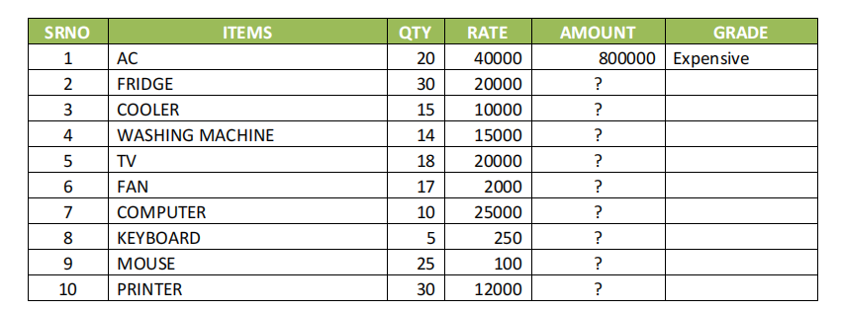

**Q.1 Using of Product Fomula for Calculate Amount = Qty*Rate**

**=C2*D2**

**Q.2 How Many Items in a List**

**=COUNTA(B2:B11)**

**Q.3 How Many Items qty Greate Then > 20 and Less Then <20**

**=COUNTIF(C2:C11, ">20"),** **=COUNTIF(C2:C11, "<20")**

**Q.4 Calculate Item Computer Qty, Rate and Amount using Sumif Formula**

**=SUMIF(B2:B11,"computer",C2:C11),** **=SUMIF(B2:B11,"computer",D2:D11),**

**=SUMIF(B2:B11,"computer",E2:E11)**

**Q.5 If Items Amount is Greater > 500000, Then Items "Expensive" otherwise "Lets Buy it".**

**=IF(E2>500000, "Expensive", "Let's Buy it")**

**Assignment -3**

**Use of Formulas - Sum, NestedIf, Counta, Countif, Sumif, Vlookup**

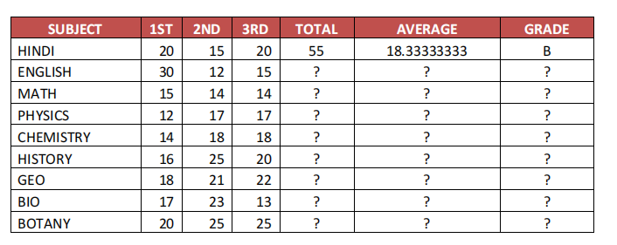

**Q.1 HOW MANY SUBJECT ? (**Use of Counta )

=COUNTA(B2:B10)

**Q.2 HOW MANY SUBJECT 1 PAPER GREATER THAN 20 ? (**Use of Countif )

=COUNTIF(B2:B10,">20")

**Q.3 SUBJECT HINDI, MATH & ENGLISH TOTAL NO. & GRADE (** Use of Vlookup)

=VLOOKUP(E2,F:G,2,TRUE)

**Q.4 IF AVE. GREATHER THAN 20 THEN "A", IF AVE. GREATEHR THAN 15 AVE. "B" OTHERWISE "C"**

**=IF(F2>20, "A", IF(F2>15, "B", "C"))**

**Q.5 SUBJECT PHYSICS, MATHS & ENGLISH TOTAL /AVERAGE(** Use of Vlookup)

Total marks =SUM(B2:C2:D2)

Average =AVERAGE(B2:D2)

=VLOOKUP(E2,G:H,2,TRUE)

**Assignment -4 (Salary Sheet)**

**Use of Formulas - Sum, NestedIf, Counta, Countif, Sumif, Vlookup**

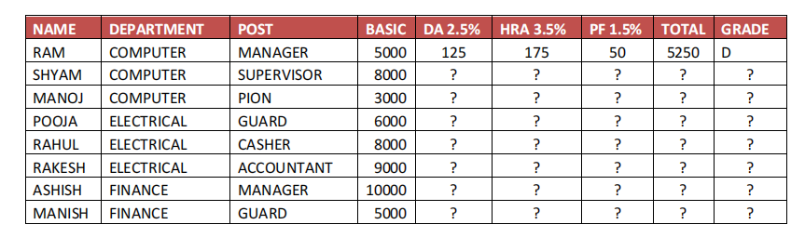

**Q.1 HOW MANY EMPLOYEE IN COMPUTER, FINANCE, ELECTRICAL DEPARTMENT**

Use of Countif

=COUNTIF(B2:B9,"computer"), =COUNTIF(B2:B9,"finance"), =COUNTIF(B2:B9,"electrical department")

**Q.2 HOW MANY BASIC SALARY IN COMPUTER DFPARTMENT ONLY?**

**Use of Sumif**

**=SUMIF(B2:B9, "computer", D2:D9)**

**Q.3 MANOJ, ASHISH POST & GRADE**

Use of Vlookup

=VLOOKUP("Manoj", A2:I9, 3, FALSE), =VLOOKUP("Manoj", A2:I9, 9, FALSE)

=VLOOKUP("Ashish", A2:I9, 3, FALSE), =VLOOKUP("Ashish", A2:I9, 9, FALSE)

**Q.4 IF TOTAL SALALRY IS GREATER THEN 20000 THEN "A", IF TOTAL SALARY GREATER THEN 10000 THEN "B",**

**OTHERWISE "C**

=IF(H2>20000,"A",IF(H2>10000,"B","C"))

**Q.5 HOW MANY EMPLOYEE IS MANAGER & GUARD?**

Use of Countif

=COUNTIF(C2:C9, "manager"), =COUNTIF(C2:C9, "guard")

**Assignment -6**

**Use of Formulas - Counta, Countif, Sumif, Hlookup,**

**Conditional Formatting**

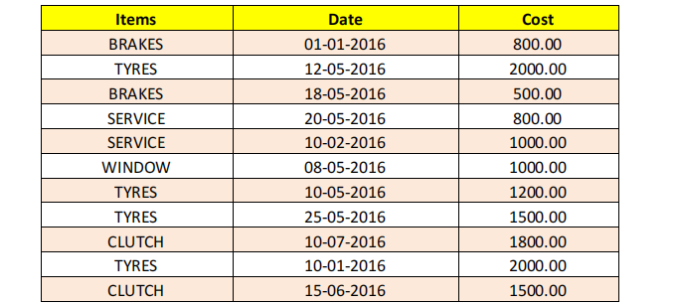

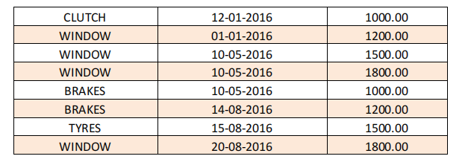

**Q.1 HOW MANY ITEMS ?**

Use of Counta

=COUNTA(A2:A20)

**Q.2 HOW MANY BRAKE, WINDOW & TYRES HAVE BEEN BOUGHTS?**

Use of Countif

=COUNTIF(A:A, B1)

**Q.3 HOW MANY ITEMS COST IS >1000 & BELOW > = 1000?**

=COUNTIF(A1:A10, ">1000") - This formula counts the number of times the cost is greater than 1000 in the range A1:A10

=COUNTIF(A1:A10, "<=1000") - This formula counts the number of times the cost is less than or equal to 1000 in the range A1:A10

**Q.4 HIGHLIGHT TYRES ITESM & 500 BETWEEN 2000 COST.**

Use of Conditional

F

**=IF(A2>=500, A2<=2000), "Within Range", "Outside Range")**

**Q.5 ITEMS COLOUMN IS 15, 18 & 20 ITEMS NAME?**

Use of Hlookup

**=HLOOKUP(B1, A1:D20, 2, FALSE)**

**Q.6 Total Cost of Window and Brakes Items?**

Use of Sumif

=SUMIF(A1:A10, C1, B1:B10) + SUMIF(A1:A10, C2, B1:B10)

**Assignment -7**

**Create Pivot Table Using Data**

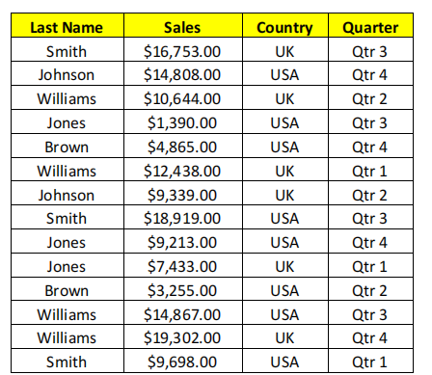

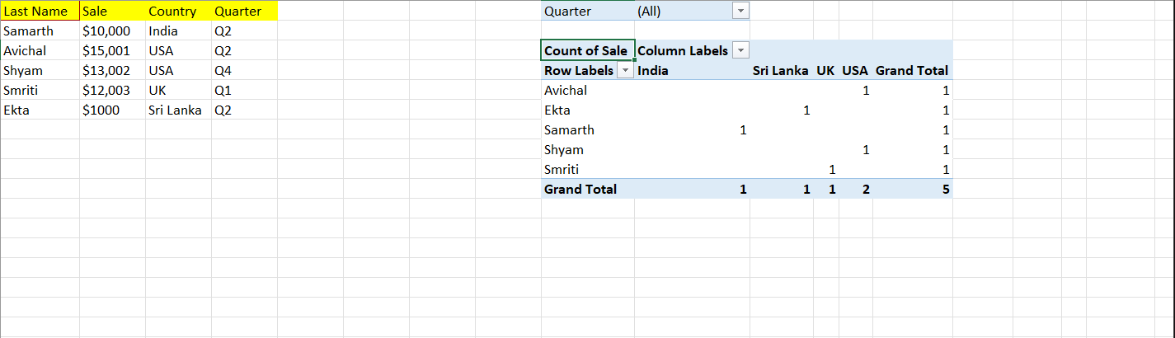

**Assignment -8**

**USE OF HLOOKUP**

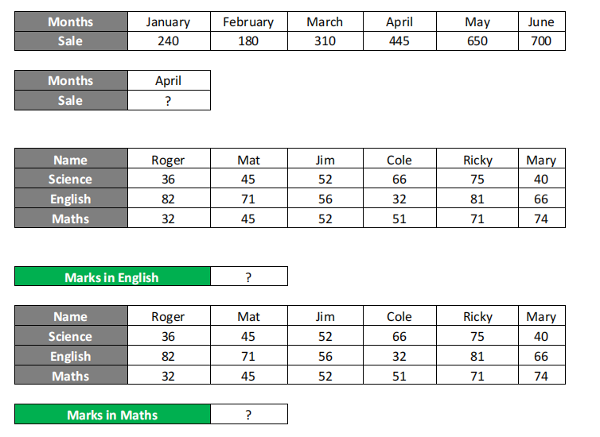

* + - 1. =HLOOKUP("april",$A$18:$G$19,2,FALSE)
      2. =HLOOKUP(A27,$A$25:$G$28,3,0)
      3. =HLOOKUP(A28,$A$25:$G$28,4,0)

**Use of Sumif**

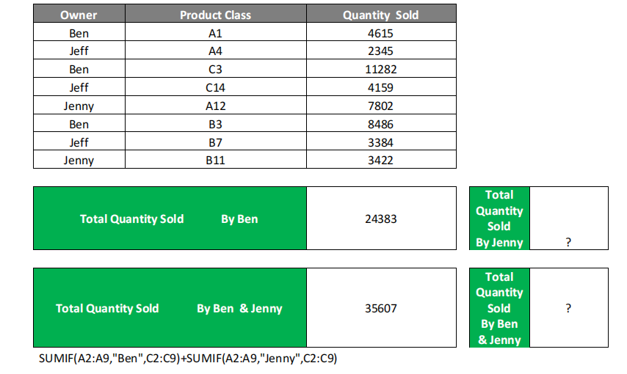

=sumif(A1:A8,”Jenny”,C1:C8)

=sumif(A1:A8,”Jenny”,C1:C8) + =sumif(A1:A8,”Ben”,C1:C8)

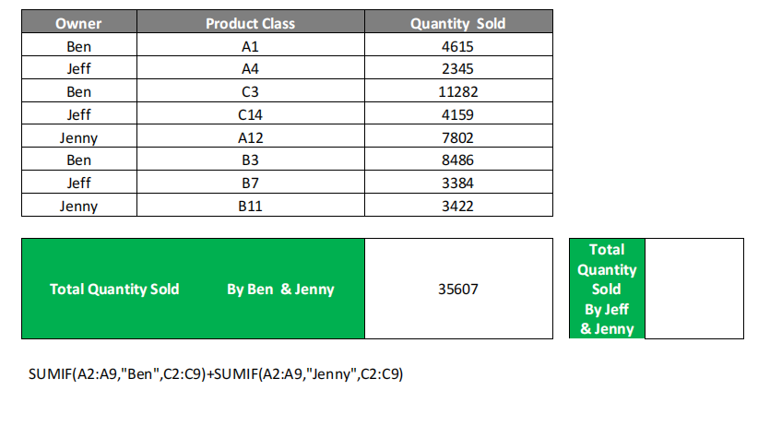

=sumif(A1:A8,”Jenny”,C1:C8) + =sumif(A1:A8,”Jeff”,C1:C8)

**Assignment -10**

***USE OF VLOOKUP***

***WITH CONDITION TRUE/FALSE***

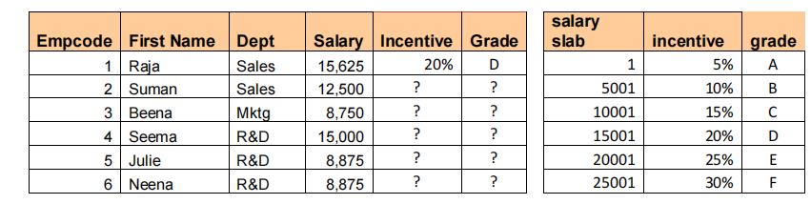

=VLOOKUP(D37,$I$37:$K$42,5,0)

Assignment-11

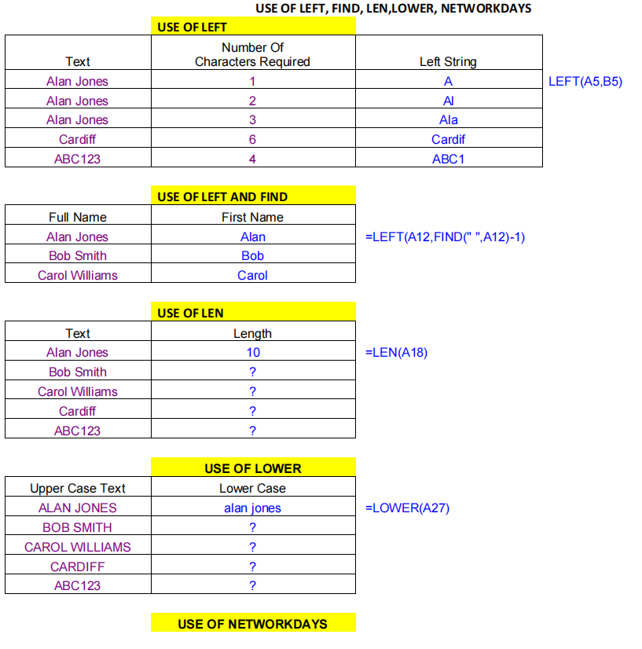

Use of Len

=LEN(A19),8

Use of Left

=LEFT(A2,2)

Use of Left and find

=LEFT(A2,FIND("bob",A2)-1)

Use of Lower

=Lower(A2)

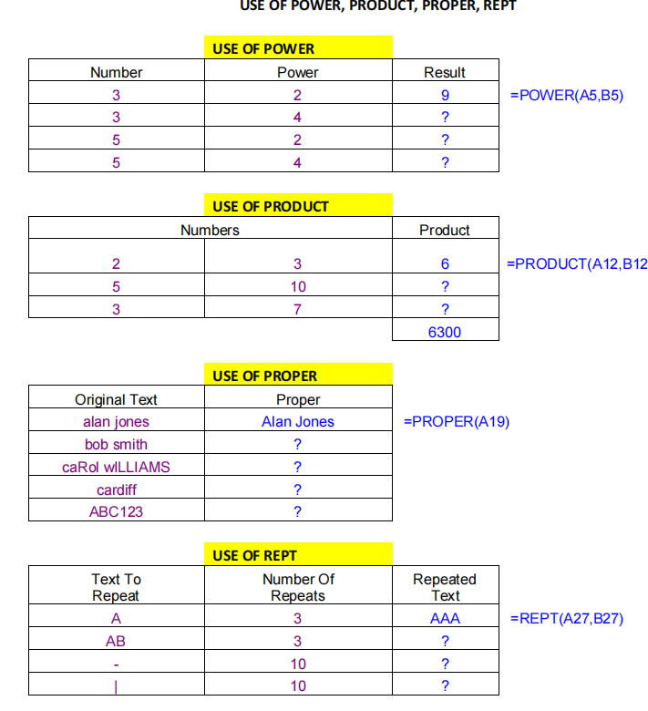

Use of Power

=Power(A2,B2)

Use of Product

=Product(A2,B2)

Use of Proper

=Proper(B2)

Use of repeat

=REPT(A2,B2)

**Assignment-12**

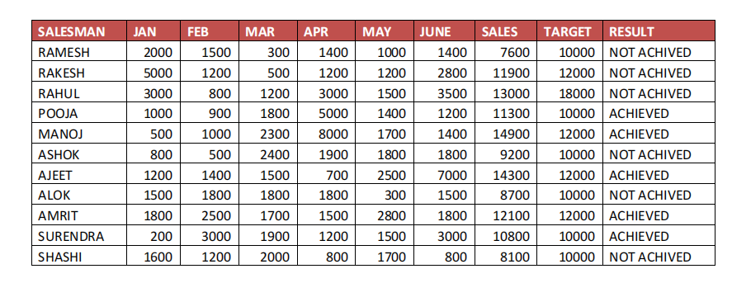

Q.1 How many salesman? Salesman Ajeet Targest & Result?

USE OF COUNTA AND VLOOKUP

=COUNTA(A:A)

For target

=VLOOKUP("Ajeet", A:C, 2, FALSE)

For Result

=VLOOKUP("Ajeet", A:C, 3, FALSE)

Q.3 Rahul Pooja & Ashok Targest & result?

USE OF VLOOKUP

For Rahul's Target

=VLOOKUP(D1, A:C, 2, FALSE)

For Rahul's Result

=VLOOKUP(D1, A:C, 3, FALSE)

For Pooja's Target

=VLOOKUP(D2, A:C, 2, FALSE)

For Pooja's Result

=VLOOKUP(D2, A:C, 3, FALSE)

For Ashok's Target

=VLOOKUP(D3, A:C, 2, FALSE)

For Ashok's Result

=VLOOKUP(D3, A:C, 3, FALSE)

Q.4 How Many Salesman Achived Target.

USE OF COUNTIF

=COUNTIF(C:C, D1)

Q.5 Which Sales Man Jan Sales 2000, & Feb Sales is 2500?

USE OF LOOKUP

=VLOOKUP(2000, B1:A3, 2, FALSE)for january

=VLOOKUP(2500, B1:A3, 2, FALSE)for February

Q.6 How Many sales Man sales Jan Months Sales >2000 & March Sales

<=1500 ?

USE OF COUNTIF

=COUNTIF(B2:B100, ">2000") + COUNTIF(C2:C100, "<=1500")

Q.7 Jan to Target Highlights 2000 between 5000, Font Red &

Background Yeloow?

USE OF CONDITIONAL FORMATTING

=AND(B2>=2000, B2<=5000)

1. Click on the "Format" button.
2. In the "Format Cells" dialog box, go to the "Font" tab.
3. Choose the red font color.
4. Go to the "Fill" tab.
5. Choose the yellow background color.
6. Click "OK" to close the "Format Cells" dialog box.
7. Click "OK" again to close the "New Formatting Rule" dialog box.

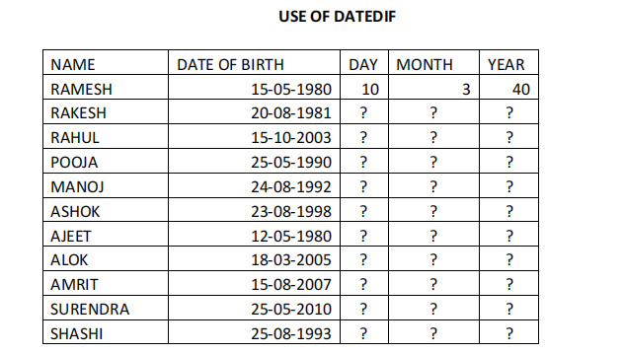

Q.1 HOW MANY STUDENT?

=COUNTA(A2:A10)

Q.2 STUDENT SURENDRA IS HOW MANY YEAR OLD?

=DATEDIF(B2, TODAY(), "Y")

Q.3 HOW MANY STUDENT AGE GREATER THEN 20 YEARS?

=COUNTIF(f2:f10, ">20")

Q.4 IF STUDENT AGE IS GREATHER THEN 20 THEN

STUDENT ADULT / CHILD?

=IF(F2>20, "Adult", "Child")

Q.5 HOW MANY STUDENT AGE IS >= 25 YEARS?

=COUNTIF(F2:F10, ">=25")