Assignment 1

Create a pivot table from the data - property portfolio file to show:

* The asking price as the value field;
* The type of property in the rows;
* The location in the columns;
* The remaining fields in the filter area.

Change the filters and aggregate functions to show a **count** of properties that have:

* 3 bedrooms;
* A medium garden; and
* 2 bathrooms.

Your pivot table should look something like this:

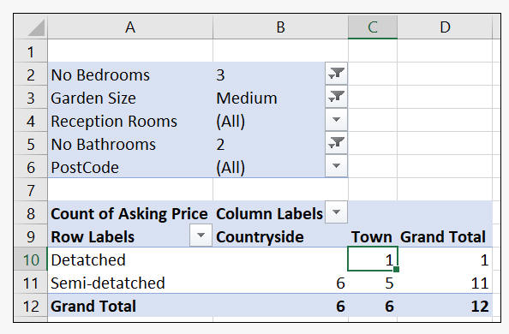

Assignment 2

Create a dummy dataset that contains information about employees in a company. The dataset has four columns: "Name", "Department", "Salary", and "Hire Date". We want to use Power Query Excel to clean and transform the data before analyzing it.

1. Import Data: Select the dataset and go to the Data tab, click on "From Table/Range" under the Get & Transform Data section.
2. Clean Data: In the Power Query Editor window, let's clean the data by removing any blank or null values, renaming column headers, and formatting data types. To do this, follow the below steps:

* Select the "Name" column and go to the Transform tab, select "Replace Values" from the dropdown list.
* In the "Replace Values" dialog box, enter "null" and "blank" in the "Value to Find" field and leave the "Replace with" field empty. Click OK to remove them.
* Select the "Salary" column, then go to the Home tab, and select the "Comma Style" option from the Number Format dropdown list to format the data as currency.
* Rename the "HireDate" column to "Date" and change the data type to "Date".

1. Transform Data: In this step, let's use Power Query Excel to add a new column, "Year", that extracts the year from the "Date" column using Power Query's built-in functions.

* Select the "Date" column, go to the Add Column tab, and click on "Date", select the "Year" option from the dropdown list.
* Rename the new column to "Year" and load the data.

1. Analyze Data: We can use the new column "Year" along with the other columns to create a PivotTable and analyze the data.

* Select any cell within the dataset.
* Go to the Insert tab, choose PivotTable.
* In the Create PivotTable dialog box, insert the values from the dataset you want to analyze into the "Rows" or "Values" section.
* Drag the "Year" column into the "Columns" section.

1. Create a Report: You can create a report that summarizes the data analysis, insights, and key findings.

* Add charts, tables, or graphs to the report to visualize the data.
* Use the report to communicate the results of the data analysis.

Assignment 3

Create a nested **=IF** formula that either calculates the parking charges or displays the message **Free Parking**.  Use these rules to help you:

* If the hours parked > 8, the driver should pay £1 per hour
* If the hours parked >5, the driver should pay £1.50 per hour
* Anything less should display **Free Parking**

|  |  |  |  |  |  |
| --- | --- | --- | --- | --- | --- |
| **Car Reg** | **No Hours Parked** | **Parking Charge** |  | If park >8 hours pay £1 pr hr | |
| DA12 NEJ | 6 |  |  | If park >5 hours pay £1.50 pr hr | |
| MA16 BVW | 12 |  |  | Anything less "Free Parking" | |
| DD11 SFD | 8 |  |  |  |  |
| MA14 NHG | 11 |  |  | Threshold1 | **8** |
| YK14 BHH | 5 |  |  | Threshold2 | **5** |
| DY15 FLB | 3 |  |  | Long Hour Fee | **£1.00** |
| MM12 SWL | 12 |  |  | Med Hour Fee | **£1.50** |
| MA16 GKW | 7 |  |  |  |  |
| FS12 DSD | 1 |  |  |  |  |
| DA11 SBM | 6 |  |  |  |  |

Assignment 4

Use vlookup to bring in the pay band label for the Pay range

|  |  |  |  |  |  |  |
| --- | --- | --- | --- | --- | --- | --- |
| **Pay Band Table** | |  |  | **Pay Report** | | |
|  |  |  |  |  |  |  |
| **Pay Min** | **Pay Band** |  |  | **Employee ID** | **Pay** | **Pay Band** |
| $25,000 | Level A |  |  | 990678 | $84,289 |  |
| $50,000 | Level B |  |  | 830385 | $1,37,670 |  |
| $75,000 | Level C |  |  | 795574 | $1,90,024 |  |
| $1,00,000 | Level D |  |  | 580622 | $1,22,604 |  |
| $1,50,000 | Level E |  |  | 549457 | $1,11,709 |  |
|  |  |  |  | 392128 | $85,931 |  |
|  |  |  |  | 391006 | $1,68,114 |  |
|  |  |  |  | 352711 | $89,627 |  |
|  |  |  |  | 253072 | $1,49,946 |  |
|  |  |  |  | 612235 | $1,45,893 |  |
|  |  |  |  | 611810 | $64,757 |  |
|  |  |  |  | 602693 | $71,478 |  |
|  |  |  |  | 110608 | $1,31,505 |  |