Week 4 Task: Predictive Modeling and Optimization in Logistics Systems
Student report based on a hypothetical logistics dataset

1. Introduction
In logistics, knowing roughly how long a shipment may take can help teams plan deliveries and manage customer expectations. In this project, I used Python to build and compare models that predict delivery time from basic shipment details. I also considered how predictions could help a logistics team decide which shipments need attention.
The data is hypothetical and was created for this assignment. It is not real company data, so the results are used to demonstrate the analysis process.

2. Problem Definition
The problem is to predict Delivery_Time_Days using shipment distance, shipment volume, region, transport mode, and priority. This is a supervised regression problem because the target is a numerical value measured in days.
Item | Description
Target variable | Delivery_Time_Days
Input features | Distance_km, Shipment_Volume_Units, Region, Transport_Mode, Priority
Dataset size | 600 hypothetical shipment records
Training/testing split | 80% training and 20% testing

3. Dataset Structure and Data Preparation
The dataset contains six columns. Distance and shipment volume are numerical features. Region, transport mode, and priority are categorical features. Delivery_Time_Days is the target. Delivery times were simulated using distance, volume, mode, priority, region, and random variation.
Feature | Meaning | Type
Region | Destination area | Categorical
Transport_Mode | Road, Rail, or Air | Categorical
Priority | Standard or Express | Categorical
Distance_km | Shipment distance in kilometres | Numerical
Shipment_Volume_Units | Number of units in the shipment | Numerical
Delivery_Time_Days | Delivery duration to predict | Numerical target

I used Pandas to organise the data and separated the input columns from the target. I split the data into training and test sets. OneHotEncoder changed the category values into numeric columns so the models could use them. I placed the preprocessing and model in a pipeline to keep the steps consistent.

4. Model Selection and Rationale
I compared three models. Linear Regression was used as a simple baseline. Decision Tree can learn non-linear patterns. Random Forest combines many decision trees and can work well when relationships are more complex. All three models were evaluated on the same test set.
Model | Reason for selection
Linear Regression | Simple starting point and easy to interpret.
Decision Tree Regressor | Can learn non-linear patterns and split data into rules.
Random Forest Regressor | Combines several trees and may reduce errors from one tree.

5. Python Code: Training and Prediction
from sklearn.model_selection import train_test_split
from sklearn.compose import ColumnTransformer
from sklearn.preprocessing import OneHotEncoder
from sklearn.pipeline import Pipeline
from sklearn.ensemble import RandomForestRegressor

X = df.drop(columns=["Delivery_Time_Days"])
y = df["Delivery_Time_Days"]

cat_cols = ["Region", "Transport_Mode", "Priority"]
num_cols = ["Distance_km", "Shipment_Volume_Units"]

prep = ColumnTransformer([
("cat", OneHotEncoder(handle_unknown="ignore"), cat_cols),
("num", "passthrough", num_cols)
])

X_train, X_test, y_train, y_test = train_test_split(
X, y, test_size=0.20, random_state=42
)

model = Pipeline([
("prep", prep),
("model", RandomForestRegressor(
n_estimators=120, max_depth=10,
min_samples_leaf=2, random_state=42
))
])
model.fit(X_train, y_train)
predictions = model.predict(X_test)
The model learns from the training records and then predicts delivery times for the separate test records. Keeping the test set aside helps estimate how the model may perform on records it did not train on.

6. Evaluation Metrics
I used three metrics. Mean Absolute Error (MAE) shows the average size of the prediction error in days. Root Mean Squared Error (RMSE) is also measured in days, but larger errors affect it more. R-squared shows how much of the variation in delivery time is explained by the model. Looking at all three gives a more balanced view of performance.
from sklearn.metrics import mean_absolute_error, mean_squared_error, r2_score

mae = mean_absolute_error(y_test, predictions)
rmse = mean_squared_error(y_test, predictions) ** 0.5
r2 = r2_score(y_test, predictions)
Model | MAE (days) | RMSE (days) | R-squared
Linear Regression | 0.438 | 0.556 | 0.785
Decision Tree | 0.463 | 0.607 | 0.743
Random Forest | 0.412 | 0.521 | 0.811

On this test set, Random Forest had the lowest MAE (0.412 days). This means it had the smallest average absolute error among the three models in this experiment. It does not guarantee that the same model will perform best on real logistics data.
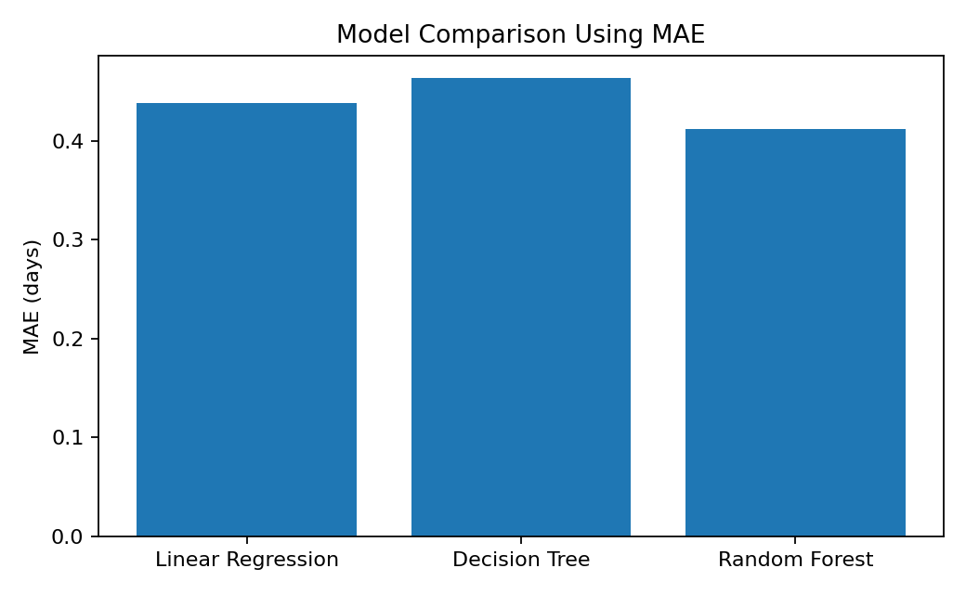
Figure 1. Model comparison by MAE. A lower value means a smaller average absolute prediction error.
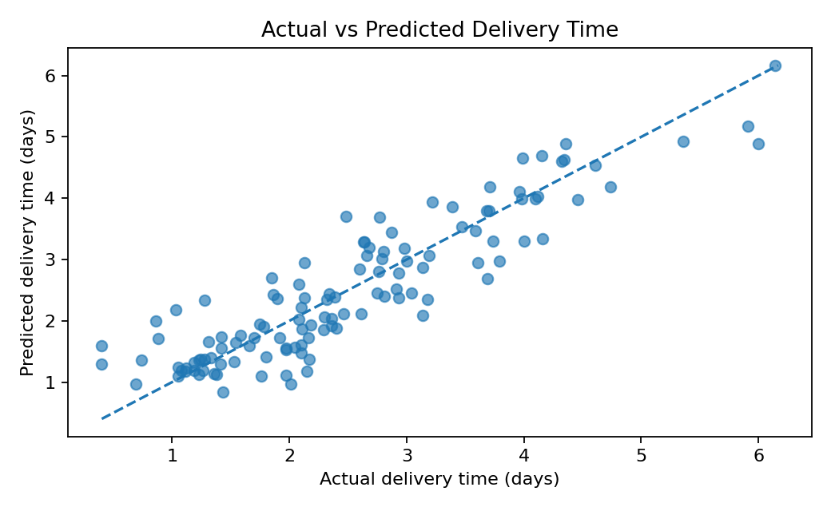
Figure 2. Actual and predicted delivery times for Random Forest. Points close to the dashed line indicate more accurate predictions.

7. Validation and Hyperparameter Tuning
I used 5-fold cross-validation on the training data for Random Forest. The training records are split into five groups. The model trains on four groups and is checked on the remaining group, and this repeats until each group has been used for validation. The average cross-validation MAE was 0.431 days (standard deviation 0.016).
I also used GridSearchCV to compare a small set of Random Forest settings. It tested maximum tree depths of 6 and 10 and minimum leaf sizes of 1 and 2, using three-fold cross-validation on the training data. The test set was not used to choose these settings.
from sklearn.model_selection import GridSearchCV

params = {
"model__max_depth": [6, 10],
"model__min_samples_leaf": [1, 2]
}
search = GridSearchCV(
pipeline, params, cv=3,
scoring="neg_mean_absolute_error"
)
search.fit(X_train, y_train)
best_model = search.best_estimator_
The best settings found in this small search were max_depth=6 and min_samples_leaf=1. After the search, the tuned model had test MAE 0.419 days, RMSE 0.533 days, and R-squared 0.802. This is a small example of tuning, not an exhaustive search.

8. Explaining the Visualizations and Results
The model-comparison chart makes the differences in MAE easy to see. The actual-versus-predicted chart shows whether predictions are close to the actual delivery times. Points farther from the dashed line represent larger prediction errors. These visuals make the evaluation easier to understand than reading metric values alone.
In this simulated dataset, Random Forest had the lowest MAE among the three initial models. However, the data was generated from rules, and real delivery times can also depend on traffic, weather, warehouse delays, holidays, vehicle issues, and driver availability. Those factors are not included here.

9. Optimization Recommendations
Recommendation | How it could help
Flag potentially late shipments | Review shipments whose predicted delivery time is above the expected delivery target.
Plan transport mode carefully | Compare expected delivery time with actual transport costs before selecting a mode.
Review urgent shipments | Give extra attention to express shipments with longer predicted delivery times.
Compare regions | Investigate regions where shipments often take longer.
Plan staffing and dispatch | Use expected shipment workload to help plan staffing and dispatch capacity.
Improve route choices | Combine predictions with real route and traffic information to compare routes.

These are recommendations based on the prediction idea, not results from a real logistics operation. A company could test one suggestion on a small group of shipments and compare late-delivery rates before and after. Route optimisation would need real route and traffic data, which this dataset does not contain.

10. Limitations
The data is simulated, includes only 600 records, and has a limited number of features. The delivery-time values were generated using known rules, so the model may learn those patterns more easily than it would from real company data. Actual operational factors such as traffic, weather, and warehouse delays are missing. The results should therefore be treated as a learning exercise.

11. Conclusion
In this project, I defined a delivery-time prediction problem, prepared a hypothetical dataset, trained and compared three regression models, and evaluated them using MAE, RMSE, and R-squared. I also used cross-validation and a small GridSearchCV search to check model settings. The results show how predictions could help identify shipments needing attention and support planning. Before using the approach in a real business, it should be tested on historical shipment records and the proposed actions should be checked against real outcomes.

Appendix: Dataset Simulation (Python)
import numpy as np
import pandas as pd
rng = np.random.default_rng(42)
n = 600
df = pd.DataFrame({
"Region": rng.choice(
["North", "South", "East", "West", "Central"], n
),
"Transport_Mode": rng.choice(
["Road", "Rail", "Air"], n, p=[0.62, 0.25, 0.13]
),
"Priority": rng.choice(
["Standard", "Express"], n, p=[0.72, 0.28]
),
"Distance_km": rng.integers(40, 1801, n),
"Shipment_Volume_Units": rng.integers(1, 121, n)
})
mode_factor = df["Transport_Mode"].map(
{"Road": 1.0, "Rail": 0.68, "Air": 0.22}
)
priority_factor = df["Priority"].map(
{"Standard": 1.0, "Express": 0.72}
)
region_factor = df["Region"].map({
"North": 0.25, "South": 0.5, "East": 0.8,
"West": 0.1, "Central": 0.35
})
df["Delivery_Time_Days"] = (
0.35
+ df["Distance_km"] / 420 * mode_factor
+ df["Shipment_Volume_Units"] / 160 * mode_factor
+ region_factor
) * priority_factor + rng.normal(0, 0.45, n)
df["Delivery_Time_Days"] = (
df["Delivery_Time_Days"].clip(lower=0.4).round(2)
)
# Optional: save the simulated data as a CSV file
df.to_csv("week4_hypothetical_logistics_data.csv", index=False)
Note: This report uses hypothetical data created for this assignment. It does not represent actual company records.

