Week 3 Task: Advanced Data Analysis and Visualization in Logistics
Exploratory Data Analysis of a Hypothetical Logistics Dataset
In this project, I use Python, pandas, NumPy, and Matplotlib to explore logistics data.

1. Introduction and Objective
In this project, I explore logistics performance using a hypothetical dataset. I focus on delivery time, shipment volume, travel distance, transportation cost, transport mode, region, and on-time delivery. My aim is to understand possible patterns and suggest practical improvements. I simulated the dataset for learning, so it does not describe a real company.

2. Dataset Structure
I created a dataset with 300 shipment records and 9 columns. Each row represents one shipment. The columns are Shipment_ID, Region, Transport_Mode, Priority, Shipment_Volume_Units, Distance_km, Delivery_Time_Days, Transport_Cost_USD, and On_Time_Delivery.
Variable | Meaning | Type
Shipment_ID | Unique shipment label | Text
Region | Shipment destination region | Category
Transport_Mode | Road, Rail, or Air | Category
Priority | Standard or Express | Category
Shipment_Volume_Units | Number of units in shipment | Numeric
Distance_km | Travel distance in kilometres | Numeric
Delivery_Time_Days | Delivery duration in days | Numeric
Transport_Cost_USD | Estimated transportation cost | Numeric
On_Time_Delivery | Whether shipment arrived on time | Category

3. Methodology and Data Quality Checks
I generated the data in Python with a fixed random seed so I can repeat the analysis. I set up the simulated values to reflect possible logistics patterns: distance affects travel time and cost, transport modes have different cost levels, and express shipments receive a small time adjustment. In my notebook, I check the dataset shape, column types, missing values, and duplicate rows before analysing the data.
I found 0 missing values and 0 duplicate rows in my generated dataset. This is expected because I created the data for this exercise. With real data, I would investigate missing or duplicated records before drawing conclusions.

4. Exploratory Data Analysis
I calculated descriptive statistics for shipment volume, distance, delivery time, and transportation cost. The mean describes the average, the median gives the middle value, and the minimum and maximum show the observed range.
Metric | Mean | Median | Minimum – Maximum
Shipment volume (units) | 98.26 | 94.00 | 20.00 – 179.00
Distance (km) | 771.67 | 730.00 | 50.00 – 1,500.00
Delivery time (days) | 3.74 | 3.63 | 0.50 – 8.26
Transport cost (USD) | 1,962.08 | 1,830.95 | 199.01 – 6,706.23
Across the 300 shipments, the average delivery time was 3.74 days and the median was 3.63 days. The average transportation cost was $1,962.08, while the median cost was $1,830.95. The average route distance was 771.7 km and the average shipment volume was 98.3 units.

5. Visualizations and Interpretation

5.1 Delivery-time distribution
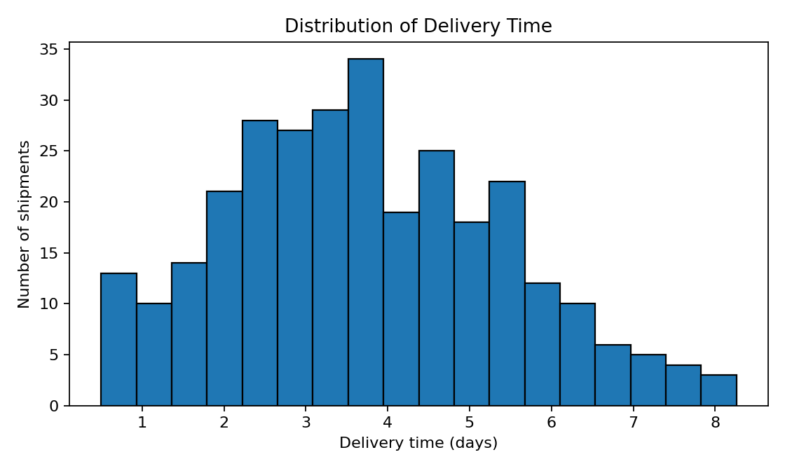
I used a histogram to show how often delivery durations fall within different ranges. It helps me identify common delivery times and check whether a few shipments take much longer than usual. A logistics team could review unusually long deliveries to look for possible causes.

5.2 Distance and transportation cost
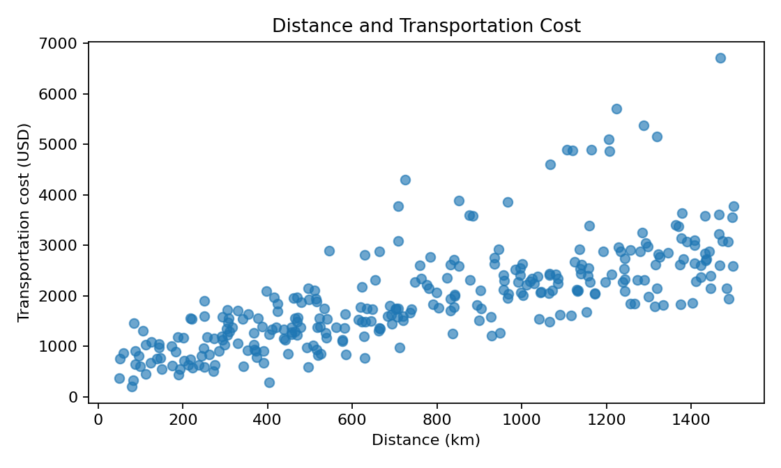
I used a scatter plot to compare each shipment’s distance with its estimated cost. The correlation between distance and cost is 0.72. This positive relationship means that longer trips generally cost more in my simulated dataset. However, transport mode and shipment volume can also affect cost, so I would not treat distance as the only cost driver.

5.3 Average delivery time by transport mode
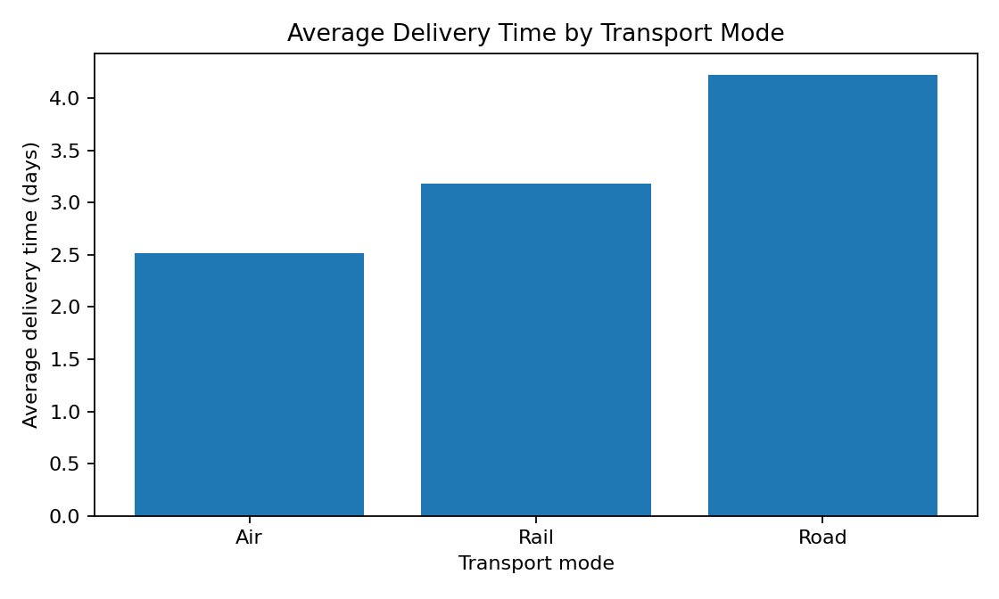
I chose a bar chart because it makes it easy to compare averages across categories. It shows which transport mode has the highest or lowest average delivery duration in my sample. I would consider cost, shipment size, and service needs as well as speed when comparing transport modes.

5.4 On-time delivery by region
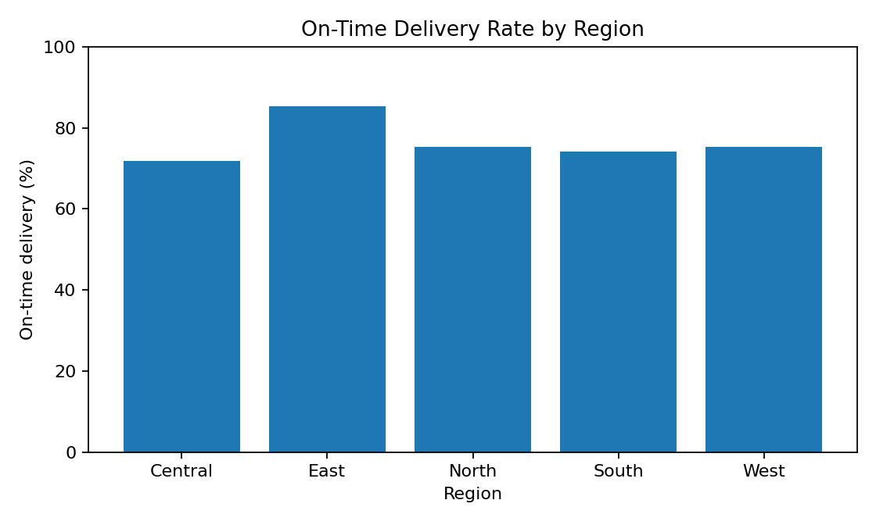
I used this bar chart to compare the percentage of shipments marked as on time in each region. I would review regions with lower rates for possible route-planning issues, hand-off delays, or other local factors. Since my data is simulated, these are possible areas to investigate, not confirmed real-world problems.

5.5 Correlation between numeric variables
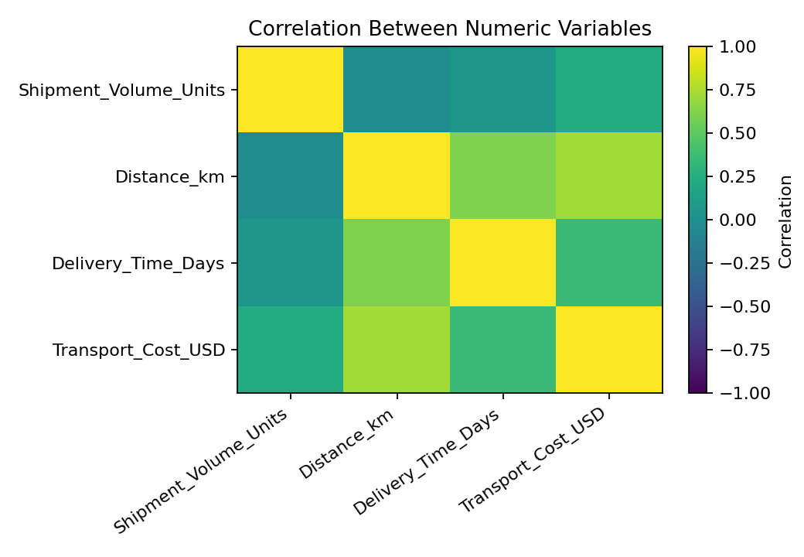
I used the correlation chart to summarise linear relationships between numeric fields. Distance and delivery time have a correlation of 0.61, while shipment volume and cost have a correlation of 0.23. I use correlation to identify relationships worth exploring, but I do not treat it as proof that one variable causes another.

6. Operational Comparison Tables
I used the following table to compare average performance across transport modes. I rounded the values to two decimal places.
Mode | Shipments | Avg. delivery (days) | Avg. cost (USD) | On-time rate (%)
Air | 34 | 2.52 | $3,183.99 | 79.4
Rail | 83 | 3.18 | $1,469.52 | 86.8
Road | 183 | 4.22 | $1,958.45 | 70.5
I also compared performance by region:
Region | Shipments | Avg. delivery (days) | Avg. cost (USD) | On-time rate (%)
Central | 39 | 4.55 | $2,027.09 | 71.8
East | 41 | 3.73 | $1,755.29 | 85.4
North | 85 | 3.52 | $1,702.54 | 75.3
South | 62 | 3.64 | $2,113.16 | 74.2
West | 73 | 3.63 | $2,217.36 | 75.3

7. Key Findings
1. The overall on-time delivery rate was 76.0%, so 24.0% of simulated shipments were marked late. This provides a simple service-level measure for the sample.
2. East had the highest on-time rate (85.4%), while Central had the lowest (71.8%). The gap suggests that a regional comparison can help prioritise further checks.
3. Air had the lowest average delivery time (2.52 days), while Road had the highest (4.22 days). This comparison should be read alongside cost, because a faster mode may not be the most economical choice.
4. Distance and transportation cost showed a correlation of 0.72. This supports checking route distance when investigating cost, while also considering mode and volume.

8. Recommendations
- Review late shipments by region and route to identify repeated delay points.
- Compare transport modes using both delivery time and cost, rather than speed alone.
- Track a small set of regular KPIs: on-time delivery rate, average delivery days, average cost per shipment, and cost per kilometre.
- Investigate unusually high-cost or long-duration shipments individually before making policy changes.
- Repeat the analysis monthly using actual operational data and compare the results over time.

9. Python Tools and Code Example
I used pandas to organise the data and calculate summaries, NumPy to generate repeatable simulated values, and Matplotlib to create the charts. I included the full code in the notebook, which can be run from top to bottom in Google Colab.
# Example: compare average delivery time by transport mode
mode_summary = df.groupby("Transport_Mode").agg(
Avg_Delivery_Days=("Delivery_Time_Days", "mean"),
Avg_Cost_USD=("Transport_Cost_USD", "mean")
).round(2)
print(mode_summary)
plt.bar(mode_summary.index, mode_summary["Avg_Delivery_Days"])
plt.xlabel("Transport mode")
plt.ylabel("Average delivery time (days)")
plt.title("Average Delivery Time by Transport Mode")
plt.show()

10. Limitations
I used a hypothetical dataset for practice, so the patterns are not evidence about an actual company. My dataset does not include factors such as weather, fuel prices, traffic, warehouse processing time, failed delivery attempts, or exact pickup and delivery timestamps. Before applying my recommendations, a logistics team should check them against real data and local knowledge.

11. Conclusion
This project demonstrates a basic logistics analysis workflow in Python. I created a simulated dataset, checked its structure, calculated summary statistics, compared groups, and used visualizations to study delivery time, cost, distance, and on-time performance. The main lesson is that logistics decisions should balance service quality and cost. The analysis also shows how simple charts can help turn a table of shipment records into questions that an operations team can investigate.

Appendix: Files Included
I included a Jupyter Notebook with the full code for generating the data, performing EDA, and creating the charts. I also included a CSV file so the dataset can be inspected separately.

