- Evidence of programming compiling and running - Report evidencing the testing of the application functionality

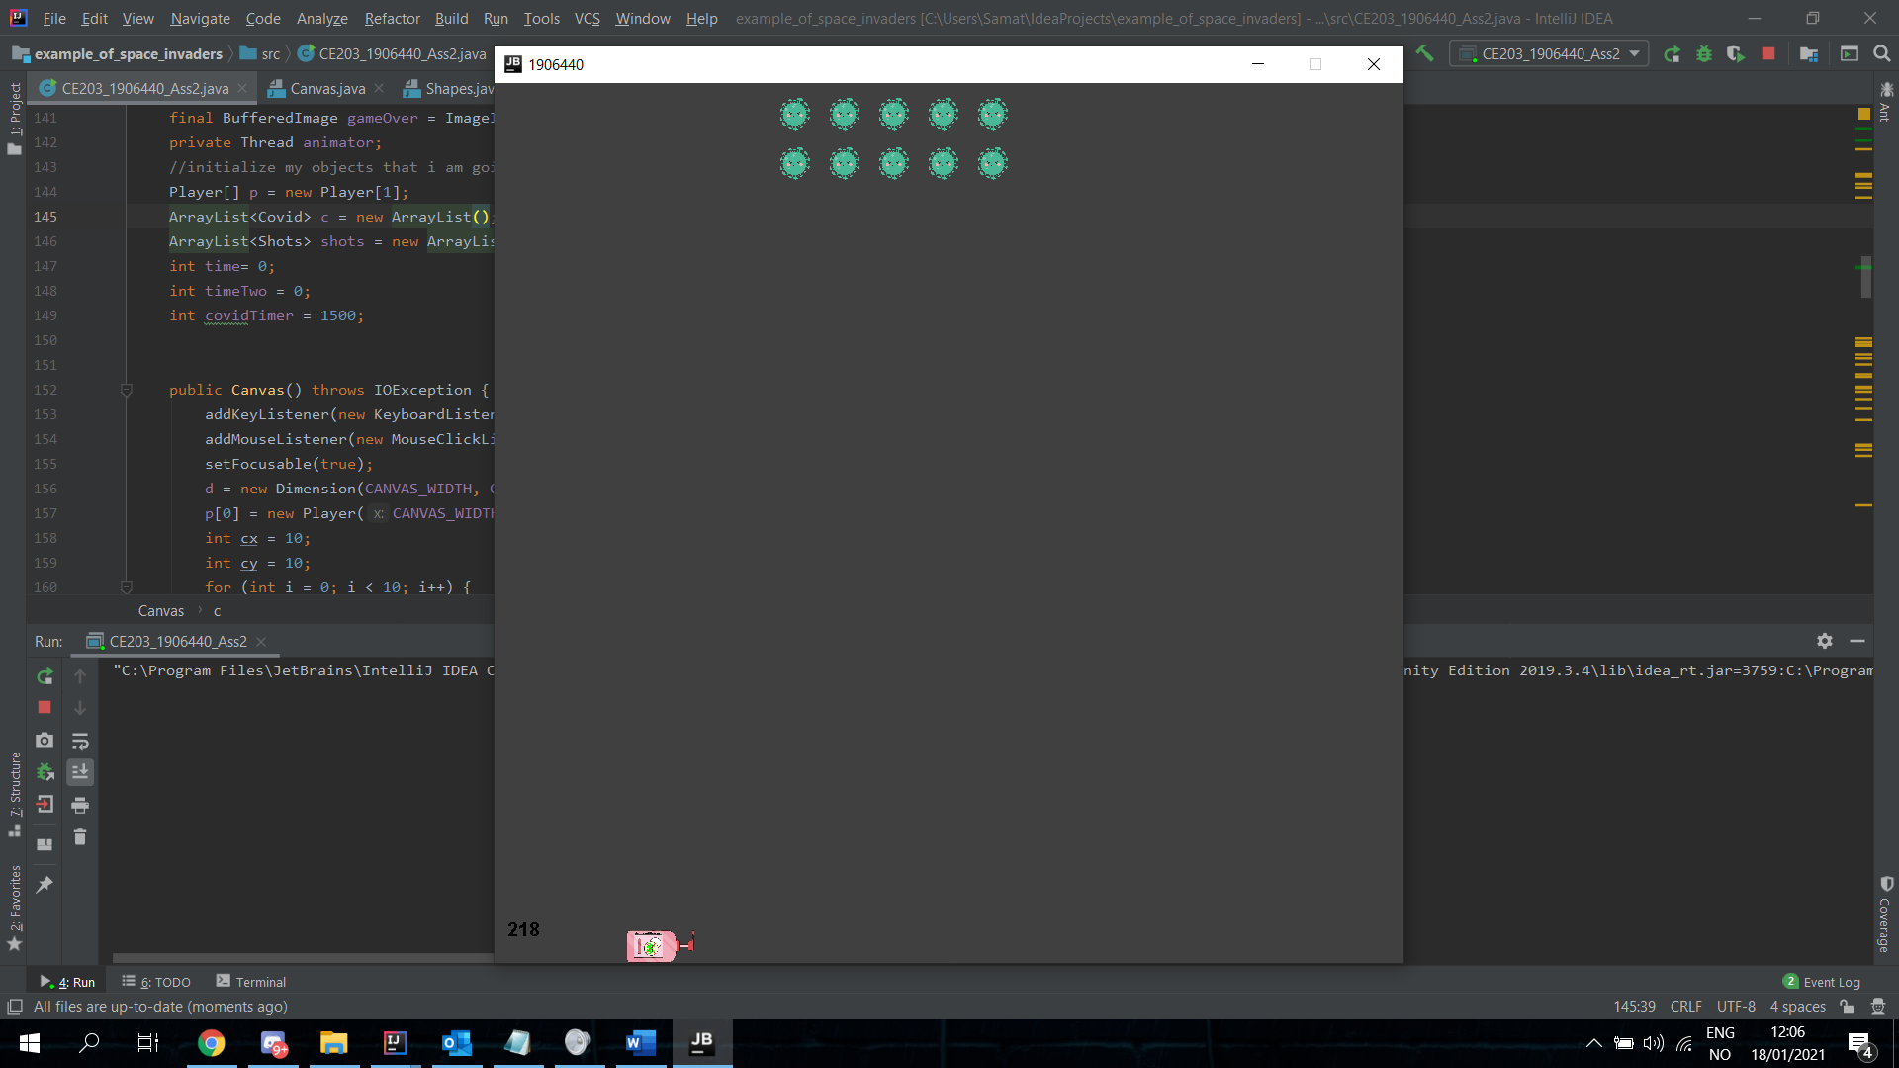

Here is some clear evidence that showcases the movement of the hand-sanitizer bottle and the covid-19.

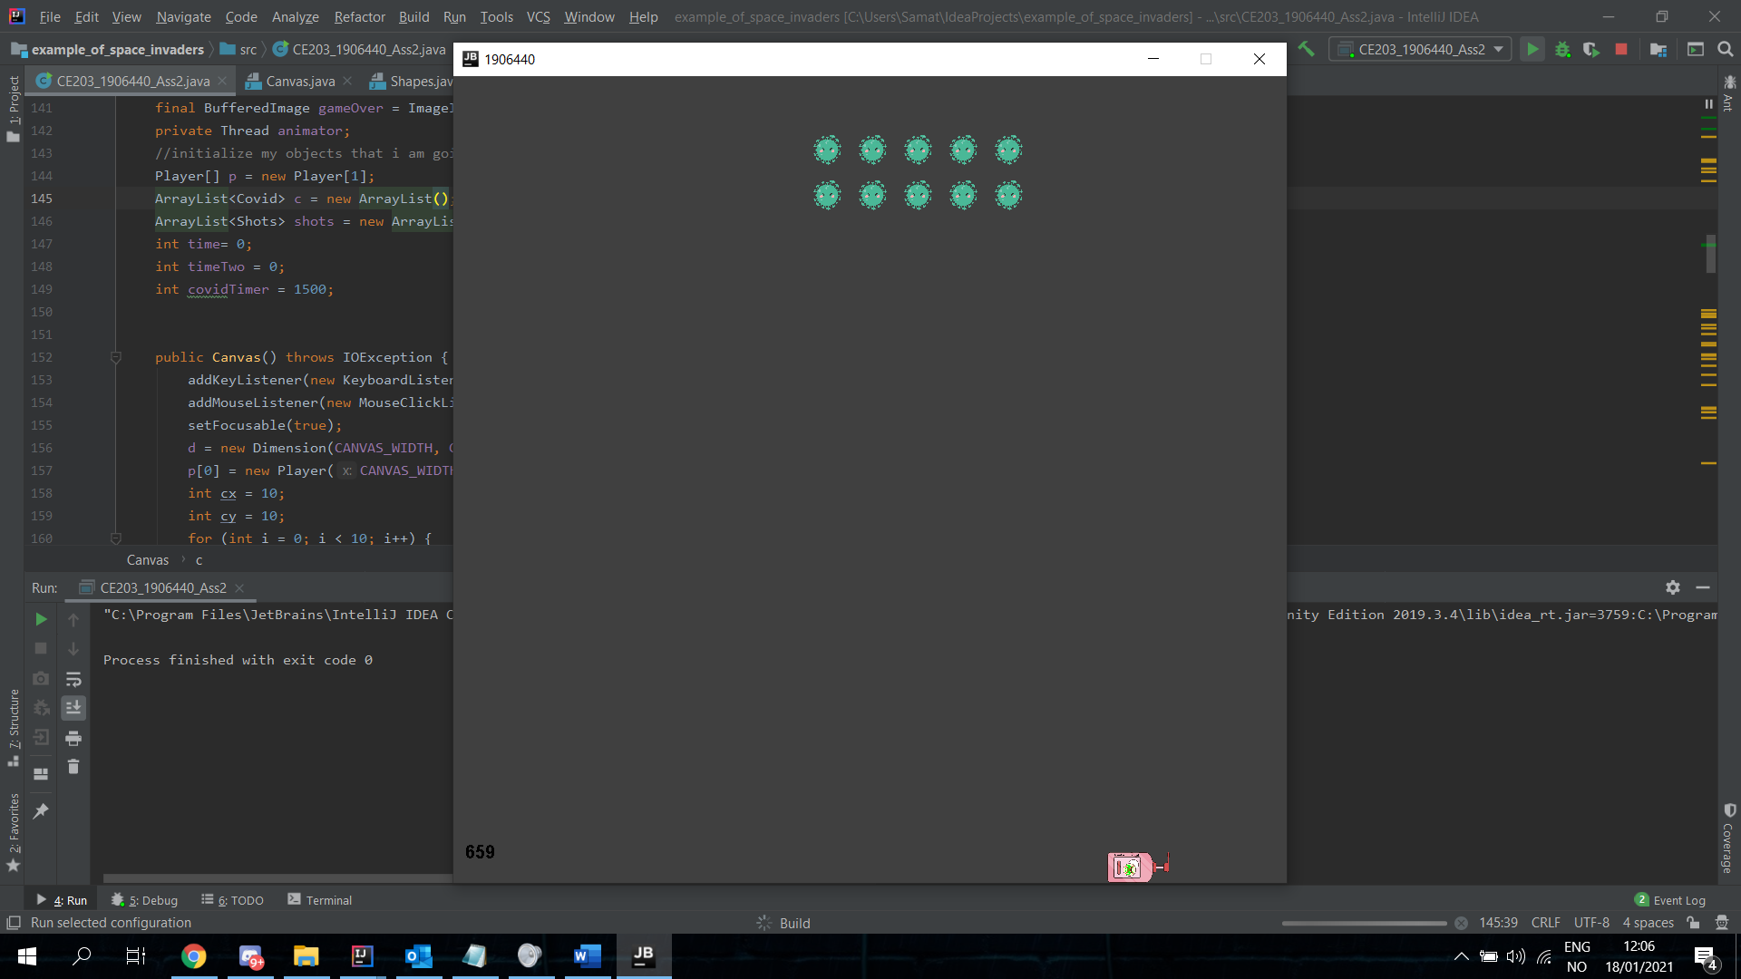

Here is a image of the hand-sanitizer shooting some bullets towards the covid.

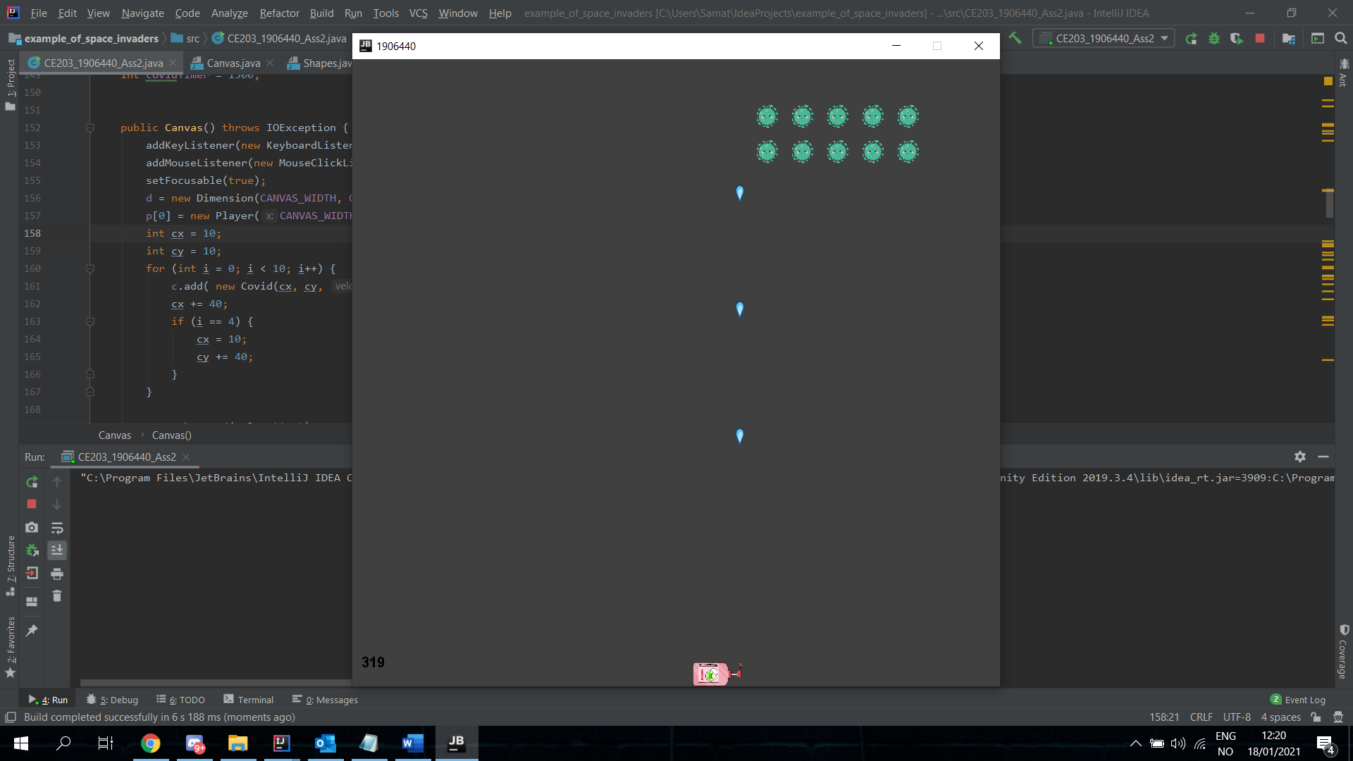

Here we can see the effect after bullets collide with the covid making both objects disappear.

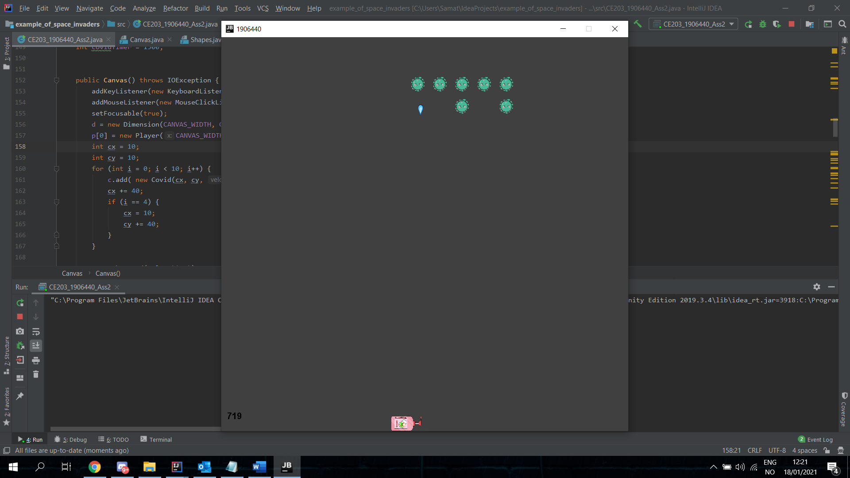

This is what happens the covid gets passed the hand-sanitizer.

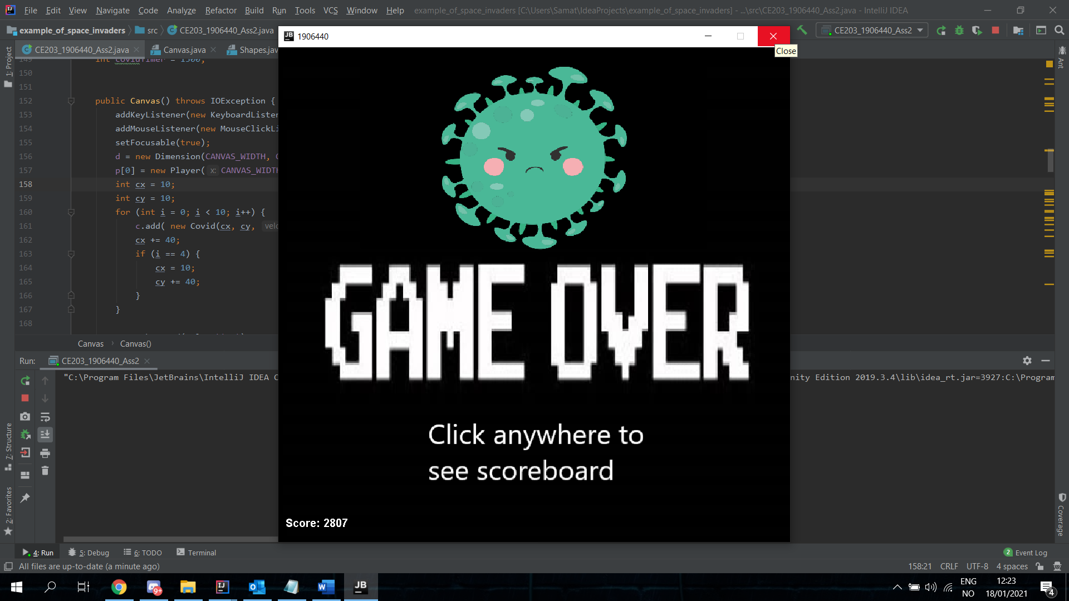

If you click the screen this is what is seen:

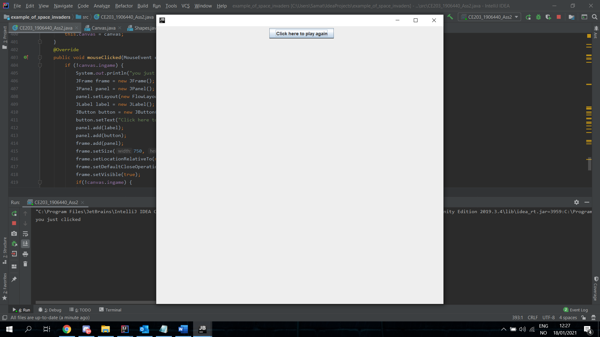

- Explain the event driven model underlying the program using one or more design patterns (GRASP patterns, Observer or MVC/MVP)

- Demonstrate using written explanations with pseudo code how the implemented scoring features could be extended to store player scores in an SQL database using JDBC

A report should be produced showing the testing of your program (see below). The report should also:

- Explain one or more underlying features of your code that is based one or more design patterns described in Unit 7. Here you should accompany your explanation with appropriate UML diagram(s) for the parts of your code that implements the design patterns you have selected.

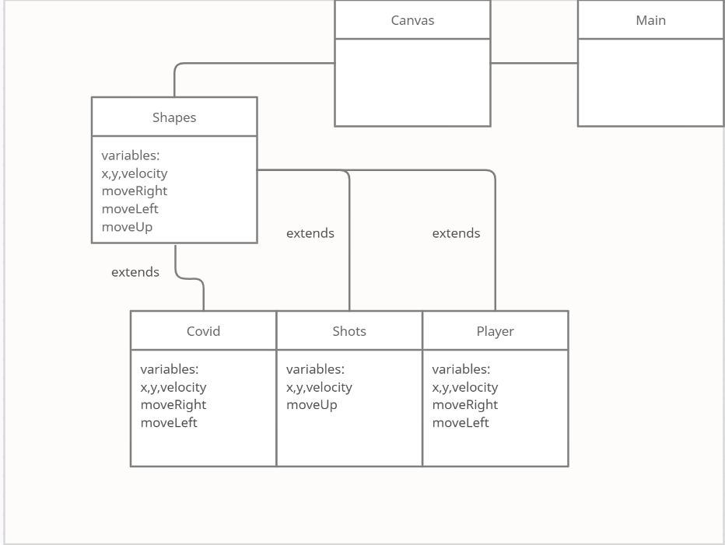

This image is an UML diagram of how my classes interact with each other and work. The key component of this design is shapes class which holds all the variables used for the game objects. These classes that extend shapes all make instances of themselves creating all the game objects that are seen on screen. It is through the canvas the everything is outputted on a panel, meanwhile main holds the frame where the panel is added.