Software Architecture and Design Specification
Online Quiz Management System
Document | Value
Project | Online Quiz Management System
Document type | Software Architecture and Design Specification
Version | 1.0
Authors | Samatma A Bharadwaj (PES1UG24CS609); Tejaswini M (PES1UG24CS638); Kedar S Vastrad (PES1UG25CS822)
Date | 13 November 2026
Status | Submission copy

Revision History
Version | Date | Author | Change summary
1.0 | 13 November 2026 | Project team | Completed for the current MERN application and documented features.

Approvals
Role | Name | Signature and date
Course coordinator
Project supervisor

1. Introduction

1.1 Purpose
This specification describes the implemented architecture and design of the Online Quiz Management System. It provides the component structure, data responsibilities, security boundaries, API conventions, and principal user flows needed to understand, maintain, and assess the submitted application.

1.2 Scope
The product is a web application for account registration and sign-in, quiz discovery and authoring, timed multiple-choice attempts, automatic scoring, answer review, course enrollment, custom syllabus management, and AI-assisted question drafting. Students and teachers use the same client; teacher privileges are represented by the admin role. Chints uses Google Gemini when configured and a syllabus-based fallback when it is unavailable.

1.3 Audience
The intended readers are the project team, instructors and evaluators, developers, testers, and maintainers.

1.4 Definitions
Term | Meaning
MERN | MongoDB, Express, React, and Node.js application stack.
JWT | Signed JSON Web Token used as a bearer credential.
RBAC | Role-based access control for user and admin capabilities.
Chints | Project AI assistant for syllabus parsing and question generation.
Attempt | A user's server-recorded run of a quiz, including timing and answers.
SRS | Software Requirements Specification.

2. Document Overview

2.1 How to use this document
Sections 3 and 4 describe the architecture and concrete design decisions. API details are representative interfaces from the repository. The SRS, test plan, test cases, and reports provide the corresponding requirements and verification evidence.

2.2 Related documents
- Software Requirements Specification for the Online Quiz Management System.
- Software Test Plan and Test_Cases.md.
- README.md and DEPLOYMENT.md for setup, configuration, and API usage.
- docs/System_Validation_Report.md and docs/Unit_Test_Report.md for recorded verification results.

3. Architecture

3.1 Goals and constraints
- Separate browser presentation, HTTP application logic, domain services, and persistence responsibilities.
- Keep timed quiz state and answer-key decisions on the server so client changes cannot determine scores.
- Use MongoDB and Mongoose for account, quiz, attempt, subject, enrollment, category, reset-token, and revoked-token data.
- Run the React/Vite client separately from the Node/Express API; deployment requires configured MongoDB and secrets.
- Gemini generation depends on an optional server-side API key; a deterministic syllabus engine is the fallback.

3.2 Stakeholders and concerns
Stakeholder | Primary concern
Student | Private account data, fair timed tests, reliable answer saving, understandable results.
Teacher or admin | Quiz authoring, platform-wide oversight, results access, and role controls.
Project maintainer | Clear module boundaries, reproducible setup, safe configuration, and testability.
Evaluator | Traceability between requirements, design, test cases, and recorded outcomes.

3.3 Component architecture
The system uses a three-tier client-server structure with an external AI adapter. The following flow summarizes the main dependencies:
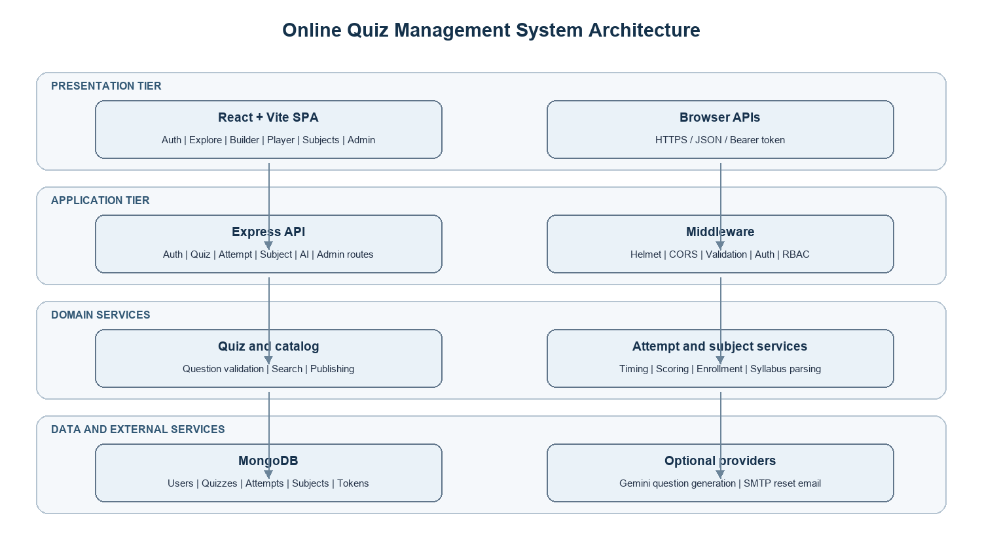
Tier | Components | Responsibility
Presentation | React + Vite SPA; AuthPage, Dashboard, Explore, Builder, Player, Subjects, Manage, Profile | Renders views, gathers input, calls the API, and presents progress and results.
Application | Express app; auth, quiz, category, attempt, subject, AI, and admin routes; middleware | Validates requests, authenticates callers, authorizes access, and returns JSON.
Domain services | questions, catalog, attempts, subjects, passwordReset, seedData | Encapsulates parsing, filtering, scoring, expiry, and domain rules.
Persistence | Mongoose models backed by MongoDB | Stores users, quizzes, attempts, categories, subjects, enrollments, and token records.
External adapter | Google Gemini API, optional | Generates structured questions when configured; fallback logic runs locally.

3.4 Component descriptions
Component | Key responsibilities
React client | Authentication screens; catalog and subject navigation; quiz authoring; attempt timer and answer controls; review and admin pages.
API middleware | Helmet headers, origin-restricted CORS, JSON size bound, authentication parsing, optional authentication, admin checks, and centralized errors.
Auth and reset routes | Register, login, logout, password reset, and change-password operations.
Quiz and category routes | Create and update quizzes and questions; publish state; category management; public catalog serialization.
Attempt routes and service | Create an immutable attempt snapshot, save answers, enforce deadline and closure, calculate score, and return history/review.
Subject routes and service | List built-in and custom subjects, enrollment, syllabus parsing, and unit-specific quiz visibility.
AI route | Validate generation inputs, call Gemini when configured, normalize output, or return fallback questions.
Admin routes | Expose platform overview, user and role operations, categories, quizzes, and aggregate results to admin users.

3.5 Architecture pattern and rationale
A layered client-server architecture fits the single web product and keeps UI, request handling, domain rules, and persistence responsibilities explicit. Domain logic is placed in service modules so it can be tested without rendering the browser interface. The repository does not use microservices; the optional Gemini integration is isolated behind the AI route rather than treated as a required system dependency.

3.6 Technology stack and data stores
- Client: React and Vite.
- Server: Node.js and Express with ES modules.
- Persistence: MongoDB accessed through Mongoose.
- Authentication: bcryptjs password hashing and signed two-hour JWTs; revoked-token hashes and token versions support session invalidation.
- Security middleware: Helmet, restricted CORS, bounded JSON requests, route-specific rate limits, validation, and role/ownership checks.
- AI: optional Google Gemini configured only on the server; built-in syllabus-aware fallback.

3.7 Risks and mitigations
Risk | Mitigation or handling
Database unavailable | API startup/health and request errors expose failure; deployment must provide a reachable MongoDB URI and backup process.
Gemini unavailable or malformed output | Validate and normalize generated questions; use the built-in fallback when live generation is unavailable.
Client closes during an attempt | Persist answer changes on the server and determine expiry from server timestamps on subsequent requests.
Answer key exposed before completion | Public quiz and active attempt serializers omit correctOption; review data is returned only after completion.
Unauthorized quiz or result access | Apply authentication, role checks, ownership checks, and role-scoped catalog/result queries.

3.8 Traceability to requirements
Requirement area | Design element
Account access and recovery | Auth routes, User model, password reset service, auth middleware.
Quiz authoring and discovery | Quiz/category routes, catalog service, Quiz model, Explore and Builder views.
Timed tests and scoring | Attempt routes, attempts service, Attempt model, Player view.
Subjects and AI generation | Subject service/routes, AI route, built-in subject data, Chints panels.
Teacher oversight | Admin routes, requireAdmin middleware, Manage/Admin client views.

3.9 Security architecture
Threat | Control in the design
Credential theft or guessing | bcrypt password hashing; login and reset rate limits; generic invalid-credential responses; two-hour JWT lifetime.
Privilege escalation | Public registration assigns user role; admin endpoints require admin role; ownership checks guard quiz mutations.
Answer-key leakage | Correct option omitted from public quiz and in-progress attempt responses.
Replay after logout/reset | Logout records a SHA-256 token hash; password reset increments token version to invalidate prior sessions.
Injection or oversized input | Schema/domain validation, escaped and bounded catalog search, 512 KB JSON request limit, and route rate limits.
Transport or secret exposure | Deployment should use HTTPS; server secrets and Gemini keys belong in environment configuration and are not sent to the client.

4. Design

4.1 Design overview
The client is a single-page application that calls JSON endpoints using bearer tokens for protected operations. The API authenticates and authorizes each request, delegates domain work to services, and persists state through Mongoose models. A quiz attempt snapshots the quiz questions and answer keys when it starts, preventing later quiz edits from changing that attempt's score.

4.2 Sequence flow: start, answer, and submit a quiz
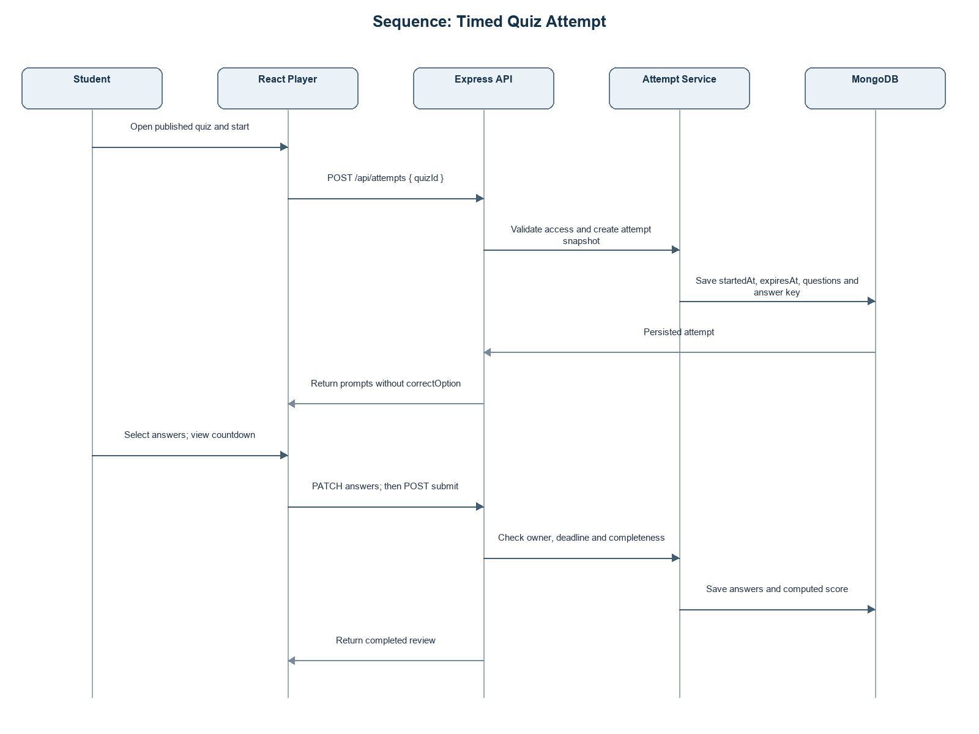
Step | Interaction
1 | Student opens a published quiz and requests POST /api/attempts with the quiz ID.
2 | API validates access and creates an attempt snapshot with startedAt and expiresAt.
3 | API returns question prompts and options without correctOption.
4 | Client submits selected options to PATCH /api/attempts/:attemptId/answers while active.
5 | Student submits POST /api/attempts/:attemptId/submit; the service validates deadline and completion.
6 | Service calculates the score from the stored answer key, closes the attempt, and returns review data.

4.3 Sequence flow: Chints question generation
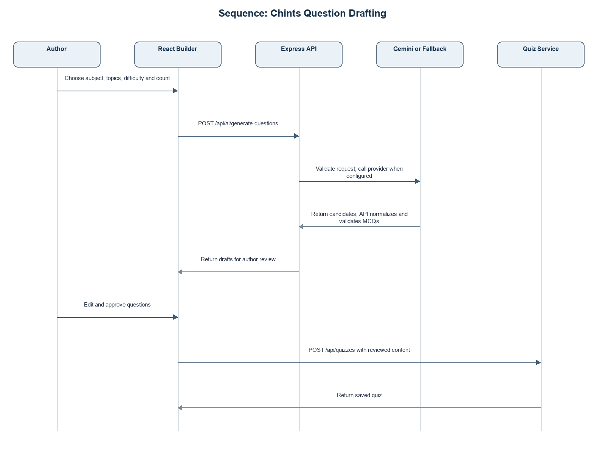
Step | Interaction
1 | Author selects a subject/unit or supplies topic focus and a supported difficulty/count.
2 | Client sends the generation request to POST /api/ai/generate-questions.
3 | Server validates inputs and calls Gemini if configured; otherwise it uses the syllabus fallback.
4 | Server parses and normalizes candidate questions, rejecting invalid question structures.
5 | Client displays drafts for author review; author edits and saves them through quiz routes.

4.4 API design
Endpoint | Method | Access | Purpose
/api/auth/register | POST | Public | Create an account and return a public profile/token.
/api/auth/login | POST | Public | Authenticate and issue a bearer token.
/api/auth/logout | POST | Authenticated | Revoke the current token.
/api/auth/password-reset/request | POST | Public, rate limited | Request a one-time reset link without revealing account existence.
/api/quizzes | GET/POST | Public catalog / authenticated author | List quizzes or create a quiz.
/api/quizzes/:quizId/questions | POST | Owner or admin | Add a validated multiple-choice question.
/api/attempts | POST | Authenticated | Start a timed attempt.
/api/attempts/:attemptId/answers | PATCH | Attempt owner | Save active answers.
/api/attempts/:attemptId/submit | POST | Attempt owner | Submit and score the attempt.
/api/subjects | GET/POST | Authenticated for personalized data | List/enroll/manage subjects; custom-subject creation is protected.
/api/ai/generate-questions | POST | Authenticated, rate limited | Generate and validate question drafts.
/api/admin/overview | GET | Admin | Return teacher console overview and platform statistics.

4.5 Error handling, logging, and monitoring
Routes return JSON errors with appropriate 4xx/5xx status codes through centralized error handling. Validation failures are client errors; missing resources return not-found responses; closed attempts reject answer changes; authentication and authorization failures do not disclose protected data. The application exposes /api/health. Deployment operators should monitor API health, MongoDB connectivity, request failures, rate-limit events, and scheduled backup/recovery status. Secrets, passwords, and reset tokens must not be written to logs.

4.6 UX design
The React client provides responsive catalog, authoring, attempt, subject, and administrative views. During an attempt it displays remaining time and saved-answer state; submitted attempts show score and answer review. The deployment should be checked in the target browsers and viewport sizes. Formal accessibility conformance is not asserted by the source repository and should be evaluated separately.

4.7 Open issues and next steps
- Record the approved hosting environment, production URL, and operational ownership in the deployment handoff.
- Run and retain submission-build test logs; current repository reports describe prior test runs.
- Confirm accessibility expectations and performance targets with the course evaluator.
- Define backup retention and recovery procedures for the selected MongoDB deployment.

5. Appendices

5.1 Glossary
API: application programming interface. JWT: JSON Web Token. MCQ: multiple-choice question. RBAC: role-based access control. SPA: single-page application.

5.2 References
- Repository README.md and server source code.
- Online_Quiz_System_Requirements.pdf.
- Security_Requirment.docs.pdf.
- Test_Cases.md and the reports under docs/.

5.3 Tools
React, Vite, Node.js, Express, MongoDB, Mongoose, and the Node.js built-in test runner, as declared or used in the repository.

