Software Requirements Specification
Online Quiz Management System
Document | Value
Project | Online Quiz Management System
Document type | Software Requirements Specification
Version | 1.0
Authors | Samatma A Bharadwaj (PES1UG24CS609); Tejaswini M (PES1UG24CS638); Kedar S Vastrad (PES1UG25CS822)
Date | 13 November 2026
Status | Submission copy

Revision History
Version | Date | Author | Change summary | Approval
1.0 | 13 November 2026 | Project team | Completed from the implemented repository and project requirements. | Pending course approval

Approvals
Role | Name | Signature and email | Date
Course coordinator
Project supervisor

Contents
- 1. Introduction
- 2. Overall description
- 3. External interface requirements
- 4. System features
- 5. Non-functional and security requirements
- 6. Quality attributes and acceptance tests
- 7. System models
- 8. Requirements traceability

1. Introduction

1.1 Purpose
This SRS defines the functional and quality requirements for the Online Quiz Management System. It is based on the current source repository and supporting requirements and test documents; it is intended for the student project team, instructors, developers, and testers. Requirements marked as acceptance criteria describe observable behavior that can be checked against the cited test cases.

1.2 Scope
The system is a browser-based quiz platform with Student and Teacher roles. It supports account access, quiz discovery and authoring, timed attempts, server-side scoring, result review, subject enrollment, custom syllabus parsing, and Chints-assisted question drafting. Hosting, identity providers, payment, and the internal operation of Google Gemini or MongoDB Atlas are outside this product boundary.

1.3 Audience
Project authors, course evaluators, developers, testers, and maintainers.

1.4 Definitions
Term | Definition
Student | User role represented by user in the API.
Teacher | Administrative role represented by admin in the API.
Attempt | Server-side record of a user's run of a quiz.
MCQ | Multiple-choice question.
JWT | Signed bearer token used for API authentication.
Chints | Syllabus-aware question generation and parsing assistant.
RTM | Requirements Traceability Matrix.

2. Overall description

2.1 Product perspective
The product is a MERN application. A React/Vite single-page client communicates with an Express JSON API. The API uses Mongoose to store data in MongoDB and optionally calls Google Gemini for question generation. The client does not determine authoritative scores or expose answer keys during active attempts.

2.2 Major product functions
- Register, sign in, sign out, and recover a password.
- Browse, search, filter, sort, and paginate published quizzes.
- Create and maintain quizzes and their questions; publish or unpublish quizzes.
- Start timed attempts, save answers, submit, and review scores and history.
- Enroll in built-in subjects or create custom subjects from syllabus text.
- Generate question drafts with Chints and review them before saving.
- Provide Teacher administration and platform oversight.

2.3 User roles and characteristics
Role | Capabilities and boundaries
Student | Browse allowed quizzes, create account-owned quizzes as supported, take tests, manage subject enrollment, and view own results.
Teacher | Student capabilities plus administrative visibility and management functions guarded by the admin role.
Guest | May access public registration/login and public published quiz details/share entry points; protected actions require authentication.

2.4 Operating environment
Modern browser with JavaScript enabled; React/Vite client; Node.js server; MongoDB instance. Repository setup documents Node.js 20 or later and environment configuration for MongoDB and JWT signing. Production deployment should use HTTPS and server-side secret configuration.

2.5 Constraints and assumptions
- MongoDB must be configured and reachable for persistent account and quiz operations.
- Gemini is optional and requires a server-side GEMINI_API_KEY; fallback question generation remains available.
- Public registration cannot assign arbitrary administrator privileges.
- Question options are validated to contain 2 through 6 entries; supported quiz duration is a positive number of minutes up to 600.
- External mail delivery for password resets requires SMTP configuration.
- Performance thresholds and formal accessibility conformance targets have not been approved in the repository and require evaluator confirmation.

3. External interface requirements

3.1 User interfaces
The React client provides authentication and reset flows, a searchable quiz catalog, quiz authoring, a timed player, attempt history and answer review, subject pages, profile/settings, and Teacher administration. The client shall communicate validation failures and relevant attempt state to the user.

3.2 Hardware interfaces
No dedicated hardware interface is required. The application runs in a user browser on a general-purpose computer or mobile device with network access.

3.3 Software interfaces
Interface | Purpose
MongoDB via Mongoose | Persistent users, quizzes, questions, categories, attempts, custom subjects, enrollments, and token records.
Google Gemini API | Optional external question generation service, accessed from the server only.
SMTP server | Optional password-reset email delivery.
HTTP JSON API | Client/server communication through /api routes.

3.4 Communications
The client and API exchange JSON over HTTP during local development and HTTPS in deployment. Protected requests use Authorization: Bearer tokens. The API applies restricted CORS and a 512 KB JSON request limit.

4. System features
The following functional requirements describe the repository-supported product. Priority is High unless marked Medium. Each acceptance reference points to existing test documentation or identifies an additional check needed for sign-off.
Req ID | Feature | Requirement | Priority | Acceptance / test reference
FR-01 | Account registration | The system shall allow a person to register with a name, email, password, and selected Student or Teacher role, subject to input validation and unique email handling. | High | TC-01, TC-04
FR-02 | Sign in | The system shall authenticate a registered user and issue a signed bearer token for an accepted credential pair. | High | TC-02, TC-03
FR-03 | Sign out | The system shall revoke the current session token so subsequent protected requests using it are rejected. | High | TC-17
FR-04 | Password recovery | The system shall provide one-time password-reset requests and completion; reset requests shall not reveal whether the email exists. | High | Password-reset unit tests
FR-05 | Browse quizzes | The system shall list published quizzes available to the current user, applying the Student ownership and Teacher visibility rules. | High | TC-05
FR-06 | Find and filter | The system shall support title search, category and difficulty filters, sorting, and paginated catalog results. | High | TC-06, TC-16
FR-07 | Open quiz details | The system shall return published quiz details and question prompts while withholding correct-option values before review. | High | TC-07, TC-15
FR-08 | Author quizzes | An authorized user shall be able to create, update, publish, and unpublish quizzes with a supported category, difficulty, and duration. | High | TC-21
FR-09 | Maintain questions | An authorized quiz owner or Teacher shall be able to add, replace, and remove questions; each question shall contain a prompt, 2 to 6 options, and a valid correct option. | High | Question-service unit tests
FR-10 | Manage categories | Teachers shall be able to manage categories; catalog entries shall refer to active categories. | High | TC-22
FR-11 | Start timed attempt | An authenticated user shall be able to start an attempt for an accessible published quiz; the server shall record its start and expiry times and snapshot its questions. | High | TC-07
FR-12 | Save answers | The system shall accept answer updates for an active attempt owned by the caller and retain the latest selected option per question. | High | TC-09, TC-10
FR-13 | Submit attempt | The system shall accept complete answers before expiry, reject incomplete early submission, and prevent answer edits after closure. | High | TC-11, TC-12, TC-14
FR-14 | Expire attempt | The system shall close and score expired attempts using saved answers when the server next processes the attempt or history request. | High | TC-08, TC-12
FR-15 | Score and review | The system shall calculate score and percentage from the server-side answer key and show the completed attempt's answer breakdown to its owner. | High | TC-11, TC-13
FR-16 | Attempt history | The system shall let an authenticated user retrieve their own attempt history and completed-result review. | High | TC-13
FR-17 | Use built-in subjects | The system shall provide the five seeded subject keys SE, UIUX, KOTLIN, DBMS, and ML with unit syllabus data. | High | TC-18
FR-18 | Enroll and add subjects | Authenticated users shall be able to enroll in or leave subjects; they may create a custom subject from syllabus text that the parser structures into units and topics. | High | TC-18, TC-19
FR-19 | Generate question drafts | Authenticated authors shall be able to request validated multiple-choice question drafts using subject/unit or topic input; the server shall use Gemini when configured and the built-in fallback otherwise. | High | TC-20
FR-20 | Teacher oversight and sharing | Teachers shall be able to view platform quiz/result summaries and manage supported administration data. Published quizzes shall have direct links that permit quiz access under the share-link flow. | High | TC-21, TC-22

5. Non-functional and security requirements
The requirements below focus on observable security, integrity, usability, and maintainability behaviors present in or expected by the project. The repository does not define an approved production response-time or uptime threshold; those values must be agreed before they are treated as release criteria.
Req ID | Category | Requirement | Verification
NFR-01 | Security | Passwords shall be stored as bcrypt hashes and never returned in public API responses. | Inspect User model and authentication responses; run auth tests.
NFR-02 | Session security | Signed access tokens shall expire after two hours; logout and password reset shall invalidate prior sessions. | Check token expiry configuration and verify revoked/reset token rejection.
NFR-03 | Answer confidentiality | Correct options shall not appear in public quiz details or active-attempt responses. | Inspect serialized payloads in TC-07 and attempt-view tests.
NFR-04 | Authorization | Protected operations shall reject unauthenticated requests, non-admin admin requests, and unauthorized cross-account quiz mutations. | Exercise auth, role, and ownership checks; expect 401/403.
NFR-05 | Input robustness | Invalid quiz, question, pagination, and search values shall be validated or bounded before processing. | Run validation and catalog unit tests; check TC-04 and TC-16.
NFR-06 | Abuse controls | Authentication, password-reset, and AI routes shall apply configured rate limits. | Inspect server configuration and verify limit behavior in an integration environment.
NFR-07 | Transport and configuration | A deployed instance shall use HTTPS; database credentials, JWT secrets, and Gemini keys shall remain server-side and outside source control. | Deployment review of TLS and environment configuration; no secrets in client bundle.
NFR-08 | Data integrity | Scoring shall use the server-stored attempt snapshot and shall be stable across later quiz edits or repeated submissions. | Run attempt-service tests and submit the same closed attempt more than once.
NFR-09 | Usability | The client shall provide visible validation/errors, attempt time remaining, answer-saving feedback, and result review for supported user flows. | Manual UI check across registration, test-taking, and review flows.
NFR-10 | Maintainability and testability | Domain services and API routes shall remain separated sufficiently to run the repository's Node test suites without requiring the browser UI. | Run npm --prefix server test and inspect service-level test coverage.

5.1 Security objectives
ID | Objective
SO-01 | Confidentiality
SO-02 | Integrity and accountability

5.2 Security requirements
Req ID | Requirement
SR-01 | Authentication
SR-02 | Password handling
SR-03 | Role enforcement
SR-04 | Ownership enforcement
SR-05 | Answer-key protection
SR-06 | Session invalidation
SR-07 | Reset-token handling
SR-08 | Input validation
SR-09 | HTTP hardening
SR-10 | Secure deployment

6. Quality attributes and acceptance tests
- Functional completeness: all High priority requirements above have an implemented flow and a mapped check.
- Security: protected access, role and ownership enforcement, and answer-key confidentiality are verified.
- Integrity: attempts use server-side snapshots and saved answers; post-closure mutation is rejected.
- Usability: authentication, timed attempt, save feedback, and result review are manually checked at the target viewport sizes.
- Regression: automated server tests and the API smoke suite are run on the submission build; results and environment are retained.
Acceptance evidence already recorded in the repository includes 22 functional/system test cases reported as passed on 11 November 2026, plus automated unit and smoke-test reports. Re-run the checks against the exact submission build before signing final acceptance.

7. System models

7.1 Use-case model
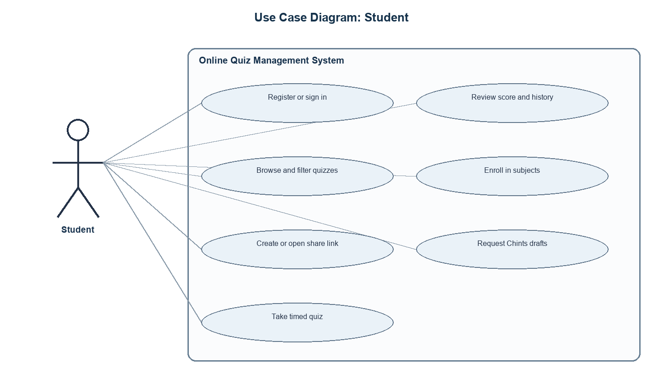
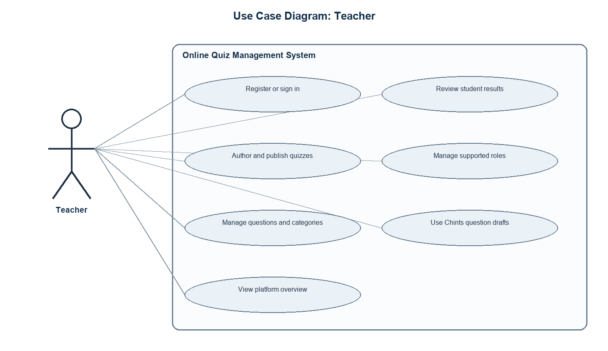
Actor | Use cases
Student | Register, sign in, browse/search quizzes, create or open a share link, attempt a quiz, review results, manage subjects, request question drafts, sign out.
Teacher | Student use cases plus view platform summaries/results and manage supported administrative data.
Guest | Register, sign in, and open accessible published quiz details or share entry points.

7.2 Principal flow: timed quiz
1. User opens an accessible published quiz and starts an attempt.
2. Server creates an attempt with an expiry time and returns question prompts without answer keys.
3. Client displays a countdown and sends answer updates while the attempt is active.
4. User submits all answers before expiry or the server closes the attempt after expiry.
5. Server scores from its stored answer key and makes the review available to the attempt owner.

8. Requirements traceability
Req ID | Requirement short | Test case / evidence | Status
FR-01 | Account registration | TC-01, TC-04 | Implemented; verify against cited case
FR-02 | Sign in | TC-02, TC-03 | Implemented; verify against cited case
FR-03 | Sign out | TC-17 | Implemented; verify against cited case
FR-04 | Password recovery | Password-reset unit tests | Implemented; verify against cited case
FR-05 | Browse quizzes | TC-05 | Implemented; verify against cited case
FR-06 | Find and filter | TC-06, TC-16 | Implemented; verify against cited case
FR-07 | Open quiz details | TC-07, TC-15 | Implemented; verify against cited case
FR-08 | Author quizzes | TC-21 | Implemented; verify against cited case
FR-09 | Maintain questions | Question-service unit tests | Implemented; verify against cited case
FR-10 | Manage categories | TC-22 | Implemented; verify against cited case
FR-11 | Start timed attempt | TC-07 | Implemented; verify against cited case
FR-12 | Save answers | TC-09, TC-10 | Implemented; verify against cited case
FR-13 | Submit attempt | TC-11, TC-12, TC-14 | Implemented; verify against cited case
FR-14 | Expire attempt | TC-08, TC-12 | Implemented; verify against cited case
FR-15 | Score and review | TC-11, TC-13 | Implemented; verify against cited case
FR-16 | Attempt history | TC-13 | Implemented; verify against cited case
FR-17 | Use built-in subjects | TC-18 | Implemented; verify against cited case
FR-18 | Enroll and add subjects | TC-18, TC-19 | Implemented; verify against cited case
FR-19 | Generate question drafts | TC-20 | Implemented; verify against cited case
FR-20 | Teacher oversight and sharing | TC-21, TC-22 | Implemented; verify against cited case

Appendix A. References
- README.md, DEPLOYMENT.md, and repository API implementation.
- Online_Quiz_System_Requirements.pdf.
- Security_Requirment.docs.pdf.
- Test_Cases.md and docs/System_Validation_Report.md.

