Fake News Detection Using Natural Language Processing:
A Comparative Study of Text Representations and Classification Models
Summer Internship Program in AI & ML, 2026
Indian Institute of Computing and Technology
Abstract —
Abstract — This project builds a fake news detection pipeline from a merged corpus of 44,898 news articles (23,481 labeled Fake, 21,417 labeled True) and evaluates it as a controlled comparison rather than a single pipeline reported once. Three text representations, Bag-of-Words, TF-IDF, and averaged Word2Vec embeddings, are compared under one fixed classifier, and four classifiers, K-Nearest Neighbors, Logistic Regression, Random Forest, and a feed-forward neural network, are compared under one fixed representation. A second experiment tests whether two handcrafted behavioral features, exclamation mark count and article length, improve a linear model and a tree-based model differently. The strongest result comes from Logistic Regression on Bag-of-Words features, reaching 99.37% test accuracy, ahead of TF-IDF (98.43%) and Word2Vec (98.07%). Handcrafted features produced a small gain for Random Forest (97.20% to 97.44%) and a negligible loss for Logistic Regression (98.43% to 98.39%), showing that engineered features help only the model that can act on them directly. Error analysis on the best enhanced model finds 80 false positives against 46 false negatives, and the report argues that false negatives, real misinformation reaching a reader unlabeled, are the more costly error for this task, which makes the model's actual error mix the safer failure pattern. A feature-importance check also surfaces a source-attribution artifact: the single strongest word pushing a prediction toward True is "reuter," a byline marker rather than a linguistic signal of truthfulness, which is reported here as a limitation rather than a hidden strength.
Keywords — fake news detection, natural language processing, text classification, TF-IDF, Bag-of-Words, Word2Vec, logistic regression, random forest, feature engineering, error analysis

I. INTRODUCTION

A. Problem Statement and Motivation
The spread of misinformation through digital platforms has made automatic fake news detection a practical problem, not just an academic one. Unlike generic text classification, distinguishing fake from real news requires picking up on both what an article says and how it is written, including tone, sourcing language, and structural habits that differ between fabricated and professionally reported content.
This project builds a complete pipeline from raw, unlabeled-by-feature CSV files to a compared set of trained classifiers. Every preprocessing decision, from dropping a column to choosing a stemmer, is treated as a choice that can be checked against the data rather than assumed to be correct because it is common practice.

B. Project Objectives
The project set out to: build a complete natural language processing pipeline for fake news classification; compare Bag-of-Words, TF-IDF, and Word2Vec as text representations under identical conditions; evaluate four classical and neural classifiers side by side; measure whether handcrafted numerical features change model behavior instead of assuming they help; inspect which words a linear model actually relies on rather than reporting accuracy alone; and produce a pipeline whose decisions are documented well enough to be reproduced and questioned.

C. Why a Comparative Study
A large share of publicly available fake news detection notebooks load a dataset, apply TF-IDF, and train a single Logistic Regression model. That approach can reach a respectable accuracy number without ever showing whether the preprocessing choices mattered, whether a different representation would have done just as well or better, or whether an engineered feature earned its place in the pipeline. This project is structured specifically to answer those questions: every representation and every feature addition is compared against a baseline before being trusted, and the comparisons, not a single headline accuracy figure, are the actual output of the work.

II. DATASET DESCRIPTION

A. Source and Composition
The dataset is the Kaggle Fake and Real News collection, distributed as two CSV files, Fake.csv and True.csv, each containing a title, article body text, subject tag, and publication date. Fake.csv contains 23,481 rows and True.csv contains 21,417 rows, for a combined 44,898 articles before any cleaning. The two files are merged, each row is assigned a binary label (0 for Fake, 1 for True), and the merged set is shuffled with a fixed random seed so that class order has no effect on the later train/test split.

B. Class Balance
The 23,481-to-21,417 split works out to roughly 52% Fake against 48% True, which Fig. 1 confirms visually. This is close enough to balanced that no resampling or class weighting was applied anywhere in the pipeline.
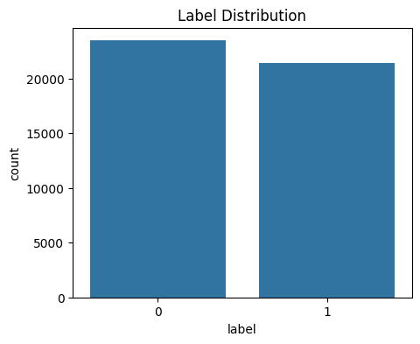
Fig. 1. Class distribution of the merged dataset (0 = Fake, 1 = True).

C. Exploratory Observations
Two structural issues surfaced during initial inspection and directly shaped the cleaning pipeline in Section III. First, the subject column is a near-perfect proxy for the label: Fake articles are tagged across six categories (News, politics, left-news, Government News, US_News, Middle-east) while True articles fall into exactly two (politicsNews, worldnews). Training on subject, even indirectly through a combined feature set, would let a model shortcut the classification task instead of learning from article content, so subject was dropped before feature extraction.
Second, the merged dataset contained zero missing values in any column but 5,793 fully duplicated rows (12.9% of the merged total) and 631 articles with an empty text field but a usable title. Both were addressed directly: duplicates were removed before the train/test split to prevent the same article from appearing on both sides of the split, and title and text were combined into a single content field so that articles with empty bodies were not discarded outright.

III. METHODOLOGY

A. Data Cleaning and Leakage Prevention
Beyond dropping subject and date, title and text were concatenated into a single content field on the reasoning that headlines often carry sharper linguistic signals, such as sensational phrasing, than body text alone. Duplicate rows were removed after this step and before vectorization, and the original title and text columns were dropped once content existed, leaving a working set of 39,105 unique articles carried forward into preprocessing.

B. Text Preprocessing Pipeline
Each transformation below was applied as a distinct, separately verified step rather than one combined cleaning function, so that its individual effect could be checked against the data:
Lowercasing; exclamation mark counting (before punctuation is touched); article length measurement; URL detection followed by URL normalization, which replaces links with a single url token rather than deleting them outright; HTML tag removal (68 articles affected); punctuation removal; whitespace collapsing; tokenization using NLTK's word_tokenize; English stopword removal; and Porter stemming, followed by rejoining tokens into a single string for vectorization. URL presence was deliberately checked for and recorded before the links themselves were removed, since the presence of a hyperlink can itself be a useful behavioral signal even after the link's content is gone.

C. Handcrafted Feature Engineering
Three numerical features were engineered directly from the article text: exclamation_count, text_length, and has_url. Fake articles average 0.85 exclamation marks per article against 0.06 for True, roughly a 13-fold difference. The URL gap is even larger in relative terms: 14.3% of Fake articles contain a raw URL against 0.2% of True. Length separates the classes far less cleanly, 2,579 characters average for Fake against 2,444 for True, with medians only ten characters apart. Of these three, only exclamation_count and text_length were carried into the enhanced feature set used for modeling in Section III-E; has_url was measured and reported here but not used downstream, which is noted as a direction for future work in Section VI-B.

D. Text Vectorization Techniques
Three representations of the cleaned text were built, all on the same 39,105-article corpus:
Bag-of-Words (BoW): a 10,000-feature CountVectorizer capturing raw word frequency with no weighting for how informative a word is across the corpus.
TF-IDF: a 10,000-feature TfidfVectorizer, matched in vocabulary size to BoW so that any accuracy difference between the two comes from the weighting scheme itself rather than a difference in vocabulary.
Word2Vec: a 100-dimensional embedding model trained directly on this corpus (vocabulary size 71,234) rather than loaded from an external pretrained source, with each article represented as the mean of its in-vocabulary word vectors.

E. Model Selection and Experimental Design
Four classifiers were trained on the TF-IDF representation to form the baseline comparison: K-Nearest Neighbors (non-parametric, k=5), Logistic Regression (parametric, linear), Random Forest (ensemble, 100 trees, max depth 10), and a feed-forward neural network (one hidden layer, 50 units). Logistic Regression was then re-trained on Bag-of-Words and Word2Vec to isolate the effect of representation choice while holding the classifier fixed, forming the representation comparison in Section IV-B. Separately, Logistic Regression and Random Forest were re-trained on TF-IDF concatenated with the exclamation_count and text_length features to test whether handcrafted features improve a linear model and a tree-based model differently. All models were trained on an 80/20 stratified split (31,284 train, 7,821 test rows), preserving the roughly 52/48 class ratio in both partitions, with a fixed random seed used throughout for reproducibility.

F. Evaluation Metrics
Every model is scored on accuracy (train and test, to check for overfitting), precision, recall, and F1-score per class, and a confusion matrix. Accuracy alone was treated as insufficient throughout this project, since it does not distinguish between a model that fails symmetrically and one that fails in a specific, costly direction; that distinction is addressed directly in the error analysis in Section V-D.

IV. RESULTS

A. Baseline Model Comparison (TF-IDF)
TABLE I
Model | Train Acc. | Test Acc. | F1 (Fake) | F1 (True)
KNN | 0.9093 | 0.8579 | 0.8288 | 0.8786
Logistic Regression | 0.9895 | 0.9843 | 0.9827 | 0.9856
Random Forest | 0.9817 | 0.9720 | 0.9687 | 0.9747
Neural Network | 1.0000 | 0.9875 | 0.9863 | 0.9885
Ranked by test accuracy: Neural Network (0.9875), Logistic Regression (0.9843), Random Forest (0.9720), then KNN well behind at 0.8579. KNN's train and test accuracy sit five points apart, the widest gap of any baseline model, and its Fake-class recall of only 0.75 means a quarter of actual fake articles are classified as True. Distance-based voting in a 10,000-dimensional sparse space is the likely cause; it does not separate the classes as cleanly as a linear decision boundary or a tree ensemble does. The Neural Network reaches perfect training accuracy (1.0000), a textbook overfitting signature, yet test accuracy barely suffers, suggesting the two classes are separable enough in TF-IDF space that even a memorized boundary generalizes well.

B. Representation Comparison (Logistic Regression)
TABLE II
Representation | Train Acc. | Test Acc. | F1 (Fake) | F1 (True)
TF-IDF | 0.9895 | 0.9843 | 0.9827 | 0.9856
Bag-of-Words | 1.0000 | 0.9937 | 0.9931 | 0.9942
Word2Vec | 0.9824 | 0.9807 | 0.9789 | 0.9822
Bag-of-Words edges out TF-IDF, 0.9937 against 0.9843, despite being the simpler, unweighted representation. Word2Vec, despite compressing every article down to 100 dense dimensions and discarding exact word identity, still reaches 0.9807, within a point and a half of the sparse 10,000-dimension representations. The full spread across all three representations is under one percentage point, indicating that for this dataset, representation choice matters far less than the presence of strong lexical and topical separators between the two classes, discussed further in Section IV-C.

C. Feature Importance
Logistic Regression's coefficients on the TF-IDF representation identify which terms push a prediction toward each class. This analysis only applies cleanly to a linear model; there is no equivalent coefficient to inspect for KNN, Random Forest, or the neural network.
TABLE III
Toward True | Coef. | Toward Fake | Coef.
reuter | 21.75 | video | -8.96
said | 18.64 | imag | -8.92
washington | 6.18 | via | -8.67
us | 5.50 | gop | -5.73
wednesday | 5.24 | hillari | -5.29
The single strongest coefficient in the entire model is "reuter" at 21.75, well ahead of the next-strongest term. This is reported here as a limitation rather than a strength: the True half of this dataset is sourced entirely from Reuters, so the model has partly learned to recognize a wire-service byline rather than a general property of trustworthy reporting. "said," "washington," and the weekday names that follow it are more generalizable, reflecting the attribution-heavy, dateline-driven style of straight news writing. On the Fake side, "video," "imag," and "via" point to embedded media and sensational framing, a signal likely to transfer better to unseen data than a single source name would.

D. Effect of Handcrafted Features
TABLE IV
Model | Train Acc. | Test Acc. | F1 (Fake) | F1 (True)
Logistic Regression | 0.9895 | 0.9843 | 0.9827 | 0.9856
Random Forest | 0.9817 | 0.9720 | 0.9687 | 0.9747
Logistic Regression (Enh.) | 0.9894 | 0.9839 | 0.9823 | 0.9852
Random Forest (Enh.) | 0.9842 | 0.9744 | 0.9715 | 0.9768
Adding exclamation_count and text_length to the TF-IDF representation moves the two models in opposite directions. Logistic Regression's test accuracy is essentially flat, 0.9843 to 0.9839, since the two new columns are added alongside 10,000 existing TF-IDF weights and are too small in relative influence to shift a linear decision boundary that is already this accurate. Random Forest improves modestly, 0.9720 to 0.9744, because a tree can split directly on a raw text_length or exclamation_count value, giving it a concrete mechanism to exploit those two columns that a linear model does not have in the same way. This is treated as a genuine answer to whether engineered features help, rather than an assumption baked into the pipeline: they help the model that can act on them directly, and do effectively nothing for the one that cannot.

E. Confusion Matrices
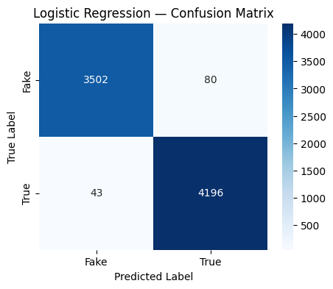
Fig. 2. Confusion matrix, Logistic Regression (TF-IDF, baseline).
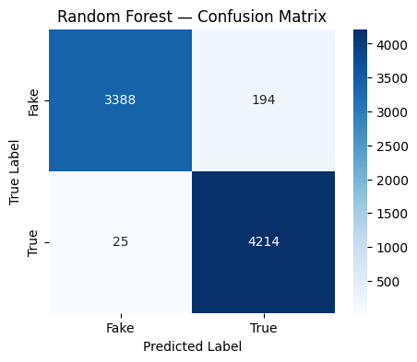
Fig. 3. Confusion matrix, Random Forest (TF-IDF, baseline).
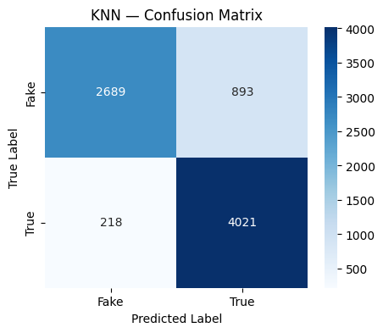
Fig. 4. Confusion matrix, KNN (TF-IDF, baseline).
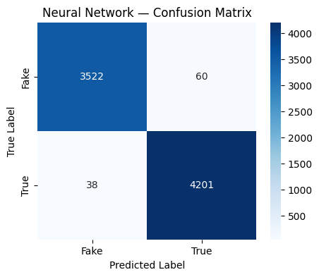
Fig. 5. Confusion matrix, Neural Network (TF-IDF, baseline).
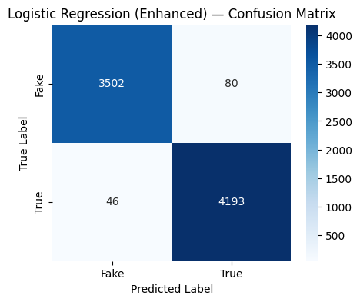
Fig. 6. Confusion matrix, Logistic Regression (Enhanced, best model used for error analysis).

V. DISCUSSION

A. Parametric vs. Non-Parametric Models
Logistic Regression, a parametric model, and KNN, a non-parametric one, sit at opposite ends of this project's results. Logistic Regression assumes a linear decision boundary and learns a fixed, compact set of coefficients, one per TF-IDF feature; that assumption turns out to fit this problem well, given the balanced 0.98-to-0.99 precision and recall across both classes. KNN makes no such assumption and instead classifies by proximity to training examples in the full 10,000-dimensional feature space, but sparse high-dimensional spaces are exactly where distance metrics stop being meaningful; most points end up roughly equidistant from each other, which is the most likely explanation for KNN's five-point train-test gap and its weak 0.75 recall on the Fake class. Random Forest, an ensemble of non-parametric decision trees, does not share this weakness, since each tree splits on individual features rather than measuring distance across all of them at once. The practical conclusion is that non-parametric status alone does not predict weak performance; it is specifically distance-based non-parametric methods that struggle in this kind of feature space, not tree-based ones.

B. Representation Trade-offs
The under-one-point spread between Bag-of-Words, TF-IDF, and Word2Vec (Table II) suggests that this dataset's two classes are separated more by vocabulary and topic than by the kind of subtle semantic relationship that would make a dense embedding meaningfully outperform a sparse count-based method. That is a property of this particular dataset, not a general claim that simpler representations always suffice; a dataset where fake and real articles cover the same topics in different language would likely show a larger gap in Word2Vec's favor.

C. Error Analysis and the Cost of a False Negative
The best enhanced model, Logistic Regression (Enhanced), produced 80 false positives and 46 false negatives on the held-out test set. In a fake news detection system, these two error types are not equally costly. A false negative lets a genuinely fabricated article through unlabeled, where it can reach a reader, shape a real belief or decision, and spread further before anyone corrects it. A false positive wrongly flags a real article, which is a cost too, but one a human reviewer can typically catch and reverse, since the article itself remains true regardless of the label attached to it. By this standard, a system that errs toward more false positives and fewer false negatives is exhibiting the safer failure pattern for this specific application, and that is what this model actually does: 80 false positives against 46 false negatives is a roughly 1.7-to-1 ratio in the less costly direction.
Reading the individual misclassified articles supports this framing but also raises a genuine open question. The three sampled false positives share a plain, attribution-heavy reporting tone despite using ALL-CAPS headlines, which plausibly explains why the model read them as True. The false negatives are more surprising: all three are genuinely Reuters wire pieces, and one directly contains the string "(Reuters)" in its text, yet two of the three center on criticism of Donald Trump. That overlap with the sharper, more opinionated vocabulary the model associates with the Fake class may be enough to pull a correctly-sourced, properly-attributed article toward a wrong prediction. This is reported as an observation rather than a settled explanation, since three examples are not a statistically reliable sample.

D. Data Leakage Consideration
The Top Words result in Section IV-C is directly relevant to how this model's accuracy should be interpreted. Because every True article in this dataset originates from Reuters, the model's strongest single signal is, in part, a proxy for source rather than for truthfulness. A production system trained the same way would likely perform worse on real news from any outlet other than Reuters, since it has never seen a True example written in a different house style. This does not invalidate the comparisons drawn in this report, which hold the dataset fixed across every model and representation, but it does mean the absolute accuracy numbers should not be read as a general-purpose fake news detection accuracy.

E. Custom Prediction Case Study
As a final qualitative check, a single fabricated article ("New Study Reveals That Eating Chocolate While Listening To Mozart Makes You 45% Smarter...") was run through every trained model. All four baseline models and Logistic Regression (Enhanced) correctly labeled it Fake; Random Forest (Enhanced) alone labeled it True. The enhanced Random Forest relies partly on exclamation_count and text_length, and this snippet contains zero exclamation marks and an ordinary length, giving that particular model less to work with on the two features it was built to exploit. A single example is not statistical evidence of anything on its own, but it illustrates concretely why this report compares several models instead of reporting the output of just one.

VI. CONCLUSION

A. Summary of Findings
This project built a fake news detection pipeline from raw CSV files through cleaning, three text representations, four classifiers, an engineered-feature experiment, and an error analysis grounded in the actual cost of each error type. The strongest configuration tested was Logistic Regression on Bag-of-Words features (99.37% test accuracy), narrowly ahead of TF-IDF (98.43%) and Word2Vec (98.07%), with all three representations landing within a single percentage point of each other. Handcrafted behavioral features helped Random Forest and did not help Logistic Regression, which is reported as a direct answer to whether engineered features are worth adding, rather than an assumption. Error analysis found more false positives than false negatives, which is the less costly failure direction for this task, though a feature-importance check also surfaced a genuine limitation: part of the model's strongest signal traces back to a single news source rather than a general marker of truthfulness.

B. Limitations
This work is limited to English-language, binary-labeled text. TF-IDF and Bag-of-Words ignore word order entirely, and the Word2Vec vectors used here are static, one vector per word regardless of context, rather than the contextual embeddings a transformer model would produce. The feed-forward neural network used is intentionally shallow and cannot model long-range dependencies across a document. The has_url feature was measured during exploratory analysis but never incorporated into the enhanced feature set, leaving a signal on the table that showed the largest relative class gap of the three engineered features. Most significantly, the source-attribution artifact discussed in Section V-D means the reported accuracy figures likely overstate how well this pipeline would generalize to real news from sources outside this specific dataset.

C. Future Scope
Natural extensions include: incorporating has_url into the enhanced feature set and re-running the baseline-versus-enhanced comparison; replacing static Word2Vec with contextual transformer embeddings such as BERT or DistilBERT; applying explainability tools such as SHAP or LIME to individual predictions rather than global coefficients alone; sourcing True-labeled articles from multiple outlets to reduce the Reuters attribution artifact; and extending the pipeline to multilingual fake news detection or a continually updated dataset fed by a live news API.

VII. APPENDIX

A. Dataset Schema and Sample
Raw columns (Fake.csv / True.csv): title, text, subject, date. Working columns after cleaning: label (0 = Fake, 1 = True), clean_content (preprocessed text), exclamation_count, text_length. The has_url column was computed during exploratory analysis and is present in the working DataFrame but was not saved to the final processed file.
TABLE V
Stage | Excerpt
Raw content | Ben Stein Calls Out 9th Circuit Court...
Lowercased + URL/HTML cleaned | ben stein calls out 9th circuit court...
Tokenized | ['ben','stein','calls','out','9th',...]
Stopwords removed | ['ben','stein','calls','9th','circuit',...]
Stemmed | ['ben','stein','call','9th','circuit',...]

B. Full Preprocessing Pipeline (Ordered)
1. Load Fake.csv and True.csv. 2. Assign binary labels. 3. Merge and shuffle with a fixed seed. 4. Drop subject and date (leakage risk). 5. Check for missing values and duplicates. 6. Combine title and text into content. 7. Remove duplicate rows. 8. Drop original title/text columns. 9. Lowercase. 10. Count exclamation marks. 11. Measure text length. 12. Detect URLs, then normalize them to a single url token. 13. Remove HTML tags. 14. Remove punctuation. 15. Collapse whitespace. 16. Tokenize (NLTK word_tokenize). 17. Remove English stopwords. 18. Apply Porter stemming. 19. Rejoin tokens into clean_content. 20. Save the processed dataset.

C. Environment and Libraries
Python 3, pandas, numpy, matplotlib, seaborn, scikit-learn (CountVectorizer, TfidfVectorizer, KNeighborsClassifier, LogisticRegression, RandomForestClassifier, MLPClassifier, train_test_split, classification_report, confusion_matrix), NLTK (stopwords, PorterStemmer, word_tokenize), gensim (Word2Vec), scipy.sparse (hstack), wordcloud. Random seed fixed at 42 throughout for reproducibility.

D. Supplementary Result Tables
Full per-class precision, recall, and F1-score for every baseline model, matching the summary in Table I.
TABLE VI
Model | Prec.(F) | Rec.(F) | Prec.(T) | Rec.(T)
KNN | 0.9250 | 0.7507 | 0.8183 | 0.9486
Logistic Regression | 0.9879 | 0.9777 | 0.9813 | 0.9899
Random Forest | 0.9927 | 0.9458 | 0.9560 | 0.9941
Neural Network | 0.9893 | 0.9833 | 0.9859 | 0.9910
(F) = Fake class, (T) = True class.
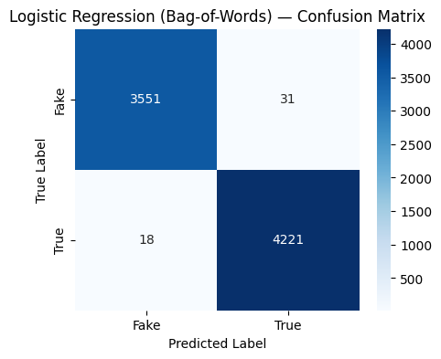
Fig. 7. Confusion matrix, Logistic Regression (Bag-of-Words).
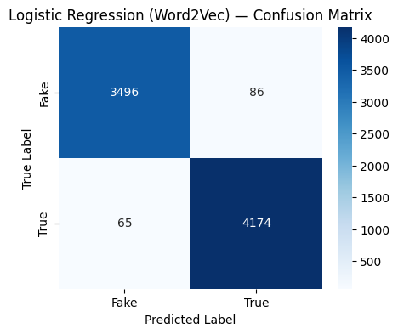
Fig. 8. Confusion matrix, Logistic Regression (Word2Vec).
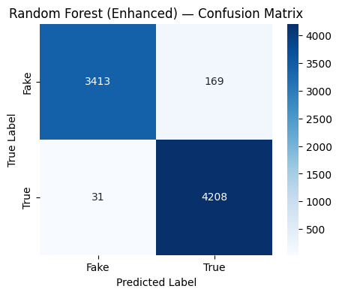
Fig. 9. Confusion matrix, Random Forest (Enhanced).

Fig. 10. Word cloud of the cleaned corpus (both classes combined; a preprocessing sanity check, not a class-specific signal).

REFERENCES
[1] G. Salton and C. Buckley, "Term-weighting approaches in automatic text retrieval," Information Processing & Management, vol. 24, no. 5, pp. 513–523, 1988.
[2] T. Mikolov, K. Chen, G. Corrado, and J. Dean, "Efficient estimation of word representations in vector space," arXiv preprint arXiv:1301.3781, 2013.
[3] L. Breiman, "Random forests," Machine Learning, vol. 45, no. 1, pp. 5–32, 2001.
[4] F. Pedregosa et al., "Scikit-learn: Machine learning in Python," Journal of Machine Learning Research, vol. 12, pp. 2825–2830, 2011.
[5] S. Bird, E. Klein, and E. Loper, Natural Language Processing with Python. Sebastopol, CA: O'Reilly Media, 2009.
[6] Ř. Řehůřek and P. Sojka, "Software framework for topic modelling with large corpora," in Proc. LREC 2010 Workshop on New Challenges for NLP Frameworks, 2010, pp. 45–50.
[7] C. Bisaillon, "Fake and real news dataset," Kaggle, 2020. [Online]. Available: https://www.kaggle.com/datasets/clmentbisaillon/fake-and-real-news-dataset

