
Department of Computer Engineering & Technology
CSE-AIDS --- LEVEL 1
Capstone Project Synopsis 2026-27
Group No: | Students names | PRN | Email, Mobile number | Panel | Sign of student
 | Mrinmayee Gokhale | 1032232136 | mrinmayee.gokhale@mitwpu.edu.in  9930043925 | A
 | Hritvi Bhole | 1032231780 | hritvi.bhole@mitwpu.edu.in  9167638656 | A
 | Samay Gandhi | 1032232197 | samay.gandhi@mitwpu.edu.in  9503631008 | A

Project Title: Active Verification — An Agentic Multi-Domain Framework for LLM-Generated Phishing
Primary Domain: Cybersecurity
Tech Domain: Agentic AI, Large Language Models, Natural Language Processing (NLP), Explainable AI (XAI), Machine Learning / Deep Learning, Generative AI, Human-Computer Interaction, Web Security
INHOUSE PROJECT: YES
Abstract:
The emergence of Large Language Models has significantly altered the phishing threat landscape: attackers can now generate linguistically coherent, contextually adaptive content at scale, which undermines classifiers trained on the stylistic patterns of a single generator or attack channel. Conventional detection systems further limit themselves by treating phishing defense as a single-step classification task — a static score computed once, with no provision for further verification.
This project proposes a Domain-Agnostic Active Verification Framework that structures phishing defense as a multi-stage investigative process rather than a single inference step, applied across both email and web-based attack surfaces, through four coordinated stages — Detect (domain-specific classifiers), Investigate (a debate-structured multi-agent panel using OSINT evidence), Unmask (a sandboxed, memory-augmented agent that actively engages the suspected source), and Explain (an auditable evidence dashboard). The framework is evaluated using a self-adversarial red-teaming protocol, testing it against an adaptive threat model rather than static benchmark performance alone.
Existing Systems and How This Project Differs
Everyday email providers such as Gmail and Outlook already run spam/phishing filters, but these operate as a single-shot classifier: one score is computed, one decision is made, and there is no second opinion — which is exactly why important, legitimate emails are sometimes wrongly flagged as spam, with no mechanism to catch and correct that mistake. Academic work (summarised in the Literature Survey section below) has begun addressing pieces of this problem — better classifiers, multi-agent debate, LLM honeypots — but always in isolation and only for a single domain (email OR network deception, not both).
This project differs in four concrete ways:
- Investigation before final verdict: unlike Gmail-style filters, a flagged item is not immediately trusted — it is cross-checked against real OSINT evidence before a verdict is finalised, directly reducing false positives on legitimate mail.
- Domain-agnostic coverage: one shared framework handles both suspicious emails and suspicious websites, instead of the single-domain scope of most existing work.
- Active verification, not passive classification: the system engages the suspected source directly (honeypot conversation, decoy credentials) rather than only scoring static content.
- Adaptive, self-adversarial evaluation: effectiveness is measured against an AI adversary that keeps generating new evasive attacks, not just a fixed, static test set.
Literature Survey
Sr.  No | Title, Authors & Year | Gist of the Paper | Gap Identified
1 | Devising and Detecting Phishing Emails Using Large Language Models — Heiding, Schneier, Vishwanath, Bernstein & Park, IEEE Access, 2024 | Shows LLMs can both generate convincing phishing emails and be repurposed to detect them, establishing baseline capability on both the offense and defense side. | Detection is treated as a single-shot classification task; no investigative or interactive verification step follows the initial score.
2 | Next-Generation Phishing: How LLM Agents Empower Cyber Attackers — Afane, Wei, Mao, Farooq & Chen, IEEE BigData, 2024 | Demonstrates that autonomous LLM agents can independently conduct multi-step phishing campaigns, from reconnaissance to content generation, at scale. | Focuses only on the attacker side; does not propose a matching agentic defense or verification architecture.
3 | Cross-Model Evaluation of Phishing Detectors Against LLM-Generated Emails — Frontiers in Big Data, 2026 | Systematically tests whether a phishing detector trained on emails from one LLM generalizes to phishing emails generated by a different, unseen LLM. | Confirms a real cross-generator generalization gap: detectors trained on a single generator degrade sharply on unseen generators — the core gap this project targets.
4 | Debate-Driven Multi-Agent LLMs for Phishing Email Detection — arXiv:2503.22038, 2025 | Uses multiple LLM agents debating over several rounds to reach a phishing verdict, improving reasoning quality over single-agent classification. | Debate is confined to email text alone — no OSINT evidence grounding, no website domain coverage, and no active engagement with the sender.
5 | Multimodal Large Language Models for Phishing Webpage Detection and Identification — Lee, Lim, Hooi & Divakaran, eCrime Symposium, 2024 | Uses multimodal LLMs to analyse webpage screenshots and text together for phishing identification and brand-target recognition. | Passive detection only — no interactive or decoy-based verification of how the website actually behaves.
6 | LLM Agent Honeypot: Adaptive Cyber Deception — Bridges et al., arXiv, 2025 | Uses generative LLMs to simulate realistic network/SSH services and engage attackers automatically, adapting responses in real time. | Applied to network/SSH-level deception only; not integrated with an upstream email/website detection-and-investigation pipeline.
Project Objectives for Team
1. Develop a detection system for LLM-generated phishing emails and websites using machine learning, NLP, and structural/visual analysis.
2. Investigate suspicious content using multiple AI agents and OSINT evidence such as domain information, DNS records, and threat intelligence.
3. Actively verify suspicious sources using a sandboxed agent, honeypot conversations, and decoy interactions to identify malicious or automated behaviour.
4. Provide an explainable, auditable dashboard that combines detection results, investigation evidence, and verification results in one place.
5. Evaluate the system against adaptive attacks using red-team-generated phishing content and evasive strategies.
Individual Project Objectives
Mrinmayee Gokhale
- Develop and evaluate the phishing detection models for email and website analysis.
- Work on NLP-based analysis of suspicious email content.
- Assist in testing the detection models against different phishing samples.
Hritvi Bhole
- Develop the multi-agent investigation module using prosecution, defense, and judge agents.
- Integrate OSINT sources such as WHOIS, DNS, SPF/DKIM, and threat intelligence.
- Work on evidence collection and final verdict generation.
Samay Gandhi
- Develop the active verification and unmasking module using honeypot conversations and decoy interactions.
- Analyse response behaviour, redirects, and other verification evidence.
- Develop/integrate the dashboard for displaying the final verdict and supporting evidence.
H/w & S/w Requirements:
Hardware:
- Development Machine: 16GB+ RAM, GPU recommended (NVIDIA, 6GB+ VRAM) for transformer fine-tuning/inference
- Cloud GPU (optional): AWS / GCP / Colab Pro — for training if local GPU is insufficient
- Standard internet connectivity for OSINT API calls (WHOIS, VirusTotal, DNS lookups)
Software:
- Language: Python 3.10+
- ML / NLP: HuggingFace Transformers, PyTorch, scikit-learn
- Agent Orchestration: LangChain / LangGraph
- LLM APIs: OpenAI / Anthropic / Google Gemini API
- OSINT Integration: WHOIS API, VirusTotal API, URLhaus, DNS/SPF/DKIM lookup libraries
- Backend: FastAPI
- Database: PostgreSQL or MongoDB
- Frontend / Dashboard: React or Streamlit
- Deployment: Docker (+ optional AWS/GCP/Render for demo hosting)
- Version Control: Git / GitHub
High Level Design [Architecture diagram/block diagram]
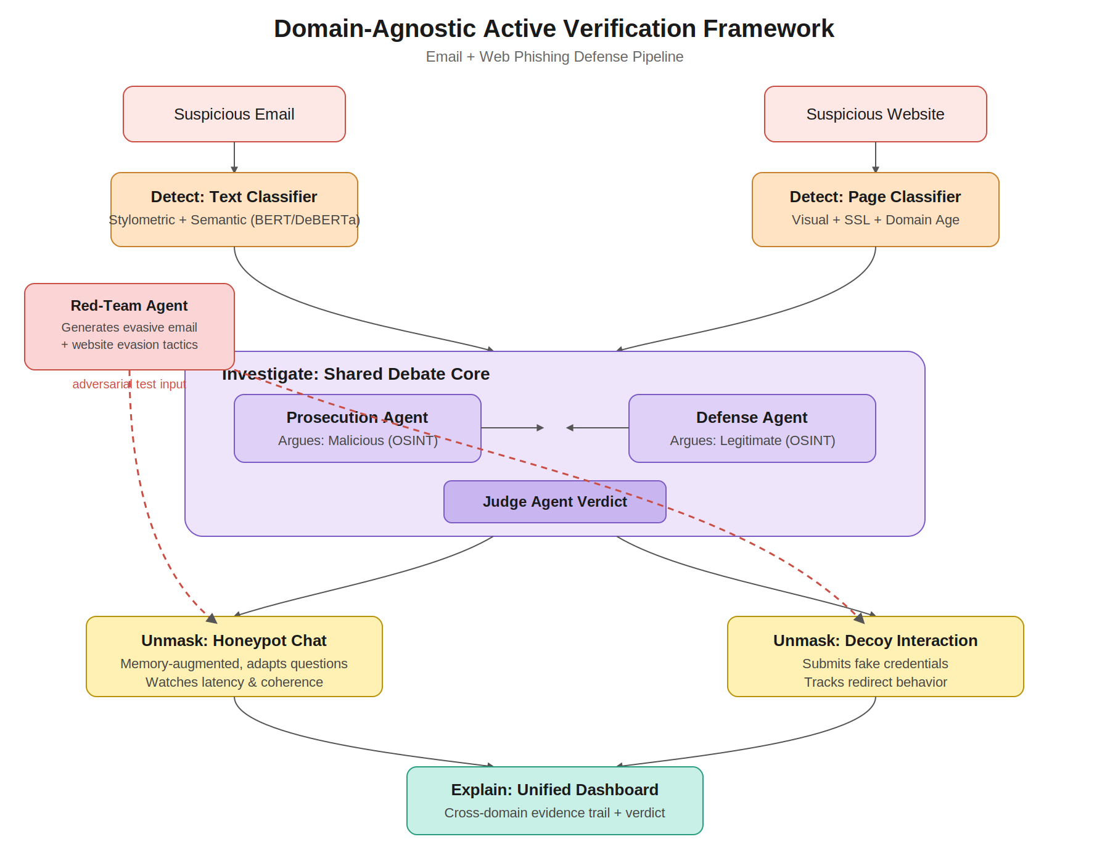
Working:
1. Input: The system receives a suspicious email or website.
2. Detect: The email is analysed using a text-based classifier, while the website is analysed using visual and structural features such as SSL validity, domain age, and layout similarity.
3. Investigate: The flagged content is passed to a shared multi-agent debate system. The Prosecution Agent looks for evidence of malicious behaviour, the Defense Agent checks evidence supporting legitimacy, and a Judge Agent evaluates both sides and produces the verdict.
4. Unmask: The system actively interacts with the suspected source — a honeypot agent engages in conversation for emails, or decoy interactions are used to observe credential handling and redirect behaviour for websites.
5. Explain: Classifier confidence, OSINT evidence, interaction details, and the verdict are presented through a unified dashboard for analysis and auditing.
6. Red-Team Testing: A red-team agent generates evasive phishing samples to test whether the system handles changing, adaptive attacks.
Evaluation Methodology
The system is evaluated the same way any classifier is scored against ground truth, using the standard confusion-matrix metrics, with a specific focus on the false-positive problem seen in real filters like Gmail:
- Precision: of everything flagged as phishing, how much actually was phishing.
- Recall: of all real phishing attempts, how many were correctly caught.
- F1 Score: a single balanced measure of precision and recall, used to compare versions of the system.
- False Positive Rate (FPR): the percentage of legitimate emails wrongly flagged — the exact failure mode this project targets.
Evaluation Plan
- Baseline comparison: the Detect-only classifier is scored first, representing standard filters in use today; the full Detect + Investigate pipeline is then scored on the same test set to show the improvement in FPR without a drop in recall.
- Hard-negative testing: the test set deliberately includes legitimate emails that resemble phishing on the surface (password resets, new senders, marketing mail) — the exact category real filters get wrong.
- Cross-generator generalisation: the classifier is trained on phishing samples from one LLM and tested on phishing generated by a different, unseen LLM, reporting the accuracy drop.
- Unmask accuracy: the honeypot/decoy module is tested on known-bot vs. known-human sandboxed conversations, reporting how often it correctly tells them apart.
- Red-team round: system performance is measured before and after each defense improvement against the red-team adversary, giving a concrete before/after robustness result.
Tools: scikit-learn.metrics for precision/recall/F1/confusion matrices; a fixed, held-out test set never used in training, to keep reported numbers trustworthy; confusion matrix visualisation included in the Explain dashboard for viva demonstration.

