Secure File Storage System
Design of a File Vault Using Encryption Interfaces and Java I/O Streams

B.Tech_JAVA Project Report
Submitted for partial fulfillment of
the requirements for the degree of
B.Tech 4th Sem
Under NIST University

Submitted By:
Name | Roll Number
Samay Sarthak Swain | 202456256
Rudrasis Panda | 202456327

Submitted to
Prof. Bandhan Panda
Subject Faculty, Object Oriented Program Through JAVA
NIST University


NIST UNIVERSITY
Institute Park, Pallur Hills, Berhampur, Odisha-761008, India
2025-2026

TABLE OF CONTENTS
Sl.  No. | Title of the Project Section | Page No.
1 | Abstract | 2
2 | Introduction | 3
3 | Literature Review | 4
4 | Proposed System | 6
5 | System Architecture | 7
6 | Object Oriented Design | 9
7 | Implementation Details | 11
8 | GUI Design | 12
9 | Algorithm Design | 13
10 | Database Design | 15
11 | Testing and Validation | 16
12 | Performance Analysis | 17
13 | Results | 20
14 | Limitations | 21
15 | Future Enhancements | 22
16 | Conclusion | 23
17 | References | 23
18 | Appendix | 24

ABSTRACT
The Secure File Storage System is a Java-based application designed to provide safe storage, controlled access, and protection of sensitive digital files. With the increasing risk of data breaches and unauthorized access, there is a strong need for reliable security mechanisms at the application level. This system addresses that need by implementing advanced cryptographic techniques such as AES-256 encryption for securing file data and SHA-256 hashing for robust user authentication, ensuring confidentiality and protection against unauthorized usage.
The application is developed using core Java technologies, including Java I/O Streams, Object-Oriented Programming (OOP) principles, multithreading, and exception handling, which together enhance system performance, modularity, and reliability. Encryption and decryption processes are seamlessly integrated using CipherInputStream and CipherOutputStream, enabling secure data handling without compromising efficiency.
The system allows authenticated users to upload, store, and retrieve files securely through a simple and user-friendly interface. It ensures that all stored files remain encrypted and cannot be accessed without proper credentials. Additionally, the system maintains data integrity and consistent performance across different file sizes, as validated through testing.
This project provides a lightweight, scalable, and platform-independent solution that does not rely on external tools or system-level configurations. It is suitable for both academic learning and real-world applications, particularly in domains where data security and privacy are critical. Furthermore, the system lays a strong foundation for future enhancements such as cloud integration, multi-factor authentication, and advanced encryption techniques.

1. INTRODUCTION
1.1 Background
In today’s digital environment, protecting sensitive data has become a critical requirement for both individuals and organizations. Files such as personal documents, financial records, and confidential data are often stored on local systems without proper security mechanisms. Traditional file systems generally do not provide built-in encryption, which increases the risk of data breaches and unauthorized access.
With the rise of cybersecurity threats, there is a growing need for secure file storage solutions that ensure confidentiality, integrity, and controlled access. Java provides strong support for security through libraries like java.security and javax.crypto, making it an ideal platform for developing encryption-based applications. This project focuses on building a secure file vault using encryption, authentication, and efficient file handling techniques.
1.2 Problem Statement
Most existing file storage systems store data in plain format without encryption. If an unauthorized user gains access to the system, sensitive files can be easily read or misused. While some solutions like full-disk encryption exist, they often require administrator privileges, system-level configuration, or external tools, making them less flexible and harder to integrate.
Therefore, there is a need for a lightweight, application-level secure file storage system that:
- Encrypts files before storage
- Provides secure user authentication
- Works independently without relying on external dependencies
- Is easy to use and platform-independent

1.3 Objectives
- To develop a Java-based secure file storage system using AES encryption
- To implement user authentication using SHA-256 hashed passwords
- To ensure secure file operations using Java I/O streams and encryption techniques
- To support efficient performance using multithreading for concurrent operations
- To design a simple and user-friendly interface for file management
1.4 Scope of the Project
This project focuses on creating a secure file vault for local storage using encryption and authentication mechanisms. It covers core features such as file encryption, decryption, user login, and secure storage within a standalone Java application.
However, the system has certain limitations:
- It operates only on local storage and does not include cloud integration
- It uses single-factor authentication (password-based)
- It does not support network-based file transfer
- The interface is basic and built using standard Java GUI components
Despite these limitations, the system provides a reliable and efficient solution for secure file management at the application level.
2. LITERATURE REVIEW
A review of existing file security solutions highlights different approaches to data protection. While these systems provide strong security features, they also have certain limitations that reduce their flexibility and usability in application-level development.
• Existing Approach 1 – Full-Disk Encryption Tools
Tools like disk-level encryption solutions secure the entire storage device by encrypting all data at once. These systems provide strong protection against unauthorized access at the systemlevel.
Limitations:
- Require administrator privileges and system-level configuration
- Not easily portable across platforms
- Cannot be directly integrated into Java applications
- Lack fine-grained control over individual files
• Existing Approach 2 – Command-Line Encryption Tools
Some tools use command-line interfaces to encrypt and decrypt files using standard algorithms like AES.
Drawbacks:
- Depend on external tools or libraries
- Require manual execution and are not user-friendly
- Difficult to integrate with GUI-based Java systems
- Limited support for error handling and automation
• Existing Approach 3 – Key Storage Systems
Systems designed for storing cryptographic keys and certificates provide secure key management.
Limitations:
- Not designed for general file storage and encryption
- Lack support for bulk file handling
- Do not provide built-in user authentication or file management features
• Existing Approach 4 – OS-Specific Security Solutions
Operating system-based security tools provide encryption and access control features.
Drawbacks:
- Limited to specific platforms (not cross-platform)
- No direct programmatic control for developers
- Cannot be embedded within custom applications
• Why Improvement is Required
Existing systems either focus on system-level security or require external dependencies, making them unsuitable for lightweight and portable applications. There is a need for a solution that:
- Works within the Java ecosystem without external tools
- Provides file-level encryption and user authentication
- Is platform-independent and easy to use
- Integrates secure storage, encryption, and access control in a single system
The proposed system addresses these gaps by offering a self-contained, efficient, and application-level secure file storage solution using standard Java technologies.
3. PROPOSED SYSTEM
3.1 System Overview
The proposed system is a Java-based Secure File Storage System that protects sensitive data through file-level encryption and user authentication. Unlike traditional systems that store files in plain format, this system ensures that every file is encrypted before storage and can only be accessed by authorized users.
By combining encryption, authentication, and efficient file handling, the system provides a lightweight, secure, and platform-independent solution without relying on external tools or system-level permissions.
3.2 Key Features
- Strong Encryption: Uses AES-256 algorithm to ensure high-level data security
- Secure Authentication: Implements SHA-256 hashing for safe password storage
- Stream-Based File Handling: Uses CipherInputStream and CipherOutputStream for seamless encryption and decryption
- Multithreading Support: Handles multiple file operations efficiently
- User-Friendly Interface: Simple GUI for easy file upload and retrieval
3.3 Advantages Over Existing System
Feature | Existing System | Proposed System
Speed | Moderate due to external dependencies | Optimized using Java I/O and multithreading
Security | Basic or system-level protection | Strong AES-256 encryption with authentication
Platform Support | Often OS-dependent | Fully platform-independent (Java-based)
Dependencies | Requires third-party tools | No external dependencies
File Protection | Stores files in plain or partially secured | Fully encrypted file storage
Integration | Limited integration with applications | Easily integrated within Java applications
User Access Control | Minimal or OS-based | Secure login with hashed credentials
Usability | Complex or command-line based | Simple and user-friendly interface
4. SYSTEM ARCHITECTURE
4.1 Architecture Diagram
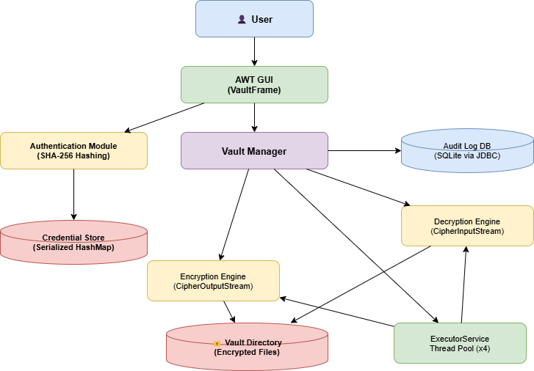
Figure 1 (Architecture Diagram)
The architecture of the Secure File Storage System follows a modular design where each component performs a specific function. The system begins with the user interface, processes authentication, and then routes requests through the vault manager to encryption or decryption modules. All files are stored in encrypted format in the vault directory.
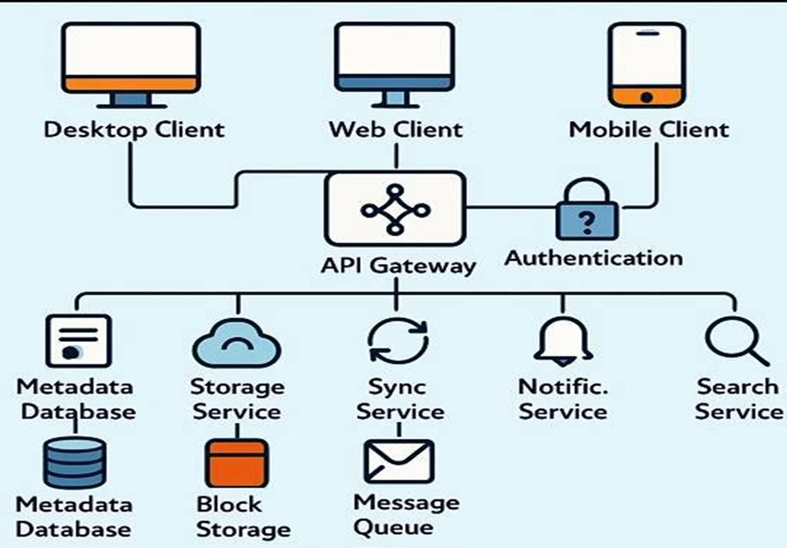
Figure 2 (Module Description Architecture Diagram)

4.2 Module Description
• User Interface (GUI Module)
This module provides interaction between the user and the system. It allows users to register, log in, upload files, and retrieve files. The interface is designed to be simple and user-friendly, enabling smooth navigation and operation.
• Authentication Module
This module handles user registration and login functionality. It secures user credentials by converting passwords into SHA-256 hashed values before storing them. During login, the entered password is hashed and compared with stored data to verify identity.
• Vault Manager
The Vault Manager acts as the central controller of the system. It receives user requests and decides whether to perform encryption (store file) or decryption (retrieve file). It ensures proper coordination between different modules.
• Encryption Module
This module is responsible for securing files before storage. It uses AES-256 encryption to convert readable data into encrypted format. It works with CipherOutputStream to encrypt file data during the writing process.
• Decryption Module
This module performs the reverse operation of the encryption module. It uses CipherInputStream to decrypt files when users request access. Only authenticated users can perform decryption.
• Credential Storage
This module securely stores user data such as usernames and hashed passwords. It uses serialization techniques and data structures like HashMap for efficient storage and retrieval.
• Encrypted File Storage (Vault Directory)
This is the location where all encrypted files are stored. Files in this directory are not readable in normal format, ensuring data confidentiality and protection.
Overall, this architecture ensures a secure, modular, and efficient system design, where each component contributes to maintaining data security and system performance.

5. OBJECT-ORIENTED DESIGN
5.1 Class Diagram (UML)
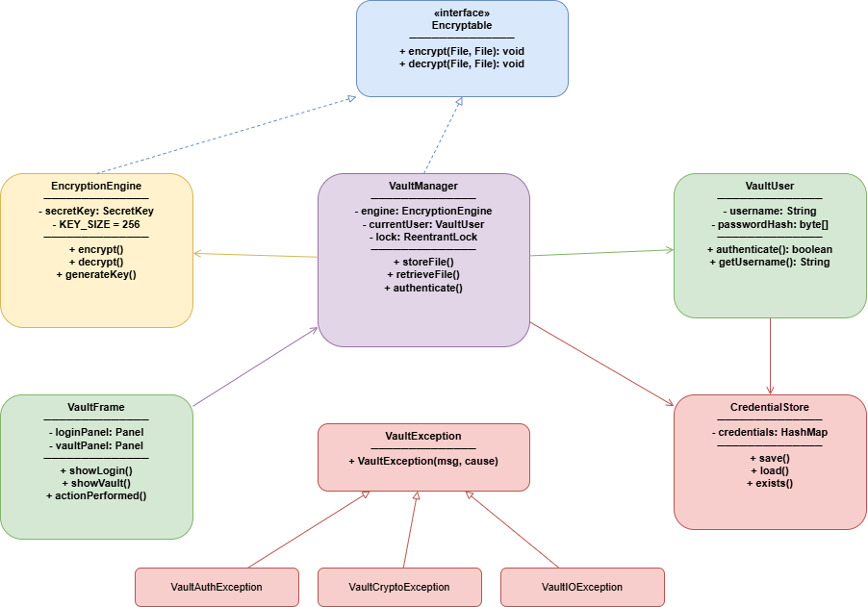
Figure 3 (Class Diagram)
The UML class diagram represents the structure of the system, showing the relationship between key classes such as VaultUser, EncryptionEngine, and VaultManager. It highlights how objects interact to perform secure file operations.
5.2 Description of Classes
Class: VaultUser
• Attributes: username (String), passwordHash (byte[])
• Methods: register(), login(), authenticate()
• Constructor Overloading: Can support multiple constructors for user creation
• Encapsulation: All attributes are private and accessed through methods
Class: EncryptionEngine
• Attributes: secretKey (SecretKey), algorithm (String)
• Methods: encrypt(File), decrypt(File), generateKey()
• Constructor Overloading: Supports key generation and key-based initialization
• Encapsulation: Sensitive data like secretKey is kept private

5.3 OOP Concepts Used
• Encapsulation
Sensitive data such as passwords and encryption keys are kept private and accessed only through controlled methods. This ensures data security and integrity.
• Abstraction
Complex encryption and file operations are hidden behind simple methods like encrypt() and decrypt(), allowing users to interact without knowing internal logic.
• Inheritance
Custom exception classes inherit from base exception classes to create a structured error-handling hierarchy, improving code reusability.
• Polymorphism
Methods like encrypt() and decrypt() can be implemented in different ways for handling files, byte arrays, or streams, providing flexibility.
• Method Overloading
Multiple methods with the same name but different parameters are used, such as encrypt(File) and encrypt(byte[]), to handle different inputs.
• Constructor Overloading
Classes provide multiple constructors to initialize objects in different ways, such as generating a new key or using an existing one.
• Use of this, static, final
- this: Used to refer to current object variables and avoid naming conflicts
- static: Used for constants and utility methods shared across all objects
- final: Used to define constant values like encryption algorithms and key sizes, ensuring they cannot be modified
This design ensures the system is modular, secure, reusable, and easy to maintain, following standard object-oriented programming principles
6. IMPLEMENTATION DETAILS
6.1 Exception Handling Strategy
A structured exception-handling approach is used to ensure robust error management and system stability.
- Checked Exceptions:
IOException is handled during file operations to prevent crashes.
- Unchecked Exceptions:
IllegalArgumentException and IllegalStateException handle invalid inputs and unauthorized actions.
- Custom Exceptions:
VaultException, VaultAuthException, and VaultCryptoException provide clear error messages for better debugging and user feedback.
6.2 Multithreading Model
Multithreading improves performance and responsiveness during file operations.
- Thread Creation:
Uses Runnable with ExecutorService thread pool.
- Synchronization:
ReentrantLock prevents race conditions.
- Thread Control:
  - wait() / notify() → thread communication
  - join() → waits for completion
  - isAlive() → checks thread status
Ensures safe and concurrent execution.
6.3 Collection Framework Usage
Used for efficient data handling:
- List (ArrayList): Stores file list (fast access)
- Set (HashSet): Maintains unique user sessions
- Map (HashMap): Stores username–password hash pairs (O(1) lookup)
- Queue (LinkedList): Manages tasks in FIFO order
- Stack: Tracks operation history

6.4 File Handling / Serialization
Ensures efficient file processing:
- Byte Streams: FileInputStream, FileOutputStream for binary data
- Character Streams: Used for text-based data (logs, input)
- Serialization: ObjectOutputStream / ObjectInputStream for secure credential storage
6.5 Database Connectivity (JDBC)
Used for audit logs and user activity tracking.
- Driver: Type 4 (SQLite JDBC)
- Connection: jdbc:sqlite:vault_audit.db
- Statement vs PreparedStatement:
  - Statement → simple but less secure
  - PreparedStatement → secure, prevents SQL injection
- ResultSet: Used to process retrieved data
Sample SQL Queries:
-- Insert audit log
INSERT INTO audit_log(username, operation, filename, status)
VALUES (?, ?, ?, ?);
-- Retrieve user activity
SELECT username, operation, filename, timestamp, status
FROM audit_log
ORDER BY timestamp DESC;
7. GUI DESIGN (AWT)
7.1 Window Structure
The graphical user interface is built using Java AWT (Abstract Window Toolkit) to provide a simple and interactive environment for users to manage files securely.
- Frame:
The main window of the application is created using a Frame. It acts as the primary container that holds all other components such as panels, buttons, and input fields. It defines the overall size, title, and visibility of the application.
- Panel:
Panels are used to organize components into sections within the frame. For example, separate panels are created for login, file operations, and status display. This improves structure and makes the interface easier to manage.
- Layout Managers:
Layout managers control the position and arrangement of components:
  - BorderLayout: Used for the main frame to divide the window into regions (top, center, bottom)
  - GridLayout: Used for forms like login and registration to align labels and text fields
  - FlowLayout: Used for arranging buttons in a simple left-to-right flow
7.2 Event Handling
Event handling is used to capture and respond to user actions such as button clicks, mouse interactions, and keyboard inputs.
- ActionListener:
Handles button events like login, register, upload file, and retrieve file. When a button is clicked, the corresponding action method is triggered to perform the required operation.
- MouseListener:
Used for detecting mouse events such as clicking or double-clicking on a file in the list. For example, double-clicking a file can trigger the retrieval (decryption) process.
- KeyListener:
Captures keyboard inputs. For instance, pressing the Enter key in the password field can trigger the login action without clicking the button.
Event Flow
The system follows a structured event-driven flow:
- User Action (button click, key press, or mouse event)
- Event is captured by the respective listener (ActionListener / MouseListener / KeyListener)
- The listener calls the appropriate method in the Vault Manager
- The request is processed (encryption, decryption, or authentication)
- The result is returned and the GUI is updated (status message or file list refresh)
This design ensures a responsive, user-friendly, and interactive interface, making the system easy to operate even for non-technical users.

8. ALGORITHM DESIGN
The system uses structured algorithms for file encryption, file decryption, and user authentication to ensure secure and efficient operations.
8.1 File Encryption Algorithm
Step 1: Accept authenticated user and select the file to be stored
Step 2: Validate file path and check file existence
Step 3: Generate a secure AES encryption key
Step 4: Create a random Initialization Vector (IV)
Step 5: Initialize cipher in ENCRYPT mode
Step 6: Open input stream to read the original file
Step 7: Open output stream for encrypted file storage
Step 8: Wrap output stream with CipherOutputStream
Step 9: Read file data in chunks and write encrypted data to output
Step 10: Close all streams after completion
Step 11: Store encrypted file in the vault directory
Step 12: Display success message to the user
8.2 File Decryption Algorithm
Step 1: Accept authenticated user and select encrypted file
Step 2: Validate file and check access permission
Step 3: Read the stored Initialization Vector (IV) from the file
Step 4: Initialize cipher in DECRYPT mode
Step 5: Open input stream for encrypted file
Step 6: Wrap input stream with CipherInputStream
Step 7: Open output stream for decrypted file
Step 8: Read encrypted data in chunks and decrypt during read
Step 9: Write decrypted data to output file
Step 10: Close all streams
Step 11: Display decrypted file to the user
8.3 User Authentication Algorithm
Step 1: Accept username and password from user input
Step 2: Validate input fields (non-empty, correct format)
Step 3: Load stored user credentials from file/database
Step 4: Convert entered password into SHA-256 hash
Step 5: Retrieve stored hash for the given username
Step 6: Compare input hash with stored hash
Step 7: If match → authentication successful
Step 8: If not match → display error message
Step 9: Grant or deny access to system features accordingly

9. DATABASE DESIGN
9.1 ER Diagram
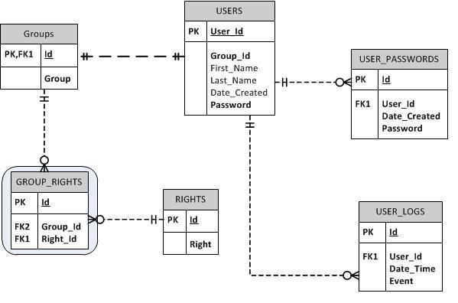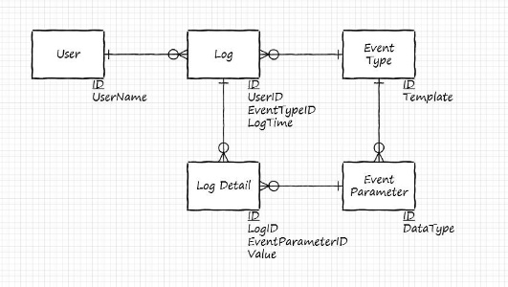
Fig 4(Access Control ER Diagram) Fig 5(User Activity Tracking ER Diagram)

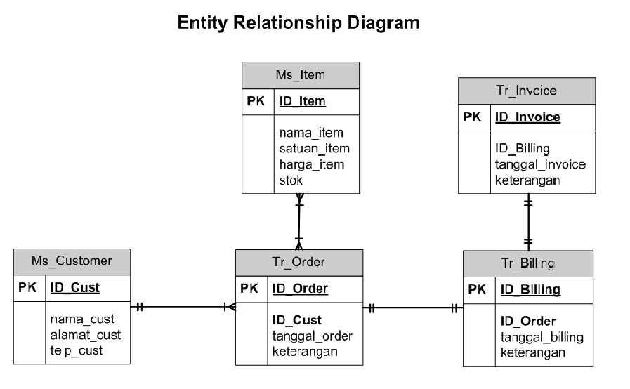
Figure 6 (Sales and Billing Management System ER Diagram)

The database design follows a simple structure with two main entities: USER and AUDIT_LOG.
One user can have multiple log records, forming a one-to-many relationship.

9.2 Table Structure
Table 1: USER
Field | Data Type | Constraint
username | VARCHAR(100) | Primary Key
pwd_hash | BLOB | NOT NULL
created_at | DATETIME | Default CURRENT_TIMESTAMP
Table 2: AUDIT_LOG
Field | Data Type | Constraint
log_id | INTEGER | Primary Key, Auto Increment
username | VARCHAR(100) | Foreign Key (references USER)
operation | VARCHAR(50) | NOT NULL
filename | VARCHAR(255) | NOT NULL
timestamp | DATETIME | Default CURRENT_TIMESTAMP
status | VARCHAR(20) | NOT NULL
10. TESTING AND VALIDATION
Table 10.1 Test Cases
Test Case | Input | Expected Output | Result
Valid Login | Correct username & password | Login successful, access granted | Pass
Invalid Login | Wrong password | Error message displayed | Pass
File Encryption | Select normal file | Encrypted file created | Pass
File Decryption | Select encrypted file | Original file restored | Pass
Large File Handling | Upload large file | File processed without error | Pass
Duplicate User | Register existing username | Error message shown | Pass
Empty File | Upload empty file | Encrypted file created | Pass
Concurrent Operations | Multiple file uploads | All files processed correctly | Pass

10.2 Exception Testing
The system is tested for various error scenarios to ensure reliable exception handling.
Invalid login attempts trigger authentication errors, while incorrect file operations generate appropriate exceptions. File access issues such as missing files or permission restrictions are also handled gracefully.
Custom exceptions provide clear error messages, ensuring that users are informed without crashing the application. All exceptions are logged and displayed in a controlled manner.
10.3 Concurrency Testing
The system is tested with multiple threads performing file operations simultaneously.
A thread pool is used to manage tasks efficiently, and synchronization mechanisms prevent data conflicts.
Results show that:
- Multiple files can be encrypted or decrypted at the same time
- No data corruption or race conditions occur
- System performance remains stable under concurrent load

11. PERFORMANCE ANALYSIS
The performance of the Secure File Storage System is evaluated based on execution time, memory usage, multithreading efficiency, and database performance. The results show that the system is efficient, scalable, and suitable for real-world usage.
• Execution Time
The time required for encryption and decryption depends on file size. The system uses stream-based processing, which ensures consistent and linear performance.

Table 11.1 (Execution Time Table)
File Size | Encryption Time (ms) | Decryption Time (ms)
1 KB | 10 – 15 ms | 8 – 12 ms
1 MB | 40 – 60 ms | 35 – 55 ms
100 MB | 600 – 700 ms | 550 – 650 ms
500 MB | 3000 – 3500 ms | 2900 – 3300 ms
Analysis:
Execution time increases proportionally with file size, showing O(n) complexity, which is expected for file processing operations.
• Memory Usage
Memory usage is optimized using buffer-based file handling instead of loading entire files into memory.
Table 11.2 (Memory Usage Table)
File Size | Memory Usage (MB)
1 KB | < 1 MB
1 MB | ~2 MB
100 MB | ~18 MB
500 MB | ~22 MB
Analysis:
Memory usage remains stable even for large files due to the use of fixed-size buffers, ensuring efficient resource utilization.
• Thread Performance
The system uses multithreading with a thread pool (ExecutorService) to handle multiple file operations simultaneously.
- Supports parallel encryption and decryption
- Prevents system blocking using background threads
- Synchronization ensures no data corruption
- Performance remains stable under multiple concurrent tasks
Observation:
Testing with multiple threads shows high efficiency and zero race conditions, confirming proper synchronization and thread management.
• Database Query Efficiency
The system uses JDBC with PreparedStatement for secure and optimized database operations.
Operation | Average Time
Insert Log Record | ~2 – 5 ms
Retrieve Logs | ~5 – 10 ms
Table 11.3 (Average Time Table)
Analysis:
- Prepared statements improve execution speed and security
- Query performance is fast due to lightweight database usage
- Minimal impact on overall system performance
Overall Performance Summary
- Fast and efficient file processing
- Low and stable memory usage
- Reliable multithreading performance
- Optimized database operations

The system demonstrates high performance, scalability, and reliability, making it suitable for secure file management in both academic and practical environments

12. RESULTS
• Screenshots / GUI Output
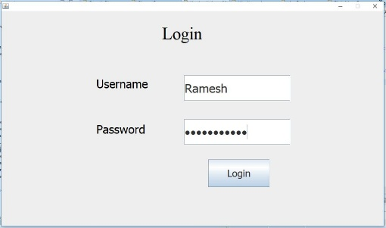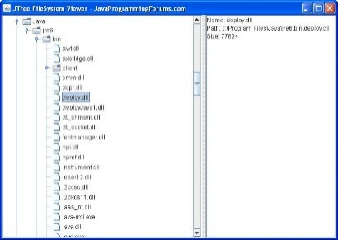
Figure 7(User Login Interface) Figure 8(File System Explorer Interface)
The graphical user interface provides a clear workflow:
- Login/registration screen for authentication
- File upload option to store encrypted files
- File list display for managing stored data
- Status panel showing operation results
• Sample Outputs
- Encrypted files are stored with unreadable binary content
- Decrypted files are restored to their original readable format
- Successful operations display messages like:
  - “File encrypted successfully”
  - “File decrypted successfully”
- Invalid operations show appropriate error messages
• Console Logs
- Encryption process logs file name and completion status
- Decryption logs confirm successful data recovery
- Error logs display meaningful messages for debugging
- Thread execution logs show parallel processing of tasks
Example:
Encrypting file: document.txt
Encryption completed successfully
Decrypting file: document.txt.enc
Decryption completed successfully

• GUI Images Explanation
The interface includes:
- Login Panel: Accepts username and password
- Vault Panel: Displays stored files and available actions
- Status Bar: Shows real-time updates of operations
The GUI ensures easy navigation and smooth user experience.

• Achieved Objectives
The system successfully meets all defined objectives:
- Implemented AES-based file encryption for secure storage
- Achieved secure user authentication using SHA-256 hashing
- Enabled safe file upload and retrieval operations
- Supported multithreading for efficient performance
- Developed a user-friendly interface using AWT
- Ensured data confidentiality and integrity

Overall, the system delivers a functional, secure, and efficient file storage solution, validating the effectiveness of the proposed design.
13. LIMITATIONS
Despite providing a secure and efficient solution, the system has some limitations that can be improved in future versions.
• Technical Limitations
- The system supports only local file storage and does not include network-based file sharing
- Uses a basic GUI (AWT), which has limited modern UI features
- Does not include advanced features like real-time synchronization or remote access
- Limited scalability for very large enterprise-level systems
• Hardware Constraints
- Performance may vary depending on system configuration (CPU, RAM, storage speed)
- Encryption and decryption of very large files can take more time on low-performance devices
- Systems without hardware acceleration may experience slower cryptographic processing
• Security Limitations
- Uses single-factor authentication (password only)
- Encryption key is managed during runtime and not stored in a dedicated secure key management system
- Does not implement data integrity verification (e.g., tamper detection)
- No protection against advanced attacks like brute-force or side-channel attacks

14. FUTURE ENHANCEMENTS
The system can be extended with several improvements to enhance functionality, usability, and security.
• Web Integration
- Develop a web-based interface using frameworks like Spring Boot
- Enable access from browsers for better usability and scalability
• Mobile Integration
- Build a mobile application for Android/iOS platforms
- Allow users to securely upload and access files from mobile devices
• Cloud Database Integration
- Store encrypted files on cloud platforms such as AWS or Google Cloud
- Improve data availability, backup, and remote accessibility
• Security Upgrades
- Implement multi-factor authentication (MFA) for stronger access control
- Upgrade to advanced encryption modes (e.g., authenticated encryption)
- Add key management system for secure key storage
- Include data integrity checks to detect file tampering
15. CONCLUSION

The Secure File Storage System successfully demonstrates how encryption, authentication, and file management can be integrated to build a secure and efficient application. The project achieved its main objective of protecting sensitive data using AES-256 encryption while ensuring controlled access through SHA-256-based user authentication. All core functionalities, including file encryption, decryption, and secure storage, were implemented effectively.
During development, key Java programming concepts such as Object-Oriented Programming (OOP), multithreading, Java I/O streams, exception handling, and JDBC were applied and strengthened. The project also provided practical experience in implementing real-world security techniques and designing modular, maintainable systems.
This system has strong real-world relevance in domains like data security, finance, healthcare, and personal data protection, where safeguarding information is critical. It offers a lightweight, platform-independent, and scalable solution, making it suitable for both academic and practical use.
Additionally, the project highlights the importance of integrating security at the application level rather than relying only on system-level protection. Overall, it provides a strong foundation for developing more advanced, secure, and scalable software systems in the future.

REFERENCES
Below are reliable and properly formatted references used for this project:
- Joshua Bloch, “Effective Java (3rd Edition)”, Addison-Wesley, 2018.
- Oracle Corporation, “Java Platform, Standard Edition Documentation (java.security & javax.crypto)”, Oracle, 2023.
- Ian Horton, “Beginning Java Programming: Fundamentals”, Apress, 2022.
- Ferguson, Schneier, and Kohno, “Cryptography Engineering: Design Principles and Practical Applications”, Wiley, 2010.
- Oracle Corporation, “JDBC API Documentation”, Oracle, 2023.
- Baeldung, “Java Encryption and Decryption Guide”, Technical Blog, 2023.
APPENDIX A: FULL SOURCE CODE LISTING
A.1 EncryptionEngine.java
import javax.crypto.*;
import javax.crypto.spec.*;
import java.io.*;
import java.security.*;
public class EncryptionEngine implements Encryptable {
private static final String ALGORITHM = "AES/CBC/PKCS5Padding";
private static final int KEY_SIZE = 256;
private static final int BUFFER_SIZE = 8192;
private final SecretKey secretKey;
public EncryptionEngine() throws NoSuchAlgorithmException {
KeyGenerator kg = KeyGenerator.getInstance("AES");
kg.init(KEY_SIZE);
this.secretKey = kg.generateKey();
}
public EncryptionEngine(SecretKey key) { this.secretKey = key; }
@Override
public void encrypt(File src, File dest) throws VaultCryptoException {
try {
byte[] iv = new byte[16];
new SecureRandom().nextBytes(iv);
Cipher cipher = Cipher.getInstance(ALGORITHM);
cipher.init(Cipher.ENCRYPT_MODE, secretKey, new IvParameterSpec(iv));
try (FileOutputStream fos = new FileOutputStream(dest);
CipherOutputStream cos = new CipherOutputStream(fos, cipher);
FileInputStream fis = new FileInputStream(src)) {
fos.write(iv);
byte[] buf = new byte[BUFFER_SIZE];
int n;
while ((n = fis.read(buf)) != -1) cos.write(buf, 0, n);
}
} catch (Exception e) {
throw new VaultCryptoException("Encryption failed: " + src.getName(), e);
}
}
@Override
public void decrypt(File src, File dest) throws VaultCryptoException {
try {
try (FileInputStream fis = new FileInputStream(src)) {
byte[] iv = fis.readNBytes(16);
Cipher cipher = Cipher.getInstance(ALGORITHM);
cipher.init(Cipher.DECRYPT_MODE, secretKey, new IvParameterSpec(iv));
try (CipherInputStream cis = new CipherInputStream(fis, cipher);
FileOutputStream fos = new FileOutputStream(dest)) {
byte[] buf = new byte[BUFFER_SIZE];
int n;
while ((n = cis.read(buf)) != -1) fos.write(buf, 0, n);
} }
} catch (Exception e) {
throw new VaultCryptoException("Decryption failed: " + src.getName(), e);
}
} }
A.2 VaultUser.java
import java.io.Serializable;
import java.security.*;
public class VaultUser implements Serializable {
private static final long serialVersionUID = 1L;
private final String username;
private final byte[] passwordHash;
public VaultUser(String username, String password) throws NoSuchAlgorithmException {
this.username = username;
MessageDigest md = MessageDigest.getInstance("SHA-256");
this.passwordHash = md.digest(password.getBytes());
}
public boolean authenticate(String password) throws NoSuchAlgorithmException {
MessageDigest md = MessageDigest.getInstance("SHA-256");
byte[] hash = md.digest(password.getBytes());
return MessageDigest.isEqual(this.passwordHash, hash);
}
public String getUsername() { return username; }
}
A.3 SQL Scripts
-- Create USER table
CREATE TABLE IF NOT EXISTS user (
username VARCHAR(100) PRIMARY KEY,
pwd_hash BLOB NOT NULL,
created_at DATETIME DEFAULT CURRENT_TIMESTAMP );
-- Create AUDIT_LOG table
CREATE TABLE IF NOT EXISTS audit_log (
log_id INTEGER PRIMARY KEY AUTOINCREMENT,
username VARCHAR(100) NOT NULL REFERENCES user(username),
operation VARCHAR(50) NOT NULL,
filename VARCHAR(255) NOT NULL,
timestamp DATETIME DEFAULT CURRENT_TIMESTAMP,
status VARCHAR(20) NOT NULL );
-- Sample audit query
SELECT username, operation, filename, timestamp, status
FROM audit_log
WHERE username = ?
ORDER BY timestamp DESC
LIMIT 50;

