Exploratory Data Analysis
STOR 320.002 Group 16
April 27, 2026

Load Necessary Libraries
suppressPackageStartupMessages(library(tidyverse))
## Warning: package 'purrr' was built under R version 4.5.3
suppressPackageStartupMessages(library(janitor))
suppressPackageStartupMessages(library(funModeling))
suppressPackageStartupMessages(library(skimr))
suppressPackageStartupMessages(library(readxl))
suppressPackageStartupMessages(library(readr))
suppressPackageStartupMessages(library(lubridate))
suppressPackageStartupMessages(library(DataExplorer))
suppressPackageStartupMessages(library(dlookr))
suppressPackageStartupMessages(library(knitr))
suppressPackageStartupMessages(library(gt))
suppressPackageStartupMessages(library(ggridges))
suppressPackageStartupMessages(library(PerformanceAnalytics))
## Warning: package 'PerformanceAnalytics' was built under R version 4.5.3
## Warning: package 'xts' was built under R version 4.5.3
knitr::opts_chunk$set(echo = TRUE)
options(scipen = 999) # big number = strongly discourages scientific notation
knitr::opts_chunk$set(
echo = TRUE,
tidy = TRUE,
tidy.opts = list(
width.cutoff = 80,
arrow = TRUE, # makes pipes look nicer
indent = 2
),
message = FALSE,
warning = FALSE
)
options(width = 90) # helps with printed tables too

Statement of the Business Problem.
What is the “Business” Problem?
- Consumers, automakers, and policymakers face a growing challenge in navigating the tension between vehicle design and performance on one hand, and competing pressures on the other, including after-purchase financial realities such as rising fuel costs, alongside fuel efficiency regulations and environmental protection measures. This has made understanding real-world fuel costs increasingly critical for consumers, manufacturers, and regulators alike.
What are the goals that the “business” wants to achieve?
- The goal of this analysis is to explore the 2025 EPA Fuel Economy dataset which contains 868 vehicle configurations across 23 manufacturers and 20 vehicle classes, to identify the key vehicle features that are most associated with annual fuel cost. By doing so, we aim to clarify which design and technology choices drive the cost of fueling a vehicle, and where the biggest gaps between vehicles lie.
How does the business currently work?
- The EPA currently tests every new vehicle model annually and publishes city, highway, and combined MPG estimates, GHG ratings on a 1-10 scale, and annual fuel cost estimates through the Fuel Economy Guide and fueleconomy.gov. However, these figures tell consumers what a vehicle’s predicted fuel cost is, but not what the underlying factors are that cause these levels of costs, leaving the relationship between specific design features and fuel cost outcomes largely opaque to both consumers and analysts.
In what ways could a predictive analytics model help to address the business problem?
- A predictive model built on this data could estimate a vehicle’s annual fuel cost from its design features and fuel efficiency characteristics, such as engine displacement, drive type, and fuel efficiency. This would help consumers anticipate the true long-term cost of owning a vehicle beyond the sticker price, help automakers identify which feature combinations minimize fuel costs for consumers, and help policymakers evaluate whether current regulations are effectively incentivizing designs that reduce the financial burden of fuel on drivers, ultimately supporting better decisions across all three groups.

Clean the Data and Take A Glimpse
knitr::opts_chunk$set(echo = TRUE)
library(tidyverse)
# Import Data Below
# read_csv()
cars_fe <- read.csv("Group 16 2025 Fuel Economy Dataset(FEguide).csv") |>
clean_names() |>
mutate(across(where(is.character), ~ str_squish(.))) |>
mutate(across(where(is.character),
~ na_if(.x, ""))) |>
mutate(across(where(is.character),
~ case_when(
.x %in% c("", " ", "NA", "NULL", "N/A", "?", "-") ~ NA_character_,
TRUE ~ .x)))

Convert all Characters to Factors
cars_fe <- cars_fe |>
mutate(
across(where(is.character), as.factor),
release_date = as.Date(release_date, format = "%m/%d/%Y")
)

Extracting all Numeric Features
cars_fe_num_data <- cars_fe |>
select_if(is.numeric)

Skimming all Numeric Features
num_s <- skim_without_charts(cars_fe_num_data)

Extracting Some Interesting Outputs
focus_table <- as.data.frame(num_s) |>
select(
skim_variable,
numeric.p0,
numeric.p25,
numeric.mean,
numeric.p50,
numeric.p75,
numeric.p100,
numeric.sd
)

Adding a Count Column to the Table
focus_table$count <- rep(868, 15)
focus_table <- focus_table |>
relocate(count, .before = 2)

Constructing Numeric Data Quality Report
extra_two <- funModeling::status(cars_fe_num_data)[, c("p_na", "unique")]
rownames(extra_two) <- NULL
numeric_report_table <- cbind(focus_table, extra_two)
numeric_report_table <- numeric_report_table |>
relocate(p_na, .before = 3) |>
relocate(unique, .before = 4)
names(numeric_report_table) <- c("Feature",
"Count",
"% Missing",
"Cardinality",
"Min",
"1st Qrt.",
"Mean",
"Median",
"3rd Qrt.",
"Max",
"Std. Dev.")

Storing Categorical Features
cars_fe_cat_data <- cars_fe |>
select_if(is.factor)

Skimming and Viewing Data Summary of Categorical Features as a Whole
cars_fe_cat_data |>
skim() |>
summary()
Data summary
Name | cars_fe_cat_data
Number of rows | 868
Number of columns | 12
_______________________
Column type frequency:
factor | 12
________________________
Group variables | None

Storing Detailed Statistics for Every Individual Variable
cat_s <- skim_without_charts(cars_fe_cat_data)

Creating a Focus Table
focus_table_2 <- as.data.frame(cat_s) |>
select(
skim_variable,
n_missing,
complete_rate,
factor.n_unique,
factor.top_counts
)

Constructing Categorical Data Quality Report
focus_table_2 <- focus_table_2 |>
mutate(Count = nrow(cars_fe))
cat_report_table <- focus_table_2 |>
tidyr::extract(
factor.top_counts,
into = c("Mode", "Mode Freq.", "2nd Mode", "2nd Mode Freq."),
regex = "(.+?):\\s*(\\d+), \\s*(.+?):\\s*(\\d+)",
remove = TRUE
) |>
mutate(
`Mode Freq.` = as.numeric(`Mode Freq.`),
`2nd Mode Freq.` = as.numeric(`2nd Mode Freq.`),
`% Miss.` = round(100 * n_missing / Count, 2),
`Mode %` = round(100 * `Mode Freq.` / Count, 2),
`2nd Mode %` = round(100 * `2nd Mode Freq.` / Count, 2)
) |>
rename(
Feature = skim_variable,
Cardinality = factor.n_unique
) |>
select(
Feature,
Count,
`% Miss.`,
Cardinality,
Mode,
`Mode Freq.`,
`Mode %`,
`2nd Mode`,
`2nd Mode Freq.`,
`2nd Mode %`
)

Final Table Data Quality Report: Numeric Features
numeric_report_table
## Feature Count % Missing Cardinality Min 1st Qrt. Mean
## 1 model_year 868 0.00000000 1 2025.0000 2025.00000 2025.000000
## 2 engine_displacement 868 0.00000000 32 1.2000 2.00000 2.956567
## 3 num_of_cylinders 868 0.00000000 7 3.0000 4.00000 5.297235
## 4 city_fe 868 0.00000000 45 8.0000 17.00000 21.754608
## 5 hwy_fe 868 0.00000000 41 12.0000 23.00000 27.428571
## 6 comb_fe 868 0.00000000 44 9.0000 19.00000 23.892857
## 7 city_unadj_fe 868 0.00000000 555 9.5000 21.32960 28.154119
## 8 hwy_unadj_fe 868 0.00000000 581 16.5000 32.49907 39.559594
## 9 comb_unadj_fe 868 0.00000000 738 11.7416 25.24697 32.153329
## 10 num_gears 868 0.00000000 7 1.0000 7.00000 7.668203
## 11 max_ethanol_percent 868 0.02073733 3 10.0000 10.00000 17.694118
## 12 max_biodiesel_percent 868 0.97926267 1 20.0000 20.00000 20.000000
## 13 annual_fuel_cost 868 0.00000000 53 900.0000 2100.00000 2641.647465
## 14 ghg_rating 868 0.00000000 8 1.0000 4.00000 4.691244
## 15 x4dr_pass_vol 868 0.75576037 32 87.0000 94.00000 100.259434
## Median 3rd Qrt. Max Std. Dev.
## 1 2025.00000 2025.00000 2025.0000 0.000000
## 2 2.70000 3.50000 8.0000 1.170944
## 3 4.00000 6.00000 16.0000 1.714755
## 4 20.00000 25.00000 57.0000 7.422085
## 5 26.00000 32.00000 58.0000 6.698704
## 6 23.00000 27.00000 57.0000 6.995882
## 7 25.50440 31.80000 82.8000 10.873110
## 8 37.79105 46.12728 77.8000 9.741842
## 9 29.88570 36.98208 80.4727 10.206697
## 10 8.00000 9.00000 10.0000 2.153949
## 11 10.00000 15.00000 85.0000 19.838288
## 12 20.00000 20.00000 20.0000 0.000000
## 13 2550.00000 3100.00000 7100.0000 783.904509
## 14 5.00000 5.00000 8.0000 1.299123
## 15 99.00000 102.00000 157.0000 11.504940

Final Table Data Quality Report: Categorical Features
cat_report_table
## Feature Count % Miss. Cardinality Mode Mode Freq. Mode % 2nd Mode
## 1 mfr_name 868 0.00 23 Gen 144 16.59 Toy
## 2 division 868 0.00 41 TOY 78 8.99 BMW
## 3 carline 868 0.00 670 SIL 9 1.04 SIL
## 4 trans_description 868 0.00 7 Sem 382 44.01 Aut
## 5 lockup_torque_converter 868 0.00 2 Y 673 77.53 N
## 6 trans_creeper_gear 868 0.00 2 N 860 99.08 Y
## 7 drive_desc 868 0.00 5 All 353 40.67 2-W
## 8 fuel_usage_desc 868 0.00 5 Gas 415 47.81 Gas
## 9 descriptor_model_type 868 7.49 11 SID 402 46.31 SID
## 10 carline_class_desc 868 0.00 20 Sma 170 19.59 Sta
## 11 stop_start_system_status 868 0.00 2 Yes 708 81.57 No
## 12 air_aspiration 868 0.00 5 Tur 557 64.17 Nat
## 2nd Mode Freq. 2nd Mode %
## 1 115 13.25
## 2 73 8.41
## 3 9 1.04
## 4 211 24.31
## 5 195 22.47
## 6 8 0.92
## 7 169 19.47
## 8 225 25.92
## 9 172 19.82
## 10 134 15.44
## 11 160 18.43
## 12 266 30.65

Data Issues and Outline of proposed Handling Techniques.
- In our data, the features x4dr_pass_vol and max_biodiesel_percent are missing over 50% of their values. This is because these categories do not apply to every car. The maximum biodiesel percent has 97.93% missing with a cardinality of 1. We have decided to handle this by removing the variable and not analyzing it going forward. The feature x4dr_pass_vol or the passenger volume in a 4-door car has a missing percentage of 75.57%. While this percentage is very high, it is a variable we have been exploring; it will end up being only applicable to 4-door vehicles. We can also remove the model_year variable because our dataset is strictly 2025, so all the vehicles have the same model year.

Creator: Annabelle Lawson

Q1: Is there an association between the transmission type and the combined (guide) FE?
ggplot(cars_fe, aes(x = comb_fe, y = fct_reorder(trans_description, comb_fe, median))) +
geom_boxplot() +
labs(
title = "Comparison of Transmission Types using Combined Fuel Efficiency",
x = "Combined Fuel Efficiency",
y = "Transmission Type"
)
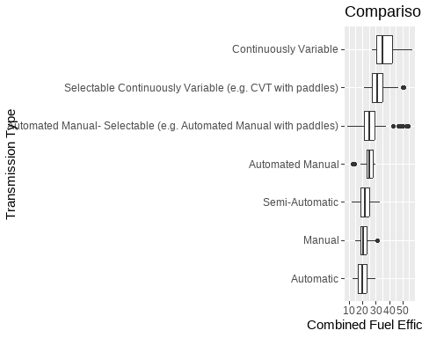

Q2: What is the correlation between the guide and unadjusted FE between city, hwy, and combined?
library(cowplot)
city <- ggplot(cars_fe, aes(x = city_fe, y = city_unadj_fe))+
geom_point()+
labs(
title = "City Fuel Efficiency:Guide vs Unadjusted",
x = "City Guide Fuel Efficiency",
y = "City Unadjusted Fuel Efficiency"
)
hwy <- ggplot(cars_fe, aes(x = hwy_fe, y = hwy_unadj_fe))+
geom_point()+
labs(
title = "Highway Fuel Efficiency:Guide vs Unadjusted",
x = "Highway Guide Fuel Efficiency",
y = "Highway Unadjusted Fuel Efficiency"
)
comb <- ggplot(cars_fe, aes(x = comb_fe, y = comb_unadj_fe))+
geom_point()+
labs(
title = "Combined Fuel Efficiency:Guide vs Unadjusted",
x = "Combined Guide Fuel Efficiency",
y = "Combined Unadjusted Fuel Efficiency"
)
plot_grid(city, hwy, comb, ncol = 3)
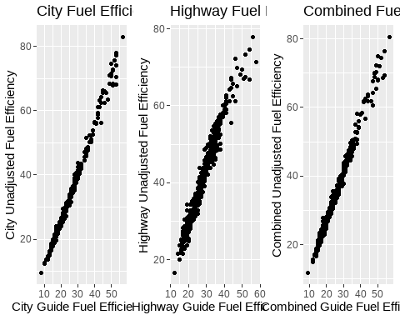

Interpreter: Cooper Lair

Q1: Are there ethanol percentage differences across different divisions of the same manufacturer?
multi_div_mfr <- cars_fe |>
group_by(mfr_name) |>
filter(n_distinct(division) > 1) |>
ungroup()
multi_div_mfr |>
filter(!is.na(max_ethanol_percent)) |>
ggplot(aes(x = division, y = max_ethanol_percent)) +
geom_point() +
facet_wrap(~ mfr_name, scales = "free_x") +
scale_y_continuous(expand = expansion(mult = c(0.05, 0.2))) +
coord_cartesian(ylim = c(0, 90)) +
labs(
title = "Ethanol Percentage by Division",
x = "Division",
y = "Max Ethanol Percentage"
) +
theme_minimal() +
theme(axis.text.x = element_text(angle = 45, hjust = 1))
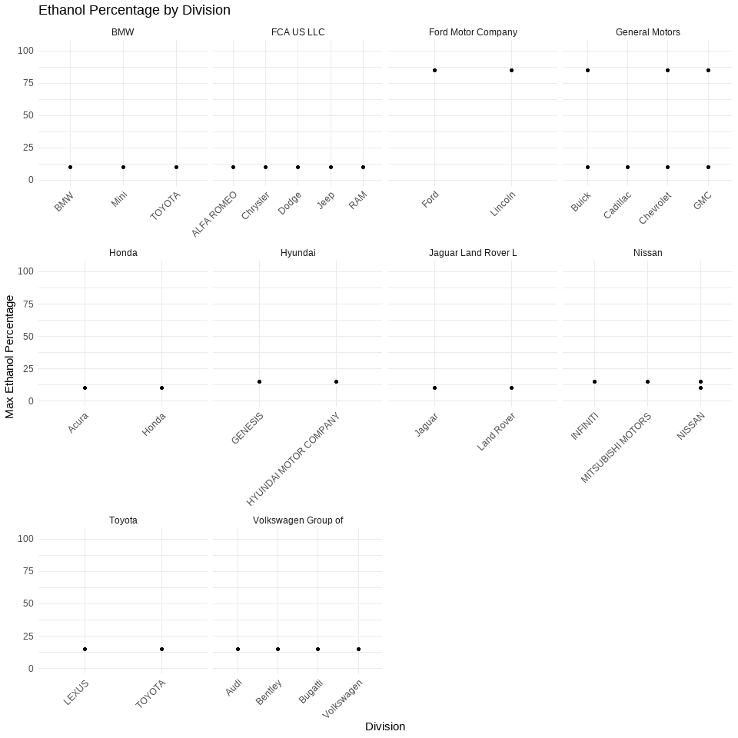

Q2: Are there a set of factors that can predict the average cost of fuel?
num_data <- cars_fe_num_data |>
select(
annual_fuel_cost,
engine_displacement,
num_of_cylinders,
city_fe,
hwy_fe,
comb_fe
) |>
na.omit()
cor_matrix <- cor(num_data)
cor_df <- as.data.frame(as.table(cor_matrix))
ggplot(cor_df, aes(Var1, Var2, fill = Freq)) +
geom_tile() +
geom_text(aes(label = round(Freq, 2)), size = 3) +
scale_fill_gradient2(low = "blue", mid = "white", high = "red", midpoint = 0) +
labs(
title = "Correlation Matrix of Factors Affecting Fuel Cost",
x = "",
y = "",
fill = "Correlation"
) +
theme_minimal() +
theme(axis.text.x = element_text(angle = 45, hjust = 1))
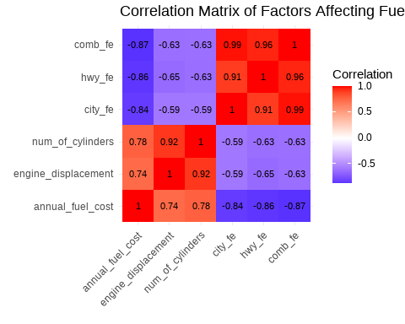

Orator 1: SAMAY SURATWALA

Q1: How does the correlation between engine displacement and combined fuel efficiency vary when comparing different drive types (AWD vs FWD vs RWD)?
ggplot(cars_fe,
aes(x = engine_displacement, y = comb_fe, color = drive_desc)) +
geom_point(alpha = 0.4) +
geom_smooth(method = "lm", se = FALSE) +
labs(
title = "Engine Displacement (L) vs Combined Fuel Efficiency (MPG) with Drive Type",
x = "Engine Displacement (L)",
y = "Combined Fuel Efficiency (MPG)",
color = "Drive Type"
) +
theme_bw() +
theme(legend.position = "bottom")
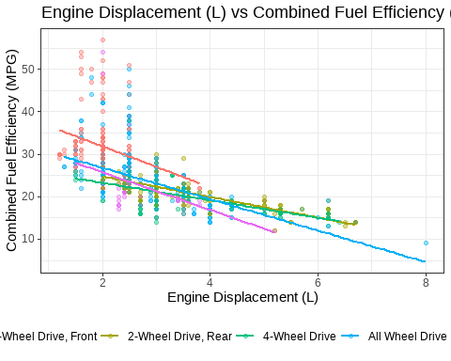

Q2: Is there a significant Greenhouse gas gap between cars with 4-cylinder engines vs 6-cylinder engines, or has modern turbocharging narrowed that gap?
#
cyl_ghg_asp <- cars_fe |>
filter(num_of_cylinders %in% c(4, 6)) |>
mutate(
chosen_cylinders = factor(num_of_cylinders, labels = c("4-Cylinder", "6-Cylinder")),
air_aspiration = factor(air_aspiration)
) |>
filter(air_aspiration %in% c("Naturally Aspirated", "Turbocharged")) |>
mutate(air_aspiration = droplevels(air_aspiration))
ggplot(cyl_ghg_asp, aes(x = ghg_rating, fill = chosen_cylinders)) +
geom_density(alpha = 0.5) +
facet_wrap(~air_aspiration, ncol = 2) +
labs(
title = "Has Modern Turbocharging Narrowed The Greenhouse Gas (GHG) Gap?",
x = "GHG Rating (1-10)",
y = "Density",
fill = "Cylinders"
) +
theme_bw() +
theme(legend.position = "bottom")
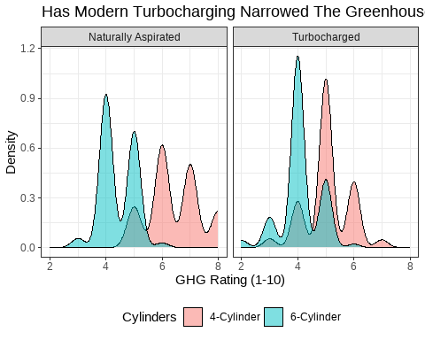
ggplot(cyl_ghg_asp, aes(x = air_aspiration,
y = ghg_rating,
color = chosen_cylinders,
group = chosen_cylinders)) +
stat_summary(fun.data = mean_cl_normal, geom = "pointrange") +
geom_line(stat = "summary", fun = mean) +
labs(
title = "Has Modern Turbocharging Narrowed The Greenhouse Gas (GHG) Gap?",
x = "Air Aspiration Type",
y = "Mean GHG (1-10) Rating",
color = "Cylinders"
) +
theme_dark() +
theme(legend.position = "bottom")
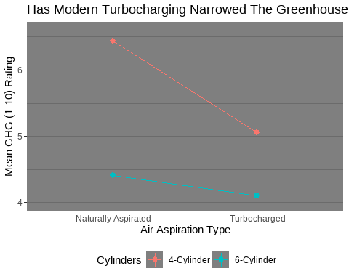

Deliverer: Akshita Padala

Q1: Does drive type (AWD vs FWD vs RWD) have a different efficiency penalty on vehicles of different car-line class descriptions (e.g., “Small SUV”, “Two Seaters”?
cars_fe |>
filter(!is.na(carline_class_desc), !is.na(drive_desc), !is.na(comb_fe)) |>
mutate(
drive_desc = droplevels(drive_desc),
carline_class_desc = droplevels(carline_class_desc)
) |>
ggplot(aes(x = drive_desc, y = comb_fe, fill = drive_desc)) +
geom_boxplot(alpha = 0.7, outlier.alpha = 0.3) +
facet_wrap(~ carline_class_desc, scales = "free_y") +
labs(
title = "Fuel Efficiency Differences by Drive Type Across Vehicle Classes",
x = "Drive Type",
y = "Combined Fuel Efficiency (MPG)",
fill = "Drive Type"
) +
theme_bw() +
theme(
legend.position = "none",
strip.text = element_text(size = 8)
)
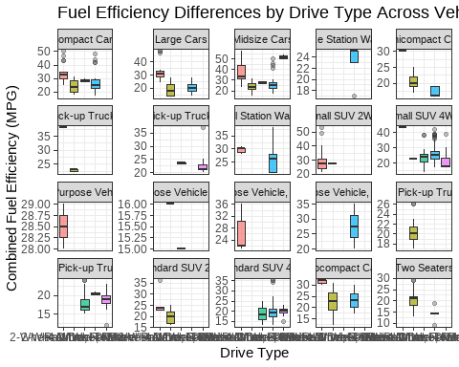

Q2: Is there a relationship between number of gears in a transmission and combined fuel efficiency?
cars_fe |>
filter(!is.na(num_gears), !is.na(comb_fe)) |>
ggplot(aes(x = num_gears, y = comb_fe)) +
geom_jitter(alpha = 0.3, width = 0.2) +
geom_smooth(method = "lm", se = FALSE, color = "blue") +
labs(
title = "Relationship Between Number of Gears and Fuel Efficiency",
x = "Number of Gears",
y = "Combined Fuel Efficiency (MPG)"
) +
theme_bw()
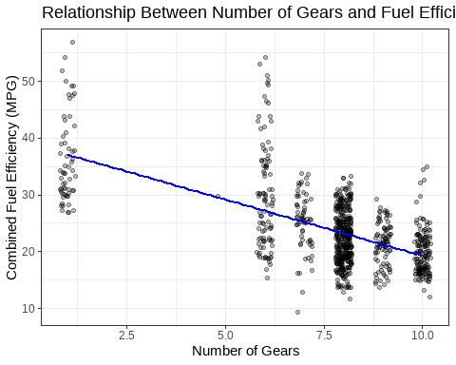

Orator 2: Alexa Kislowski

Q1: Which car manufacturers are best at efficient packaging - providing the most interior passenger space per gallon of fuel consumed?
efficiency <- cars_fe |>
mutate(space_per_mpg = x4dr_pass_vol / comb_fe) |>
group_by(division) |>
summarise(
avg_space_per_mpg = mean(space_per_mpg, na.rm=TRUE)) |>
arrange(avg_space_per_mpg) |>
filter(!is.nan(avg_space_per_mpg))
ggplot(efficiency, aes(y = reorder(division, avg_space_per_mpg), x = avg_space_per_mpg)) +
geom_col() +
labs(y = "Division",
x = expression("Avg Space per MPG (ft"^3*"/MPG)")) +
theme_bw()
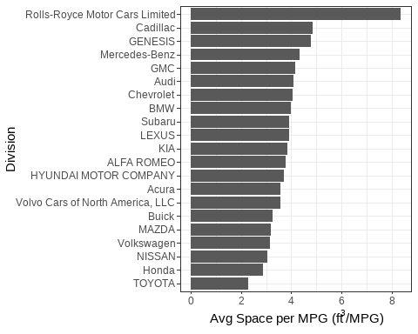

Q2: Is there a significant impact of the presence of Stop/Start system on City MPG (where stopping occurs more often) across different engine sizes?
ggplot(cars_fe, aes(x= city_fe, y= engine_displacement, color= stop_start_system_status)) +
geom_point() +
labs(
title = "Is there an impact of having a Start/Stop System on City MPG across engine sizes?",
x = "City MPG",
y= "Engine Size",
color = "Stop/Start System"
)
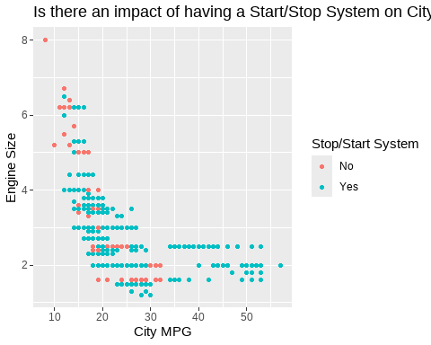

Follow-up Questions

New Questions Based Off Initial Investigation
- Q1: Is the fuel-cost advantage of Stop/Start systems consistent across vehicle classes, or concentrated in specific ones? (Extension of Q8)
- Q2: Do vehicle class and drive type together explain variation in combined fuel economy beyond what either explains alone? (Extension of Q1 and Q5)
- Q3: Does air aspiration type moderate the relationship between engine displacement and annual fuel cost? (Extension of Q4 and Q5)
- Q4: Is there a relationship between vehicle class and fuel-saving technologies (Stop/Start, turbocharging, and hybrid descriptors), and do those technology combinations predict better fuel economy outcomes? (Extension of Q6 and Q8)

Investigation of Follow-up Questions
GIVE WHAT 2 QUESTIONS YOU ATTEMPTED TO INVESTIGATE FURTHER IN COMPLETE SENTENCES
- Our group decided to investigate Q1 and Q3 in further detail.
SHOW AT LEAST 2 TABLES OR FIGURES BELOW THAT EXPLORE ANSWERS FOR THE QUESTIONS YOU ARE INVESTIGATING FURTHER.

Q1: Is the fuel-cost advantage of Stop/Start systems consistent across vehicle classes, or concentrated in specific ones?
stop_start_by_class <- cars_fe |>
select(
carline_class_desc,
stop_start_system_status,
city_fe
)
stop_start_by_class <- stop_start_by_class |>
filter(!carline_class_desc %in% c(
"Special Purpose Vehicle 2WD",
"Special Purpose Vehicle, minivan 4WD",
"Small Pick-up Trucks 2WD",
"Special Purpose Vehicle cab chassis",
"Midsize Station Wagons",
"Special Purpose Vehicle, minivan 2WD",
"Small Pick-up Trucks 4WD",
"Standard Pick-up Trucks 2WD"))
stop_start_by_class |>
filter(!is.na(stop_start_system_status)) |>
ggplot(aes(x = stop_start_system_status,
y = city_fe,
fill = stop_start_system_status)) +
stat_summary(fun = mean, geom = "bar", width = 0.6) +
stat_summary(fun.data = mean_se, geom = "errorbar", width = 0.25, linewidth = 0.5) +
facet_wrap(~ carline_class_desc, ncol = 4) +
labs(
title = "City FE by Stop/Start System Presence Across Vehicle Classes",
subtitle = "Bars show mean city MPG, lines above show standard error · 2025 EPA Fuel Economy Data",
x = NULL,
y = "Mean City FE (MPG)",
fill = "Stop/Start",
caption = "Sparse vehicle classes removed (n < 10)"
) +
theme_minimal(base_size = 10)
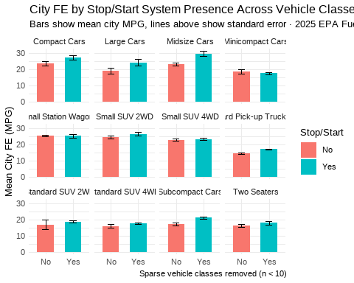
stop_start_diff <- stop_start_by_class |>
filter(!is.na(stop_start_system_status)) |>
group_by(carline_class_desc, stop_start_system_status) |>
summarise(mean_city_fe = mean(city_fe, na.rm = TRUE), .groups = "drop") |>
pivot_wider(names_from = stop_start_system_status,
values_from = mean_city_fe) |>
mutate(diff = Yes - No)
ggplot(stop_start_diff, aes(x = diff, y = reorder(carline_class_desc, diff), fill = diff > 0)) +
geom_col(width = 0.6) +
scale_fill_manual(values = c("TRUE" = "#185FA5", "FALSE" = "#D85A30"),
labels = c("TRUE" = "Stop/Start helps", "FALSE" = "Stop/Start hurts"),
name = NULL) +
labs(
title = "City FE Advantage of Stop/Start System by Vehicle Class",
x = "Mean City FE Difference (MPG)",
y = NULL,
caption = "Sparse vehicle classes removed (n < 10)"
) +
theme_minimal()
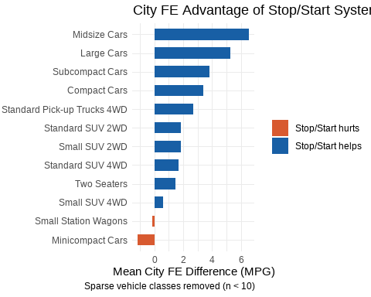

Q3: Does air aspiration type moderate the relationship between engine displacement and annual fuel cost? (Extension of Q4 and Q5)
aspiration_data <- cars_fe |>
select(
engine_displacement,
air_aspiration,
annual_fuel_cost
) |>
filter(
air_aspiration %in% c("Turbocharged", "Naturally Aspirated")
)
aspiration_data |>
ggplot(aes(x = engine_displacement, y = annual_fuel_cost, color = air_aspiration)) +
geom_point() +
geom_smooth(method = "lm", se = TRUE, linewidth = 1)
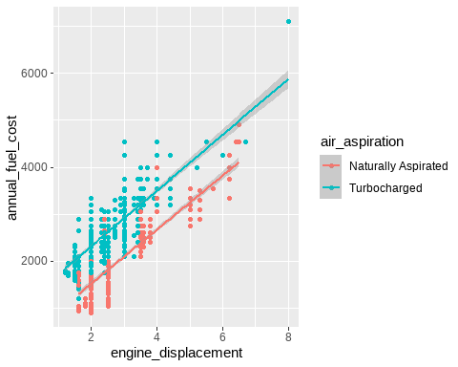

Summary
GIVE A 2 PARAGRAPH SUMMARY.
PARAGRAPH 1 SHOULD DESCRIBE WHAT YOU LEARNED ABOUT YOUR DATA FROM INVESTIGATING THE INITIAL QUESTIONS. DID YOU FIND ANYTHING UNUSUAL IN YOUR DATA? DID ANYTHING SURPRISE YOU? WHICH OF THE INITIAL QUESTIONS WERE HELPFUL IN LEADING YOU TO MORE QUESTIONS?
PARAGRAPH 2 SHOULD SUMMARIZE WHAT YOU LEARNED FROM INVESTIGATING THE FOLLOW-UP QUESTIONS. WHY ARE THESE FOLLOW-UP QUESTIONS INTERESTING FOR INVESTIGATION? DESCRIBE THE TABLES/FIGURES YOU USED TO EXPLORE ANSWERS TO THESE FOLLOW-UP QUESTIONS? WHAT DID YOU LEARN FROM THE TABLES/FIGURES REGARDING THE FOLLOW-UP QUESTIONS YOU PROPOSED?
One of the initial questions that we investigated was about the impact of Start/Stop systems across different engine sizes on city fuel efficiency. Our observations from this visualization were that cars with a start/stop system tend to have a much higher city MPG than cars without it across engine sizes with the difference being most noticeable in engines with smaller displacement. This led us to develop more questions about whether the results from this question are consistent across vehicle classes or concentrated in specific ones. One interesting thing we observed came from investigating the question about which factors could be used to predict the cost of fuel, the correlation matrix shows that the features most correlated with annual_fuel_cost are engine_displacement and num_of_cylinders, meaning that larger, more powerful engines will often increase the amount spent on fuel. Another question that led us to more questions was about the correlation between engine displacement and combined fuel efficiency when comparing different drive types (AWD vs FWD vs RWD). All of the drive types had a negative correlation with combined FE, but FWD seemed to have a slightly higher combined FE than other drive types.
Our two follow-up questions investigated whether the impact of Start/Stop systems on city MPG was consistent across vehicle classes or concentrated in specific ones. We created a set of visualizations which show the difference in mean and variability of cars with Start/Stop systems and those without, separated by vehicle classes. From this we found that Stop/Start systems help in most vehicle classes, with the highest advantage for midsize and large cars. It also hurts fuel efficiency in minicompact cars and small station wagons. We also investigated if air aspiration type moderates the relationship between engine displacement and annual fuel cost. We created a dot plot visualization that showed engine displacement and annual fuel cost on the axes, with the points that were plotted being separated by color based on the air aspiration type which allowed us to see the impact of air aspiration type on the relationship between engine displacement and fuel cost. The graph shows a clear split between naturally aspirated and turbocharged cars. Both regression lines are roughly parallel with the turbo line being higher meaning turbocharged cars generally cost more than naturally aspirated as the engine displacement rises.

