Assigment-2

1. Which of the following components of program state are shared across threads in a multithreaded process?

a. Register values

b. Heap memory

c. Global variables

d. Stack memory

1. The program shown in the following figure uses the Pthreads API. What would be the output from the program at LINE C and LINE P ?

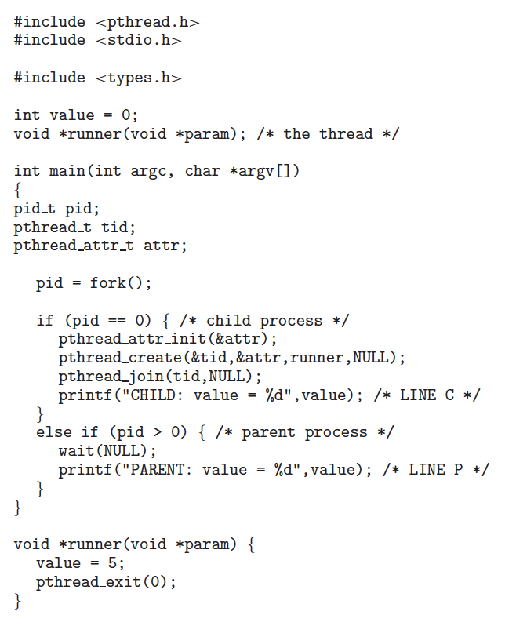

LINE C: CHILD: value = 5

LINE P: PARENT: value = 0