Assigment-1

Hint: wait() is a system call that is usually called in the parent process by passing a null argument to it, i.e. wait(NULL). The purpose of calling wait(NULL) is to suspend the parent process until the child process terminates.

1. What output will be at line A?

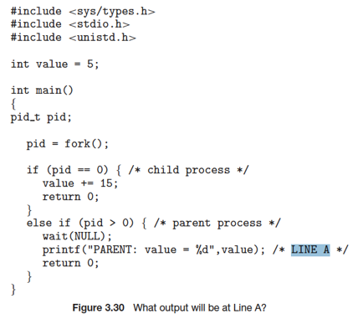

A: PARENT: value = 5

Hint: the return value of fork() is:

* 0, for the child process
* the PID of the child process, for the parent process

1. Assume that the pids of parent and child are 2600 and 2603, respectively. Identify the values of pids at lines A, B, C, D. Hint: getpid() is a system call that returns the PID of the calling process.

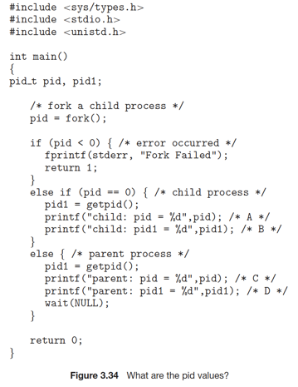

A: child: pid = 0

B: child: pid1 = 2603

C: child: pid = 2603

D: child: pid1 = 2600