Assigment-10

1.

Consider the following page reference string:

7, 2, 3, 1, 2, 5, 3, 4, 6, 7, 7, 1, 0, 5, 4, 6, 2, 3, 0, 1.

Assuming demand paging with three frames, how many page faults would occur for the following replacement algorithms?

• LRU replacement A:18

• FIFO replacement A:17

• Optimal replacement A:13

|  |  |  |  |  |  |  |  |  |  |  |
| --- | --- | --- | --- | --- | --- | --- | --- | --- | --- | --- |
|  |  | LRU | | | FIFO | | | OPTIMAL | | |
| NO. | current | frame | fault | count | frame | fault | count | frame | fault | count |
| 1 | 7 |  | T | 1 |  | T | 1 |  | T | 1 |
| 2 | 2 | 7 | T | 2 | 7 | T | 2 | 7 | T | 2 |
| 3 | 3 | 72 | T | 3 | 72 | T | 3 | 72 | T | 3 |
| 4 | 1 | 723 | T | 4 | 723 | T | 4 | 723 | T | 4 |
| 5 | 2 | 231 | F | 4 | 231 | F | 4 | 123 | F | 4 |
| 6 | 5 | 312 | T | 5 | 312 | T | 5 | 123 | T | 5 |
| 7 | 3 | 152 | T | 6 | 125 | T | 6 | 531 | F | 5 |
| 8 | 4 | 523 | T | 7 | 253 | T | 7 | 531 | T | 6 |
| 9 | 6 | 345 | T | 8 | 534 | F | 7 | 451 | T | 7 |
| 10 | 7 | 346 | T | 9 | 346 | T | 8 | 614 | T | 8 |
| 11 | 7 | 746 | F | 9 | 467 | F | 8 | 715 | F | 8 |
| 12 | 1 | 746 | T | 10 | 467 | T | 9 | 715 | F | 8 |
| 13 | 0 | 716 | T | 11 | 571 | T | 10 | 715 | T | 9 |
| 14 | 5 | 710 | T | 12 | 710 | T | 11 | 105 | F | 9 |
| 15 | 4 | 510 | T | 13 | 105 | T | 12 | 105 | T | 10 |
| 16 | 6 | 540 | T | 14 | 054 | T | 13 | 104 | T | 11 |
| 17 | 2 | 546 | T | 15 | 546 | T | 14 | 106 | T | 12 |
| 18 | 3 | 246 | T | 16 | 462 | T | 15 | 102 | T | 13 |
| 19 | 0 | 236 | T | 17 | 623 | T | 16 | 103 | F | 13 |
| 20 | 1 | 230 | T | **18** | 230 | T | **17** | 103 | F | **13** |

2.

The page table shown in the following figure is for a system with 16-bit virtual and physical addresses and with 4,096-byte pages. The reference bit is set to 1 when the page has been referenced. Periodically, a thread zeroes out all values of the reference bit. A dash for a page frame indicates the page is not in memory. The page-replacement algorithm is localized LRU, and all numbers are provided in decimal.

a. Convert the following virtual addresses (in hexadecimal) to the equivalent physical addresses. You may provide answers in either hexadecimal or decimal. Also set the reference bit for the appropriate entry in the page table.

• 0xE12C

0x312C

• 0x3A9D

0xAA9D

• 0xA9D9

0x59D9

• 0x7001

0xF001

• 0xACA1

0x5CA1

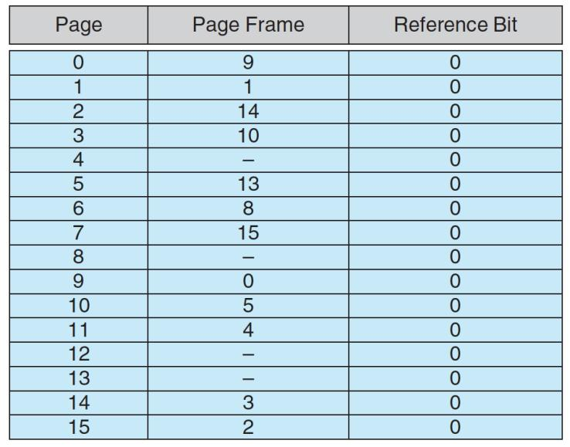

b. Using the above addresses as a guide, provide an example of a logical address (in hexadecimal) that results in a page fault.

0x4100

c. From what set of page frames will the LRU page-replacement algorithm choose in resolving a page fault?

Reference bit为0的page会被LRU调用以解决缺页问题