Assigment-3

1. Which of the following scheduling algorithms could result in starvation?

a. First-come, first-served

b. Shortest job first

c. Round robin

d. Priority

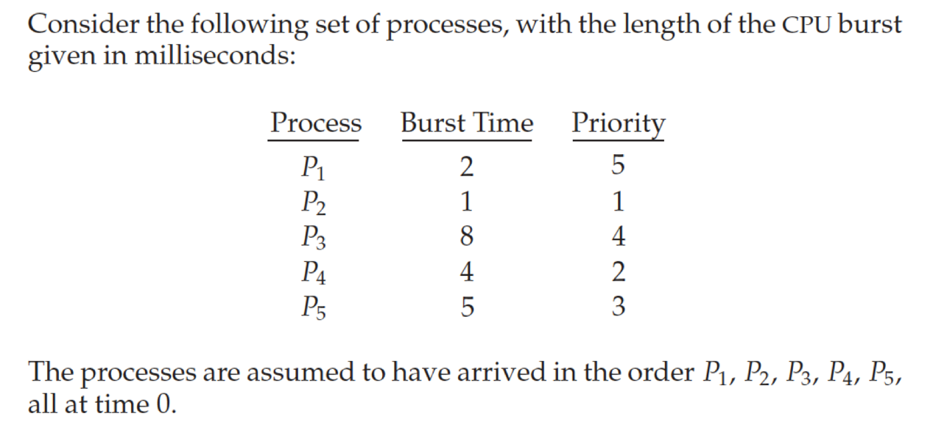

Draw the Gantt charts that illustrate the execution of these processes using the RR algorithm with time slice = 2. What is the waiting time of each process?

使用Excel绘制甘特图如图所示：

