西南大学

《高等数学IA》课程
2015～2018学年 第1学期 |  |  |  |  |  |  |  |  |  |  |  |  |  |  | 期
考试时间 |  |  | 120分钟 |  |  | 考核方式 |  |  |  |  | 学生类别 |  |  |  |  |  |  |  |  | 人数 |  | 230
适用专业或科类 |  |  |  | 计信院软件工程、自动化专业 |  |  |  |  |  |  |  |  |  |  |  | 年级 |  | 2015级
题号 |  |  |  |  |  |  |  |  |  |  |  |  |  |  |  |  |  |  |  |  | 合计
得分
签名
阅卷须知：阅卷用红色墨水笔书写，得分用阿拉伯数字写在每小题题号前，用正分表示，不得分则在题号前写0；大题得分登录在对应的分数框内；统一命题的课程应集体阅卷，流水作业；阅卷后要进行复核，发现漏评、漏记或总分统计错误应及时更正；对评定分数或统分记录进行修改时，修改人必须签名。
特别提醒：学生必须遵守课程考核纪律，违规者将受到严肃处理。

PLEASE ANSWER IN CHINESE OR IN ENGLISH OR BILINGUALISM!!
1. Fill the correct answer in the blanks (3 points each，15 points in all)
(1) 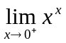= ___ ________.

(2) The horizontal asymptotes for the graph of the function 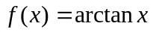is
___ __.

(3) The point of inflection of the curve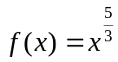is ____ _______.

(4) If 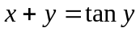, find 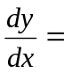 .

(5) If 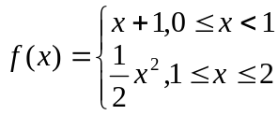, then 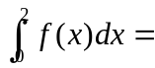= _______ __.

2. Choose the corresponding letter of the best answer that best completes the statement or answers the question among A, B, C, and D, and fill in the blanks (3 points each，15 points in all).

(1) If 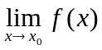 exists and 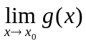does not exist, then ( ).
A. Both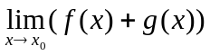and 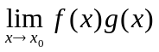exist.
B. Neithernor exist.
C. certainly does not exist.
D. certainly does not exist.
(2)The function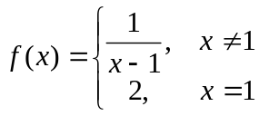 at x = 1 is ( ).
A. not continuous, f(1) does not exist and 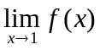 does not exist.
B. continuous.
C. not continuous, f(1) exists but does not exist
D. not continuous, and f(1) exist but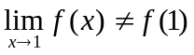.
(3) For the function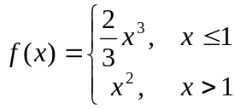, we have the assert ( ).
A．f(x) has the right-hand and left-hand derivatives at x = 1.
B．f(x) has the right-hand derivative but has no left-hand derivative at x = 1.
C．f(x) has the left-hand derivative but has no right-hand derivative at x = 1.
D．f(x) has derivative at x = 1.
(4) Which one of these following statements is correct? ( )
A．If 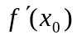doesn’t exist, then f(x) is not continuous at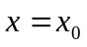.
B．If doesn’t exist, then there is no tangent line to the graph of f(x) at.
C．If exists, then there is a tangent line to the graph of f(x) at.
D．If f(x) is continuous at, then exists.
(5) Which one of these following improper integrals converges? ( )
A．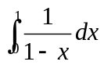 B．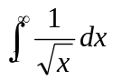
C．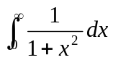 D．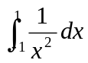

3. Find the solutions for following problems by computing (8 points each，40 points in all)
(1) Find the limit 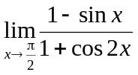

(2) Find 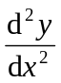as a function of t if 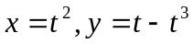

(3) Find 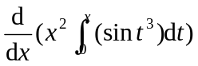.

(4) Evaluate the indefinite integral 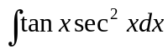

(5) Evaluate the definite integral 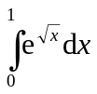

4. Solve the following comprehensive problems (10 points each，30 points in all)
(1) Evaluate the indefinite integral 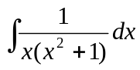

(2) Identify the local extreme values of the function 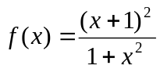.

(3) Find the area of the region in the first quadrant that is bounded by 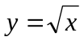and the x-axis and the line 

