计算机与信息科学学院 软件学院
课程过程性考核命题记录表
（适用于平时作业等过程性考核）

（ 2023 － 2024 学年第 2 学期）

课程名称 | 操作系统原理 | 任课教师 | 赵恒军
年级/专业 /班级 | 2022级软件工程1-4班 | 考核时间 | 2024.4.16
考核点对应教学内容（如章/节编号、名称） |  | Ch6，Ch7
本次过程性考核内容（如作业题目、题目序号、调研内容）
- Consider how to implement a mutex lock using an atomic hardware instruction. Assume that a mutex lock is defined as
boolean lock
(lock == 0) indicates that the lock is available, and a value of 1 indicates that the lock is unavailable. Illustrate how the following functions
void acquire(boolean *lock)
void release(boolean *lock)
can be implemented using the atomic test_and_set() instruction. The meaning of test_and_set() can be explained as:
boolean test and set(boolean *target) {
boolean res = *target;
*target = true;
return res;
}
Be sure to include any initialization that may be necessary.
- Consider the code example for allocating and releasing processes shown in the following figure:
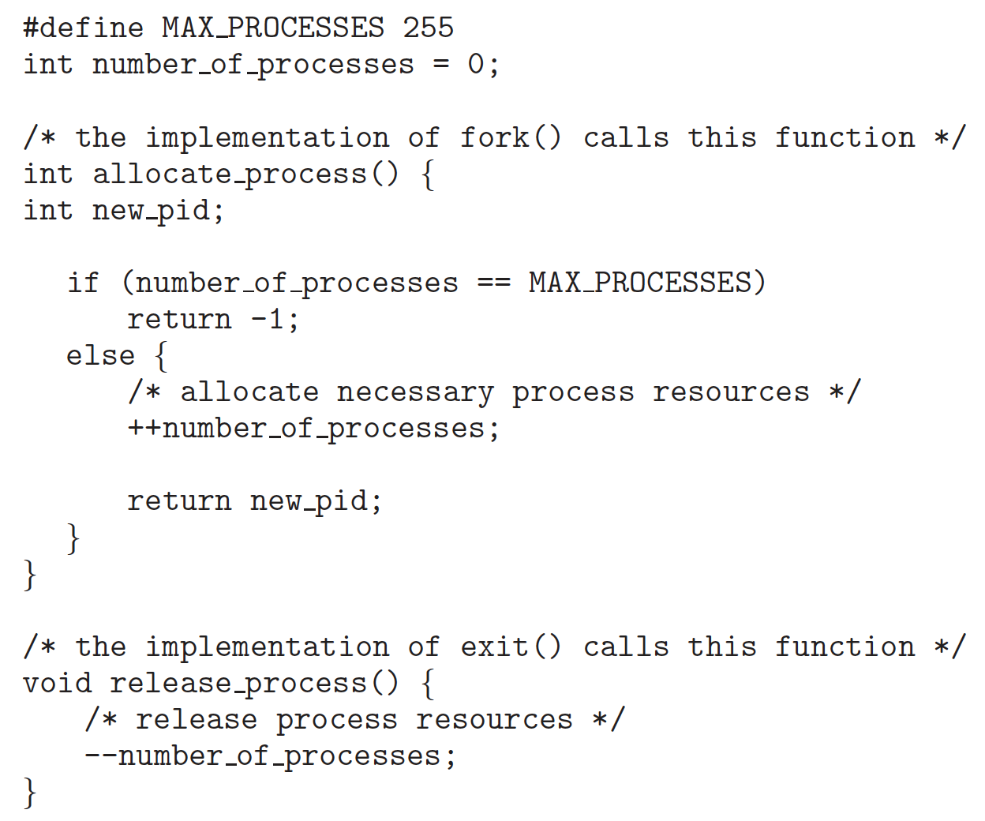
a. Identify the race condition(s).
b. Assume you have a mutex lock named mutex_lock with the operations acquire() and release(). Indicate where the locking needs to be placed to prevent the race condition(s).
- We define a semaphore as follows:
typedef struct {
int value;
struct process *list;
} semaphore;
Each semaphore has an integer value and a list of processes list. When a process must wait on a semaphore, it is added to the list of processes. A signal() operation removes one process from the list of waiting processes and awakens that process.
Now, the wait() semaphore operation can be defined as
wait(semaphore *S) {
S->value--;
if (S->value < 0) {
add this process to S->list;
block();
}
}
And the signal() semaphore operation can be defined as
signal(semaphore *S) {
S->value++;
if (S->value <= 0) {
remove a process P from S->list;
wakeup(P);
}
}
The block() operation suspends the process that invokes it. The wakeup(P) operation resumes the execution of a blocked process P. These two operations are provided by the operating system as basic system calls.
Identify race conditions in the above implementation of wait() and signal(), and illustrate how to resolve the problem using the mutex lock mechanism.

Consider a system consisting of four resources of the same type that are shared by three processes, each of which needs at most two resources. Show that the system is deadlock free.

请在下方给出所有问题的解答。

- 原子指令解决方案中的mutex lock方法，上课讲了两种，分别是test_and_set()和compare_and_swap()。我们这里既然题目要求了，就使用test_and_set()。
首先lock要初始化为false。
boolean lock = false;
在acquire函数中，我们使用一个while循环来重复调用test_and_set()函数。如果test_and_set()返回true，表示锁已经被其他线程占用，当前线程继续在循环中等待。一旦test_and_set()返回false，表示当前线程成功获取了锁，循环结束。代码如下：

void acquire(boolean *lock) {
while (test_and_set(lock)) {
// 循环等待锁被释放
}
}

在release函数中，我们直接将lock的值设置为false就好了，这样其他线程就可以通过acquire函数尝试获取这个锁。代码如下：
void release(boolean *lock)
{ *lock = false;}

2.
a) 如果进程数已经达到max-1，此时有两个进程同时调用allocate-process，同时读取number_of_processes值，都认为还可以创建新进程，导致超过MAX_PROCESSES的限制。

b) 我们使用mutex_lock来防止这种竞态条件，确保任何时候只有一个进程可以执行临界区的代码：
在访问或修改number_of_processes之前，每个函数都会调用acquire来获取mutex_lock。
当完成对共享资源的访问或修改后，每个函数都会调用release来释放mutex_lock。与第一题的实现方式一样，也是使用test_and_set函数，代码如下：
boolean test and set(boolean *target) {
boolean res = *target;
*target = true;
return res;
}

void acquire(boolean *mutex_lock) {
while (test_and_set(mutex_lock)) {
// 循环等待锁被释放
}
}

void release(boolean *mutex_lock) {
*mutex_lock = false; // 释放锁
}

int allocate_process() {
acquire(&mutex_lock); // 获取锁
if (number_of_processes == MAX_PROCESSES) {
release(&mutex_lock); // 释放锁
return -1;
} else {
++number_of_processes;
release(&mutex_lock); // 释放锁
return new_pid;
}
}

void release_process() {
acquire(&mutex_lock); // 获取锁
// release process resources
--number_of_processes;
release(&mutex_lock); // 释放锁
}

3.
这里的竞态条件还是出现在对共有资源value的访问上，举个例子：假设进程a执行wait函数读取了value发现不是负数，而在进入while语句之前进程b也执行了wait函数，value再次自减，这下成了负数，那么进程a判断时就会判定value是负数，错误地进入等待。
Acquire和release的实现同第2题
void wait(semaphore *S) {
acquire(&mutex_lock); //获取锁
S->value--;
if (S->value < 0) {
add_this_process_to(S->list);
block();
}
release(&mutex_lock); //释放锁
}

void signal(semaphore *S) {
acquire(&mutex_lock); // 获取锁
S->value++;
if (S->value <= 0) {
struct process *P;
remove_process_from(S->list, &P);
wakeup(P);
}
release(&mutex_lock); // 释放锁
}

4.
三个进程分配四个相同资源，每个进程最多需要两个资源项。我们考虑最坏的情况，每个进程都必须要两个资源项才能运行。这个问题的关键在于当一个进程获得了两个资源，他就可以完成。而这三个进程中必然有一个能够占有两个资源，那么这个进程就没有其它请求，可以顺利执行完，释放资源项，其他两个进程就可以获得释放的资源。最坏的情况下也不会发生死锁
命题教师
签 字

年 月 日

