计算机与信息科学学院 软件学院
课程过程性考核命题记录表
（适用于平时作业等过程性考核）

（ 2023 － 2024 学年第 2 学期）

课程名称 | 操作系统原理 | 任课教师 | 赵恒军
年级/专业 /班级 | 2022级软件工程1-4班 | 考核时间 | 2023.5.14
考核点对应教学内容（如章/节编号、名称） |  | Ch3, ch4, ch8, ch9
本次过程性考核内容（如作业题目、题目序号、调研内容）
- What output will be at line A for Fig.3.30?
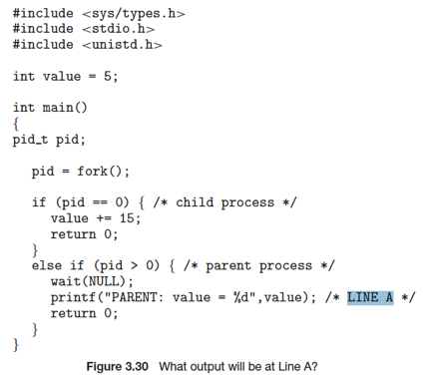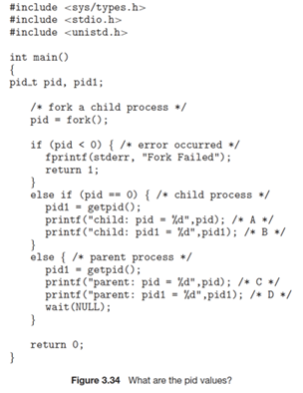
Hint: the return value of fork() is:
- 0, for the child process
- the PID of the child process, for the parent process
- Assume that the pids of parent and child are 2600 and 2603, respectively. Identify the values of pids at lines A, B, C, D for Fig.3.34. Hint: getpid() is a system call that returns the PID of the calling process.
- Which of the following components of program state are shared across threads in a multithreaded process?
a. Register values
b. Heap memory
c. Global variables
d. Stack memory
- The program shown in the following figure uses the Pthreads API. What would be the output from the program at LINE C and LINE P ?
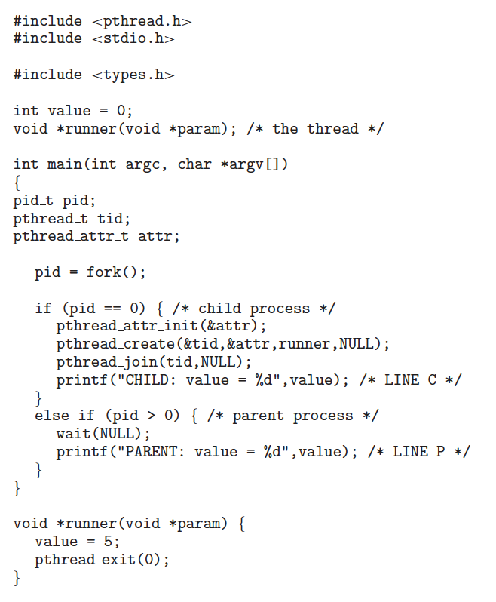

Consider the following segment table (all numbers are in decimal):
Segment Base Limit
0 219 600
1 2300 14
2 90 100
3 1327 580
4 1952 96
What are the physical addresses for the following logical addresses?
a. 0, 430
b. 1, 10
c. 2, 500
d. 3, 400
e. 4, 112

Assuming a 1-KB page size, what are the page numbers and offsets for the following address references (provided as decimal numbers):
a. 3085
b. 42095
c. 215201

Consider a logical address of 256 pages with a 4-KB page size, mapped onto a physical memory of 64 frames.
a. How many bits are required in the logical address?
b. How many bits are required in the physical address?

Consider a computer system with a 32-bit logical address and 4-KB page size. The system supports up to 512 MB of physical memory. How many entries are there in a conventional single level page table?

Consider a paging system with the page table stored in memory.
a. If a memory reference takes 50 nanoseconds, how long does a paged memory reference take?
b. If we add TLBs, and 75 percent of all page-table references are found in the TLBs, what is the effective memory reference time? (Assume that finding a page-table entry in the TLBs takes zero nanoseconds, if the entry is present.)

Assume that a program has just referenced an address in virtual memory. Describe a scenario in which each of the following can occur. (If no such scenario can occur, explain why.)
• TLB miss with no page fault
• TLB miss and page fault
• TLB hit and no page fault
• TLB hit and page fault
Note: here ‘page fault’ means that the physical page is not present
11.
Assume that we have a demand-paged memory. The page table is held in registers. It takes 8 milliseconds to service a page fault if an empty frame is available or if the replaced page is not modified and 20 milliseconds if the replaced page is modified. Memory-access time is 100 nanoseconds. Assume that the page to be replaced is modified 70 percent of the time. What is the maximum acceptable page-fault rate for an effective access time of no more than 200 nanoseconds?
12.
When a page fault occurs, the process requesting the page must block while waiting for the page to be brought from disk into physical memory. Assume that there exists a process with five user-level threads and that the mapping of user threads to kernel threads is one to one. If one user thread incurs a page fault while accessing its stack, would the other user threads belonging to the same process also be affected by the page fault—that is, would they also have to wait for the faulting page to be brought into memory? Explain.
13.
Consider a demand-paging system with a paging disk that has an average access and transfer time of 20 milliseconds. Addresses are translated through a page table in main memory, with an access time of 1 microsecond per memory access. Thus, each memory reference through the page table takes two accesses. To improve this time, we have added an associative memory that reduces access time to one memory reference if the page-table entry is in the associative memory. Assume that 80 percent of the accesses are in the associative memory and that, of those remaining, 10 percent (or 2 percent of the total) cause page faults. What is the effective memory access time?

请将答案写在下方：

- 这里父进程调用了wait(NULL)函数等待子进程结束，然后打印 value 的值。这里父子进程各自维护自己的全局变量，内存空间相互隔离，value初始值为5，那么子进程执行自增15，子进程value变为20。而父进程并没有自增，所以最后打印的是：PARENT: value = 5。

- A：0（fork调用后，会返回两次，在子进程中fork返回给变量pid的是0）
B：2603（getpid方法返回的是子进程的真正pid）
C：2603（fork返回给父进程的是创建的子进程的pid）
D：2600（父进程中用getpid方法返回的当然是父进程的pid）

- B heap 和C global variables 是线程之间共享的
堆内存是由操作系统管理的一块统一的内存区域，它不是线程特定的
全局变量是属于进程的内存空间，可以被当前进程的所有线程访问

- LineC：“CHILD: value = 5”（子进程中创建了线程，而线程函数中将value改为5）
LineP：“PARENT: value = 0”（父进程使用wait(NULL)等待子进程结束，而父进程中没有修改value，子进程只是修改了自己内存空间中的那个value，进程之间内存是相互隔离的

- a. 0, 430：219+430=649
b. 1, 10：2300+10=2310
c. 2, 500：500 > 100 超出了本段的limit
d. 3, 400：1327+400=1727
e. 4, 112：112>96超出了本段的limit

- a. 3085：page num=3085/1024=3，offsets=3085%1024=13
b. 42095：page num=42095/1024=41，offsets=42095%1024=111
c. 215201：page num=215201/1024=210，offsets=215201%1024=161

- 256是2^8，4K是2^12，页数需要8位，偏移量需要12位，逻辑地址共需要20位
64是2^6，4K是2^12，帧数需要6位，偏移量需要12位，物理地址共需要18位

- 32位的系统，可以支持的最大内存为2^32B，也就是4GB，题目中说现在的物理内存是512MB，这和页表的大小并无关系，因为页表大小由逻辑地址位数决定。一个page为4KB，也就是页内偏移占有12位，32位中剩下的20位是用于page选择，所以页表共有2^20行。

- a：如果题目说的是一级页表，那么访问一次数据需要访问两次内存，第一次是访问页表查物理地址，第二次是根据物理地址找数据。所以用时50+50=100ns。
b：75%的访问命中TLB，此时查询页表时间不计，只进行一次内存访问。另外的25%仍然需要访问两次，也就是说25%*50+50=62.5ns

• TLB miss with no page fault：没有缺页错误说明这个页已经被调到了内存中，而这个页可能很久没有访问过了，所以TLB中并没有记录，所以TLB未命中，之后在页表中命中了
• TLB miss and page fault：TLB未命中，接下来检索页表，也没有检索到。这通常意味着页面可能被交换出去了，或者这是程序首次访问这个页面，此时就会发出缺页错误。
• TLB hit and no page fault：TLB命中！这样说明内存是能识别出这一页存在的，当然是没有缺页错误。
• TLB hit and page fault：这种情况应该不会发生，TLB命中说明内存是能识别出这一页存在的，应该不会发生缺页错误

- 假设maximum acceptable page-fault rate = x，则effective access time = (1-x)*100+x*(0.7*20000000+0.3*8000000+100) <= 200，解的x<=1/164000 ns。

- 本题是一对一的映射模型，每个用户线程都有一个对应的内核线程。内核线程负责处理用户线程的执行，包括处理缺页中断。同一进程间的线程之间有很多资源是共享的，比如全局变量，所以如果某个线程发生了缺页中断，其他线程正好也访问这个变量，那真得等待。但是如果其他线程没有访问到发生缺页中断的页面，它们就不会受到影响。

- effective memory access time=0.8*1*1+0.2*(0.1*20000+1*2) = 401.2ns
缺页中断的只是比正常的多一个磁盘访问的过程。
命题教师
签 字

年 月 日

