CHAPTER 7—CONCEPTUAL DATA MODELING
STUDENT CHAPTER OBJECTIVES
After studying this chapter, you should be able to:
- Determine how to develop conceptual data models from use cases and other narratives.
- Understand UML notations for conceptual data modeling.
- Explain relationship characteristics such as degree and multiplicity.
- Describe data relationships such as association, aggregation, and generalization.
- Describe different kinds of attributes such as identifier, multivalued, and derived.
CHAPTER OVERVIEW
Chapter 6 explained how to write a detailed description of a use case from user requirements. This chapter will describe how to structure requirements and develop models to represent the requirements (Figure 7.1). Specifically, this chapter will discuss conceptual data modeling, which examines the structure of organizational data from user requirements while staying independent of implementation considerations. Note that a use case does not capture all the user requirements. However, CASE tools allow the remaining requirements to be attached as documents to the use-case description. After the user requirements are documented, other systems analysis activities can be undertaken, such as developing class diagrams. A significant portion of a UML class diagram is composed of data elements. Thus, for business applications, conceptual data modeling is one of the most important analysis activities and is the subject of this chapter.
For business applications, the entity relationship (ER) diagram is still a popular conceptual data modeling choice among data modelers. ER diagramming often is taught in a database course. OOSAD data modeling, however, uses the UML notation, which bears resemblance to the ER notation but can be used to model behavioral aspects of the system. Note that the goal of analysis is to come up with an analysis class diagram. Data modeling is an intermediate step, which provides entity classes that are then used to develop analysis classes.
CHAPTER OUTLINE
- Conceptual Data Modeling
  - The process of conceptual data modeling
- Gathering Information for Conceptual Data Modeling
- Introduction to UML Data Modeling
  - Class
  - Object
  - Attributes
  - Identifiers
  - Important considerations for selecting primary keys (identifiers)
  - Multivalued attributes
  - Composite attributes
  - Relationships
    - Degree of a relationship
    - Unary relationship
    - Binary relationship
    - Ternary relationship
    - Multiplicity in relationships
    - Multiplicity in a unary relationship
    - Multiplicity in a ternary relationship
  - Association
  - Aggregation relationship
  - Composite structure diagram
  - Generalization relationship
- An Example of Conceptual Data Modeling for PVF WebStore
- Key Points Review
- Key Terms Checkpoint
- Review Questions
- Problems and Exercises
- Discussion Questions
- Case Problems
  - GuardTech Training, Inc.
  - New Tampa Junior Women’s Club (NTJWC)
- Case: Broadway Entertainment Company, Inc.
Conceptual Data Modeling for the Web-Based Customer Relationship Management System
  - Case introduction
  - Structuring the high-level data modeling findings from requirements determination
  - Case summary
  - Case questions
TEACHING TIPS/ADDITIONAL INFORMATION
Construction Metaphor
This can still work, but it isn’t as easy as previous chapters. The house has several rooms, and each room has a unique identifier, walls, electrical outlets, etc. Some rooms may have additional features—220 electrical hookups, gas hookups, fireplace, etc. Since this chapter models focus on data and construction of a building focuses on materials, the comparison is not as powerful.
Extending the text
Page 189—CASE tool
The repository function of a CASE tool is worth elaboration. The electronic repository allows restrictions on check-out of code, and can force versioning of code that is checked back in to the repository. All changes can be tracked by date and by coder. Metrics regarding coding time are therefore available, as well.

Page 191—controls
A create, read/receive, update, delete matrix is often used to explore these relationships. Organizational locations are on one edge of the matrix; data entities are on the other edge. C, R, U, and/or D is then placed at the intersection of the two. Each data element must be able to be created, updated, and deleted. Each data element is unnecessary if it is not ever read/received. Missing actions can be discovered with this matrix.

Page 194—candidate keys
I point out to students that my university has multiple possible candidate keys to identify employees. We each have a SSN, we each have a university ID, we each have a network logon ID, and we each have a unique email address. I also mention that we may have unique names, and discuss why names are not a good choice for identifiers. (Well, Mr. Smith, we’d love to hire you, but we already have a John Smith, and our database structure won’t support two employees with the same name. Would you prefer to change your name or to look elsewhere for a job?) Along the same line, the powers that be at a university would probably not be amused if the database structure required that prospective students not be admitted unless they changed their name from one that already existed in the database.

Page 194—concatenated primary keys
When multiple attributes are required to create a primary key, sometimes students think the object has more than one key. It is important to clarify that there is a single key, but it is composed of multiple attributes. No one attribute is sufficient to uniquely identify the object, therefore the single attribute is not a primary key. It is the combination that creates a single identifier.

Page 194—meaningless primary keys
The authors say “…an attribute like gameId might have to be created. I warn students that different database administrators have different opinions about these meaningless primary keys. Some prefer to use them instead of concatenated primary keys. Some prefer not to use them because they require storing data that has no real meaning in the database. I point out that when they are DBA they can make that decision. Until then, they do whatever their DBA specifies.

Page 197—standards
The authors state, “The exact standards to be followed will vary from company to company.” I find it useful to point out that students will be hired to support the way the company currently does business, not to tell the company what is wrong with the way they do business.

Page 198—cardinality and multiplicity
When students are attempting to determine these, it is important that they start their discovery sentence with “For any one…” For example, “For any one movie, there can be zero or more videotapes.” A more general statement, like “How many videotapes of movies are there?” makes it impossible to determine cardinality. Each relationship is bidirectional, and each sentence must start the same way. When the relationship between movie and video has been established, the reverse relationship is discovered by using the related statement, “Any one videotape is of exactly one movie.” The statement “videotapes are of how many movies?” is not useful to discover cardinality.

Page 205—generalization
People at a college or university are a great example of this. There are multiple groups of people. Information about each of them is stored. The supertype might include ID, name, address, phone, SSN, network logon, and email address at least. Then the subclasses might be students and employees. But students might be further subdivided into prospective, active, and former. And active students might be working on an undergraduate or graduate degree. Subclasses help reduce redundancy, because, with the superclass/subclass, an employee who is also a student only has the superclass information saved once instead of twice.

Page 208—cardinality
The data model shows that any one customer has placed zero to many orders. Ask students if this is correct, and ask them to give reasons for their answers. This is another example of information technology being required to support the way the organization does business. From a database standpoint, one to many relationships are easier to validate through referential integrity. From a logic standpoint, isn’t an order what makes a customer? Not necessarily. The students have no way to accurately answer this question except by knowing the business rules of this company. If the company has a customer approval process, it is the successful completion of that process that makes them a customer, not any order information. If the company considers everyone who has ordered a catalog to be a customer, the models (and database) have to support that business rule. If the company policy is that a customer is someone who has placed an order, then the data model is incorrect.

KEY TERMS CHECKPOINT (matching)
Definition | Key Term
- A strong form of aggregation in which the aggregate is meaningless without parts, and the parts are meaningless without the aggregate. | j. Composition (p. 203)
- A single occurrence of a class. | s. Object (p. 193)*
- An attribute that can take on more than one value for each object. | r. Multivalued attribute (p. 195)
- A simultaneous relationship among objects of three classes. | x. Ternary relationship (p. 198)
- A collection of objects that share common properties and behavior. | h. Class (p. 193)*
- A relationship between objects of two classes. | e. Binary relationship (p. 197)
- A many-to-many association that the data modeler chooses to model as a class. | c. Associate Class (200)
- A named property of a class that describes a range of values that instances of the attribute might hold. | d. Attribute (p. 193)
- The number of objects of class A that can (or must) be associated with each object of class B. | g. Cardinality (p. 198)
- An association that models a whole-part relationship between an aggregate, which is called whole, and its parts. It is a strong form of association in which the aggregate has no meaning without parts. | a. Aggregation (p. 202)
- A candidate key that has been selected as the unique, identifying characteristic for a class. | t. Primary Key (p. 194)
- A semantic connection between objects of one or more classes. | u. Relationship (p. 196)
- The range of the number of objects of class A that can (or must) be associated with each object of class B. | q. Multiplicity (p. 198)
- An attribute (or combination of attributes) that uniquely identifies each object of a class. | f. Candidate key (p. 194)
- A relationship or link between instances (or objects) of classes. | b. Association (p. 200)
- The number of classes that participate in a relationship. | l. Degree (p. 197)
- A relationship between the objects of one class. | y. Unary relationship (p. 197)
- A superclass/subclass relationship based on inheritance. | o. Generalization (p. 205)
- A detailed model that shows the overall structure of organizational data while being independent of any database management system or other implementation considerations. | k. Conceptual data model (p. 189)
- An attribute whose value can be determined from other data in the model. | m. Derived attribute (p. 207)
- A graphical representation for depicting a conceptual data model using the notions of entity, attribute, and relationship among entities. | n. Entity relationship (ER) data model
- A name to identify a relationship end within a relationship. | v. Role (p. 197)
- A construct that allows extension of the UML vocabulary. | w. Stereotype (p. 194)
- An attribute or a combination of attributes that has been selected to be used as the unique characteristic for a class. | p. Identifier (p. 194)
- A diagram that shows how a whole is made up of parts, especially in cases where the whole has a number of interacting parts. | i. Composite structure diagram (p. 204)
*Most of these definitions are exactly the same as in the chapter. These two are significantly different.
ANSWERS TO REVIEW QUESTIONS
- List any five categories of questions that you should ask system users and business managers about data modeling.
Table 7-1 lists eight categories of questions to consider when developing data models: classes; attributes; identifier; association, aggregation and composition; generalization; time dimensions; integrity rules; and security controls. The table also supplies information the analyst should expect to derive from users and business managers when asking about these areas (p. 191)
- Explain why a ternary relationship is not the same as three binary relationships.
A ternary relationship represents the simultaneous association of three entities (such as selling a selling relationship linking a customer with a product and a salesperson). Three binary relationships (between a salesperson and product; a salesperson and customer; and a product and customer) lose the cohesiveness of the ternary relationship. (p. 198)
- When must a many-to-many relationship be modeled as an associative class?
A many-to-many relationship must be modeled as an associative class when there are attributes associated with the relationship. (pp. 200-201)
- Which of the following types of relationships can have attributes associated with them: one-to-one, one-to-many, many-to-many?
One-to-one and many-to-many relationships (associative entities) may have attributes. For example, a one-to-one unary relationship between employees, Married to, may have a Date Married attribute, and a many-to-many binary relationship between students and courses, Takes, may have a Grade attribute. (p. 201)
- What is the degree of a relationship? Give an example of each of the relationship degrees illustrated in this chapter.
The degree of relationship indicates the number of entity types participating in a relationship. The three most common relationships are unary, binary, and ternary. An employee working for a department is an example of a binary relationship. A part composed of other parts is an example of a unary relationship. A student studying a subject with a professor is an example of a ternary relationship. (pp. 197-198)
- Give an example of a ternary, an aggregation, and a generalization relationship (different from any example in this chapter).
An example of a ternary relationship might be that of a driver getting his car serviced. A particular driver takes his car to a particular mechanic for an oil change. An example of an aggregation relationship is a student in a course. A class is made up of students and the student is subordinate to the course. An example of generalization is a freshman (or a sophomore, or senior) “is a” student. Also, a manager (or a clerk or a vice president) “is an” employee.
- What is the difference between cardinality and multiplicity?
In a relationship between objects of two classes, the cardinality of the first class is the number of objects that may (or must) be associated with each object of the second class. For example, if university policy requires that at least five students register for a class in order for the registrar not to cancel it, then the minimum cardinality of student to class is 5. If that course is taught in a room with a seating capacity of 35 seats, then the maximum cardinality of the student-to-class relationship is 35. The multiplicity of this relationship refers to the range of cardinalities, or in this case, the multiplicity is 5..35. If there were no cap on enrollment for this course, the multiplicity would have been 5..n (or many). (p. 198)
- List the ideal characteristics of an identifier (primary key).
An identifier that meets the criteria set forth in the chapter (page) is an ideal choice. These criteria include: 1) choosing an attribute that will not change its value over the life of each entity type, 2) choosing an attribute that for each instance of the entity will have valid values and will not be null, 3) avoiding intelligent key usage, and 4) substituting surrogate keys for large composite keys. (p. 194)
- Explain the difference between a candidate key and the identifier of a class.
An identifier is an attribute (or combination of attributes) that distinguishes this class definition from other class definitions. A candidate key is an attribute (or combination of attributes) that distinguishes instance objects of an individual class from each other. (p. 194)
ANSWERS TO PROBLEMS AND EXERCISES
- Assume that at Pine Valley Furniture each product (described by Product No., Description, and Cost) is comprised of at least three components (described by Component No., Description, and Unit of Measure) and components are used to make one or many products (i.e., must be used in at least one product). In addition, assume that components are used to make other components and that raw materials are also considered to be components. In both cases of components being used to make products and components being used to make other components, we need to keep track of how many components go into making something else. Draw a conceptual data model for this situation.
The constraint of a minimum of three components required for making a product does not apply to components making components. The multiplicity of components to product is 3..n for each product made. For components making components, a unary relationship indicates that one or more components are required for each complex component, and each simple component can be used in one or more complex components. The following UML diagram shows these relationships.
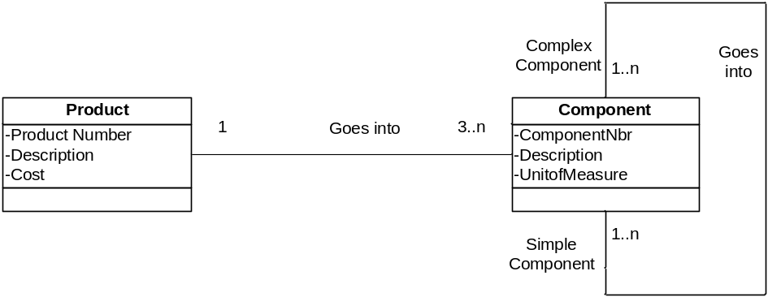
- A software training program is identified by a code and has a short description that explains its goals. Each software training program is divided into training modules, and each module is described by module name and the approximate practice time. Each module sometimes has prerequisite modules. Model this situation of training programs and modules with a conceptual data model.
This exercise defines two classes. A training program is composed of one or more training modules. An optional unary relationship exists with the training module in that zero-to-many modules may serve as prerequisites to another training module, that module may have zero prerequisites. The UML for this is:

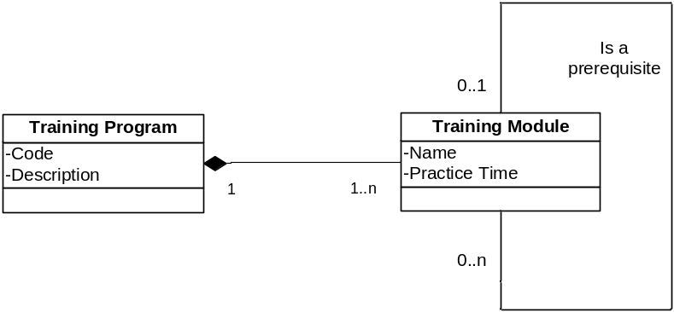
- Each semester, a student must be assigned an advisor who counsels students about degree requirements and helps them register for classes. Students must register for classes with the help of an advisor, but if their assigned advisor is not available, they may register with any advisor. Assume student and advisor are classes. We must keep track of students, their assigned advisors, and with whom the student registered for the current term. Represent this situation of students and advisors with a conceptual data model.
The following UML diagram shows one possible solution to the problem with two relationships between the identified classes. In the “is assigned advisor” relationship, an advisor is assigned zero-to-many students and a student is assigned exactly one advisor. In the “registers” relationship, an advisor advises zero-to-many students and a student is advised by exactly one advisor. Alternatively, you might introduce an associative class “Role” with the attribute of “role played” between these two classes. Values for this attribute would be advises, advises and registers, and registers.

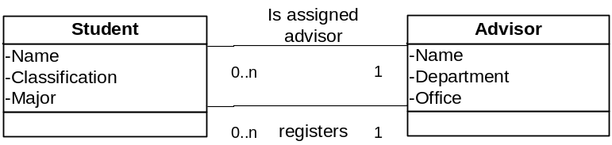
- An airline reservation is an association between a passenger, a flight, and a seat. (You may visit an airline Web site to become familiar with the reservation details.) Select a few pertinent attributes for each of these classes and represent the scenario using a conceptual data model.
Here is a possible approach to the airline problem.

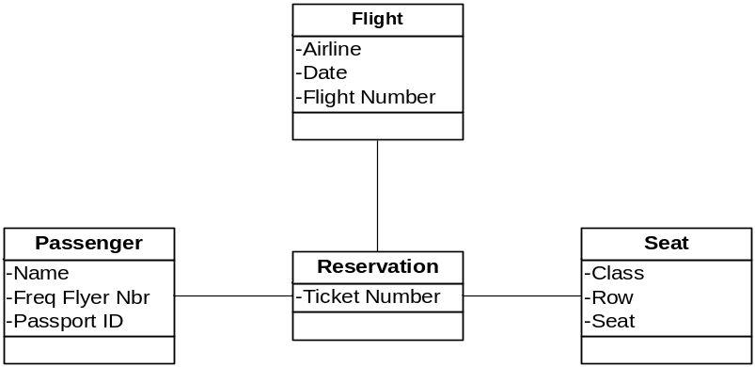

- In a real estate database, there are properties for sale by the agency. A property is identified by a code. Other data recorded for a property include its description and listed price. Each time a potential property buyer makes a purchase offer on a property, the agency records the date, offering price, and name of the person making the offer. The agency keeps data about potential buyers, including their names, addresses, and phone numbers. Prepare a conceptual data model.
This real estate example requires an associative class to account for the relationship between a property and buyer because many buyers may make an offer on a property, and a buyer could make offers on many properties. The attributes of offer date and offer price relate to the relationship and therefore suggest the need for the associative class “offer.”

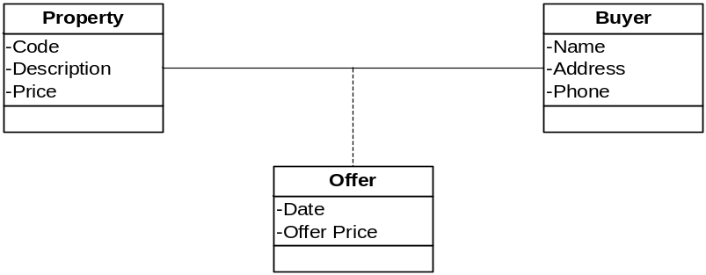
- Consider the marriedTO unary relationship in Figure 7.16.
- Assume we wanted to know the date on which a marriage occurred. Augment this diagram to include a Datemarried attribute.
Suggested answers are provided as follows.

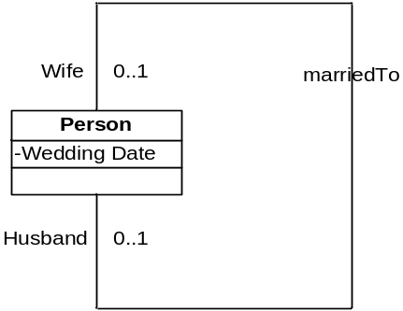
- Because persons sometimes remarry after the death of a spouse or divorce, redraw this diagram to show the whole history of marriages (not just the current marriage) for Persons. Show the Datemarried attribute on this diagram. (If you would like additional practice, we recommend the conceptual data modeling exercises in the book Modern Database Management, 7th edition, by Hoffer, Prescott, and McFadden. Chapter 3 has 17 high-quality exercises.)
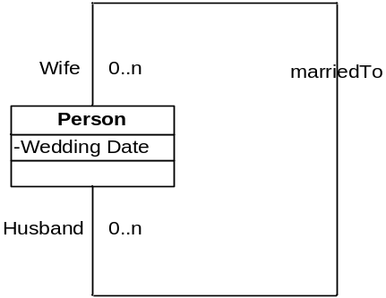

ANSWERS TO DISCUSSION QUESTIONS
- Discuss the role of conceptual data modeling in the overall systems analysis and design process.
Figure 7-3 provides a coherent basis for this discussion. The goal of the model is to prepare the systems analyst to develop the class diagram, which will form the basis for the system design. The conceptual data model shows all of the organizational data and the relationship of individual attributes to each other.
- Using Table 7-1 as a guide, develop a script of at least 10 questions you would ask during an interview of the customer order processing department manager at Pine Valley Furniture. Assume the focus is on analyzing the requirements for a new order entry system. The purpose of the interview is to develop a preliminary class diagram for this system.
Encourage the students to come up with at least one question from each of the eight categories. If they feel that one of the categories in Table 7-1 does not apply to this scenario, have them explain their reasoning. This question works well in a group setting. Have the students come up with their own lists, then work in groups to evaluate their questions--coming up with a top 10 list of questions from their combined effort.
- If possible, contact a systems analyst in a local organization. Discuss with this systems analyst the role of conceptual data modeling in the overall systems analysis and design of information systems at his or her company. How, and by whom, is conceptual data modeling performed? What training in this technique is given? At what point(s) is this done in the development process?
This type of activity is unpredictable, but almost always more engaging for the students. Prepare them for the visit by having them put together a couple of questions each that they would like to ask the professional analyst in addition to those suggested in this question.
- Talk to MIS professionals at a variety of organizations and determine the extent to which CASE tools are used in the creation and editing of class diagrams. Try to determine whether or not they use CASE tools for this purpose; which CASE tools are used; and why, when, and how they are used. In companies that do not use CASE tools for this purpose, determine why not and what would have to change in order to use them.
Have the students complete some of the Problems and Exercises in this chapter prior to their interviews with professionals. With a bit of experience in the use of Microsoft Visio or ArgoUML to their credit, they will better appreciate the tools used by professionals and perhaps better appreciate the differences between the tools available for modeling.

- Ask a systems analyst to give you a copy of the standard notation he or she uses to draw data modeling diagrams. In what ways is this notation different from notation in this text? Which notation do you prefer and why? What is the meaning of any additional notation?
This can be difficult to accomplish without some instruction or explanation in the differing lexicography. Another approach to this concept would be to get a different book that deals with UML and ask your students to note any differences in the symbols used, breadth of expression in the diagrams, and the ability of each to express complex data relationships more clearly.
ANSWERS TO CASE PROBLEMS
1. GuardTech Training, Inc.
- List the entities in the case. What criteria did you employ to recognize these entities?
(See diagram below.) The names at the tops of the boxes are the entity names. Students might identify entities by listing the items about which they wanted to store information, or they might have normalized an attribute listing.
- For each entity, specify the identifier (i.e., primary key). Do your identifiers meet the considerations for identifiers listed in the book?
See diagram below.
- Define the relationships among the entities. Specify the multiplicity of each relationship.
The following UML diagram is one approach to this problem. The critical issue for students is to make sure they feel comfortable in discerning the difference between class entities and the attributes of those classes. There are several variations possible with this problem description. This diagram shows a ternary relationship between course offering, student, and classroom. There are two associative class relationships shown to mark receipt of book orders and trainer competency with a given course offering.
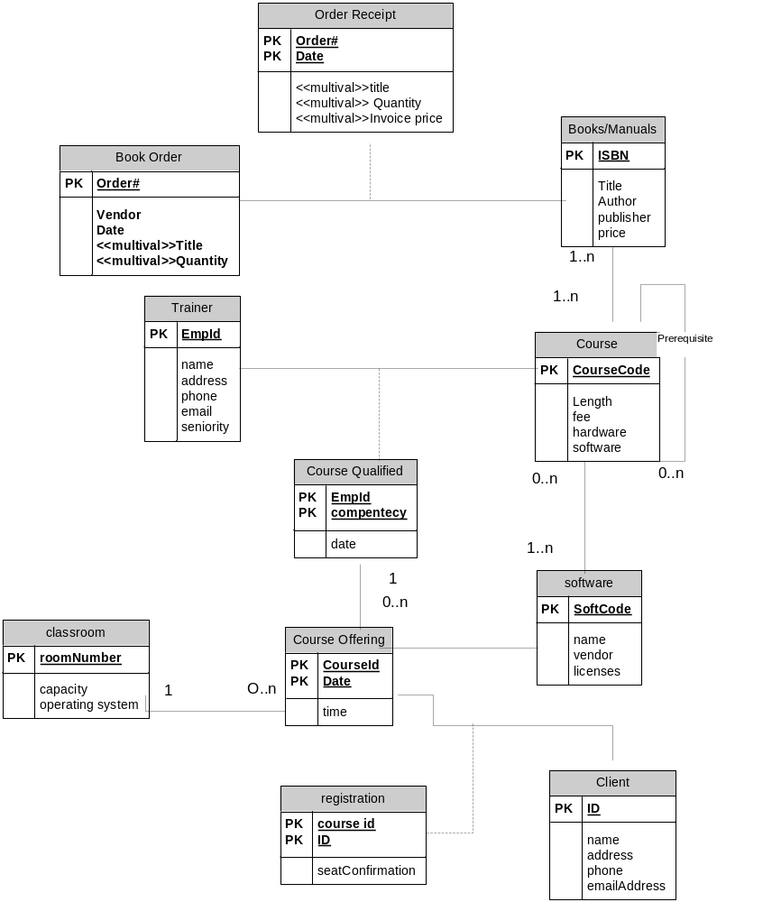
2. New Tampa Junior Women’s Club (NTJWC)
- List the entities in the case. What criteria did you employ to recognize these entities?
(See diagram below.) The names at the tops of the boxes are the entity names. Students might identify entities by listing the items about which they wanted to store information, or they might have normalized an attribute listing.
- For each entity, specify the identifier (i.e., primary key). Do your identifiers meet the considerations for identifiers listed in the book?
See diagram below.
- Define the relationships among the entities. Specify the multiplicity of each relationship.
See diagram below.
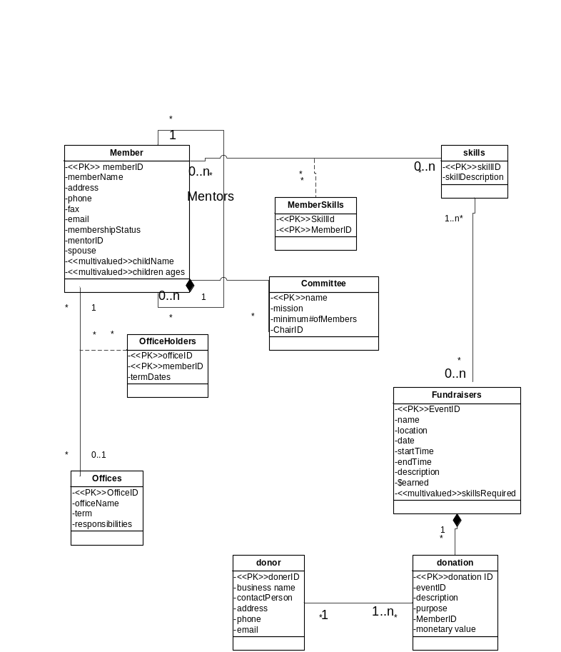

Case: Broadway Entertainment, Inc.
Case Summary
The MyBroadway team found that the remaining use cases depended on these use cases for obtaining the reports. The team is going over the use cases (listed in Chapter 6) to ensure that the data requirements for MyBroadway are complete.
Case Questions
- List the entities in the case. What criteria did you employ to recognize these entities?
See diagram below.
- For each entity, specify the identifier (i.e., primary key). Do your identifiers meet the considerations for identifiers listed in the book?
Student answers will vary.

- Define the relationships among the entities. Specify the multiplicity of each relationship. Did you encounter a ternary relationship?
See diagram below.
