CHAPTER 8—OBJECT-RELATIONAL MODELING
STUDENT CHAPTER OBJECTIVES
After studying this chapter, you should be able to:
- Understand the relational data model.
- Normalize data to the third normal form.
- Understand the object-oriented extensions to the relational model.
- Realize the role of object relations in systems analysis.
- Be able to translate a conceptual data model into object relations.
- Be able to integrate object relations obtained from different use cases.
CHAPTER OVERVIEW
This chapter will continue coverage of how to structure requirements into models (see Figure 8.1). Specifically, students will be taught how to translate a conceptual data model into object relations. The previous chapter mentioned that the goal of analysis is to come up with an analysis class diagram. Data modeling is an intermediate step that provides entity classes, which are then used to develop analysis classes. This chapter will explain how to obtain entity classes, which in the object-oriented language are also called persistent classes. These entity classes will contain data characteristics only. Incorporating behavioral characteristics will be covered in the next chapter.
The entity classes are generated from object relations. An object relation has the features of the relational data model, as well as certain object-oriented extensions. To understand an object relation, one needs to first understand the relational data model, which uses several normalization steps. Normalization is a process of obtaining database structures that have minimum redundancy and allow users to insert, modify, and delete the rows in a table without errors or inconsistencies. The normalization steps are illustrated in the earlier part of this chapter. This is followed by a discussion of the object-oriented features that are available in contemporary database management systems (DBMSs). The chapter then addresses the translation of a conceptual data model into object relations. Finally, the chapter shows how to integrate object relations obtained from different use cases.
CHAPTER OUTLINE
- Object-Relational Data Modeling
- Relational Data Model (RDM)
  - Well-structured relations
  - Normalization
    - Rules of normalization
    - Functional dependency and primary keys
    - Second normal form
    - Third normal form
    - The fourth, the BCNF, and the other normal forms
    - Where does the relational data model (RDM) fall short?
- Object Extensions to Relational Data Model
  - Generalization/Specialization
  - Multivalued attributes
  - Mechanisms to support aggregation
    - Nested tables
    - Clusters
  - Object Identifiers
  - Relationship by reference
  - Incorporation of methods in an object relation
  - Richer set of types
- Translating Conceptual Data Models Into Object Relations
  - Translating classes
  - Translating relationships
    - Binary 1:N and 1:1 relationships
    - Binary and higher degree M:N relationships
    - Unary relationships
    - Aggregation and composition
    - Generalization
  - Merging object relations
- Logical Design of PBF WebStore
- Key Points Review
- Key Terms Checkpoint
- Review Questions
- Problems and Exercises
- Discussion Questions
- Case Problems
  - GuardTech Training Inc.
  - New Tampa Junior Women’s Club
  - Broadway Entertainment Company, Inc.
    - Case introduction
    - Mapping relationships
    - Case summary
    - Case questions
TEACHING TIPS/ADDITIONAL INFORMATION
Construction Metaphor
Extending the text
Page 218—object relations paragraph
It appears that the second sentence might be incomplete. Perhaps it should say “…take advantage [of object-oriented features], if the….”
Page 220 to 224—normalization
I teach normalization as three questions and three checks. I start out with an example of loans for a loan company. I ask students how we would structure a table if we were hired to computerize the loans for a loan company. After the students mull it over for a while, I suggest that we might create one big table that had all of the data for each loan—the loan number, the loan amount, the item financed, the customer information, the interest rate, the payment amount, the term, the loan officer ID, name, and phone number—everything that they can think of for the loan. We discuss that all of the necessary contact information would be in one record, based on loan number, and everything is easy to find. Then I ask what would happen if we had someone’s first and second mortgage, both of their cars, and their boat, and they move. We now have to update the address five places. What if we miss one? I ask students how many of them pay bills they don’t get. In three months, when we go pick up the boat, everybody’s angry. We’re angry because they didn’t make the boat payments. They’re angry because they paid every bill they received. Big Mess. Then I talk about redundancy as being the reason for the problem. I ask if there are any other problems with redundancy. Students always come up with the problem of additional storage space, and with it increased response time. I agree that those are issues, but point out that storage and main memory are both better and less expensive than they have ever been. The biggest problem, as we have seen, is that it can cause errors, or anomalies, in our database tables. We have just seen update anomalies—incomplete updates leading to incorrect data. Then I ask about a customer coming in to get preapproved for a mortgage. How do we track that information? We can’t, since we need a loan number to track a customer. That’s called an insertion anomaly—we can’t store data we need because we don’t have some additional data to go with it. Then I ask what happens if a person who has one loan with us pays it off and we remove them from the table. Now we have no contact information for that person. But we want contact information for someone who PAID THEIR LOAN! That’s a deletion anomaly—when we delete information we don’t need, we also lose information we do need. So how do we deal with these anomalies? We reduce the redundancy through normalization.
I compare normalization to the algebraic order of operations—we have to do the operations one set at a time, and we don’t have the answer until we have worked through all of the operations. By the same pattern, we wouldn’t implement a 1NF data structure, it is just a step toward the final structure.
For the example I work on the board, I switch to student transcripts, since the loan example doesn’t give me a INF change with loan number as the primary key. Now I write on the board all of the data values that students can think of that need to be on their college transcript. They usually come up with a respectable list, and I add anything that they miss. I also include advisor ID and advisor name, pointing out that the advisor is NOT a faculty member. I need that for 3NF. Once all the attributes are on the board, I ask how that would be implemented in a single table. It takes a bit of working out, but we get to a row for each course taken by each student. Now we have each student’s contact information 40 or 50 times! I explain that the entire purpose of normalization is to reduce redundancy, and that the final goal is that each non-key data item will be stored one time.
INF eliminates duplicate values. Using student ID as the primary key, I tell them the question to ask for 1NF is, “For any one value of the primary key, could I have more than one value of [each attribute in the list]?” I manipulate the fields by saying “primary address” and “primary phone” to eliminate those issues. As we work through the list, I put {} around those values that could repeat. After the question has been asked and answered, we move to the actual creation of INF entities. I tell them to move everything that doesn’t repeat into one entity—student. So the contact information, the cumulative GPA, the major, and the advisor all go into the student entity. The rest of the attributes deal with students' course work, so we create a new entity called student-course, and put all of the other attributes in it. I point out that we also need to put Student ID in the new entity. I ask the students why, and they can figure out that we need to be able to tell who these courses belong to. Now we need a primary key. Student ID won’t do, or these attributes would be in the other entity. I work through the possibilities, asking what effect it would have on our design if we used various attributes as the primary key. What if we used Course ID? Each course could be taken only one time. Oops. What if we used Instructor ID? Each instructor could teach only one course. Oops. We finally figure out that NO one attribute can serve as primary key. Then we talk about how many of the attributes we need to combine. In this case, it is Student ID, Course ID, and term taken, since it is possible for a student to take a course more than once. Then we do my three checks—balance, form, and PK/FK combinations. I quickly go down the unnormalized listing and check off each attribute in the 1NF listing just to make sure I haven’t left anything out. Then I ask the 1NF question for both of my entities. Then I make sure I can put the two entities back together by verifying my primary key/foreign key combinations. Then I ask, if we implemented this structure, would we have eliminated any redundancy? Students can easily see that we are now storing all of the student information only once instead of 40 or 50 times, which is a significant reduction in redundancy.
2NF eliminates partial dependency. Since we can only have partial dependency if we have an entity with a concatenated primary key, I tell students they get a big freebie here. The student entity, with its single attribute primary key, is automatically in 2NF since it is in 1NF. We just move it over to the next column on the board. The question for the remaining entity is, for each attribute, “Does this attribute depend on the entire concatenated primary key or only on part of it?” If it depends on the entire primary key, it stays. If it depends on part of the primary key, it is moved into an entity where that part if the primary key is the entire primary key. In this example, they will find partial dependency in course title and course credit hours. They need to be moved to a new entity, Course, with Course ID as the primary key. They will have a bit of trouble with Instructor ID, however, since more than one instructor could teach a particular course, and that instructor could change from term to term as well. Therefore, it depends on all three parts of the concatenated primary key. When the new entities have been created and populated, then we do the same three checks—balance, form, and PK/FK combination. This time, we don’t have to add an attribute, just mark the Course ID attribute in the concatenated table as a FK. Again, I ask if we have eliminated any redundancy. Now we are storing the information for each course only once, instead of once for every student who ever took the course.
3NF eliminates transitive dependency. I explain that transitive dependency is in two parts—calculated values and string attributes. We look for calculated values, and eliminate them. This eliminates the cumulative and term GPA fields, as well as class rank if they included it in their attribute listing. Then they determine that advisor name does not depend on Student ID, but on Advisor ID. Therefore, we have to create a new entity with the attribute that it depends on as the primary key—an advisor entity. We also have to create an instructor entity for the same reason. After the new entities have been created and populated, we do the same three checks. Again I ask if we have eliminated any redundancy. Then I ask if we are storing any data values more than once. The easy answer is no, but sometimes, if we have broken down the address into street, city, state, zip, students will point out that we are storing the city, state, and zip more than once. Then I tell them about lookup tables, and say that we could create a zip lookup table, and only store the city and state once. Zip then becomes an FK in the student entity.
I teach normalization easy—three questions, three checks, done.

Page 225—generalization
The transcript example lends itself well to a discussion of generalization/specialization. There are three different entities that are people—student, advisor, and instructor. They all have some common attributes. It is easy for students to understand how those could be grouped into a “person” entity with specialization for students, advisors, and instructors.

Pages 225 and 227—multivalued attributes
The authors state that the way to prevent a violation of 1NF is to create a new entity. However, a simpler way, that would allow all of the student attributes to remain together, is to give each phone number a unique descriptor—primary land-line phone, secondary land-line phone, primary cell phone, secondary cell phone, primary work phone, secondary work phone, etc.

Page 227—transforming a conceptual data model
If step 3, normalize, were to be done first, then the object relations created in the renumbered steps 2 & 3 would NOT have unnecessary redundancy.

Page 228—1:1 relationships
If two entities are identified as having a 1:1 relationship, they should be looked at carefully to see if they are the same entity or if they could be combined into one entity.
KEY TERMS CHECKPOINT (matching)
Definition | Key Term
- A relation for which every nonprimary key attribute is functionally dependent on the whole primary key. | l. Second Normal Form (2NF)
- A value that stores the address of a row object for the purpose of linking. | g. Pointer (p. 225)
- A named, two-dimensional table of data. | j. Relation (p. 218)
- Two different names that are used for the same attribute. | m. Synonyms (p. 231)
- A process for converting complex data structures into well-structured relations. | e. Normalization (p. 220)
- A relation that contains a minimum amount of redundancy and allows users to insert, modify, and delete the rows in a table without errors or inconsistencies. | o. Well-structured relation/table (p. 219)
- Two different characteristics that are defined using the same name. | d. Homonym (p. 232)
- An attribute that appears as a nonprimary key attribute or part of a primary key in one relation and as a primary key attribute in another relation. | b. Foreign key (p. 223)
- A relational data model with object-oriented extensions. | f. Object-relational data model (ORDM) (p. 224)
- A relation that is in second normal form and that has no functional (transitive) dependencies between two (or more) nonprimary key attributes. | n. Third normal form (3NF) (p. 222)
- An attribute or combination of attributes that determines other attributes. | a. Determinant (p. 222)
- Data represented as a set of related tables or relations. | k. Relational data model (p. 218)
- The functional dependence of B on A is represented by an arrow (A → B) and implies that every valid value of A uniquely determines the value of B. | c. Functional dependency (p. 221)
- The presence of each value of an attribute, called a foreign key, in the values of another attribute. | i. Referential integrity (p. 223)
- A foreign key in an object relation that references the primary key values of that same relation. | h. Recursive foreign key (p. 230)
ANSWERS TO REVIEW QUESTIONS
- In what ways is a relation different from a non-relational table?
A relation is similar to a matrix, with the restriction that all columns in the matrix are named and the rows are not. That is, all data elements in a given column of the matrix are related in that they describe different instances of the same type, such as in Figure 8-3, the first column describes nothing but employee IDs. Although each ID is different, all data in that column are IDs. A name cannot appear in the first column. A relation will follow the five rules outlined on page 219. A non-relational table has the same physical appearance without the restriction of columns or rows relating logically to each other; it does not follow the five rules.
- Give one example of each of the three normal forms (other than those included in the chapter).
A relation in 1NF might be Class_Member (CourseID, CourseName, Section, StudentID, StudentName), although this relation would have redundant data and there is dependency between CourseID and CourseName and Section. A relation in 2NF would be GradeBook (StudentID, StudentName, Score, LetterGrade, GPA). This relation has dependency between LetterGrade and Score. A 3NF of GradeBook would eliminate LetterGrade and calculate it from the Score attribute.
- Create a table that violates all three normal forms.
The relation TrackChamp (BirthYear, LastName, DistanceRun, Track, State) violates all three normal forms. Recording only year and last name in the key will allow redundancy, violating one of the 1NF rules. Year is dependent on the person’s name, violating 2NF. A track exists in a single state, making these elements dependent, thus violating the 3NF.

- If referential integrity is violated, what problems will result?
The most basic problem with violating referential integrity is that cross-referencing between tables becomes corrupted. If a foreign key in one table has a value that cannot be located as primary key in another table, then the relational database loses its value.
- Create a relation that has several multi-valued attributes.
GradeBook (StudentID, {testScores}, {quizScores}, {homeWorkScores}, Final_Avg, Grade).
- Consider a conceptual data model with an m:n relationship and apply the 1:n translation rule to obtain object relations. What are the problems with this representation?
Applying the 1:n translation rule would require the primary key of the first class to be added as a foreign key to the second. As any given instance of the second class could relate to many of the first, the foreign key essentially becomes a multi-valued entity. This would have to be implemented using an array for the foreign key.
- Consider a conceptual data model with an 1:n relationship and apply the m:n translation rule to obtain object relations. What are the problems with this representation?
The m:n translation requires that the relation between two classes be implemented by combining the primary keys of both classes in the many-to-many relationship. If the actual scenario is 1:n, then the key for the first class would be duplicated unnecessarily for each of the many instances of the second class to which it relates.
- How are relationships between classes represented in the relational data model?
Relationships between classes are represented with the same notation as translating classes themselves. The procedure for translating relationships is dependent upon the degree of the relationship (unary, binary, or ternary) and the multiplicity of the relationship (1:1, 1:n, m:n).
- How is a foreign key represented in relational notation?
A foreign key is represented with a dashed underscore (see Figure 8-8).
- Can instances of a relation (sample data) prove the existence of a functional dependency? Why or why not?
Sample data in a relation do not prove that a functional dependency exists. Only knowledge of the problem domain, obtained from a thorough requirements analysis, is a reliable method for identifying a functional dependency. However, sample data can be used to demonstrate that a functional dependency does not exist between two or more attributes.
ANSWERS TO PROBLEMS AND EXERCISES
1–6. Consider the six problems and exercises in the previous chapter. In each case, translate the conceptual data model into object relations. Note, especially, if there are occurrences of generalization, aggregation, and multivalued attributes.
- Object relations for the product-component scenario:
Product (ProdNbr, Description, Cost)
Component (ComponentNbr, Description, UnitOfMeasure, ProdNbr)
CompIntoComp (ComponentNbr, ComplexComponentNbr)
- Object relations for the training program-training module scenario, which involves composition:
TrainingProg (Code, Description)
TrainingModule (Name, PracticeTime, Code)
Prerequisite (Name, PrereqName)
- Object relations for student-advisor:
Student (StuName, Classification, Major, AdName)
Advisor (AdName, Department, Office)
- Object relations for the airline problem:
Flight (Airline, Date, FlightNbr)
Passenger (Name, FreqFlyNbr, Passport)
Seat (Row, Seat, Class)
Reservation (Airline, Date, FlightNbr, Name, Row, Seat)
- Object relations for the real estate example with an associative class:
Property (Code, Description, Price)
Buyer (Name, Address, Phone)
Offer (Code, Name, Date, Offer)
- First marriage scenario:
Person (Name, Spouse, DateWed)
Second marriage scenario:
Person (Name)
Wedding (Name, Spouse, DateWed
- Consider the following list of individual 3NF relations.
These relations were developed from several separate normalization activities.
PATIENT (Patient_ID, Room_Number, Admit_Date, Address)
ROOM (Room_Number, Phone, Daily_Rate)
PATIENT (Patient_Number, Treatment_Description, Address)
TREATMENT (Treatment_ID, Description, Cost)
PHYSICIAN (Physician_ID, Name, Department)
PHYSICIAN (Physician_ID, Name, Supervisor_ID)
- Merge these relations into a consolidated set of 3NF relations. Make and state whatever assumptions you consider necessary to resolve any potential problems you identify in the merging process.
Listed below are the merged 3NF relations for this hospital example. This exercise shows how semantically lacking the relational data model is, since questions arise about functional dependencies across separately developed relations. The second 3NF PATIENT relation in this exercise has only one value of TREATMENT DESCRIPTION so each patient must be associated with only one treatment, otherwise this relation would not be in 3NF. We assume that each department has only one supervisor and each supervisor can supervise only one department. This means we can create either a supervisor or a department relation, but not both. One final assumption about supervisors: SUPERVISOR is a separate entity from PHYSICIAN. We assume that the attribute ADDRESS means the same address in both PATIENT relations. We assume Patient_Number and Patient_ID are synonyms, as with Treatment_Description and Description.

PATIENT (PatientNbr, Address, RoomNbr, AdmitDate, TreatmentID)
ROOM (RoomNbr, Phone, DailyRate)
PHYSICIAN (PhysicianID, Name DepartmentID)
TREATMENT (TreatmentID, Description, Cost)
SUPERVISOR (DepartmentID, SupervisorID)
- Draw a class diagram for your answer to Part a.
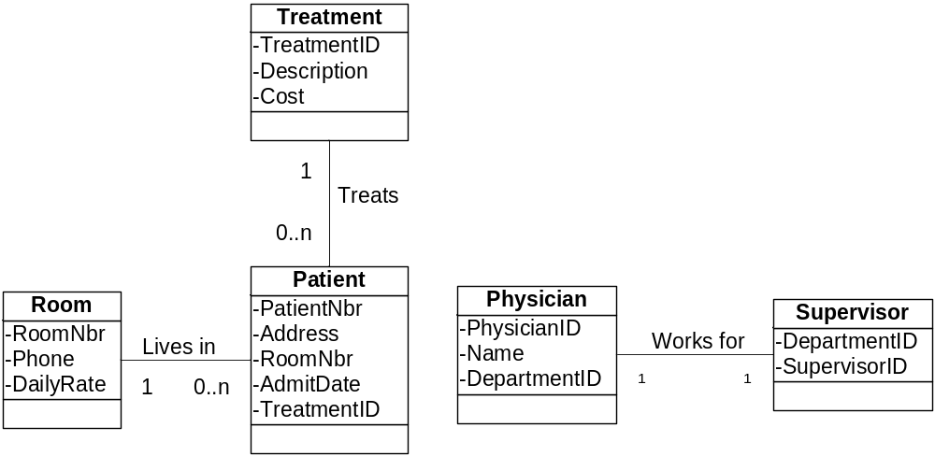

- Consider the following well-structured object relations about a sorority or fraternity:
MEMBER (Member_ID, Name, Address, {Phone Number}, Dues_Owed)
OFFICE (Office_Name, Officer_ID, Term_Start_Date, Budget)
EXPENSE (Ledger_Number, Office_Name, Expense_Date, Amt_Owed)
PAYMENT (Check_Number, Expense_Ledger_Number, Amt_Paid)
RECEIPT (Member_ID, Receipt_Date, Dues_Received)
COMMITTEE (Committee_ID, Officer_in_Charge)
WORKERS (Committee_ID, Member_ID)
  - Foreign keys are not indicated in these relations. Decide which attributes are foreign keys and justify your decisions.
There are several foreign keys in these relations. OfficerID is a foreign key in OFFICE referencing MemberID from the MEMBER relation. OfficeName is a foreign key in EXPENSE referencing OfficeName in the OFFICE relation. OfficerInCharge is a foreign key in COMMITTEE referring to OfficerID or OfficeName in the OFFICE relation. ExpenseLedgerNbr is a foreign key in PAYMENT referencing LedgerNbr in the EXPENSE relation. MemberID in both RECEIPT and WORKERS cross-references MemberID in the MEMBER relation. CommitteeID in WORKERS cross-references CommitteeID in COMMITTEE.
The WORKERS relation exists because of the many-to-many relationship between MEMBER and COMMITTEE and is an associative class.
The relations imply that one member might have many receipts, but a receipt must belong to a single member. An expense sometimes has multiple payments, but each payment must have an expense. Each office sometimes has multiple expenses, but each expense relates to a single office. Each office may have a member as an officer-in-charge, and each member may hold multiple offices simultaneously. An office sometimes has responsibility for many committees, and each committee must have an office to which it reports (whether that office has a member assigned as officer-in-charge or not). Committees sometimes have many workers, and each worker sometimes works on many committees. The class diagram annotates these relationships more clearly with the minimum and maximum cardinalities of each relation.

  - Draw a class diagram for these relations, using your answer to Part a. Employ aggregation and generalization concepts, if applicable. List the assumptions you made about multiplicities in your answer to Part b.
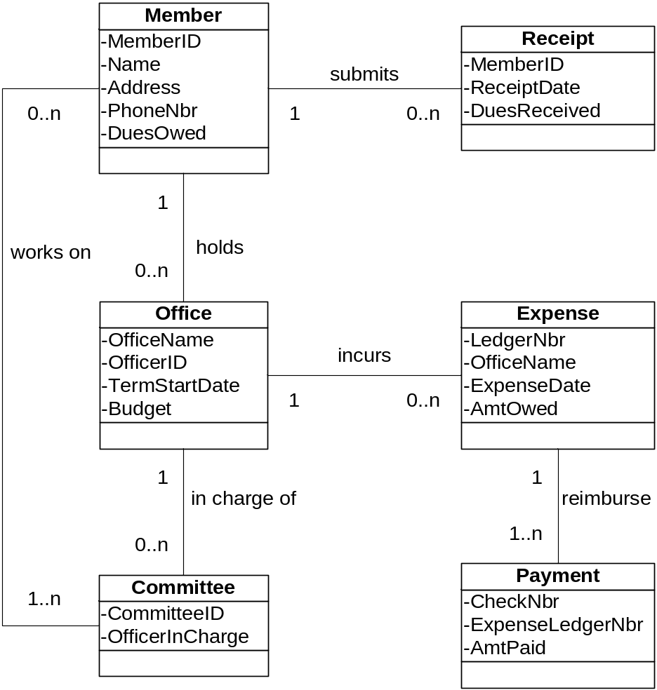
- Normalize the report shown in Figure 8.13. You may first develop a conceptual data model. A customer order is a transaction involving a list of specific quantities of products to be delivered at an agreed price. An order is processed by one salesperson for one customer.
The following is a conceptual data model for customer orders.
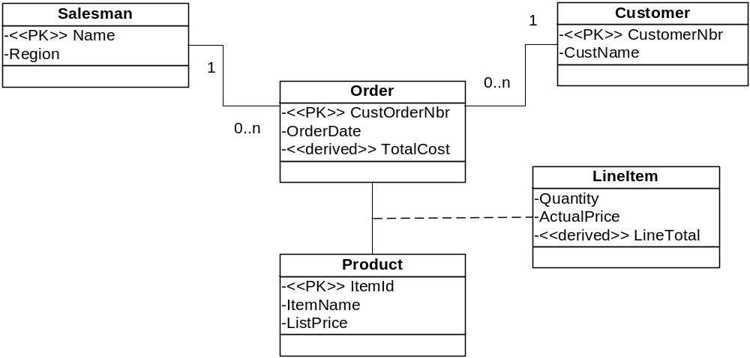 Translating these classes into object relations:

Customer (CustomerNbr, CustName)
Order (CustOrderNbr, OrderDate, <<derived>> TotalCost, CustomerNbr, Name)
Product (ItemID, ItemName, ListPrice)
Salesman (Name, Region)
LineItem (CustOrderNbr, ItemID, Quantity, ActualPrice, <<derived>> LineTotal)
- Normalize the reports shown in Figures 8.14a and 8.14b. You may first develop a conceptual data model. Integrate the object relations with those obtained in Problem and Exercise 9. Note that products can be assembled into packages to make other products. For example, the animal photography package is made up of eight items. In addition, some packages become part of much larger packages. All of the various items are considered products, and each has its own product code. In addition, each item is classified into a particular product line, such as clothing, equipment, or recreation.
The conceptual data model for Figure 8-14 follows.
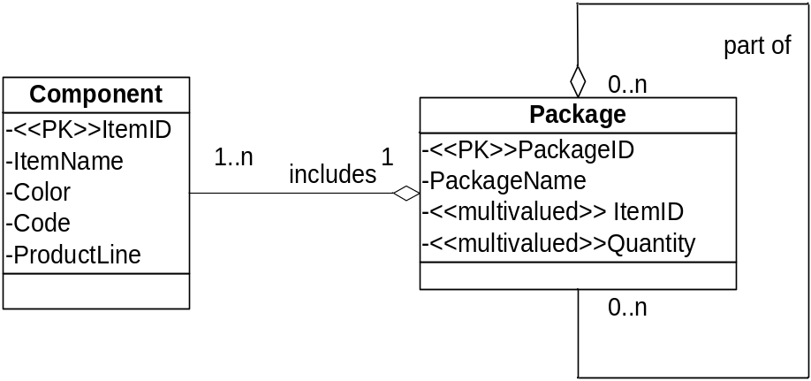
Translating these classes into object relations:
Component (ItemID, ItemName, Color, Code, ProductLine, PackageID)
Package (PackageID, PackageName, <<multivalued>> ItemID, <<multivalued>> Quantity)
CompoundPackage (PackageID, PackagePartID)
Integrating these object relations would require the addition of a 1:1 relation between product and package, with the PackageID as the primary key and the only non-key item being the price, which is dependent upon the key. This problem is similar to the first Problem and Exercise in chapters 7 and 8.
- Normalize the report shown in Figure 8.15. You may first develop a conceptual data model. Each course can have many sections, but each section refers to only one course. A student registers for a particular section of a course. A course section has a unique Section_Code that identifies the particular section number of a particular course; for example, Section_Code 2366 refers to section 1 of course ISM4210.
Even though the section code provides a unique classroom offering in the school, there is a functional dependency between the course number and its name and units. Therefore, to get to 3NF, you need to break the course information into two classes as shown in the data model below. The registration itself is an associative class taking the place of the m:n relationship between a student and the section of a class for which they wish to register.

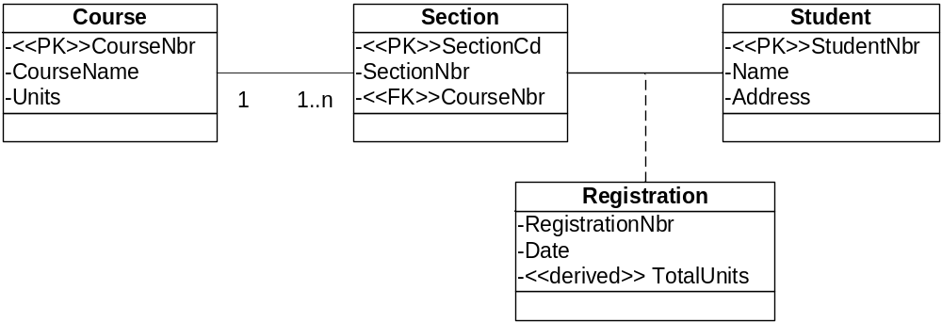Translating these classes into object relations:

Course (CourseNbr, CourseName, Units)
Section (SectionCd, SectionNbr, CourseNbr)
Student (StudentNbr, Name, Address)
Registration (SectionCd, StudentNbr, RegNbr, Date, <<derived>> TotalUnits)

ANSWERS TO DISCUSSION QUESTIONS
- Talk to MIS professionals at a variety of organizations and elicit their definition of object-relational data modeling. Determine to what extent these professionals are using object-oriented features mentioned in this chapter for data modeling. Does the use of object-oriented features create any problems?
Suggest that students bring some of their own work in this area not only to get a professional’s opinion on their effort, but to help explain their question should any of the offices they visit use related practices by other names. Have students share in class any of their discussions, especially as they relate to problems discovered during practice of these or similar techniques. See if they can suggest ways that these offices might resolve their encountered problems.
- Talk to MIS professionals at a variety of organizations and find out if they strictly follow normalization. Do they adhere to the first normal form? Do they adhere to normal forms beyond the third normal form?
Encourage students to locate information systems organizations that have large enough staffs to include a database administrator. Analysts in smaller shops may not be as familiar with data normalization.
- Find out what database management systems are available at your university for student use. Investigate which data types these DBMSs support. Compare these DBMSs based upon data types supported, and suggest which types of applications each DBMS is best suited for based on this comparison.
If the students are not able to find a variety either in academic labs or in administrative computing offices for the university, this research is easily conducted online, as well. Caution the students to validate their information, though, rather than accepting the marketing propaganda of vendors or personal preferences of programmers and analysts they may have to interview.
- From your library, borrow recently published books on popular DBMSs such as Oracle, DB2, Informix, and SQL Server. Compare and contrast the object-relational features.
Database journals are another source of information to accomplish this comparison. Students should also visit the Web sites of these companies to locate the technical specifications of their products and breadth of product line in handling data in an object-oriented environment.

ANSWERS TO CASE PROBLEMS
GuardTech Training, Inc.
- Translate the conceptual data model of the case GuardTech Training, Inc. from the previous chapter into object relations.
- Translate each entity into a relation. Did you have any multivalued attribute? If yes, how did you handle it in the relational model? Did you encounter composite attributes?
Based upon the conceptual data model of the previous chapter for this case, the object relations translate as follows.

BookManual (ISBN, Title, Author, Publisher, Price)
BookOrder (OrderNbr, Vendor, Date, <<multivalue>> Title, <<multivalue>> Quantity)
OrderReceipt (OrderNbr, ISBN, Date, QuanReceived, InvPrice)
Trainer (EmpID, Name, Address, Phone, Email, Seniority)
Software (SoftCode, Name, Vendor, Licenses)
Course (CourseCode, Length, Fee, Hardware, PrereqCode, <<multivalue>> SoftCode)
CourseQualified (EmpID, Competency, Date,)
CourseOffering (CourseID, Date, Time, EmpID, CourseCode, RoomNumber)
Client (ID, Name, Address, Phone, Email)
Classroom (RoomNumber, Capacity, Operating System)
Registration (ID, CourseID, SeatConfirmation)
- Consider each 1:m relationship. How did you translate such relationships? Did you have a 1:1 relationship? If yes, how did you handle it in the relational model?
1:m relationships were translated by adding the primary key on the 1 side as a foreign key on the many side. There were no 1:1 relationships.
- Consider each m:n relationship. How did you translate such relationships? Did any of the m:n relationships have attributes?
Many to many relationships were resolved into a pair of one to many relationships. There is a many to many relationship between instructors and courses, which is resolved by the courseOffering derived relationship. CourseOffering has its own attributes.
- Do you encounter a unary relationship? If yes, how did you handle it in the relational model?
There is a unary relationship with course prerequisites. PrereqCode was listed as a multivalue attribute in course.
- Do you encounter a ternary relationship? If yes, how did you handle it in the relational model?
CourseOffering is a ternary relationship, relating employee, course, and room.
- Is your solution normalized after translation? Did you have to go through any explicit normalization step?
It is not normalized to the extent that it has repeating values.
- New Tampa Junior Women’s Club
Translate the conceptual data model of the case New Tampa Junior Women’s Club from the previous chapter into object relations. Carry out tasks a through f as in Question 1.
  - Translate each entity into a relation. Did you have any multivalued attribute? If yes, how did you handle it in the relational model? Did you encounter composite attributes?
Based upon the conceptual data model of the previous chapter for this case, the object relations translate as follows.
Member (MemberID, MemberName, Address, Phone, Fax, Email, MembershipStatus, MentorID, spouse, <<multivalue>> ChildName, <<multivalue>> ChildAge
MemberSkill (SkillID, MemberID)
Office (OfficeID, OfficeName)
OfficeHolder (OfficeID, MemberID, TermDates)
MemberSkill (SkillID, MemberID)
Committee (Name, Mission, Minimum#ofMembers, ChairID)
Skill (SkillID, SkillDescription)
Fundraiser (EventID, Name, Location, Date, StartTime, EndTime, Description, $Earned, <<multivalue>> SkillsRequired)
Donation (DonationID, EventID, DonorID, Description, Purpose, MemberID, MonetaryValue)
Donor (DonorID, BusinessName, ContactPerson, Address, Phone, Email)

There are some multivalued attributes in the conceptual model. Address is a composite attribute.
  - Consider each 1:m relationship. How did you translate such relationships? Did you have a 1:1 relationship? If yes, how did you handle it in the relational model?
1:m relationships were translated by adding the primary key on the 1 side as a foreign key on the many side. There were no 1:1 relationships.
  - Consider each m:n relationship. How did you translate such relationships? Did any of the m:n relationships have attributes?
Many-to-many relationships were resolved into a pair of one to many relationships. There is a many-to-many relationship between donors and fundraisers and between member and skills.
  - Do you encounter a unary relationship? If yes, how did you handle it in the relational model?
There is a unary relationship with members and mentors. A mentor ID foreign key was added to the member relation.
  - Do you encounter a ternary relationship? If yes, how did you handle it in the relational model?
There is a ternary relationship between donors, fundraisers, and members. It was resolved into the donation relation.
  - Is your solution normalized after translation? Did you have to go through any explicit normalization step?
It is not normalized to the extent that it has repeating values.
Case: Broadway Entertainment, Inc.
Case Summary
The students are pleased with the progress, but they understand that they have only modeled the data requirements of the system. The classes pertaining to the interface and the business rules are yet to be modeled. Further, the data classes include mainly the attributes, but the operations of these classes have not been specified. They also note the use cases that deal with reports from the system have not been addressed. They look forward to the next milestone in their project, which will accomplish the specification of analysis classes, that is, classes that include the interface and business rules, and specify both data and behavior.
Case Questions
- Verify that the relations you say represent the MyBroadway database are in third normal form. If they are not, change them so that they are.
If students are having problems at this point in translating their object relations into 3NF, have them take one relation at a time and explicitly answer the five questions to determine 1NF on page 219, the 2NF conditions on page 221, and the 3NF instructions on pages 222-223. Explicitly stating compliance with these rules will help students understand the process.

- Did you show minimum cardinalities on both ends of each relationship when preparing the conceptual data model for Chapter 7? Are minimum cardinalities represented in some way in the relations in your answer to Question 1? If not, how are minimum cardinalities enforced in the database?
This is a good second check on the designs developed in question two. All relations should specify minimum cardinalities except in ternary relations and associative classes, where the minimum of 1 is implied by the design. Most database systems will enforce a minimum cardinality of 1 on key fields; otherwise minimum (and maximum) cardinalities can be enforced during implementation.
- Did you notice that transactions typically have a certain pattern in conceptual data modeling, as well as when mapped into relations? Verify this for the transactions, sale/rental, extension, and inquiry. Did you find any differences among the three in their structure?
Transactions typically are many-to-many relationships. They are resolved into a pair of one-to-many relationships, with a concatenated primary key comprised of at least the primary key of each parent.
- Did you come across any example of a synonym or homonym?
Student answers will vary according to their earlier work.

