计算机与信息科学学院 软件学院
课程过程性考核命题记录表
（适用于平时作业等过程性考核）

（ 2023 － 2024 学年第 2 学期）

课程名称 | 操作系统原理 | 任课教师 | 赵恒军
年级/专业 /班级 | 2022级软件工程1-4班 | 考核时间 | 2024.4.16
考核点对应教学内容（如章/节编号、名称） |  | Ch6，Ch7
本次过程性考核内容（如作业题目、题目序号、调研内容）
- Consider how to implement a mutex lock using an atomic hardware instruction. Assume that a mutex lock is defined as
boolean lock
(lock == 0) indicates that the lock is available, and a value of 1 indicates that the lock is unavailable. Illustrate how the following functions
void acquire(boolean *lock)
void release(boolean *lock)
can be implemented using the atomic test_and_set() instruction. The meaning of test_and_set() can be explained as:
boolean test and set(boolean *target) {
boolean res = *target;
*target = true;
return res;
}
Be sure to include any initialization that may be necessary.
- Consider the code example for allocating and releasing processes shown in the following figure:
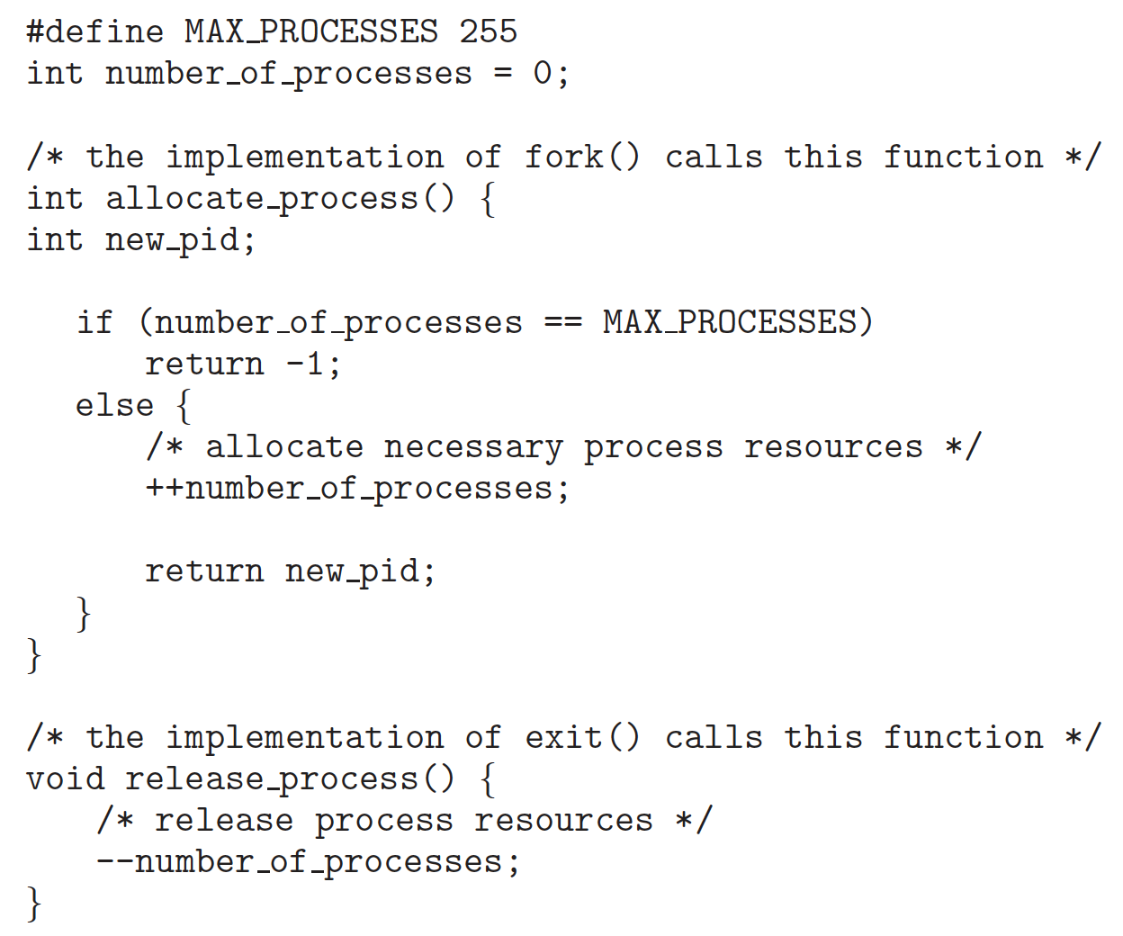
a. Identify the race condition(s).
b. Assume you have a mutex lock named mutex_lock with the operations acquire() and release(). Indicate where the locking needs to be placed to prevent the race condition(s).
- We define a semaphore as follows:
typedef struct {
int value;
struct process *list;
} semaphore;
Each semaphore has an integer value and a list of processes list. When a process must wait on a semaphore, it is added to the list of processes. A signal() operation removes one process from the list of waiting processes and awakens that process.
Now, the wait() semaphore operation can be defined as
wait(semaphore *S) {
S->value--;
if (S->value < 0) {
add this process to S->list;
block();
}
}
And the signal() semaphore operation can be defined as
signal(semaphore *S) {
S->value++;
if (S->value <= 0) {
remove a process P from S->list;
wakeup(P);
}
}
The block() operation suspends the process that invokes it. The wakeup(P) operation resumes the execution of a blocked process P. These two operations are provided by the operating system as basic system calls.
Identify race conditions in the above implementation of wait() and signal(), and illustrate how to resolve the problem using the mutex lock mechanism.

Consider a system consisting of four resources of the same type that are shared by three processes, each of which needs at most two resources. Show that the system is deadlock free.

请在下方给出所有问题的解答。

1,
*lock = 0;
Void acquire(boolean * lock){
While(test_and_set(lock));
}

Void release(boolean * lock){
*lock = false;
}
2,
a:多个线程或进程可能同时增加或减少number_of_processes变量的值，而没有使用任何同步机制来保护对共享资源的访问。
b：
#define MAX_PROCESSES 255
int number_of_processes = 0;
boolean mutex_lock = false; // 初始化为false的互斥锁
int allocate_process() {
acquire(&mutex_lock);
if (number_of_processes >= MAX_PROCESSES) {
release(&mutex_lock); // 释放互斥锁
return -1;
} else {
number_of_processes++;
release(&mutex_lock); // 释放互斥锁
return new_pid; // 假设这是获取的新的PID
}
}

void release_process() {
acquire(&mutex_lock);
number_of_processes--; // 安全地减少进程数量
release(&mutex_lock); // 释放互斥锁
}

命题教师
签 字

年 月 日

