

实验报告

课程名称：交互式媒体原理
开课学期：2020-2021学年第1学期
专 业：软件工程
年级班级：2019级2班
学生姓名：付若轩
学 号：222019321062060
指导教师：韩先锋

计算机与信息科学学院 软件学院

实验项目名称 |  | 网页设计—音乐新闻与歌词注释网站
实验时间 |  | 2020年 9 月 18 日 | 实验类型 |  | □验证性 □设计性 □综合性
一、实验目的
1.熟悉html与css样式的使用
2.熟悉网页设计的布局

二、实验要求
1.制作4张网页，题材为自己感兴趣的内容

三、实验内容与设计
1.Home Page
<!doctype html>
<html>

<head>

<style type="text/css">
div {
border-style: 0px solid;

}
a:visited{
color: white;
}
.HeadText h2 {
font: normal;
color: #ffff64;
text-shadow: #000 -2px 3px 1px;
}

.PageHeaderTop {

height: 35px;
background-color: #FFFF64;
}

.search {
position: relative;
left: 10px;
top: 3px;
width: 15%;
display: flex;

}

.search input {
float: left;
flex: 4;
height: 30px;
outline: none;
border: 1px solid white;
box-sizing: border-box;
padding-left: 10px;
}

.search button {
float: right;
flex: 1;
height: 30px;
background-color: gray;
color: white;
border-style: none;
outline: none;
}

.search button i {
font-style: normal;
}

.search button:hover {
font-size: 16px;
}

.HeadText {
float: left;
position: relative;
left: 48%;

bottom: 50px;
width: 200px;
height: 20px;
}

.HeadIcon {
position: relative;

bottom: 20px;
font-size: small;

float: right;
width: 250px;
height: 30px;
}
.HeadIcon a:visited{
color: #000;
}
.PageHeaderBottom {
height: 35px;
background-color: #121212;
font-family: Arial, Helvetica, sans-serif;
color: white;
}

.PageHeaderBottom a {
position: relative;
left: 20%;
top:10px;
padding: 35px;
}

.HomeContent {
min-height: 1000px;
}

.news {
height: 1080px;
width: 960px;
}

.TopSong {
min-height: 1920px;
}

.Grid {
position: relative;
left: 360px;
margin-top: 50px;
margin-bottom: 50px;
width: 1200px;
min-height: 800px;
}

.Content1 {
float: left;

margin-top: 20px;
margin-left: 40px;
height: 309px;
width: 440px;
}

.Content1 a {
font-size: 30px;
}

.Content2 {
float: left;
margin-top: 20px;
margin-left: 65px;
margin-right: 40px;
height: 309px;
width: 600px;
}

.Content3 {
float: left;
margin-top: 52px;
margin-left: 40px;
margin-right: 40px;
height: 400px;
width: 250px;
}

.Content3 a {
font-size: 20px;
font-family: Arial, Helvetica, sans-serif;
}

.Content4 {
float: left;
margin-top: 40px;
margin-left: 218px;
margin-right: 40px;
height: 400px;
width: 250px;
}

.Content4 a {
font-size: 20px;
}

.Content5 {
float: left;
margin-top: 40px;
margin-left: 10px;
margin-right: 40px;
height: 400px;
width: 250px;
}

.Content5 a {
font-size: 20px;
}

.GridTopping {
min-height: 100px;
}

.FullGrid2 {
height: 1000px;
margin-top: 50px;
}
.FullGrid2 img{
border-radius: 50%;
}
.FullGrid2 a {
font-family: Arial, Helvetica, sans-serif;
font-size: 24px;
color: #000000;
}
a:hover{
color: #FF1464;
}
.FullGrid2 a:visited{
color: black;
}
.PageHeaderBottom a:visited{
color: white;
}
.PageBottom {
height: 600px;
color: white;
background-color: #000;
}

.BottomCenter {
float: left;
margin-top: 55px;
margin-left: 35px;
min-height: 300px;
width: 250px;

}

.BottomCenter a {
font-size: 16px;
display: block;
margin: 10px;
font-family: Arial, Helvetica, sans-serif;
font-weight: bold;

}

.BottomRight {
float: left;
margin-top: 55px;
margin-left: 50px;
min-height: 300px;
width: 250px;
}

.BottomRight a {
font-size: 16px;
display: block;
margin: 10px;
font-family: Arial, Helvetica, sans-serif;
font-weight: bold;
}

.BottomCenterHeader {

height: 100px;
width: 600px;
}

.BottomRightHeader {

height: 100px;
width: 600px;
}
</style>

</head>

<body>
<div class="PageHeader">
<div class="PageHeaderTop">
<div class="search">
<input type="text" placeholder="Search Lyrics & More" name="" id="" value="" />
<button><i>Search</i></button>
</div>
<div class="HeadText">
<h2>G e n i u s</h2>
</div>
<div class="HeadIcon">
<a href="#"><b>SIGN UP&nbsp;&nbsp;</b></a>
<a href="#"><b>SIGN IN</b></a>
</div>
</div>
<div class="PageHeaderBottom">
<a href="#" onclick="Redirect('1')">FEATURED</a>
<a>|</a>
<a href="#" onclick="Redirect('2')">CHARTS</a>
<a>|</a>
<a href="#" >VIDEOS</a>
<a>|</a>
<a href="shop.html">SHOP</a>
</div>
</div>
<div class="HomeContent">
<div class="News">
<div class="Grid">
<div class="Content1">
<a>Despite The Pandemic Recording Industry Revenue Rose 5.6 Percent In The First Half Of
2020<br></a>
<a style="font-size:15px;font-family: Arial, Helvetica, sans-serif;">Streaming now dwarf all other
income streams by huge margins.</a>
<div style="margin-top:20px;">
<a style="font-size:12px;color: #000000;">by Chris Mench/</a>
<a style="font-size: 12px;columns: #9a9a9a;">Sep 11 2020</a>
</div>
</div>
<div class="Content2"><img src="frank ocean.webp"></div>
<div class="Content3">
<div style="font-size:15px;margin-bottom:20px;"><a>NEWS</a></div>
<a>Trippie Redd Recruits Busta Rhymes & Flips One Of His Classic Hits On "I Got
You"</a>
<div style="margin-top:80px;">
<a style="font-size:12px;color: #000000;">by Chris Mench/</a>
<a style="font-size: 12px;columns: #9a9a9a;">Sep 12 2020</a>
<img src="content3.gif"></img>
</div>
</div>

<div class="Content4">
<div style="font-size:15px;margin-bottom:20px;"><a>FEATURE</a></div><a>Chart Climber:24KGoldn & Lann
Dior ROcket To The Top 10 With "Mood"</a>
<div style="margin-top:80px;">
<a style="font-size:12px;color: #000000;">by Chris Mench/</a>
<a style="font-size: 12px;columns: #9a9a9a;">Sep 11 2020</a>
<img src="content4.gif"></img>
</div>
</div>
<div class="Content5">
<div style="font-size:15px;margin-bottom:20px;"><a>NEWS</a></div><a>Read All The Lyrics To YoungBoy
Never Broke Again's New Album 'Top'</a>
<div style="margin-top:80px;">
<a style="font-size:12px;color: #000000;">by Chris Mench/</a>
<a style="font-size: 12px;columns: #9a9a9a;">Sep 11 2020</a>
<img src="content5.jpeg"><img>
</div>
</div>
</div>
</div>
<div class="TopSongs">
<div class="Grid">
<div class="GridTopping">
<a
style="font-size:80px;font-family: Arial, Helvetica, sans-serif;position: relative;left:40%;">CHARTS</a>
<br>
<a
style="font-size:14px;font-family: Arial, Helvetica, sans-serif;color:#FF1464;position: relative;left:47%">
TRENDING ON GENIUS
</a>
</div>
<div class="FullGrid2">
<div style="min-height:75px;margin-bottom:20px">
<div style="float:left;width:14px;margin-right:60px;margin-top:20px;">
<a>1</a></div>
<img src="drake.jpg" style="float:left;margin-top:8px"></img>
<div style="margin-left:150px;position: relative;top:20px;">
<a href="singer.html" style="margin-left:30px;">Drake</a></div>
</div>
<div style="min-height:75px;margin-bottom:20px">
<div style="float:left;width:14px;margin-right:60px;margin-top:20px;">
<a>1</a></div>
<img src="drake.jpg" style="float:left;margin-top:8px"></img>
<div style="margin-left:150px;position: relative;top:20px;">
<a href="singer.html"style="margin-left:30px;">Drake</a></div>
</div>
<div style="min-height:75px;margin-bottom:20px">
<div style="float:left;width:14px;margin-right:60px;margin-top:20px;">
<a>1</a></div>
<img src="drake.jpg" style="float:left;margin-top:8px"></img>
<div style="margin-left:150px;position: relative;top:20px;">
<a href="singer.html"style="margin-left:30px;">Drake</a></div>
</div>
<div style="min-height:75px;margin-bottom:20px">
<div style="float:left;width:14px;margin-right:60px;margin-top:20px;">
<a>1</a></div>
<img src="drake.jpg" style="float:left;margin-top:8px"></img>
<div style="margin-left:150px;position: relative;top:20px;">
<a style="margin-left:30px;">Drake</a></div>
</div>
<div style="min-height:75px;margin-bottom:20px">
<div style="float:left;width:14px;margin-right:60px;margin-top:20px;">
<a>1</a></div>
<img src="drake.jpg" style="float:left;margin-top:8px"></img>
<div style="margin-left:150px;position: relative;top:20px;">
<a style="margin-left:30px;">Drake</a></div>
</div>
<div style="min-height:75px;margin-bottom:20px">
<div style="float:left;width:14px;margin-right:60px;margin-top:20px;">
<a>1</a></div>
<img src="drake.jpg" style="float:left;margin-top:8px"></img>
<div style="margin-left:150px;position: relative;top:20px;">
<a style="margin-left:30px;">Drake</a></div>
</div>
<div style="min-height:75px;margin-bottom:20px">
<div style="float:left;width:14px;margin-right:60px;margin-top:20px;">
<a>1</a></div>
<img src="drake.jpg" style="float:left;margin-top:8px"></img>
<div style="margin-left:150px;position: relative;top:20px;">
<a style="margin-left:30px;">Drake</a></div>
</div>
<div style="min-height:75px;margin-bottom:20px">
<div style="float:left;width:14px;margin-right:60px;margin-top:20px;">
<a>1</a></div>
<img src="drake.jpg" style="float:left;margin-top:8px"></img>
<div style="margin-left:150px;position: relative;top:20px;">
<a style="margin-left:30px;">Drake</a></div>
</div>
<div style="min-height:75px;margin-bottom:20px">
<div style="float:left;width:14px;margin-right:60px;margin-top:20px;">
<a>1</a></div>
<img src="drake.jpg" style="float:left;margin-top:8px"></img>
<div style="margin-left:150px;position: relative;top:20px;">
<a style="margin-left:30px;">Drake</a></div>
</div>

<div style="min-height:75px;margin-bottom:20px">
<div style="float:left;width:14px;margin-right:60px;margin-top:20px;">
<a>1</a></div>
<img src="drake.jpg" style="float:left;margin-top:8px"></img>
<div style="margin-left:150px;position: relative;top:20px;">
<a style="margin-left:30px;">Drake</a></div>
</div>
</div>

</div>
</div>
</div>
<div class="PageBottom">
<div class="BottomLeft" style="width:560px;height:400px;float:left;padding:50px;margin-left:260px;">
<a style="font-size:36px;">Genius is the world's biggest collection of song lyrics and musical knowledge</a>
<br>
<img src="facebook.png" style="margin-right: 50px;margin-top:20px;"></img>
<img src="twitter.png" style="margin-right: 50px;"></img>
<img src="instagram.png" style="margin-right: 50px;"></img>
<img src="youtube.png"></img>
</div>
<div class="BottomCenter"><a>About Genius</a><br><a>Conntributor
Guidelines</a><br><a>Press</a><br><a>Advertise</a><br><a>Event Space</a><br><a>Privacy Policy</a>
<div class="BomttomCenterHeader">
<p style="font-family:Arial, Helvetica, sans-serif;font-size:12px;color:#9a9a9a;padding:7px;">©2020
Genius Media Group Inc.</p>
</div>
</div>

<div class="BottomRight"><a>About Genius</a><br><a>Conntributor
Guidelines</a><br><a>Press</a><br><a>Advertise</a><br><a>Event Space</a><br><a>Privacy Policy</a>
<div class="BomttomRightHeader">
<p style="font-family:Arial, Helvetica, sans-serif;font-size:12px;color:#9a9a9a;padding:7px;">Terms of
Use</p>
</div>
</div>

</div>
</body>

</html>
2.Shop Page
<!DOCTYPE html>
<html>

<head>
<style>
.TopGrid {
width: 100%;
height: 200px;
background-color: #ffff64;
}

.CenterGrid {
width: 100%;
min-height: 800px;
}

.Content1 {
float: left;
margin-top: 50px;
margin-left: 20%;
min-width: 250px;
min-height: 300px;
}

.Content2 {
float: left;
margin-top: 50px;
margin-left: 45px;
min-width: 250px;
min-height: 300px;
}

.Content3 {
float: left;
margin-top: 50px;
margin-left: 45px;
min-width: 250px;
min-height: 300px;
}

.Content4 {
float: left;
margin-top: 50px;
margin-left: 45px;
min-width: 250px;
min-height: 300px;
}

.Content5 {
float: left;
margin-left: 20%;
margin-top: 50px;
min-width: 250px;
min-height: 300px;
}

.Content6 {
float: left;
margin-left: 45px;
margin-top: 50px;
min-width: 250px;
min-height: 300px;
}

.Content7 {
float: left;
margin-left: 45px;
margin-top: 50px;
min-width: 250px;
min-height: 300px;
}

.Content8 {
float: left;
margin-left: 45px;
margin-top: 50px;
min-width: 250px;
min-height: 300px;
}

.BottomGrid {
width: 100%;
min-height: 300px;
margin-top: 42px;
background-color: #ffff64;
}

.Line1 {
margin-top: 50px;
margin-left: 360px;
padding-top: 20px;
width: 1200px;
height: 50px;
}

.Line1 ul {
display: block;

list-style-type: none;

}

.Line1 li {
display: inline;
margin-right: 15px;
}

.dropbtn {
background-color: #ee2761;
color: #f9f9f9;
padding: 16px;
font-size: 16px;
width: 150px;
border: none;
cursor: pointer;
}

.dropdown {
position: relative;
top: -50px;
left: 1000px;
width:150px;

}

.dropdown-content {
display: none;
position: absolute;
background-color: #f9f9f9;
min-width: 160px;
box-shadow: 0px 8px 16px 0px rgba(0, 0, 0, 0.2);
}

.dropdown-content a {
color: black;
padding: 12px 16px;
text-decoration: none;
display: block;
}

.dropdown-content a:hover {
background-color: #f1f1f1
}

.dropdown:hover .dropdown-content {
display: block;
}

.dropdown:hover .dropbtn {
background-color: #ee2720;
}

.Line2 {
margin-top: 35px;

margin-bottom: 50px;
width: 1200px;
min-height: 50px;
padding-left: 40px;
}
</style>
</head>

<body>
<div class="TopGrid">
<div class="TopHeader">
<p style="
font: normal;
font-size:60px;
color: #ffff64;
text-shadow: #000 -5px 5px 1px;bottom: 20px;position: absolute;left: 42%;top:5px;">G E N I U S</p>
<p style="font:normal;font-size:20px;color:#ee2761;position: absolute;left:880px;top:140px;">All Products
</p>
</div>
</div>
<div class="CenterGrid">
<div class="Content1">
<img src="shop.gif"></img>
<p style="font-size: 15px;position: relative;left:7%"><b>Champion x Genius Verified</b></p>
<p style="font-size: 10px;color: #6a6f72;">&nbsp;&nbsp;Champion Reverse Weave Unisex Hoodie</p>
<p style="font-size: 10px;color: #6a6f72;position: relative;left:40%;">
$55.00</p>
</div>
<div class="Content2"><img src="shop.gif"></img>
<p style="font-size: 15px;position: relative;left:7%"><b>Champion x Genius Verified</b></p>
<p style="font-size: 10px;color: #6a6f72;">&nbsp;&nbsp;Champion Reverse Weave Unisex Hoodie</p>
<p style="font-size: 10px;color: #6a6f72;position: relative;left:40%;">
$55.00</p>
</div>
<div class="Content3"><img src="shop.gif"></img>
<p style="font-size: 15px;position: relative;left:7%"><b>Champion x Genius Verified</b></p>
<p style="font-size: 10px;color: #6a6f72;">&nbsp;&nbsp;Champion Reverse Weave Unisex Hoodie</p>
<p style="font-size: 10px;color: #6a6f72;position: relative;left:40%;">
$55.00</p>
</div>
<div class="Content4"><img src="shop.gif"></img>
<p style="font-size: 15px;position: relative;left:7%"><b>Champion x Genius Verified</b></p>
<p style="font-size: 10px;color: #6a6f72;">&nbsp;&nbsp;Champion Reverse Weave Unisex Hoodie</p>
<p style="font-size: 10px;color: #6a6f72;position: relative;left:40%;">
$55.00</p>
</div>

<div class="Content5"><img src="shop.gif"></img>
<p style="font-size: 15px;position: relative;left:7%"><b>Champion x Genius Verified</b></p>
<p style="font-size: 10px;color: #6a6f72;">&nbsp;&nbsp;Champion Reverse Weave Unisex Hoodie</p>
<p style="font-size: 10px;color: #6a6f72;position: relative;left:40%;">
$55.00</p>
</div>
<div class="Content6"><img src="shop.gif"></img>
<p style="font-size: 15px;position: relative;left:7%"><b>Champion x Genius Verified</b></p>
<p style="font-size: 10px;color: #6a6f72;">&nbsp;&nbsp;Champion Reverse Weave Unisex Hoodie</p>
<p style="font-size: 10px;color: #6a6f72;position: relative;left:40%;">
$55.00</p>
</div>
<div class="Content7"><img src="shop.gif"></img>
<p style="font-size: 15px;position: relative;left:7%"><b>Champion x Genius Verified</b></p>
<p style="font-size: 10px;color: #6a6f72;">&nbsp;&nbsp;Champion Reverse Weave Unisex Hoodie</p>
<p style="font-size: 10px;color: #6a6f72;position: relative;left:40%;">
$55.00</p>
</div>
<div class="Content8"><img src="shop.gif"></img>
<p style="font-size: 15px;position: relative;left:7%"><b>Champion x Genius Verified</b></p>
<p style="font-size: 10px;color: #6a6f72;">&nbsp;&nbsp;Champion Reverse Weave Unisex Hoodie</p>
<p style="font-size: 10px;color: #6a6f72;position: relative;left:40%;">
$55.00</p>
</div>
</div>
<div class="BottomGrid">
<div class="Line1">
<ul>
<li>About</li>
<li>Blog</li>
<li>Jobs</li>
<li>Terms</li>
<li>Privacy</li>
<li>Security</li>
<li>Track Order</li>
<li>Training Center</li>
<li>Impressum</li>
<li>Our Values</li>

</ul>
<div class="dropdown">
<button class="dropbtn"style="width: 150px;">country&amp;region</button>
<div class="dropdown-content">
<a href="#">English</a>
<a href="#">简体中文</a>
<a href="#">Español</a>
</div>
</div>
<div class="Line2">
<p>If you are a California resident,you may request : Do not sell my personal information.</p>
<p>© 2020 Teespring,Inc.</p>
</div>
</div>
</body>

</html>
3.Singer Page
<!DOCTYPE html>
<html>

<head>
<style>

.TopGrid {
height: 100px;
background-color: #ffff64;
width: 1920px;
}

.LeftGrid {
float: left;
margin-left: 250px;
margin-top: 50px;
width: 400px;
min-height: 500px;
padding:20px;

}

.RightGrid1 {
float: right;
width: 1000px;
min-height: 300px;
margin-top: 50px;
margin-right: 100px;
}

.RightGrid2 {
float: right;
width: 1000px;
min-height: 300px;
margin-top: 50px;
margin-right:100px;
}

.PageBottom {
color: white;
background-color: black;
position: absolute;
top: 1000px;
min-height: 200px;
width: 1920px;
}

.BottomCenter {
float: left;
margin-left: 35px;
margin-top: 55px;
height: 300px;
width: 250px;

}

.BottomCenter a {
font-size: 16px;
display: block;
margin: 10px;
font-family: Arial, Helvetica, sans-serif;
font-weight: bold;

}

.BottomRight {
float: left;
margin-top: 55px;
margin-left: 50px;
min-height: 300px;
width: 250px;
}

.BottomRight a {
font-size: 16px;
display: block;
margin: 10px;
font-family: Arial, Helvetica, sans-serif;
font-weight: bold;
}

.BottomCenterHeader {

height: 100px;
width: 600px;
}

.BottomRightHeader {

height: 100px;
width: 600px;
}
</style>
</head>

<body>
<div class="TopGrid">
<p style="
font: normal;
font-size:40px;
color: #ffff64;
text-shadow: #000 -5px 5px 1px;bottom: 20px;position: absolute;left: 45%;top:0px;
height: 50px;
margin-top: 20px;">G E N I U S</p>
</div>
<div class="LeftGrid">
<img src="drake2.jpg" style="width: 300px;padding-left:50px;border-radius: 50px;"></img>
<div style="background-color: #9a9a9a;padding: 15px;margin:50px;">
<p>Aubrey Drake Graham (born October 24, 1986) is a Canadian rapper, singer, songwriter, actor, record
producer, and entrepreneur. A prominent figure in popular music, Drake is widely credited for
popularizing the Toronto sound to the music industry. He first gained recognition as an actor on the teen
drama television series Degrassi: The Next Generation (2001-2007); intent on pursuing a career in music, he
left the series in 2007 after releasing his debut mixtape Room for Improvement. He released two further
independent projects, Comeback Season and So Far Gone, before signing to Young Money Entertainment in June
2009.</p>
</div>
</div>
<div class="RightGrid1">
<p style="height: 5px;margin-left: 40px;">
Pop Songs
</p>
<div style="float:left;width: 225px;height:260px;margin-left:40px;margin-top:40px;">
<a href="lyrics.html"><img src="Laugh Now Cry Later.jpg" style="width: 225px;height: 230px;"></img></a>
<p style="margin-left: 45%;margin-top: 0px;color: #9a9a9a;">2020</p>
</div>
<div style="float:left;width: 225px;height:260px;margin-left:40px;margin-top:40px;">
<img src="Laugh Now Cry Later.jpg" style="width: 225px;height: 230px;"></img>
<p style="margin-left: 45%;margin-top: 0px;color: #9a9a9a;">2020</p></div>
<div style="float:left;width: 225px;height:260px;margin-left:40px;margin-top:40px;">
<img src="Laugh Now Cry Later.jpg" style="width: 225px;height: 230px;"></img>
<p style="margin-left: 45%;margin-top: 0px;color: #9a9a9a;">2020</p></div>
</div>
<div class="RightGrid2">
<p style="height: 5px;margin-left: 40px;">
Pop Album
</p>
<div style="float:left;width: 225px;height:260px;margin-left:40px;margin-top:40px;"> <img src="Take Care.jpg" style="width: 225px;height: 230px;"></img>
<p style="margin-left: 45%;margin-top: 0px;color: #9a9a9a;">2020</p></div>
<div style="float:left;width: 225px;height:260px;margin-left:40px;margin-top:40px;"> <img src="Take Care.jpg" style="width: 225px;height: 230px;"></img>
<p style="margin-left: 45%;margin-top: 0px;color: #9a9a9a;">2020</p></div>
<div style="float:left;width: 225px;height:260px;margin-left:40px;margin-top:40px;"> <img src="Take Care.jpg" style="width: 225px;height: 230px;"></img> <p style="margin-left: 45%;margin-top: 0px;color: #9a9a9a;">2020</p></div>
</div>
<div class="PageBottom">
<div class="BottomLeft" style="width:560px;height:300px;float:left;margin:50px;padding:50px;margin-left:260px;">
<a style="font-size:36px;">Genius is the world's biggest collection of song lyrics and musical knowledge</a>
<br>
<img src="facebook.png" style="margin-right: 50px;margin-top:20px;"></img>
<img src="twitter.png" style="margin-right: 50px;"></img>
<img src="instagram.png" style="margin-right: 50px;"></img>
<img src="youtube.png"></img>
</div>
<div class="BottomCenter"><a>About Genius</a><br><a>Conntributor
Guidelines</a><br><a>Press</a><br><a>Advertise</a><br><a>Event Space</a><br><a>Privacy Policy</a>
<div class="BomttomCenterHeader">
<p style="font-family:Arial, Helvetica, sans-serif;font-size:12px;color:#9a9a9a;padding:7px;">©2020
Genius Media Group Inc.</p>
</div>
</div>
<div class="BottomRight"><a>About Genius</a><br><a>Conntributor
Guidelines</a><br><a>Press</a><br><a>Advertise</a><br><a>Event Space</a><br><a>Privacy Policy</a>
<div class="BomttomRightHeader">
<p style="font-family:Arial, Helvetica, sans-serif;font-size:12px;color:#9a9a9a;padding:7px;">Terms of
Use</p>
</div>
</div>
</div>
</body>

</html>
4.Lyric Page
<!DOCTYPE html>
<html>

<head>
<style>

.TopGrid {
height: 100px;
background-color: #ffff64;
width: 1920px;
}

.CenterGrid {
min-height: 1000px;
width: 1920px;
}

.LeftGrid {
float: left;
margin-top: 100px;
margin-left: 150px;
min-height: 600px;
width: 700px;
}

.RightGrid1 {
float: right;
margin-top: 100px;
margin-right: 200px;
width: 700px;
height: 300px;
}

.RightGrid2 {
float: right;
margin-top: 50px;
margin-right: 200px;
width: 700px;
min-height: 300px;

}

.PageBottom {
color: white;
background-color: black;
position: absolute;
top: 1000px;
min-height: 200px;
width: 1920px;
}

.BottomCenter {
float: left;
margin-left: 35px;
margin-top: 55px;
height: 300px;
width: 250px;
}

.BottomCenter a {
font-size: 16px;
display: block;
margin: 10px;
font-family: Arial, Helvetica, sans-serif;
font-weight: bold;
}

.BottomRight {
float: left;
margin-top: 55px;
margin-left: 50px;
min-height: 300px;
width: 250px;
}

.BottomRight a {
font-size: 16px;
display: block;
margin: 10px;
font-family: Arial, Helvetica, sans-serif;
font-weight: bold;
}

.BottomCenterHeader {

height: 100px;
width: 600px;
}

.BottomRightHeader {

height: 100px;
width: 600px;
}
</style>
</head>

<body>
<div class="TopGrid">
<p style="
font: normal;
font-size:40px;
color: #ffff64;
text-shadow: #000 -5px 5px 1px;bottom: 20px;position: absolute;left: 45%;top:0px;
height: 50px;
margin-top: 20px;">G E N I U S</p>
</div>
<div class="CenterGrid">
<div class="LeftGrid">
<p style="padding-left: 40px;padding-right:40px;">[Intro: Drake]<br>
Woah, woah<br>
Yeah<br>
<br>
[Chorus: Drake]<br>
Sometimes we laugh and sometimes we cry, but I guess you know now, baby
I took a half and she took the whole thing, slow down, baby
We took a trip, now we on your block and it's like a ghost town, baby
Where do these niggas be at when they say they doin' all this and all that?
<br><br>
[Verse 1: Drake]<br>
Tired of beefin' you bums, you can't even pay me enough to react
Been wakin' up in the crib and sometimes I don't even know where I'm at
Please don't play that nigga songs in this party, I can't even listen to that
Anytime that I ran into somebody, it must be a victory lap, ayy
Shawty, come sit on my lap, ayy, they sayin' Drizzy just snap
Distance between us is not like a store, this isn't a closeable gap, ayy
I've seen some niggas attack and don't end up makin' it back
<br><br>
[Pre-Chorus: Drake]<br>
I know that they at the crib goin' crazy, down bad
What they had didn't last, damn, baby
<br><br>
[Chorus: Drake]<br>
Sometimes we laugh and sometimes we cry, but I guess you know now, baby
I took a half and she took the whole thing, slow down, baby
We took a trip, now we on your block and it's like a ghost town, baby
Where do these niggas be at when they say they doin' all this and all that?</p>
</div>
<div class="RightGrid1">
<p style="padding-left: 40px;padding-right: 40px;color: #9a9a9a;">"LAUGH NOW CRY LATER" TRACK INFO</p>
<p style="padding-left: 40px;padding-right: 40px;color: #9a9a9a;">Featuring Lil Durk<br>
Produced By Rogét Chahayed, Yung Exclusive, Cardo & 1 more<br>
Written By G. Ry, Yung Exclusive, Rogét Chahayed & 3 more<br>
Mixing Engineer Turn Me Up Josh, Chris Athens & 40<br>
Artwork Ben Dorado<br>
Video Sound Mix Tom Paolantonio<br>
Video Vfx Supervisor Les Umberger<br>
Video Colorist Stefan Sonnenfeld<br>
Video Editor Greg Scruton<br>
</p>
</div>
<div class="RightGrid2">
<p style="padding-left: 40px;padding-right: 45px;">Will there be a DaBaby feature on the album?
On December 10, 2019, Drake made a guest appearance at DaBaby’s concert in Toronto, where he revealed
that he was working on the album. Minutes afterwards, DaBaby informed the audience that he intended to
feature on the album:
<br>
"
<br>
Toronto, I’m tryna pull up on Drake and drop a verse on the muthafuckin' album
</p>
</div>
</div>
<div class="PageBottom">
<div class="BottomLeft" style="width:560px;height:300px;float:left;margin:50px;padding:50px;margin-left:260px;">
<a style="font-size:36px;">Genius is the world's biggest collection of song lyrics and musical knowledge</a>
<br>
<img src="facebook.png" style="margin-right: 50px;margin-top:20px;"></img>
<img src="twitter.png" style="margin-right: 50px;"></img>
<img src="instagram.png" style="margin-right: 50px;"></img>
<img src="youtube.png"></img>
</div>
<div class="BottomCenter"><a>About Genius</a><br><a>Conntributor
Guidelines</a><br><a>Press</a><br><a>Advertise</a><br><a>Event Space</a><br><a>Privacy Policy</a>
<div class="BomttomCenterHeader">
<p style="font-family:Arial, Helvetica, sans-serif;font-size:12px;color:#9a9a9a;padding:7px;">©2020
Genius Media Group Inc.</p>
</div>
</div>
<div class="BottomRight"><a>About Genius</a><br><a>Conntributor
Guidelines</a><br><a>Press</a><br><a>Advertise</a><br><a>Event Space</a><br><a>Privacy Policy</a>
<div class="BomttomRightHeader">
<p style="font-family:Arial, Helvetica, sans-serif;font-size:12px;color:#9a9a9a;padding:7px;">Terms of
Use</p>
</div>
</div>
</div>
</body>

</html>

四、实验结果 （可给出截图等加以说明）
1.Home Page
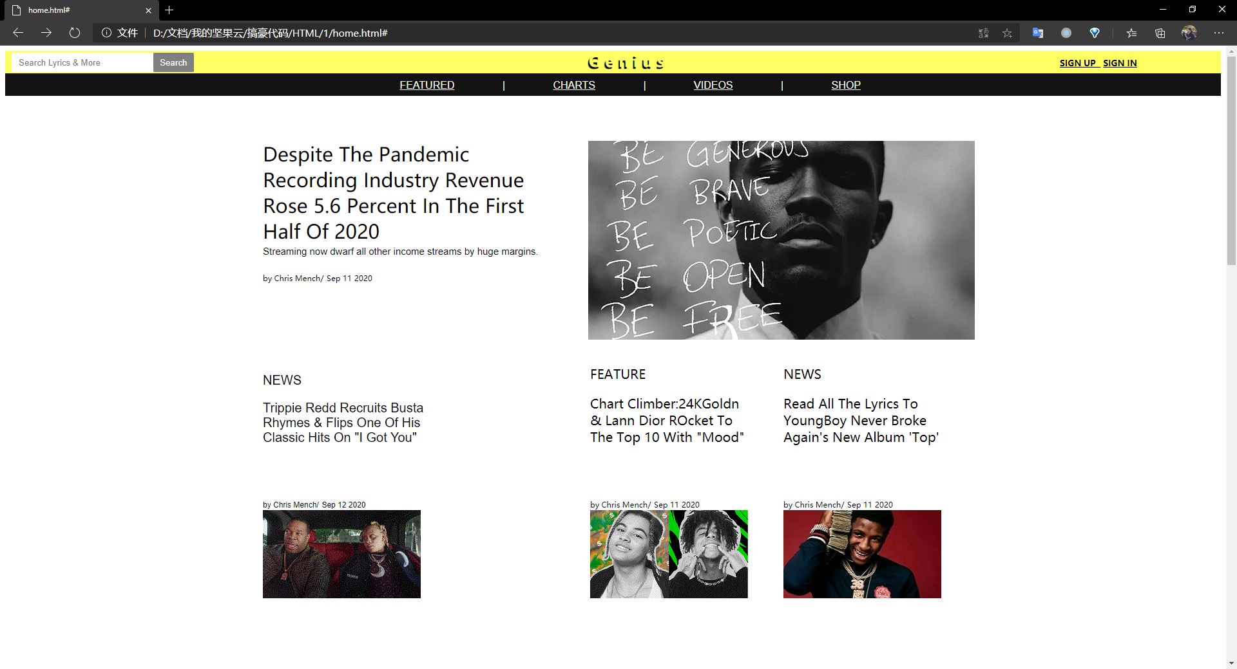

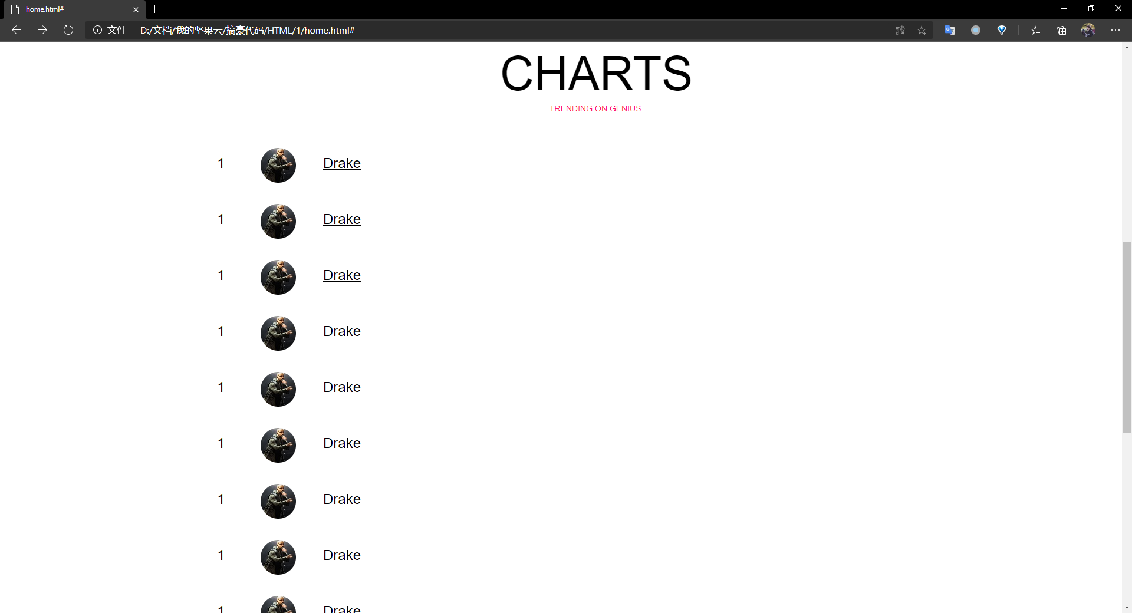
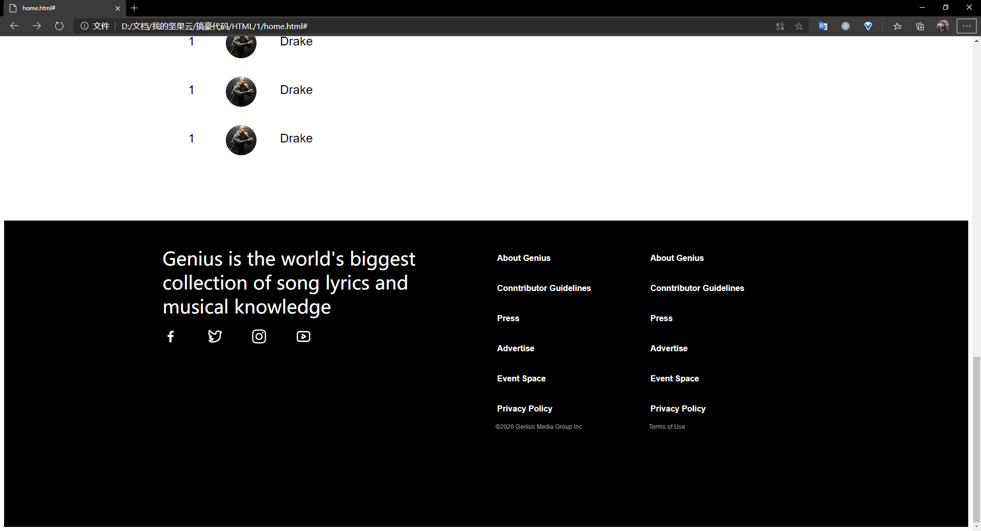
2.Shop Page
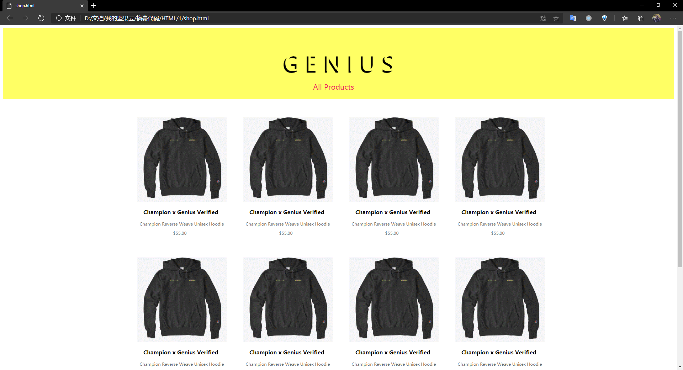
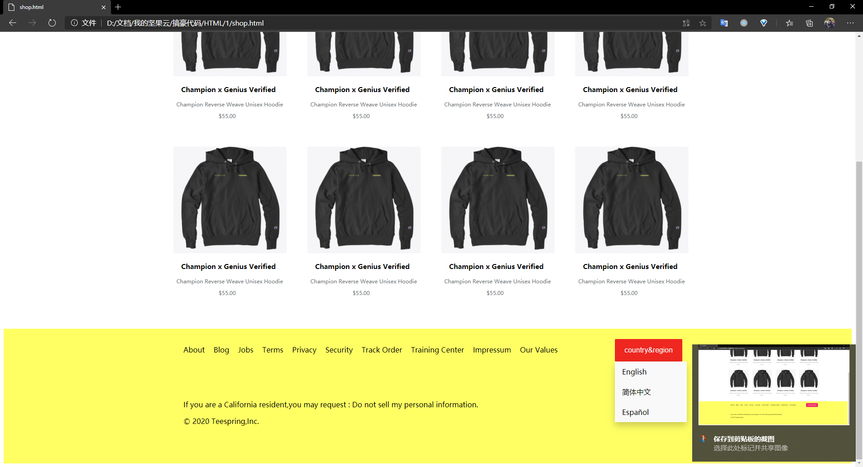
3.Singer Page
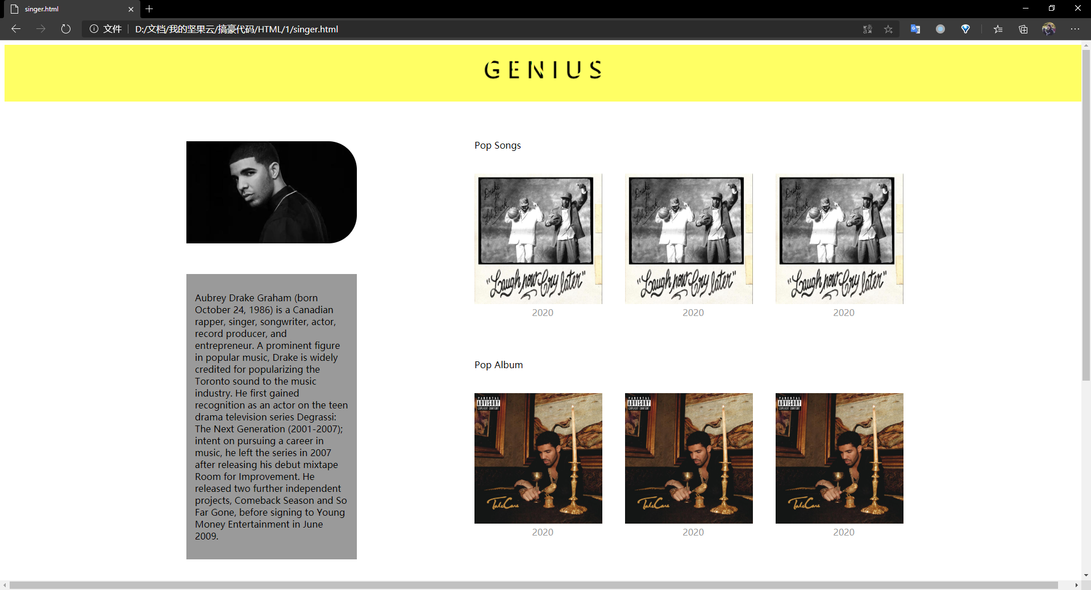
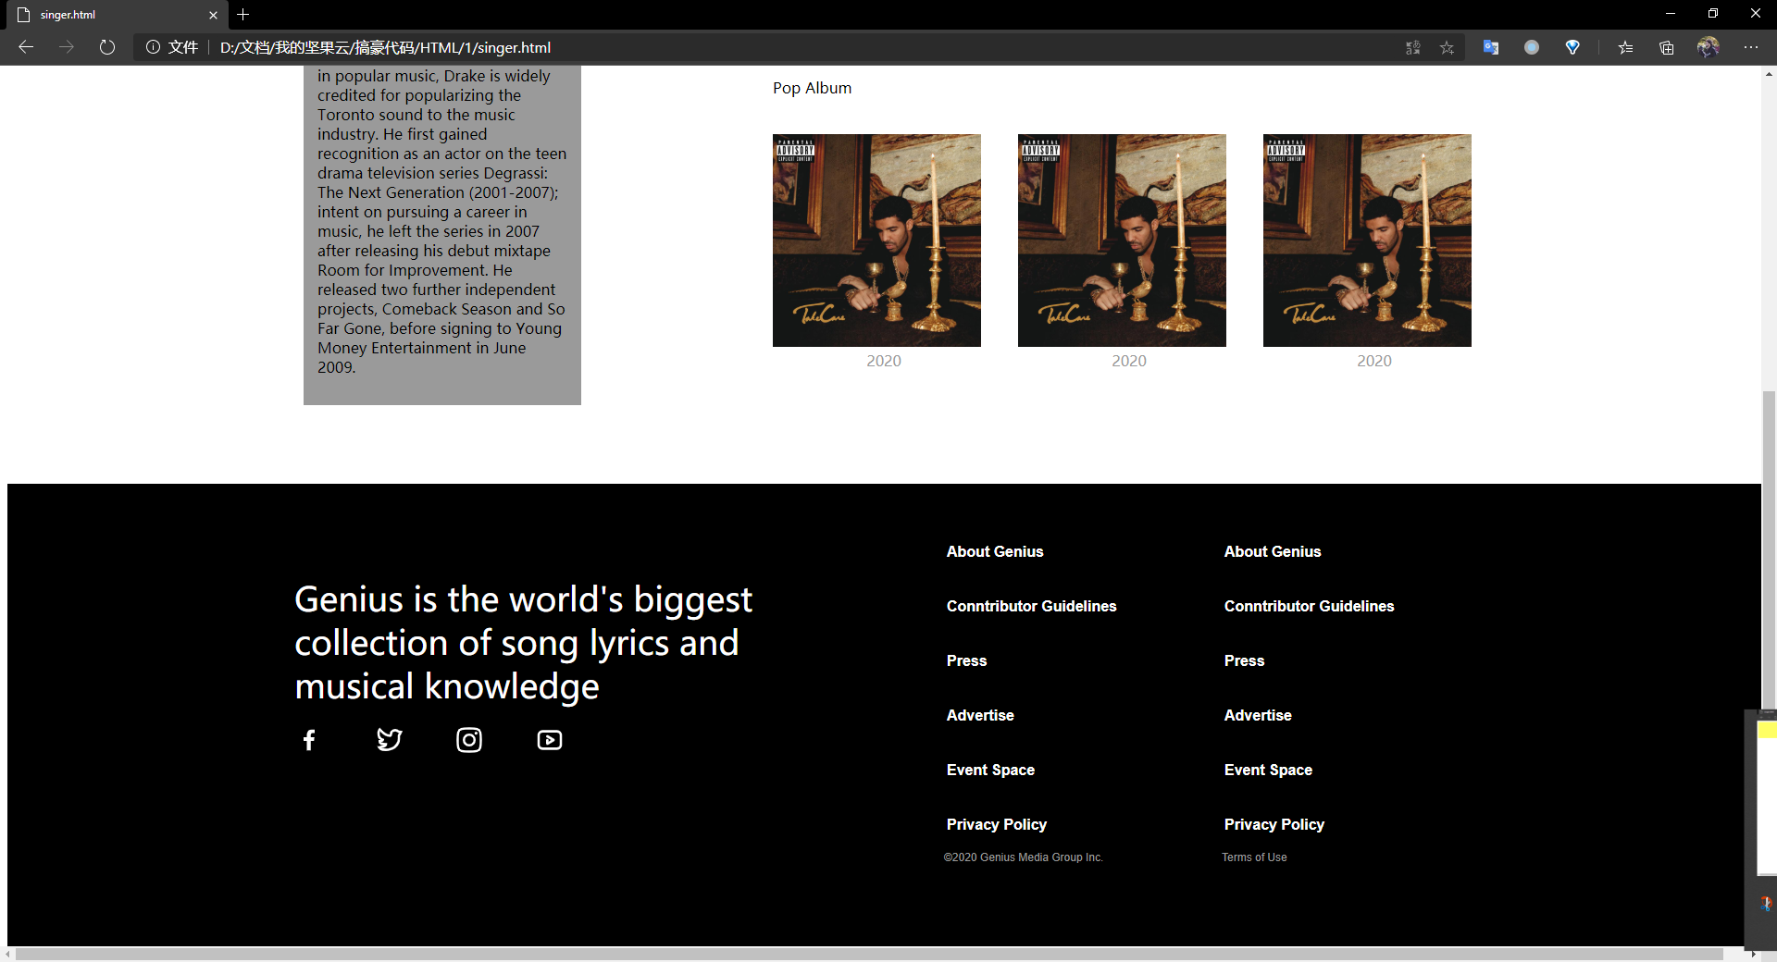
4.Lyrics Page
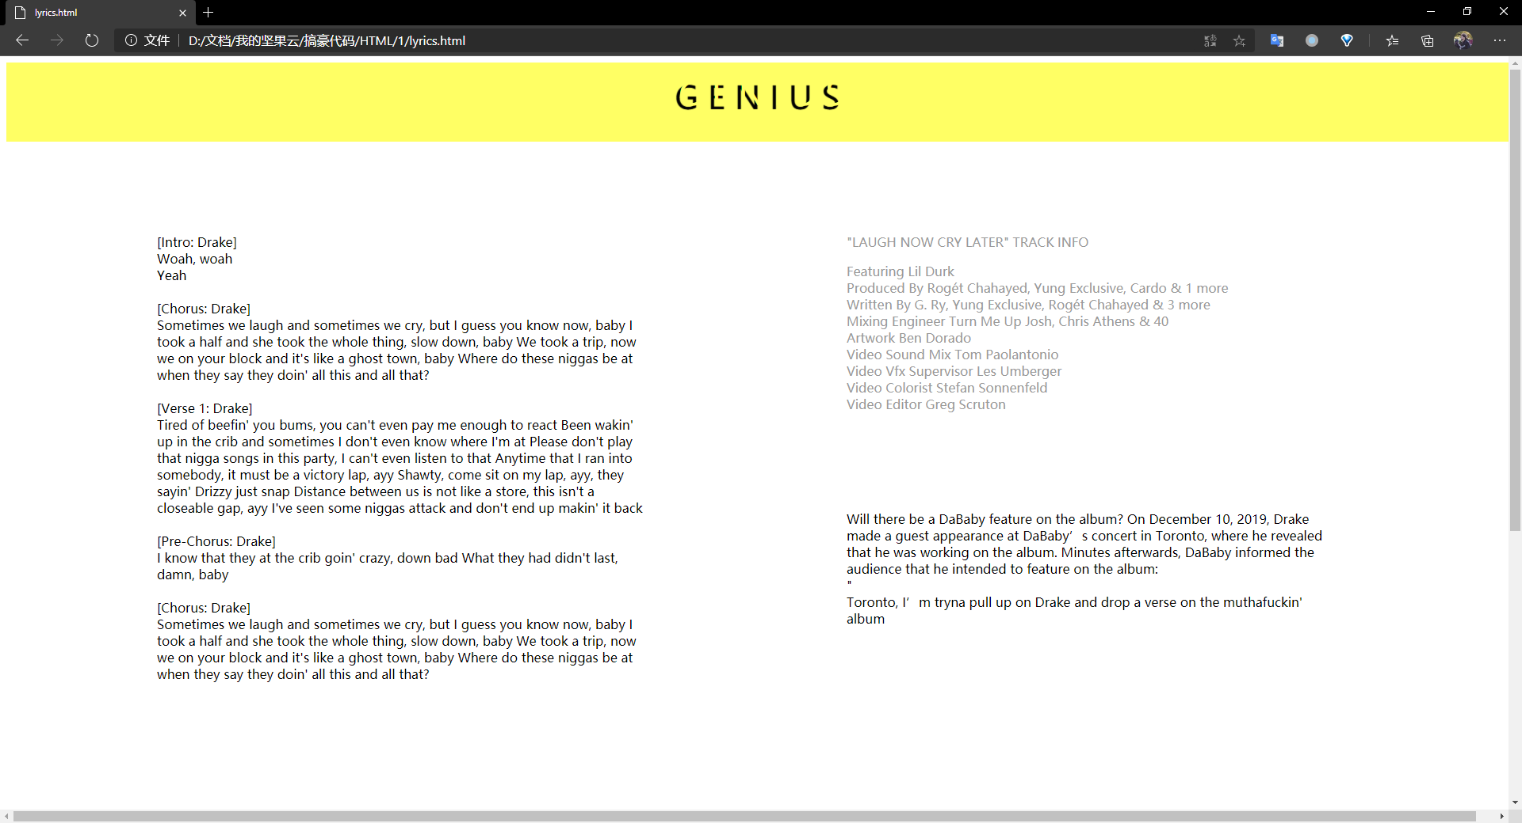
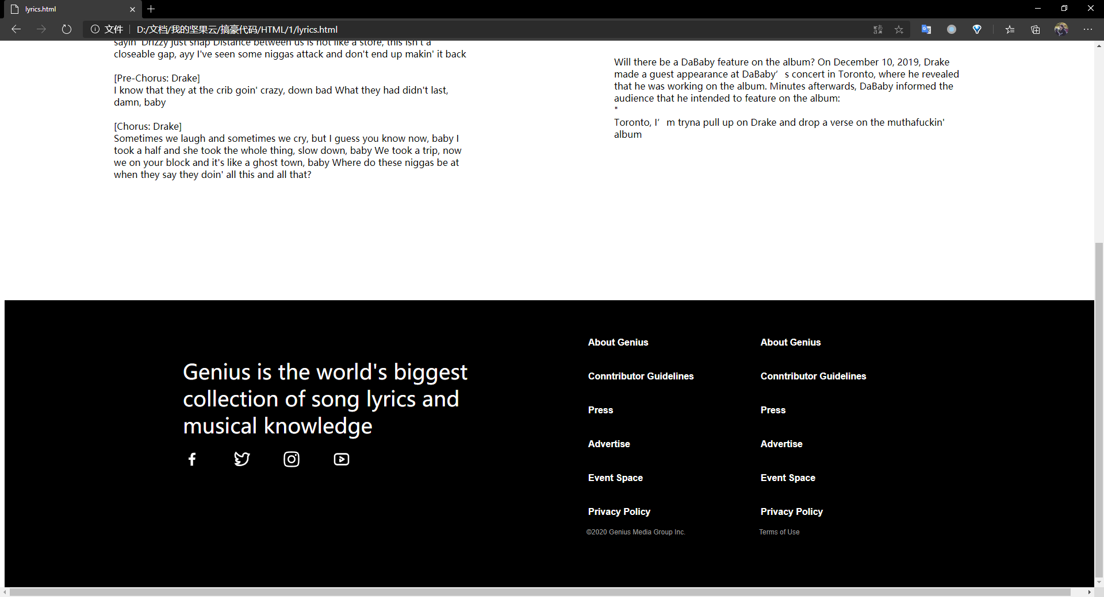
五、结果分析及总结（对实验的结果是否达到预期进行分析，总结实验的收获和存在的问题等）
分析：
1.实验结果差强人意。预先设计的布局基本都实现了。
2.HomePage实现了对新闻的展示，提供了跳转到其他网页的入口。同时chart部分提供了排名以及网页底部的更多信息。
3.ShopPage实现了对商品的展示。
4.SingerPage实现了对歌手的简介以及热门单曲与热门专辑的展示
5.Lyrics实现了对歌词的展示以及制作人信息的展示
收获：
- 重新熟悉了html与css的基本语法
- 对div布局有了更深的认识
- 为了实现下拉菜单改变内容的功能学习了一点JavaScript的基本知识
问题：
- 一部分预想中的功能没有能实现，比如下拉菜单改变内容以及加载更多功能按钮
- 使用了较多的内联样式表
- 对div布局不够熟悉，在网页布局上花费了较多时间。

教  师  评  阅 | 实验目的和要求明确（A-E）：
教  师  评  阅 | 实验内容与设计（A-E）：
教  师  评  阅 | 实验结果（A-E）：
教  师  评  阅 | 结果分析和总结（A-E）：
教  师  评  阅 | 实验报告规范性（A-E）
教  师  评  阅 | 实验成绩（A-E）：

