

实验报告

课程名称：交互式媒体原理
开课学期：2020-2021学年第1学期
专 业：软件工程
年级班级：2019级2班
学生姓名：付若轩
学 号：222019321062060
指导教师：韩先锋

计算机与信息科学学院 软件学院

实验项目名称 |  | Image Processing
实验时间 |  | 2020年 9 月 23 日 | 实验类型 |  | □验证性 □设计性 □综合性
一、实验目的
1.了解图像处理的基本知识
2.了解常见的图像类型
3.了解图像的颜色空间
4.了解伽马校正的基本原理

二、实验要求
1.读取和展示图像
2.获取图像基本信息
3.展示RGB图像的R、G、B分量
4.将RGB图像转换成二值图像
5.将RGB图像转换成灰度图像
6.对图像进行伽马校正
7.实现RGB图像与YUV图像相互转换，并显示Y、U、V分量图像
6.实现RGB图像与YCrCb图像相互转换，并显示Y、Cr、Cb分量图像
7.实现RGB图像与HSV图像相互转换，并显示H、S、V分量图像
8.实现RGB图像与CIE XYZ图像相互转换，并显示X、Y、Z分量图像
9.实现RGB图像与CIE Lab图像相互转换，并显示Y、a、b分量图像
10.实现交互式界面，集成上述功能

三、实验内容与设计
1.源代码
classdef app1 < matlab.apps.AppBase

% Properties that correspond to app components
properties (Access = public)
UIFigure matlab.ui.Figure
Button matlab.ui.control.Button
Button_2 matlab.ui.control.Button
GUILabel matlab.ui.control.Label
Button_3 matlab.ui.control.Button
RGBRGBButton matlab.ui.control.Button
RGBButton matlab.ui.control.Button
RGBButton_2 matlab.ui.control.Button
Button_5 matlab.ui.control.Button
RGB2YUVYUVButton matlab.ui.control.Button
RGB2YCrCbYCrCbButton matlab.ui.control.Button
RGB2HSVHSVButton matlab.ui.control.Button
RGB2XYZXYZButton matlab.ui.control.Button
RGB2LABLABButton matlab.ui.control.Button
end

% Callbacks that handle component events
methods (Access = private)

% Button pushed function: Button
function ButtonPushed(app, event)
[filename, pathname] = uigetfile( ...
{'*.jpg;*.tif;*.png;*.gif','All Image Files';...
'*.*','All Files' },...
'Select the images（Multi-Select）', ...
'MultiSelect', 'on');%选择任意格式的图片文件
img = imread( [pathname, filename] );%读取文件
figure;
imshow(img);%展示文件

end

% Button pushed function: Button_2
function Button_2Pushed(app, event)
exit;%退出程序
end

% Button pushed function: Button_3
function Button_3Pushed(app, event)
[filename, pathname] = uigetfile( ...
{'*.jpg;*.tif;*.png;*.gif','All Image Files';...
'*.*','All Files' },...
'Select the images（Multi-Select）', ...
'MultiSelect', 'on');%选择任意格式的图片文件
output=(imfinfo([pathname,filename]));%变量存储图片信息
name=sprintf('Filename:%s\nFileModDate:%s\nFileSize:%d\nFormat:%s\nWidth:%d\nHeight:%d\nBitDepth:24\nColorType:%s',output.Filename,output.FileModDate,output.FileSize,output.Format,output.Width,output.Height,output.BitDepth,output.ColorType);
%变量存储输出的信息
msgbox(name);%弹出窗口显示信息
end

% Button pushed function: RGBRGBButton
function RGBRGBButtonPushed(app, event)
[filename, pathname] = uigetfile( ...
{'*.jpg;*.tif;*.png;*.gif','All Image Files';...
'*.*','All Files' },...
'Select the images（Multi-Select）', ...
'MultiSelect', 'on');
imgRGB = imread( [pathname, filename] );
img_r = imgRGB(:,:,1);%存储r分量
img_g = imgRGB(:,:,2);%存储g分量
img_b = imgRGB(:,:,3);%存储b分量
zero = zeros(size(img_r));
R=cat(3,img_r,zero,zero);%连接数组
G=cat(3,zero,img_g,zero);
B=cat(3,zero,zero,img_b);
RGB=cat(3,img_r,img_g,img_b);
figure;
subplot(2,2,1),imshow(img_r),title('Red component');%显示
subplot(2,2,2),imshow(img_g),title('Green component');
subplot(2,2,3),imshow(img_b),title('Blue component');
subplot(2,2,4),imshow(RGB),title('Original image');
end

% Button pushed function: RGBButton_2
function RGBButton_2Pushed(app, event)
[filename, pathname] = uigetfile( ...
{'*.jpg;*.tif;*.png;*.gif','All Image Files';...
'*.*','All Files' },...
'Select the images（Multi-Select）', ...
'MultiSelect', 'on');
imgRgb = imread( [pathname, filename] );
imgGray = rgb2gray(imgRgb); % 转为 灰度图像
figure;
subplot(2,1,1),imshow(imgRgb),title('Original image'); % 显示彩色图像
subplot(2,1,2),imshow(imgGray),title('Grey image'); % 显示转化后的灰度图像

end

% Button pushed function: RGBButton
function RGBButtonPushed(app, event)
[filename, pathname] = uigetfile( ...
{'*.jpg;*.tif;*.png;*.gif','All Image Files';...
'*.*','All Files' },...
'Select the images（Multi-Select）', ...
'MultiSelect', 'on');
imgRgb = imread( [pathname, filename] );

imgGray = rgb2gray(imgRgb); % 转为 灰度图像
imgBinary=dither(imgGray);%转为 二值图像
figure;
subplot(2,1,1),imshow(imgRgb),title('Original image'); % 显示彩色图像
subplot(2,1,2),imshow(imgBinary),title('Binary image'); % 显示转化后的二值图像
end

% Button pushed function: Button_5
function Button_5Pushed(app, event)
gamma = 0.5;
[filename, pathname] = uigetfile( ...
{'*.jpg;*.tif;*.png;*.gif','All Image Files';...
'*.*','All Files' },...
'Select the images（Multi-Select）', ...
'MultiSelect', 'on');
img = imread( [pathname, filename] );
img = rgb2gray(img);%转为灰度图像
figure;
subplot(2,1,1),imshow(img),title('Original image');
img = double(img);
[row,col] = size(img);
new_img = zeros(row,col);
for i = 1:row
for j = 1:col
new_img(i,j) = img(i,j).^gamma;%0.5的伽马校正
end
end

new_img = mat2gray(new_img);

subplot(2,1,2),imshow(new_img),title('After Gamma Correction');
end

% Button pushed function: RGB2YUVYUVButton
function RGB2YUVYUVButtonPushed(app, event)
[filename, pathname] = uigetfile( ...
{'*.jpg;*.tif;*.png;*.gif','All Image Files';...
'*.*','All Files' },...
'Select the images（Multi-Select）', ...
'MultiSelect', 'on');
imgYUV = imread( [pathname, filename] );
imgYUV = rgb2ycbcr(imgYUV);
img_y = imgYUV(:,:,1);%存储Y,U,V分量
img_u = imgYUV(:,:,2);
img_v = imgYUV(:,:,3);
zero = zeros(size(img_y));
Y=cat(3,img_y,zero,zero);%连接数组
U=cat(3,zero,img_u,zero);
V=cat(3,zero,zero,img_v);
YUV=cat(3,img_y,img_u,img_v);
figure;
subplot(2,2,1),imshow(img_y),title('Luma component');
subplot(2,2,2),imshow(img_u),title('Chrominace component');
subplot(2,2,3),imshow(img_v),title('Chroma component');
subplot(2,2,4),imshow(YUV),title('YUV image');
end

% Button pushed function: RGB2HSVHSVButton
function RGB2HSVHSVButtonPushed(app, event)
[filename, pathname] = uigetfile( ...
{'*.jpg;*.tif;*.png;*.gif','All Image Files';...
'*.*','All Files' },...
'Select the images（Multi-Select）', ...
'MultiSelect', 'on');
imgRGB = imread( [pathname, filename] );
imghsv = rgb2hsv(imgRGB);%存储H,S,V分量
img_h = imghsv(:,:,1);
img_s = imghsv(:,:,2);
img_v = imghsv(:,:,3);
zero = zeros(size(img_h));
h=cat(3,img_h,zero,zero);%连接数组
s=cat(3,zero,img_s,zero);
v=cat(3,zero,zero,img_v);
HSV=cat(3,img_h,img_s,img_v);
figure;
subplot(2,2,1),imshow(img_h),title('Hue component');%显示
subplot(2,2,2),imshow(img_s),title('Saturation component');
subplot(2,2,3),imshow(img_v),title('Value component');
subplot(2,2,4),imshow(HSV),title('HSV image');
end

% Button pushed function: RGB2XYZXYZButton
function RGB2XYZXYZButtonPushed(app, event)
[filename, pathname] = uigetfile( ...
{'*.jpg;*.tif;*.png;*.gif','All Image Files';...
'*.*','All Files' },...
'Select the images（Multi-Select）', ...
'MultiSelect', 'on');
imgRGB = imread( [pathname, filename] );
cform = makecform('srgb2xyz');%转换颜色空间
xyz = applycform(imgRGB,cform);
xyz = xyz2double(xyz);
img_x = xyz(:,:,1);
img_y = xyz(:,:,2);
img_z = xyz(:,:,3);
zero = zeros(size(img_x));
x=cat(3,img_x,zero,zero);
y=cat(3,zero,img_y,zero);
z=cat(3,zero,zero,img_z);
XYZ=cat(3,img_x,img_y,img_z);
figure;
subplot(2,2,1),imshow(img_x),title('X component');%显示
subplot(2,2,2),imshow(img_y),title('Y component');
subplot(2,2,3),imshow(img_z),title('Z component');
subplot(2,2,4),imshow(XYZ),title('CITXYZ image');
end

% Button pushed function: RGB2LABLABButton
function RGB2LABLABButtonPushed(app, event)
[filename, pathname] = uigetfile( ...
{'*.jpg;*.tif;*.png;*.gif','All Image Files';...
'*.*','All Files' },...
'Select the images（Multi-Select）', ...
'MultiSelect', 'on');
imgRGB = imread( [pathname, filename] );
cform = makecform('srgb2lab');%转换颜色空间
lab = applycform(imgRGB,cform);
lab = lab2double(lab);
img_l = lab(:,:,1);
img_a = lab(:,:,2);
img_b = lab(:,:,3);
zero = zeros(size(img_l));
x=cat(3,img_l,zero,zero);%连接数组
y=cat(3,zero,img_a,zero);
z=cat(3,zero,zero,img_b);
LAB=cat(3,img_l,img_a,img_b);
figure;
subplot(2,2,1),imshow(img_l),title('L component');%显示
subplot(2,2,2),imshow(img_a),title('A component');
subplot(2,2,3),imshow(img_b),title('B component');
subplot(2,2,4),imshow(LAB),title('LAB image');
end

% Button pushed function: RGB2YCrCbYCrCbButton
function RGB2YCrCbYCrCbButtonPushed(app, event)
[filename, pathname] = uigetfile( ...
{'*.jpg;*.tif;*.png;*.gif','All Image Files';...
'*.*','All Files' },...
'Select the images（Multi-Select）', ...
'MultiSelect', 'on');
imgRGB = imread( [pathname, filename] );
img_r = imgRGB(:,:,1);
img_g = imgRGB(:,:,2);
img_b = imgRGB(:,:,3);
img_y = 0.2990*img_r + 0.5870*img_g + 0.1140*img_b;%存储Y,Cr，Cb分量
img_cr = -0.1687*img_r - 0.3313*img_g + 0.5000*img_b + 128;
img_cb = 0.5000*img_r - 0.4187*img_g - 0.0813*img_b + 128;
zero = zeros(size(img_y));
Y=cat(3,img_y,zero,zero);%连接数组
Cr=cat(3,zero,img_cr,zero);
Cb=cat(3,zero,zero,img_cb);
YCrCb=cat(3,img_y,img_cr,img_cb);
figure;
subplot(2,2,1),imshow(img_y),title('Y component');%显示
subplot(2,2,2),imshow(img_cr),title('Cr component');
subplot(2,2,3),imshow(img_cb),title('Cb component');
subplot(2,2,4),imshow(YCrCb),title('YCrCb image');
end
end

% Component initialization
methods (Access = private)

% Create UIFigure and components
function createComponents(app)

% Create UIFigure and hide until all components are created
app.UIFigure = uifigure('Visible', 'off');
app.UIFigure.Position = [100 100 640 480];
app.UIFigure.Name = 'UI Figure';

% Create Button
app.Button = uibutton(app.UIFigure, 'push');
app.Button.ButtonPushedFcn = createCallbackFcn(app, @ButtonPushed, true);
app.Button.FontSize = 14;
app.Button.Position = [57 329 210 30];
app.Button.Text = '读取和展示图像';

% Create Button_2
app.Button_2 = uibutton(app.UIFigure, 'push');
app.Button_2.ButtonPushedFcn = createCallbackFcn(app, @Button_2Pushed, true);
app.Button_2.Position = [477 30 100 24];
app.Button_2.Text = {'退出'; ''};

% Create GUILabel
app.GUILabel = uilabel(app.UIFigure);
app.GUILabel.FontSize = 16;
app.GUILabel.Position = [271 379 99 51];
app.GUILabel.Text = '图像处理GUI';

% Create Button_3
app.Button_3 = uibutton(app.UIFigure, 'push');
app.Button_3.ButtonPushedFcn = createCallbackFcn(app, @Button_3Pushed, true);
app.Button_3.FontSize = 14;
app.Button_3.Position = [57 282 210 30];
app.Button_3.Text = '获取图像基本信息';

% Create RGBRGBButton
app.RGBRGBButton = uibutton(app.UIFigure, 'push');
app.RGBRGBButton.ButtonPushedFcn = createCallbackFcn(app, @RGBRGBButtonPushed, true);
app.RGBRGBButton.FontSize = 14;
app.RGBRGBButton.Position = [57 237 210 30];
app.RGBRGBButton.Text = {'展示RGB图像的R、G、B分量'; ''};

% Create RGBButton
app.RGBButton = uibutton(app.UIFigure, 'push');
app.RGBButton.ButtonPushedFcn = createCallbackFcn(app, @RGBButtonPushed, true);
app.RGBButton.FontSize = 14;
app.RGBButton.Position = [57 150 210 30];
app.RGBButton.Text = {'将RGB图像转换成二值图像'; ''};

% Create RGBButton_2
app.RGBButton_2 = uibutton(app.UIFigure, 'push');
app.RGBButton_2.ButtonPushedFcn = createCallbackFcn(app, @RGBButton_2Pushed, true);
app.RGBButton_2.FontSize = 14;
app.RGBButton_2.Position = [57 195 210 30];
app.RGBButton_2.Text = {'将RGB图像转换成灰度图像'; ''};

% Create Button_5
app.Button_5 = uibutton(app.UIFigure, 'push');
app.Button_5.ButtonPushedFcn = createCallbackFcn(app, @Button_5Pushed, true);
app.Button_5.FontSize = 14;
app.Button_5.Position = [57 107 210 30];
app.Button_5.Text = {'对图像进行伽马校正'; ''};

% Create RGB2YUVYUVButton
app.RGB2YUVYUVButton = uibutton(app.UIFigure, 'push');
app.RGB2YUVYUVButton.ButtonPushedFcn = createCallbackFcn(app, @RGB2YUVYUVButtonPushed, true);
app.RGB2YUVYUVButton.FontSize = 14;
app.RGB2YUVYUVButton.Position = [367 329 210 30];
app.RGB2YUVYUVButton.Text = 'RGB2YUV，显示YUV分量图像';

% Create RGB2YCrCbYCrCbButton
app.RGB2YCrCbYCrCbButton = uibutton(app.UIFigure, 'push');
app.RGB2YCrCbYCrCbButton.ButtonPushedFcn = createCallbackFcn(app, @RGB2YCrCbYCrCbButtonPushed, true);
app.RGB2YCrCbYCrCbButton.FontSize = 14;
app.RGB2YCrCbYCrCbButton.Position = [368 282 209 30];
app.RGB2YCrCbYCrCbButton.Text = 'RGB2YCrCb，显示YCrCb分量';

% Create RGB2HSVHSVButton
app.RGB2HSVHSVButton = uibutton(app.UIFigure, 'push');
app.RGB2HSVHSVButton.ButtonPushedFcn = createCallbackFcn(app, @RGB2HSVHSVButtonPushed, true);
app.RGB2HSVHSVButton.FontSize = 14;
app.RGB2HSVHSVButton.Position = [369 237 209 30];
app.RGB2HSVHSVButton.Text = 'RGB2HSV，显示HSV分量';

% Create RGB2XYZXYZButton
app.RGB2XYZXYZButton = uibutton(app.UIFigure, 'push');
app.RGB2XYZXYZButton.ButtonPushedFcn = createCallbackFcn(app, @RGB2XYZXYZButtonPushed, true);
app.RGB2XYZXYZButton.FontSize = 14;
app.RGB2XYZXYZButton.Position = [367 195 209 30];
app.RGB2XYZXYZButton.Text = 'RGB2XYZ，显示XYZ分量';

% Create RGB2LABLABButton
app.RGB2LABLABButton = uibutton(app.UIFigure, 'push');
app.RGB2LABLABButton.ButtonPushedFcn = createCallbackFcn(app, @RGB2LABLABButtonPushed, true);
app.RGB2LABLABButton.FontSize = 14;
app.RGB2LABLABButton.Position = [368 150 209 30];
app.RGB2LABLABButton.Text = 'RGB2LAB，显示LAB分量';

% Show the figure after all components are created
app.UIFigure.Visible = 'on';
end
end

% App creation and deletion
methods (Access = public)

% Construct app
function app = app1

% Create UIFigure and components
createComponents(app)

% Register the app with App Designer
registerApp(app, app.UIFigure)

if nargout == 0
clear app
end
end

% Code that executes before app deletion
function delete(app)

% Delete UIFigure when app is deleted
delete(app.UIFigure)
end
end
end

四、实验结果 （可给出截图等加以说明）
1.GUI界面
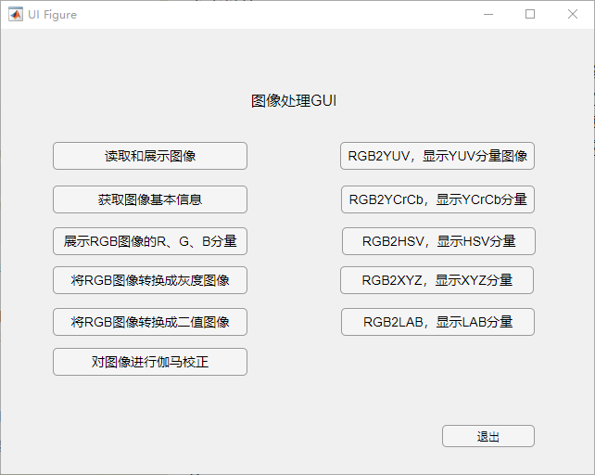
2.读取和展示图像
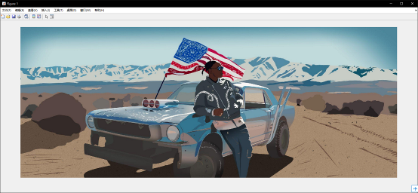
3.获取图像基本信息
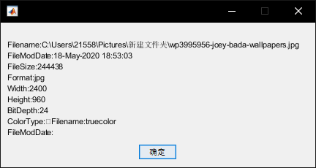
4.展示RGB图像的R、G、B分量
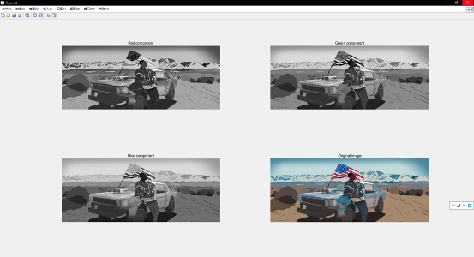
5.将RGB图像转换成灰度图像
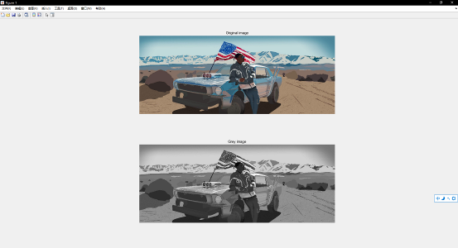
6.将rgb图像转换成二值图像
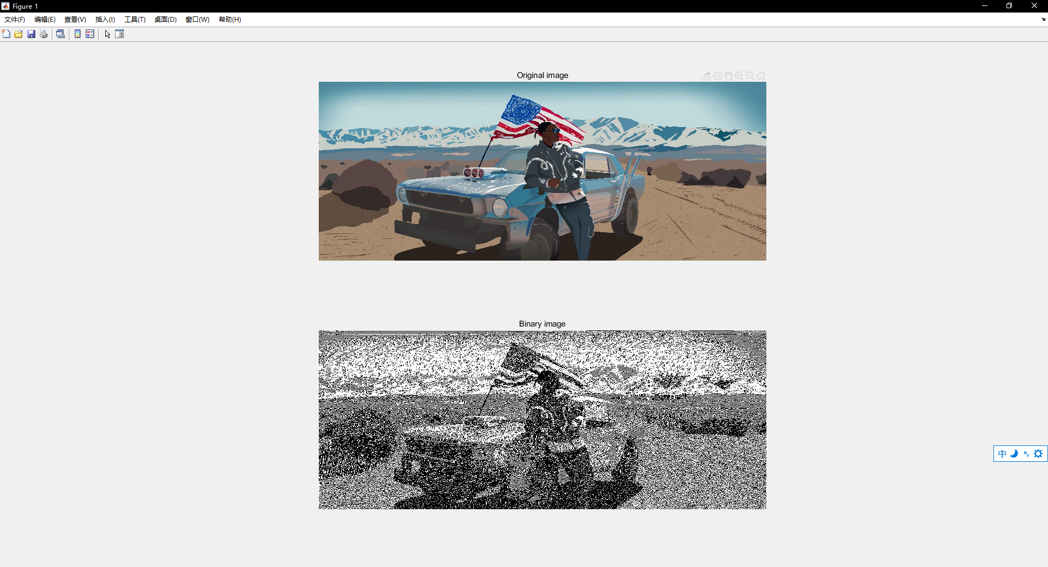
7.伽马校正
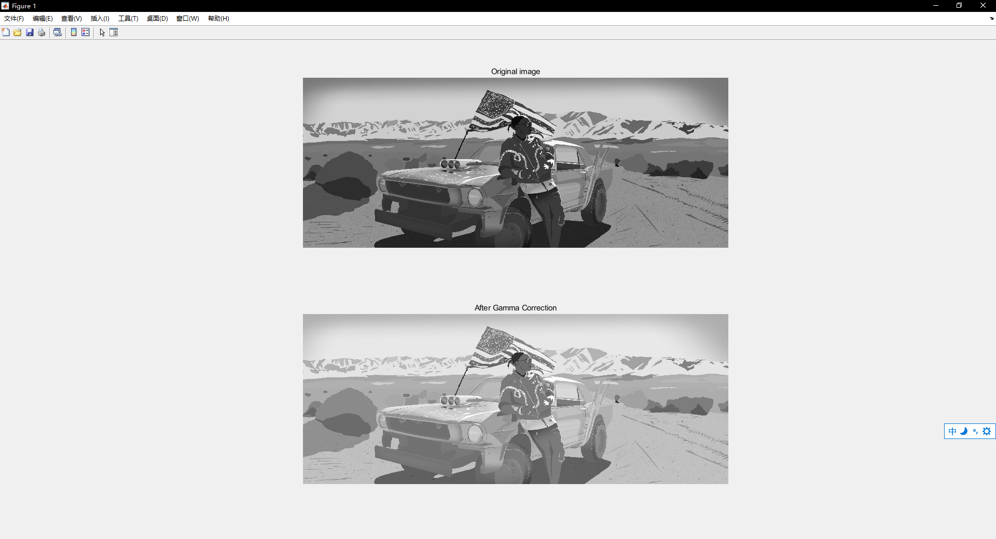
8.YUV
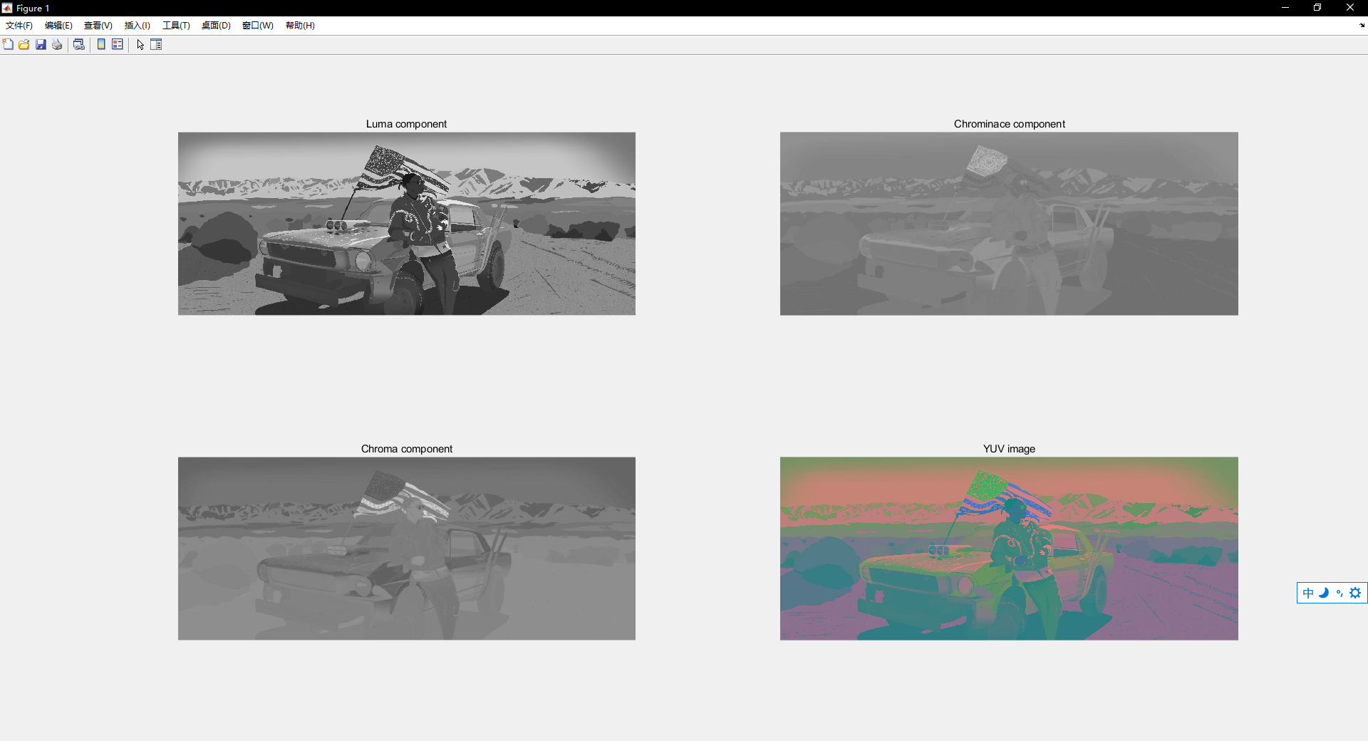
9.YCrCb
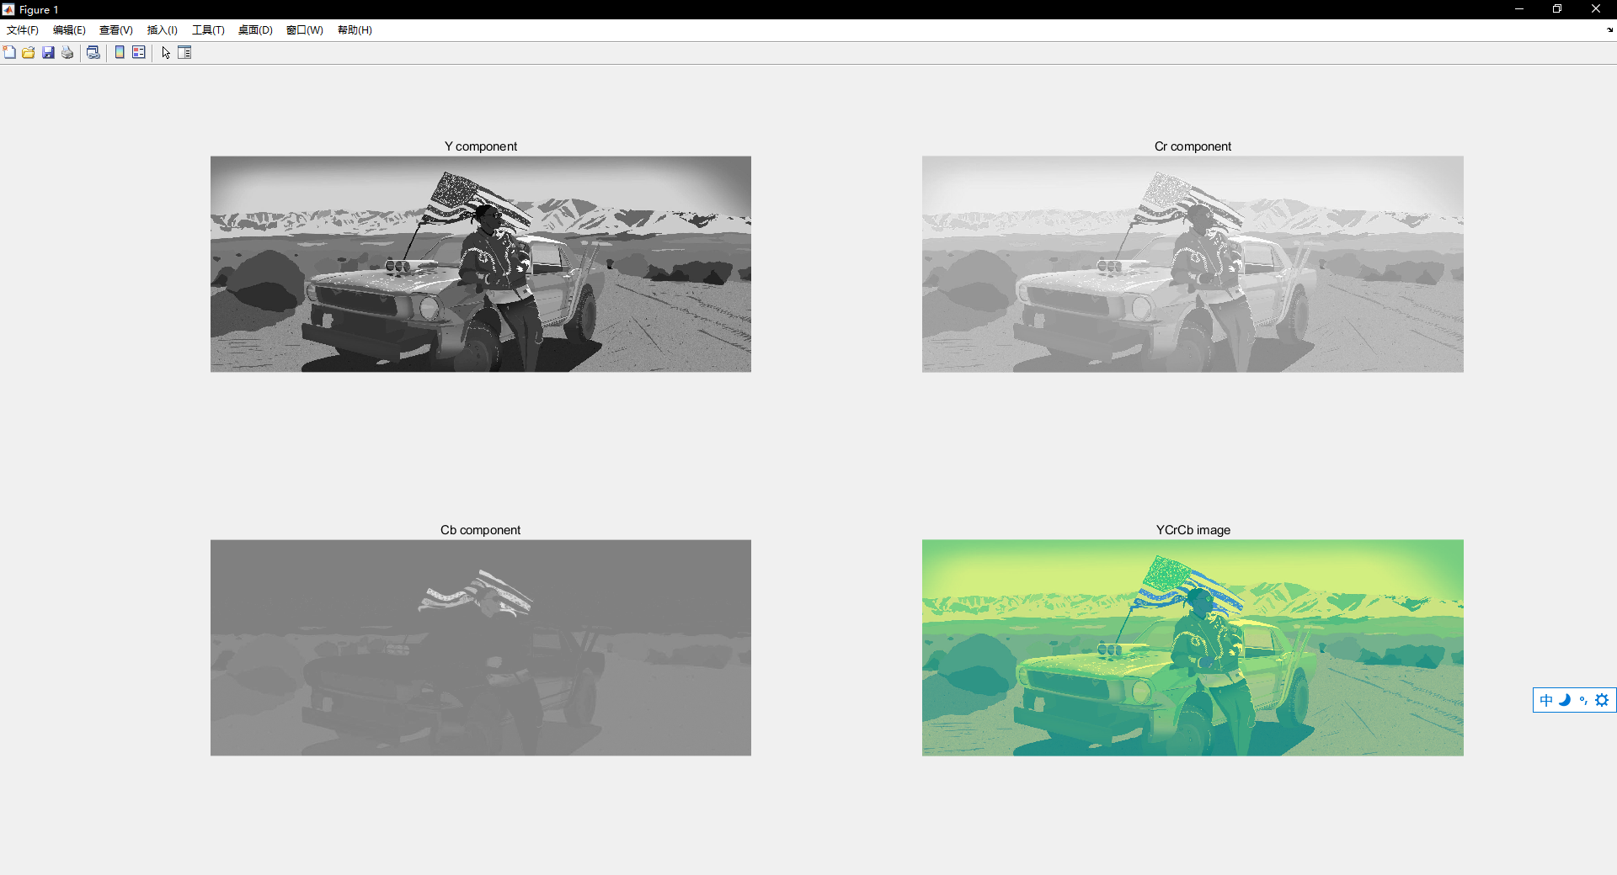
10.HSV
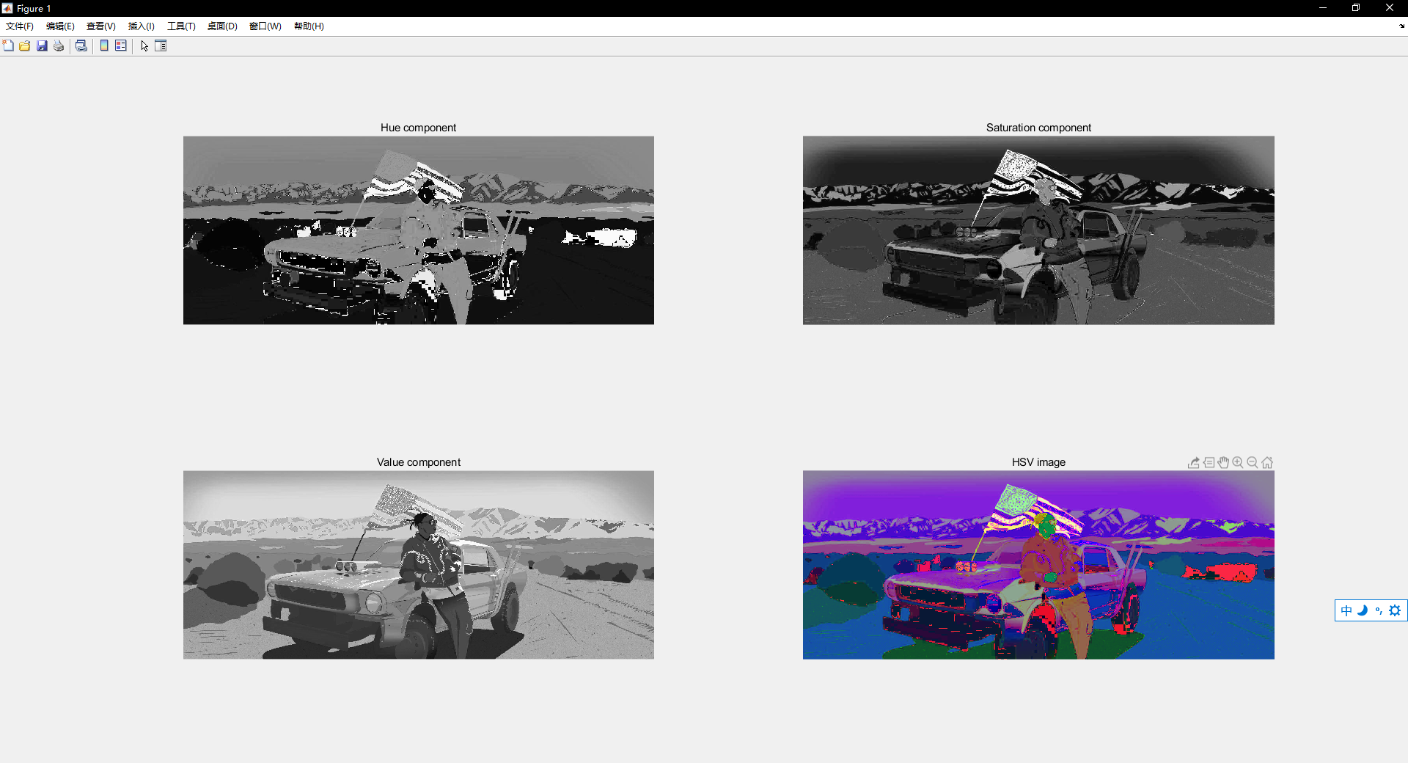
11.CITXYZ
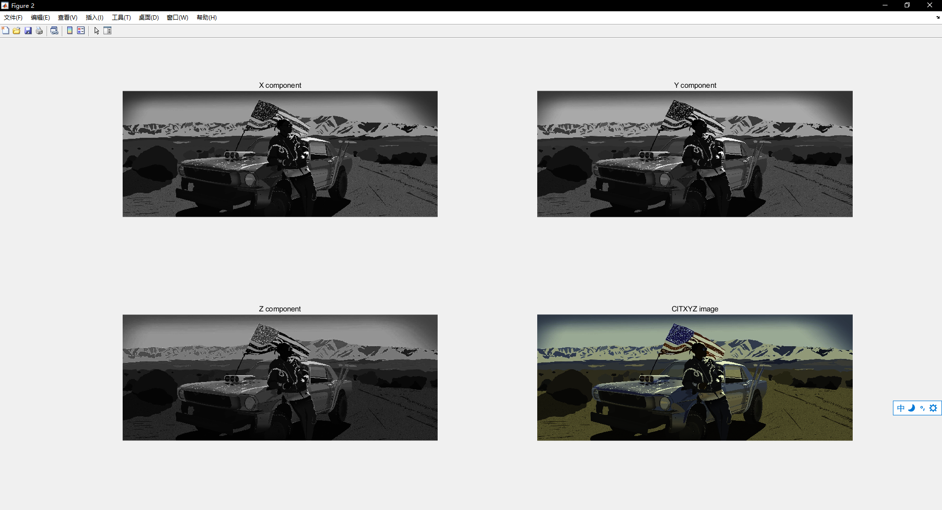
12.CITLAB
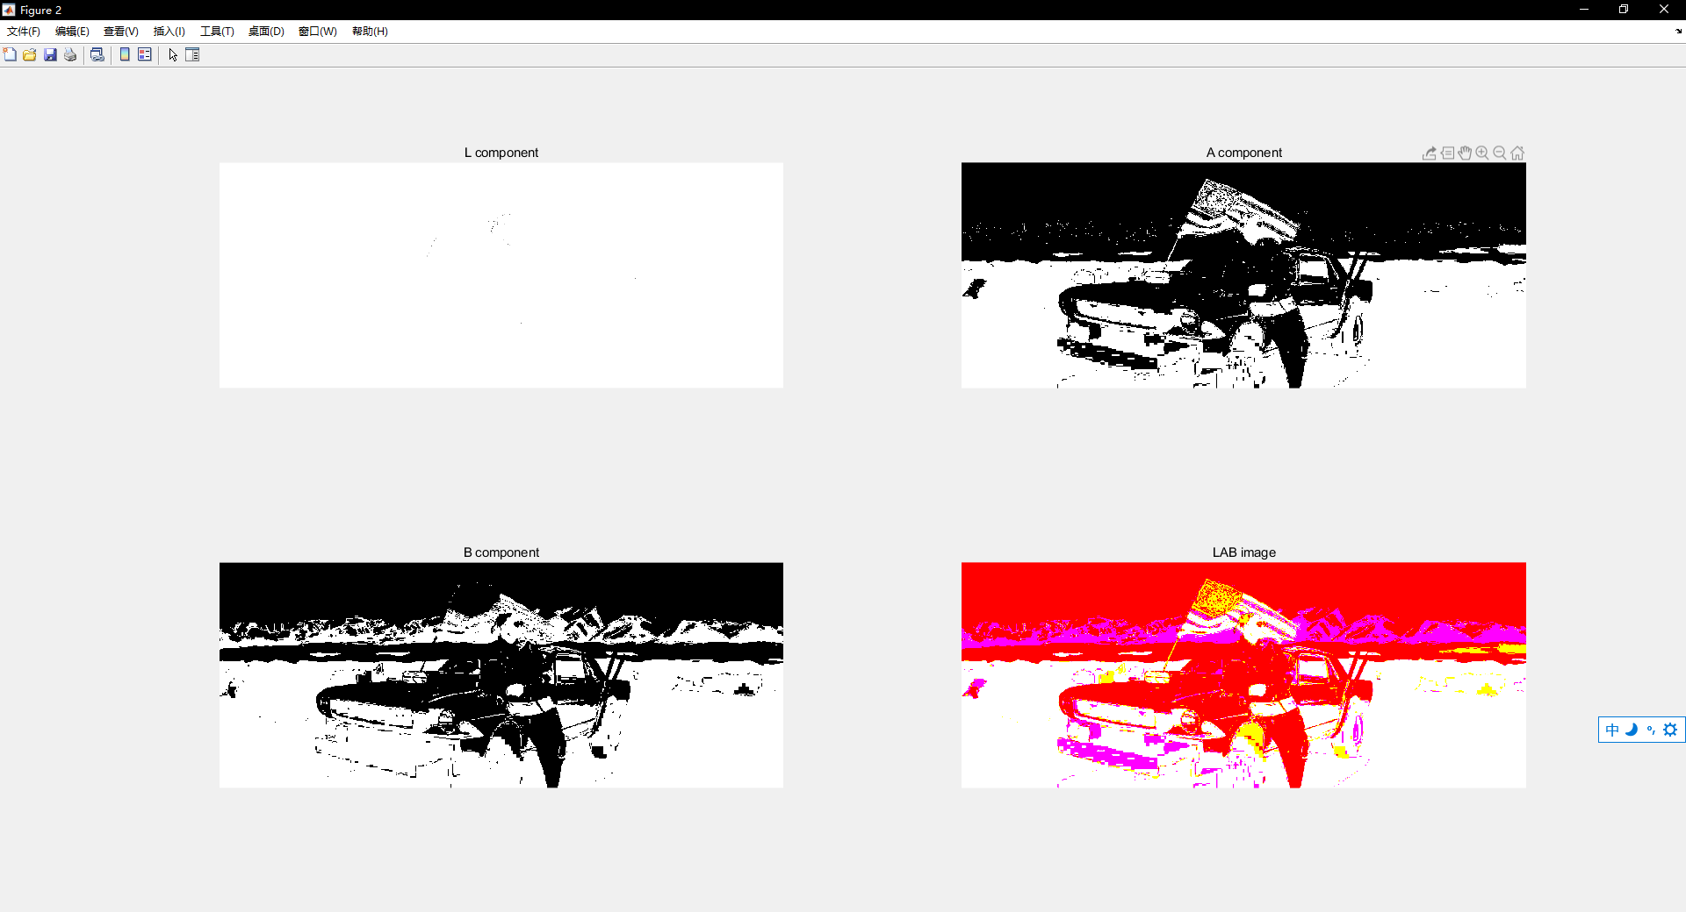
五、结果分析及总结（对实验的结果是否达到预期进行分析，总结实验的收获和存在的问题等）
分析：
1.实验结果比较满意，完成了所有的实验要求，设计了GUI界面以及打包为了.exe文件
2.通过uigetfile（）函数实现选择任意格式的照片文件，通过figure命令新打开一个窗口，使用imshow（）展示文件
3.获取图片信息使用了imfinfo（）函数得到一个结构体，使用变量存储每一个字段进行输出
4.rgb图像通过矩阵分离向量分别输出各分量，灰度图像，二值图像，YUV,YCrCb，HSV,分别用函数或对每个分量进行运算的到新的图像进行输出
5.指定一个伽马值，将矩阵的每一个元素都将gamma值作为指数运算
6.颜色空间使用makecform(‘’)和applycform（，）函数转换颜色空间
收获：
- 对图像处理有了初步的认识
- 对matlab的使用有了基础，熟悉了matlab图像处理相关的函数以及GUI的编写
- 了解了图像的颜色空间和伽马校正
问题：
- 主要使用了库函数
- 没有进行算法优化
- 没有实现伽马校正的伽马值的输入与赋值

教  师  评  阅 | 实验目的和要求明确（A-E）：
教  师  评  阅 | 实验内容与设计（A-E）：
教  师  评  阅 | 实验结果（A-E）：
教  师  评  阅 | 结果分析和总结（A-E）：
教  师  评  阅 | 实验报告规范性（A-E）
教  师  评  阅 | 实验成绩（A-E）：

