

实验报告

课程名称：交互式媒体原理
开课学期：2020-2021学年第1学期
专 业：软件工程
年级班级：2019级2班
学生姓名：付若轩
学 号：222019321062060
指导教师：韩先锋

计算机与信息科学学院 软件学院

实验项目名称 |  | 实验四：压缩算法
实验时间 |  | 2020年 11 月 1 日 | 实验类型 |  | □验证性 设计性 □综合性
一、实验目的
- 了解各种无损压缩算法的基本思想
- 掌握无损压缩算法的代码实现

二、实验要求
- 自选编程语言实现各种无损压缩算法

三、实验内容与设计
- 代码展示
2.
choice.h
- #pragma once
- #include <iostream>
- #include "RunLength.h"
- #include "LZW.h"
- #include "Arithmetic.h"
- #include "ShannonFano.h"
- #include "Huffman.h"
- #include <string>
- #include <cmath>
- #include <cstdio>

- using namespace std;

- class Choice
- {
- public:
- Choice();
- void input();
- ~Choice();

- private:
- int choices;
- string str;
- };
Choice.cpp
- #include "choice.h"
- #include "../../InteractionMedia/InteractionMedia/Huffman.h"

- struct CharacterT
- {
- char c;
- int freq;
- string code;
- };

- void ShannonFano(CharacterT* chars, int end, int start = 0, const string& branch = "", const string& fullBranch = "")
- {
- string code = fullBranch + branch;

- // 找到某个字符，显示值
- if (start == end)
- {
- chars[start].code = code;
- return;
- }

- int sum = 0; // 频率的和
- // 计算从开始到结束的频率的总和
- for (int i = start; i <= end; i++)
- sum += chars[i].freq;

- sum /= 2;
- int i, sum2 = chars[start].freq;

- for (i = start + 1; abs(sum - (sum2 + chars[i].freq)) < abs(sum - sum2) && i < end; i++)
- sum2 += chars[i].freq;

- ShannonFano(chars, i - 1, start, "0", code);
- ShannonFano(chars, end, i, "1", code);
- }

- Choice::Choice()
- {
- choices = 0;
- str = "\0";
- }

- void Choice::input()
- {
- while (true)
- {
- cout << "Please input a string:\n";
- cin >> str;
- if (str=="***")
- {
- break;
- }
- cout << "Please chosse a mode:\n";
- cout << "1. Run-Length Encodinig" << endl;
- cout << "2. Shannon-Fano Algorithm" << endl;
- cout << "3. Huffman encoding" << endl;
- cout << "4. LZW Compression & Decompression" << endl;
- cout << "5. Arithmetic Encoding" << endl;
- cin >> choices;

- switch (choices)
- {
- case 1:
- {
- RunLength a(str);
- a.compress();
- a.print();
- break;
- }
- case 2:
- {
- CharacterT* chars = new CharacterT[str.length()];
- int size = 0;

- for (int i = 0; i < str.length(); i++) {
- int j = 0;

- while (j < size && chars[j].c != str[i])
- j++;

- if (j == size) {
- chars[size].c = str[i];
- chars[size++].freq = 1;
- }
- else
- chars[j].freq++;
- }

- bool isSorted = false;
- while (!isSorted) {
- isSorted = true;

- for (int i = 0; i < size - 1; i++) {
- if (chars[i].freq < chars[i + 1].freq) {
- CharacterT tmp = chars[i];
- chars[i] = chars[i + 1];
- chars[i + 1] = tmp;
- isSorted = false;
- }
- }
- }

- ShannonFano(chars, size - 1);

- cout << "+-------------------+" << endl;
- cout << "| c | freq | code |" << endl;
- cout << "+---+------+--------+" << endl;
- for (int i = 0; i < size; i++)
- printf("| %c | %4d | %6s |\n", chars[i].c, chars[i].freq, chars[i].code.c_str());
- cout << "+-------------------+" << endl;

- delete[] chars;

- break;
- }
- case 3:
- buildHuffmanTree(str);
- break;
- case 4:
- {
- LZW b;
- vector<LZW::encodeinfo> res = b.LZW_encode(str, 128);
- cout << "解码输出字符串：" << b.LZW_decode(res, 128) << endl;
- cout << endl;
- break;
- }
- case 5:
- {
- Arithmetic a;
- a.RequireCode(str);
- cout << a.Encode(str) << endl;
- cout << a.Decode(a.Encode(str)) << endl;
- break;
- }
- default:
- break;
- }
- }

- }

- Choice::~Choice()
- {

- }

RunLength.h
- #pragma once
- #include <vector>
- #include <iostream>
- using namespace std;
- class RunLength
- {
- public:
- RunLength();
- RunLength(string s);
- string compress();
- void print();
- ~ RunLength();

- private:
- string str;
- };
RunLength.cpp
- #include "RunLength.h"
- #include <string>
- RunLength::RunLength()
- {
- str = "\0";
- }

- RunLength::RunLength(string s)
- {
- str = s;
- }

- string RunLength::compress()
- {
- if (str == "\0" || str.length() <= 1)
- {
- return str;
- }

- vector<char>temp;
- vector<char>::iterator itr1;
- string::iterator itr2;
- string re;
- temp.push_back(str[0]);
- char pre_c = str[0];
- int count = 1;
- for (itr2 = str.begin() + 1; itr2 < str.end(); itr2++)
- {
- char c = *itr2;
- if (c == pre_c)
- {
- count++;
- }
- else
- {
- temp.push_back((char)(count + '0'));
- temp.push_back(c);
- count = 1;
- pre_c = c;
- }
- }
- temp.push_back((char)(count + '0'));

- for (itr1 = temp.begin(); itr1 != temp.end(); itr1++)
- {
- re += *itr1;
- }
- return re;
- }

- void RunLength::print()
- {
- cout << "After compress:" << RunLength::compress() << endl;
- }

- RunLength::~RunLength()
- {
- }
Huffman.h
- #include <iostream>
- #include <string>
- #include <queue>
- #include <unordered_map>
- using namespace std;

- // 一个树结点
- struct HNode
- {
- char ch;
- int freq;
- HNode* left, * right;
- };

- // 创建一个新树
- HNode* getNode(char ch, int freq, HNode* left, HNode* right)
- {
- HNode* node = new HNode();

- node->ch = ch;
- node->freq = freq;
- node->left = left;
- node->right = right;

- return node;
- }

- struct comp
- {
- bool operator()(HNode* l, HNode* r)
- {
- return l->freq > r->freq;
- }
- };

- void encode(HNode* root, string str,
- unordered_map<char, string>& huffmanCode)
- {
- if (root == nullptr)
- return;

- // 找到一个叶子结点
- if (!root->left && !root->right) {
- huffmanCode[root->ch] = str;
- }

- encode(root->left, str + "0", huffmanCode);
- encode(root->right, str + "1", huffmanCode);
- }

- void decode(HNode* root, int& index, string str)
- {
- if (root == nullptr) {
- return;
- }

- // found a leaf node
- if (!root->left && !root->right)
- {
- cout << root->ch;
- return;
- }

- index++;

- if (str[index] == '0')
- decode(root->left, index, str);
- else
- decode(root->right, index, str);
- }

- // 建立赫夫曼树，解码输入的字符串
- void buildHuffmanTree(string text)
- {
- unordered_map<char, int> freq;
- for (char ch : text) {
- freq[ch]++;
- }

- priority_queue<HNode*, vector<HNode*>, comp> pq;

- for (auto pair : freq) {
- pq.push(getNode(pair.first, pair.second, nullptr, nullptr));
- }

- while (pq.size() != 1)
- {
- HNode* left = pq.top(); pq.pop();
- HNode* right = pq.top(); pq.pop();

- int sum = left->freq + right->freq;
- pq.push(getNode('\0', sum, left, right));
- }

- HNode* root = pq.top();

- // 遍历赫夫曼树并存储编码到map里同时打印
- unordered_map<char, string> huffmanCode;
- encode(root, "", huffmanCode);

- cout << "Huffman Codes are :\n" << '\n';
- for (auto pair : huffmanCode) {
- cout << pair.first << " " << pair.second << '\n';
- }

- cout << "\nOriginal string was :\n" << text <<endl;

- // 打印
- string str = "";
- for (char ch : text) {
- str += huffmanCode[ch];
- }

- cout << "\nEncoded string is :\n" << str << endl;

- // 遍历赫夫曼树
- // 解码
- int index = -1;
- cout << "\nDecoded string is: \n";
- while (index < (int)str.size() - 2) {
- decode(root, index, str);
- }
- }
LZW.h
- #pragma once
- #include <iostream>
- #include <string>
- #include <map>
- #include <vector>

- using namespace std;

- class LZW
- {
- public:
- struct encodeinfo
- {
- string P;
- int index;
- };//键值对
- LZW();

- vector<encodeinfo> LZW_encode(string s, int encodenum);
- string LZW_decode(vector<encodeinfo> code, int beginnum);

- map <string, int> dict;//字典
- map <int, string> revdict;//解码时使用
- ~LZW();
- };
LZW.cpp
- #include "LZW.h"
- using namespace std;

- LZW::LZW()
- {
- dict.clear();
- revdict.clear();
- for (int i = 0; i < 128; i++)
- {
- string s = "t";
- s[0] = char(i);
- dict[s] = i;
- revdict[i] = char(i);
- }
- }

- vector<LZW::encodeinfo> LZW:: LZW_encode(string s, int encodenum)
- {
- string P = "";
- char C;
- vector<encodeinfo> EncodeResult; //存储编码之后的结果

- for (int i = 0; i < s.length(); i++)
- {
- C = s[i];
- string tempStr = P + C;
- //在字典里面寻找这个字符串
- map<string, int>::iterator iter = dict.find(tempStr);
- if (iter != dict.end()) {//找到了
- P = tempStr;
- }
- else {//没找到
- encodeinfo a = { P, dict[P] };
- EncodeResult.push_back(a);//将P的对应的编码存放起来
- //建立起一个新的索引
- encodenum++;
- dict[tempStr] = encodenum;
- P = C;
- }
- }
- encodeinfo a = { P, dict[P] };
- EncodeResult.push_back(a);//最终结尾处

- //这是编码过程的输出
- cout << "LZW编码输出的信息如下：" << endl;
- for (int i = 0; i < EncodeResult.size(); i++){
- cout << EncodeResult[i].P << " " << EncodeResult[i].index << endl;
- }

- return EncodeResult;

- }
- string LZW::LZW_decode(vector<encodeinfo> code, int beginnum) {
- string ret = "";//最终译码的输出
- string P = "";
- char C;
- int pW, cW;
- //第一步，初始化，读入第一个的符号cW，解码输出
- cW = code[0].index;
- ret += revdict[cW];//解码输出

- for (int i = 1; i < code.size(); i++) {
- pW = cW;
- cW = code[i].index;
- map<int, string>::iterator iter = revdict.find(cW);

- if (iter != revdict.end()) { //找到了
- //解码输出
- ret += iter->second;
- P = revdict[pW];
- C = revdict[cW][0];
- string tempStr = P + C;
- beginnum++;
- revdict[beginnum] = tempStr;
- }
- else
- {
- P = revdict[pW];
- C = revdict[pW][0];
- beginnum++;
- string tempStr = P + C;
- revdict[beginnum] = tempStr;
- ret += tempStr;
- }
- }
- return ret;
- }

- LZW::~LZW()
- {
- }

Range.h
- #pragma once
- class range
- {
- public:
- range();
- ~range();
- double GetLow();
- double GetHigh();
- void SetLow(double low);
- void SetHigh(double high);
- void SetDelta(double delta);

- private:
- double low;
- double high;
- double deltalevel;
- };
Range.cpp
- //用于存储算术编码中的上下界
- #include "range.h"

- range::range()
- {
- low = 0.0;
- high = 1.0;
- deltalevel = 1.0;
- }

- range::~range()
- {
- low = 0;
- high = 0;
- deltalevel = 0;
- }

- double range::GetLow()
- {
- return this->low;
- }

- double range::GetHigh()
- {
- return this->high;
- }

- void range::SetLow(double low)
- {
- this->low = low;
- }

- void range::SetHigh(double high)
- {
- this->high = high;
- }

- void range::SetDelta(double delta)
- {
- this->deltalevel = delta;
- }
Arithmetic.h
- #pragma once
- #include <iostream>
- #include "range.h"
- #include <map>
- #include <string>
- using namespace std;

- class Arithmetic
- {
- public:
- Arithmetic();
- ~Arithmetic();

- void RequireCode(string str);
- double Encode(string str);
- string Decode(double value);
- int getLength();

- private:
- int length;
- map<char, range>map;
- };

Arithmetic.cpp
- #include "Arithmetic.h"

- Arithmetic::Arithmetic()
- {
- length = 0;
- }

- Arithmetic::~Arithmetic()
- {
- }

- void Arithmetic::RequireCode(string str)
- {
- double lowlevel = 0.0;
- double highlevel = 0.0;
- double probability = 0.0;
- for (int i = 0; i < str.length(); i++)
- {
- cout << "Please input the probability" << endl;
- cin >> probability;
- lowlevel = highlevel;
- highlevel = lowlevel + probability;
- range r;
- r.SetLow(lowlevel);
- r.SetHigh(highlevel);
- r.SetDelta(probability);
- map.insert(std::pair<char, range>(str[i], r));
- }
- }

- double Arithmetic::Encode(string str)
- {
- double LowRange = 0.0, HighRange = 1.0;
- for (string::iterator itr = str.begin(); itr != str.end(); ++itr)
- {
- double delta = HighRange - LowRange;
- HighRange = LowRange + delta * map[*itr].GetHigh();
- LowRange = LowRange + delta * map[*itr].GetLow();

- ++length;
- }

- return LowRange;
- }

- string Arithmetic::Decode(double value)
- {
- double LowInterval = 0;
- double HighInterval = 0;
- string symbol = "";

- for (auto itr = map.begin(); itr != map.end(); ++itr)
- {
- if ((itr->second).GetLow() < value && (itr->second).GetHigh() > value)
- {
- LowInterval = (itr->second).GetLow();
- HighInterval = (itr->second).GetHigh();
- symbol += (itr->first);
- break;
- }
- }
- for (int i = 0; i < length - 1; ++i)
- {
- /* decode code */
- double deltaInterval;
- deltaInterval = HighInterval - LowInterval;
- value -= LowInterval;
- value /= deltaInterval;

- for (auto i = map.begin(); i != map.end(); ++i) {
- if ((i->second).GetLow() < value && (i->second).GetHigh() > value) {
- LowInterval = (i->second).GetLow();
- HighInterval = (i->second).GetHigh();
- symbol += (i->first);
- break;
- }
- }
- }

- return symbol;
- }

Main.cpp
- #include "choice.h"
- using namespace std;
- int main()
- {
- Choice choice;
- choice.input();

- }

四、实验结果 （可给出截图等加以说明）
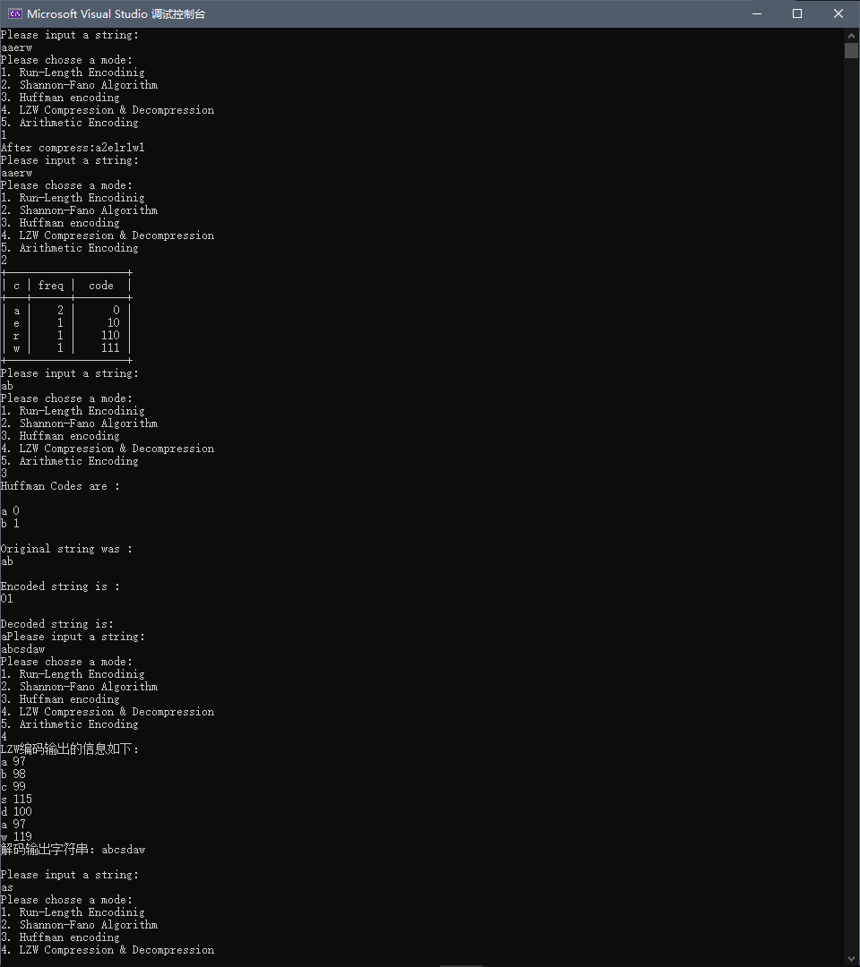
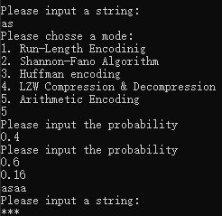
输入任意字符串，选择编码解码的方法
五、结果分析及总结（对实验的结果是否达到预期进行分析，总结实验的收获和存在的问题等）
分析
实验结果基本达到预期，其中赫夫曼编码和算术编码的结果正确但是输出有一定问题。赫夫曼编码不会输出解码后的最后一位字符，算术编码会造成在解码的最后重复输出第一位字符
收获
- Run-Length Encoding
基本思想为将重复且连续出现多次的字符使用（连续出现次数，某个字符）来描述。缺点是如果文本重复较少，会白白浪费编码的资源却没有达到节省空间的效果
- Shanno-Fano Encoding
  - 对于给定的符号列表，指定相应的概率列表
  - 排序根据频率的符号列表，最常出现的符号在左边，最少出现的符号在右边（个人认为类似二叉查找树）
  - 列表分为两部分，使得左边部分的总频率尽可能等于右边部分的总频率
  - 该列表左半边分配0，右半边分配1
  - 对分好的两部分递归实现步骤3，4，直到每一个符号成为叶子结点
- Huffman Encodinig
类似于Shanno-Fano Encoding，不同的是该方法是将概率最小的两个相加作为左右子树，重复过程直到概率值最终等于1。

- LZW compression and decompression
将出现过的字符串映射到记号上，这样可以用较短的编码表示长的字符串。最开始会将所有字母用ASCII码存储在一个字典中，在这个基础上添加的新的映射即从256开始后添加的元素为扩展项。
例如ABABAB编码
  - 遇到A，用97表示，编码为97.
  - 遇到B，用98表示，编码为98
  - 发现了一个字串AB，用257表示，添加进字典中
  - 后面继续发现AB用257表示
- Arithmetic Encoding
  - 假设有一段数据需要编码，统计其中所有的字符和出现的次数
  - 将区间[0，1]不包括1连续划分为多个子区间，每个子区间代表一个字符，子区间大小正比与出现的概率。所有子区间的和是[0，1]不包括1
  - 编码首先从初始区间开始[0，1]不包括1开始，设置
low = 0, high = 1
  - 不断读入原始数据的字符，找到字符所在的区间[L，H]
low = low+（high-low）*L
high=low+（high-low）*H
最后得到的区间中的任一小数输出即为编码的数据

存在问题
- 面向对象编程和面向过程编程混用，代码不够规范
- 两个算法的解码输出结果有问题

教  师  评  阅 | 实验目的和要求明确（A-E）：
教  师  评  阅 | 实验内容与设计（A-E）：
教  师  评  阅 | 实验结果（A-E）：
教  师  评  阅 | 结果分析和总结（A-E）：
教  师  评  阅 | 实验报告规范性（A-E）
教  师  评  阅 | 实验成绩（A-E）：

