西南大学

《离散数学》课程
2017～2018学年 第学期 |  |  |  |  |  |  |  |  |  |  |  |  |  |  | 期
考试时间 |  |  | 120分钟 |  |  | 考核方式 |  |  |  |  | 学生类别 |  |  |  |  |  |  |  |  | 人数 |  | 240
适用专业或科类 |  |  |  | 计信院软件工程、计算机科学与技术 |  |  |  |  |  |  |  |  |  |  |  | 年级 |  | 2017 级
题号 |  |  |  |  |  |  |  |  |  |  |  |  |  |  |  |  |  |  |  |  | 合计
得分
签名
阅卷须知：阅卷用红色墨水笔书写，得分用阿拉伯数字写在每小题题号前，用正分表示，不得分则在题号前写0；大题得分登录在对应的分数框内；统一命题的课程应集体阅卷，流水作业；阅卷后要进行复核，发现漏评、漏记或总分统计错误应及时更正；对评定分数或统分记录进行修改时，修改人必须签名。
特别提醒：学生必须遵守课程考核纪律，违规者将受到严肃处理。

1(15 points).
(a) (12 points).
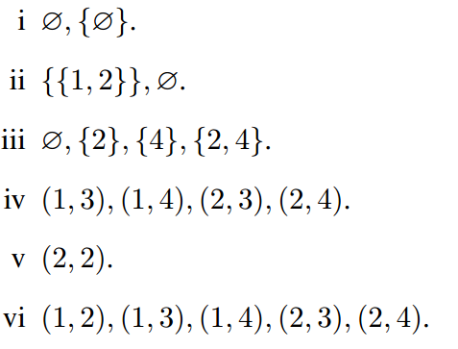
(b) (3 points).It is a tautology. Truth table can be used to show the answer.
2. (15 points).
(a) (9 points)
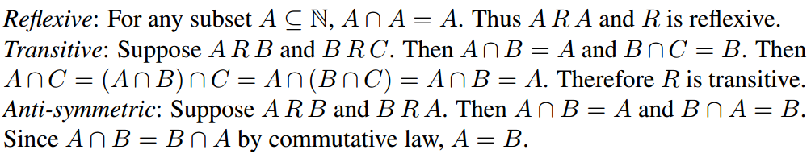
(b) (3 points)
(c) (3 points)
Define the equivalence relation R ={(1,1), (2, 2), (3,3)}, which has 3 equivalence classes.

3(15 points).
(a) (7 points)
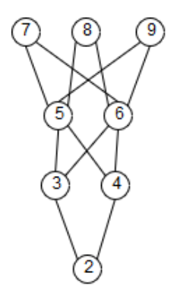
(b) (3 points) 7, 8, 9
(c) (3 points)Take B = {3, 4, 5}
(d) (2 points) Take C as the set of prime numbers.

4(15 points).
(a) (4 points)

(b) (4 points)
(c) (4 points)
y = -1/2, x = -1?
(d) (3 points)Domain is X – {0}. Range is {-1}.

5. (10 points).
(a) i. (2 points)
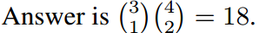
ii (3 points)
(b) (3 points)Choose the triple rank: 13 choices. Then the other ranks: 12 choices. Then suit of triple rank: C(4,1) = 4 choices. Then suits of other ranks: C(4,2) = 6 choices. Result is 13·12·4·6.
(c). (2 points)C(4+10-1, 10) = C(13, 10) = C(13, 3):
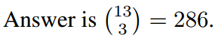

6. (10 points).
(a) (2 points) i. 2
ii.
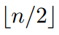
(b) (4 points)We define a directed graph for the road network. The nodes are the intersections and the directed edges correspond to the roads that connect the intersections. We would like to find whether this directed graph is strongly connected (or there is only one strongly connected component in the digraph).
(c) (4 points)
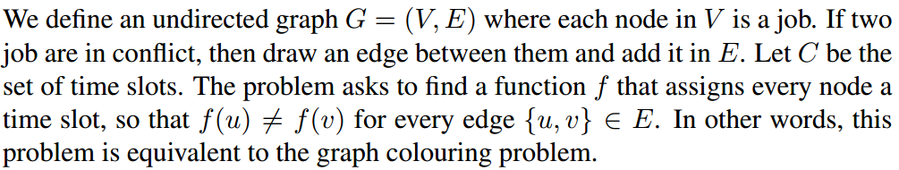

7. (10 points).
(a) (5 points)
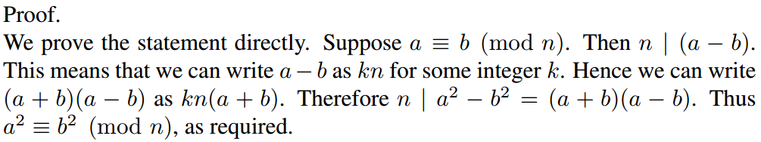
(b) (5 points)
5
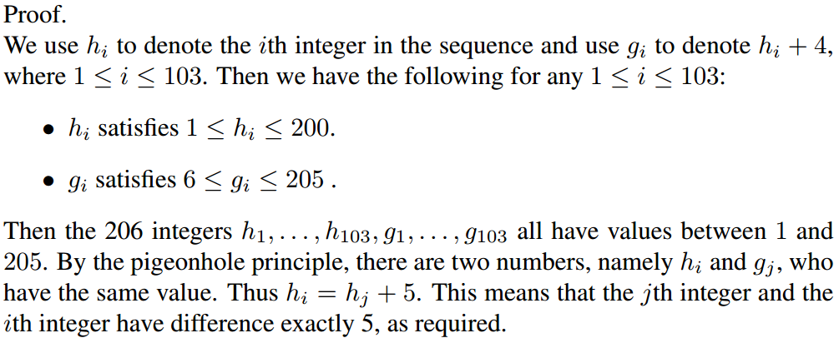

8. (10 points).
(a) (5 points)
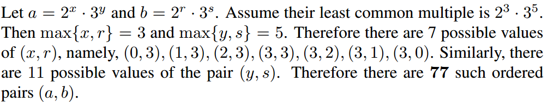

(b) (5 points)
