西南大学

《离散数学》课程
2017～2018学年 第2学期 |  |  |  |  |  |  |  |  |  |  |  |  |  |  | 期
考试时间 |  |  | 120分钟 |  |  | 考核方式 |  |  |  |  | 学生类别 |  |  |  |  |  |  |  |  | 人数 |  | 240
适用专业或科类 |  |  |  | 计信院软件工程、计算机科学与技术 |  |  |  |  |  |  |  |  |  |  |  | 年级 |  | 2017级
题号 |  |  |  |  |  |  |  |  |  |  |  |  |  |  |  |  |  |  |  |  | 合计
得分
签名
阅卷须知：阅卷用红色墨水笔书写，得分用阿拉伯数字写在每小题题号前，用正分表示，不得分则在题号前写0；大题得分登录在对应的分数框内；统一命题的课程应集体阅卷，流水作业；阅卷后要进行复核，发现漏评、漏记或总分统计错误应及时更正；对评定分数或统分记录进行修改时，修改人必须签名。
特别提醒：学生必须遵守课程考核纪律，违规者将受到严肃处理。

PLEASE ANSWER IN CHINESE OR IN ENGLISH!!
1.(15 marks) Answer the following questions.
(a) Suppose A = {0, 1, 2}, B = {1, 2, 3, 4}. List all elements of the following sets. [2 marks each,8 marks in all]
i. ☓A.
ii. P({|A|, |B|}).
iii. 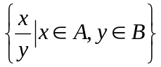.
iv. (B - A)☓(A - B).
Solution

(b) Prove that P(AB) = P(A)  P(B). [7 marks]
Proof

2. (15 marks) (a) Verify that 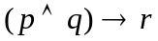and 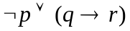 are logically equivalent using standard logical equivalences. You are not allowed to use truth table for this question. [6 marks]
Proof

(b) Write down the negation of the following statement in plain English: [3 marks each, 9 marks in all]
(i) The product of any real number and any integer is a real number.
Solution

(ii) There is a natural number n such that, for every real number x, x^{n} is non-negative.
Solution

(iii) Any person should wear a helmet when riding a bicycle if he is 15 years of age or under.
Solution

3. (15 marks) (a) Define a binary relation R on P (N) – {} by A R B if and only if min(A) ≤ min(B), namely, the smallest element in A is less than or equal to the smallest element in B. Comment on which of these properties does R satisfy: reflexive, transitive, symmetric, anti-symmetric. Prove your claims. [6 marks]
Solution

(b) Let A = {1, 2, 3}. How many different equivalence relations on A are there? Explain your answer. [6 marks]
Solution

(c) Define an equivalence relation on N that has only finitely many equivalence classes. [3 marks]
Solution

4. (15 marks) (a) Define functions f : P(N)²  P (N) by f(A, B) = A B. Comment on whether f satisfies the following properties: injective, surjective, bijective. [6 marks]
Solution

(b) Let A ={2^{n}|n  N}. Draw the Hasse diagram of the poset (A, |), where | is the division relation. Show that this poset is a total order. [6 marks]
Solution

(c) Which element is the greatest in the poset (P({2, 3, 4}), ⊆)? Which element is the least in this poset? [3 marks]
Solution

5. (10 marks) (a) A small airline in China provides the round-trip service shown in the following table. “No” means the service is not provided between the two cities, and “Yes” means that the service is provided.
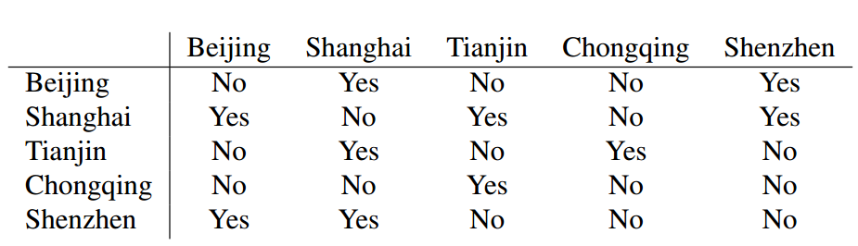
A travel agent wants to represent this service in a diagram. Draw a graph that reflects this service. [4 marks]
Solution

(b) Let V ={1, 2, 3, 4, 5, 6}, and E = {{1, 4}, {1, 6}, {2, 4}, {2, 3}, {3, 4}, {4, 5}, {5, 6}}, and G = (V; E).
i. Determine the edge set for the subgraph of G induced by W ={1, 3, 4, 6}. [2 marks]
Solution

ii. What is the distance from 2 to 6? [2 marks]
Solution

iii. Is this graph a bipartite graph? [2 marks]
Solution

6. (10 marks) (a) We want to select a subset of size 5 from the set of 18 men and a subset of size 7 from the set of 16 women. How many ways are there? [3 marks]
Solution

(b) How many license plates are there that consist of 6 digits (0 to 9) and exactly 2 of the digits are the same? [3 marks]
Solution

(c) A bag contains 24 different balls: 8 red, 4 blue, 7 green, and 5 yellow balls. We pick 3 balls from this bag. How many ways are there to do this so that the 3 balls have at least two colours? Note that all balls are considered distinguishable from each other. [4 marks]
Solution

7. (10 marks) (a) Show that the complete bipartite graph K_{3,3} is isomorphic to the pictured graph. [5 marks]
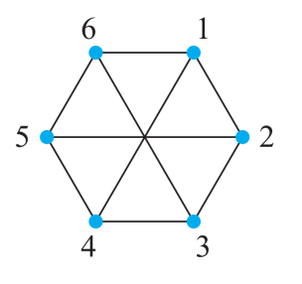
Proof

(b) Draw a spanning tree of the following graph. [5 marks]
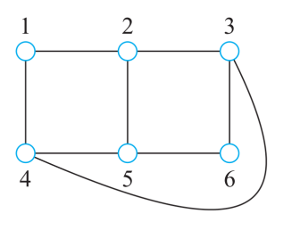
Solution

8. (10 marks) (a) Let {s_{n}} be the recurrence relation defined by
Proving using mathematical induction that for all n ≥ 0, 3| s_{n}. [5 marks]
Proof

[5 marks]
Proof

