西南大学

《离散数学》课程
2017～2018学年 第学期 |  |  |  |  |  |  |  |  |  |  |  |  |  |  | 期
考试时间 |  |  | 120分钟 |  |  | 考核方式 |  |  |  |  | 学生类别 |  |  |  |  |  |  |  |  | 人数 |  | 240
适用专业或科类 |  |  |  | 计信院软件工程、计算机科学与技术 |  |  |  |  |  |  |  |  |  |  |  | 年级 |  | 2017 级
题号 |  |  |  |  |  |  |  |  |  |  |  |  |  |  |  |  |  |  |  |  | 合计
得分
签名
阅卷须知：阅卷用红色墨水笔书写，得分用阿拉伯数字写在每小题题号前，用正分表示，不得分则在题号前写0；大题得分登录在对应的分数框内；统一命题的课程应集体阅卷，流水作业；阅卷后要进行复核，发现漏评、漏记或总分统计错误应及时更正；对评定分数或统分记录进行修改时，修改人必须签名。
特别提醒：学生必须遵守课程考核纪律，违规者将受到严肃处理。

1(15 points).
(a) (8 points)
i. ∅
ii. {∅, {3}, {4}, {3,4}}
iii. {0, 1, 1/2, 1/3, 1/4, 2, 2/3}
iv. {(3, 0), (4, 0)}
(b). (7 points)
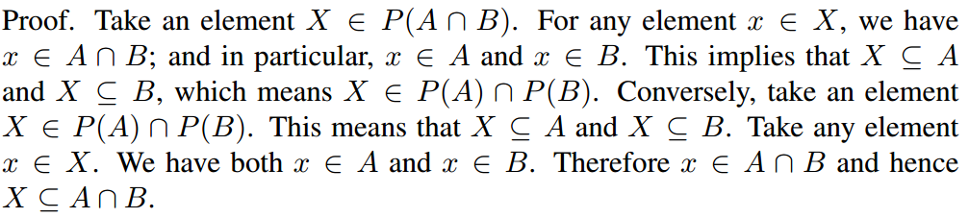

2(15 points).
(a) (6 points)
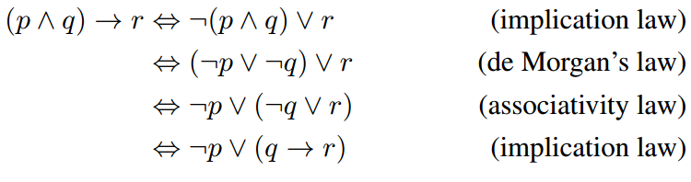
(b) (9 points)
i. There are a real number and an integer whose product is not a real number.
ii. For any natural number n there is some real number x such that x^{n} is negative.
iii. Some person may be 15 years or age or under but does not wear a helmet when riding a bicycle.

3(15 points).
(a) (6 points)
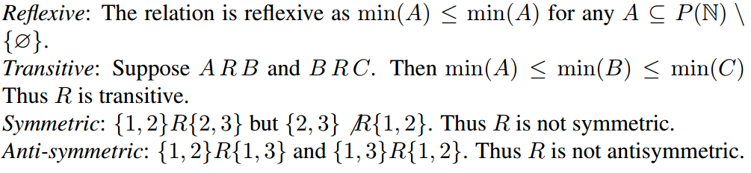
(b) (6 points)
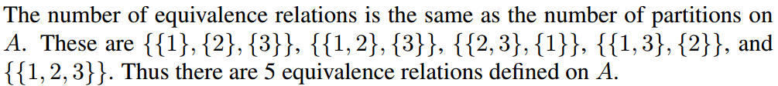
(c) (3 points)
4(15 points).
(a) (6 points)
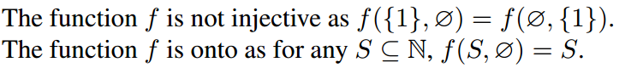
(b) (6 points)
Clearly.
(c) (3 points)
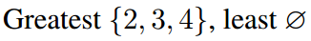

5(10 points).
(a) (4 points)Use the table above as an adjacency matrix to visualise the graph.
(b) (6 points)
i. {1,4}, {3, 4}
ii. 3
iii. No. There is an odd length cycle containing 2,3,4.

6(10 points).
(a) (3 points)
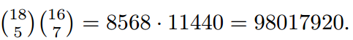
9
(b) (3 points)
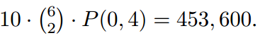
(c) (4 points)
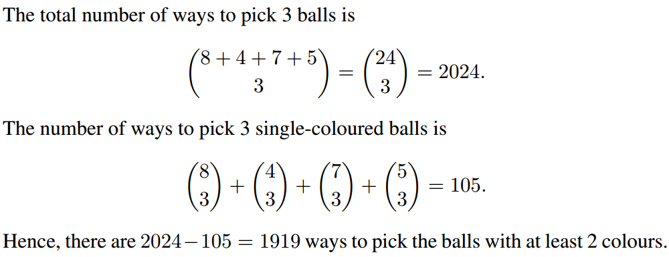

7(10 points).
(a) (5 points)
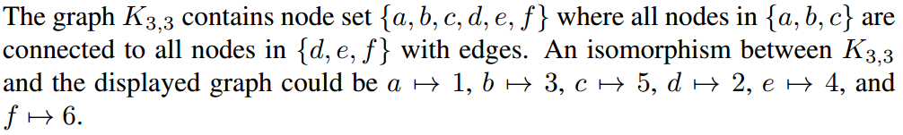
(b) (5 points)

8(10 points).
(a) (5 points)
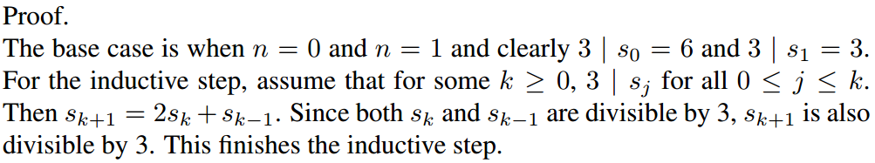
(b) (5 points)
