计算机与信息科学学院 软件学院
课程过程性考核命题记录表
（适用于平时作业等过程性考核）

（ 2023 － 2024 学年第 2 学期）

课程名称 | 操作系统原理 | 任课教师 | 赵恒军
年级/专业 /班级 | 2022级软件工程1-4班 | 考核时间 | 2023.5.14
考核点对应教学内容（如章/节编号、名称） |  | Ch3, ch4, ch8, ch9
本次过程性考核内容（如作业题目、题目序号、调研内容）
- What output will be at line A for Fig.3.30?
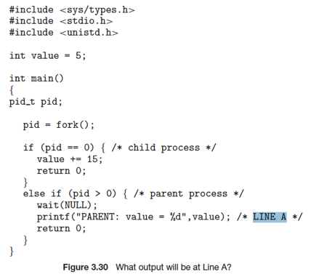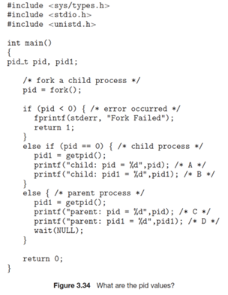
Hint: the return value of fork() is:
- 0, for the child process
- the PID of the child process, for the parent process
- Assume that the pids of parent and child are 2600 and 2603, respectively. Identify the values of pids at lines A, B, C, D for Fig.3.34. Hint: getpid() is a system call that returns the PID of the calling process.
- Which of the following components of program state are shared across threads in a multithreaded process?
a. Register values
b. Heap memory
c. Global variables
d. Stack memory
- The program shown in the following figure uses the Pthreads API. What would be the output from the program at LINE C and LINE P ?
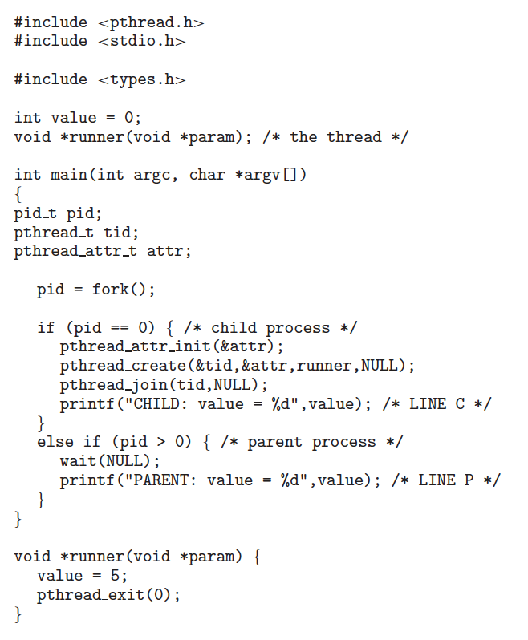

Consider the following segment table (all numbers are in decimal):
Segment Base Limit
0 219 600
1 2300 14
2 90 100
3 1327 580
4 1952 96
What are the physical addresses for the following logical addresses?
a. 0, 430
b. 1, 10
c. 2, 500
d. 3, 400
e. 4, 112

Assuming a 1-KB page size, what are the page numbers and offsets for the following address references (provided as decimal numbers):
a. 3085
b. 42095
c. 215201

Consider a logical address of 256 pages with a 4-KB page size, mapped onto a physical memory of 64 frames.
a. How many bits are required in the logical address?
b. How many bits are required in the physical address?

Consider a computer system with a 32-bit logical address and 4-KB page size. The system supports up to 512 MB of physical memory. How many entries are there in a conventional single level page table?

Consider a paging system with the page table stored in memory.
a. If a memory reference takes 50 nanoseconds, how long does a paged memory reference take?
b. If we add TLBs, and 75 percent of all page-table references are found in the TLBs, what is the effective memory reference time? (Assume that finding a page-table entry in the TLBs takes zero nanoseconds, if the entry is present.)

Assume that a program has just referenced an address in virtual memory. Describe a scenario in which each of the following can occur. (If no such scenario can occur, explain why.)
• TLB miss with no page fault
• TLB miss and page fault
• TLB hit and no page fault
• TLB hit and page fault
Note: here ‘page fault’ means that the physical page is not present
11.
Assume that we have a demand-paged memory. The page table is held in registers. It takes 8 milliseconds to service a page fault if an empty frame is available or if the replaced page is not modified and 20 milliseconds if the replaced page is modified. Memory-access time is 100 nanoseconds. Assume that the page to be replaced is modified 70 percent of the time. What is the maximum acceptable page-fault rate for an effective access time of no more than 200 nanoseconds?
12.
When a page fault occurs, the process requesting the page must block while waiting for the page to be brought from disk into physical memory. Assume that there exists a process with five user-level threads and that the mapping of user threads to kernel threads is one to one. If one user thread incurs a page fault while accessing its stack, would the other user threads belonging to the same process also be affected by the page fault—that is, would they also have to wait for the faulting page to be brought into memory? Explain.
13.
Consider a demand-paging system with a paging disk that has an average access and transfer time of 20 milliseconds. Addresses are translated through a page table in main memory, with an access time of 1 microsecond per memory access. Thus, each memory reference through the page table takes two accesses. To improve this time, we have added an associative memory that reduces access time to one memory reference if the page-table entry is in the associative memory. Assume that 80 percent of the accesses are in the associative memory and that, of those remaining, 10 percent (or 2 percent of the total) cause page faults. What is the effective memory access time?

请将答案写在下方：

- 输出PARENT:value=5

2,
A:0
B:2603
C:2603
D:2600

3，c

4，LineC:CHILD: value=5
LineP:PARENT:value=0

5, a: 649 b:2310 c:error d:1727 e: 2064

6, a: page number:3 offsets:13
b: page number:41 offsets:111
c: page number:210 offsets: 161

7,a. 逻辑地址需要20位。 b. 物理地址需要18位。

8，131072

9, a:100纳秒
b:0.75*50+0.25*100=62.5纳秒

10，
- ：当没有在TLB中找到对应的页表条目，也没有发生缺页错误，说明访问的是已经调入内存为有效的页
- ：没有在TLB中找到对应的页表条目，发生了缺页错误，说明访问到的是无效的页面，是还没有调入内存的页面
- ：在TLB中找到对应的页表条目，也没有发生缺页错误，说明页码在TLB中，可以直接找到对应的物理框号，而且访问的内存是有效的。
- ：不可能出现这种情况，因为在如果页码在TLB中出现，就说明了已经该页已经处于物理内存上，不可能出现还没有调入内存的的情况。

- （1-p）*100+p*0.3*8000000+p*0.7*20000000<=200
P<=1/163999
12,
In the context of this problem, other user threads are not directly affected by the page error because they execute independently. Each kernel thread has its own stack area and executes concurrently on different processors.(在本题的背景下，其他用户线程不会直接受到页面错误的影响，因为它们会独立的执行。每个内核线程都有自己的栈区，在不同的处理器上并发地执行。)
13, 0.8*1+0.18*2+0.02*40000=801.16微秒

命题教师
签 字

年 月 日

