Southwest University

“Introduction to Web Development” Experiment Report

School：School of Computer & information Science
Major：Software engineering
Class： Soft Engineering 2
Name: Fu Ruoxuan
Student Number：222019321062060
Experiment Report
1.Objective：
- Use css to make the movie information website better
2.Detailed requirements：
Ex1：
- Use css to complete website design
3.Procedure:
Ex1
1)Start.html
These codes determine the overall arrangement of this website and set an iframe to display a series of websites. The series of label <a>
make the links more active.
CSS
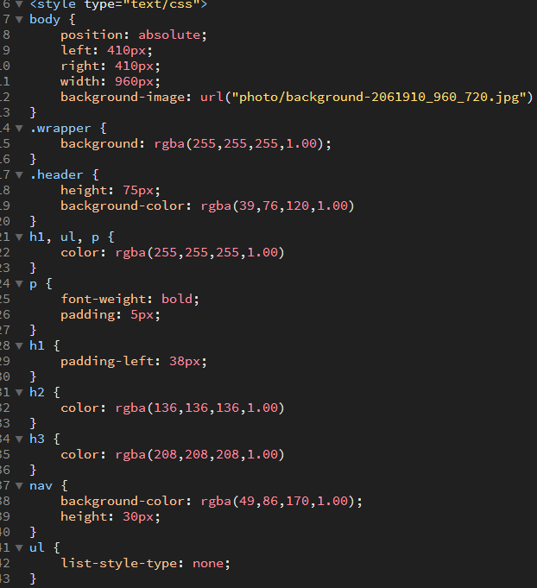
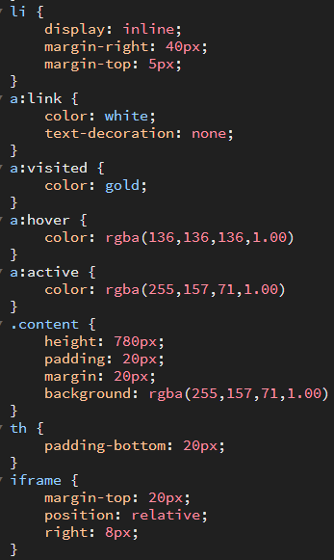
HTML
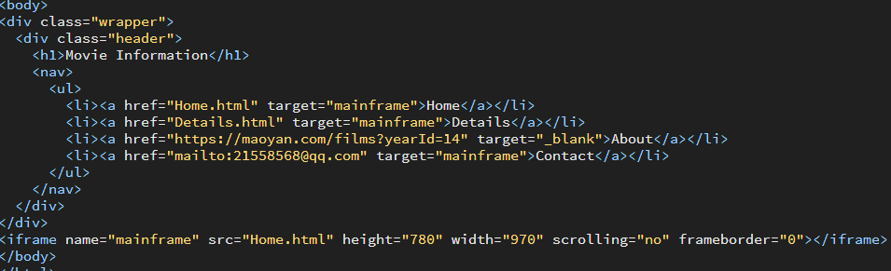

2)Home.html
These codes are in order to set the position of the picture and the text by using div and float. Also, it determines the style of the text.
CSS
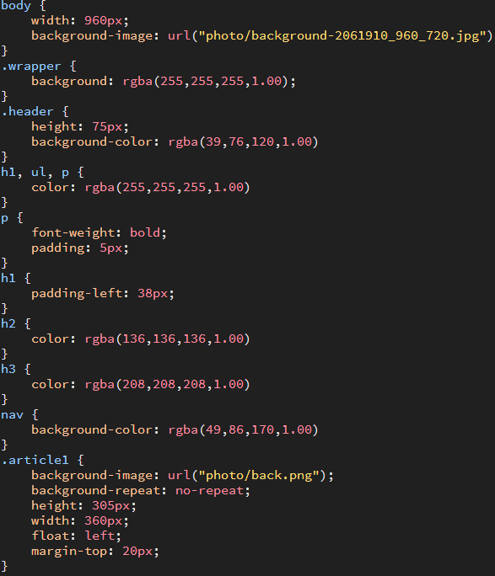
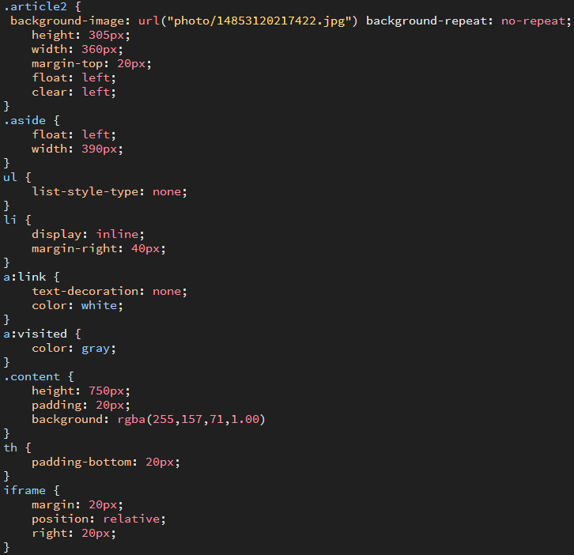
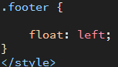

HTML
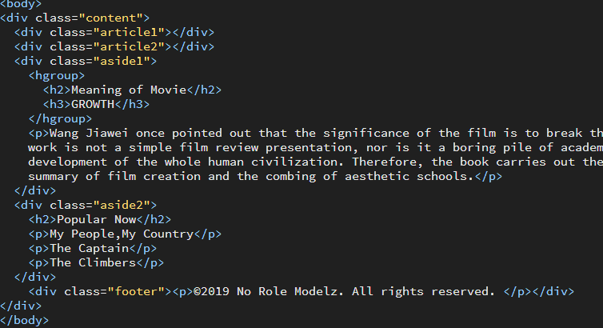
3)Details
Also, using the div and float to determine the position of picture and text.
CSS
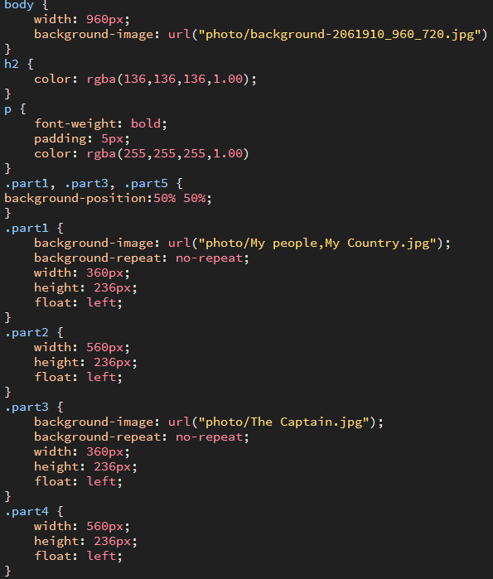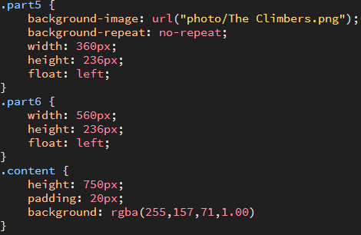
HTML
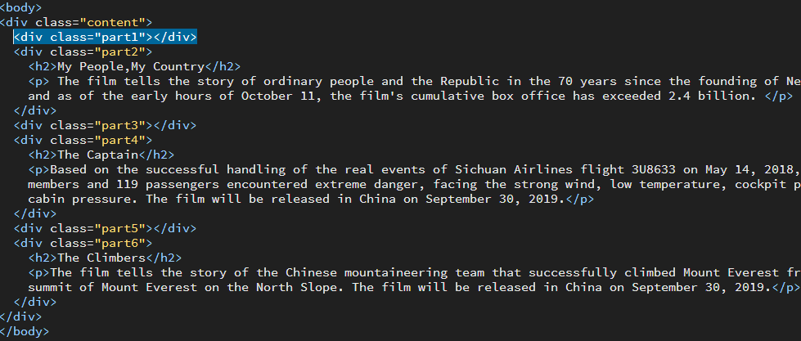

4.Results
Ex 1
1)
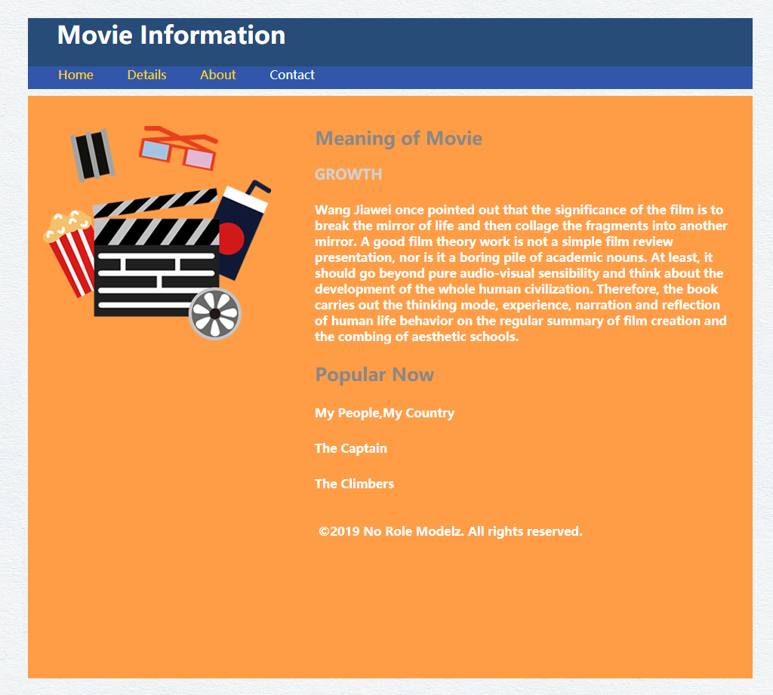
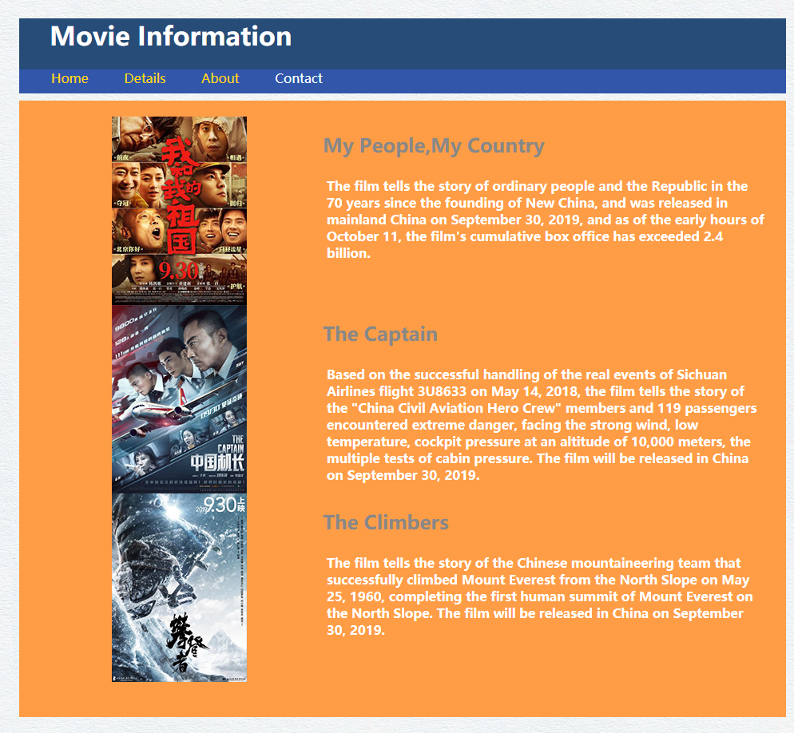

5.Analysis：
Ex 1:
1)At first, I draw a main 960px general framework.
2)And then I fill the content into these well-planned block.
3)After completing the basement, I set the background color and text color. Besides, to make the website more vivid, I set the hover and visited label.
Total:
1. Be able to complete a static web page by using css independently
2. Still be not familiar with the influence of width and floating elements on divs. After this experiment, I should practice more on that.

