Southwest University

“Introduction to Web Development” Experiment Report

School：School of Computer & information Science
Major：Software engineering
Class： Soft Engineering 2
Name: Fu Ruoxuan
Student Number：222019321062060
Experiment Report
1.Objective：
- Learn the usage of css about text
2.Detailed requirements：
Ex1：
- Use css about text.
- Use css to decorate the introduction of SWU in a website
3.Procedure:
Ex1
1)Background
These codes define the style of background.
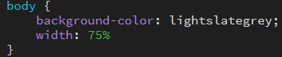
2)Headline
These codes are in order to create the headline and insert a photo about SWU.CSS defines the style of them.
HTML
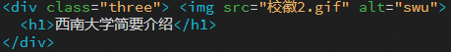
CSS
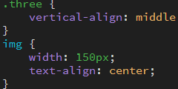
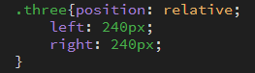
3) Dividing line
These codes define the dividing line’s size and position.
HTML
CSS
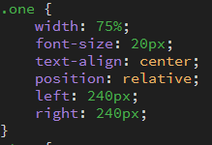
4)text
The “.two” defines the whole text position and some box styles.
The “p” dines the words alignment, color and their font style.
HTML
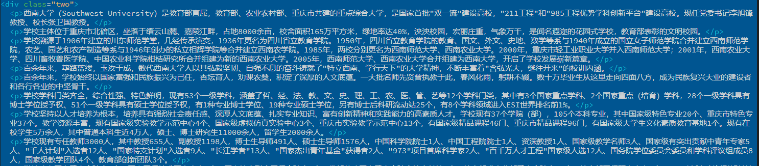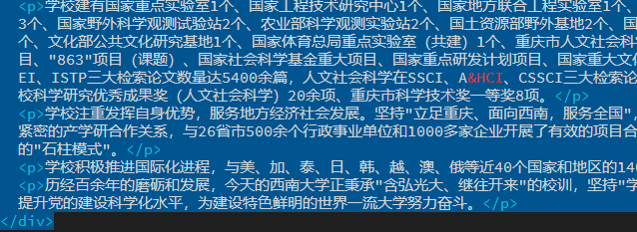
CSS
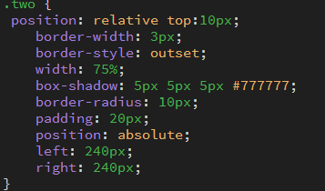
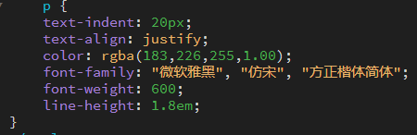

4.Results
Ex 1
1)
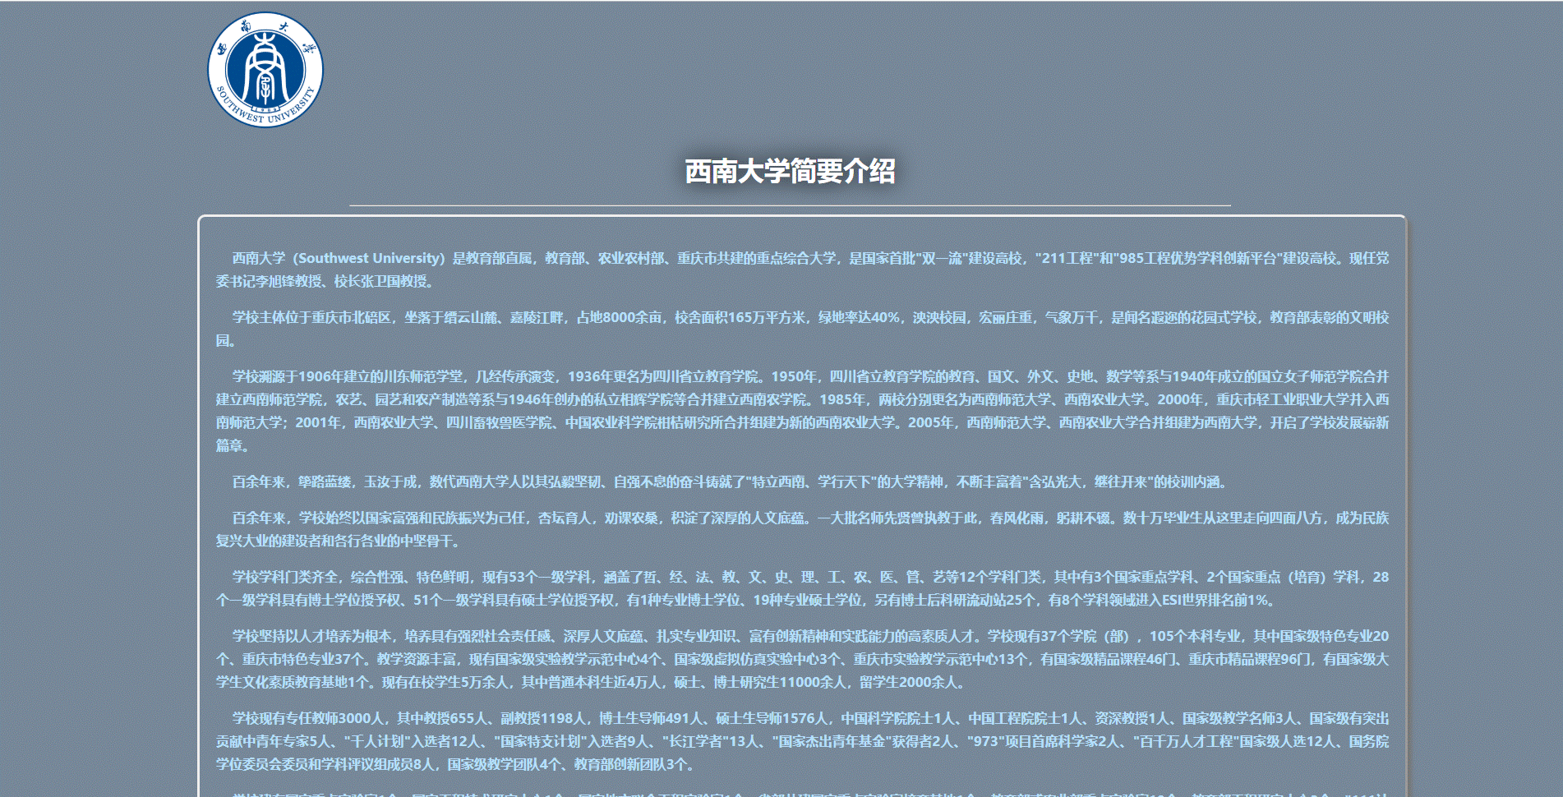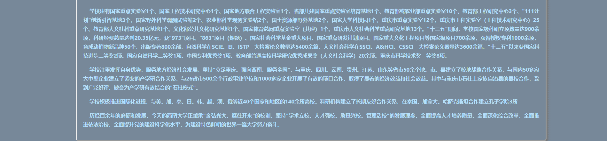

5.Analysis：
Ex 1:
1)First, I make a general structure of this web page. To put all the content in the middle, I use css to control the text and the headline alignment. But if I want to control the whole text position, the paragraph becomes a mess, so I choose to use the div element and the position attribute to control the alignment.
Total:
1. Basically master the usage of css about text through experiments.
2. In the process of the experiment, I have some problems about the
Class elements. I will do better in the future.

