西南大学

《 高等数学 IB 》课程
2018～2019学年 第2学期 |  |  |  |  |  |  |  |  |  |  |  |  |  |  | 期
考试时间 |  |  | 120分钟 |  |  | 考核方式 |  |  |  |  | 学生类别 |  |  |  |  |  |  |  |  | 人数
适用专业或科类 |  |  |  | 计算机与信息科学学院（软件学院）  计算机各专业 |  |  |  |  |  |  |  |  |  |  |  | 年级 |  | 2017级
题号 |  |  |  |  |  |  |  |  |  |  |  |  |  |  |  |  |  |  |  |  | 合计
得分
签名
阅卷须知：阅卷用红色墨水笔书写，得分用阿拉伯数字写在每小题题号前，用正分表示，不得分则在题号前写0；大题得分登录在对应的分数框内；统一命题的课程应集体阅卷，流水作业；阅卷后要进行复核，发现漏评、漏记或总分统计错误应及时更正；对评定分数或统分记录进行修改时，修改人必须签名。
特别提醒：学生必须遵守课程考核纪律，违规者将受到严肃处理。

1 Fill the blanks（3 marks each, 15 marks in total）
(1) The general solution for 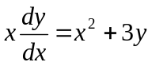 (x>0) is .
(2)The acute angle between the planes x=7 and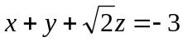 is .
(3) If f(u,v,w) is differentiable and u=x−y, v=y−z, w=z−x,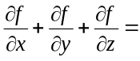 .
(4) The equivalent form of integration for 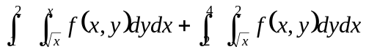 by reversing the order of integration is .
(5) The interval of convergence for the series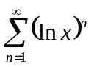is .
2 Multiple choice（3 marks each,15 marks in total）
(1) At the point (0, 0), the function 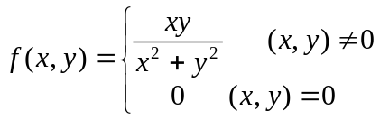 is（ ）
(A) continuous and has partial derivatives
(B) continuous but has no partial derivatives
(C) not continuous but the partial derivatives exist
(D) not continuous and the partial derivatives do not exist
(2) Let D be the closed region bounded by the surfaces 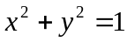, z=1, and z=0, then the integral 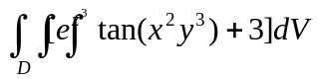=( )
(A) 0 (B) 3π (C) π (D) 3
(3) Given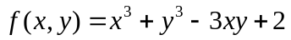, which of the following statements is correct?( )
(A) f(0,0)is a local maximum (B) f(1,1) is a local maximum
(C) f(0,0)is a local minimum (D) f(1,1) is a local minimum
(4) If 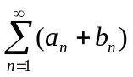 converges，which of the following statements is true?（ ）
(A)both 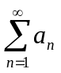and 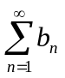converge (B) at least one of and converges
(C)both and may not converge (D) 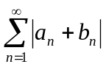 converges

(5)Which of the following equations is incorrect?（ ）
(A)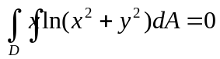 (B)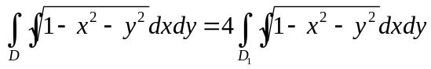
(C)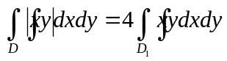 (D) 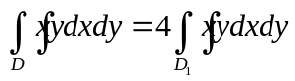
where D：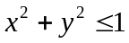，D₁：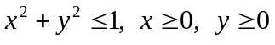。

3 Find solutions for the following problems（6 marks each, 42 marks in total)
(1) Find the derivative of the function 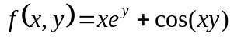at the point (2,0) in the direction of v=3i−4j.

(2) Evaluate the line integral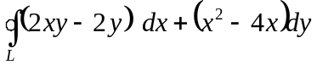, where L is the circle: r(t)=(3cost)i+(3sint)j, 0≤t≤2π.

(3) Evaluate the triple integral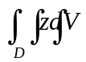, where D is the region bounded by 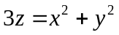 and 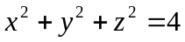.

(4) Integrate the function G(x,y,z)=x−y−z over the portion of the plane x+y=1 in the first octant between z=0 and z=1.

(5) Find the point M on the curve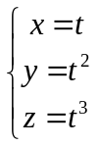, at which the tangent line of the curve is parallel to the plane x+2y+z=4.

(6)(a) Prove that the differential form: is exact for some scalar function u(x, y) on the xy-plane; (b) Find such a function u(x, y).

(7) Use geometric series to represent the function 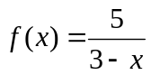as a power series about x = 0, and find the interval of convergence.

4 Solve the following problems（28 marks in total）
(1) (10 marks) Given the exact differential form dz=2xdx−2ydy for the function z=f(x,y) with f(1,1)=2, find the absolute maximum and minimum values of f(x,y) on the region 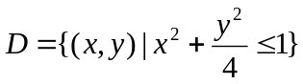.

(2) (10 marks) Given the vector field, (1) find the flux of A outward through the surface bounded by 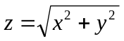and z=1; (2) find the curl of A at the point (1, 2, −1).

(3) (8 marks) Find the area of the surface cut from the hyperbolic paraboloid z=xy by the cylinder 

