西南大学

《 高等数学 IB 》课程
1 Fill the blanks（3 marks each, 15 marks in total）
(1) 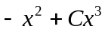
(2) 
(3) 0
(4) 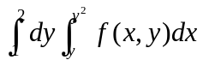
(5) 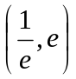

2 Multiple choice（3 marks each,15 marks in total）
(1) C；(2) B；(3) D；(4) C；(5) D

3 Find solutions for the following problems（6 marks each, 42 marks in total)
(1) Solution 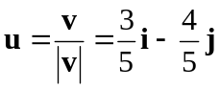 (1mark)
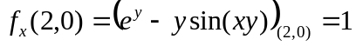 (2 marks)
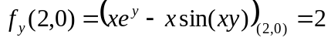 (2 marks)
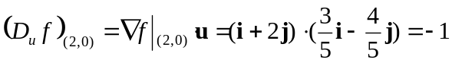 （1 mark）
(2) Solution P=2xy-2y, Q=x²-4x, 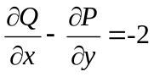 (2 marks)
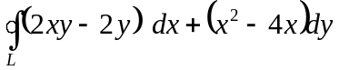=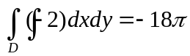 (4marks)

(3) Solution 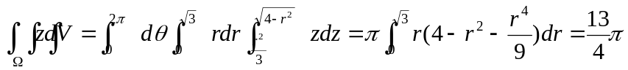
( The computing process: 4 marks, and the result: 2 marks)

(4) Solution 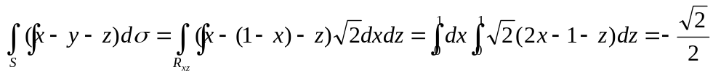
( The computing process: 4 marks, and the result: 2 marks)

(5) Solution The tangent vector at M (x, y, z) is 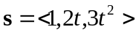, the normal of the plane is 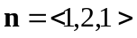, and 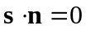, i.e., 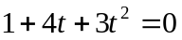. (2 marks)
Solve this equation, we have 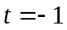 and 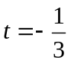.
when , 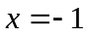, 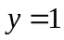, 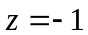 ( 2 marks)
when , 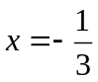, 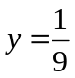, 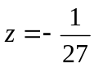 (2 marks)
Therefore, the coordinate of M is 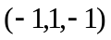or 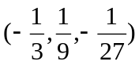.

(6) (a)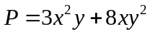 and 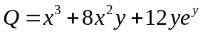 both have continuous derivatives, and
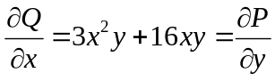 (2 marks)
Therefore, the differential form is exact for some function.
(b) (4 marks)
(7) 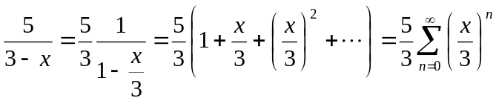 (-3<x<3)
( The computing process: 4 marks, and the result: 2 marks)
4 Solve the following problems（28 marks in total）
(1) (10 marks) Solution From dz=2xdx−2ydy we know that 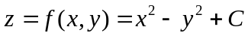. As f(1,1)=2, we have C=2, therefore,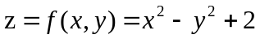. (3 marks)
Set 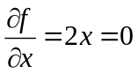 and 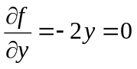, we get the only critical point (0, 0) inside the ellipse, where f(0,0)=2. (3 marks)
On the ellipse, 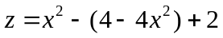, i.e., 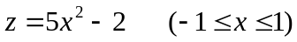, the maximum value of z is 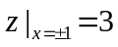, and the minimum value is 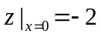. (3 marks)
Compare the above values we know that 3 is the maximum value and -2 is the minimum value on D. (1 mark)

(2) (10 marks) Solution (a)
(2 marks)
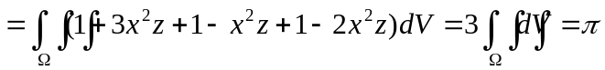 (3 marks)
(b) 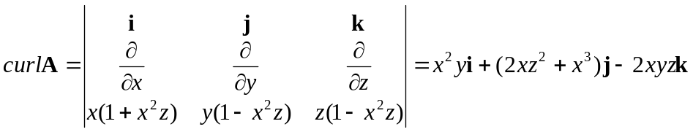 (3 marks)
therefore, 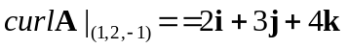 (2 marks)

(3) (8 marks) Solution 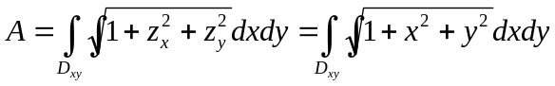
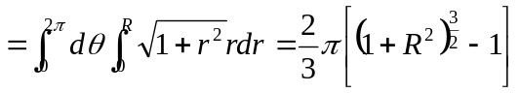
( The computing process: 6 marks, and the result: 2 marks)

