西南大学

《 高等数学 IB 》课程
2018～2019学年 第2学期 |  |  |  |  |  |  |  |  |  |  |  |  |  |  | 期
考试时间 |  |  | 120分钟 |  |  | 考核方式 |  |  |  |  | 学生类别 |  |  |  |  |  |  |  |  | 人数
适用专业或科类 |  |  |  | 计算机与信息科学学院（软件学院）  计算机各专业 |  |  |  |  |  |  |  |  |  |  |  | 年级 |  | 2017 级
题号 |  |  |  |  |  |  |  |  |  |  |  |  |  |  |  |  |  |  |  |  | 合计
得分
签名
阅卷须知：阅卷用红色墨水笔书写，得分用阿拉伯数字写在每小题题号前，用正分表示，不得分则在题号前写0；大题得分登录在对应的分数框内；统一命题的课程应集体阅卷，流水作业；阅卷后要进行复核，发现漏评、漏记或总分统计错误应及时更正；对评定分数或统分记录进行修改时，修改人必须签名。
特别提醒：学生必须遵守课程考核纪律，违规者将受到严肃处理。

1 Fill in the blanks（3 marks each, 15 marks in total）
(1) If 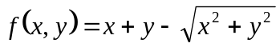,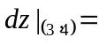 .
(2)The radius of convergence for the power series 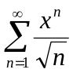 is .
(3) Change the Cartesian integral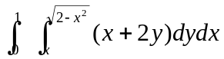 into an equivalent polar integral .
(4) The line x=1+2t, y=−1−t, z=3t meets the three coordinate planes in the three points .
(5) The general solution for 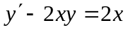 is .
2 Multiple choice（3 marks each, 15 marks in total）
(1) Given 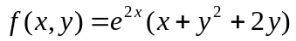, the point 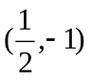 is ( ).
(A) a critical point but 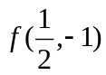 isn't a local extreme value
(B) a critical point and is a local minimum
(C) a critical point and is local maximum
(D) a critical point where f_{x} and f_{y} do not exist.
(2) Which of the following statements about the position of the line x=2+t, y=3−2t, z=−1−t, and the plane 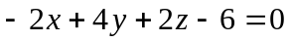 is true? ( )
（A）the line is parallel to the plane but does not lie in it
（B）the line intersects with the plane but isn't perpendicular to it
（C）the line lies in the plane
（D）the line is perpendicular to the plane.
(3) Let D be a region in the first octant bounded 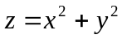 and z=1, then the integral 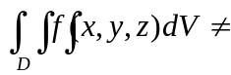 ( )
(A) 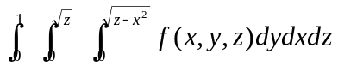 (B) 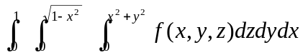
(C) 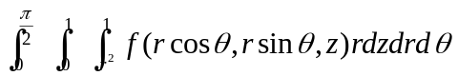 (D) 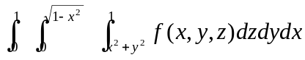.
(4) Suppose the power series 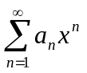and 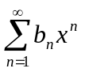 have radius of convergence 1 and 2 respectively, the radius of convergence for 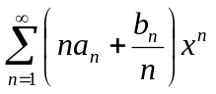 is（ ）
(A) 1 (B) 2 (C) 3 (D) inconclusive.
(5) The angle between the plane z=0 and the tangent plane of the surface 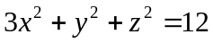 at the point M (−1,0, 3) is ( )
(A)  (B) 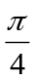 (C) 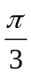 (D) 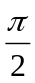.
3 Find solutions for the following problems（6 marks each, 42 marks in total)

(1)Evaluate the limit：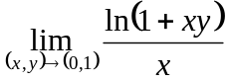.

(2) Let 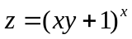, find 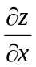.

(3) Suppose that 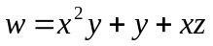, where 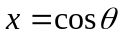, 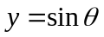, and 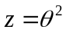. Find 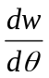 and evaluate it at 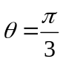.

(4) Find the volume of the solid under the surface , above the xy-plane, and inside the cylinder 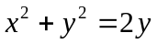.

(5) Let C be the boundary of the triangle with vertices (0,0), (1,2), and (0,2) and in positive direction with respect to the region enclosed by C. Calculate 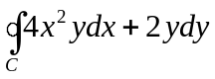 (a) by the direct method of line integral, and (b) by Green's Theorem.

(6) Find the area of the surface below the plane z=9.

(7) Use geometric series to represent the function 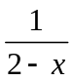 as a power series about x=1, and find the interval of convergence.

4 Solving the following problems（28 marks in total)
(1) (9 marks) Let S be the solid cylinder bounded by 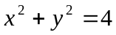, z=0 and z=3, and let n be the outer unit normal to the boundary ∂S. If , find the flux of F across ∂S.

(2) (9 marks) Find the power series about x=2 for the function 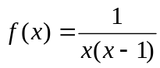.

(3) (10 marks) Find the minimum of 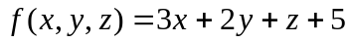 subject to the constraint 

