西南大学

《 高等数学 IB 》课程
1 Fill in the blanks（3 marks each, 15 marks in total）
(1) 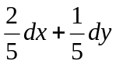
(2) 1
(3) 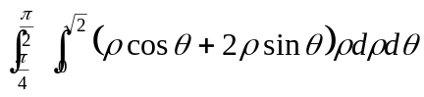
(4) (1, -1, 0) (0, -1/2, -3/2) (-1, 0, -3)
(5) 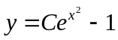

2 Multiple choice（3 marks each, 15 marks in total）
(1) B；(2) D；(3) B；(4) A；(5) B

3 Find solutions for the following problems（6 marks each, 42 marks in total)
(1) Solution 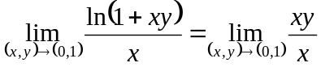 (3 marks)
=1 (3 marks)

(2) Solution 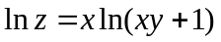
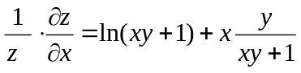 (4 marks)
By solving the above equation, we obtain 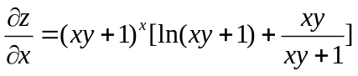 (2 marks)
(3) Solution 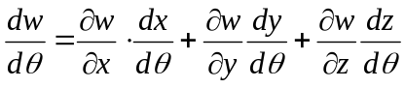 (2 marks)
(2 mark)
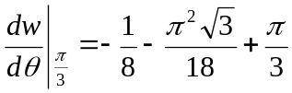 (2 mark)
(4) Solution From symmetry, we can double the volume in the first octant.
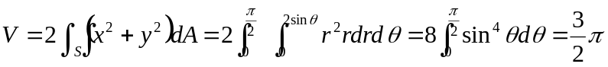
(The computing process: 4 marks, the answer: 2 marks)

(5) Solution (a) Let 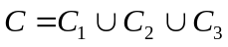, where C₁: y=2x (x:0→1), C₂: y=2 (x:1→0), and C₃: x=0 (y:1→0), therefore, (2 marks)
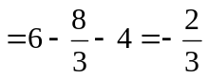 (1 mark)
(b) By Green's Theorem, 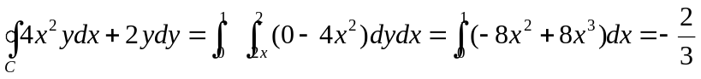 (3 marks)
(6) Solution The designated part of the surface projects onto the circular region 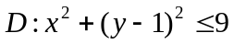.
(The computing process: 4 marks, the answer: 2 marks)
(7) Solution 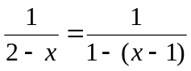 (2 marks)
= (4 marks)

4 Solving the following problems（28 marks in total)
(1) (9 marks) Solution div F=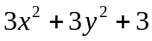, by Gauss's Theorem we have
(The computing process: 7 marks, the answer: 2 marks)
(2) (9 marks) Solution 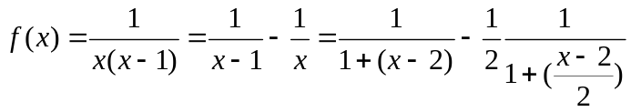
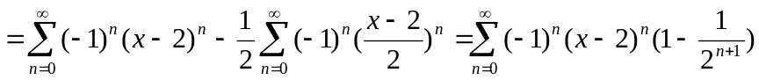
(The computing process: 7 marks, the answer: 2 marks)

(3) (10marks) Solution
The gradients of f and g are 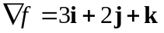and 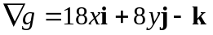. (2 marks)
To find the critical points, we solve the equations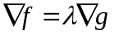 and g=0, i.e., 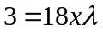, 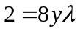, 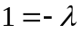, and 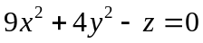. (3 marks)
Thus the critical point is 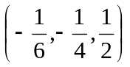, which is the only critical point. (3 marks)
Therefore, the minimum of f subject to the constraint g=0 is 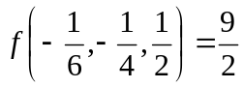 (2 marks)

