Internal Accuracy Cannot Rank Brain MRI Tumour Classifiers: Seed Variance, Shifted-Domain Discrimination, and a Simpson’s Paradox in Model Selection
Samuel Bertrand Bernard Gonzalves¹, Tan Tian Swee^{1*}
¹ Department of Biomedical Engineering & Health Science, Faculty of Electrical Engineering, Universiti Teknologi Malaysia, 81310 Skudai, Johor, Malaysia
*Corresponding Author. E-mail: tantswee@utm.my

Abstract
Deep learning models for brain MRI tumour classification routinely report internal test accuracies above 98% on a small number of public benchmarks, and these figures are widely used to compare one architecture against another. Such comparisons almost always rest on a single training run per architecture, yet deep network training is stochastic in weight initialisation, data ordering and augmentation sampling. This study developed and evaluated a reliability-first framework to determine whether internal performance on a widely used four-class brain MRI benchmark is reproducible enough to support the architecture comparisons drawn from it, and whether it predicts behaviour under dataset shift. Three architectures — ResNet18, EfficientNet-B0 and ViT-B/16 — were each trained at five random seeds on an identical leakage-aware split, giving fifteen runs. The split was constructed after exact-duplicate removal and perceptual near-duplicate grouping, which detected 1,926 near-duplicate pairs crossing the distributed train/test boundary. Candidate external datasets were audited for overlap; one was rejected after 4,740 of its 5,950 images proved byte-identical to the training data. Behaviour under shift was assessed on two glioma-focused probes: a cross-species canine collection of 53 patients and a same-species human adult-glioblastoma collection of 610 patients. Internal test macro-F1 spanned 0.9557–0.9673, but the between-architecture spread of 0.0116 was only 2.52 times the mean seed-induced standard deviation of 0.0046; the two best architectures differed by 0.0011 and the ordering changed between seeds. The same-species probe separated the architectures at a signal-to-noise ratio of 4.91, with glioma prediction rates of 0.674 ± 0.073, 0.514 ± 0.065 and 0.264 ± 0.114, and one architecture ranked first at all five seeds. Misassigned glioma slices concentrated in the no-tumour class, from 0.271 to 0.628 on identical slices, and the architecture least able to recognise human glioma was the most confident at every seed. Internal performance correlated +0.886 with shift behaviour between architectures and −0.514 within them. These results demonstrate that single-run internal accuracy on this benchmark does not distinguish these architectures against seed variation and does not predict behaviour under shift.
Keywords: Brain MRI; Tumour classification; Reliability evaluation; Dataset shift; Calibration; Data leakage; Seed variance; Underspecification

1. Introduction
Brain tumour classification from magnetic resonance imaging is an active task within medical-imaging artificial intelligence. MRI provides the soft-tissue contrast required to visualise tumour-related abnormality non-invasively, and it is the modality of choice for brain tumour assessment. Deep learning methods are now routinely applied to this task, and the published literature reports internal test accuracies approaching saturation on the small number of public benchmarks on which the field is built [1, 2]. For a decision-support application, however, the quantity of interest is not accuracy on a familiar test partition but reliability: whether a model behaves predictably when the data it encounters differ from the data on which it was developed.
The benchmarks that dominate this literature serve two distinct purposes. The first is to report performance. The second, and more consequential, is to compare architectures against one another and conclude that one is preferable. The four-class aggregated brain MRI dataset distributed through Kaggle [3] is the most heavily used of these, and comparative studies on it and its constituent sources regularly rank convolutional and transformer families by their internal test metrics [4]. This second purpose is the one the present study interrogates.
Reported performance on these benchmarks clusters tightly. Across transfer-learning comparisons, fine-tuned convolutional networks and transformer variants, test accuracies fall between roughly 98% and 99% irrespective of architecture [5–7]. Metrics of this kind describe only whether the predicted class is correct on a held-out partition of a single dataset. They are silent on whether that partition was genuinely independent of training, whether the dataset was internally contaminated, whether the model’s confidence is trustworthy, whether performance would survive a change of imaging source, and whether the reported figure would recur if the model were trained again.
Each of these silences has an established literature. Data leakage and benchmark contamination can inflate apparent performance by tens of percentage points: splitting three-dimensional volumes at the two-dimensional slice level substantially inflates held-out accuracy in brain MRI, and a randomly labelled dataset reached approximately 96% accuracy under slice-level splitting against the expected 50% under subject-level splitting [8]. The benchmark family used here is specifically affected. Wallis and Buvat [9] showed that high classification accuracy is achievable on a widely used brain tumour MRI dataset using no information about the tumour itself, arising from implicit radiologist input in slice selection, and noted that no other paper using the dataset had mentioned the bias. Independent audits have since documented duplicate-induced leakage in the same family and constructed de-duplicated versions of it [10, 11].
Modern networks are also systematically overconfident, and confidence values influence how outputs are interpreted [12]. Temperature scaling is the standard post-hoc remedy, learning a single scalar from validation logits; because it is monotonic in the logits it improves calibration without changing the predicted class. That property is also its limit: it can adjust the confidence attached to a prediction but cannot correct the prediction, and its benefits degrade under distribution shift [13]. Internal accuracy itself frequently fails to survive a change of imaging source. Of 86 externally validated radiological algorithms, 81% showed some decrease in external performance, 49% a decrease of at least 0.05 and 24% at least 0.10, with no study characteristic predicting the size of the drop [14].
A fifth source of optimism is less often examined and is the pivot of this study. Deep network training is stochastic: weight initialisation, the ordering of training examples, augmentation sampling and non-deterministic accelerator operations all vary with the random seed, so training the same architecture twice on identical data yields two different models. Repeated-run studies in medical imaging have found this variation to be substantial. Training nnU-Net at fifty seeds across three three-dimensional tasks including brain tumour, Åkesson et al. [15] found that the best-performing seed of an algorithm statistically significantly outperformed between none and roughly three-quarters of the remaining seeds of the same algorithm, and concluded that a statistically significant performance difference is a weak and unreliable indicator of a true difference between learning algorithms. Bosma et al. [16] retrained top-performing algorithms for three diagnostic tasks and found retraining variance significant relative to variance arising from the data, with 15% of comparisons between runs of the same method producing spurious significance at p < 0.05. Sanchez et al. [17] quantified the evidentiary consequence, showing by simulation that seed variability of around one per cent substantially raises the threshold of evidence required before an outperformance claim is justified. Comparable findings have been reported for computer vision more broadly, where outlier seeds can be identified across large numbers of training runs [18]. Yet architecture comparisons on public brain MRI benchmarks are almost universally drawn from a single run each.
The remaining research gap is therefore not the absence of another high-accuracy predictor. Existing studies have already demonstrated effective deterministic prediction, cross-architecture comparison, and in some cases external validation. Leakage-aware splitting, exact and perceptual overlap auditing, multi-metric calibration with post-hoc temperature scaling, qualified shifted-domain testing, and repeated-run estimation each address a different way in which internal accuracy can mislead. However, a practical gap remains in integrating these concepts into a unified evaluation that simultaneously provides: (i) leakage-controlled internal performance reported with dispersion across repeated runs, (ii) empirically audited dataset independence before any external claim is made, (iii) calibration assessed both in-distribution and under shift, and (iv) a quantitative comparison of how well each evaluation distinguishes the architectures against seed-induced variation.
Accordingly, the novelty of the present study lies in the task-specific integration of leakage-aware preparation, contamination auditing, multi-metric calibration, paired shifted-domain probing, and repeated-run estimation within a single reproducible framework for brain MRI tumour classification. The contribution is not the isolated introduction of any one of these methods. Instead, they are combined and applied so that the reliability of the standard evaluation protocol can itself be measured. A summary of related approaches, their principal findings, limitations, and the gaps addressed here is presented in Table 1.
INSERT TABLE 1 — Summary of related works on brain MRI tumour classification and evaluation reliability
Table 1. Summary of related works. Columns: study, methodology, application, limitation, and gap addressed in this work. Suggested entries: Shah et al. [6], Zulfiqar et al. [7], Disci et al. [5], Reyes and Sánchez, Yagis et al. [8], Wallis and Buvat [9], Lu et al. [11], Åkesson et al. [15], Bosma et al. [16], Yu et al. [14], and the present work. A final column reporting whether repeated training runs were used should read “no” for every prior entry.
The contributions of this study are therefore threefold. First, the study establishes a leakage-aware evaluation of three architecture families in which every configuration is repeated across five random seeds, so that between-architecture differences can be read against within-architecture variation. Second, an exact and perceptual contamination audit is applied to every candidate external dataset before use, resulting in the rejection of one candidate and the retention of two shifted-domain probes with documented independence. Third, internal classification, multi-metric calibration and shifted-domain behaviour are assessed jointly under a common protocol, enabling a direct comparison of how well each evaluation resolves the architectures against seed noise.

2. Methodology
This study develops a reliability-first evaluation framework for brain MRI tumour classification. The methodology comprises six main stages: (i) dataset preparation and role assignment, (ii) leakage-aware splitting of the internal dataset, (iii) contamination auditing of candidate external datasets, (iv) preprocessing audits of the shifted-domain probes, (v) model training with repeated runs and provenance recording, and (vi) three-layer evaluation covering internal classification, calibration, and shifted-domain behaviour. Each stage is described below.
The overall system architecture of the proposed framework is shown in Figure 1. The architecture summarises all stages from dataset acquisition through contamination auditing, the retain-or-reject decision applied to each candidate, repeated training of three architectures on a fixed leakage-aware split, and the three evaluation layers whose outputs are synthesised into the reliability evidence reported in Section 3.
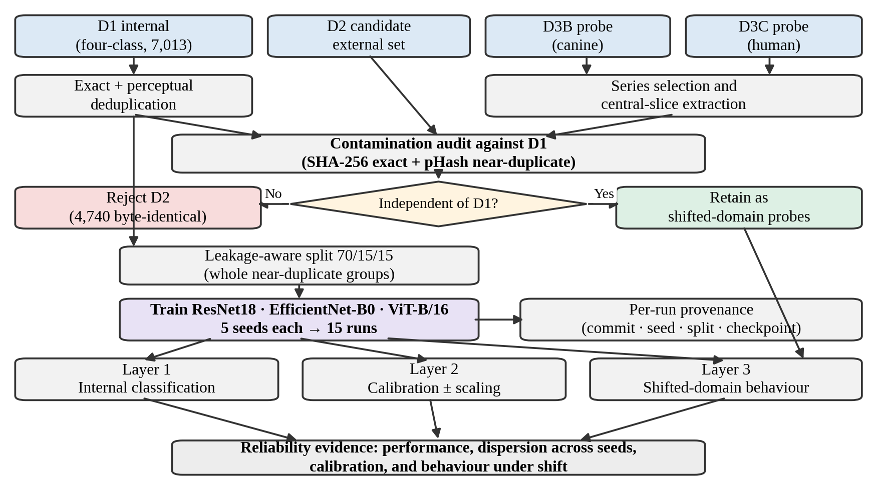
Figure 1. System architecture of the reliability-first evaluation framework. Datasets are prepared and audited for contamination against the internal dataset D1; a candidate failing the audit is excluded from any external-validation role. Three architectures are trained on the fixed leakage-aware split at five seeds each, and evaluation proceeds across internal, calibration and shifted-domain layers.

2.1 Dataset Preparation and Roles
Four dataset roles were defined. D1 is the internal dataset used for training, validation and testing, obtained from the publicly available four-class brain MRI collection distributed through Kaggle [3], which aggregates three widely used sources: a contrast-enhanced MRI collection [19], the SARTAJ dataset, and a brain tumour detection collection [20]. D2 was a candidate four-class external validation set [21]. D3B and D3C are glioma-focused shifted-domain probes obtained from The Cancer Imaging Archive, selected to differ along a single deliberate axis, biological species: D3B is a canine glioma collection [22] representing cross-species shift, and D3C a human adult-glioblastoma collection [23] representing same-species shift.
Neither probe reproduces the four-class label structure of D1; each carries a collection-level glioma label only. Consequently neither supports a four-class external accuracy figure, and both are described throughout as shifted-domain probes rather than external validation sets. The study is a retrospective secondary analysis of publicly available, de-identified imaging collections.
Dataset | Source and modality | Label structure | Retained cohort | Study role | Usage decision
D1 | Aggregated public four-class brain MRI collection; 2D images | Four-class: glioma, meningioma, pituitary, no tumour | 7,013 images after exact deduplication | Internal training, validation and testing | Retained as the primary internal dataset
D2 | Candidate four-class brain MRI collection; contrast-enhanced T1 | Four-class, nominally matching D1 | 5,950 images | Candidate external validation | Rejected: 4,740 images byte-identical to D1
D3B | Canine glioma collection; DICOM T1 | Collection-level glioma label only | 53 patients / 53 series / 265 central slices | Cross-species shifted-domain probe | Retained; not four-class external validation
D3C | Human adult-glioblastoma collection; DICOM T1 | Collection-level glioma label only | 610 patients / 610 series / 3,050 central slices | Same-species shifted-domain probe | Retained; not four-class external validation
Table 2. Summary of the four datasets used in this study.

2.2 Deduplication and Leakage-Aware Splitting
D1 was audited for exact duplication by SHA-256 hashing of image content. Of the 7,200 images as distributed, 7,013 were unique; 187 images across 153 duplicate groups were removed. The deduplicated set was then audited for near-duplication using a perceptual hash at a Hamming distance threshold of 4, which detected 5,125 near-duplicate pairs, of which 1,926 crossed the distributed train/test boundary and 46 crossed class boundaries. Because visually near-identical images appeared on both sides of the distributed partition, that partition was not used for any reported result.
A leakage-aware split was constructed instead. Each near-duplicate pair was treated as an edge between two images, and connected components were formed over these edges by a union–find procedure, so that images transitively linked by near-duplication were placed in a single leakage group. Formally, for images i and j with perceptual hashes h(i) and h(j), an edge exists where the Hamming distance satisfies
d_{H}(h(i), h(j)) ≤ θ, θ = 4 (1)
This produced 4,755 leakage groups, the largest containing 24 images and 25 spanning more than one class label. Whole leakage groups, never individual images, were assigned to training, validation and test partitions in 70/15/15 proportions using a greedy per-class-deficit rule, yielding 4,909, 1,053 and 1,051 images respectively, verified free of cross-partition near-duplicate pairs at the chosen threshold. The resulting split file is fixed for the study and identified by its SHA-256 hash; all fifteen runs reported below were trained on it.
Class | Train | Validation | Test | Total
Glioma | 1,248 | 269 | 269 | 1,786
Meningioma | 1,250 | 267 | 267 | 1,784
No tumour | 1,178 | 252 | 251 | 1,681
Pituitary | 1,233 | 265 | 264 | 1,762
Total | 4,909 | 1,053 | 1,051 | 7,013
Table 3. Composition of the leakage-aware D1 split by class and partition.
Because D1 is distributed without patient-level identifiers, this procedure controls leakage at the level of images and near-duplicate groups rather than at the patient level. Internal performance is accordingly not interpreted as evidence of patient-level generalisation.

2.3 Dataset Independence and Contamination Auditing
Public medical-imaging datasets are frequently reused, repackaged and redistributed, so independence between a candidate external dataset and the internal dataset must be demonstrated rather than assumed [24]. Contamination was assessed in two stages. First, exact duplication was detected by identifying SHA-256 hashes shared between D1 and the candidate; a shared hash indicates byte-identical images and therefore direct reuse. Second, near-duplication was detected using a perceptual hash, which maps each image to a compact binary fingerprint stable under reformatting, recompression, resizing and minor intensity change. For every image pair the Hamming distance between fingerprints was computed as
d_{H}(a, b) = ∑_{k=1}^{K} 𝟙[a_{k} ≠ b_{k}] (2)
where a and b are the K-bit perceptual hashes of two images and the bracket denotes an indicator function. Any pair with d_H ≤ 4 was flagged as a near-duplicate, and cross-class pairs were recorded separately. A candidate exhibiting substantial exact or near-duplicate overlap was treated as non-independent and excluded from any external-validation role. A candidate with no or negligible overlap was retained as a shifted-domain probe, subject to the caveat that perceptual hashing establishes visual distinctness only and cannot by itself demonstrate patient-level independence.
Comparison | Pairwise comparisons | Exact-overlap pairs | Near-duplicate pairs | Cross-class pairs | Decision
D1 vs D2 | 41,727,350 | 4740 | 7290 | 0 | Rejected
D1 vs D3B | 1858445 | 0 | 0 | 0 | Retained
D1 vs D3C | 21529910 | 0 | 7 | 0 | Retained
Table 4. Contamination audit of each candidate dataset against D1.

2.4 Shifted-Domain Series Selection and Slice Extraction
The two probes were obtained by programmatic download of selected series. At most one T1-weighted anatomical series was retained per patient, with post-contrast series preferred over non-contrast where both were available. Within each retained series, slices were ordered deterministically by DICOM InstanceNumber where present, falling back in turn to ImagePositionPatient, SliceLocation and filepath, and the five most central slices were selected. Each selected slice was converted to an 8-bit grayscale image using 1st–99th percentile intensity windowing, which clips extreme intensities before linear rescaling and provides a consistent contrast mapping across scanners without manual per-image adjustment.
For D3B this yielded 53 series from 53 patients, comprising 28 post-contrast and 25 non-contrast T1 series, and 265 central slices. For D3C, 614 series were converted to 3,070 central slices; each converted series was then checked for imaging plane using the DICOM direction cosines, and four series more than 45 degrees from axial were excluded, leaving an analysis cohort of 610 patients, 610 series and 3,050 slices. A further eleven series lie between 10 and 45 degrees from axial; these were retained, flagged, and used for the plane sensitivity analysis reported in Section 3.4.
Because slices were selected by anatomical position rather than confirmed tumour presence, the resulting images are representative central sections rather than lesion-verified slices, and probe labels are collection-level rather than slice-level annotations.

2.5 Preprocessing Audits
Two preprocessing differences that could plausibly explain shifted-domain behaviour were tested directly rather than assumed.
Skull stripping. D3C is distributed in a processed form, which had been assumed to imply skull stripping and therefore a systematic difference from the unstripped internal images. Forty D3C series were sampled at random and measured against forty matched D1 glioma images on four quantities: presence of a masked background, proportion of the outer air region exactly zero, proportion of non-zero image corners, and proportion of outer-ring pixels exceeding the brain-core median. No D3C image had a masked background. The air region was 26.2% exactly zero at the median, where a background mask would give a value near 1.0; image corners were 54.0% non-zero; and 25.6% of outer-ring pixels exceeded the brain-core median, which is the expected signature of scalp fat on T1-weighted imaging. The same measurements taken directly from the source DICOM matched the converted images, ruling out the conversion step as a cause. On these measures D3C retains extracranial anatomy throughout and is in fact less masked than D1, whose air region is 37.3% exactly zero at the median. The skull-stripping concern was therefore withdrawn and no corresponding control was applied.
Imaging plane. Because imaging plane is a plausible alternative explanation for shifted-domain prediction behaviour, all D3C behavioural metrics were additionally recomputed on a sensitivity cohort with the eleven oblique series excluded, and the difference is reported alongside the full-cohort values in Section 3.4.
Residual preprocessing differences — co-registration, resampling and intensity normalisation applied by the probe distributor — remain uncontrolled and are carried into the limitations.

2.6 Common Model-Input Preprocessing
A single preprocessing path converted every prepared image, internal and probe alike, into model input. Each image was loaded and converted to a three-channel representation by replicating its single grayscale channel, so that inputs matched the format expected by the pretrained backbones, and was resized to 224×224 pixels. During training, two light augmentations were applied identically across all architectures: random horizontal flipping with probability 0.5 and random rotation of up to ±10 degrees. No augmentation was applied during any evaluation; the validation set, the internal test set and both probes passed through an identical resize-and-normalise path with no stochastic transformation. Tensors were normalised using standard ImageNet channel statistics.

2.7 Model Architectures
Three image-classification architectures were used, selected to span distinct model families so that a reliability difference appearing consistently across all three would be more informative than one observed for a single model. The three were ResNet18, a compact residual convolutional network of approximately 11.7 million parameters [25]; EfficientNet-B0, a compound-scaled convolutional network of approximately 5.3 million parameters [26]; and ViT-B/16, a vision transformer of approximately 86 million parameters that partitions each image into fixed 16×16 patches and models their relationships through self-attention [27]. All three were taken from standard implementations and initialised with publicly available ImageNet-1k pretrained weights. Each was adapted to the four-class task by replacing the original classification layer with a new fully connected layer producing four output logits. No layers were frozen; all parameters were updated during training. The three families differ in inductive bias and in how they aggregate spatial information, and their relative merits under robustness evaluation remain unsettled [28].
Model | Architecture family | Approx. parameters | Pretrained weights | Modified component
ResNet18 | Compact residual CNN | 11.7 M | ImageNet-1k | Final fully-connected layer
EfficientNet-B0 | Compound-scaled CNN | 5.3 M | ImageNet-1k | Final classifier layer
ViT-B/16 | Vision transformer | 86 M | ImageNet-1k | Classification head
Table 5. Summary of backbone architectures used in this study.

2.8 Training, Repetition and Provenance
All models were fine-tuned on the training partition and monitored on the validation partition following a common procedure. The elements defining the procedure were held fixed across architectures: optimisation with AdamW using a weight decay of 1×10⁻⁴, standard multi-class cross-entropy loss, a maximum of 20 epochs, and early stopping. Model selection and early stopping were both governed by macro-averaged F1 on the validation set, with the checkpoint achieving the highest validation macro-F1 retained and training halted after five consecutive epochs without improvement. No learning-rate scheduler was applied.
Learning rate and batch size were the only settings permitted to vary between architectures. The two convolutional models were trained with a learning rate of 1×10⁻⁴ and a batch size of 32, whereas ViT-B/16 was trained with a learning rate of 5×10⁻⁵ and a batch size of 16. A reduced learning rate is conventional when fine-tuning vision transformers, and the smaller batch size also reflected the memory footprint of the transformer on the available hardware.
Repetition. Each architecture was trained five times, once at each of five random seeds (42–46), giving fifteen runs in total. All fifteen used the identical leakage-aware split and the identical preprocessing path. The seed was supplied to each run as an explicit parameter and applied to the Python, NumPy and framework random number generators for both CPU and accelerator, to seeded data-loader worker initialisation, and to a seeded generator for shuffling.
Repeating each configuration across seeds is a requirement of the design rather than a robustness check added afterwards. The comparison being made is between architectures, and a single run per architecture cannot distinguish a difference in architecture from a difference in random initialisation and data ordering [15, 16]. All quantities reported below are therefore means with standard deviations across the five seeds, and no result is reported from a single run. No cross-validation or hyperparameter search was performed.
Provenance. Each run wrote its outputs to a seed-scoped directory and recorded a provenance record containing the run-set identifier, architecture, seed, code commit hash, SHA-256 hash of the data-split file and SHA-256 hash of the resulting checkpoint. Summary generation verifies these records before producing any aggregate, requiring that all contributing runs share a single run-set identifier, an identical split hash, matching seed sets across architectures and identical evaluation cohorts, and refusing to produce a summary otherwise.
Model | Batch size | Learning rate | Weight decay | Optimiser | Max epochs | Patience | Seeds | Best epoch
ResNet18 | 32 | 1×10⁻⁴ | 1×10⁻⁴ | AdamW | 20 | 5 | 42–46 | 6.4 ± 3.5
EfficientNet-B0 | 32 | 1×10⁻⁴ | 1×10⁻⁴ | AdamW | 20 | 5 | 42–46 | 9.8 ± 3.7
ViT-B/16 | 16 | 5×10⁻⁵ | 1×10⁻⁴ | AdamW | 20 | 5 | 42–46 | 7.0 ± 2.9
Table 6. Summary of training and repetition parameters.

2.9 Evaluation Protocol and Metrics
Each trained checkpoint was evaluated at three levels: internal classification performance on the held-out test partition; calibration of predicted probabilities on that partition, before and after temperature scaling; and prediction and confidence behaviour on the two shifted-domain probes. Every metric was computed independently for each of the fifteen runs.
Internal classification performance was measured using overall accuracy, balanced accuracy and the macro-averaged F1 score, together with per-class precision, recall and F1 and the full confusion matrix. The macro-averaged F1 score, which was also the model-selection criterion, is the unweighted mean of the per-class F1 scores,
macro-F1 = 1/C · ∑_{c=1}^{C} F1_{c} (3)
where C is the number of classes and F1_{c} is the F1 score of class c. Macro-averaging gives each class equal weight regardless of frequency, so that performance on smaller classes is not masked by performance on larger ones.
Four calibration metrics were computed. The expected calibration error (ECE) partitions predictions into M equal-width confidence bins and measures the average gap between confidence and accuracy across bins,
ECE = ∑_{m=1}^{M} ( |B_{m}| / n ) · | acc(B_{m}) − conf(B_{m}) | (4)
where B_{m} is the set of predictions whose confidence falls in bin m, n is the total number of predictions, acc(B_{m}) is the accuracy of the predictions in bin m and conf(B_{m}) their mean confidence. Following common practice, M was set to 15 [29]. The negative log-likelihood penalises low probability assigned to the true class,
NLL = − 1/n · ∑_{i=1}^{n} log p_{i, yi} (5)
where p_{i, yi} is the probability the model assigned to the true class of example i. The multiclass Brier score measures the mean squared difference between the predicted probability vector and the one-hot true-label vector,
BS = 1/n · ∑_{i=1}^{n} ∑_{k=1}^{K} ( p_{i,k} − y_{i,k} )² (6)
where K is the number of classes, p_{i,k} is the predicted probability of class k for example i, and y_{i,k} is 1 if k is the true class and 0 otherwise. A confidence–accuracy gap was additionally reported as the absolute difference between mean confidence and overall accuracy. For all four metrics, lower values indicate better calibration.
Because the probes carry only a collection-level glioma label, conventional classification accuracy is undefined on them. Behaviour under shift was characterised instead through the glioma prediction rate, used as the primary behavioural measure and defined as the proportion of slices assigned to the glioma class,
R_{glioma} = 1/N · ∑_{i=1}^{N} 𝟙[ŷ_{i} = glioma] (7)
where N is the number of probe slices, ŷ_{i} is the predicted class of slice i, and the bracket denotes an indicator function. The full distribution of predicted classes, the mean and median glioma probability, the mean and median maximum confidence, and the predictive entropy were also recorded. The predictive entropy,
H(p) = − ∑_{k=1}^{K} p_{k} log p_{k} (8)
summarises how spread out the probability vector is, with higher values indicating a more uncertain, less peaked prediction. Because each patient contributed a single series of five central slices, slice-level predictions were additionally aggregated to the patient level by majority vote, and both slice-level and patient-level rates were reported so that observed behaviour is not an artefact of the aggregation level.

2.10 Calibration and Temperature Scaling Procedure
Temperature scaling was applied as a post-hoc calibration method that adjusts confidence without altering which class is predicted [12]. A single scalar temperature T > 0 was used to divide the logits before the softmax, so that the scaled probability of class k is
p̂_{k} = exp( z_{k} / T ) / ∑_{j=1}^{K} exp( z_{j} / T ) (9)
where z is the logit vector and T the scalar temperature. The temperature was fitted independently within each of the fifteen runs, on that run’s own validation logits, by choosing the value of T that minimises the negative log-likelihood of the validation set, with the model weights held fixed. Optimisation used the L-BFGS algorithm. The fitted temperature was then applied unchanged to that run’s test logits and to both probes, so that no target-domain information was used to calibrate the model.
Because dividing the logits by a positive constant preserves their order, temperature scaling leaves the predicted class of every example unchanged; accuracy, balanced accuracy, macro-F1 and the confusion matrix are therefore identical before and after scaling, and only confidence-dependent metrics are affected. Fitting a temperature per run rather than per architecture is necessary because the temperature is a property of a trained checkpoint rather than of an architecture, as Section 3.3 demonstrates.

2.11 Statistical Analysis
Two sources of variation are reported separately.
Between-run variation. Every architecture-level quantity is reported as a mean with standard deviation over the five seeds. To characterise whether an evaluation resolves the architectures against seed-induced variation, the between-architecture spread is reported against the mean within-architecture standard deviation as a signal-to-noise ratio,
SNR = ( max_{a} μ_{a} − min_{a} μ_{a} ) / ( 1/A · ∑_{a=1}^{A} σ_{a} ) (10)
where μ_{a} and σ_{a} are the mean and standard deviation across seeds for architecture a, and A is the number of architectures. Values near or below 2 indicate that the between-architecture differences are of the same order as the variation induced by the random seed alone. Ranking stability is additionally reported as the number of distinct architecture orderings observed across the five seeds and the count of seeds at which each architecture ranks first.
Within-run sampling variation. The patient is treated as the independent unit of inference, since five central slices from one patient are correlated and resampling slices would treat them as independent draws, producing intervals too narrow by approximately the design effect √(1 + (K − 1)·ICC) where K is the number of slices per patient and ICC the intraclass correlation. Patient-clustered bootstrap intervals over 1,000 resamples of patients are reported for probe rates, and Wilson intervals for patient-majority rates. Between-architecture comparisons on the same probe use McNemar’s test on paired patient-level predictions with Holm correction for multiplicity.
The association between internal macro-F1 and probe glioma prediction rate was computed at three levels: pooled across the fifteen runs, between architecture means, and within architectures after centring each run on its architecture mean. A sign change between the between- and within-architecture terms is reported as a Simpson’s paradox. Bootstrap resampling characterises variance arising from the evaluation set, not from training, and does not substitute for repeated runs; Bosma et al. [16] show that paired bootstrapping claims significance approximately three times more often than it should when comparing runs of the same training method.

3. Results and Discussion
The proposed reliability-first framework was evaluated across three layers: dataset independence and internal classification performance, calibration in-distribution and under shift, and prediction behaviour on two shifted-domain probes. Results are presented through tables and figures to provide a detailed overview of predictive performance, reproducibility across training runs, calibration quality, and behaviour under dataset shift.

3.1 Dataset Audit and the Rejection of a Candidate External Set
The two-stage audit determined which datasets entered the study and in what role. The audit of D2 against D1 revealed extensive contamination. Of the 5,950 images in D2, 4,740 were byte-identical to images in D1 under SHA-256 hashing — approximately four-fifths of the entire dataset. Perceptual hashing detected a further 7,290 near-duplicate pairs at the chosen threshold, of which 5,037 were exact perceptual matches at Hamming distance zero, and 68 pairs additionally crossed class boundaries. This pattern indicates that D2 is substantially a repackaging of the same underlying images as D1 rather than an independent collection. Had D2 been used as an external validation set, any resulting external accuracy would have been measured largely on images the models had already seen during training. D2 was therefore excluded from every performance, calibration and generalisation claim.
Both probes passed the same audit. For D3B, all 1,858,445 image-pair comparisons against D1 returned no exact duplicates and no perceptual near-duplicates. For D3C, all 21,529,910 comparisons returned no exact duplicates; perceptual hashing flagged only seven near-duplicate pairs, all within the glioma class rather than across classes and concentrated in two patients. Seven flagged pairs out of more than twenty-one million comparisons is a negligible rate consistent with coincidental anatomical similarity between central glioma slices rather than shared provenance, and the flagged pairs were reviewed and retained on that basis. A separate check confirmed that no perceptual hash value within D3C is shared between patients, so all within-probe hash collisions occur between adjacent central slices of the same series, as expected by construction.
The rejection of D2 is reported as a methodological result in its own right. It demonstrates concretely that two separately named public benchmarks can share the majority of their images, and that external-validation independence must be verified rather than presumed. What the audit does not establish is equally important: perceptual cleanliness demonstrates visual distinctness, not patient-level independence.
These findings are consistent with contamination analyses reported in other domains. Barz and Denzler [30] purged CIFAR-10 and CIFAR-100 of near-duplicates and found that 3.3% and 10% of the respective test sets were duplicated in training, with accuracy falling by 9 to 14 percentage points once they were removed. The magnitude of contamination is comparable, although their setting concerns natural images and within-dataset duplication whereas the present finding concerns cross-dataset reuse between two separately distributed medical benchmarks. Within the same brain MRI benchmark family, Lu et al. [11] independently documented duplicate-induced leakage and constructed a de-duplicated version reducing the 7,023-image set to 3,522 unique scans, and Saifullah et al. [10] applied perceptual-hash de-duplication with before-and-after model comparison. The present result and theirs are concordant, reached by different methods; the difference is that they build cleaned benchmarks whereas this study audits a candidate dataset pairing before use.

3.2 Internal Performance and the Limits of Internal Ranking
All three architectures reached high internal performance on the held-out leakage-aware test partition, with test macro-F1 means between 0.9557 and 0.9673. Their accuracy, balanced accuracy, macro-F1 and per-seed macro-F1 range are summarised in Table 7.
Architecture | Test accuracy | Balanced accuracy | Test macro-F1 | macro-F1 range
ResNet18 | 0.9660 ± 0.0072 | 0.9658 ± 0.0072 | 0.9662 ± 0.0071 | 0.9546–0.9723
EfficientNet-B0 | 0.9672 ± 0.0043 | 0.9674 ± 0.0043 | 0.9673 ± 0.0043 | 0.9632–0.9744
ViT-B/16 | 0.9557 ± 0.0024 | 0.9554 ± 0.0025 | 0.9557 ± 0.0024 | 0.9529–0.9588
Table 7. Internal classification performance on the held-out test partition (n = 1,051), reported as mean ± standard deviation across seeds 42–46.
As shown in Table 7, EfficientNet-B0 recorded the highest mean test macro-F1 at 0.9673, marginally ahead of ResNet18 at 0.9662, with ViT-B/16 lower at 0.9557. These differences should be interpreted with caution. The spread between architecture means is 0.0116, against a mean within-architecture standard deviation across seeds of 0.0046, giving a signal-to-noise ratio of 2.52 by equation (10). The two convolutional models differ by 0.0011, roughly a quarter of one standard deviation, and their per-seed ranges of 0.9546–0.9723 and 0.9632–0.9744 overlap almost entirely. Across the five seeds the architecture ordering by internal macro-F1 takes two distinct forms, with EfficientNet-B0 ranking first at two seeds and ResNet18 at three. Only the contrast between ViT-B/16 and EfficientNet-B0 is separated cleanly, with non-overlapping ranges.
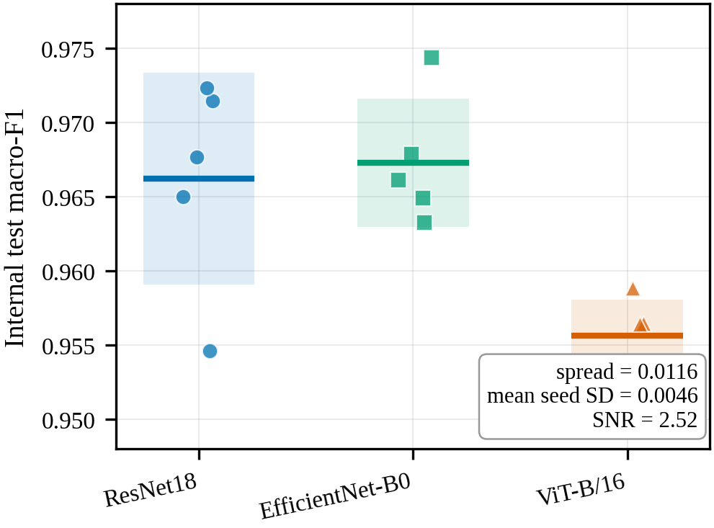
Figure 2. Internal test macro-F1 for each of the 15 runs, grouped by architecture. Points are individual runs with horizontal jitter applied for visibility; horizontal bars are architecture means and shaded bands span ±1 standard deviation across the 5 seeds. The vertical axis is truncated to 0.948-0.978 to resolve differences that are small in absolute terms; this truncation is the point of the figure, since the between-architecture spread is only 2.52 times the mean within-architecture standard deviation.
This is the first substantive result of the study, and it is negative: on this benchmark the internal metric does not carry a reproducible architecture-ranking signal. A single-run comparison of these three architectures — the design used almost universally in this literature — would report a difference lying within seed noise. It is worth stating precisely what this does and does not mean. It is not a claim that the three architectures are equally capable. It is a claim about the measuring instrument: at this level of performance, internal macro-F1 on this dataset cannot distinguish them.
Per-class performance is consistent across architectures. Pituitary tumour is the best-recognised class for all three, with F1 between 0.9770 and 0.9905. The principal internal confusion is between the no-tumour and meningioma classes: meningioma precision is the lowest per-class value for every architecture, between 0.9217 and 0.9289, while meningioma recall is among the highest, indicating that images from other classes are drawn into the meningioma decision region. No architecture confuses glioma with pituitary in either direction at any seed.
The present findings extend previous repeated-run analyses in medical imaging. Åkesson et al. [15] trained nnU-Net at fifty seeds across three three-dimensional medical segmentation tasks and found that the best-performing seed of an algorithm statistically significantly outperformed between none and roughly three-quarters of the remaining seeds of the same algorithm under hold-out validation, concluding that a statistically significant performance difference is a weak and unreliable indicator of a true difference between learning algorithms. The present result is the classification-side instance of that argument; direct numerical comparison would not be appropriate because the task, dimensionality, evaluation metric and number of seeds all differ, and their fifty-seed design provides a substantially more precise variance estimate than the five used here. Bosma et al. [16] retrained top-performing algorithms for three diagnostic tasks and found retraining variance significant relative to data variance, with 15% of comparisons between independently trained runs of the same method producing spurious significance at p < 0.05. Their comparison is between runs of one method whereas the present study compares architectures, but the mechanism is identical, and their finding that a challenge leaderboard’s top submission would place first again only 38% of the time on retraining is the direct analogue of the ranking instability reported here.
Five seeds is a small sample from which to estimate variance, and the standard deviations reported here are themselves uncertain. The claim defended is that the between-architecture differences are of the same order as seed-induced variation, not that the variance has been precisely characterised.

3.3 Internal Calibration and Temperature Scaling
Calibration was assessed to determine whether the models’ predicted confidences matched their empirical accuracy on the internal test set, and whether post-hoc temperature scaling improved that agreement. All three architectures were mildly overconfident before scaling, with expected calibration error between 0.0158 and 0.0259 and every learned temperature above one. Temperature scaling improved every calibration metric for every architecture, as summarised in Table 8.
Architecture | Temperature (range) | ECE raw → scaled | NLL raw → scaled | Brier raw → scaled
ResNet18 | 1.226 ± 0.066 [1.152–1.311] | 0.0158 ± 0.0030 → 0.0113 ± 0.0016 | 0.1186 ± 0.0167 → 0.1101 ± 0.0115 | 0.0529 ± 0.0077 → 0.0519 ± 0.0071
EfficientNet-B0 | 1.226 ± 0.102 [1.070–1.308] | 0.0194 ± 0.0055 → 0.0155 ± 0.0051 | 0.1190 ± 0.0147 → 0.1069 ± 0.0141 | 0.0518 ± 0.0076 → 0.0504 ± 0.0073
ViT-B/16 | 1.234 ± 0.015 [1.219–1.258] | 0.0259 ± 0.0036 → 0.0208 ± 0.0048 | 0.1539 ± 0.0165 → 0.1396 ± 0.0133 | 0.0707 ± 0.0066 → 0.0683 ± 0.0058
Table 8. Internal calibration before and after post-hoc temperature scaling, mean ± standard deviation across seeds. Lower values indicate better calibration for all metrics.
Two observations follow, both visible only once seeds are aggregated. First, the learned temperature is a property of the checkpoint rather than of the architecture. The three architecture means are nearly identical at 1.226, 1.226 and 1.234, while the variation across seeds within a single architecture is larger than the variation between architectures: ResNet18 alone spans 1.152 to 1.311 and EfficientNet-B0 spans 1.070 to 1.308. Any interpretation attaching a characteristic temperature to an architecture on the basis of a single training run describes that run rather than that architecture.
Second, ViT-B/16 is consistently the worst calibrated of the three, both before and after scaling and on all four metrics. It retains the highest expected calibration error after scaling, at 0.0208 ± 0.0048 against ResNet18’s 0.0113 ± 0.0016, together with the highest negative log-likelihood and Brier score. This holds at all five seeds and mirrors its slightly lower internal macro-F1.
Because expected calibration error depends on the binning scheme and is estimated here from 1,051 test predictions, it carries non-trivial variance and is best read alongside the two proper scoring rules, which evaluate the full predictive distribution and do not depend on binning [29, 31]. The consistency of improvement across all four metrics is what makes the calibration result credible rather than an artefact of any single measure.
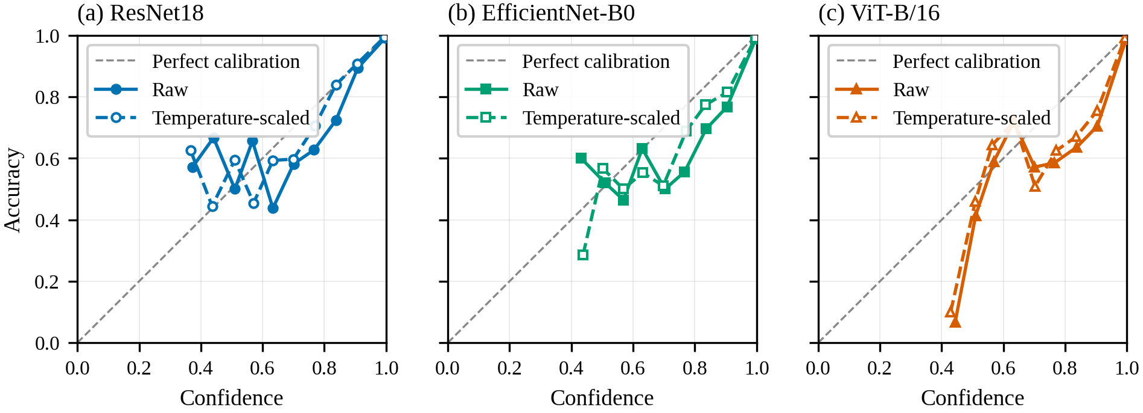
Figure 3. Reliability diagrams on the internal test partition, pooled across 5 seeds per architecture and weighted by bin count. Solid lines with filled markers are raw probabilities; dashed lines with open markers are temperature-scaled. The diagonal indicates perfect calibration. Bins containing fewer than five predictions are omitted.
Guo et al. [12] established temperature scaling as a surprisingly effective post-hoc remedy relative to more complex methods on in-distribution data, which the present result confirms in this domain; the difference is that their evaluation does not test whether a fitted temperature transfers under shift, nor report across repeated runs. Xiong et al. [32] find that systematic miscalibration biases, in particular overconfidence on low-density atypical inputs, persist after temperature scaling, and report transformer-based models to be more susceptible to this bias than convolutional networks. The consistently poorer calibration of ViT-B/16 observed here agrees with that direction, although their mechanism is proximity bias within a distribution whereas the present concern is behaviour across datasets.
The scope of this result is in-distribution. It establishes that the models are well calibrated on the dataset they were trained on and that temperature scaling refines rather than rescues that calibration. Whether internal calibration transfers to visually distinct data is a separate question, addressed in Sections 3.4 and 3.6.

3.4 Shifted-Domain Behaviour and Ranking Stability
Placing internal performance beside both probes makes the central argument of the study explicit. The question is not merely whether behaviour changes under shift, but which evaluation can distinguish the architectures at all. Table 9 reports the between-architecture spread, the mean within-architecture standard deviation, the resulting signal-to-noise ratio, and the ranking stability for each of the three evaluations.
Evaluation | Between-arch. spread | Mean within-arch. SD | SNR | Distinct orderings | Overlapping pairs
Internal macro-F1 | 0.0116 | 0.0046 | 2.52 | 2 | 2 of 3
D3B glioma rate (canine) | 0.1532 | 0.1093 | 1.40 | 4 | 3 of 3
D3C glioma rate (human) | 0.4109 | 0.0837 | 4.91 | 2 | 1 of 3
Table 9. Architecture separation against seed-induced variation for each evaluation. Distinct orderings are counted across the five seeds; the signal-to-noise ratio follows equation (10).
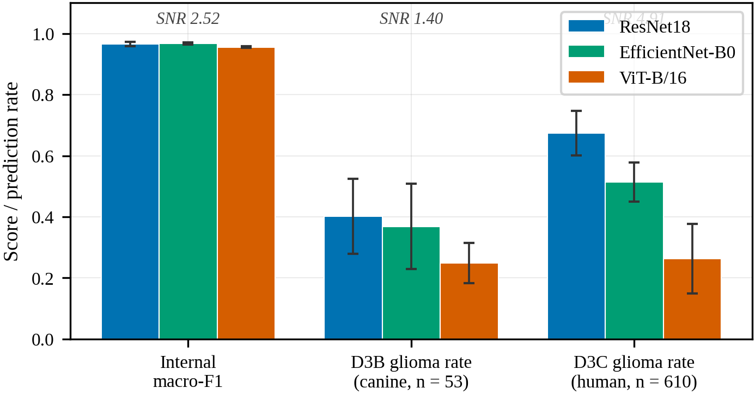
Figure 4. Internal test macro-F1 and shifted-domain glioma prediction rate for the three architectures. Bars are means across 5 seeds and error bars are ±1 standard deviation. The signal-to-noise ratio above each group is the between-architecture spread divided by the mean within-architecture standard deviation (equation 10); values near or below 2 indicate that the evaluation does not resolve the architectures against seed variation.
The same-species human probe separates the architectures widely and consistently. Slice-level glioma prediction rates were 0.6744 ± 0.0727 for ResNet18, 0.5138 ± 0.0646 for EfficientNet-B0 and 0.2635 ± 0.1139 for ViT-B/16, with patient-majority rates closely tracking the slice-level figures. Three architectures that are not reliably distinguishable on internal macro-F1 therefore range from recognising roughly two-thirds of human glioma slices to about one quarter. This separation is stable: the between-architecture spread is 0.4109 against a mean within-architecture standard deviation of 0.0837, giving a signal-to-noise ratio of 4.91; only one of the three pairwise comparisons shows overlapping ranges; and ResNet18 ranks first at every one of the five seeds.
The cross-species canine probe does not. No architecture assigned a majority of canine glioma slices to the glioma class, with rates of 0.4023 ± 0.1227, 0.3683 ± 0.1396 and 0.2491 ± 0.0656, but the between-architecture spread of 0.1532 stands against a mean within-architecture standard deviation of 0.1093 — a signal-to-noise ratio of 1.40, with all three pairwise ranges overlapping and the ordering taking four distinct forms across five seeds. At 53 patients the probe supports the finding that every architecture substantially under-recognises glioma under extreme covariate shift, but it does not support any claim about which architecture does so least. The most likely explanation is cohort size, since a single patient constitutes close to 2% of the cohort.
This asymmetry is the study’s central constructive finding. A shifted-domain probe of sufficient size is not merely a different instrument from the internal metric but a more discriminative one, resolving at 4.91 what the internal metric resolves at 2.52. The failure of the smaller probe to rank the architectures is itself informative, and is a finding about probe design rather than about the architectures.
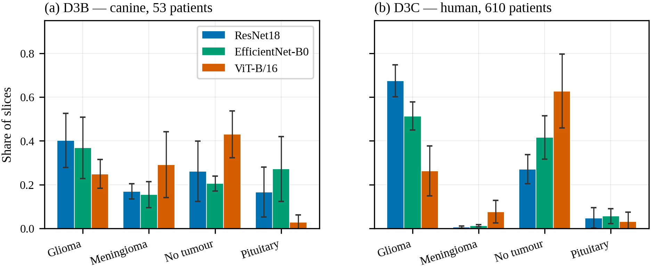
Figure 5. Distribution of predicted classes on the two shifted-domain probes. Bars are means across 5 seeds and error bars are ±1 standard deviation. All architectures were evaluated on identical slices, so between-architecture differences reflect learned behaviour rather than slice selection.
The predicted-class distribution locates where the non-glioma predictions go, and on the human probe this is the most pointed observation of the analysis. For every architecture the dominant destination for misassigned human glioma slices is the no-tumour class: ResNet18 assigns 0.271 ± 0.066 of slices to no-tumour, EfficientNet-B0 0.416 ± 0.099 and ViT-B/16 0.628 ± 0.169, while meningioma and pituitary receive very little. Because all three architectures were evaluated on an identical set of slices, the large between-architecture difference in no-tumour assignment cannot be attributed to the slice-selection strategy; it reflects genuinely different learned behaviour under shift. On the canine probe the picture differs, with predictions spread more evenly across the non-glioma classes.
Imaging plane was tested as an alternative explanation for the observed separation. Eleven of the 610 patients carry series acquired more than 10 degrees from axial. Recomputing every behavioural metric on a sensitivity cohort with those patients removed, comprising 599 patients and 2,995 slices, changes the mean glioma prediction rate by at most 0.0052 and preserves the architecture ordering, against a between-architecture spread of 0.41. The separation reported here is therefore not attributable to imaging plane.
Two studies frame this result. Konrad et al. [33] benchmarked ten segmentation models spanning classical architectures, modern convolutional networks, a vision transformer and foundation models on a limited dataset, with explicit ablations on augmentation, input resolution and random seed stability, and found that rankings change substantially between in-distribution and out-of-distribution settings, with bootstrap confidence intervals among top models overlapping substantially and differences driven more by statistical noise than algorithmic superiority. Their conclusion agrees with the ranking instability reported here; the distinction, and the contribution of the present study, is that they report rankings changing under shift whereas this study reports the shift probe being more discriminative than the internal metric. Yu et al. [14] found that of 86 externally validated radiological algorithms, 81% showed some decrease in external performance and no study characteristic predicted the size of the drop, agreeing that internal performance does not transfer; the difference is that they measure accuracy decrease on shared-label external sets, whereas this study measures prediction-distribution shift on glioma-only probes where accuracy is undefined.

3.5 The Confidence–Recognition Inversion
The human-probe confidence results reveal a direct inversion between glioma-recognition ability and confidence, summarised in Table 10.
Architecture | Glioma rate | Mean confidence | Mean entropy | Median glioma prob.
ResNet18 | 0.6744 ± 0.0727 | 0.7837 ± 0.0523 | 0.5418 ± 0.1262 | 0.6979 ± 0.1212
EfficientNet-B0 | 0.5138 ± 0.0646 | 0.8115 ± 0.0484 | 0.4859 ± 0.1243 | 0.4843 ± 0.1473
ViT-B/16 | 0.2635 ± 0.1139 | 0.8596 ± 0.0387 | 0.3528 ± 0.0947 | 0.1017 ± 0.1556
Table 10. Prediction and confidence behaviour on the human probe (610 patients, 3,050 slices), mean ± standard deviation across seeds.
ViT-B/16, the architecture least able to recognise human glioma at 0.2635 ± 0.1139, was the most confident of the three, with a mean maximum confidence of 0.8596 ± 0.0387, the lowest mean predictive entropy at 0.3528 ± 0.0947 by equation (8), and a median glioma probability of only 0.1017 ± 0.1556. ResNet18, which recognised glioma most often, was the least confident at 0.7837 ± 0.0523 with the highest entropy, and EfficientNet-B0 sat between the two. This inversion holds at every one of the five seeds.
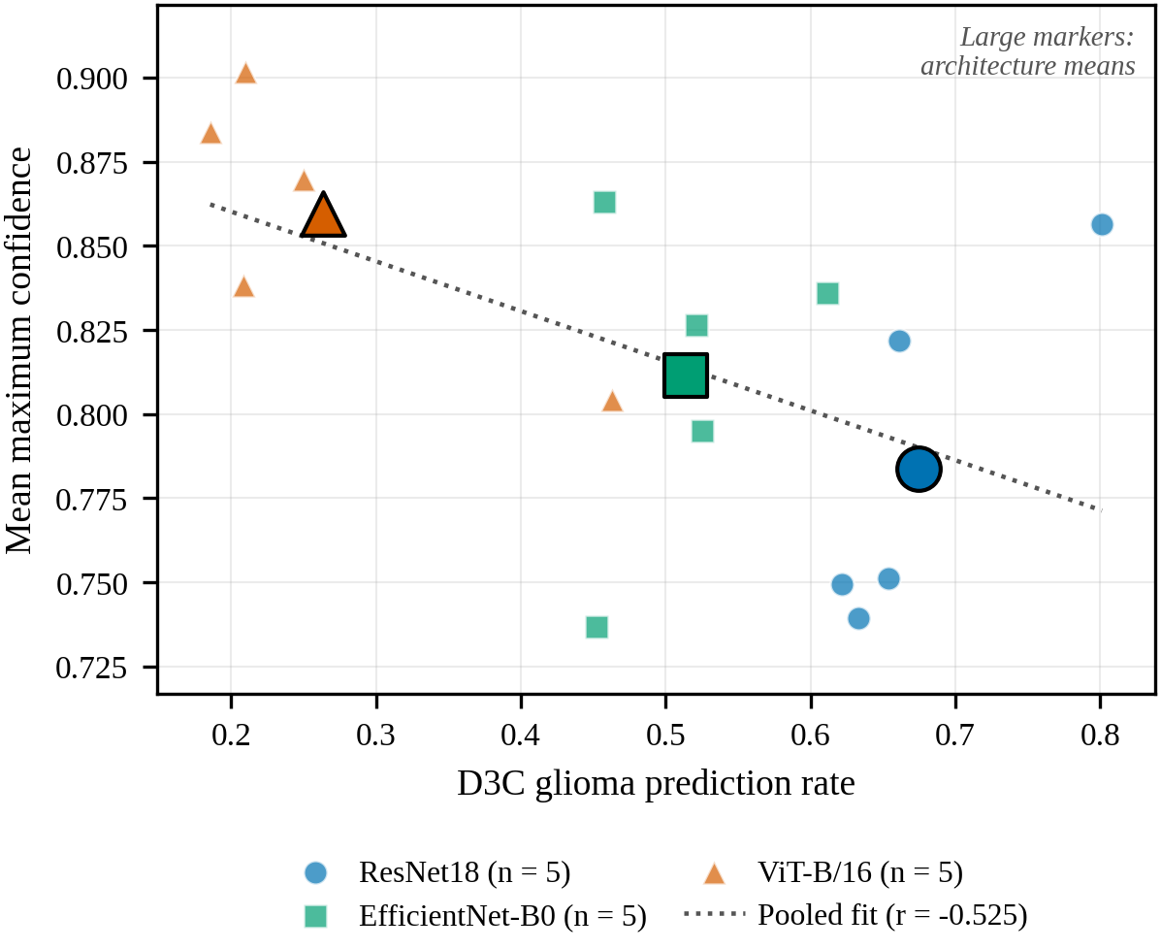
Figure 6. Human-probe glioma prediction rate against mean maximum confidence for each of the 15 runs. Small markers are individual runs; large outlined markers are architecture means. The dotted line is the least-squares fit pooled across all runs. Confidence increases as glioma recognition falls.
The load-bearing evidence here is the between-architecture divergence on identical inputs, which no property of the slices can explain. On the same 3,050 slices, ViT-B/16 assigns 62.8% to the no-tumour class and places a median glioma probability of 0.10 while remaining the most confident of the three, whereas ResNet18 assigns 27.1% to no-tumour. Confidence therefore does not track glioma-recognition ability across architectures.
The interpretation is stated precisely: ViT-B/16 confidently assigns human glioblastoma slices to non-glioma classes. The stronger unqualified claim that it is confidently wrong is not made, because central slices were selected by anatomical position rather than confirmed tumour presence and a fraction may genuinely lack conspicuous tumour. That caveat bounds the absolute interpretation of the no-tumour share but does not affect the between-architecture comparison, since all architectures were evaluated on identical slices.
This result is the clearest reliability signal in the study. A model that is confidently wrong on same-species out-of-distribution data is more hazardous than one that is uncertainly wrong, because high confidence is precisely the cue a downstream reader would treat as reassurance. It also demonstrates why prediction distribution and confidence must be reported jointly: had only aggregate confidence been reported, the fact that the least reliable architecture on the human probe was also the most confident would have been invisible.
Xiong et al. [32] report that transformer-based models are more susceptible than convolutional networks to overconfidence on atypical inputs, and that this bias persists after temperature scaling; the direction agrees, although their setting is proximity bias within a distribution rather than confidence behaviour across datasets. Ong Ly et al. [34] show that shortcut learning in medical AI leads performance to be overestimated by up to 20% on average when hidden acquisition biases are present, agreeing on the underlying fragility; the difference is that they estimate fragility without external data whereas this study observes it directly on an independent human cohort.

3.6 Temperature Scaling Does Not Transfer Under Shift
Temperature scaling, applied using each run’s own validation-fitted temperature by equation (9), softened confidence on both probes without altering any prediction. On the human probe, mean maximum confidence fell for all three architectures and entropy rose correspondingly: ViT-B/16 from 0.8596 ± 0.0387 to 0.8272 ± 0.0472 with entropy rising from 0.3528 ± 0.0947 to 0.4396 ± 0.1141. Comparable changes occurred on the canine probe, where ResNet18 fell from 0.7138 ± 0.0347 to 0.6670 ± 0.0330. In every case the slice-level, patient-majority and series-majority glioma prediction rates were identical before and after scaling.
Because temperature scaling is monotonic in the logits, it can only rescale confidence; it cannot move a prediction across the decision boundary. Calibration and shift robustness are therefore distinct problems, confirmed here across two independent shifted domains and five seeds. Softening the confidence of the architecture that assigned most human glioma slices to the no-tumour class did not make it any more likely to recognise them as glioma.
Karandikar et al. [13] show that the benefits of post-hoc rescaling degrade under distribution shift relative to calibration-sensitive training objectives, which the present result confirms empirically in this domain. Mehrtens et al. [35] argue from benchmarking work that uncertainty estimation methods should be assessed under shift rather than only on internal test sets, since a method that appears useful in-distribution may not flag unreliable shifted-domain cases; the present finding is an instance of exactly that pattern, and motivates the uncertainty-aware extension proposed below.

3.7 Simpson’s Paradox and Seed Sensitivity
Two results emerge only from repeated runs and could not be observed from a single training run per architecture. The association between internal macro-F1 and probe glioma prediction rate, computed at three levels of aggregation, is reported in Table 11.
Probe | Pooled across 15 runs | Between architecture means | Within architecture, centred
D3B (canine) | +0.756 | +0.956 | +0.664
D3C (human) | +0.474 | +0.886 | −0.514
Table 11. Pearson correlation between internal test macro-F1 and shifted-domain glioma prediction rate at three levels of aggregation.
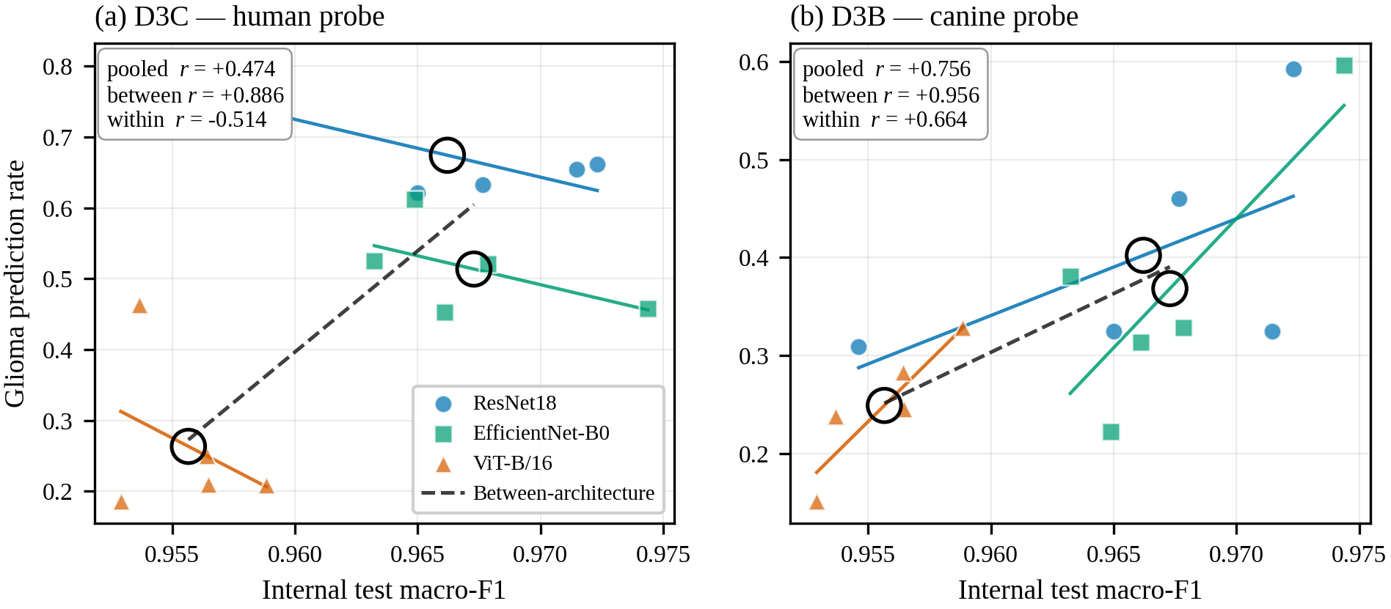
Figure 7. Internal test macro-F1 against shifted-domain glioma prediction rate for the 15 runs. Coloured lines are within-architecture least-squares fits; the dashed black line is the fit through the three architecture means, shown as large open circles. On the human probe (a) the between-architecture association is positive while the within-architecture association is negative, a Simpson’s paradox. On the canine probe (b) both are positive.
On the human probe the association is strongly positive between architectures at +0.886 and negative within them at −0.514 after centring each run on its architecture mean. This sign reversal under within-group centring is a Simpson’s paradox: across architectures, better internal performance accompanies better shifted-domain recognition, but within a single architecture the seeds that perform best internally tend to perform worse on the human probe. Selecting a checkpoint by internal validation score therefore does not merely fail to select for shifted-domain reliability on this benchmark; within an architecture it selects mildly against it. The effect is specific to the human probe, since the canine probe shows positive correlations at both levels with no sign change.
This result should be read with its limits in view. The between-architecture correlation is computed over three points, and the within-architecture correlation over fifteen runs grouped into three architectures of five. It is an observation on this benchmark with these architectures, not an established general effect, and additional architectures would strengthen it materially.
One seed warrants separate reporting. At seed 42, ResNet18 and ViT-B/16 produced their highest human-probe glioma prediction rates by a wide margin — 0.8013 and 0.4630 respectively, against ranges of 0.6220–0.6613 and 0.1856–0.2502 at the other four seeds, corresponding to approximately +8.7 and +9.3 standard deviations of each architecture’s remaining seeds. EfficientNet-B0 shows no such effect. The cause was investigated and not established: no quantity recorded about training on the internal dataset distinguishes the seed-42 runs or predicts the shifted-domain rate, including per-class recall, predicted-class shares, learned temperature, best epoch and total epochs trained. ResNet18 and ViT-B/16 track each other closely across seeds, so seed 42 is better described as the extreme end of a seed axis those two architectures share than as a discrete anomaly. It is reported as unexplained seed sensitivity rather than attributed to a mechanism the data does not support, and it was not excluded, because excluding it would require a reason established before its result was known. It is itself evidence for the argument of this study: a single-seed shifted-domain result can land far from the others for reasons invisible in every internal metric.
Teney et al. [36] show that inverse correlations between in-distribution and out-of-distribution performance occur on real-world data, arise even in a minimal linear setting, and have been systematically under-reported because model selection procedures are themselves biased toward in-distribution performance, concluding that studies using in-distribution performance for model selection will necessarily miss the best-performing models. This is the closest published antecedent of the present result; the difference in level is important, since they observe the inversion across models whereas this study observes it across seeds within an architecture. Miller et al. [37] report the opposite emphasis, finding a strong positive correlation between in-distribution and out-of-distribution generalisation across a wide range of models and shifts, such that in-distribution accuracy serves as a usable proxy. The positive between-architecture correlation observed here is consistent with their finding; the negative within-architecture term is a qualification that an analysis aggregating across models cannot detect.

3.8 Integrated Interpretation and Limitations
Taken together, the results support a conservative conclusion. Internal performance is high and closely clustered, but the clustering is tighter than the noise: the between-architecture spread is only 2.52 times the seed-induced standard deviation, and the ordering changes between seeds. Internal calibration is good and improves under temperature scaling, but the fitted temperature is a property of the checkpoint rather than the architecture and the improvement does not transfer under shift. A same-species shifted-domain probe of sufficient size separates the architectures at nearly twice the signal-to-noise of the internal metric, while a smaller cross-species probe cannot separate them at all. Misassignment under shift concentrates in the no-tumour class, to an extent that differs by a factor of more than two between architectures evaluated on identical slices. Confidence inverts against recognition at every seed. And the association between internal and shifted-domain performance reverses sign when computed within an architecture rather than across architectures.
Several limitations bound these findings. Three architectures span distinct inductive biases but constitute a thin basis for the correlation decomposition in particular, where the between-architecture term is computed over three means; the Simpson’s paradox result should be read as an observation on this benchmark rather than an established general effect. Five seeds are sufficient to show that between-architecture differences are of the same order as seed variation but constitute a small sample for estimating that variation precisely. The glioma prediction rate is a behavioural proxy rather than accuracy: a lower rate indicates that fewer glioma-domain slices were assigned to the glioma class, which does not directly establish that a model is less capable of recognising glioma as opposed to differently disposed toward the no-tumour decision region.
Slices were selected by anatomical position rather than confirmed tumour presence, which bounds the absolute interpretation of the no-tumour share though not the between-architecture comparison. Central-slice conversion does not capture the three-dimensional structure of the volumes. The canine probe is underpowered for ranking at 53 patients, and its four distinct orderings across five seeds should be read as insufficient resolution rather than genuine instability. The internal dataset is distributed without patient identifiers, so leakage was controlled at the image and near-duplicate-group level, which is cleaner than the distributed split but not equivalent to a patient-disjoint split. Although skull stripping and imaging plane were both ruled out by direct measurement, the human probe remains co-registered, resampled and intensity-normalised by its distributor while the internal dataset is not, and this residual difference is not separately controlled. Temperature scaling was the only post-hoc calibration method tested, and no uncertainty-aware methods such as Monte Carlo dropout or deep ensembles were implemented. Finally, the seed-42 behaviour on the human probe affects two of three architectures, is not predicted by any recorded internal quantity, and is reported rather than resolved.

4. Conclusion
This study developed and evaluated a reproducible, reliability-first framework for brain MRI tumour classification, applied to three established architectures each trained at five random seeds on an identical leakage-aware split. The framework combines leakage-aware dataset preparation, exact and perceptual overlap auditing of candidate external datasets, multi-metric calibration analysis with post-hoc temperature scaling, paired cross-species and same-species glioma-focused shifted-domain probes, and repeated-run estimation with dispersion reported throughout.
Internal test macro-F1 spanned 0.9557 to 0.9673, but the between-architecture spread of 0.0116 was only 2.52 times the mean within-architecture standard deviation of 0.0046; the two best architectures differed by 0.0011 and the ordering changed between seeds. One candidate external dataset was rejected after 4,740 of its 5,950 images proved byte-identical to the training data. The same-species human probe separated the architectures at a signal-to-noise ratio of 4.91, with glioma prediction rates of 0.674 ± 0.073, 0.514 ± 0.065 and 0.264 ± 0.114 and one architecture ranked first at all five seeds, whereas the smaller cross-species probe could not resolve them at 1.40. Misassigned human glioma slices concentrated in the no-tumour class, from 0.271 to 0.628 across architectures evaluated on identical slices. The architecture least able to recognise human glioma was the most confident at every seed. Temperature scaling softened confidence on both probes and changed no prediction. The association between internal performance and shifted-domain behaviour was +0.886 between architectures and −0.514 within them.
The novelty of this work lies in incorporating reproducibility and reliability components into the evaluation workflow for brain MRI tumour classification, rather than in proposing a new architecture or reporting a higher accuracy figure. The proposed framework not only reports predictive performance but also measures whether that performance is stable enough to support the architecture comparisons routinely drawn from it. On the evidence presented here, high internal accuracy on this benchmark should not be mistaken for reliability, and it should not be mistaken for a ranking either. Defensible evaluation requires leakage-aware splitting, overlap auditing, calibration assessment, repeated training runs with dispersion reported, and carefully qualified shifted-domain testing, considered jointly.
Future work should address several extensions that follow directly from this study:
- Fitting a single mixed-effects model over all fifteen runs with crossed random effects for patient and seed, giving one architecture contrast with an explicit variance component for seed. This requires no additional training.
- Adding further architectures, of which ConvNeXt-T and Swin-T are the natural candidates, to strengthen the correlation decomposition where three architecture means is currently the binding constraint.
- Increasing the seed count to tighten the variance estimates on which the central claim depends.
- Selecting slices by tumour burden using the expert-reviewed segmentations distributed with the human collection, removing the principal caveat attached to the no-tumour finding.
- Testing whether a source-class confound contributes, since the internal dataset draws its three tumour classes from one upstream lineage and its no-tumour class from another; this is testable without retraining.
- Obtaining a genuinely independent four-class external dataset that passes the same overlap audit, permitting conventional external accuracy and calibration to be reported.
- Evaluating uncertainty-aware methods under the same protocol; a deep ensemble is inexpensive here given that fifteen trained models already exist.
- Extending the contamination audit pairwise across the widely used public brain MRI classification datasets, producing a contamination matrix of direct practical use in external-set selection.

Declarations
Ethics approval. This study is a retrospective secondary analysis of publicly available, de-identified imaging collections. No new imaging data were acquired, and no patients, participants or animals were recruited, contacted or subjected to any procedure. On this basis the secondary use of these datasets did not require additional human-subjects or animal-subjects ethical approval. All datasets were used under their distribution terms.
Data availability. All datasets used are publicly available. The internal dataset and the rejected candidate are distributed through Kaggle; the two shifted-domain probes are distributed through The Cancer Imaging Archive and were retrieved programmatically by DICOM SeriesInstanceUID. Derived manifests, the leakage-aware split file and selected-slice lists are provided so that the processed datasets can be regenerated from the public sources.
Code availability. The analysis repository is released. Committed artifacts include the split file, dataset and audit reports, per-run predictions and metrics with their provenance records, result tables and figures. All summary tables and figures are generated programmatically from saved artifacts, and summary generation is gated on provenance consistency across runs.
Competing interests. The authors declare no competing interests.
Author contributions. S.B.B.G. — conceptualisation, methodology, software, formal analysis, data curation, writing (original draft). T.T.S. — supervision, methodology, writing (review and editing).
Use of AI tools. AI assistance was used for drafting, formatting and consistency checking. All reported values were verified against the source code and committed experimental artifacts.
Reporting standard. A completed CLAIM checklist is provided as Supplementary Material, and the manuscript follows TRIPOD+AI reporting where applicable.

Acknowledgments
The authors express their gratitude for the support and research-friendly environment offered by Universiti Teknologi Malaysia (UTM). [State the funding source and cost centre number here, or: The authors received no specific funding for this work.] The authors gratefully acknowledge the support provided by the Research Management Centre, School of Graduate Studies, and Faculty of Electrical Engineering at UTM.

References
[1] O. Kouli, A. Hassane, D. Badran, T. Kouli, K. Hossain-Ibrahim, and J. D. Steele, "Automated brain tumor identification using magnetic resonance imaging: A systematic review and meta-analysis," Neuro-Oncology Advances, vol. 4, no. 1, p. vdac081, 2022.
[2] Y. Xie et al., "Convolutional neural network techniques for brain tumor classification (from 2015 to 2022): Review, challenges, and future perspectives," Diagnostics, vol. 12, no. 8, p. 1850, 2022.
[3] M. Nickparvar, "Brain tumor MRI dataset," Kaggle, 2021, doi: 10.34740/kaggle/dsv/2645886.
[4] J. Maurício, I. Domingues, and J. Bernardino, "Comparing vision transformers and convolutional neural networks for image classification: A literature review," Applied Sciences, vol. 13, no. 9, p. 5521, 2023.
[5] R. Disci, F. Gurcan, and A. Soylu, "Advanced brain tumor classification in MR images using transfer learning and pre-trained deep CNN models," Cancers, vol. 17, no. 1, p. 121, 2025.
[6] H. A. Shah, F. Saeed, S. Yun, J.-H. Park, A. Paul, and J.-M. Kang, "A robust approach for brain tumor detection in magnetic resonance images using finetuned EfficientNet," IEEE Access, vol. 10, pp. 65426–65438, 2022.
[7] F. Zulfiqar, U. Ijaz Bajwa, and Y. Mehmood, "Multi-class classification of brain tumor types from MR images using EfficientNets," Biomedical Signal Processing and Control, vol. 84, p. 104777, 2023.
[8] E. Yagis et al., "Effect of data leakage in brain MRI classification using 2D convolutional neural networks," Scientific Reports, vol. 11, no. 1, p. 22544, 2021.
[9] D. Wallis and I. Buvat, "Clever Hans effect found in a widely used brain tumour MRI dataset," Medical Image Analysis, vol. 77, p. 102368, 2022.
[10] M. Saifullah, D. Baldauf, and Y. Sakumura, "Reliable brain tumor classification without metadata: A step-by-step guideline with duplicate removal," in Proc. IEEE 37th Int. Conf. Tools with Artificial Intelligence (ICTAI), 2025, pp. 1237–1244.
[11] D. Lu, Y. Zhang, and D. Chaudhary, "MTA-Swin: A multi-token attention Swin Transformer for brain tumor classification with leakage-free MRI benchmarking," Journal of Medical Systems, vol. 50, no. 1, p. 100, 2026.
[12] C. Guo, G. Pleiss, Y. Sun, and K. Q. Weinberger, "On calibration of modern neural networks," in Proc. 34th Int. Conf. Machine Learning (ICML), 2017, vol. 70, pp. 1321–1330.
[13] A. Karandikar et al., "Soft calibration objectives for neural networks," in Advances in Neural Information Processing Systems, 2021, vol. 34, pp. 29768–29779.
[14] A. C. Yu, B. Mohajer, and J. Eng, "External validation of deep learning algorithms for radiologic diagnosis: A systematic review," Radiology: Artificial Intelligence, vol. 4, no. 3, p. e210064, 2022.
[15] J. Åkesson, J. Töger, and E. Heiberg, "Random effects during training: Implications for deep learning-based medical image segmentation," Computers in Biology and Medicine, vol. 180, p. 108944, 2024.
[16] J. S. Bosma, D. Peeters, N. Alves, A. Saha, Z. Saghir, C. Jacobs, and H. Huisman, "Reproducibility of training deep learning models for medical image analysis," Proceedings of Machine Learning Research, vol. 227, pp. 1269–1287, 2024.
[17] T. Sanchez, P. M. Gordaliza, and M. B. Cuadra, "Accounting for underspecification in statistical claims of model superiority," arXiv preprint arXiv:2511.02453, 2025.
[18] D. Picard, "Torch.manual_seed(3407) is all you need: On the influence of random seeds in deep learning architectures for computer vision," arXiv preprint arXiv:2109.08203, 2023.
[19] J. Cheng, "Brain tumor dataset," figshare, 2016, doi: 10.6084/m9.figshare.1512427.
[20] A. Hamada, "Br35H: Brain tumor detection 2020," Kaggle, 2020.
[21] A. Fateh et al., "BRISC: Annotated dataset for brain tumor segmentation and classification," Scientific Data, vol. 13, no. 1, p. 361, 2026.
[22] S. B. Amin et al., "Canine glioma characterization project for ICDC (ICDC-Glioma) 01," The Cancer Imaging Archive, 2020, doi: 10.7937/TCIA.SVQT-Q016.
[23] S. Bakas et al., "The University of Pennsylvania glioblastoma (UPenn-GBM) cohort: Advanced MRI, clinical, genomics, & radiomics," Scientific Data, vol. 9, no. 1, p. 453, 2022.
[24] T. Truong, F. Khun Jush, and M. Lenga, "Benchmarking pretrained vision embeddings for near- and duplicate detection in medical images," in Proc. IEEE Int. Symp. Biomedical Imaging (ISBI), 2024, pp. 1–5.
[25] K. He, X. Zhang, S. Ren, and J. Sun, "Deep residual learning for image recognition," in Proc. IEEE Conf. Computer Vision and Pattern Recognition (CVPR), 2016, pp. 770–778.
[26] M. Tan and Q. V. Le, "EfficientNet: Rethinking model scaling for convolutional neural networks," in Proc. 36th Int. Conf. Machine Learning (ICML), 2019, vol. 97, pp. 6105–6114.
[27] A. Dosovitskiy et al., "An image is worth 16x16 words: Transformers for image recognition at scale," in Proc. Int. Conf. Learning Representations (ICLR), 2021.
[28] F. Pinto, P. H. S. Torr, and P. K. Dokania, "An impartial take to the CNN vs transformer robustness contest," in Proc. European Conf. Computer Vision (ECCV), 2022, vol. 13673, pp. 466–480.
[29] M. Pakdaman Naeini, G. Cooper, and M. Hauskrecht, "Obtaining well calibrated probabilities using Bayesian binning," in Proc. AAAI Conf. Artificial Intelligence, 2015, vol. 29, no. 1.
[30] B. Barz and J. Denzler, "Do we train on test data? Purging CIFAR of near-duplicates," Journal of Imaging, vol. 6, no. 6, p. 41, 2020.
[31] M. Kull, M. Perello-Nieto, M. Kängsepp, T. Silva Filho, H. Song, and P. Flach, "Beyond temperature scaling: Obtaining well-calibrated multi-class probabilities with Dirichlet calibration," in Advances in Neural Information Processing Systems, 2019, vol. 32, pp. 12295–12305.
[32] M. Xiong, A. Deng, P. W. Koh, J. Wu, S. Li, J. Xu, and B. Hooi, "Proximity-informed calibration for deep neural networks," in Advances in Neural Information Processing Systems, 2024, vol. 36, pp. 68511–68538.
[33] P. M. Konrad et al., "Challenges in deep learning-based small organ segmentation: A benchmarking perspective for medical research with limited datasets," arXiv preprint arXiv:2509.05892, 2025.
[34] C. Ong Ly et al., "Shortcut learning in medical AI hinders generalization: Method for estimating AI model generalization without external data," npj Digital Medicine, vol. 7, no. 1, p. 124, 2024.
[35] H. A. Mehrtens, A. Kurz, T.-C. Bucher, and T. J. Brinker, "Benchmarking common uncertainty estimation methods with histopathological images under domain shift and label noise," Medical Image Analysis, vol. 89, p. 102914, 2023.
[36] D. Teney, Y. Lin, S. J. Oh, and E. Abbasnejad, "ID and OOD performance are sometimes inversely correlated on real-world datasets," in Advances in Neural Information Processing Systems, 2022.
[37] J. Miller et al., "Accuracy on the line: On the strong correlation between out-of-distribution and in-distribution generalization," in Proc. 38th Int. Conf. Machine Learning (ICML), 2021.

