- First created ACR repo , mysql server, storage account, app service plan and Kubernetes service using terraform.

provider "azurerm" {
features {}
}

resource "azurerm_resource_group" "RG2" {
name = "project2-rg"
location = "West Europe"
}

resource "azurerm_storage_account" "storage_account" {
name = var.storage_account
resource_group_name = azurerm_resource_group.RG2.name
location = azurerm_resource_group.RG2.location
account_tier = "Standard"
account_replication_type = "GRS"
allow_blob_public_access = "true"
}

resource "azurerm_container_registry" "acr" {
name = var.ACR
resource_group_name = azurerm_resource_group.RG2.name
location = azurerm_resource_group.RG2.location
sku = "Premium"
admin_enabled = false

}
resource "azurerm_mysql_server" "MySql" {
name = var.MYSQL
location = azurerm_resource_group.RG2.location
resource_group_name = azurerm_resource_group.RG2.name

administrator_login = "vmadmin"
administrator_login_password = "Sambhavjain123"

sku_name = "B_Gen5_2"
storage_mb = 5120
version = "5.7"

auto_grow_enabled = true
backup_retention_days = 7
geo_redundant_backup_enabled = false
infrastructure_encryption_enabled = false
public_network_access_enabled = true
ssl_enforcement_enabled = true
ssl_minimal_tls_version_enforced = "TLS1_2"
}

Script for Kubernetes services

resource "azurerm_resource_group" "k8s" {
name = "AKC_RG"
location = var.AKS_RG_location
}

resource "random_id" "log_analytics_workspace_name_suffix" {
byte_length = 8
}

# azure log analytics workspace

resource "azurerm_kubernetes_cluster" "k8s" {
name = var.cluster_name
location = azurerm_resource_group.k8s.location
resource_group_name = azurerm_resource_group.k8s.name
dns_prefix = "k8sdns"

linux_profile {
admin_username = "ubuntu"

ssh_key {
key_data = "${trimspace(tls_private_key.key.public_key_openssh)} ${var.admin_username}@azure.com"
}
}

default_node_pool {
name = "agentpool"
node_count = var.agent_count
vm_size = "Standard_D2s_v3"
}

service_principal {
client_id = var.client_id
client_secret = var.client_secret
}

# addon is here

network_profile {
load_balancer_sku = "Standard"
network_plugin = "kubenet"
}

tags = {
Environment = "Development"
}

}
resource "tls_private_key" "key" {
algorithm = "RSA"
}

resource "null_resource" "save-key" {
triggers = {
key = "${tls_private_key.key.private_key_pem}"

}
}

#output

output "host" {
value = "${azurerm_kubernetes_cluster.k8s.kube_config.0.host}"

}

output "configure" {
value = <<configure
Run the following commands to configure kubernetes client :
$ terraform output kube_config > ~/.kube/aksconfig
$ export KUBECONFIG=~/.kube/askconfig

Test configuration using kubectl
$ kubectl get nodes

configure

}

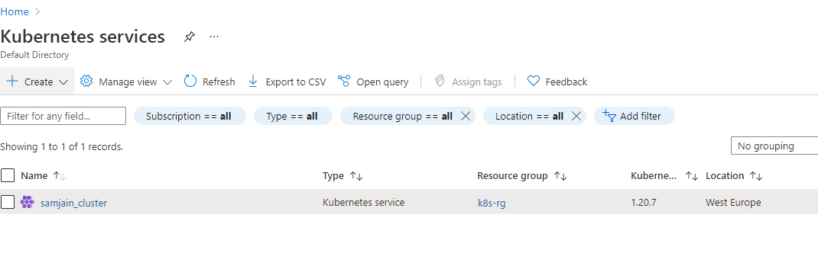

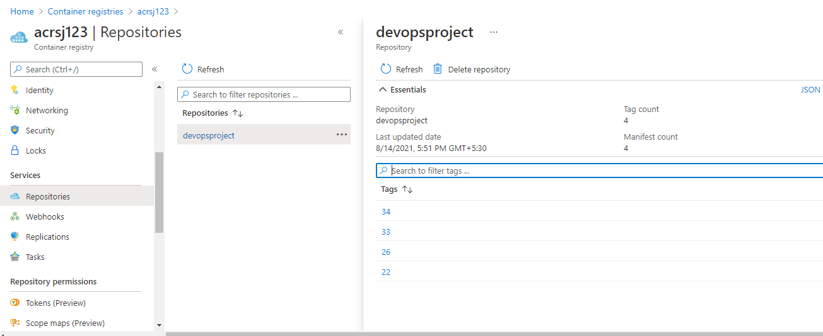

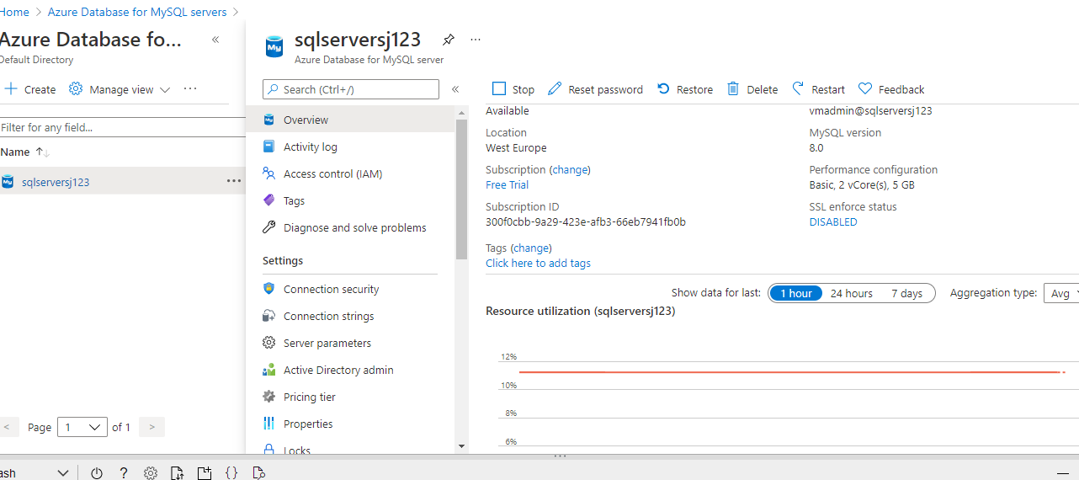

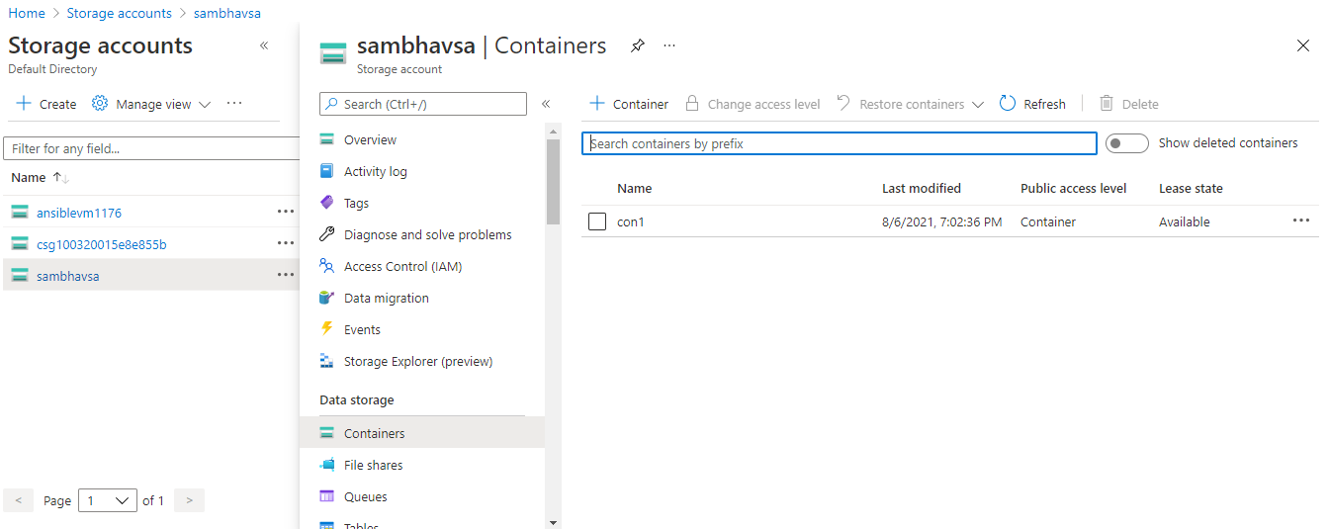

- Then uploaded images to the storage account and restored mysql database.
- Then updated the url of sqlserver in vscode and created dockerfile

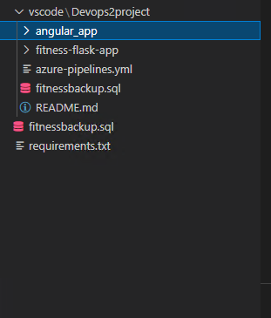

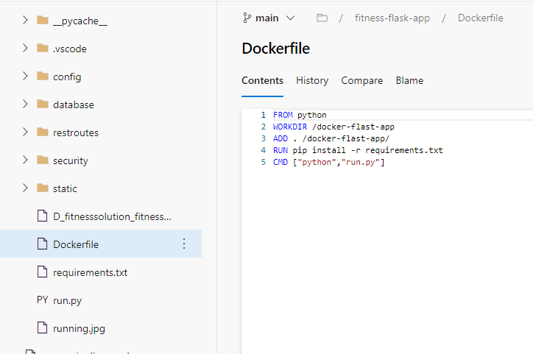
- After that created the first pipeline (Docker build and push)

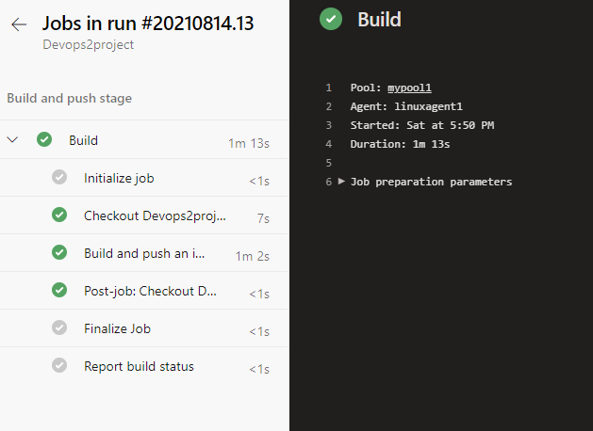

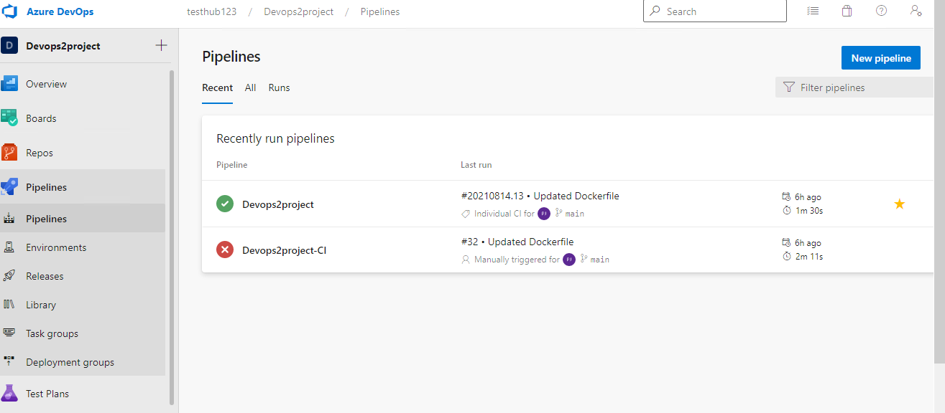

- Running the image locally and checking after pulling from the ACR

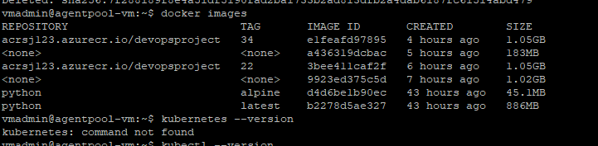

- Now creating the yaml files for deployments and services in Kubernetes and changing the ip in code to load balancer ip

