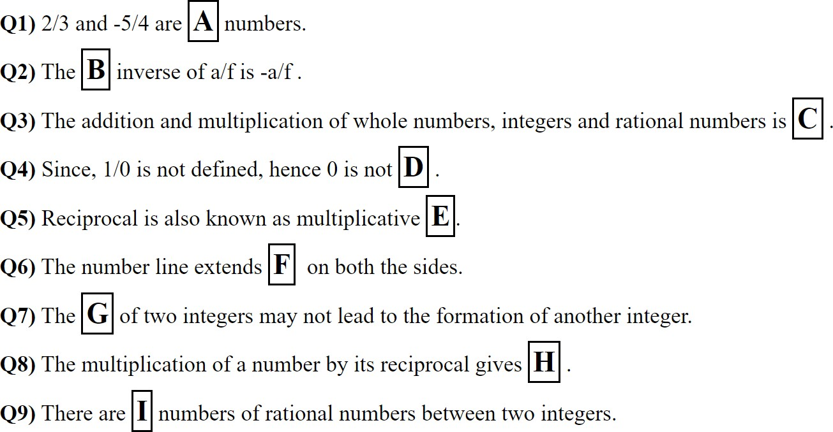CBSE CLASS 7 Math Chapter 9: Rational Numbers - Fill In the Blanks





INDEFINITELY, RIGHT, ZERO, LEFT , NEGATIVE, RATIONAL NUMBER, UNLIMITED, COMMUTATIVE, RATIONAL, -1, ONE, NUMBER, ADDITION, ADDITIVE, 1, NATURAL, -2/3, -3/4, DISTRIBUTIVE, INVERSE, ASSOCIATIVE , SMALLER, 2/7, POSITIVE

Roll Number: 

A. 

B. 

C. 

D. 

E. 

F. 

G. 

H. 



I.

