**Name:** Swapnil Thorat

**PRN:** 121B1C055

**Assignment No. 4**

**Code:**

// SPDX-License-Identifier: MIT

pragma solidity ^0.8.0;

contract DecentralizedLottery {

    address public manager;

    address[] public participants;

    // Constructor: Set the contract deployer as the manager

    constructor() {

        manager = msg.sender;

    }

    // Payable function to allow participants to enter the lottery

    function enter() public payable {

        require(msg.value > 0.01 ether, "Minimum Ether to enter is 0.01");

        // Add the sender to the participants array

        participants.push(msg.sender);

    }

    // Function to generate a pseudo-random number (using block properties)

    function random() private view returns (uint) {

        return uint(keccak256(abi.encodePacked(block.timestamp, block.prevrandao, participants.length)));

    }

    // Function to select a winner and transfer the prize

    function pickWinner() public restricted{

        require(participants.length > 0, "No participants in the lottery");

        // Select a random index from the participants array

        uint index = random() % participants.length;

        address winner = participants[index];

        // Transfer the entire contract balance to the winner

        payable(winner).transfer(address(this).balance);

        // Reset participants for the next lottery

        participants = new address[](0);

    }

    // Modifier to restrict function access to the manager only

    modifier restricted() {

        require(msg.sender == manager, "Only the manager can perform this action");

        _;

    }

    // Get the list of participants

    function getParticipants() public view returns (address[] memory) {

        return participants;

    }

    // Get the current balance of the contract

    function getBalance() public view returns (uint) {

        return address(this).balance;

    }

}

**Output:**

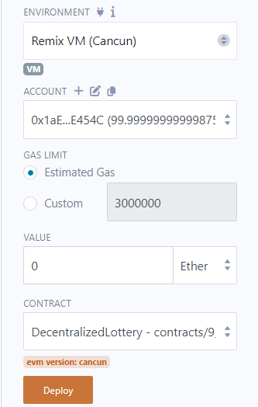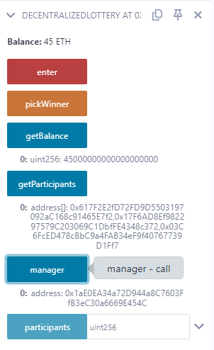

After Deciding Winner

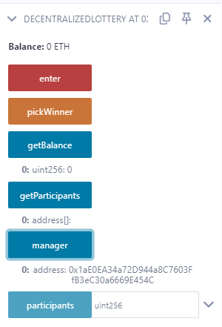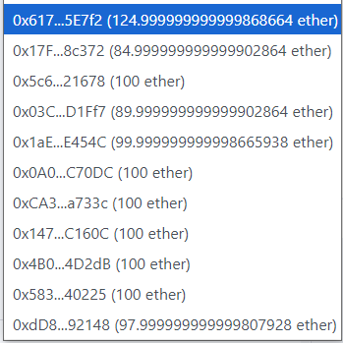

Here, participant bearing address 0x617… won the lottery.

