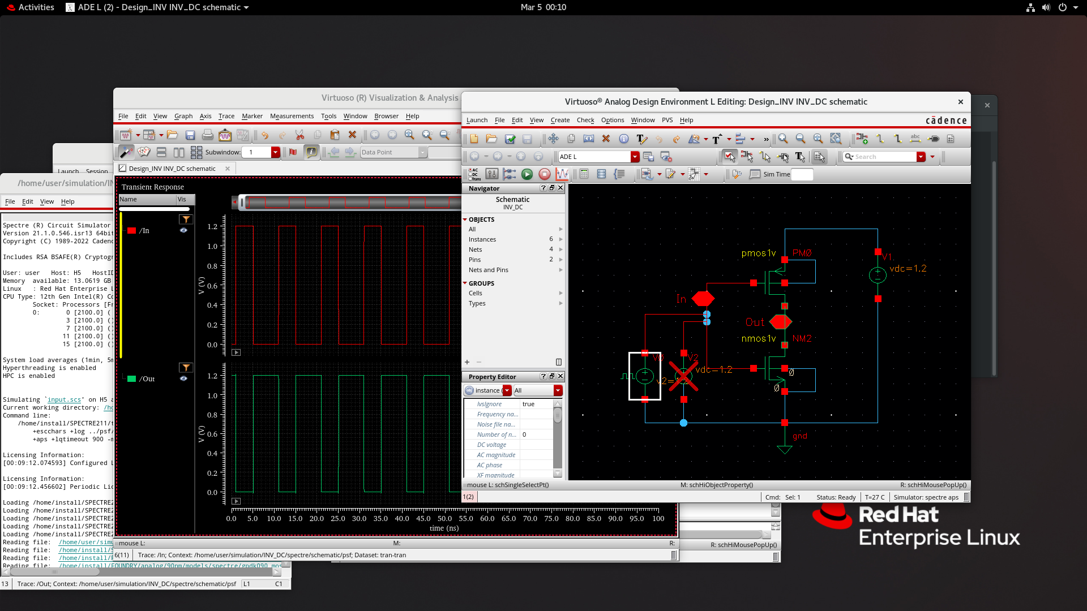
CMOS INVERTER CIRCUIT SCHEMATIC:

INPUT & OUTPUT WAVEFORM
