TASK-2

1. Create container image that’s has Jenkins installed using dockerfile

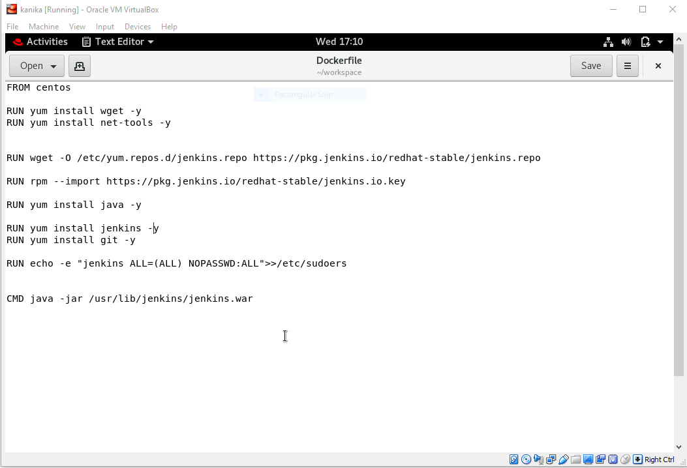

1. When we launch this image, it should automatically starts Jenkins service in the container.
2. 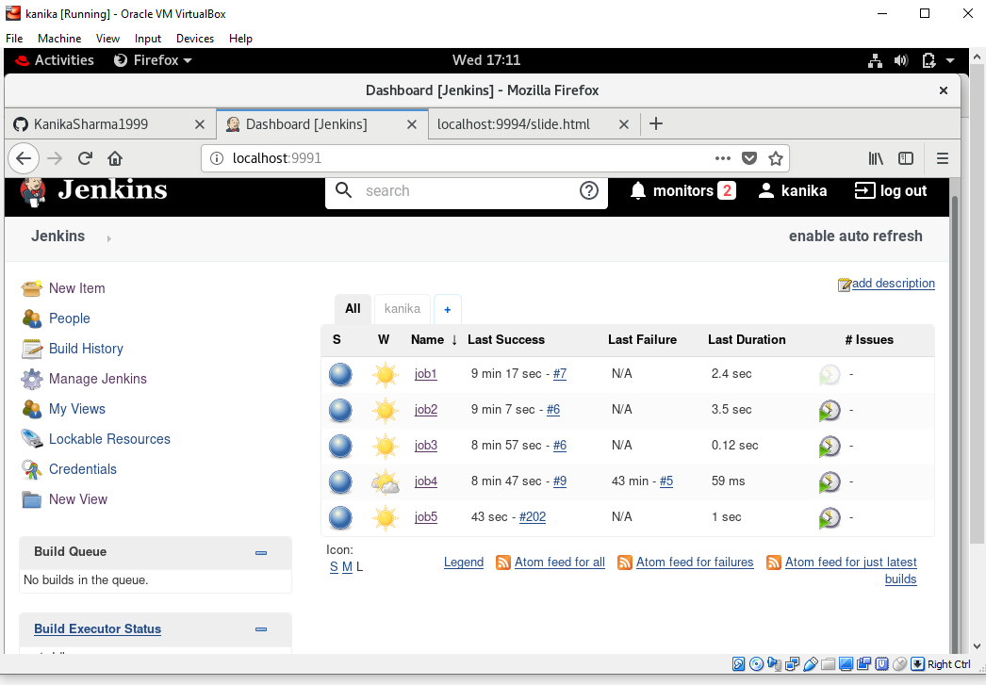
3. Create a job chain of job1, job2, job3 and job4 using build pipeline plugin in Jenkins
4. 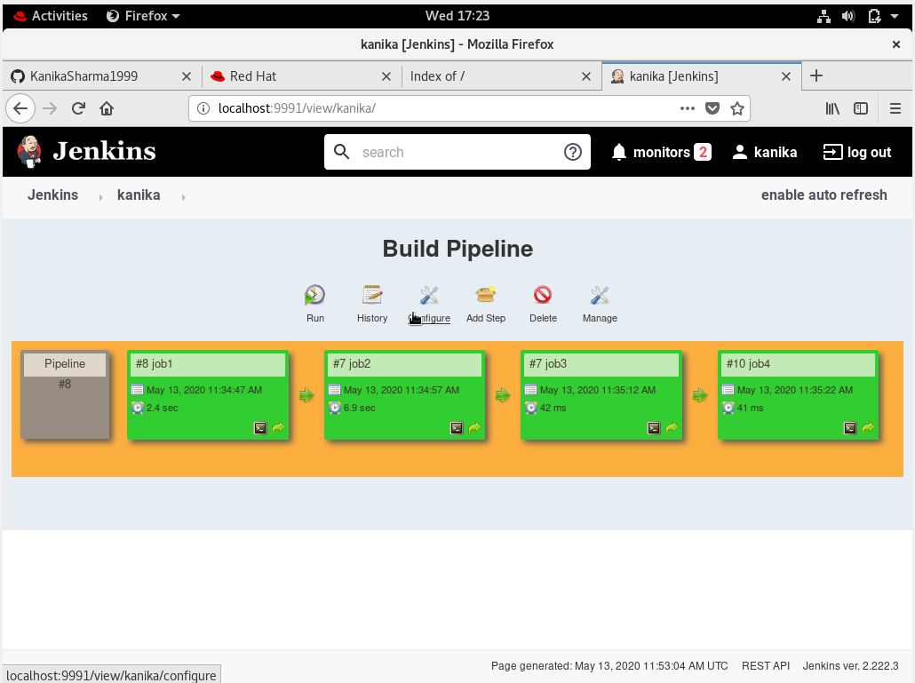

4. Job1 : Pull the Github repo automatically when some developers push repo to Github.

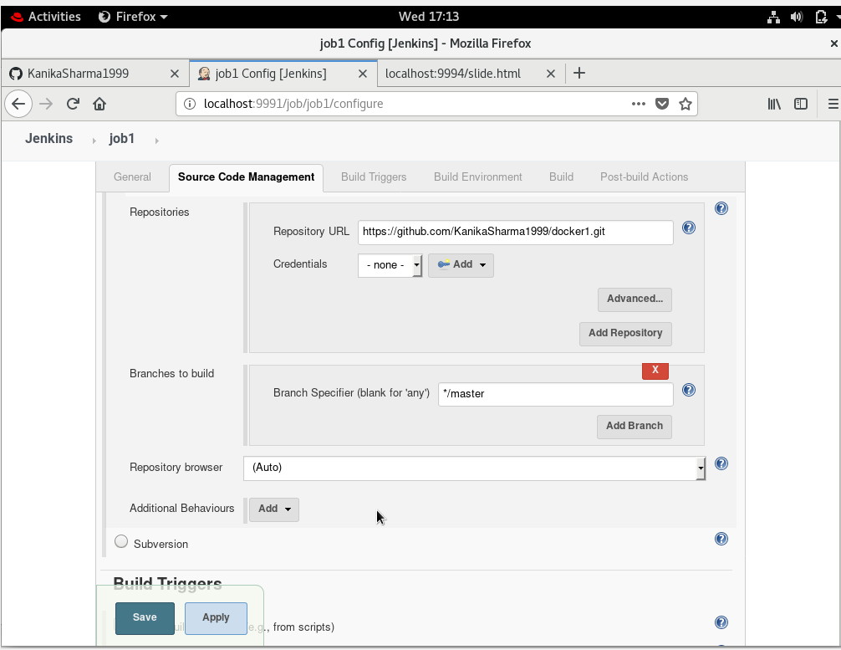

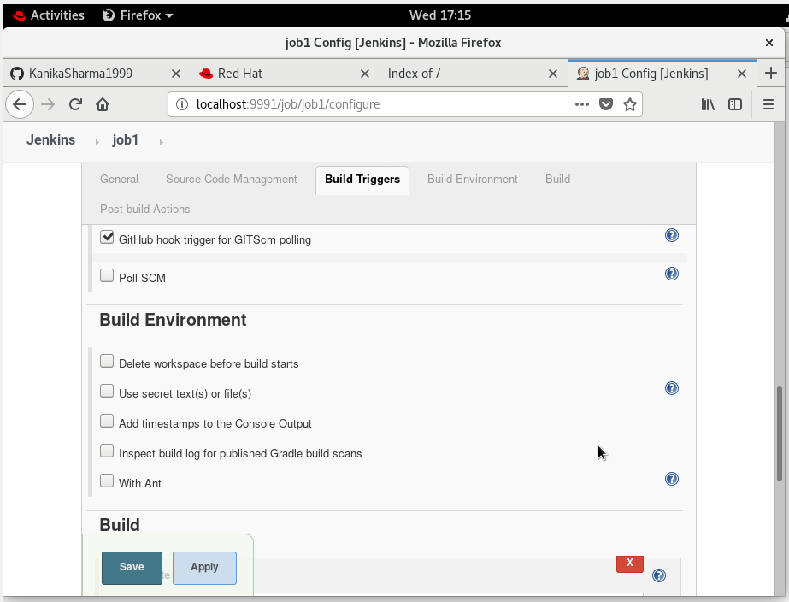



1. Job2 : By looking at the code or program file, Jenkins should automatically start the respective language interpreter install image container to deploy code ( eg. If code is of PHP, then Jenkins should start the container that has PHP already installed ).
2. 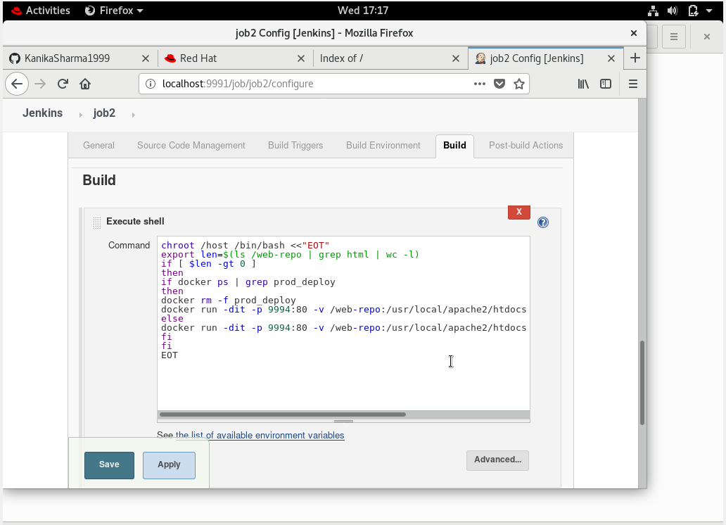

6. Job3 : Test your app if it is working or not.

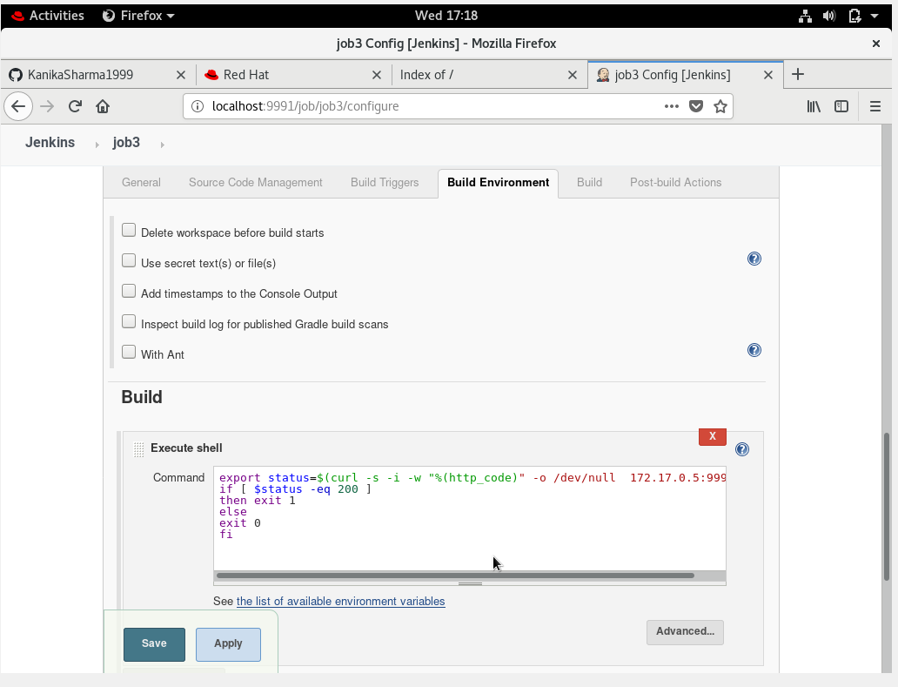

1. Job4 : if app is not working , then send email to developer with error messages.
2. 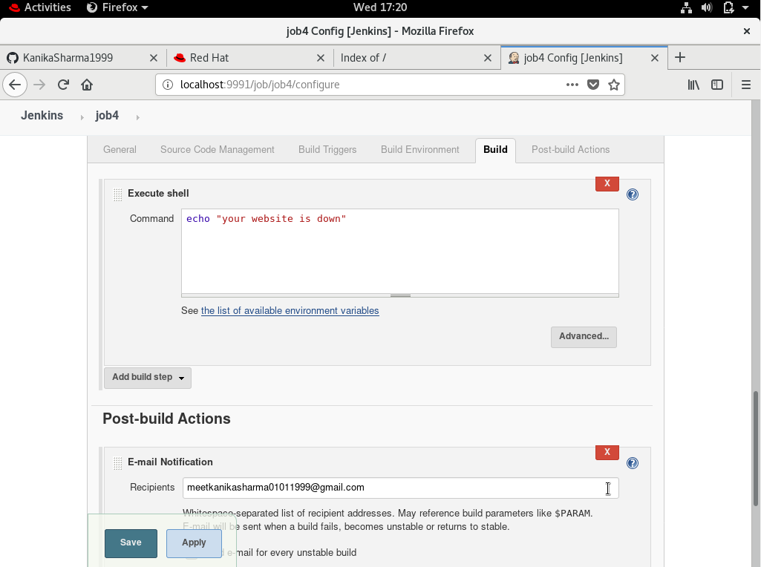

8. Create One extra job job5 for monitor : If container where app is running. fails due to any reson then this job should automatically start the container again.

