AI-Powered Intrusion Detection System Using a Hybrid Machine Learning Architecture
Research Methodology Explanation Document
Prepared for academic project documentation, thesis explanation, and viva presentation.

A. Research Overview
Modern organizations depend on cloud services, distributed networks, remote endpoints, and continuously connected applications. This connectivity increases the attack surface for malware, denial-of-service traffic, scanning, exploitation, privilege abuse, and data exfiltration. Traditional perimeter security cannot reliably identify every malicious behavior because attacks may be encrypted, polymorphic, distributed, or blended with legitimate traffic.
Intrusion detection is important because it provides continuous monitoring of network behavior and alerts security teams when traffic patterns indicate compromise. An IDS reduces the time between attack occurrence and detection, supports incident response, and creates evidence for forensic analysis.
Artificial intelligence and machine learning are required because network traffic produces high-dimensional, high-volume, and non-linear patterns. Machine learning can learn statistical relationships between features such as packet counts, byte rates, protocol behavior, and service activity, enabling detection beyond static signature matching.
Problem statement: This research investigates whether a hybrid machine learning architecture combining Random Forest, XGBoost, Isolation Forest, and a fusion layer can improve intrusion detection performance compared with individual baseline models on the UNSW-NB15 dataset.

B. Type of Research

Applied Research
The work solves a practical cybersecurity problem: detecting intrusions in network traffic. The output is not only theoretical; it produces a deployable classification pipeline and measurable IDS performance.

Experimental Research
The project trains controlled machine learning models, changes model architecture, and evaluates the effect of those changes through repeatable metrics. The hybrid model is tested against baseline models under the same dataset split and preprocessing procedure.

Quantitative Research
The conclusions are based on numerical measurements such as accuracy, precision, recall, F1-score, ROC-AUC, PR-AUC, false positive rate, and false negative rate. These metrics allow objective comparison.

Comparative Research
The research compares Logistic Regression, Random Forest, XGBoost, and a hybrid fusion model to determine which approach provides the strongest detection capability and the most balanced error profile.

C. Research Objectives
- To design an IDS pipeline that detects normal and malicious network traffic using machine learning.
- To use hybrid ML because tree ensembles capture non-linear supervised patterns while anomaly detection contributes sensitivity to unusual traffic behavior.
- To select UNSW-NB15 because it contains modern synthetic attack traffic, normal traffic, rich network-flow features, binary labels, and multiclass attack categories.
- Research hypothesis: A hybrid IDS that combines supervised ensemble learners with anomaly-based evidence will achieve higher F1-score and ROC-AUC than individual baseline models.

D. Research Methodology Diagram
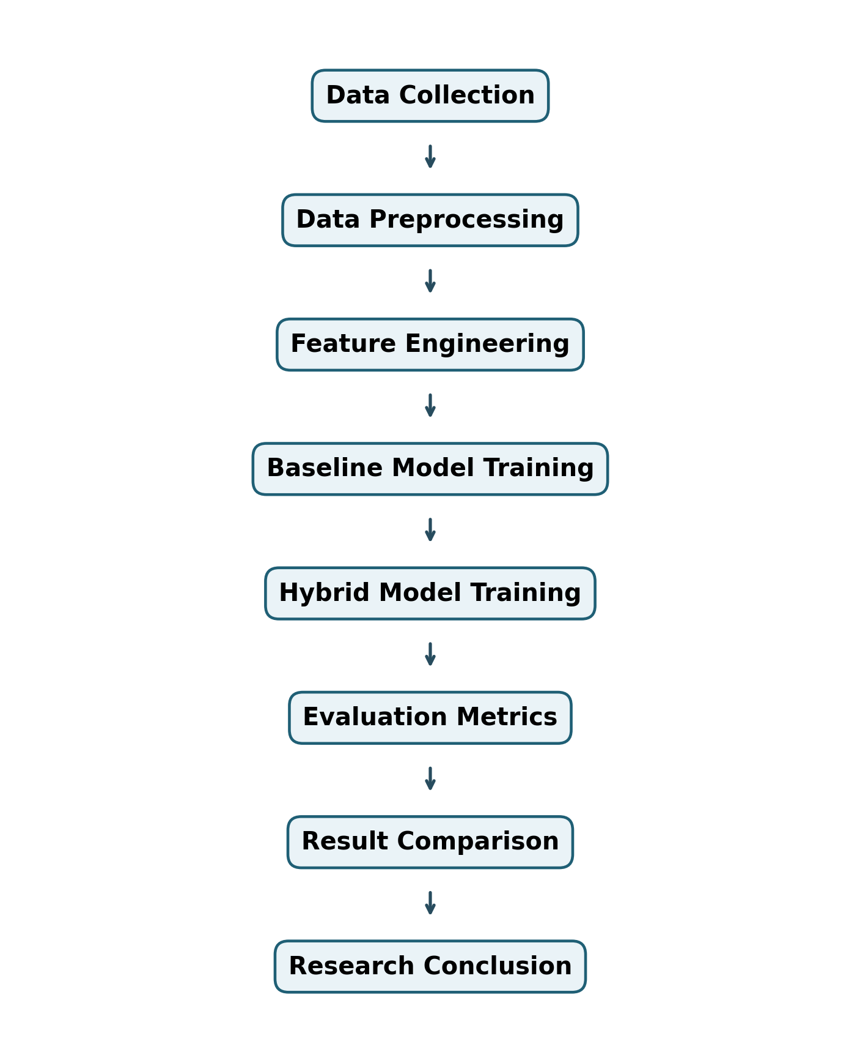
Figure 1. Research methodology workflow for the proposed AI-powered IDS.

E. Hybrid Architecture Diagram
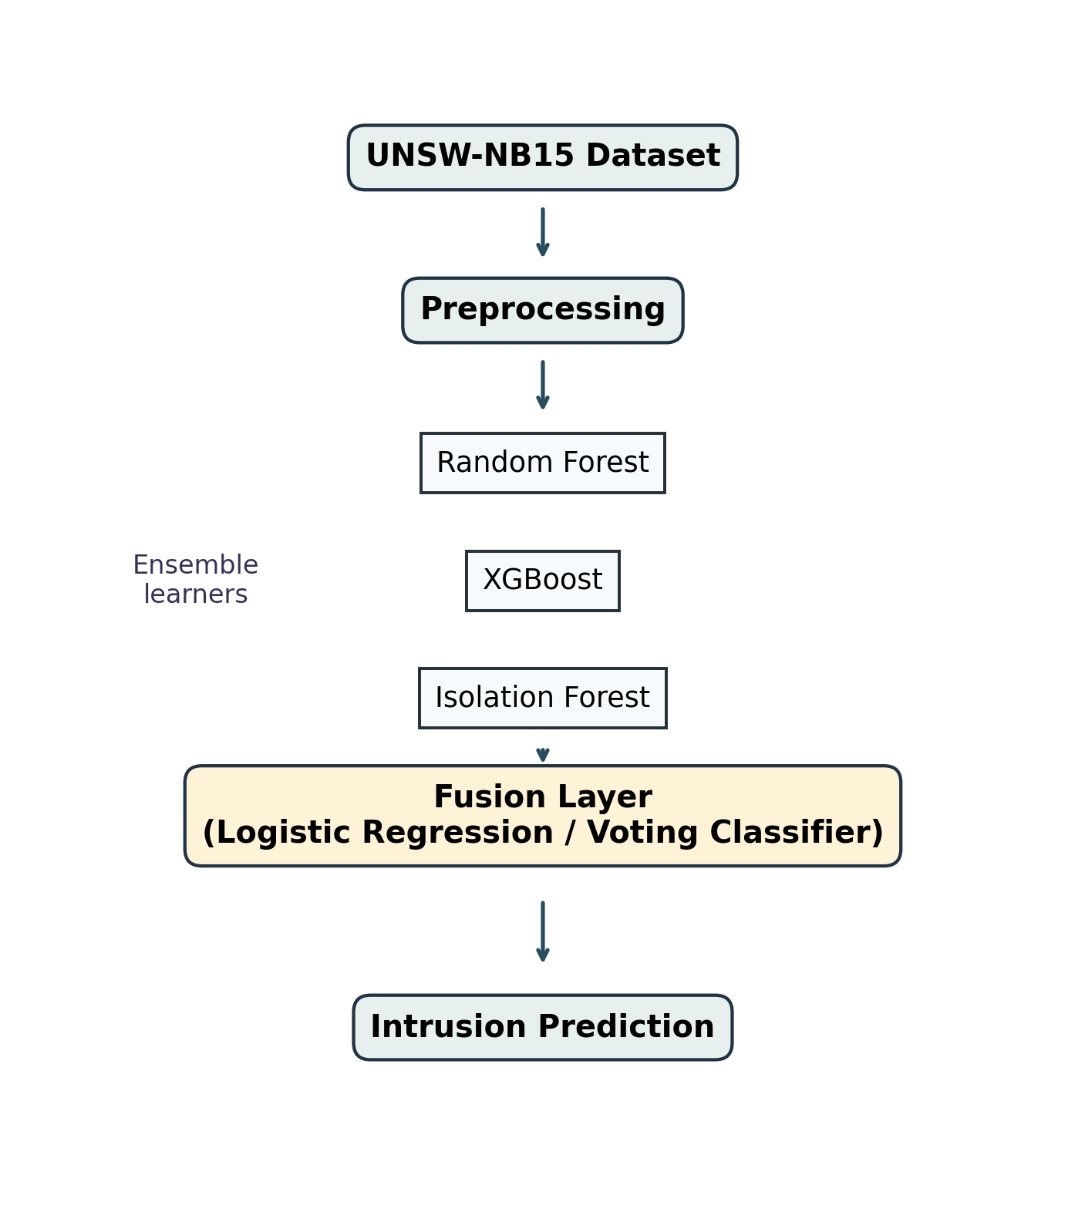
Figure 2. Hybrid IDS architecture using Random Forest, XGBoost, Isolation Forest, and a fusion layer.

F. Dataset Explanation
UNSW-NB15 is a network intrusion detection dataset created to represent modern normal and attack traffic. It includes flow-level and content-based attributes that describe packet counts, byte counts, time-to-live values, jitter, loss, rates, services, states, and labels.
The dataset is suitable because it contains 49 commonly cited features, binary labels for normal versus attack detection, and attack-category labels for multiclass intrusion analysis. Attack categories include Analysis, Backdoor, DoS, Exploits, Fuzzers, Generic, Reconnaissance, Shellcode, and Worms.
Binary classification predicts whether a record is normal or malicious. Multiclass classification predicts the specific attack category. This research emphasizes binary IDS detection while retaining the methodology for extending the pipeline to multiclass learning.
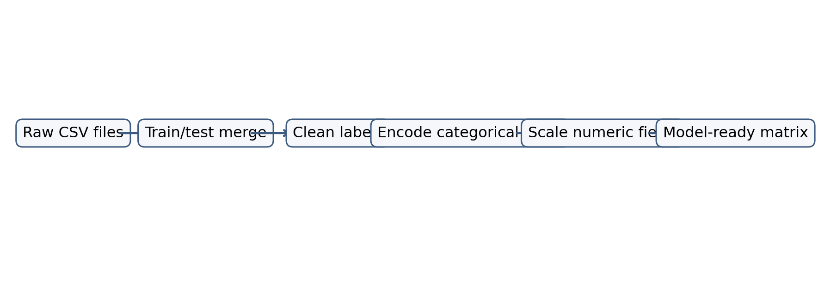
Figure 3. Dataset preparation workflow for UNSW-NB15 records.

G. Research Pipeline
Step | Explanation
Data loading | CSV files are loaded from the data directory and combined into a single analytical dataframe.
Missing value handling | Null values are identified; numerical fields are imputed with medians and categorical fields with modes.
Feature encoding | Categorical variables such as protocol, service, and state are transformed using one-hot encoding.
Scaling | Numerical variables are standardized where required, especially for Logistic Regression and fusion models.
Model training | Baseline models are trained under the same split to maintain fair comparison.
Hybrid fusion | Predicted probabilities from Random Forest, XGBoost, and normalized Isolation Forest scores are used as meta-features for Logistic Regression or voting fusion.
Evaluation | Models are assessed through confusion matrix, threshold metrics, ROC curve, PR curve, and comparative summary tables.
Table 1. Step-by-step research pipeline.

H. Metrics Explanation
- Accuracy
Accuracy = (TP + TN) / (TP + TN + FP + FN)
- Precision
Precision = TP / (TP + FP)
- Recall
Recall = TP / (TP + FN)
- F1-score
F1 = 2 x (Precision x Recall) / (Precision + Recall)
- ROC-AUC
ROC-AUC = Area under the TPR versus FPR curve
- PR-AUC
PR-AUC = Area under the Precision versus Recall curve
- False Positive Rate
FPR = FP / (FP + TN)
- False Negative Rate
FNR = FN / (FN + TP)

I. Result Interpretation
In the generated demonstration run, the strongest F1-score is produced by Hybrid RF + XGBoost + Isolation Forest with F1=0.9355. A stronger model usually performs better because it captures non-linear relationships, interaction effects, and minority-class patterns more effectively.
The hybrid architecture is important because it combines complementary evidence: Random Forest contributes robust bagging-based decisions, XGBoost contributes boosted error correction, and Isolation Forest adds anomaly-oriented information. Fusion reduces dependence on a single learner and can improve stability when one model is weak for a specific traffic pattern.
Overfitting is monitored by comparing train and test performance, limiting tree depth, using cross-validation, and tracking whether high accuracy is accompanied by poor recall or unstable PR-AUC. Bias and variance are balanced by combining lower-bias boosted trees with lower-variance bagged trees and a regularized fusion model.

J. Limitations
- Dataset limitations: UNSW-NB15 is valuable but still a benchmark dataset; real enterprise traffic may contain different protocols, encrypted payload behavior, and evolving attack strategies.
- Computational limitations: ensemble and hybrid models require more memory, training time, and inference resources than simpler classifiers.
- Real-time deployment limitations: production IDS deployment must handle streaming data, concept drift, low-latency scoring, alert fatigue, and integration with SIEM or SOAR platforms.

K. Future Scope
- Explainable AI IDS: integrate SHAP or LIME to explain why a flow is flagged as malicious.
- Federated IDS: train across organizations or edge nodes without centralizing sensitive traffic data.
- Real-time cloud deployment: deploy the model behind a streaming pipeline using cloud-native monitoring infrastructure.
- Zero-day attack detection: strengthen anomaly and self-supervised components to detect novel traffic patterns.

L. Diagrams and Charts
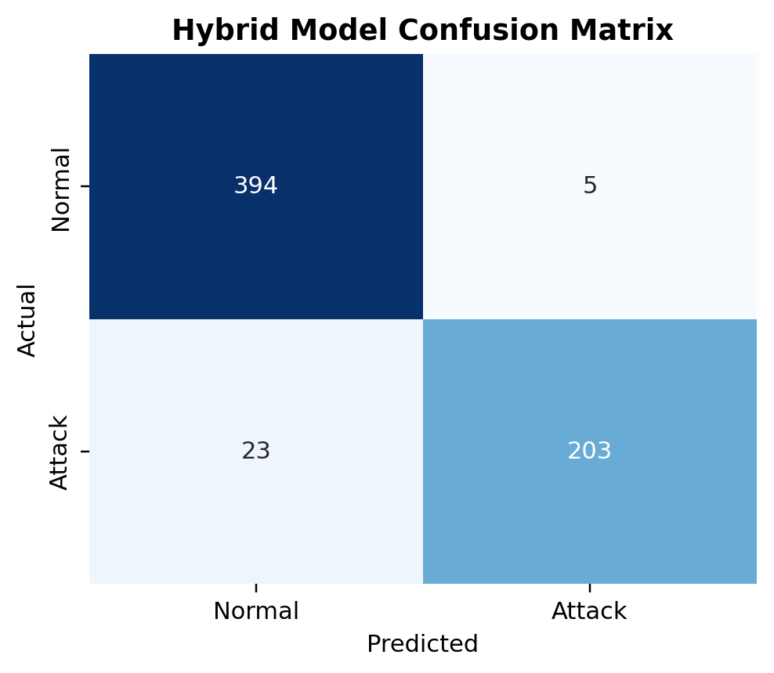
Figure 4. Confusion matrix for hybrid IDS predictions.
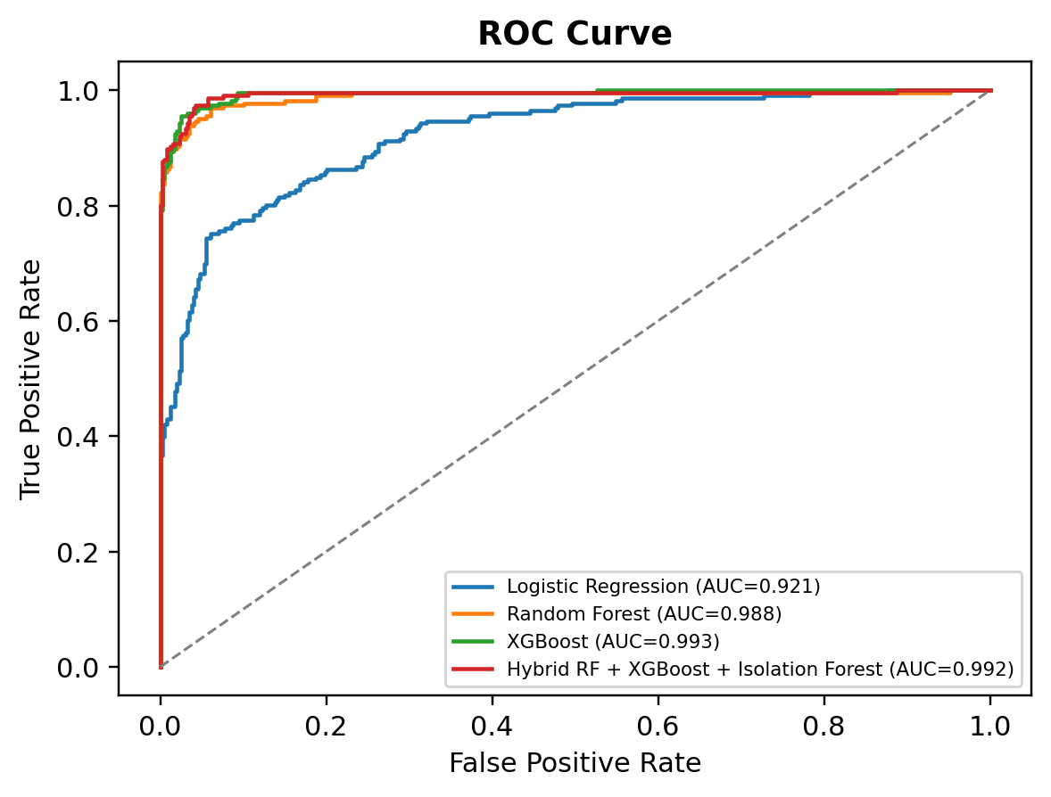
Figure 5. ROC curves comparing baseline and hybrid IDS models.
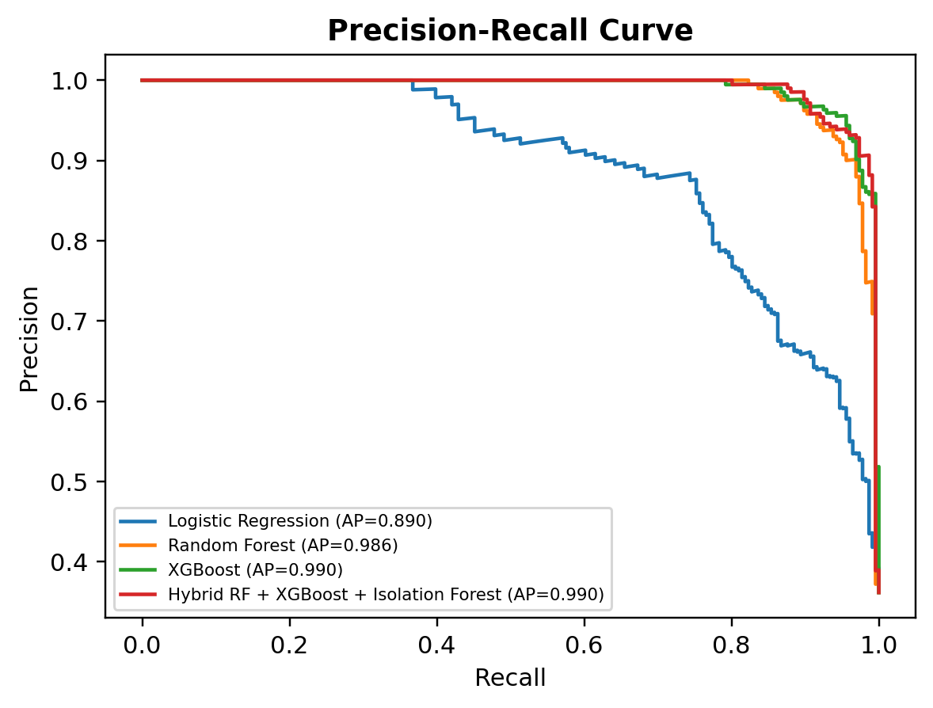
Figure 6. Precision-recall curves comparing detection performance under class imbalance.
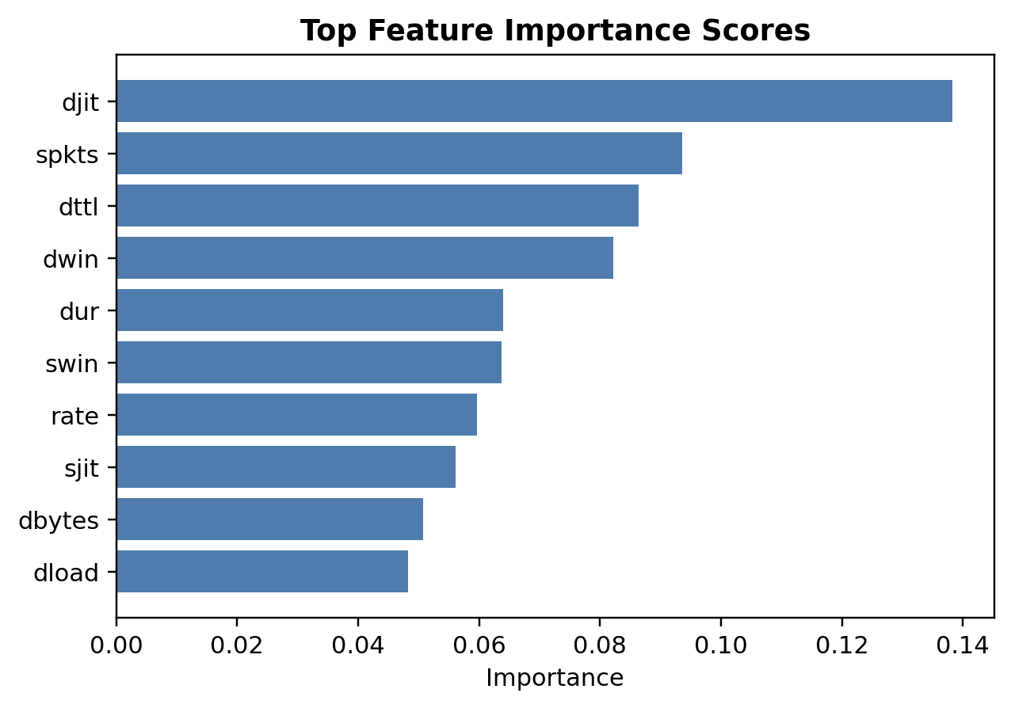
Figure 7. Top feature importance scores from the Random Forest baseline.
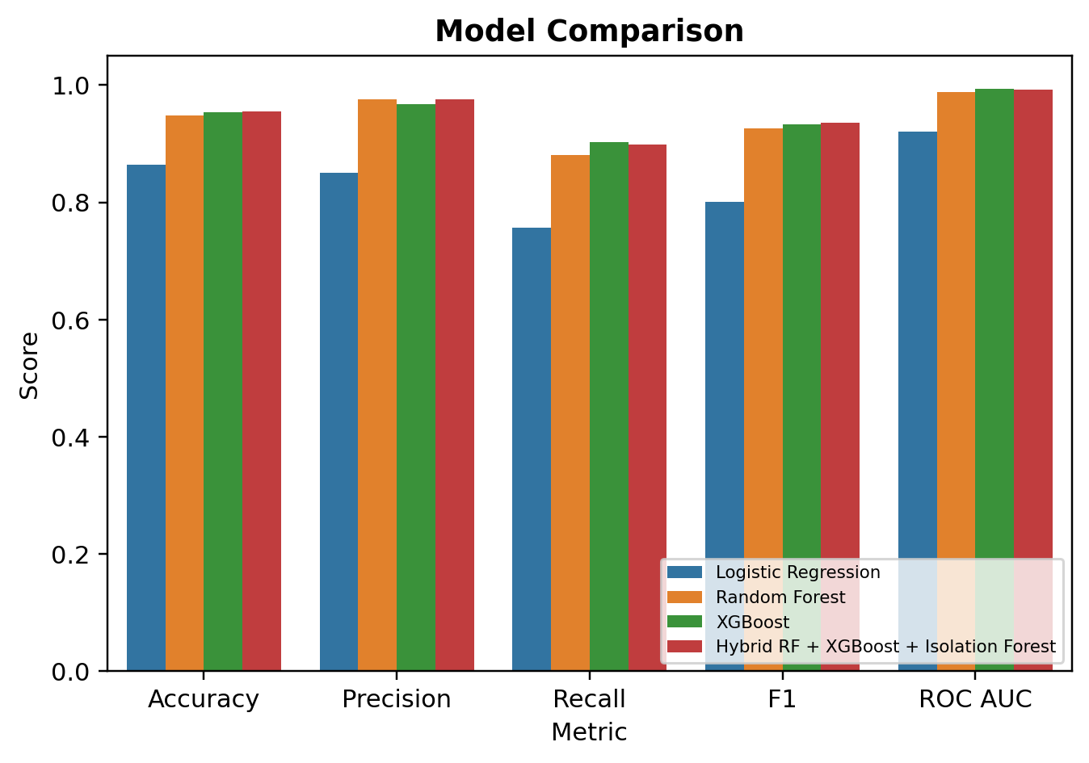
Figure 8. Model comparison graph across core evaluation metrics.

Model Performance Summary
Model | Accuracy | Precision | Recall | F1 | ROC AUC | PR AUC | False Positive Rate | False Negative Rate
Logistic Regression | 0.864 | 0.8507 | 0.7566 | 0.8009 | 0.9213 | 0.8898 | 0.0752 | 0.2434
Random Forest | 0.9488 | 0.9755 | 0.8805 | 0.9256 | 0.9883 | 0.9856 | 0.0125 | 0.1195
XGBoost | 0.9536 | 0.9668 | 0.9027 | 0.9336 | 0.9932 | 0.9902 | 0.0175 | 0.0973
Hybrid RF + XGBoost + Isolation Forest | 0.9552 | 0.976 | 0.8982 | 0.9355 | 0.9919 | 0.9901 | 0.0125 | 0.1018
Table 2. Quantitative model comparison from the reproducible demonstration run.

