A Journal-Style Empirical Study of Hybrid Machine Learning for Intrusion Detection on UNSW-NB15
Binary, multiclass, ablation, threshold, and runtime analysis with 2021-2026 literature
Author: Shivani Nayak
Department of Computer Science and Engineering

Abstract
This paper presents a real-data empirical study of machine learning-based network intrusion detection using the official UNSW-NB15 training and testing CSV files. Instead of claiming that hybrid fusion is automatically superior, the study evaluates when hybrid supervised and anomaly-aware evidence is useful and when a strong tabular learner is sufficient. Binary experiments compare Logistic Regression, Random Forest, XGBoost, Isolation Forest scoring, RF+XGBoost fusion, and RF+XGBoost+Isolation Forest fusion. Multiclass experiments evaluate attack-family detection using XGBoost. At the default threshold, XGBoost achieved the strongest binary F1-score of 0.9247; XGBoost achieved F1=0.9247, while the full hybrid achieved F1=0.9027. The results show that XGBoost remains the strongest default operating point, but the hybrid analysis is valuable for understanding fusion behavior, false-alarm tradeoffs, and deployability.
Keywords: Network intrusion detection, UNSW-NB15, XGBoost, Random Forest, hybrid fusion, multiclass classification, threshold tuning, cybersecurity

1. Introduction
Network intrusion detection systems must identify malicious behavior in high-volume traffic while maintaining a manageable false-alarm rate. This problem is difficult because modern traffic contains class imbalance, overlapping behavior between benign and malicious flows, and rare attack families with few examples. Machine learning can learn useful traffic patterns, but benchmark accuracy alone is not enough for journal-level evaluation.
This paper therefore treats hybrid IDS design as an empirical question. The study asks whether fusion improves binary detection, how threshold choice changes IDS tradeoffs, how well attack families are detected in multiclass classification, and what runtime cost is introduced by each model family.

2. Research Questions and Contributions
- RQ1: Which binary model provides the strongest normal-versus-attack detection on the official UNSW-NB15 split?
- RQ2: Does RF+XGBoost+Isolation Forest fusion improve over individual learners or simpler RF+XGBoost fusion?
- RQ3: How does threshold tuning change false positives, false negatives, and F1-score?
- RQ4: Which UNSW-NB15 attack families remain difficult under multiclass classification?
- RQ5: What inference-cost tradeoff is introduced by the evaluated models?

3. Related Work
Recent IDS literature from 2021 to 2026 emphasizes feature selection, explainability, lightweight deployment, cross-dataset generalization, and hybrid learning. The literature also shows that claims based only on high benchmark accuracy are weak unless they include class imbalance, rare-class behavior, and deployment constraints.
Study | Dataset | Method | Task | Relevance
Zoghi & Serpen, 2022 | UNSW-NB15 | Ensemble tuning | Binary/multiclass | Dataset-specific design
Yin et al., 2022 | UNSW-NB15 | IGRF-RFE + MLP | Multiclass | Feature-selection sensitivity
Explainable AI, 2024 | UNSW-NB15 | XAI comparison | Binary/multiclass | Interpretability gap
xIDS-EnsembleGuard, 2025 | Multiple IDS datasets | Explainable ensemble | Binary | Overfitting and bias
Farhan et al., 2025 | UNSW-NB15 | Deep learning | Binary | Imbalance and feature selection
LiteShield, 2026 | UNSW-NB15 | Hybrid feature selection | Binary/multiclass | Lightweight deployment
Hossain et al., 2026 | Multiple IDS datasets | Generalization study | Binary | Cross-dataset robustness
Table 1. Recent IDS literature positioning from 2021 to 2026.

4. Dataset and Experimental Design
The study uses the real UNSW-NB15 CSV files: data/UNSW_NB15_training-set.csv and data/UNSW_NB15_testing-set.csv. The binary label is used for normal-versus-attack detection. The attack_cat column is used only for multiclass attack-family evaluation and is excluded from binary model features to avoid label leakage.
Split | Records | Normal | Attack | Attack families
Training | 175,341 | 56,000 | 119,341 | 10
Testing | 82,332 | 37,000 | 45,332 | 10
Table 2. Real UNSW-NB15 split used for binary and multiclass experiments.
The preprocessing pipeline removes id, imputes numeric features with median values, standardizes numeric features, imputes categorical features with the mode, and one-hot encodes categorical protocol, service, and state fields. Binary threshold selection uses an internal stratified validation split from the training data; final reported metrics are measured on the official testing split.
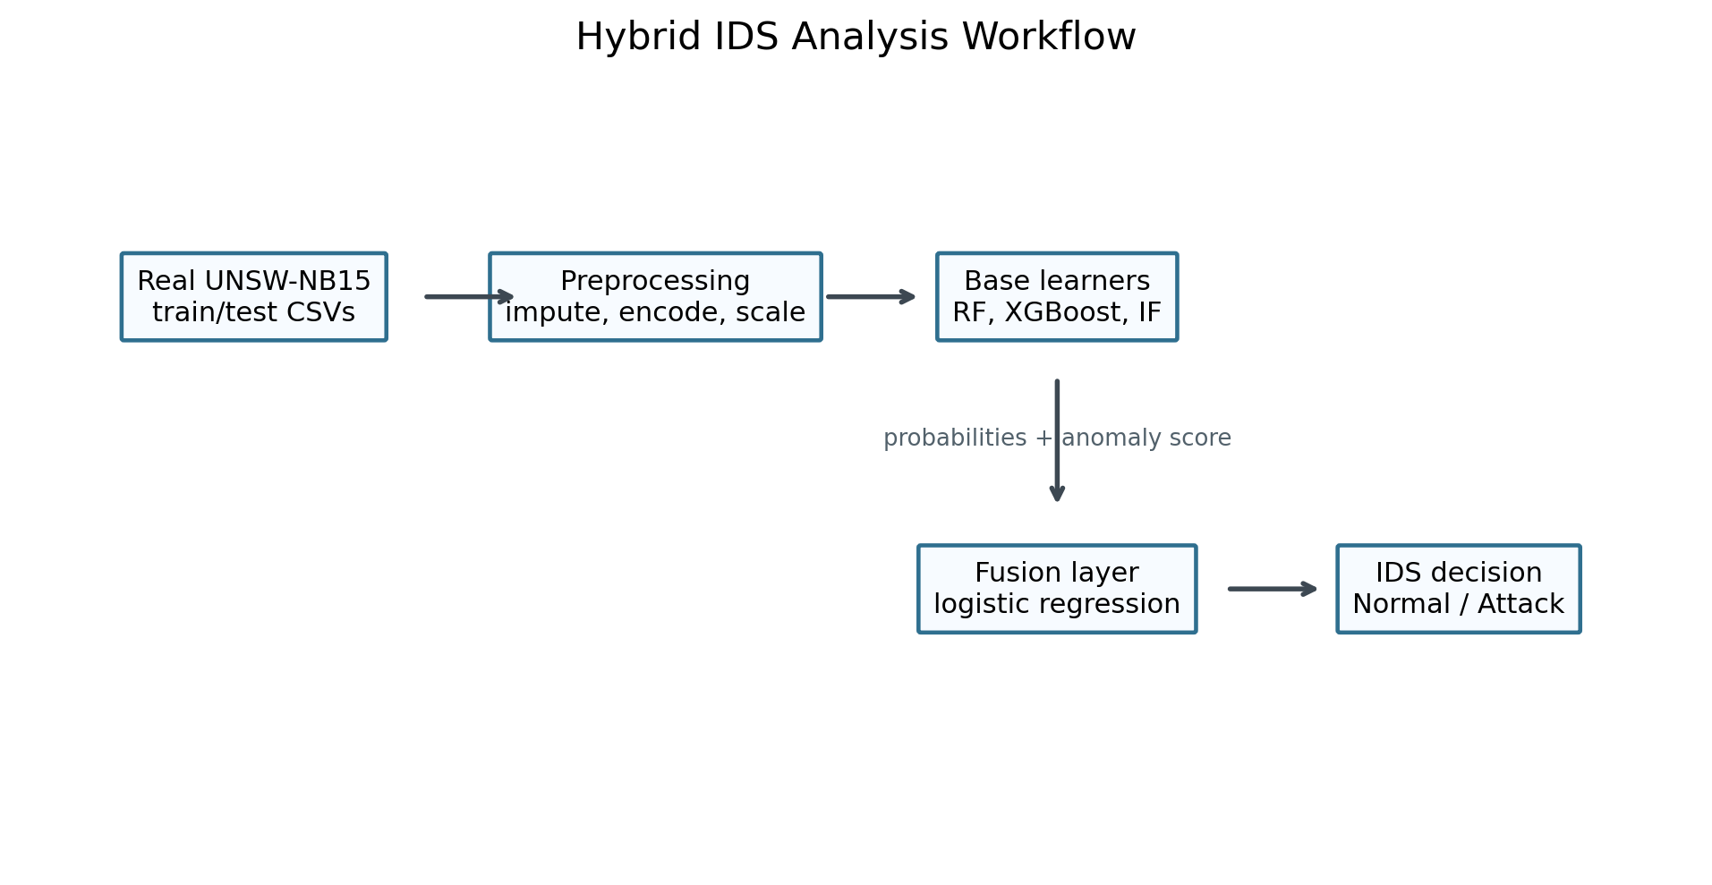
Figure 1. Hybrid IDS analysis workflow.

5. Models and Reproducibility
The binary study evaluates Logistic Regression, Random Forest, XGBoost, Isolation Forest score-only detection, RF+XGBoost fusion, and RF+XGBoost+Isolation Forest fusion. The fusion layer is logistic regression trained on validation-set probability or anomaly-score meta-features. The multiclass study uses XGBoost because it was the strongest binary model and is well suited to tabular network-flow data.
Reproducibility settings: Python 3.13.12, platform Windows 10, random_state=42, official UNSW-NB15 train/test split, scikit-learn preprocessing, and XGBoost tree models. The implementation records fit time, prediction time, and milliseconds per 1,000 test records.

6. Binary Results
Model | Accuracy | Precision | Recall | F1 | ROC AUC | PR AUC | False Positives | False Negatives
XGBoost | 0.9134 | 0.8875 | 0.9651 | 0.9247 | 0.9854 | 0.9892 | 5545 | 1583
Fusion RF + XGBoost + IF | 0.8832 | 0.8341 | 0.9835 | 0.9027 | 0.9836 | 0.9872 | 8868 | 746
Fusion RF + XGBoost | 0.8832 | 0.8338 | 0.9839 | 0.9027 | 0.9844 | 0.9884 | 8890 | 728
Random Forest | 0.8699 | 0.8152 | 0.9876 | 0.8931 | 0.9796 | 0.9827 | 10152 | 561
Logistic Regression | 0.8358 | 0.8032 | 0.9295 | 0.8617 | 0.9556 | 0.9663 | 10326 | 3196
Isolation Forest Score | 0.4521 | 0.5581 | 0.0233 | 0.0448 | 0.3608 | 0.4864 | 837 | 44275
Table 3. Binary model performance at threshold 0.50.
The binary results show that XGBoost is the strongest default-threshold model. The full hybrid does not outperform XGBoost in F1-score, which is important because it prevents an overstated novelty claim. A likely reason is that XGBoost already captures most discriminative tabular structure in the official split, while Isolation Forest adds anomaly evidence that increases recall but can also raise false positives.
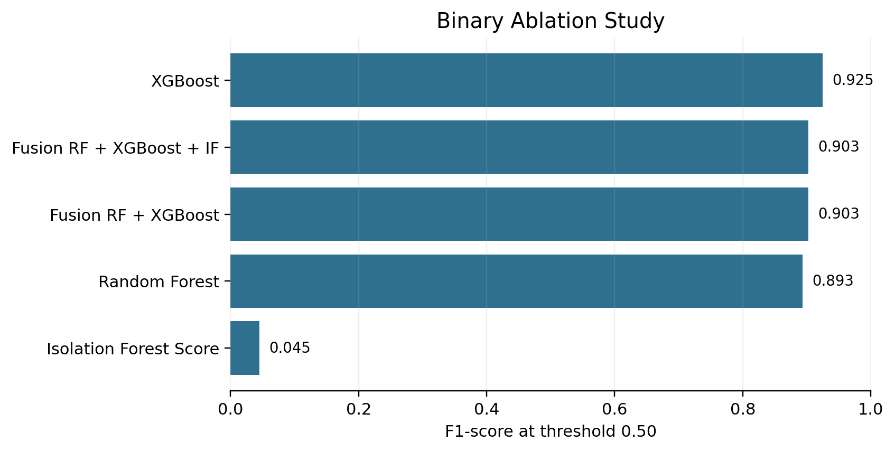
Figure 2. Ablation study showing default-threshold binary F1-score.

7. Threshold and Runtime Analysis
Model | Policy | Threshold | Precision | Recall | F1 | False Positives | False Negatives
XGBoost | Default 0.50 | 0.5000 | 0.8875 | 0.9651 | 0.9247 | 5545 | 1583
XGBoost | F1-tuned | 0.3300 | 0.8237 | 0.9872 | 0.8981 | 9581 | 579
XGBoost | Recall-oriented | 0.2400 | 0.7799 | 0.9960 | 0.8748 | 12741 | 183
Fusion RF + XGBoost + IF | Default 0.50 | 0.5000 | 0.8341 | 0.9835 | 0.9027 | 8868 | 746
Fusion RF + XGBoost + IF | F1-tuned | 0.3600 | 0.8094 | 0.9905 | 0.8909 | 10572 | 430
Fusion RF + XGBoost + IF | Recall-oriented | 0.2200 | 0.7825 | 0.9955 | 0.8762 | 12547 | 204
Table 4. Threshold policy comparison on the official test split.
Threshold tuning demonstrates that IDS performance is an operating-point decision rather than a single fixed metric. The tuned thresholds were selected on the internal validation split and then evaluated on the official test split. In this run, the default XGBoost threshold remained stronger on the final test split (F1=0.9247) than the validation-selected F1 threshold (F1=0.8981), showing that threshold policies can overfit the validation distribution. Recall-oriented thresholds reduced missed attacks but increased false positives.
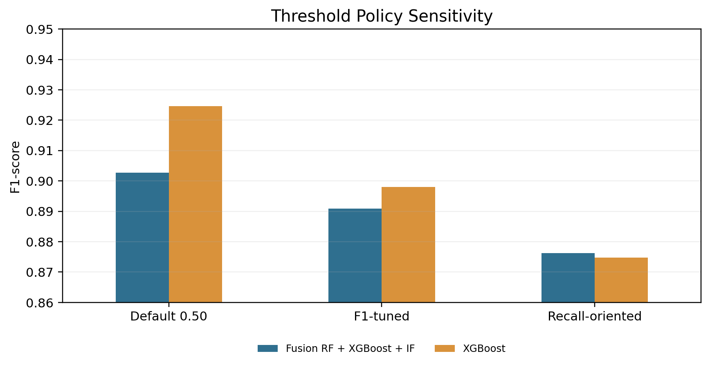
Figure 3. Threshold policy sensitivity for XGBoost and full hybrid fusion.
Model | Fit Time Seconds | Predict Time Seconds | Milliseconds Per 1000 Records
XGBoost | 4.5991 | 0.3242 | 3.9378
Fusion RF + XGBoost + IF | 327.90 | 2.8153 | 34.19
Fusion RF + XGBoost | 326.27 | 1.9438 | 23.61
Random Forest | 321.64 | 1.6144 | 19.61
Logistic Regression | 6.5290 | 0.0141 | 0.1710
Isolation Forest Score | 1.6278 | 0.8711 | 10.58
Table 5. Runtime and inference-cost comparison.
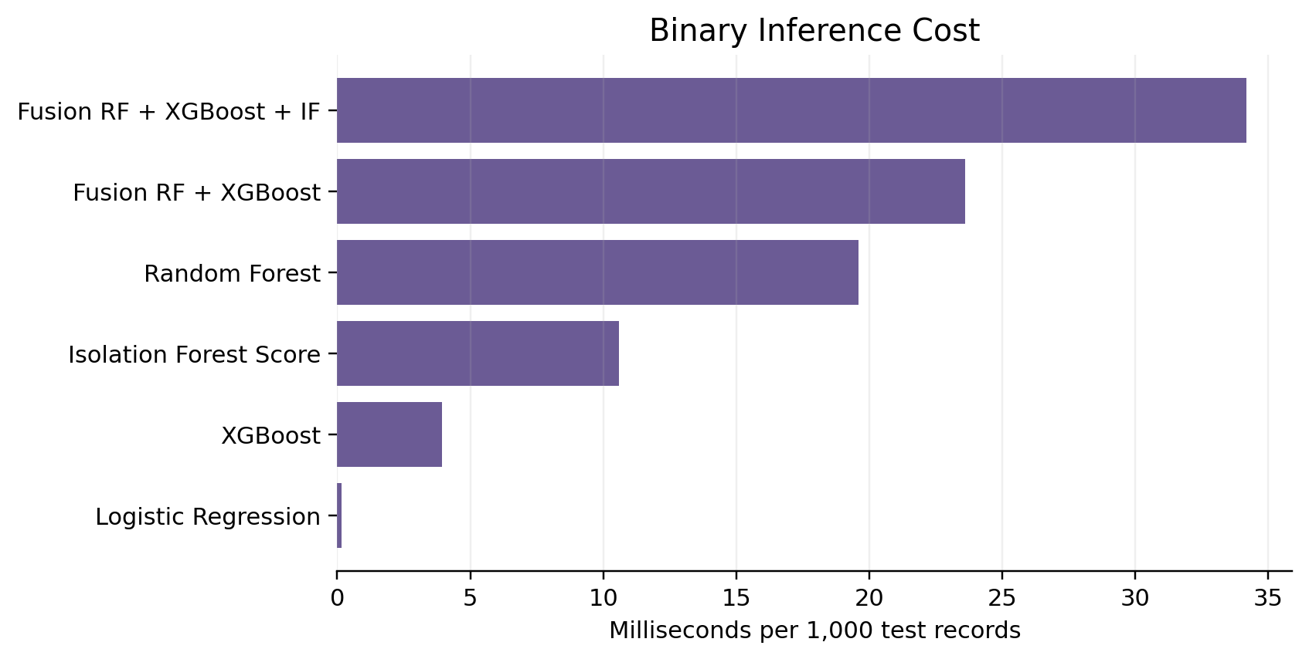
Figure 4. Binary inference cost by model.

8. Multiclass Attack-Family Results
Model | Accuracy | Macro F1 | Weighted F1 | Fit Time Seconds | Milliseconds Per 1000 Records
XGBoost multiclass | 0.7680 | 0.5003 | 0.7784 | 39.31 | 30.79
Table 6. Multiclass XGBoost summary.
Class | Support | Precision | Recall | F1
Worms | 44 | 0.6429 | 0.4091 | 0.5000
Shellcode | 378 | 0.3375 | 0.7857 | 0.4722
Backdoor | 583 | 0.0419 | 0.1201 | 0.0621
Analysis | 677 | 0.0344 | 0.0325 | 0.0334
Reconnaissance | 3496 | 0.9247 | 0.8084 | 0.8626
DoS | 4089 | 0.5483 | 0.0736 | 0.1298
Fuzzers | 6062 | 0.3136 | 0.5848 | 0.4082
Exploits | 11132 | 0.5813 | 0.8818 | 0.7007
Generic | 18871 | 0.9981 | 0.9696 | 0.9836
Normal | 37000 | 0.9673 | 0.7578 | 0.8498
Table 7. Per-class multiclass precision, recall, and F1.
Multiclass detection is substantially harder than binary detection because rare attack families have limited support. The weakest class in this run was Analysis with support=677 and F1=0.0334. These results are more informative for journal review than binary accuracy alone because they reveal where the detector may fail operationally.
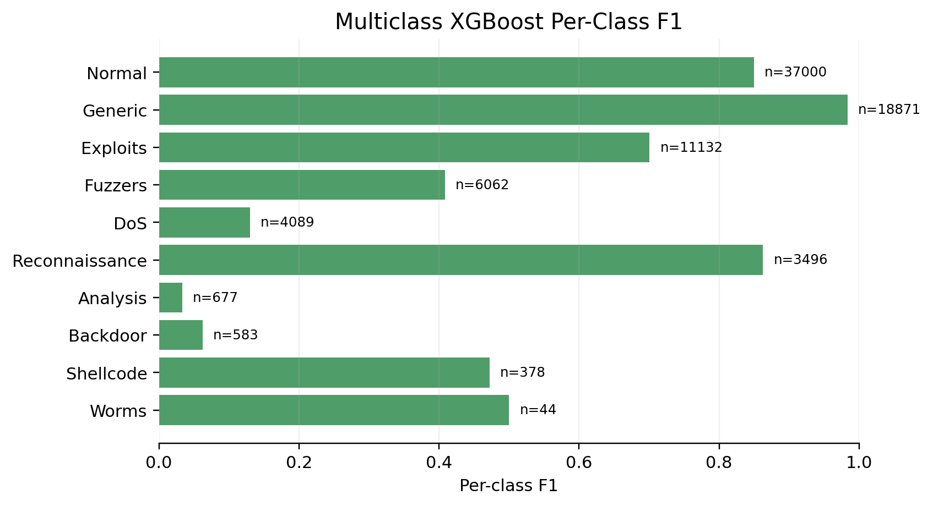
Figure 5. Per-class F1-score for multiclass attack-family detection.

9. Discussion
The experiments support a careful interpretation: hybrid fusion is a useful design pattern for combining complementary evidence, but it is not automatically superior to a strong tree-boosting baseline. The empirical contribution of this paper is therefore the broader comparison across binary detection, fusion ablation, threshold policy, multiclass rare-class behavior, and runtime cost.
For deployment, XGBoost is attractive because it provides the best default-threshold F1 and strong AUC scores. The hybrid models are still relevant when an operator wants to combine supervised confidence with anomaly evidence, but the decision threshold must be tuned to alert budget and risk tolerance.

10. Threats to Validity
- Dataset validity: UNSW-NB15 is a benchmark and may not fully represent current encrypted, cloud-native, or enterprise traffic.
- Threshold validity: validation-tuned thresholds depend on the training distribution and may drift in live networks.
- Model validity: only one dataset is used; stronger journal evidence would include CIC-IDS2017, BoT-IoT, ToN-IoT, or NF-UNSW-NB15.
- Multiclass validity: rare classes such as Worms have very small support, so per-class metrics can be unstable.
- Operational validity: the study reports offline inference time, not full streaming ingestion, SIEM integration, or analyst triage cost.

11. Conclusion
This journal-style version strengthens the original project paper by adding real-data binary experiments, multiclass attack-family detection, fusion ablation, threshold analysis, runtime measurement, and explicit threats to validity. The results show that XGBoost is the strongest default-threshold model on the official UNSW-NB15 split, while hybrid fusion provides an interpretable framework for studying complementary supervised and anomaly evidence. Future work should validate the approach on additional datasets, add explainability, and evaluate streaming deployment.

References
- Mabulage, D., & Athuraliya, B. (2026). LiteShield: Hybrid Feature Selection-Driven Lightweight Intrusion Detection for Resource-Constrained IoT Networks. arXiv:2605.02987. https://arxiv.org/abs/2605.02987
- Hossain, M. Z., et al. (2026). Assessing Generalisation Capability of Machine Learning Models for Intrusion Detection. arXiv:2605.04407. https://arxiv.org/abs/2605.04407
- Alhusseini, M. M., Rouhi, A., & Feizi-Derakhshi, M.-R. (2026). AI-Powered Hybrid Intrusion Detection Framework for Cloud Security Using Novel Metaheuristic Optimization. arXiv:2601.01134. https://arxiv.org/abs/2601.01134
- Hussein, S. A., & Repas, S. R. (2026). A Hybrid Intrusion Detection Framework Using Deep Autoencoder and Machine Learning Models. AI, 7(2), 39. https://www.mdpi.com/2673-2688/7/2/39
- A Rigorous Comparative Study of Supervised Machine Learning Techniques for Network Anomaly Detection: Empirical Insights from the UNSW-NB15 Dataset. (2026). Computers, 15(5), 285. https://www.mdpi.com/2073-431X/15/5/285
- Farhan, M., et al. (2025). Network-based intrusion detection using deep learning technique. Scientific Reports, 15, 25550. https://www.nature.com/articles/s41598-025-08770-0
- Ali, M., et al. (2025). Botnet detection in internet of things using stacked ensemble learning model. Scientific Reports, 15, 21012. https://www.nature.com/articles/s41598-025-02008-9
- Li, Z., et al. (2025). Generating detectors from anomaly samples via negative selection for network intrusion detection. Scientific Reports, 15, 36456. https://www.nature.com/articles/s41598-025-20516-6
- xIDS-EnsembleGuard: An Explainable Ensemble Learning-based Intrusion Detection System. (2025). arXiv:2503.00615. https://arxiv.org/abs/2503.00615
- Network Intrusion Detection through Stacked Machine Learning Models on UNSW-NB15 Data Set. (2025). SCITEPRESS. https://www.scitepress.org/Papers/2025/139326/139326.pdf
- A new intrusion detection method using ensemble classification and feature selection. (2025). Scientific Reports. https://www.nature.com/articles/s41598-025-98604-w
- Varzaneh, Z. A., & Hosseini, S. (2024). An improved equilibrium optimization algorithm for feature selection problem in network intrusion detection. Scientific Reports, 14, 18696. https://www.nature.com/articles/s41598-024-67488-7
- Explainable AI for Comparative Analysis of Intrusion Detection Models. (2024). arXiv:2406.09684. https://arxiv.org/abs/2406.09684
- Zoghi, Z., & Serpen, G. (2022). Ensemble Classifier Design Tuned to Dataset Characteristics for Network Intrusion Detection. arXiv:2205.06177. https://arxiv.org/abs/2205.06177
- Yin, Y., Jang-Jaccard, J., Xu, W., Singh, A., Zhu, J., Sabrina, F., & Kwak, J. (2022). IGRF-RFE: A Hybrid Feature Selection Method for MLP-based Network Intrusion Detection on UNSW-NB15 Dataset. arXiv:2203.16365. https://arxiv.org/abs/2203.16365
- UNSW-NB15 Computer Security Dataset: Analysis through Visualization. (2021). arXiv:2101.05067. https://arxiv.org/abs/2101.05067

