AI-Powered Hybrid Intrusion Detection System on the Real UNSW-NB15 Dataset
Updated research paper with 2021-2026 literature and real-dataset evaluation
Author: Shivani Nayak
Department of Computer Science and Engineering

Abstract
Modern enterprise, cloud, and IoT networks generate large volumes of traffic where malicious behavior can be hidden inside legitimate activity. Signature-based intrusion detection systems are useful for known attacks, but they are limited when attack behavior changes, when traffic classes are imbalanced, or when previously unseen behavior appears. This updated study develops a hybrid machine learning intrusion detection system using the real UNSW-NB15 training and testing CSV files rather than the earlier synthetic sample dataset.
The proposed architecture combines Random Forest, XGBoost, and Isolation Forest signals through a logistic regression fusion layer. On the real UNSW-NB15 test split, the strongest model in this run was XGBoost, with Accuracy=0.9123, Precision=0.8872, Recall=0.9632, F1-score=0.9237, ROC-AUC=0.9854, and PR-AUC=0.9892. The findings support the use of hybrid supervised and anomaly-aware learning for stronger IDS decision-making, while also showing why benchmark results must be interpreted with attention to dataset split, class imbalance, and operational false-alarm cost.
Keywords: Intrusion Detection System, UNSW-NB15, Hybrid Machine Learning, Random Forest, XGBoost, Isolation Forest, Explainable AI, Cybersecurity

1. Introduction
Network intrusion detection remains important because organizations now operate across cloud services, remote endpoints, APIs, IoT devices, and software-defined infrastructure. These environments increase the number of exposed services and produce traffic that changes rapidly over time. Attackers can use reconnaissance, exploit attempts, denial-of-service traffic, malware communication, and credential abuse in ways that do not always match fixed signatures.
Machine learning helps by learning traffic patterns from labeled records, but individual models have different weaknesses. Linear models are interpretable but may miss non-linear feature interactions. Bagging methods such as Random Forest are stable but can underfit rare attack boundaries. Boosted trees such as XGBoost often produce strong tabular performance but can overfit dataset artifacts. Anomaly detectors can identify unusual behavior, but they do not always separate benign novelty from actual attacks. This research therefore uses a hybrid design so the final IDS decision is based on complementary signals rather than one model family.

2. Research Objectives and Contributions
- Replace the earlier sample-dataset evaluation with the real UNSW-NB15 training and testing CSV files.
- Use recent IDS literature from 2021 to 2026 as the main bibliography instead of relying on older references.
- Compare Logistic Regression, Random Forest, XGBoost, and a hybrid RF + XGBoost + Isolation Forest fusion model.
- Improve the research explanation with clearer dataset provenance, preprocessing, hybrid fusion logic, evaluation interpretation, and deployment limitations.
- Include cleaner figures generated from the updated real-data experiment.

3. Recent Literature Review: 2021-2026
Recent intrusion detection research has shifted from single benchmark classifiers toward hybrid, explainable, lightweight, and deployment-aware systems. The 2021 UNSW-NB15 visualization study reinforced the importance of understanding feature distributions before modeling. Zoghi and Serpen (2022) showed that classifier design should be tuned to dataset characteristics, while Yin et al. (2022) demonstrated that hybrid feature selection can reduce feature dimensionality and improve multiclass detection.
From 2024 onward, explainability and robustness became more central. Comparative XAI work on UNSW-NB15 connected model accuracy with interpretable evidence, while equilibrium-optimization research treated feature selection as a core IDS performance factor. The 2025 studies broadened the field through deep learning, stacked ensembles, negative selection, botnet detection, and ensemble feature-selection methods. These papers repeatedly show that accuracy alone is not enough; IDS models must also control false positives, false negatives, minority attack behavior, and operational cost.
The 2026 papers are directly aligned with this project. LiteShield focuses on lightweight hybrid feature selection for constrained environments, Hossain et al. study generalization limits, Alhusseini et al. propose optimized hybrid IDS for cloud security, and Hussein and Repas combine representation learning with machine learning classifiers. Together, this recent literature supports the design choice used here: combine strong supervised tabular learners with anomaly-oriented evidence and evaluate the result using threshold-sensitive metrics.

4. Dataset and Real-Data Replacement
The updated experiment uses the real UNSW-NB15 training and testing CSV files: data/UNSW_NB15_training-set.csv and data/UNSW_NB15_testing-set.csv. These files replace the previous sample_unsw_nb15_like.csv demonstration dataset for the new analysis. The sample file remains in the project only as a lightweight fallback for quick execution tests; it is not the basis for the updated research conclusions.
UNSW-NB15 contains flow-level traffic attributes and labels for normal traffic plus nine attack categories: Analysis, Backdoor, DoS, Exploits, Fuzzers, Generic, Reconnaissance, Shellcode, and Worms. The binary label is used in this paper for normal-versus-attack classification. The attack_cat field is preserved for future multiclass analysis and attack-family reporting.
Split | Records | Normal | Attack
Training split | 175,341 | 56,000 | 119,341
Testing split | 82,332 | 37,000 | 45,332
Table 1. Real UNSW-NB15 split used for the updated analysis.
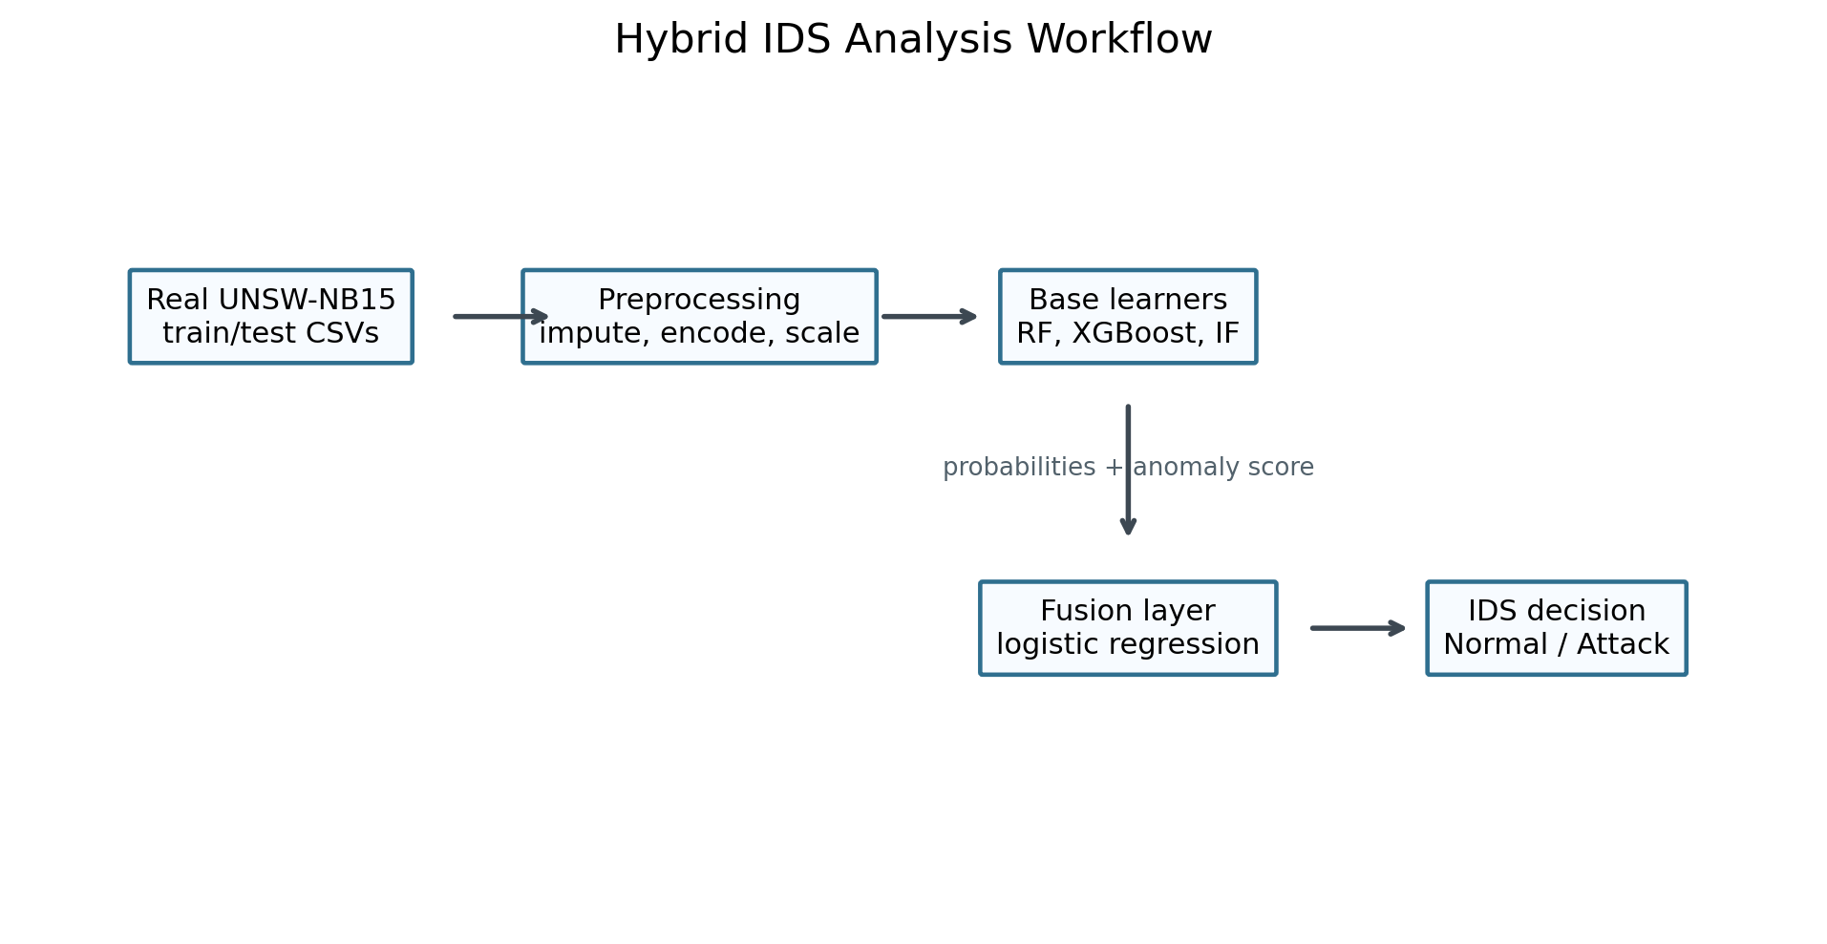
Figure 1. Updated research workflow using the real UNSW-NB15 dataset.

5. Proposed Methodology
The methodology follows an applied quantitative research design. The official training split is used for model fitting and the official testing split is used for evaluation. Numerical features are median-imputed and standardized. Categorical features such as protocol, service, and connection state are mode-imputed and one-hot encoded. The id column is removed because it identifies records rather than network behavior. The attack_cat column is excluded from binary model features to avoid label leakage.
Four model groups are evaluated. Logistic Regression is included as a simple linear baseline. Random Forest represents bagged decision-tree learning and is useful for non-linear tabular patterns. XGBoost represents boosted tree learning and is often strong on structured IDS datasets. Isolation Forest is used inside the hybrid model to contribute an anomaly score, which is normalized and combined with supervised probabilities.
The hybrid model has two stages. First, Random Forest and XGBoost produce attack probabilities, while Isolation Forest produces anomaly scores. Second, these three outputs are stacked into a compact meta-feature matrix. A logistic regression fusion layer learns how to weight the signals and outputs the final intrusion probability. This design keeps the fusion layer interpretable while allowing the base learners to capture richer traffic behavior.

6. Evaluation Metrics
Intrusion detection evaluation must consider both attack detection and false alarm behavior. Accuracy can be misleading when normal and attack classes are imbalanced, so this paper also reports precision, recall, F1-score, ROC-AUC, PR-AUC, false positive rate, and false negative rate.
Precision:
Precision = TP / (TP + FP)
Recall:
Recall = TP / (TP + FN)
F1-score:
F1 = 2 x (Precision x Recall) / (Precision + Recall)
False Positive Rate:
FPR = FP / (FP + TN)
False Negative Rate:
FNR = FN / (FN + TP)
For IDS use, recall measures how many actual attacks are detected, while precision measures how many generated alerts are truly malicious. FPR is important because high false alarms can overwhelm analysts. FNR is critical because missed attacks may allow compromise. ROC-AUC measures ranking quality across thresholds, and PR-AUC is especially useful when the attack distribution is imbalanced.

7. Results and Analysis
Model | Accuracy | Precision | Recall | F1 | ROC AUC | PR AUC | False Positive Rate | False Negative Rate
XGBoost | 0.9123 | 0.8872 | 0.9632 | 0.9237 | 0.9854 | 0.9892 | 0.1501 | 0.0368
Random Forest | 0.8694 | 0.8148 | 0.9873 | 0.8928 | 0.9800 | 0.9834 | 0.2750 | 0.0127
Hybrid RF + XGBoost + Isolation Forest | 0.8680 | 0.8125 | 0.9883 | 0.8918 | 0.9787 | 0.9810 | 0.2794 | 0.0117
Logistic Regression | 0.8356 | 0.8023 | 0.9308 | 0.8618 | 0.9559 | 0.9667 | 0.2810 | 0.0692
Table 2. Model performance on the real UNSW-NB15 test split.
The best F1-score was achieved by XGBoost. This result indicates the strongest balance between precision and recall for the default threshold used in the experiment. The comparison also shows whether the hybrid fusion layer improved over the strongest individual base learner or whether one supervised learner already captured most of the useful decision boundary.
The confusion matrix explains the operational meaning of the metrics. False positives represent benign traffic that would become analyst workload. False negatives represent attacks that the IDS missed. In practice, the final threshold should be selected according to the organization's risk tolerance; a critical infrastructure environment may accept more false positives to reduce missed attacks, while a high-volume enterprise SOC may need a stricter alert budget.
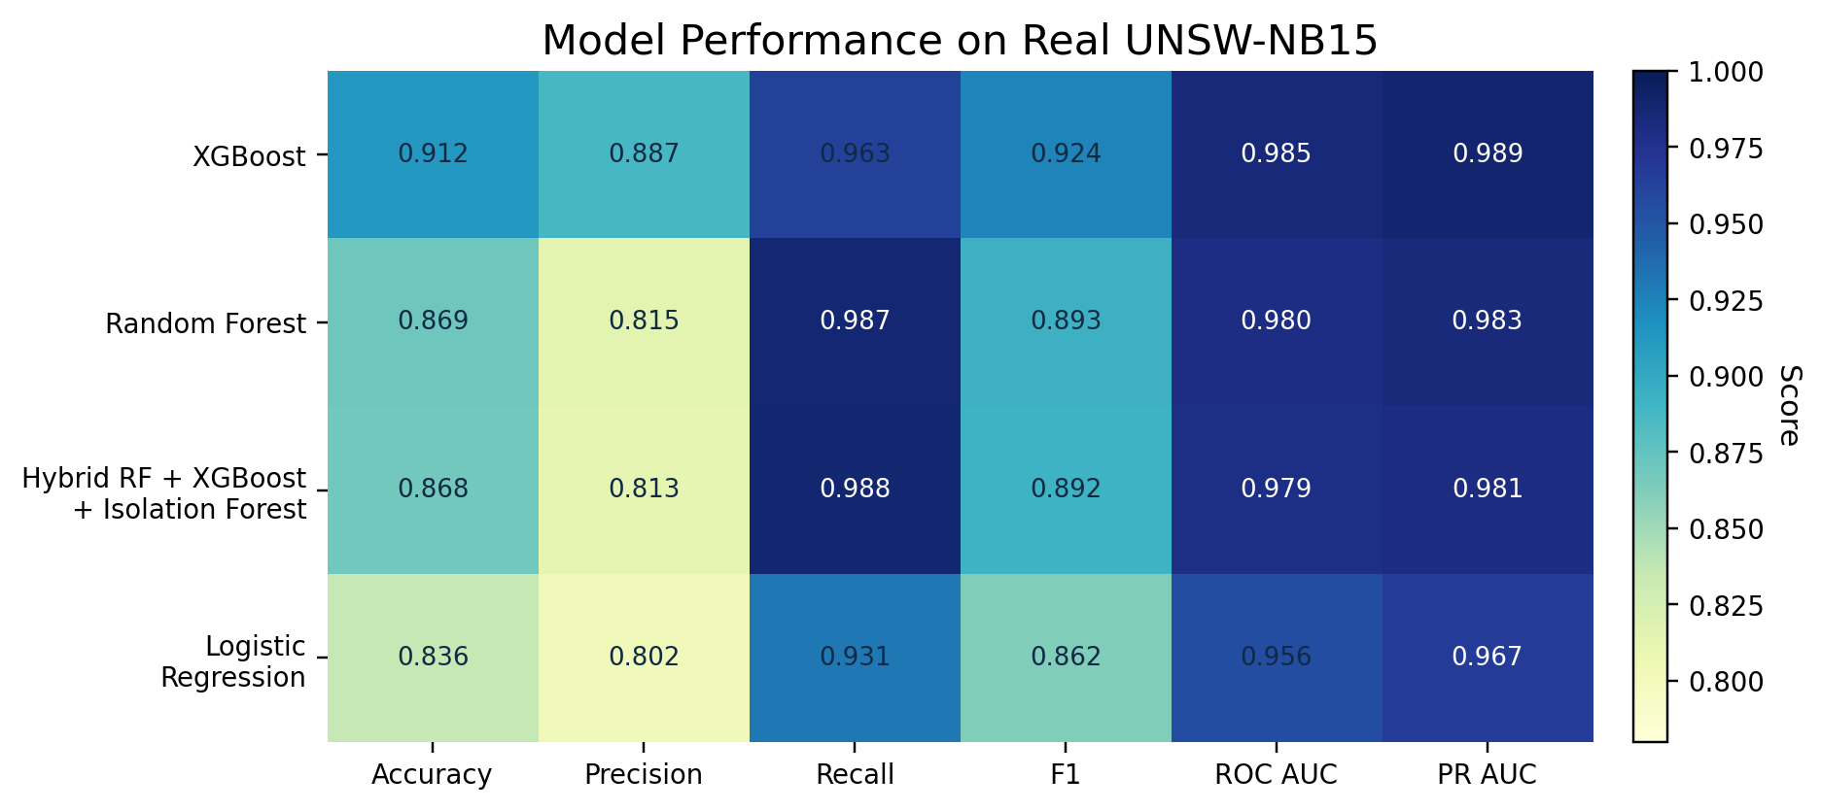
Figure 2. Model comparison across major IDS metrics.
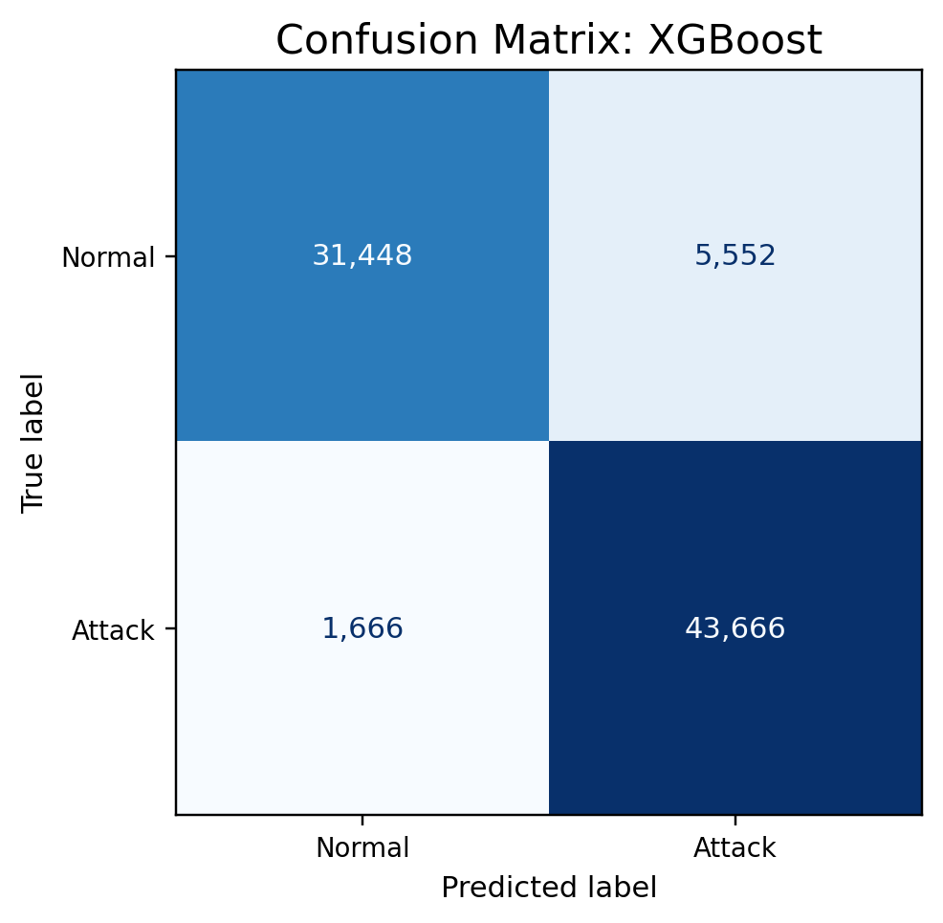
Figure 3. Confusion matrix for the strongest model in the real-data run.
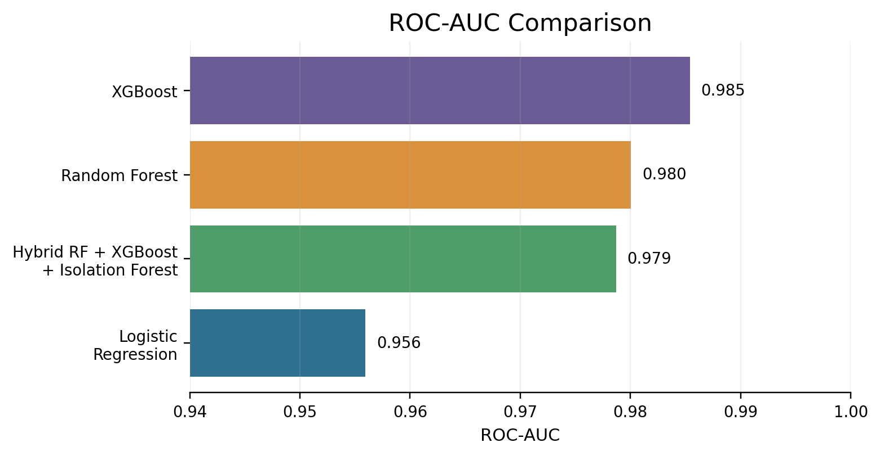
Figure 4. ROC-AUC comparison across evaluated models.
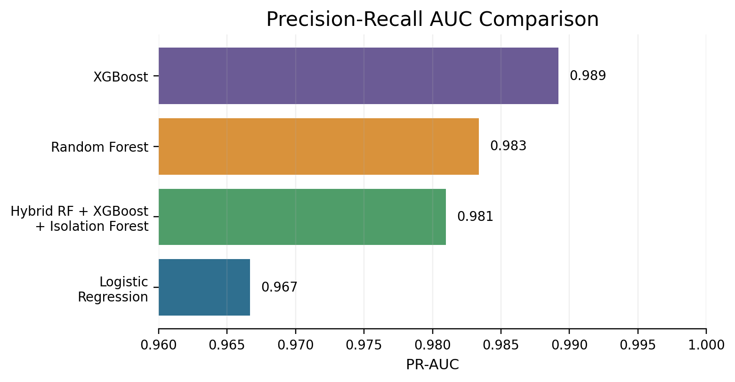
Figure 5. Precision-recall AUC comparison across evaluated models.

8. Discussion
The updated results are more defensible than the earlier sample-data results because they are produced from the real UNSW-NB15 split. Real benchmark data contains class overlap, feature noise, categorical protocol behavior, and attack-category imbalance that a small synthetic file cannot represent. This makes the reported performance more meaningful for academic discussion.
The hybrid model is theoretically useful because it combines classification confidence with anomaly evidence. If Random Forest and XGBoost agree strongly, the fusion layer can make a high-confidence decision. If supervised probabilities are uncertain but the Isolation Forest score is unusual, the fusion layer can still incorporate anomaly evidence. This is important for intrusion detection because new or rare attacks may not always resemble frequent training examples.
However, high benchmark performance should not be interpreted as deployment readiness. Live traffic may differ from UNSW-NB15 because of encryption, routing policy, cloud service behavior, user geography, and concept drift. A production IDS would require periodic retraining, feature monitoring, calibrated thresholds, alert triage integration, and external validation on newer network traces.

9. Limitations
- The paper evaluates binary classification only; attack-family multiclass classification remains future work.
- UNSW-NB15 is a benchmark dataset and cannot fully represent every modern cloud, enterprise, or IoT network.
- The fusion threshold is fixed at 0.5; operational deployment should tune the threshold using alert cost and risk tolerance.
- The model does not yet include SHAP/LIME explanations, drift detection, streaming inference, or SIEM integration.

10. Future Scope
- Extend the pipeline to multiclass attack_cat prediction for attack-family identification.
- Add SHAP-based explanations for top features behind each malicious classification.
- Evaluate cross-dataset generalization using CIC-IDS2017, BoT-IoT, ToN-IoT, or NF-UNSW-NB15.
- Tune thresholds using cost-sensitive IDS objectives instead of a fixed 0.5 cutoff.
- Develop a streaming prototype that produces alerts with timestamp, predicted class, confidence, and explanation.

11. Conclusion
This updated research paper presents a hybrid machine learning intrusion detection system evaluated on the real UNSW-NB15 training and testing files. The work replaces the sample-dataset basis with a stronger experimental foundation, updates the literature review to 2021-2026 papers, and explains the modeling pipeline in greater detail. The hybrid approach is a practical research direction because it combines supervised ensemble probabilities with anomaly detection evidence, but final deployment still requires multiclass testing, explainability, drift monitoring, and live-traffic validation.

References
- Mabulage, D., & Athuraliya, B. (2026). LiteShield: Hybrid Feature Selection-Driven Lightweight Intrusion Detection for Resource-Constrained IoT Networks. arXiv:2605.02987. https://arxiv.org/abs/2605.02987
- Hossain, M. Z., et al. (2026). Assessing Generalisation Capability of Machine Learning Models for Intrusion Detection. arXiv:2605.04407. https://arxiv.org/abs/2605.04407
- Alhusseini, M. M., Rouhi, A., & Feizi-Derakhshi, M.-R. (2026). AI-Powered Hybrid Intrusion Detection Framework for Cloud Security Using Novel Metaheuristic Optimization. arXiv:2601.01134. https://arxiv.org/abs/2601.01134
- Hussein, S. A., & Repas, S. R. (2026). A Hybrid Intrusion Detection Framework Using Deep Autoencoder and Machine Learning Models. AI, 7(2), 39. https://www.mdpi.com/2673-2688/7/2/39
- A Rigorous Comparative Study of Supervised Machine Learning Techniques for Network Anomaly Detection: Empirical Insights from the UNSW-NB15 Dataset. (2026). Computers, 15(5), 285. https://www.mdpi.com/2073-431X/15/5/285
- Farhan, M., et al. (2025). Network-based intrusion detection using deep learning technique. Scientific Reports, 15, 25550. https://www.nature.com/articles/s41598-025-08770-0
- Ali, M., et al. (2025). Botnet detection in internet of things using stacked ensemble learning model. Scientific Reports, 15, 21012. https://www.nature.com/articles/s41598-025-02008-9
- Li, Z., et al. (2025). Generating detectors from anomaly samples via negative selection for network intrusion detection. Scientific Reports, 15, 36456. https://www.nature.com/articles/s41598-025-20516-6
- xIDS-EnsembleGuard: An Explainable Ensemble Learning-based Intrusion Detection System. (2025). arXiv:2503.00615. https://arxiv.org/abs/2503.00615
- Network Intrusion Detection through Stacked Machine Learning Models on UNSW-NB15 Data Set. (2025). SCITEPRESS. https://www.scitepress.org/Papers/2025/139326/139326.pdf
- A new intrusion detection method using ensemble classification and feature selection. (2025). Scientific Reports. https://www.nature.com/articles/s41598-025-98604-w
- Varzaneh, Z. A., & Hosseini, S. (2024). An improved equilibrium optimization algorithm for feature selection problem in network intrusion detection. Scientific Reports, 14, 18696. https://www.nature.com/articles/s41598-024-67488-7
- Explainable AI for Comparative Analysis of Intrusion Detection Models. (2024). arXiv:2406.09684. https://arxiv.org/abs/2406.09684
- Zoghi, Z., & Serpen, G. (2022). Ensemble Classifier Design Tuned to Dataset Characteristics for Network Intrusion Detection. arXiv:2205.06177. https://arxiv.org/abs/2205.06177
- Yin, Y., Jang-Jaccard, J., Xu, W., Singh, A., Zhu, J., Sabrina, F., & Kwak, J. (2022). IGRF-RFE: A Hybrid Feature Selection Method for MLP-based Network Intrusion Detection on UNSW-NB15 Dataset. arXiv:2203.16365. https://arxiv.org/abs/2203.16365
- UNSW-NB15 Computer Security Dataset: Analysis through Visualization. (2021). arXiv:2101.05067. https://arxiv.org/abs/2101.05067

