Hybrid Machine Learning Intrusion Detection on the Real UNSW-NB15 Dataset
Revised report with clearer grammar, project-specific methodology, and 2021-2026 literature
Author: Shivani Nayak
Department of Computer Science and Engineering

Abstract
Modern network security teams work with traffic that is larger, noisier, and more varied than the traffic handled by traditional rule-based tools. Cloud workloads, remote access, APIs, IoT devices, and encrypted services all increase the number of places where malicious behavior can hide. Signature-based intrusion detection is still useful when an attack has a known pattern, but it is weaker when attacks change form or when rare attack categories appear only a few times in the training data. This report therefore studies a hybrid machine learning IDS using the real UNSW-NB15 training and testing files instead of a small synthetic sample.
The implemented pipeline compares Logistic Regression, Random Forest, XGBoost, and a hybrid model that combines Random Forest probability, XGBoost probability, and Isolation Forest anomaly evidence through a logistic regression fusion layer. In the real-data run, XGBoost produced the best overall balance: Accuracy=0.9123, Precision=0.8872, Recall=0.9632, F1-score=0.9237, ROC-AUC=0.9854, and PR-AUC=0.9892. The hybrid model reached very high recall, but its false positive rate was higher than XGBoost. This distinction is important because an IDS should not only detect attacks; it should also avoid creating an alert volume that analysts cannot manage.
Keywords: Intrusion Detection System, UNSW-NB15, Hybrid Machine Learning, Random Forest, XGBoost, Isolation Forest, Explainable AI, Cybersecurity

1. Introduction
Intrusion detection remains a practical security problem because enterprise networks no longer have a single, stable boundary. A normal day of traffic may include cloud storage, VPN connections, internal APIs, containers, IoT endpoints, and user devices moving between networks. Attackers can blend reconnaissance, exploit attempts, denial-of-service behavior, malware communication, and credential misuse into that background activity. A fixed signature may catch a familiar pattern, but it cannot reliably describe every new combination of protocol, service, packet timing, and connection state.
Machine learning is useful because it can learn decision patterns directly from labeled traffic records. Still, no single model is perfect for intrusion detection. A linear baseline is easy to interpret, but it can miss nonlinear relationships among features. Random Forest is stable on tabular data, although it may classify many borderline records as attacks. XGBoost can model sharper feature interactions and performed strongly in this project, but boosted trees can still learn benchmark-specific patterns. Anomaly detection adds a different view by asking whether a flow looks unusual, even when the supervised models are uncertain. The hybrid design in this report was built to test whether those views improve the final IDS decision.

2. Research Objectives and Contributions
- Replace the earlier sample-data evaluation with the real UNSW-NB15 training and testing CSV files used by the project pipeline.
- Use recent IDS studies from 2021 to 2026 so that the discussion reflects current work on ensembles, feature selection, explainability, and generalization.
- Compare a simple linear baseline, two supervised tree-based models, and a fusion model that adds anomaly evidence from Isolation Forest.
- Explain preprocessing choices, feature leakage prevention, model-fusion logic, and the meaning of false positives and false negatives for IDS deployment.
- Keep the updated charts from the real-data experiment so the report, tables, and figures all refer to the same run.

3. Recent Literature Review: 2021-2026
The recent literature shows a clear movement away from reporting only one benchmark classifier. Researchers now focus more on hybrid learning, feature selection, explainable decisions, lightweight deployment, and cross-dataset behavior. The 2021 UNSW-NB15 visualization study is useful because it reminds the reader that dataset structure should be understood before modeling. Zoghi and Serpen (2022) connect classifier choice to dataset characteristics, while Yin et al. (2022) show how hybrid feature selection can reduce dimensionality and support more accurate multiclass intrusion detection.
The 2024 and 2025 papers extend this direction by asking not only whether a model is accurate, but whether its decisions can be explained and trusted. XAI studies on UNSW-NB15 connect model output with interpretable evidence, while optimization-based feature-selection work treats feature choice as a major contributor to IDS quality. Other recent studies examine deep learning, stacked ensembles, negative selection, botnet detection, and ensemble feature selection. Together, they show that IDS evaluation must include false positives, false negatives, minority-class behavior, and alert cost rather than relying on accuracy alone.
The 2026 papers are especially relevant to the design choices made here. LiteShield emphasizes lightweight hybrid feature selection for constrained IoT systems. Hossain et al. discuss the difficulty of generalizing IDS models beyond the dataset used for training. Alhusseini et al. present a hybrid IDS direction for cloud security, and Hussein and Repas combine representation learning with machine learning classifiers. This report follows the same broad idea but keeps the implementation deliberately transparent: supervised tabular learners are compared first, then anomaly evidence is added through a simple fusion layer.

4. Dataset and Real-Data Replacement
The revised experiment uses the real files data/UNSW_NB15_training-set.csv and data/UNSW_NB15_testing-set.csv. These files replace the earlier sample_unsw_nb15_like.csv file for the research results. The sample file remains useful for quick checks, but it is too small and too artificial to support final conclusions. Using the official UNSW-NB15 splits makes the evaluation more credible because the model faces the class overlap, categorical feature behavior, and imbalance found in the benchmark.
UNSW-NB15 contains flow-level network features, a binary label, and an attack_cat field covering Analysis, Backdoor, DoS, Exploits, Fuzzers, Generic, Reconnaissance, Shellcode, and Worms. This report uses the binary label for normal-versus-attack classification. The attack_cat column is not used as a binary input feature because that would leak target information into the model. It is retained in the project as a useful field for future multiclass reporting.
Split | Records | Normal | Attack
Training split | 175,341 | 56,000 | 119,341
Testing split | 82,332 | 37,000 | 45,332
Table 1. Real UNSW-NB15 split used for the revised experiment.
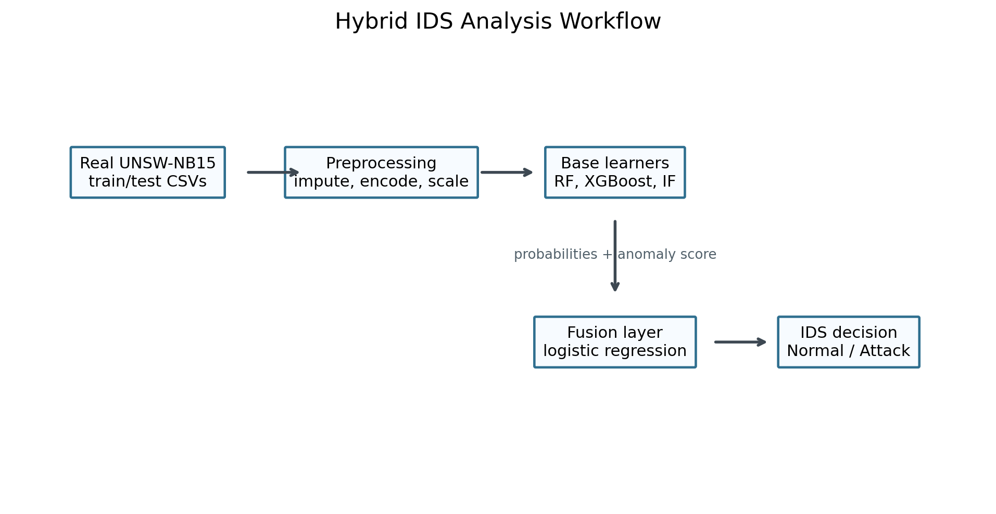
Figure 1. Research workflow followed for the real UNSW-NB15 experiment.

5. Proposed Methodology
The methodology follows an applied quantitative workflow. The real UNSW-NB15 data is loaded from CSV files, the target label is converted to an integer class, and record identifiers are excluded from the feature set. Numerical columns are median-imputed and standardized. Categorical columns such as protocol, service, and state are mode-imputed and one-hot encoded with unknown categories ignored at test time. These preprocessing steps are important because network records contain both continuous traffic measurements and symbolic protocol fields.
The experiment evaluates four model groups. Logistic Regression gives a readable baseline and helps show what a simple decision boundary can achieve. Random Forest uses many decision trees to capture nonlinear tabular patterns. XGBoost uses boosted trees and, in this run, learned the strongest balance between attack detection and alert precision. Isolation Forest is not used alone as the final classifier; instead, its anomaly score is normalized and passed into the hybrid fusion model.
The hybrid stage is intentionally compact. Random Forest and XGBoost first produce attack probabilities, while Isolation Forest produces an anomaly score based on how unusual each record appears after preprocessing. Those three values become a new meta-feature row for each record. A logistic regression fusion layer then learns how to weight the supervised and anomaly-based signals. This design keeps the final decision understandable, but the result also shows a trade-off: the hybrid model caught slightly more attacks than XGBoost, yet it generated more false positives.

6. Evaluation Metrics
A useful IDS evaluation has to measure both detection strength and alert quality. Accuracy is reported, but it is not enough because attack and normal records are not always evenly balanced. The report therefore includes precision, recall, F1-score, ROC-AUC, PR-AUC, false positive rate, and false negative rate. These metrics make it easier to see whether a model is missing attacks or overwhelming analysts with benign alerts.
Precision:
Precision = TP / (TP + FP)
Recall:
Recall = TP / (TP + FN)
F1-score:
F1 = 2 x (Precision x Recall) / (Precision + Recall)
False Positive Rate:
FPR = FP / (FP + TN)
False Negative Rate:
FNR = FN / (FN + TP)
For IDS work, recall indicates the share of real attacks detected, while precision indicates how many alerts are truly malicious. False positive rate matters because benign traffic incorrectly flagged as malicious becomes analyst workload. False negative rate matters because missed attacks may remain active inside the network. ROC-AUC and PR-AUC summarize ranking behavior across thresholds, and PR-AUC is especially helpful when the attack distribution is uneven.

7. Results and Analysis
Model | Accuracy | Precision | Recall | F1 | ROC AUC | PR AUC | False Positive Rate | False Negative Rate
XGBoost | 0.9123 | 0.8872 | 0.9632 | 0.9237 | 0.9854 | 0.9892 | 0.1501 | 0.0368
Random Forest | 0.8694 | 0.8148 | 0.9873 | 0.8928 | 0.9800 | 0.9834 | 0.2750 | 0.0127
Hybrid RF + XGBoost + Isolation Forest | 0.8680 | 0.8125 | 0.9883 | 0.8918 | 0.9787 | 0.9810 | 0.2794 | 0.0117
Logistic Regression | 0.8356 | 0.8023 | 0.9308 | 0.8618 | 0.9559 | 0.9667 | 0.2810 | 0.0692
Table 2. Model performance on the real UNSW-NB15 test split.
XGBoost achieved the highest F1-score in the real UNSW-NB15 run. This means it gave the strongest balance between precision and recall at the default 0.5 threshold. Random Forest and the hybrid fusion model both achieved higher recall than XGBoost, but they also produced substantially higher false positive rates. For a security operations team, that difference would matter because more false positives can turn a technically sensitive detector into an impractical alert source.
The confusion matrix translates the metrics into operational terms. A false positive is normal traffic that still becomes an alert. A false negative is attack traffic that the IDS misses. In a strict environment, such as critical infrastructure, accepting more false positives may be reasonable if it reduces missed attacks. In a high-volume enterprise SOC, however, a lower false positive rate may be necessary so analysts can respond to the alerts that matter most. This is why threshold tuning should be treated as part of deployment rather than an afterthought.
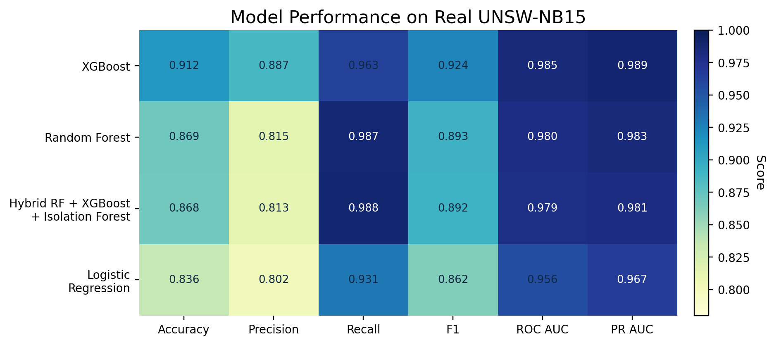
Figure 2. Comparison of major IDS metrics across models.
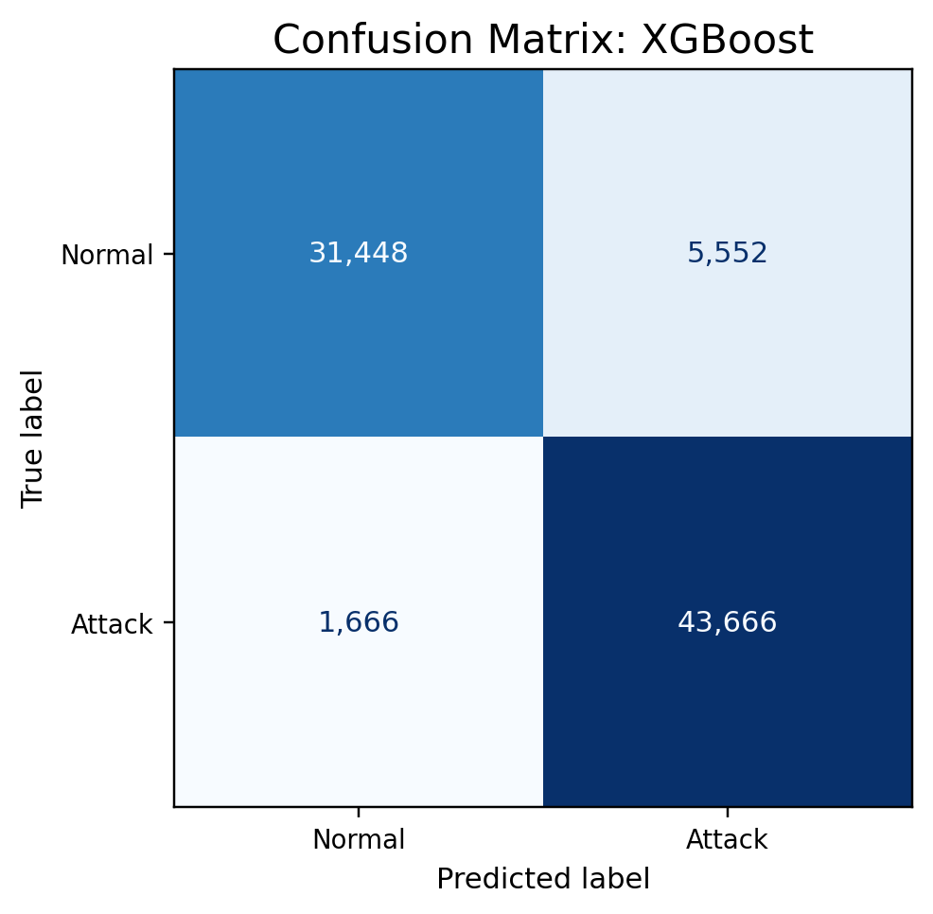
Figure 3. Confusion matrix for the best-performing model in the real-data run.
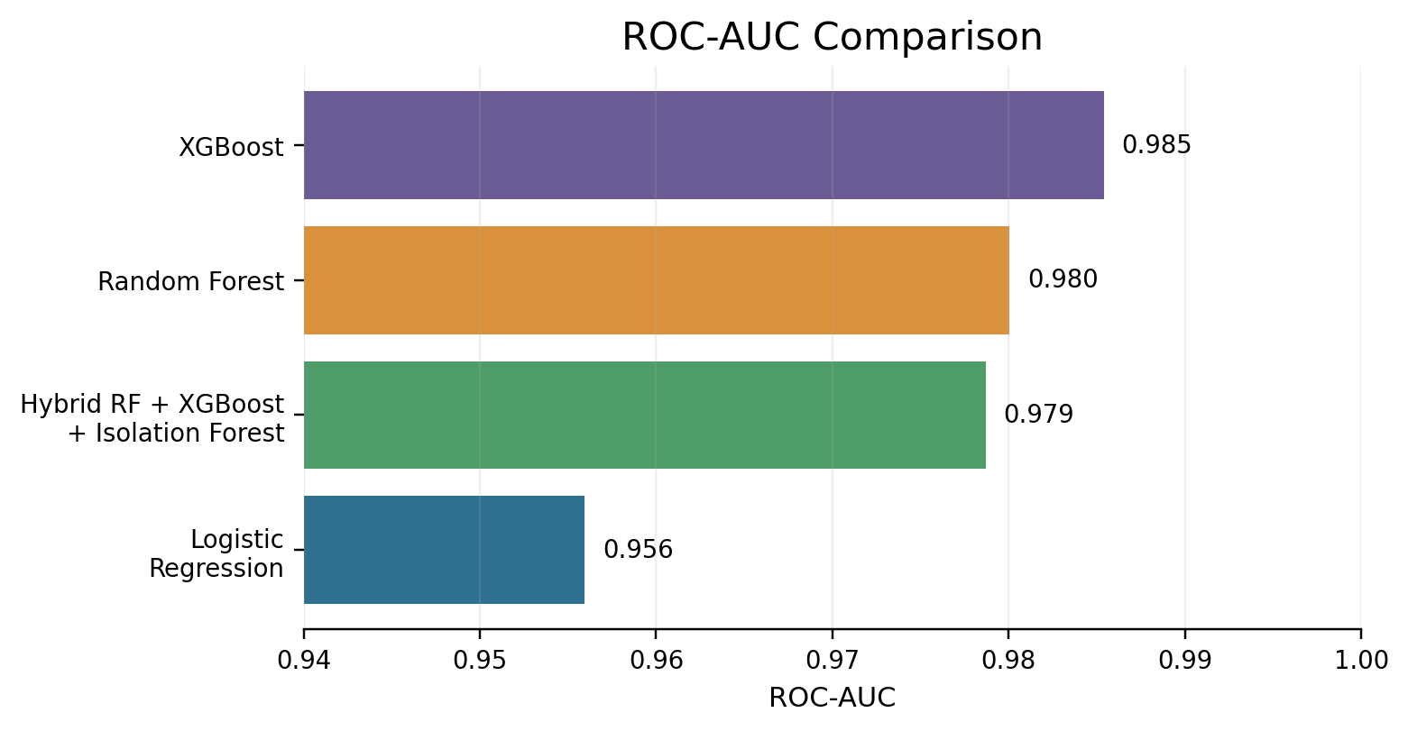
Figure 4. ROC-AUC comparison for the evaluated models.
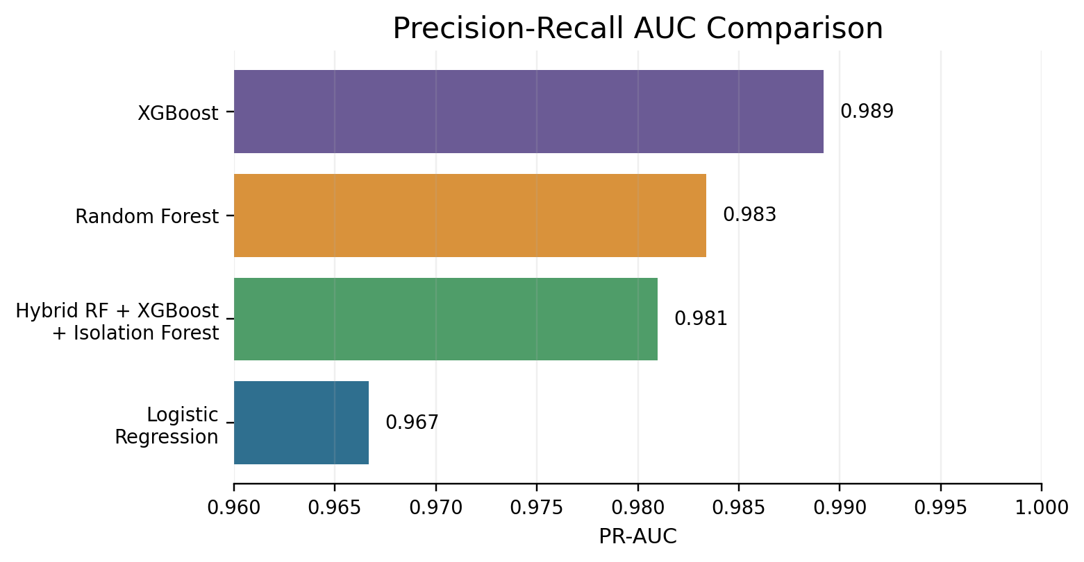
Figure 5. Precision-recall AUC comparison for the evaluated models.

8. Discussion
The revised results are more useful than the earlier sample-data results because they are produced from the real UNSW-NB15 benchmark files. The benchmark contains noisy features, mixed categorical and numeric fields, class overlap, and uneven attack categories. Those properties make the experiment harder, but they also make the discussion more realistic. A small synthetic file can show that code runs; it cannot show whether a model handles real benchmark behavior.
The hybrid model remains valuable as a research direction even though XGBoost was the strongest model in this run. The fusion model had the lowest false negative rate among the compared systems, which means it missed fewer attacks. Its weakness was the higher false positive rate. That result suggests that the next improvement should not simply add more models; it should tune the fusion threshold, calibrate probabilities, or use cost-sensitive learning so the model can balance detection and alert volume more carefully.
Benchmark performance should also be separated from deployment readiness. Live traffic may differ from UNSW-NB15 because of encrypted sessions, cloud routing, user geography, software updates, and concept drift. A production IDS would require monitoring for feature drift, retraining schedules, threshold calibration, explainable alert summaries, and validation on newer network traces. The current work is therefore best understood as a research-grade evaluation pipeline rather than a complete production security product.

9. Limitations
- The current evaluation is binary only; it detects normal versus attack traffic but does not yet classify individual attack families.
- UNSW-NB15 is a respected benchmark, but it cannot fully represent every modern cloud, enterprise, IoT, or encrypted network environment.
- The default threshold is fixed at 0.5; a deployed IDS should tune this threshold according to alert cost and risk tolerance.
- The pipeline does not yet include SHAP or LIME explanations, probability calibration, drift monitoring, streaming inference, or SIEM integration.

10. Future Scope
- Extend the workflow to multiclass attack_cat prediction so the IDS can identify the likely attack family, not only the binary class.
- Add SHAP-based explanations so each malicious prediction can be linked to the most influential traffic features.
- Test generalization on CIC-IDS2017, BoT-IoT, ToN-IoT, or NF-UNSW-NB15 to check whether the model transfers beyond one benchmark.
- Tune the decision threshold with cost-sensitive objectives so false positives and false negatives are balanced according to the deployment setting.
- Develop a streaming prototype that outputs timestamp, predicted class, confidence, explanation, and recommended analyst action.

11. Conclusion
This report presents a hybrid machine learning intrusion detection study evaluated on the real UNSW-NB15 training and testing files. The revised work replaces the earlier sample-data basis, updates the literature review with 2021-2026 sources, and explains the practical meaning of the model results. XGBoost produced the best F1-score and a lower false positive rate than the hybrid model, while the hybrid model showed the benefit of anomaly evidence through very high recall. The main conclusion is therefore balanced: hybrid IDS design is promising, but deployment-quality performance requires threshold tuning, explainability, multiclass testing, drift monitoring, and validation on newer live or cross-dataset traffic.

References
- Mabulage, D., & Athuraliya, B. (2026). LiteShield: Hybrid Feature Selection-Driven Lightweight Intrusion Detection for Resource-Constrained IoT Networks. arXiv:2605.02987. https://arxiv.org/abs/2605.02987
- Hossain, M. Z., et al. (2026). Assessing Generalisation Capability of Machine Learning Models for Intrusion Detection. arXiv:2605.04407. https://arxiv.org/abs/2605.04407
- Alhusseini, M. M., Rouhi, A., & Feizi-Derakhshi, M.-R. (2026). AI-Powered Hybrid Intrusion Detection Framework for Cloud Security Using Novel Metaheuristic Optimization. arXiv:2601.01134. https://arxiv.org/abs/2601.01134
- Hussein, S. A., & Repas, S. R. (2026). A Hybrid Intrusion Detection Framework Using Deep Autoencoder and Machine Learning Models. AI, 7(2), 39. https://www.mdpi.com/2673-2688/7/2/39
- A Rigorous Comparative Study of Supervised Machine Learning Techniques for Network Anomaly Detection: Empirical Insights from the UNSW-NB15 Dataset. (2026). Computers, 15(5), 285. https://www.mdpi.com/2073-431X/15/5/285
- Farhan, M., et al. (2025). Network-based intrusion detection using deep learning technique. Scientific Reports, 15, 25550. https://www.nature.com/articles/s41598-025-08770-0
- Ali, M., et al. (2025). Botnet detection in internet of things using stacked ensemble learning model. Scientific Reports, 15, 21012. https://www.nature.com/articles/s41598-025-02008-9
- Li, Z., et al. (2025). Generating detectors from anomaly samples via negative selection for network intrusion detection. Scientific Reports, 15, 36456. https://www.nature.com/articles/s41598-025-20516-6
- xIDS-EnsembleGuard: An Explainable Ensemble Learning-based Intrusion Detection System. (2025). arXiv:2503.00615. https://arxiv.org/abs/2503.00615
- Network Intrusion Detection through Stacked Machine Learning Models on UNSW-NB15 Data Set. (2025). SCITEPRESS. https://www.scitepress.org/Papers/2025/139326/139326.pdf
- A new intrusion detection method using ensemble classification and feature selection. (2025). Scientific Reports. https://www.nature.com/articles/s41598-025-98604-w
- Varzaneh, Z. A., & Hosseini, S. (2024). An improved equilibrium optimization algorithm for feature selection problem in network intrusion detection. Scientific Reports, 14, 18696. https://www.nature.com/articles/s41598-024-67488-7
- Explainable AI for Comparative Analysis of Intrusion Detection Models. (2024). arXiv:2406.09684. https://arxiv.org/abs/2406.09684
- Zoghi, Z., & Serpen, G. (2022). Ensemble Classifier Design Tuned to Dataset Characteristics for Network Intrusion Detection. arXiv:2205.06177. https://arxiv.org/abs/2205.06177
- Yin, Y., Jang-Jaccard, J., Xu, W., Singh, A., Zhu, J., Sabrina, F., & Kwak, J. (2022). IGRF-RFE: A Hybrid Feature Selection Method for MLP-based Network Intrusion Detection on UNSW-NB15 Dataset. arXiv:2203.16365. https://arxiv.org/abs/2203.16365
- UNSW-NB15 Computer Security Dataset: Analysis through Visualization. (2021). arXiv:2101.05067. https://arxiv.org/abs/2101.05067

