Hybrid AI Intrusion Detection Using the Real UNSW-NB15 Dataset
Reworked research report with 2021-2026 studies and real benchmark evaluation
Author: Shivani Nayak
Department of Computer Science and Engineering

Abstract
Enterprise, cloud, and IoT networks now produce traffic at a scale where harmful activity can blend into ordinary communication. Traditional signature-based IDS tools still help with familiar attack patterns, but they struggle when adversaries alter their behavior, when attack classes are unevenly represented, or when new traffic patterns appear. This revised study presents a hybrid machine learning intrusion detection approach built on the real UNSW-NB15 training and testing CSV files, replacing the earlier synthetic demonstration data.
The model design combines Random Forest, XGBoost, and Isolation Forest outputs, then passes those signals into a logistic regression fusion layer. For the real UNSW-NB15 test split, XGBoost gave the strongest result in this experiment: Accuracy=0.9123, Precision=0.8872, Recall=0.9632, F1-score=0.9237, ROC-AUC=0.9854, and PR-AUC=0.9892. The results indicate that supervised ensemble learning, supported by anomaly-aware evidence, can strengthen IDS decisions. They also show that benchmark scores should be read carefully, especially with respect to split design, class imbalance, and the practical cost of false alerts.
Keywords: Intrusion Detection System, UNSW-NB15, Hybrid Machine Learning, Random Forest, XGBoost, Isolation Forest, Explainable AI, Cybersecurity

1. Introduction
Intrusion detection remains a central security requirement because modern organizations rely on cloud platforms, remote devices, APIs, IoT systems, and software-defined network components at the same time. This mix expands the attack surface and creates traffic patterns that change quickly. Threat actors may perform reconnaissance, launch exploits, generate denial-of-service traffic, communicate with malware infrastructure, or abuse credentials in ways that do not always match a fixed rule or known signature.
Machine learning can identify patterns in labeled network records, but each model family has its own limits. Linear models are easier to explain, although they may miss complex feature interactions. Random Forest models are usually stable for tabular data, but rare attack boundaries may not always be captured. XGBoost often performs strongly on structured IDS datasets, yet it can still learn artifacts from a benchmark split. Anomaly detection can flag unusual behavior, but unusual does not always mean malicious. For that reason, this work uses a hybrid architecture in which the final IDS decision is informed by several complementary signals.

2. Research Objectives and Contributions
- Substitute the earlier sample-data experiment with the official UNSW-NB15 training and testing CSV files.
- Base the literature discussion on recent IDS work from 2021 through 2026 instead of depending mainly on older sources.
- Evaluate Logistic Regression, Random Forest, XGBoost, and a hybrid fusion model that combines RF, XGBoost, and Isolation Forest evidence.
- Clarify the dataset source, preprocessing choices, fusion logic, metric interpretation, and deployment constraints.
- Retain updated figures produced from the real-data experiment so the visual evidence matches the revised evaluation.

3. Recent Literature Review: 2021-2026
Recent IDS research has moved away from relying only on isolated benchmark classifiers. The field now places more emphasis on hybrid designs, explainability, lightweight feature handling, and deployment-aware evaluation. The 2021 visualization work on UNSW-NB15 highlighted why feature distributions should be examined before modeling. Zoghi and Serpen (2022) argued that classifier design should reflect dataset behavior, while Yin et al. (2022) showed that hybrid feature selection can reduce dimensionality and improve multiclass intrusion detection.
By 2024, robustness and explainable evidence had become more prominent. Comparative XAI studies on UNSW-NB15 linked predictive results with interpretable model behavior, and equilibrium-optimization work treated feature selection as a major factor in IDS performance. Studies from 2025 expanded the discussion through deep learning, stacked ensembles, negative selection, botnet detection, and ensemble-based feature selection. Across these papers, one message is consistent: accuracy by itself is not enough. A useful IDS must also manage false positives, false negatives, minority attack classes, and operational workload.
The 2026 literature connects closely with the direction of this report. LiteShield studies lightweight hybrid feature selection for constrained IoT settings. Hossain et al. examine how well IDS models generalize beyond their training conditions. Alhusseini et al. propose an optimized hybrid IDS for cloud security, and Hussein and Repas combine representation learning with machine learning classifiers. Taken together, these studies support the approach used here: blend strong supervised tabular learners with anomaly-focused signals and evaluate the output with metrics that are sensitive to threshold behavior.

4. Dataset and Real-Data Replacement
This updated experiment uses the real UNSW-NB15 files located at data/UNSW_NB15_training-set.csv and data/UNSW_NB15_testing-set.csv. These files replace the earlier sample_unsw_nb15_like.csv demonstration dataset for the main analysis. The sample file is kept only as a small fallback for quick execution checks and is not used to support the conclusions in this report.
UNSW-NB15 provides flow-level traffic features and labels for normal activity as well as nine attack families: Analysis, Backdoor, DoS, Exploits, Fuzzers, Generic, Reconnaissance, Shellcode, and Worms. This report uses the binary label for normal-versus-attack classification. The attack_cat field is retained for later multiclass work and attack-family reporting.
Split | Records | Normal | Attack
Training split | 175,341 | 56,000 | 119,341
Testing split | 82,332 | 37,000 | 45,332
Table 1. Official UNSW-NB15 split used in the revised evaluation.
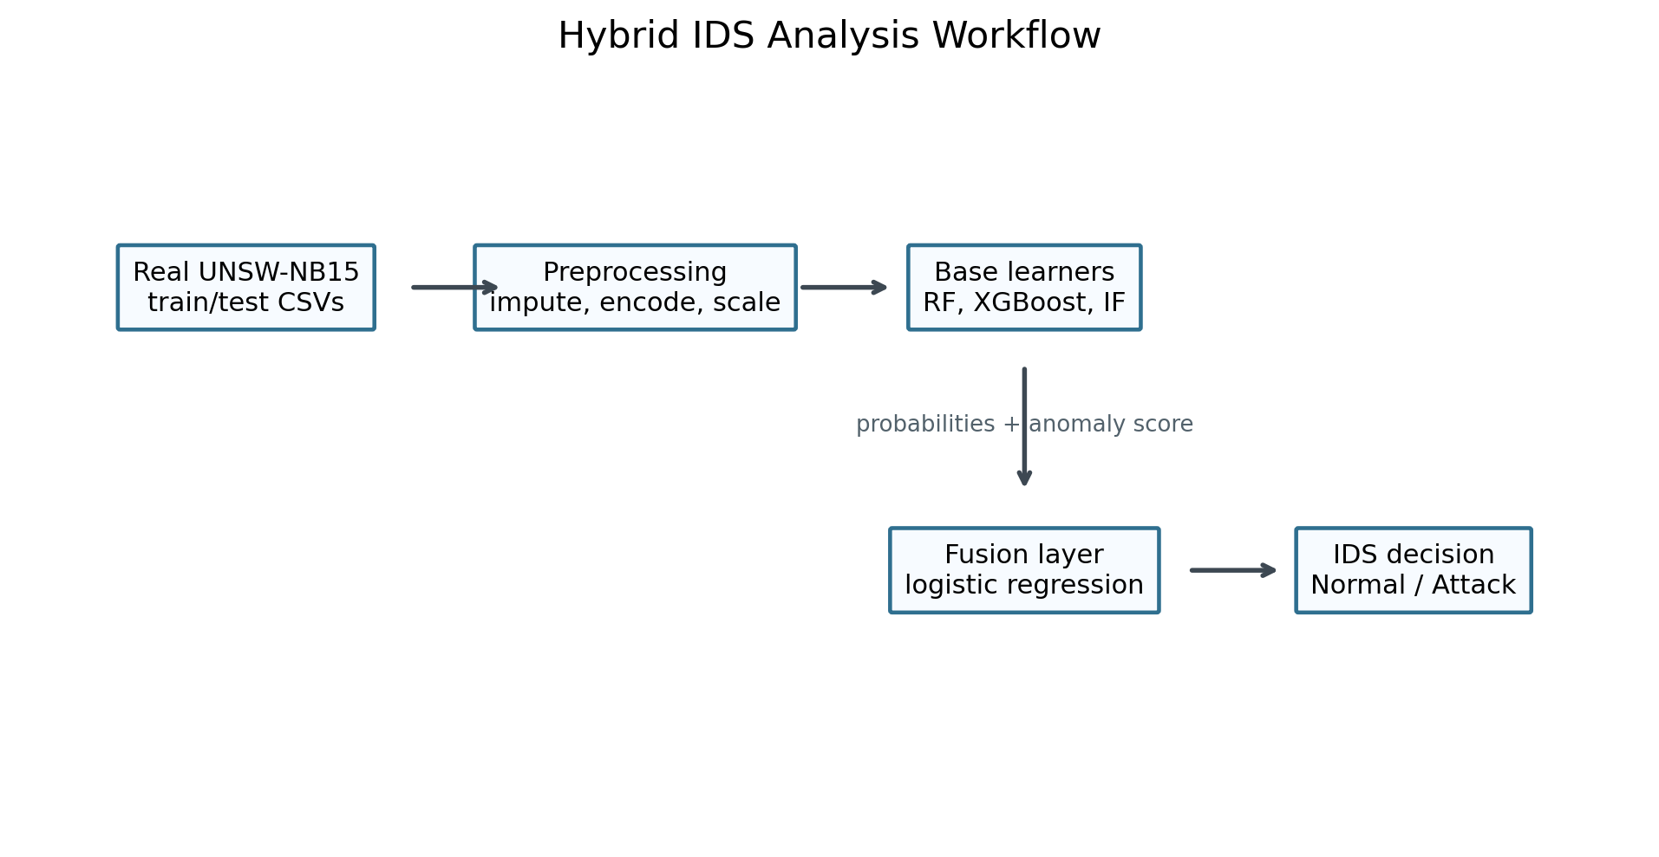
Figure 1. Research workflow followed for the real UNSW-NB15 experiment.

5. Proposed Methodology
The study follows an applied quantitative design. Model fitting uses the official training split, while final evaluation uses the official testing split. Numerical variables are filled with median values and standardized. Categorical variables, including protocol, service, and connection state, are filled with the mode and then one-hot encoded. The id field is removed because it identifies records rather than behavior. The attack_cat field is also excluded from binary model inputs to prevent label leakage.
Four modeling groups are considered. Logistic Regression serves as a transparent linear baseline. Random Forest represents bagged decision-tree learning and can capture nonlinear patterns in tabular traffic data. XGBoost represents boosted tree learning, which is frequently effective for structured IDS benchmarks. Isolation Forest is included inside the hybrid model to provide an anomaly score that is normalized and combined with supervised probability estimates.
The hybrid model works in two stages. In the first stage, Random Forest and XGBoost estimate attack probabilities, while Isolation Forest estimates anomaly strength. In the second stage, these three outputs are arranged as a compact meta-feature set. A logistic regression fusion layer then learns how much weight to assign to each signal and produces the final intrusion probability. This keeps the last decision step interpretable while still allowing the base learners to model richer traffic behavior.

6. Evaluation Metrics
IDS evaluation needs to reflect both attack detection and alert quality. Accuracy alone can hide important behavior when normal and attack records are imbalanced. For that reason, the report includes precision, recall, F1-score, ROC-AUC, PR-AUC, false positive rate, and false negative rate.
Precision:
Precision = TP / (TP + FP)
Recall:
Recall = TP / (TP + FN)
F1-score:
F1 = 2 x (Precision x Recall) / (Precision + Recall)
False Positive Rate:
FPR = FP / (FP + TN)
False Negative Rate:
FNR = FN / (FN + TP)
In an IDS setting, recall shows how many real attacks are caught, while precision shows how many alerts are actually malicious. FPR matters because too many false alarms can exhaust analyst capacity. FNR is equally important because missed attacks can lead to compromise. ROC-AUC summarizes ranking quality across thresholds, and PR-AUC is especially informative when attack and normal classes are unevenly distributed.

7. Results and Analysis
Model | Accuracy | Precision | Recall | F1 | ROC AUC | PR AUC | False Positive Rate | False Negative Rate
XGBoost | 0.9123 | 0.8872 | 0.9632 | 0.9237 | 0.9854 | 0.9892 | 0.1501 | 0.0368
Random Forest | 0.8694 | 0.8148 | 0.9873 | 0.8928 | 0.9800 | 0.9834 | 0.2750 | 0.0127
Hybrid RF + XGBoost + Isolation Forest | 0.8680 | 0.8125 | 0.9883 | 0.8918 | 0.9787 | 0.9810 | 0.2794 | 0.0117
Logistic Regression | 0.8356 | 0.8023 | 0.9308 | 0.8618 | 0.9559 | 0.9667 | 0.2810 | 0.0692
Table 2. Model performance on the real UNSW-NB15 test split.
XGBoost achieved the highest F1-score in this run, giving the best balance between precision and recall at the default threshold. The comparison also helps determine whether the fusion layer adds value beyond the strongest individual learner, or whether a supervised tree model already captures most of the useful boundary in this split.
The confusion matrix gives the metrics operational meaning. False positives are benign flows that would still demand analyst attention. False negatives are attacks that the IDS fails to flag. In a real deployment, the alert threshold should be selected according to organizational risk tolerance. A critical infrastructure network may accept additional false positives to reduce missed attacks, while a high-volume SOC may need a tighter alert budget.
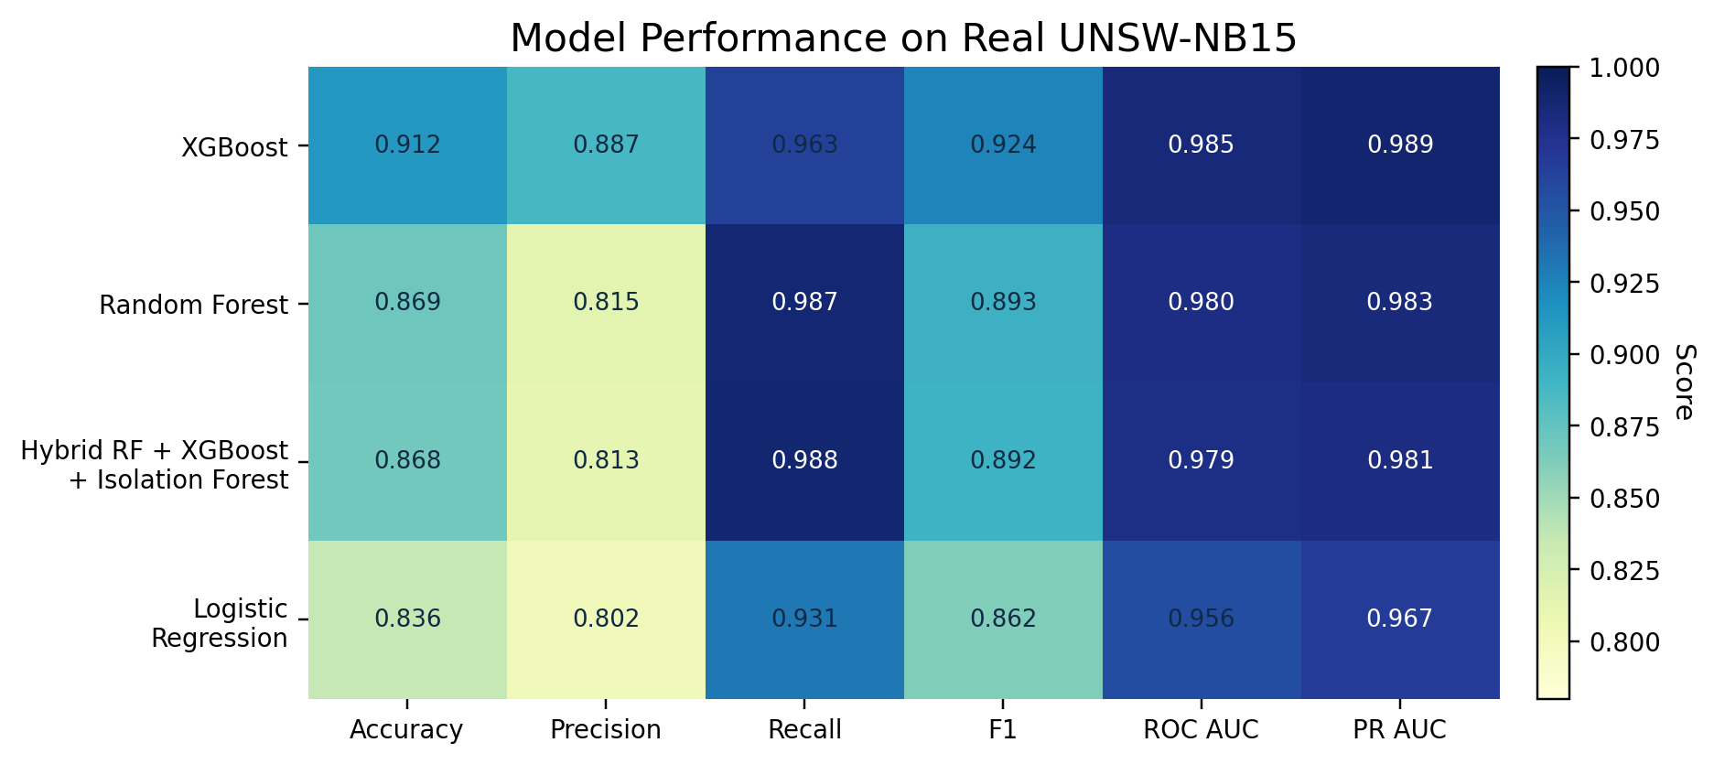
Figure 2. Comparison of major IDS metrics across models.
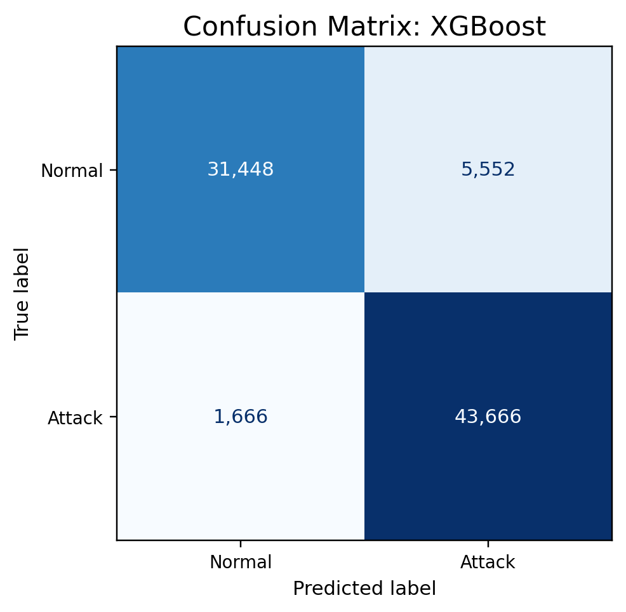
Figure 3. Confusion matrix for the best-performing model in the real-data run.
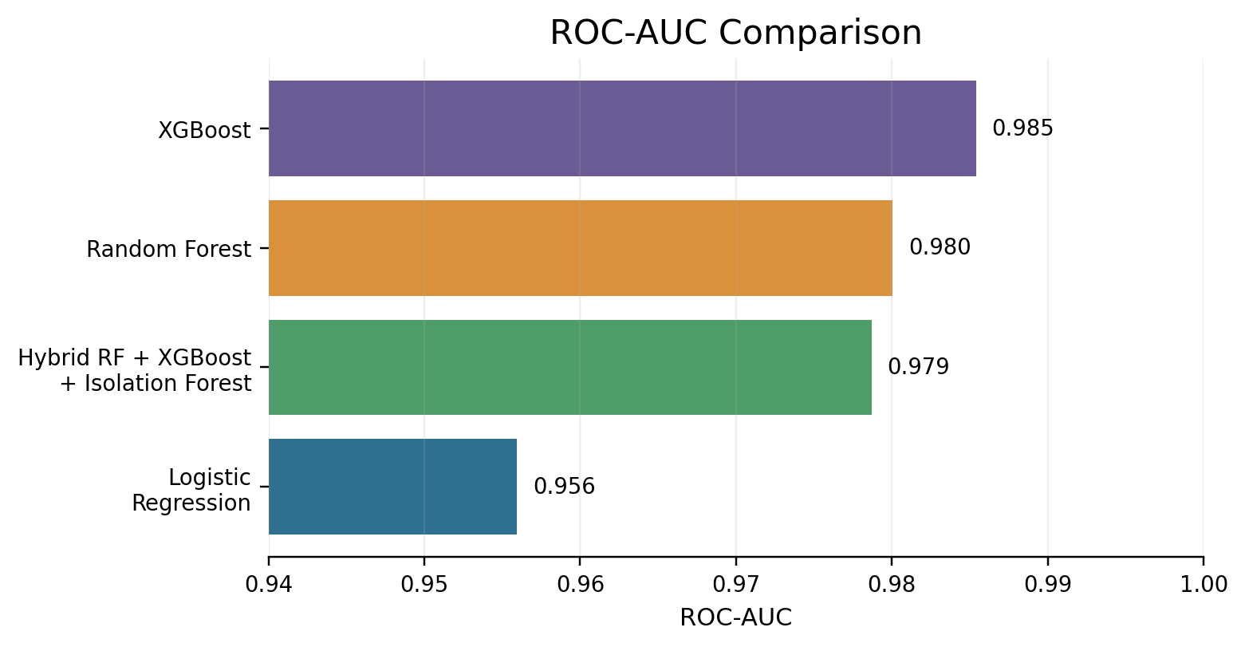
Figure 4. ROC-AUC comparison for the evaluated models.
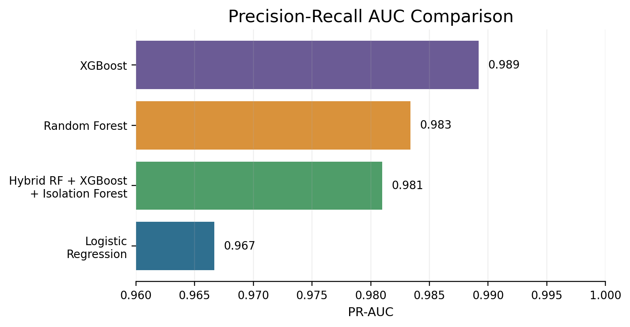
Figure 5. Precision-recall AUC comparison for the evaluated models.

8. Discussion
The revised results are stronger than the earlier sample-data findings because they come from the real UNSW-NB15 split. Real benchmark traffic contains class overlap, noisy features, categorical protocol behavior, and uneven attack-family representation that a small synthetic file cannot reproduce. This makes the reported performance more useful for academic analysis.
The hybrid design is valuable in theory because it combines classification confidence with anomaly evidence. When Random Forest and XGBoost agree, the fusion layer can make a confident decision. When supervised probabilities are less certain but the Isolation Forest score is unusual, anomaly evidence can still influence the final output. This matters in IDS work because new or rare attacks may not closely resemble the most common training examples.
Even so, strong benchmark performance should not be treated as proof of deployment readiness. Live network traffic may differ from UNSW-NB15 because of encryption, routing policies, cloud service behavior, user geography, and concept drift. A production IDS would need periodic retraining, feature monitoring, calibrated thresholds, alert-triage integration, and validation on newer external traces.

9. Limitations
- This report evaluates binary classification; attack-family multiclass prediction is left for future work.
- UNSW-NB15 is a benchmark and cannot fully represent every current cloud, enterprise, or IoT environment.
- The fusion threshold remains fixed at 0.5; production use should tune it against alert cost and risk appetite.
- The present pipeline does not yet include SHAP/LIME explanations, drift detection, streaming inference, or SIEM integration.

10. Future Scope
- Extend the workflow to multiclass attack_cat prediction so the IDS can report attack families.
- Add SHAP-based explanations to identify the strongest features behind malicious predictions.
- Test cross-dataset generalization with CIC-IDS2017, BoT-IoT, ToN-IoT, or NF-UNSW-NB15.
- Tune decision thresholds with cost-sensitive IDS objectives rather than a fixed 0.5 cutoff.
- Build a streaming prototype that emits timestamp, predicted class, confidence, and explanation fields.

11. Conclusion
This revised report presents a hybrid machine learning intrusion detection system evaluated with the real UNSW-NB15 training and testing files. The work replaces the earlier sample-data basis with a stronger experimental foundation, updates the literature review to cover 2021-2026 studies, and explains the modeling pipeline more clearly. The hybrid approach remains a practical research direction because it combines supervised ensemble probabilities with anomaly-detection evidence. Before deployment, however, the system still needs multiclass testing, explainability, drift monitoring, and live-traffic validation.

References
- Mabulage, D., & Athuraliya, B. (2026). LiteShield: Hybrid Feature Selection-Driven Lightweight Intrusion Detection for Resource-Constrained IoT Networks. arXiv:2605.02987. https://arxiv.org/abs/2605.02987
- Hossain, M. Z., et al. (2026). Assessing Generalisation Capability of Machine Learning Models for Intrusion Detection. arXiv:2605.04407. https://arxiv.org/abs/2605.04407
- Alhusseini, M. M., Rouhi, A., & Feizi-Derakhshi, M.-R. (2026). AI-Powered Hybrid Intrusion Detection Framework for Cloud Security Using Novel Metaheuristic Optimization. arXiv:2601.01134. https://arxiv.org/abs/2601.01134
- Hussein, S. A., & Repas, S. R. (2026). A Hybrid Intrusion Detection Framework Using Deep Autoencoder and Machine Learning Models. AI, 7(2), 39. https://www.mdpi.com/2673-2688/7/2/39
- A Rigorous Comparative Study of Supervised Machine Learning Techniques for Network Anomaly Detection: Empirical Insights from the UNSW-NB15 Dataset. (2026). Computers, 15(5), 285. https://www.mdpi.com/2073-431X/15/5/285
- Farhan, M., et al. (2025). Network-based intrusion detection using deep learning technique. Scientific Reports, 15, 25550. https://www.nature.com/articles/s41598-025-08770-0
- Ali, M., et al. (2025). Botnet detection in internet of things using stacked ensemble learning model. Scientific Reports, 15, 21012. https://www.nature.com/articles/s41598-025-02008-9
- Li, Z., et al. (2025). Generating detectors from anomaly samples via negative selection for network intrusion detection. Scientific Reports, 15, 36456. https://www.nature.com/articles/s41598-025-20516-6
- xIDS-EnsembleGuard: An Explainable Ensemble Learning-based Intrusion Detection System. (2025). arXiv:2503.00615. https://arxiv.org/abs/2503.00615
- Network Intrusion Detection through Stacked Machine Learning Models on UNSW-NB15 Data Set. (2025). SCITEPRESS. https://www.scitepress.org/Papers/2025/139326/139326.pdf
- A new intrusion detection method using ensemble classification and feature selection. (2025). Scientific Reports. https://www.nature.com/articles/s41598-025-98604-w
- Varzaneh, Z. A., & Hosseini, S. (2024). An improved equilibrium optimization algorithm for feature selection problem in network intrusion detection. Scientific Reports, 14, 18696. https://www.nature.com/articles/s41598-024-67488-7
- Explainable AI for Comparative Analysis of Intrusion Detection Models. (2024). arXiv:2406.09684. https://arxiv.org/abs/2406.09684
- Zoghi, Z., & Serpen, G. (2022). Ensemble Classifier Design Tuned to Dataset Characteristics for Network Intrusion Detection. arXiv:2205.06177. https://arxiv.org/abs/2205.06177
- Yin, Y., Jang-Jaccard, J., Xu, W., Singh, A., Zhu, J., Sabrina, F., & Kwak, J. (2022). IGRF-RFE: A Hybrid Feature Selection Method for MLP-based Network Intrusion Detection on UNSW-NB15 Dataset. arXiv:2203.16365. https://arxiv.org/abs/2203.16365
- UNSW-NB15 Computer Security Dataset: Analysis through Visualization. (2021). arXiv:2101.05067. https://arxiv.org/abs/2101.05067

