**Bunny Cart Performance Testing**

1.Creating Test Plan for Bunny Cart

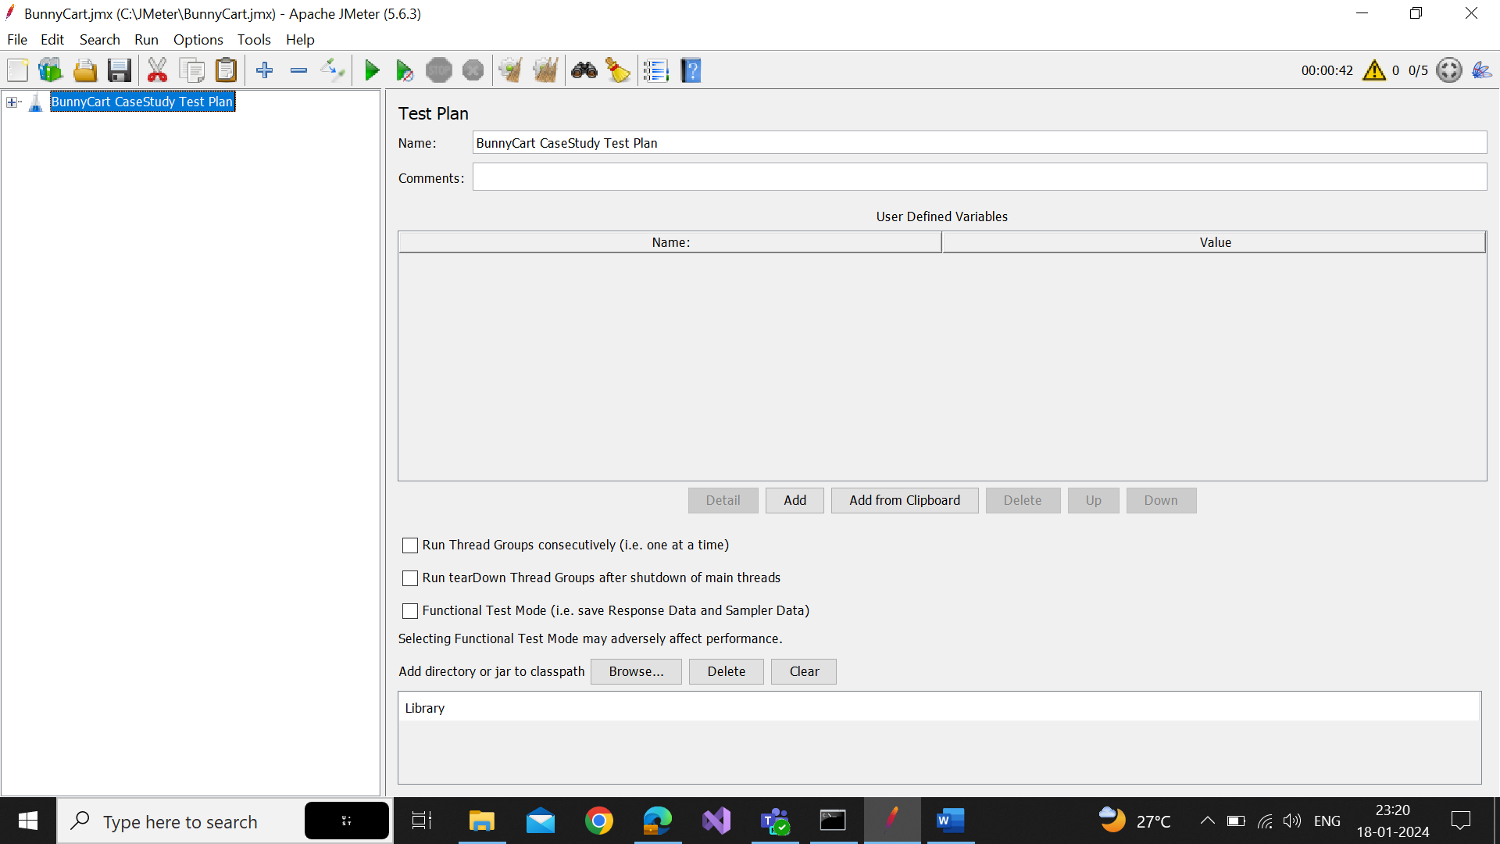

2. Creating User Defined Variable

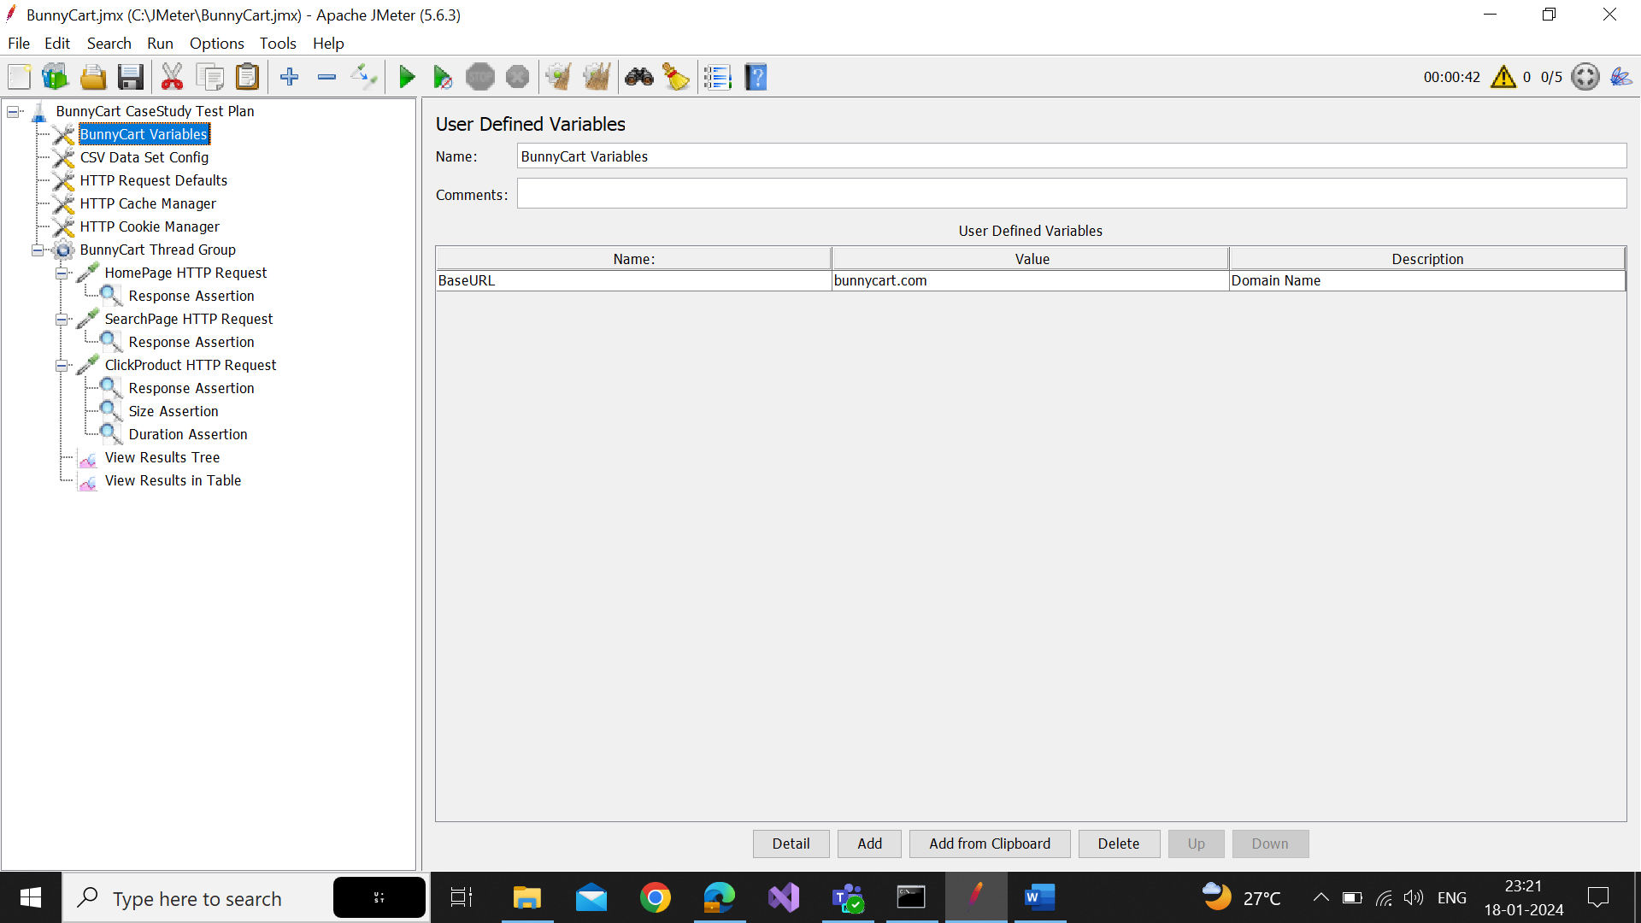

3.Creating HTTP Request Default

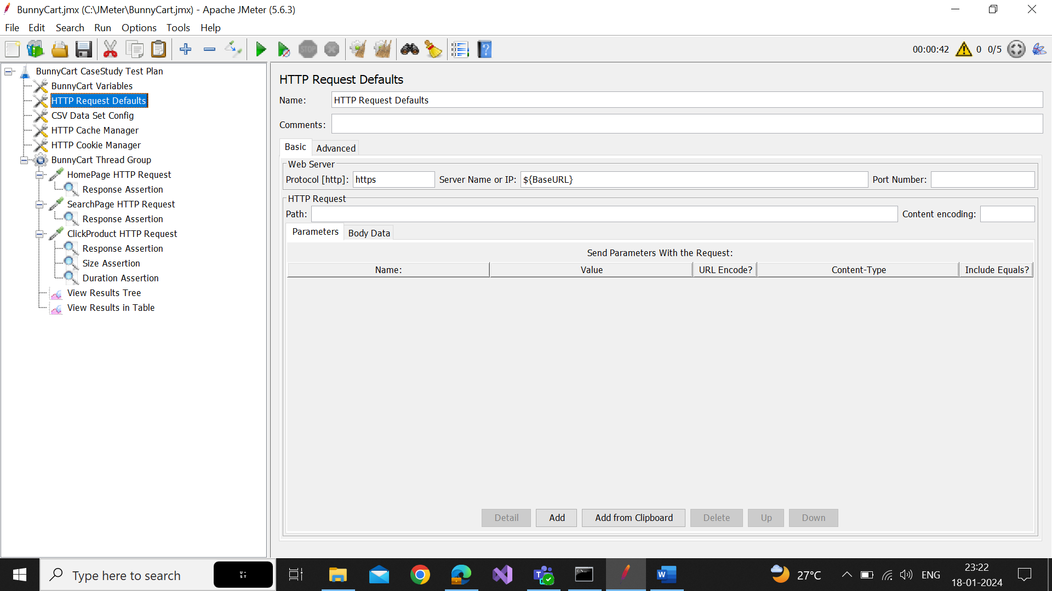

4.Creating HTTP Cache Manager

5.Creating HTTP Cookie Manager

6. Creating CSV Data Set Config

7. Creating Thread Group

8. Creating Different HTTP Requests

9. Creating Different Listeners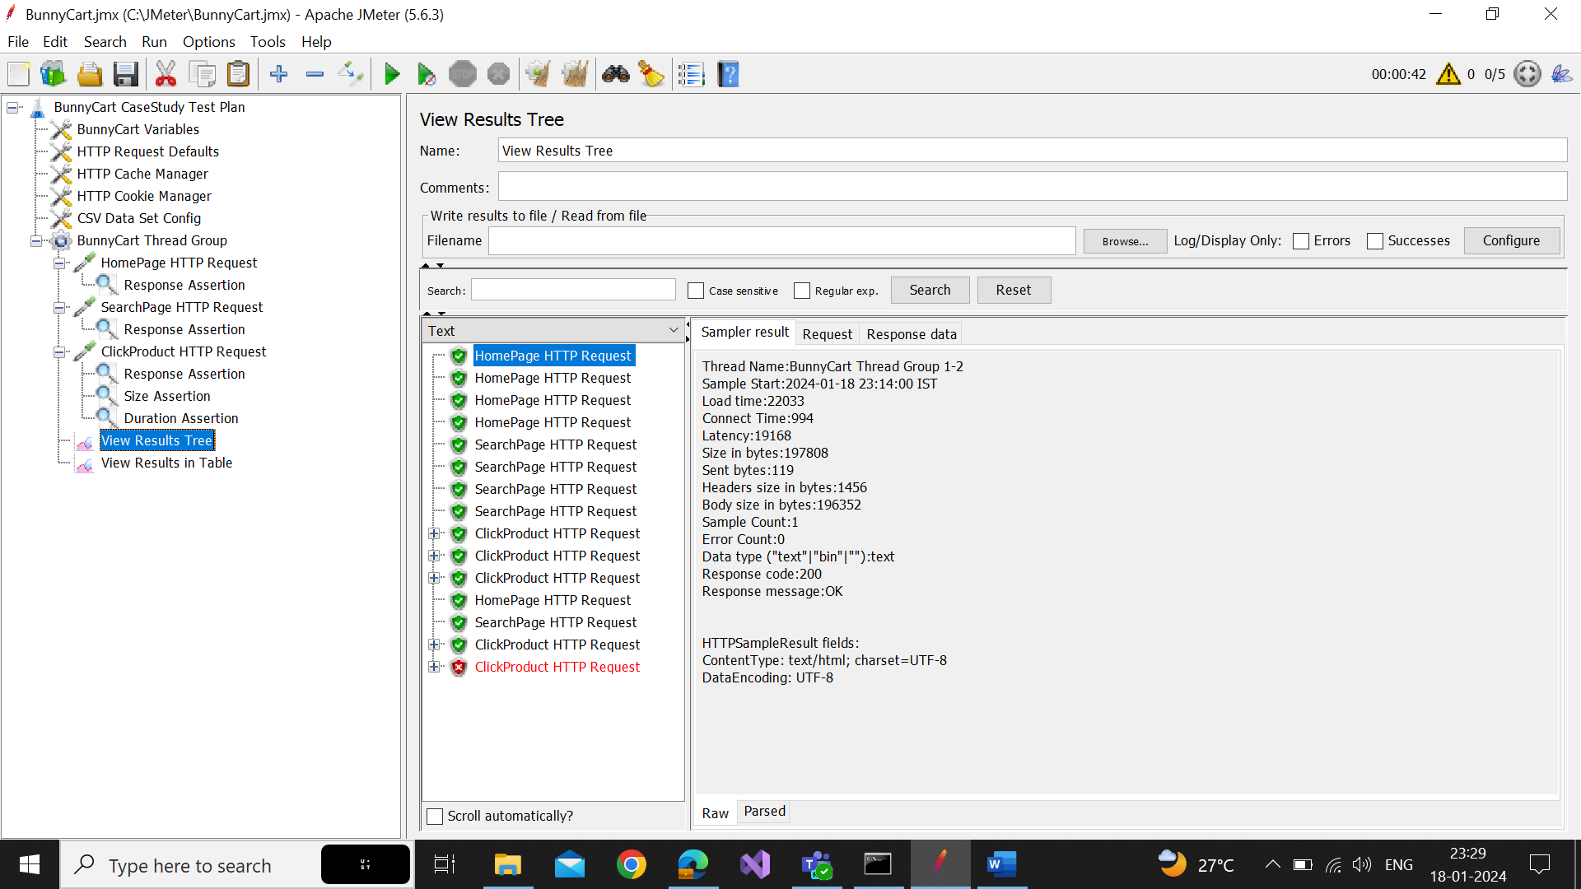

10. Finally RUN JMeter without GUI Only Using Command Lines

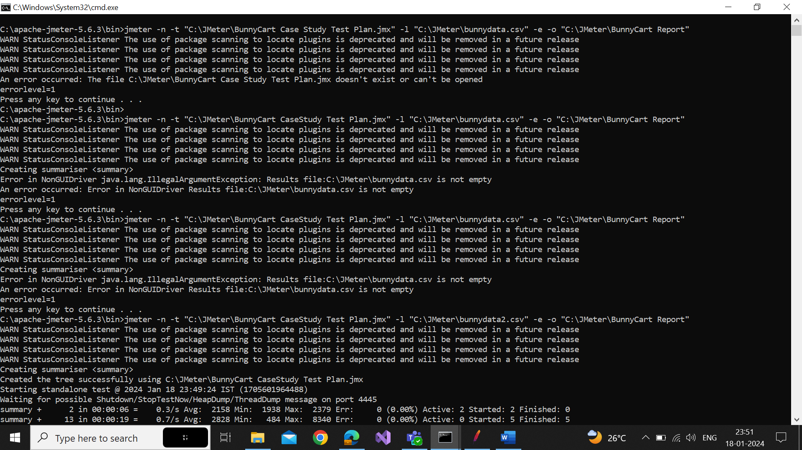

11. Log File

12. Report

